Here are some sc of git commands, not all the commands used while creating this project.
I did not take the sc of every command used. The document will be to messy with sc..
But I used git and github properly while creating this project.
Some Important sc of Noticeable commits etc.
Initializing
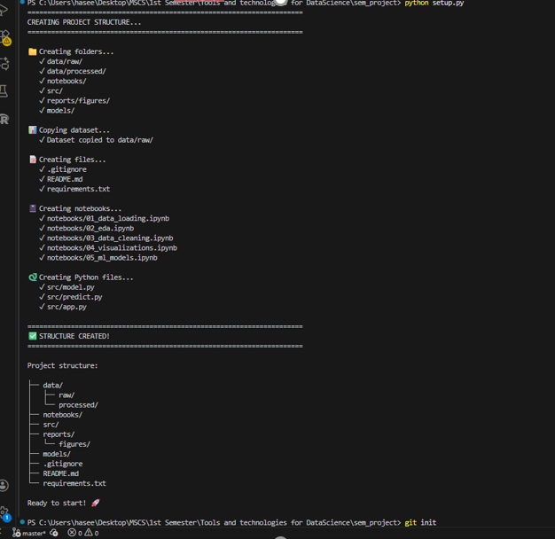

2.
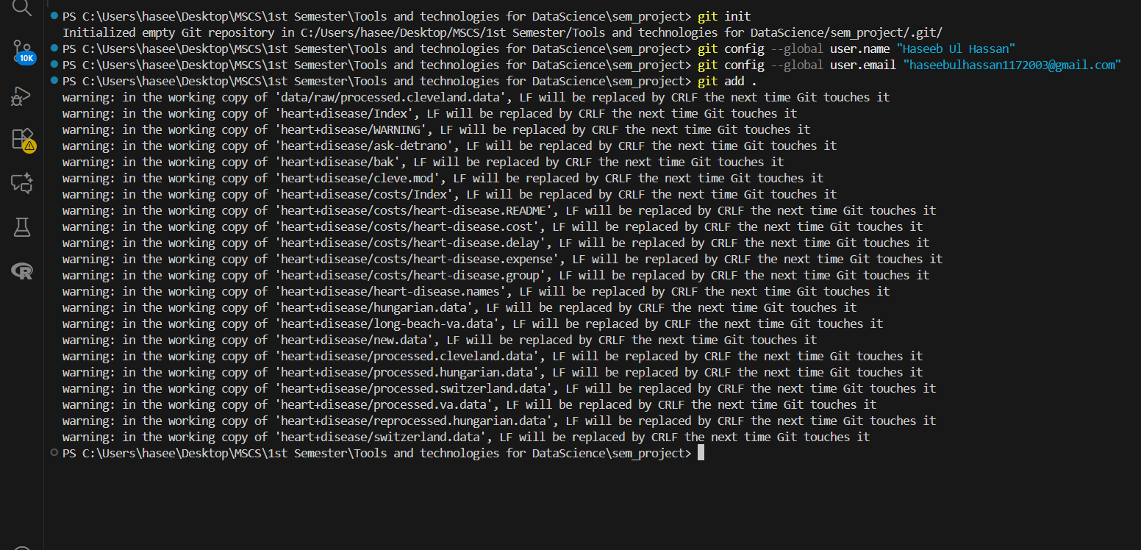
3. Project Structure
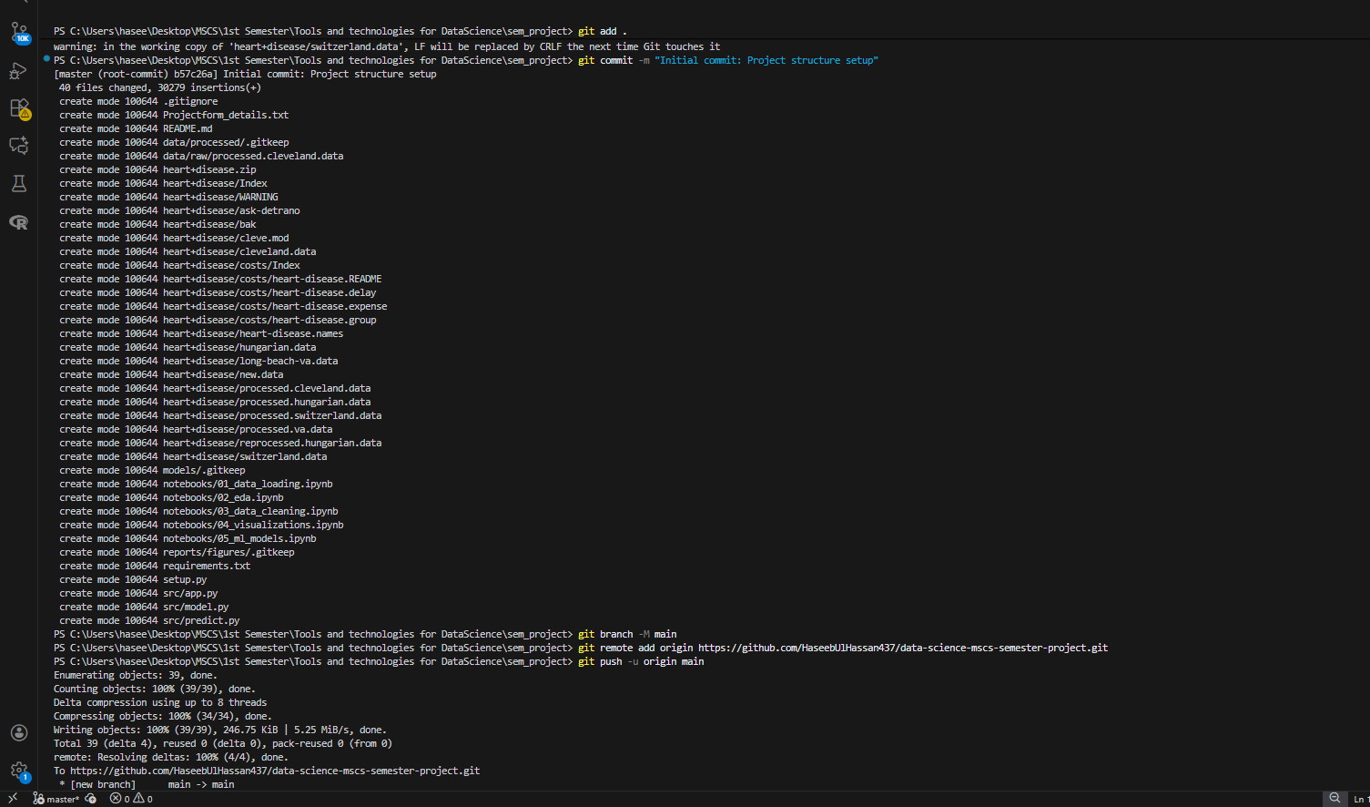
4.
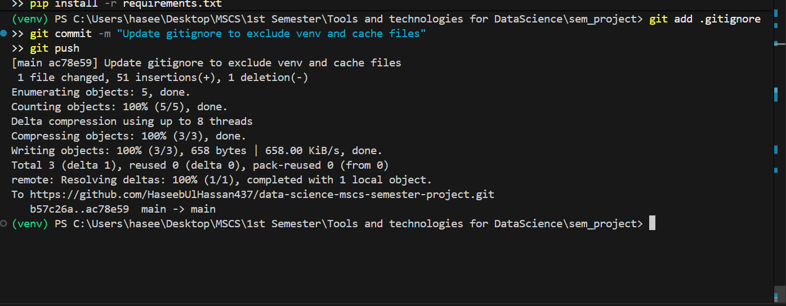
5.
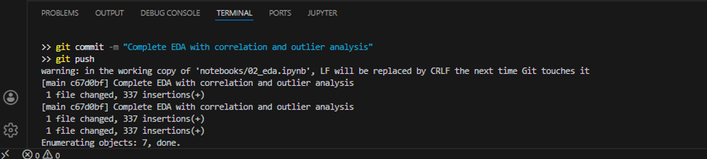

6. Git commads after EDA:

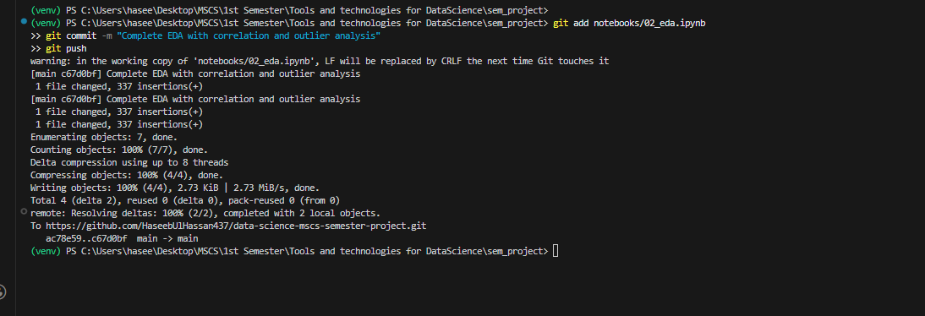

7. Git use after cleaning:
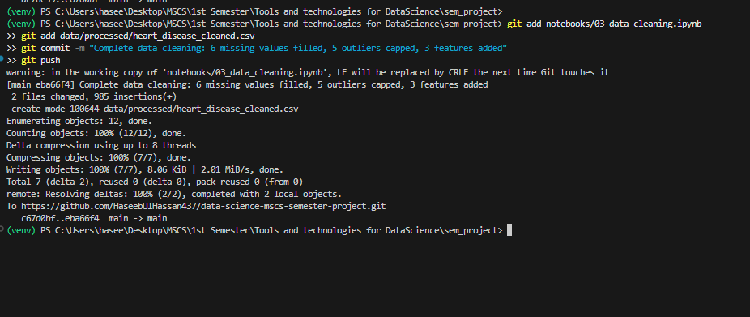

After visualization:
