# Backend

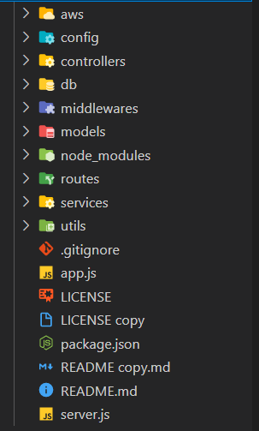

The **Backend** and is built on NodeJS framework using JavaScript,

The **APIs** are used to perform operations on the **front end**, whereas the database is **Atlas Mongo dB**, which is stored on cloud,

The **deployment server** is **cyclic** server on **Linux machine**,

For the storages the **S3 bucket** is used of **AWS.**

The **server.js** file is the entry point of the application as defined in the **package.json** file,

**Connection** folder contains the code to connect to mongo dB database, mongoose library is used to work database

**Models** folder contains the model entity classes, like student, teacher, assignment etc.

The **Services** folder contains the actual functionality of the entity and their inter connected service and relationships and references, so that data should be acid,

The **Controller** folder make high level use of the services and provide them to the **Routes** defined in the routes folder

The **Config** folder contains the configuration of the system used in it, like **AWS** configuration and dB link and modes development and production

The **Utilities**, **Errors**, **Middleware** are defined to make the application flow better without crashing the application,

**Main.js** files gets all the routes dB, cors, middlewares and apply to the application

There are list of libraries are used to enhance the functionality of the application, as defined in the **packag.json** file

# React Native App

React Native is an open-source UI software framework created by Meta Platforms for cross platform app development.

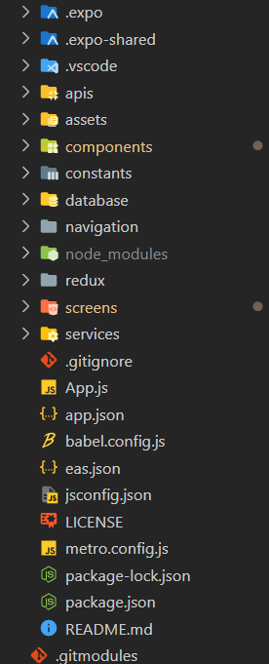

Front end is developed in the react native using JavaScript,

The list of libraries used in the project are defined in the **package.json** files

**Components** folder comprises of all the components of the application.

**Screens** folder comprises of all the Screens for student and teacher of the application.

The **routes** are defined in term of **stacks** where the different stacks are defined for student and teacher and the similar functionality is reused,

The **Services** contains all the **APIs** used in the application and called as per need bases

The services are used in the components to render the data from the backend and provide it the the user in rich way,

To call the APIs the **axios** Library is used.

Assests folder contains the basic stuff for application like resources.

The **react-native-base** is used to provide a better UI enhancement in the application

The icons are used in application for the application from the **font awesome** library,