Assignment

## Code:

#include <stdio.h>

int main()

{

float height, weight, BMI;

printf("please enter the height : ");

scanf("%f",&height);

printf("\nplease enter the weight : ");

scanf("%f",&weight);

BMI = ((10000*weight)/(height*height));

printf("\n\n Your BMI is : %f\n\n",BMI);

if(BMI<18.5)

printf("Status is Under Weight");

else if(BMI<24.9)

printf("Status is Normal Weight");

else if(BMI<29.9)

printf("Status is Over Weight");

else

printf("Status is Obese");

}

## Output:

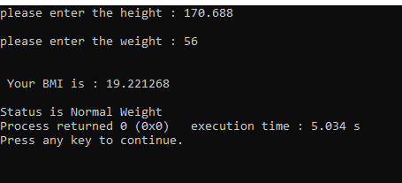

Lab 4:

# Task 1:

## Code:

#include <stdio.h>

int main()

{

int j = 0 ;

do

{

printf("value of the variable j is :%d \n",j);

j++;

}while(j<=3);

}

## Output:

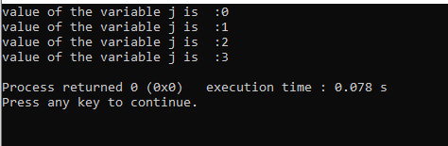

# Task 2:

## Code:

#include <stdio.h>

int main()

{

float num;

double sum = 0.0 ;

do

{

printf("Enter the non zero number : ");

scanf("%f",&num);

sum+=num;

}while(num!=0.0);

printf("\n\nthe total sum is : %f",sum);

}

## Output:

