PeaceSeeker

023-18-0057

Haseeb Ullah

# Know your communication interface

## Unplug the RJ 45 or Ethernet cable or UTP

WIFI is disconnected or connected is disabled

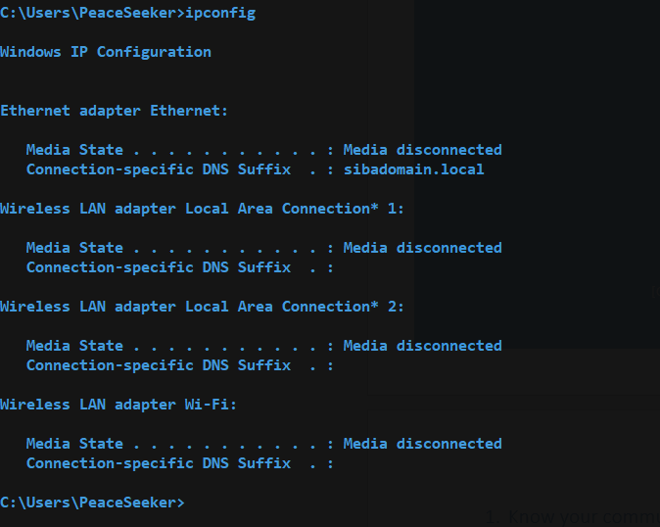

## replug the connector and observe the conectivity process

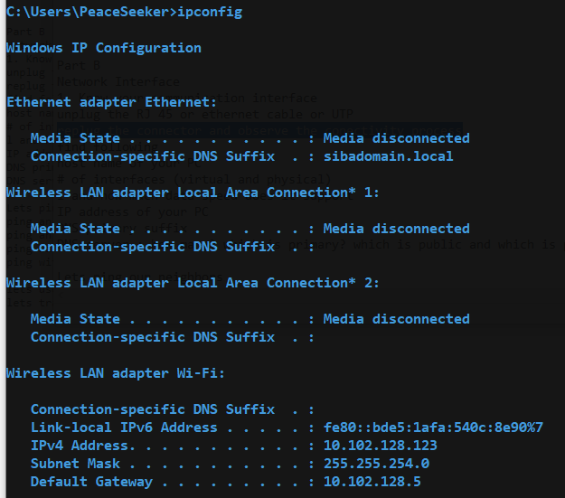

1. host name of your PC

ipconfig -all



1. # of interfaces (virtual and physical)

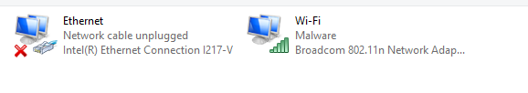

1. how much data speed does it support

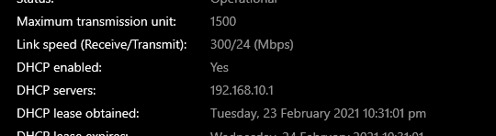

1. IP of PC

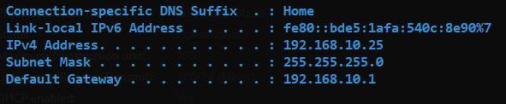

1. DNS Suffix

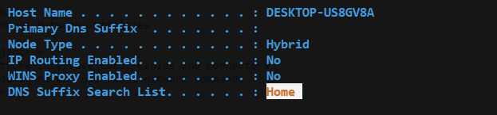

1. Private DNS



1. Ping ip

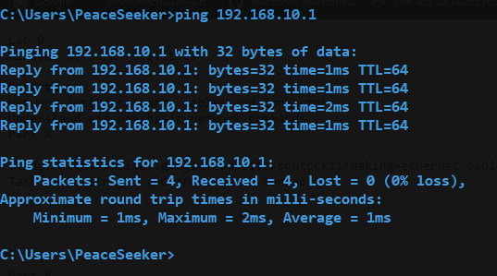

1. Ping website

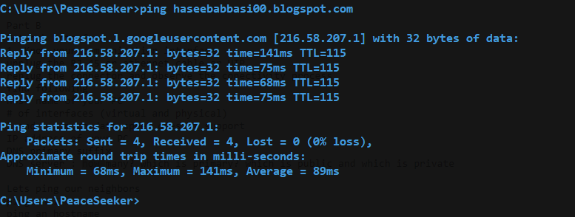

1. Ping n times

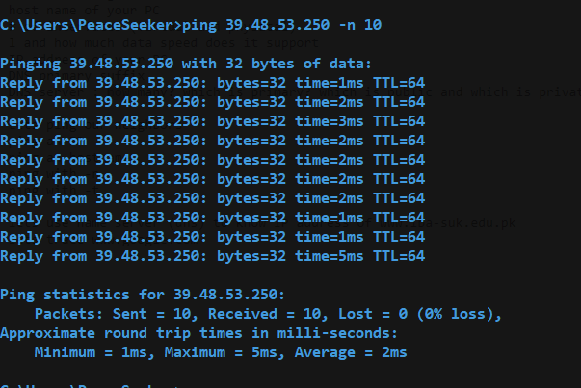

1. Ping infinite :

