# Fundamentals of Programming

## Lab Task: 4

Name: Malik Haseeb

Section: B

Roll no: 468333

Submitted to : Sir M. Affan

## Task:1

### Code:

#include <iostream>

using namespace std;

int main() {

int summation,num,i;

while(i<10)

{cout<<"Enter any Number..."<<endl;

cin>>num;

summation=summation+num;

i++;

}

cout<<"The Sum of the First Ten Natural Numbers is:"<<summation<<endl;

return 0;

}

## Output:

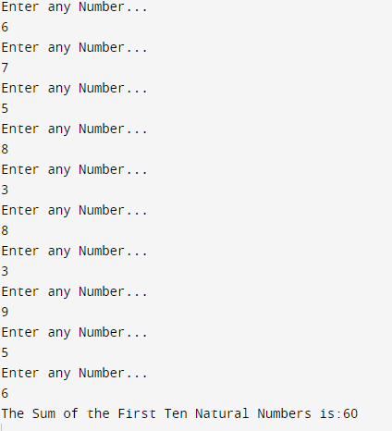

## **Task: 2**

## Code:

## #include <iostream>

## using namespace std;

## int main() {

## int number, table, ans;

## cout<<"Enter any Number"<<endl;

## cin>>number;

## for(table=1;table<=10;table++)

## {ans=number*table;

## cout<<number<<" x "<<table<<" = "<<ans<<endl;

## 

## }

## 

## return 0;

## }Output:

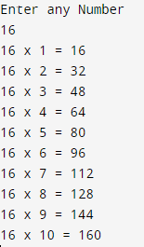

## **Task: 3**

## Code:

## #include <iostream>

## using namespace std;

## int main()

## {

## float f,num;

## cout<<"Enter any Number :"<<endl;

## cin>>num;

## for(f=num-1;f>=1;f--)

## {num*=f;}

## cout<<"The Factorial is :"<<num<<endl;

## 

## 

## return 0;

## }Output:

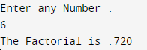

## **Task: 4**

## Code:

#include <iostream>

using namespace std;

int main() {

int fib;

cout << "Terms of the Fibonacci Sequence..";

cin >> fib;

float a = 0, b = 1, x;

cout << "Fibonacci Sequence: "<<endl;

for (int f = 0; f < fib; ++f) {

if (f <= 1) {

x = f;

} else {

x = a + b;

a = b;

b = x;

}

cout << x <<endl;

}

return 0;

}

Output:

