Name: Haseeb Ullah

ID : F20232661009

Lab 1

OOPs

**Lab Task 1**

Write a program that takes input a number in main function and passes the number to a function. The function will display the factorial of that number.

**Code:**

|  |
| --- |
| #include <iostream>  using namespace std;  int factorail(int x)  {  int fact =1;    for(int i = x; i > 0 ;i-- )  {  fact = fact * i;  }  return fact;  }  int main()  {    int num;    cout << "Factorail checker"<<endl;  cout << "Enter the number : ";  cin >> num;    cout << "The factorail is : " << factorail(num);          return 0;  } |

**Output:**

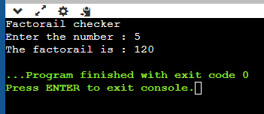

**Lab Task 2:**

Write a function ‘sum’ to add the values for three variables and store the result in another variable. Function will take 3 arguments as default. Call the function in main with 1, 2 and then 3 variables.

**CODE**

|  |
| --- |
| #include <iostream>  using namespace std;  int sum(int x, int y, int z)  {  int sum = x+y+z;  return sum;    }  int main()  {    int num1, num2, num3;    cout << "check the sum of three number."<<endl;  cout << "Enter the number three number one by one: ";  cin >> num1 >> num2 >> num3;    cout << "The sum is : " << sum(num1, num2, num3);      return 0;  } |

**Output:**

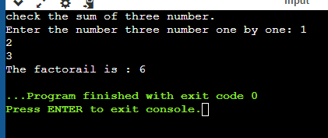

**Lab Task 3:**

Write a program that inputs radius of circle and uses an inline function AREA() to calculate and return the area of circle

**Code**

|  |
| --- |
| #include <iostream>  #include <cmath>  using namespace std;  double area_of_circle(double radius, double pi)  {  double area = pi * pow(radius,2);  return area;    }  int main()  {    double radius, pi = 3.14;      cout << "AREA OF Cicle."<<endl;  cout << "Enter the radius: ";  cin >> radius;    cout << "The area is : " << area_of_circle(radius,pi);          return 0;  } |

**Output:**

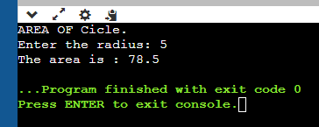

**Lab Task 4:**

Write three functions ‘output’. The first version takes no parameters and display 5 asterisk. The second version takes an integer and display the number of i integers. The third version takes an integer and a character as parameters and displays the number of n characters.

**Code:**

|  |
| --- |
| #include <iostream>  #include <cmath>  using namespace std;  void output()  {  for(int i = 1; i < 5;i++)  {  cout << "*";  }  cout << endl;  }  int output(int x)  {    for (int i = 1; i <= x; i++)  {  cout <<i;  }  }  int output(int x, char s)  {    for (int i = 1; i <= x; i++)  {  cout <<s;  }  }  int main()  {      output();    output(4);    cout <<endl;    cout << "Enter the Char: ";  char ch;    cin >> ch;    output(4,ch);    return 0;  } |
| **ANOTHER WAY**  **#include <iostream>**  **#include <cmath>**  **using namespace std;**  **void output()**  **{**  **for(int i = 1; i < 5;i++)**  **{**  **cout << "*";**  **}**  **cout << endl;**  **}**  **void output(int x)**  **{**    **for (int i = 1; i <= x; i++)**  **{**  **cout <<i;**  **}**  **}**  **void output(int x, char s)**  **{**    **for (int i = 1; i <= x; i++)**  **{**  **cout <<s;**  **}**  **}**  **int main()**  **{**      **output();**    **output(4);**    **cout <<endl;**    **cout << "Enter the Char: ";**  **char ch;**    **cin >> ch;**    **output(4,ch);**      **return 0;**  **}** |

**Output:**

