**ASSIGNMENT 01**

**on**

**Git Version Control**

**Submitted by:**

**Haseebullah Shaikh (2303.KHI.DEG.015)**

**Dated :** 05th Apr 2023

**Task 01:**

**1.Create a new git repository in a local directory.**

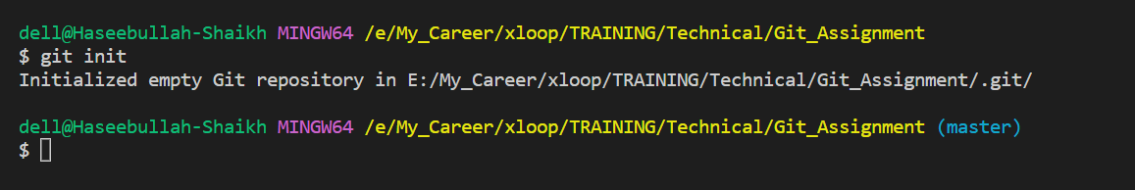

**2.Create an empty file “numbers.txt” and commit it to the current (“main” or “master”) branch.**

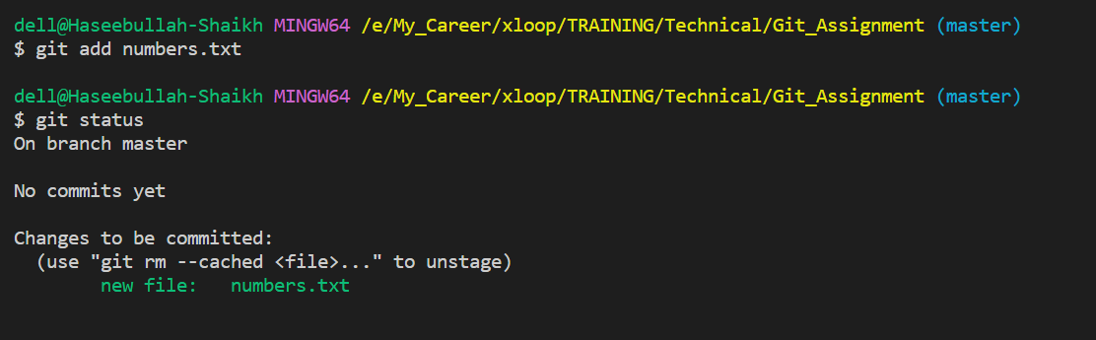

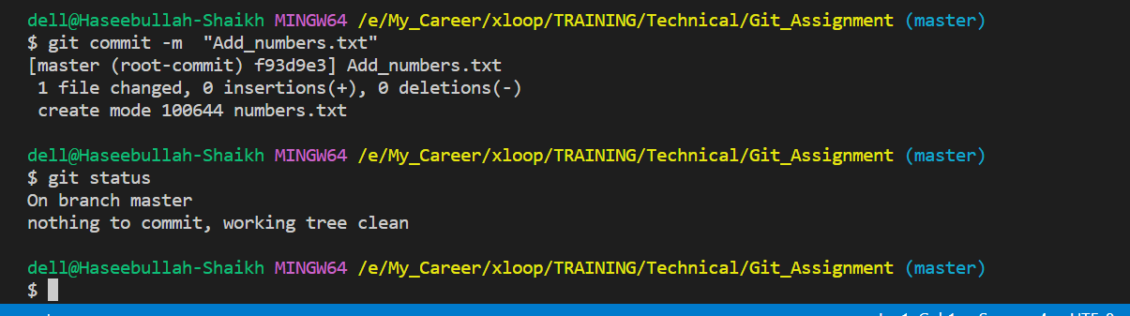

**3.Create two new branches: “odd” and “even”.**

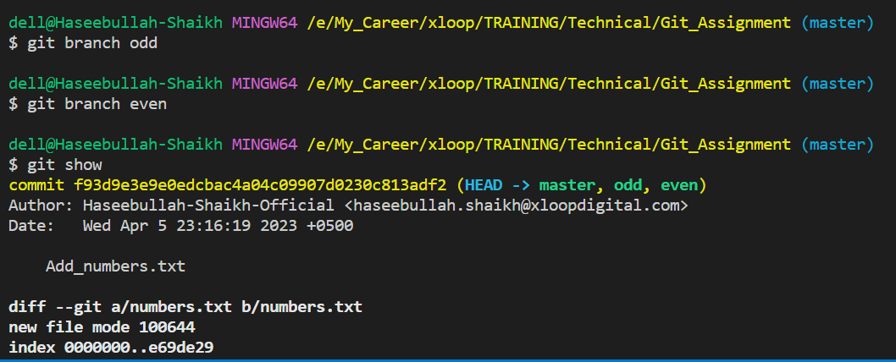

**4.Switch to the “odd” branch.**

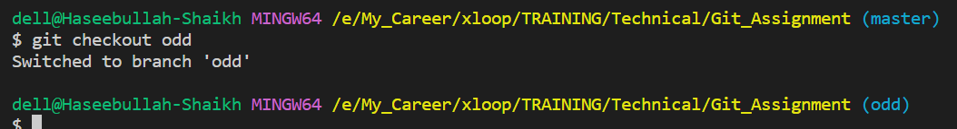

**5.Edit the “numbers.txt” file by adding some odd numbers, then commit the change.**

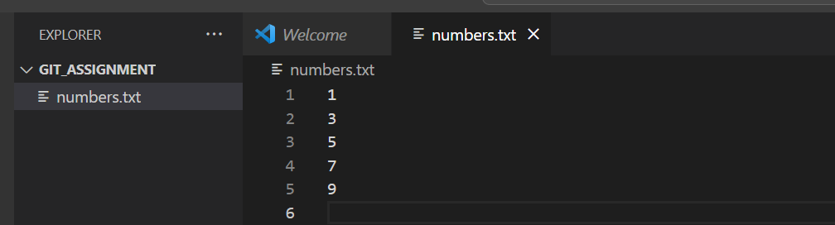

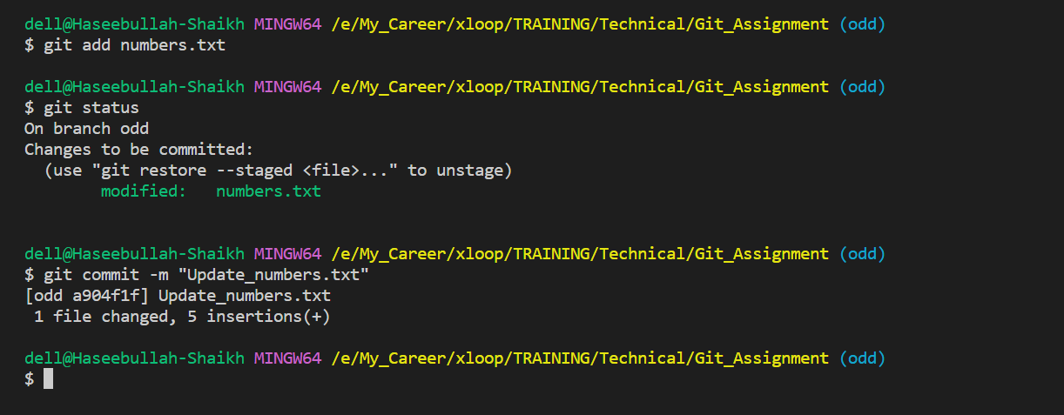

**6.Switch to the “even” branch.**

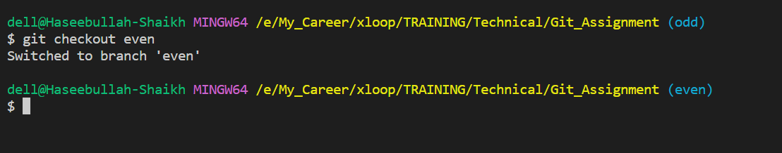

**7.Edit the “numbers.txt” file by adding some even numbers, then commit the change.**

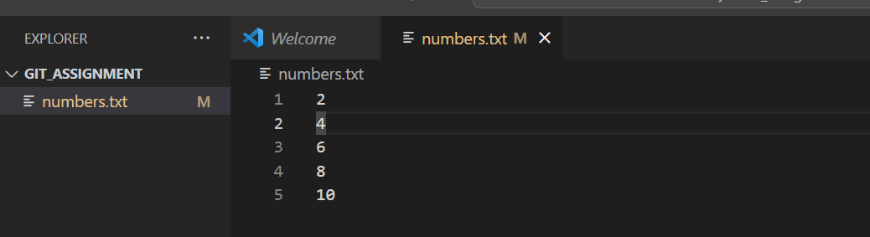

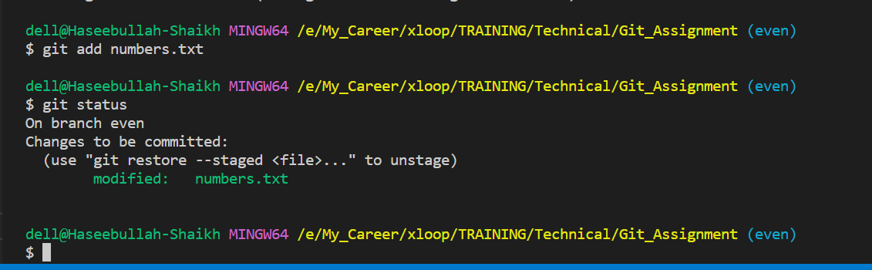

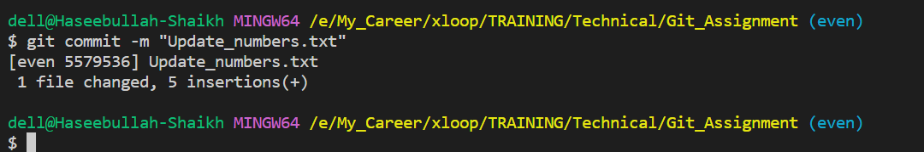

**8.Switch to the main branch.**

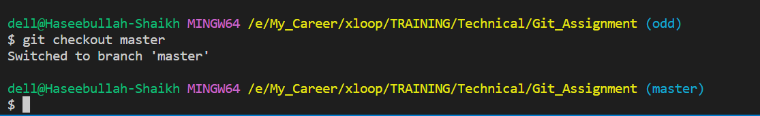

**9.Merge the “odd” branch to the current one.**

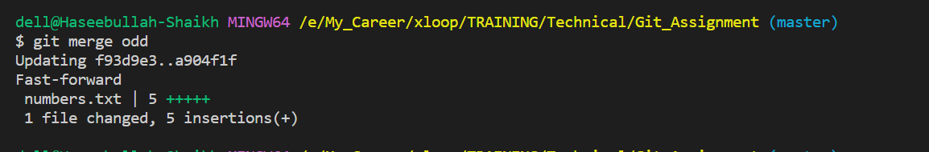

**10.Try to merge the “even” branch too – it should cause a conflict.**

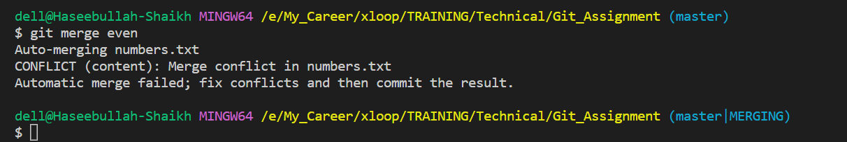

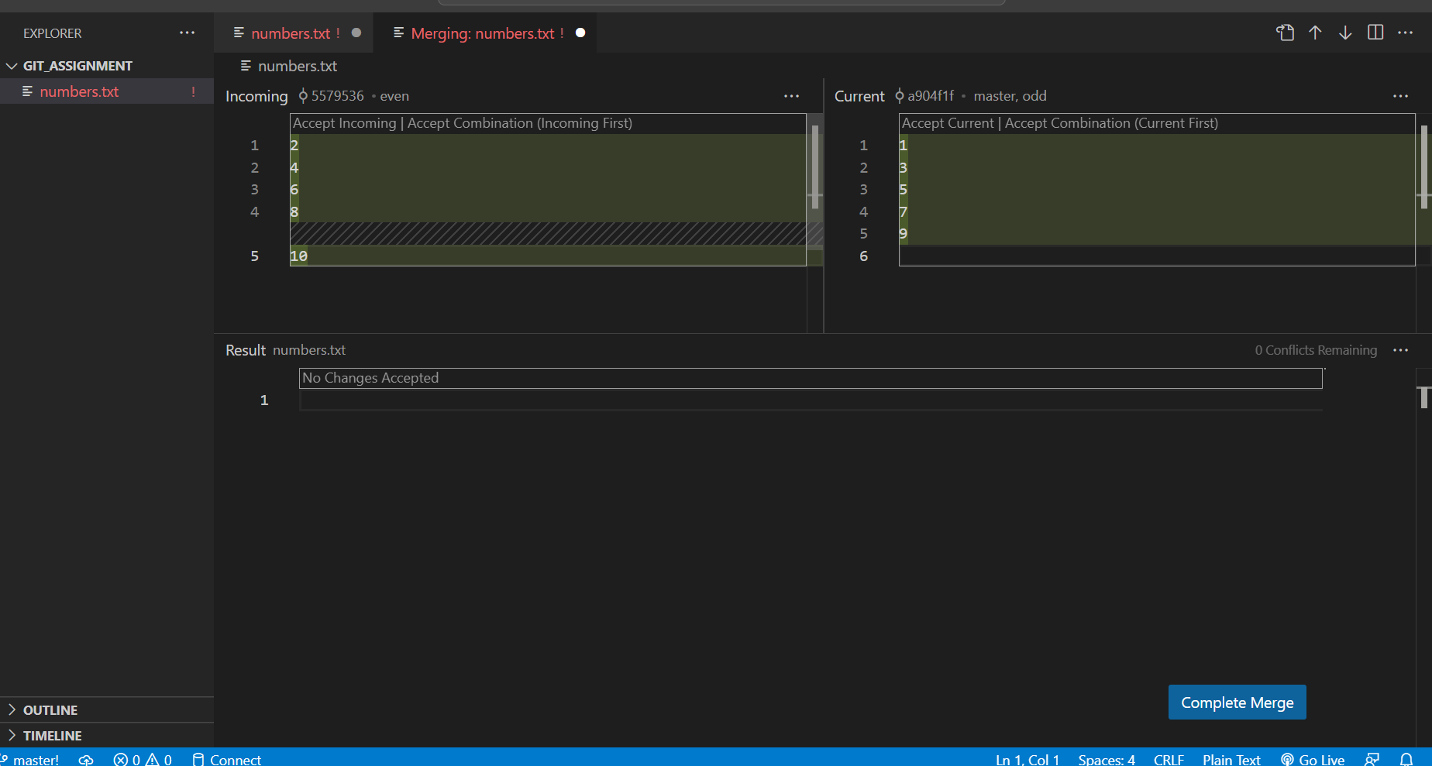

**11.Resolve the conflict by combining all the numbers and commit the merge.**

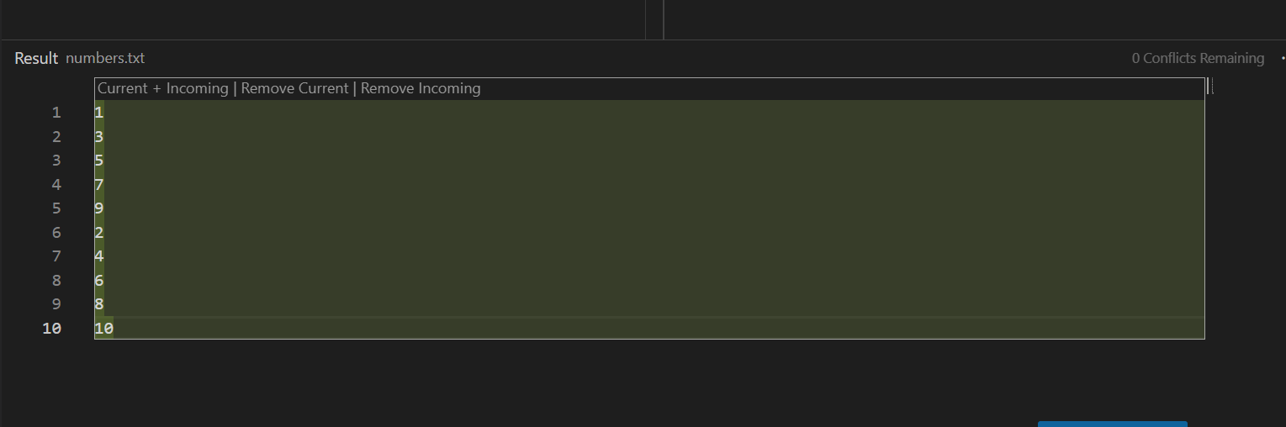

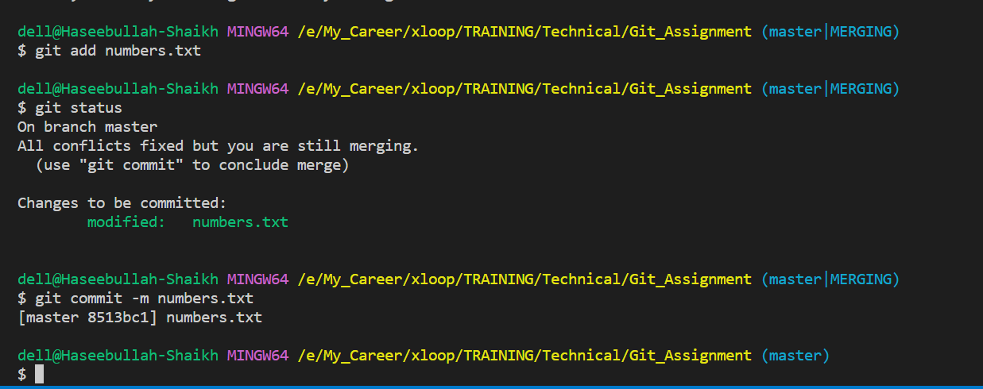

**List the commits using git log -p command and save the output in a file.**

**Output:**

**$ git log -p**

**commit 8513bc1ab06dacab621e1a587ed67e73207fb49c (HEAD -> master)**

**Merge: a904f1f 5579536**

**Author: Haseebullah-Shaikh-Official <haseebullah.shaikh@xloopdigital.com>**

**Date: Wed Apr 5 23:34:56 2023 +0500**

**numbers.txt**

**commit 5579536e1a58bd6140afdc1a70cdba4826d46c21 (even)**

**Author: Haseebullah-Shaikh-Official <haseebullah.shaikh@xloopdigital.com>**

**Date: Wed Apr 5 23:25:46 2023 +0500**

**Update_numbers.txt**

**diff --git a/numbers.txt b/numbers.txt**

**index e69de29..0e0333e 100644**

**--- a/numbers.txt**

**+++ b/numbers.txt**

**@@ -0,0 +1,5 @@**

**+2**

**+4**

**+6**

**+8**

**+10**

**\ No newline at end of file**

**commit a904f1f529294bcdae757bc0ebb4cd0d18850827 (odd)**

**Author: Haseebullah-Shaikh-Official <haseebullah.shaikh@xloopdigital.com>**

**Date: Wed Apr 5 23:21:52 2023 +0500**

**Update_numbers.txt**

**diff --git a/numbers.txt b/numbers.txt**

**index e69de29..2738e8e 100644**

**--- a/numbers.txt**

**+++ b/numbers.txt**

**@@ -0,0 +1,5 @@**

**+1**

**+3**

**+5**

**+7**

**+9**

**commit f93d9e3e9e0edcbac4a04c09907d0230c813adf2**

**Author: Haseebullah-Shaikh-Official <haseebullah.shaikh@xloopdigital.com>**

**Date: Wed Apr 5 23:16:19 2023 +0500**

**Add_numbers.txt**

**diff --git a/numbers.txt b/numbers.txt**

**new file mode 100644**

**index 0000000..e69de29**

**(END)**