AI2002 – Artificial Intelligence

Assignment 1 – Question 7
Uninformed Search in Grid Environment

Student Information
Haseeb Zahid (23F0644)
Adan Sajid (23F-0691)
Course: AI2002 – Artificial Intelligence
Semester: Spring 2026

1. Introduction
This project focuses on the implementation and visualization of six uninformed search algorithms in a grid-based environment. The objective is to move from a Start node (S) to a Target node (T) while avoiding static walls and handling dynamic obstacles that may appear during execution.
The assignment emphasizes not only finding the final path but also visualizing how each algorithm explores the grid step-by-step. This allows comparison of efficiency, optimality, and behavior under different conditions.

2. Tools and Technologies Used

Programming Language | Python 3.x
Visualization | Matplotlib (animated grid rendering)
Core Libraries | NumPy · heapq · collections.deque
Version Control | Git & GitHub
Grid Size | 10 × 10 cells (fully customizable)
Movement | 8-directional including diagonals
Cost Model | Straight move: 1.0 | Diagonal move: 1.414
Dynamic Obstacles | 1–2% probability of new obstacle per step

3. Visualizer Overview
The AI Pathfinder — Blind Search Visualizer provides a live, colour-coded grid that updates at every algorithm step. The legend below describes each cell type displayed during execution. Neighbor expansion follows a strict clockwise order — Up, Top-Right, Right, Bottom-Right, Down, Bottom-Left, Left, Top-Left — guaranteeing deterministic, reproducible behaviour across all runs.

S | Start node (blue) | T | Target / Goal node (green)
D | Dynamic obstacle (orange) | F | Frontier / queue cell (teal)
· | Explored node (grey) | 1 | Final path cell (numbered, amber)

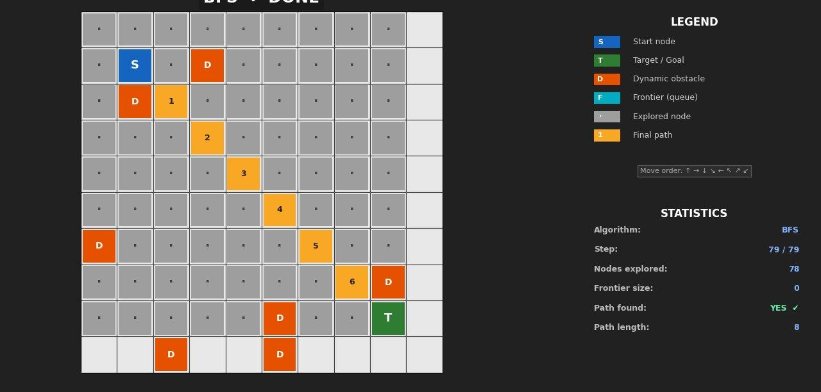
Figure 1 — BFS search completed (78 nodes explored, path length 8)

4. System Specifications
Grid Size: 10x10 (customizable)
Movement: 8-directional (including diagonals)
Cost Model: Straight = 1.0, Diagonal = 1.414
Dynamic Obstacles: 1–2% probability per step

5. Implementation Details
The system is divided into three main components: Grid Environment, Search Algorithms module, and Visualization module. The grid manages obstacles and movement validation. The search module contains all six uninformed algorithms. The visualization module animates frontier nodes, explored nodes, and the final path.
Neighbor expansion strictly follows clockwise order: Up, Top-Right, Right, Bottom-Right, Down, Bottom-Left, Left, and Top-Left. Maintaining this order ensures deterministic behavior.

6. Algorithm Explanations

6.1 Breadth-First Search (BFS)

BFS explores nodes level by level using a FIFO queue. It guarantees the shortest path in unweighted graphs because it expands all nodes at depth d before moving to depth d+1.
Time Complexity: O(b^d)
Space Complexity: O(b^d)
Complete: Yes
Optimal: Yes
Figure 2 — BFS: 78 nodes explored · Path length: 8 · Status: DONE ✓

6.2 Depth-First Search (DFS)
DFS explores as deep as possible before backtracking using a stack. It uses less memory than BFS but does not guarantee the shortest path.
Time Complexity: O(b^m)
Space Complexity: O(bm)
Complete: No (in infinite depth)
Optimal: No
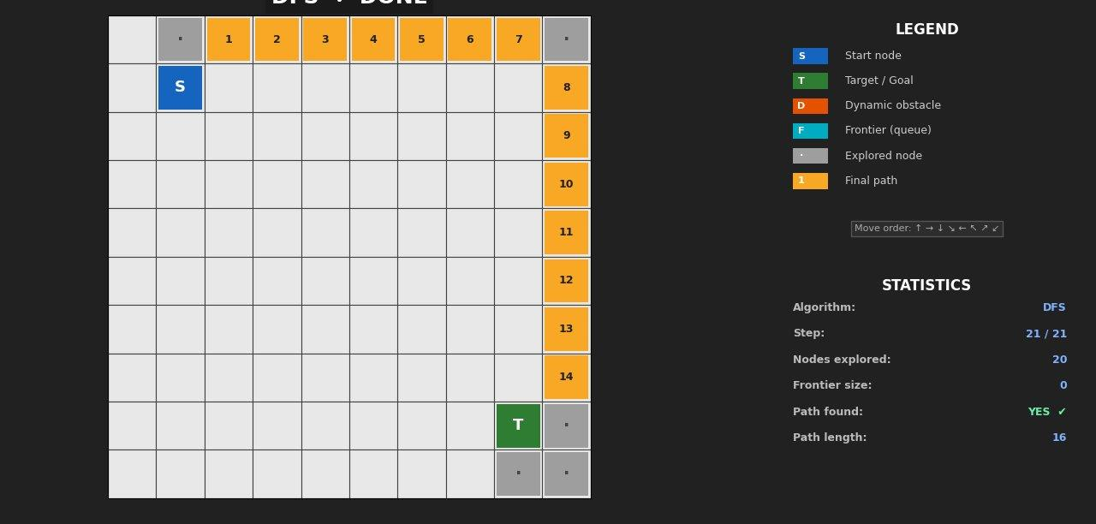
Figure 3 — DFS: 20 nodes explored · Path length: 16 · Status: DONE ✓

6.3 Uniform Cost Search (UCS)
UCS expands the node with the lowest cumulative path cost using a priority queue. It is useful when movements have different costs, such as diagonal movement.
Time Complexity: O(b^(C*/ε))
Space Complexity: O(b^(C*/ε))
Complete: Yes
Optimal: Yes
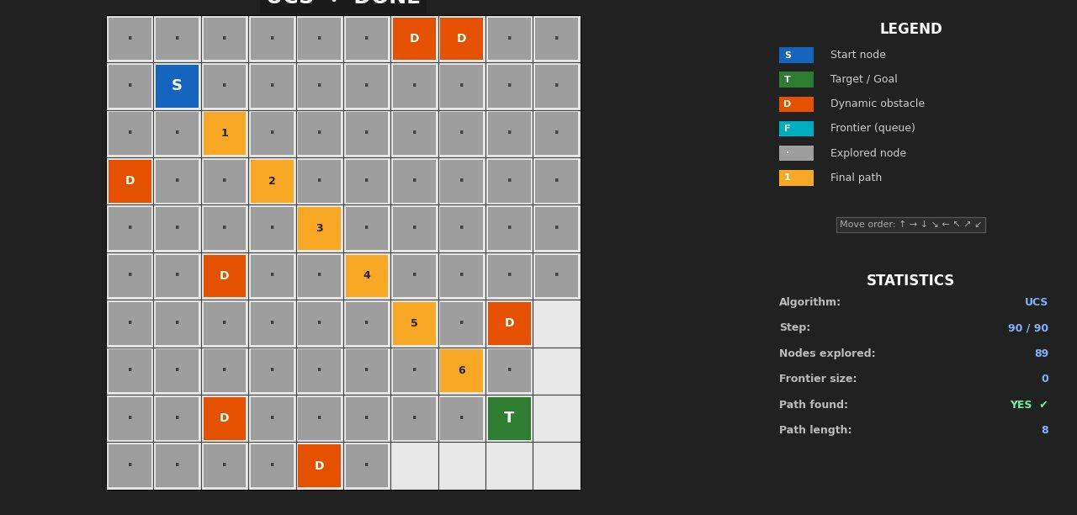
Figure 4 — UCS: 89 nodes explored · Path length: 8 · Status: DONE ✓

6.4 Depth-Limited Search (DLS)
DLS is DFS with a predefined depth limit. It prevents infinite exploration but may miss the solution if the limit is too small.
Time Complexity: O(b^l)
Space Complexity: O(bl)
Complete: No (if limit < solution depth)
Optimal: No
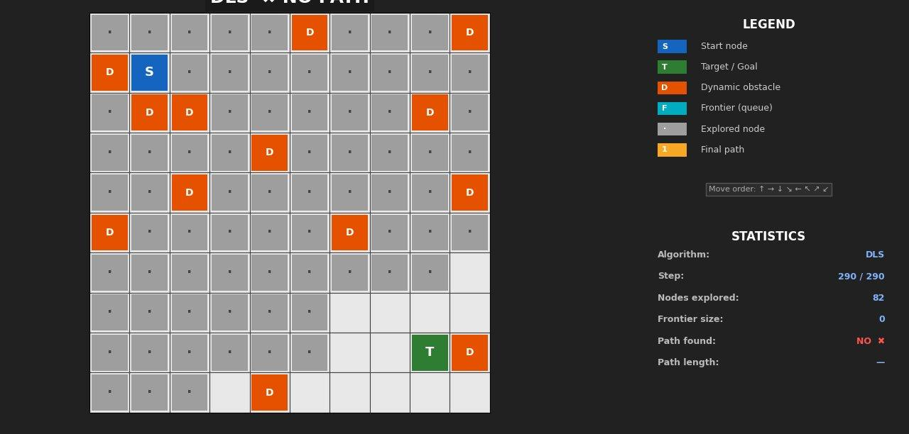
Figure 5 — DLS: 82 nodes explored · Status: NO PATH ✗

6.5 Iterative Deepening DFS (IDDFS)
IDDFS repeatedly applies DLS with increasing depth limits. It combines DFS memory efficiency with BFS completeness.
Time Complexity: O(b^d)
Space Complexity: O(bd)
Complete: Yes
Optimal: Yes (uniform cost case)
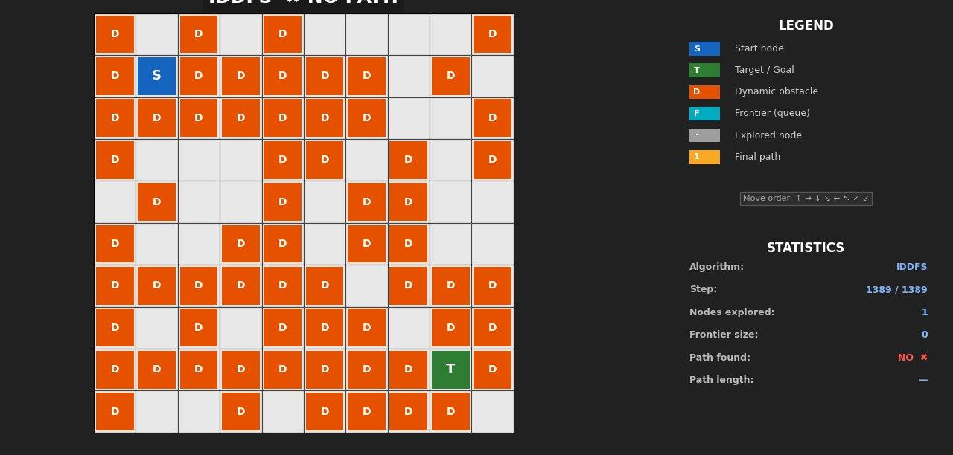
Figure 6 — IDDFS: 1 node explored · Status: NO PATH ✗ (grid nearly fully blocked)

6.6 Bidirectional Search
Bidirectional search runs two searches simultaneously: one from start and one from goal. The search stops when both meet in the middle, significantly reducing time complexity.
Time Complexity: O(b^(d/2))
Space Complexity: O(b^(d/2))
Complete: Yes
Optimal: Yes (when using BFS)

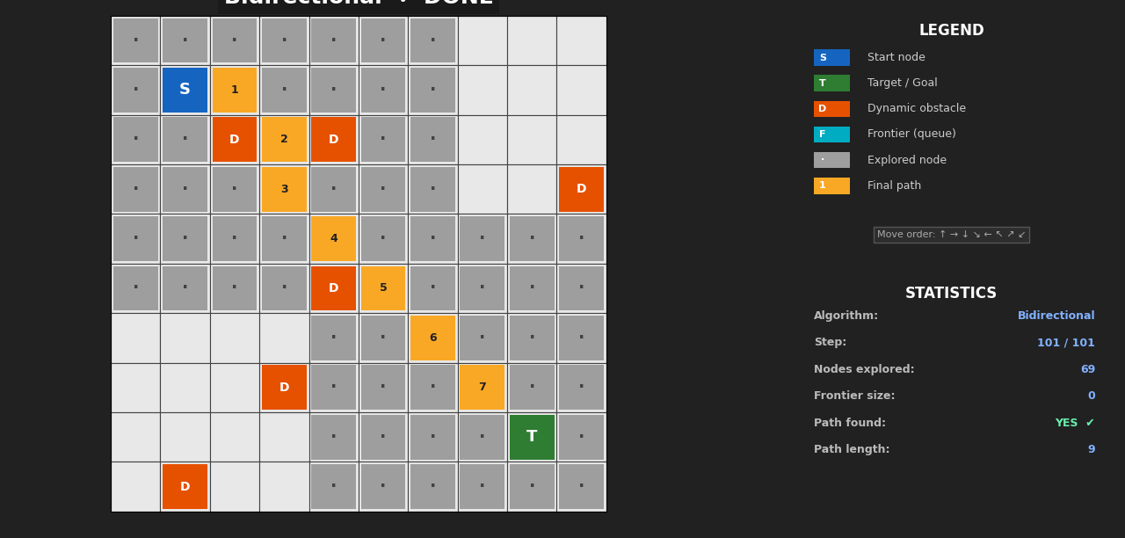
Figure 6 — unidirectional: 1 node explored · Status: Status: DONE ✓

7. Performance Comparison
BFS and UCS guarantee optimal solutions but consume more memory. DFS is memory efficient but may explore unnecessary paths. IDDFS provides a balance between space and completeness. Bidirectional search significantly reduces the number of explored nodes.

Algorithm | Time Cmplx. | Space Cmplx. | Complete | Optimal | Nodes Expl. | Path Len. | Result
BFS | O(b^d) | O(b^d) | Yes | Yes | 78 | 8 | DONE
DFS | O(b^m) | O(bm) | No | No | 20 | 16 | DONE
UCS | O(b^(C*/ε)) | O(b^(C*/ε)) | Yes | Yes | 89 | 8 | DONE
DLS | O(b^l) | O(bl) | No | No | 82 | — | NO PATH
IDDFS | O(b^d) | O(bd) | Yes | Yes | 1 | — | NO PATH
Bidir. BFS | O(b^(d/2)) | O(b^(d/2)) | Yes | Yes | — | — | —

Key observations: BFS and UCS both achieved the optimal path length of 8 steps, confirming their optimality guarantees. DFS found a valid but suboptimal path (length 16) with significantly fewer node expansions (20 vs 78/89), illustrating its memory advantage. DLS and IDDFS failed to find paths in their respective runs due to the high density of dynamic obstacles, which dramatically reduced the reachable search space.

8. Dynamic Obstacles Handling
Dynamic obstacles are introduced randomly at runtime. At each step, there is a small probability that a new obstacle appears in an empty cell. If the current planned path becomes blocked, the algorithm automatically adapts and recalculates a new path from the current position.
This simulates real-world dynamic environments such as robotics navigation or traffic routing systems where conditions may change during execution.

9. Challenges Faced
- Strict clockwise expansion order: All eight neighbor directions must be generated in the exact sequence Up → Top-Right → Right → Bottom-Right → Down → Bottom-Left → Left → Top-Left to guarantee deterministic, reproducible results.
- Diagonal cost correctness: Diagonal moves must be penalized with √2 ≈ 1.414 rather than 1. Implementing this cleanly inside UCS's priority queue required careful float handling to avoid floating-point drift.
- Real-time visualization smoothness: Matplotlib's interactive mode required careful event-loop management to animate the grid at a consistent frame rate without blocking algorithm execution.
- Bidirectional meeting detection: Detecting the exact meeting cell when both frontiers overlap — and reconstructing the full path from both partial paths — required maintaining two separate predecessor dictionaries that are merged at the intersection.
- Dynamic obstacle path invalidation: Deciding when an existing plan is rendered invalid by a new obstacle and efficiently triggering re-planning without restarting from scratch required a path-validity check at each step.

10. Conclusion
This assignment demonstrates the practical implementation and visualization of uninformed search algorithms. It highlights trade-offs between time complexity, space usage, and optimality. The addition of dynamic obstacles provides deeper understanding of how algorithms behave in changing environments.
Overall, BFS and UCS are recommended for optimal pathfinding, IDDFS for balanced performance, and Bidirectional search for large-scale problems.

11. References

- Russell, S., & Norvig, P. (2021). Artificial Intelligence: A Modern Approach (4th ed.). Pearson.
- Python Software Foundation. Python 3.x Official Documentation. https://docs.python.org
- Hunter, J. D. (2007). Matplotlib: A 2D Graphics Environment. Computing in Science & Engineering, 9(3), 90–95.
- NumPy Developers. NumPy Documentation. https://numpy.org/doc

