Name Haseeb Raza
Roll 23F-0644
Section 6F
Assignment 05

Link:
https://23f-0644-bscs-6f-assignment-05.netlify.app/

Code:
Html:
<!DOCTYPE html>
<html lang="en">
<head>
<meta charset="UTF-8" />
<meta name="viewport" content="width=device-width, initial-scale=1.0"/>
<title>AtmoSphere — Dual City Dashboard</title>
<link href="https://cdn.jsdelivr.net/npm/bootstrap@5.3.3/dist/css/bootstrap.min.css" rel="stylesheet"/>
<link href="https://cdn.jsdelivr.net/npm/bootstrap-icons@1.11.3/font/bootstrap-icons.css" rel="stylesheet"/>
<link href="https://fonts.googleapis.com/css2?family=Space+Grotesk:wght@300;400;500;600;700&family=Outfit:wght@200;300;400;600;700;900&display=swap" rel="stylesheet"/>
<link rel="stylesheet" href="style.css"/>
<script src="https://code.jquery.com/jquery-3.7.1.min.js"></script>
<script src="https://cdn.jsdelivr.net/npm/chart.js@4.4.2/dist/chart.umd.min.js"></script>
</head>
<body>
<div class="wrapper">

<nav class="topbar">
<div class="logo">Atmo<span>Sphere</span></div>
<div class="toggle-wrap">
<span class="toggle-label">Unit</span>
<button class="toggle-btn" id="unitToggle">°C → °F</button>
<span class="toggle-label" id="unitDisplay">Celsius</span>
</div>
</nav>

<section class="search-section">
<div class="city-input-group">
<label class="city-label"><i class="bi bi-geo-alt"></i> City One</label>
<div class="city-input-wrap">
<input type="text" class="city-input" id="city1Input" placeholder="e.g. London, UK" />
<button class="fetch-btn" id="fetchBtn1"><i class="bi bi-search"></i> Fetch</button>
</div>
</div>
<div class="city-input-group">
<label class="city-label"><i class="bi bi-geo-alt"></i> City Two</label>
<div class="city-input-wrap">
<input type="text" class="city-input" id="city2Input" placeholder="e.g. Tokyo, JP" />
<button class="fetch-btn" id="fetchBtn2"><i class="bi bi-search"></i> Fetch</button>
</div>
</div>
</section>

<div class="alert-area">
<div id="alert1"></div>
<div id="alert2"></div>
</div>

<main class="dashboard">
<div class="cities-grid">

<div>
<div class="skeleton-card" id="skel1">
<div class="skel skel-h1"></div>
<div class="skel skel-h2"></div>
<div class="skel skel-row"></div>
<div class="skel skel-row w85"></div>
<div class="skel skel-row w70"></div>
</div>
<div class="city-card" id="card1"></div>
</div>

<div>
<div class="skeleton-card" id="skel2">
<div class="skel skel-h1"></div>
<div class="skel skel-h2"></div>
<div class="skel skel-row"></div>
<div class="skel skel-row w85"></div>
<div class="skel skel-row w70"></div>
</div>
<div class="city-card" id="card2"></div>
</div>

</div>

<div class="compare-section" id="compareSection">
<div class="compare-title"><i class="bi bi-bar-chart-line"></i> Side-by-Side Comparison</div>
<table class="compare-table" id="compareTable"></table>
</div>
</main>

</div>

<button class="sidebar-toggle" id="sidebarToggle">
<i class="bi bi-clock-history" style="writing-mode:horizontal-tb"></i>
History
</button>

<aside class="history-sidebar" id="historySidebar">
<div class="sidebar-head">
<h5><i class="bi bi-clock-history"></i> Recent Searches</h5>
<button class="close-sidebar" id="closeSidebar"><i class="bi bi-x-lg"></i></button>
</div>
<div id="historyList"></div>
</aside>

<script src="app.js"></script>
</body>
</html>

Css:
:root {
--bg-primary: #060d1a;
--bg-secondary: #0d1b2e;
--bg-card: rgba(13, 27, 46, 0.85);
--border-glow: rgba(56, 189, 248, 0.18);
--text-primary: #e2f0ff;
--text-muted: #7bafd4;
--accent-blue: #38bdf8;
--accent-teal: #2dd4bf;
--accent-purple: #a78bfa;
--aqi-good: #22c55e;
--aqi-fair: #84cc16;
--aqi-moderate: #eab308;
--aqi-poor: #f97316;
--aqi-very-poor: #ef4444;
--font-display: 'Outfit', sans-serif;
--font-body: 'Space Grotesk', sans-serif;
}

*, *::before, *::after {
box-sizing: border-box;
margin: 0;
padding: 0;
}

body {
background: var(--bg-primary);
color: var(--text-primary);
font-family: var(--font-body);
min-height: 100vh;
overflow-x: hidden;
position: relative;
}

body::before {
content: '';
position: fixed;
inset: 0;
z-index: 0;
background:
radial-gradient(ellipse 80% 60% at 20% 10%, rgba(56,189,248,0.07) 0%, transparent 60%),
radial-gradient(ellipse 60% 40% at 80% 80%, rgba(167,139,250,0.07) 0%, transparent 60%),
radial-gradient(ellipse 50% 50% at 50% 50%, rgba(13,27,46,1) 0%, #060d1a 100%);
pointer-events: none;
}

body::after {
content: '';
position: fixed;
inset: 0;
z-index: 0;
background-image:
linear-gradient(rgba(56,189,248,0.03) 1px, transparent 1px),
linear-gradient(90deg, rgba(56,189,248,0.03) 1px, transparent 1px);
background-size: 60px 60px;
pointer-events: none;
}

.wrapper {
position: relative;
z-index: 1;
}

.topbar {
padding: 1rem 2rem;
display: flex;
align-items: center;
justify-content: space-between;
border-bottom: 1px solid var(--border-glow);
backdrop-filter: blur(12px);
position: sticky;
top: 0;
z-index: 100;
background: rgba(6,13,26,0.8);
}

.logo {
font-family: var(--font-display);
font-weight: 900;
font-size: 1.5rem;
letter-spacing: -0.04em;
background: linear-gradient(135deg, var(--accent-blue), var(--accent-teal));
-webkit-background-clip: text;
-webkit-text-fill-color: transparent;
}

.logo span {
opacity: 0.5;
font-weight: 200;
}

.toggle-wrap {
display: flex;
align-items: center;
gap: 0.6rem;
}

.toggle-label {
font-size: 0.78rem;
color: var(--text-muted);
text-transform: uppercase;
letter-spacing: 0.08em;
}

.toggle-btn {
background: var(--bg-secondary);
border: 1px solid var(--border-glow);
border-radius: 999px;
padding: 0.25rem 1rem;
color: var(--accent-blue);
font-family: var(--font-body);
font-weight: 600;
font-size: 0.85rem;
cursor: pointer;
transition: all 0.25s;
}

.toggle-btn:hover {
background: var(--accent-blue);
color: #000;
border-color: var(--accent-blue);
}

.search-section {
padding: 2.5rem 2rem 1rem;
display: grid;
grid-template-columns: 1fr 1fr;
gap: 1.5rem;
max-width: 1200px;
margin: 0 auto;
}

.city-input-group {
position: relative;
}

.city-label {
font-size: 0.7rem;
text-transform: uppercase;
letter-spacing: 0.12em;
color: var(--text-muted);
margin-bottom: 0.4rem;
display: block;
}

.city-input-wrap {
display: flex;
gap: 0.5rem;
}

.city-input {
flex: 1;
background: var(--bg-secondary);
border: 1px solid var(--border-glow);
border-radius: 10px;
padding: 0.75rem 1rem;
color: var(--text-primary);
font-family: var(--font-body);
font-size: 0.95rem;
outline: none;
transition: border-color 0.2s, box-shadow 0.2s;
}

.city-input::placeholder {
color: var(--text-muted);
}

.city-input:focus {
border-color: var(--accent-blue);
box-shadow: 0 0 0 3px rgba(56,189,248,0.12);
}

.fetch-btn {
background: linear-gradient(135deg, var(--accent-blue), var(--accent-teal));
border: none;
border-radius: 10px;
padding: 0.75rem 1.2rem;
color: #000;
font-weight: 700;
font-size: 0.9rem;
cursor: pointer;
white-space: nowrap;
transition: opacity 0.2s, transform 0.15s;
}

.fetch-btn:hover {
opacity: 0.85;
transform: translateY(-1px);
}

.fetch-btn:active {
transform: translateY(0);
}

.alert-area {
max-width: 1200px;
margin: 0 auto;
padding: 0 2rem;
}

.custom-alert {
background: rgba(239,68,68,0.12);
border: 1px solid rgba(239,68,68,0.35);
border-radius: 10px;
padding: 0.8rem 1rem;
font-size: 0.87rem;
color: #fca5a5;
display: flex;
align-items: center;
gap: 0.5rem;
margin-top: 0.75rem;
}

.dashboard {
max-width: 1200px;
margin: 0 auto;
padding: 1.5rem 2rem 3rem;
}

.cities-grid {
display: grid;
grid-template-columns: 1fr 1fr;
gap: 1.5rem;
}

.city-card {
border-radius: 20px;
border: 1px solid var(--border-glow);
background: var(--bg-card);
backdrop-filter: blur(16px);
overflow: hidden;
transition: border-color 0.5s, box-shadow 0.5s;
display: none;
}

.city-card.visible {
display: block;
}

.card-header-band {
padding: 1.5rem 1.5rem 1rem;
position: relative;
transition: background 0.5s;
}

.city-name-display {
font-family: var(--font-display);
font-size: 2rem;
font-weight: 900;
letter-spacing: -0.04em;
line-height: 1;
}

.city-country {
font-size: 0.78rem;
color: var(--text-muted);
text-transform: uppercase;
letter-spacing: 0.1em;
margin-top: 0.2rem;
}

.weather-icon-large {
font-size: 3.5rem;
position: absolute;
right: 1.5rem;
top: 1rem;
opacity: 0.9;
}

.temp-huge {
font-family: var(--font-display);
font-size: 4rem;
font-weight: 900;
letter-spacing: -0.06em;
line-height: 1;
margin-top: 0.5rem;
}

.weather-desc {
font-size: 0.9rem;
color: var(--text-muted);
margin-top: 0.2rem;
text-transform: capitalize;
}

.aqi-badge {
display: inline-flex;
align-items: center;
gap: 0.4rem;
padding: 0.3rem 0.8rem;
border-radius: 999px;
font-size: 0.78rem;
font-weight: 700;
text-transform: uppercase;
letter-spacing: 0.08em;
margin-top: 0.8rem;
}

.aqi-good { background: rgba(34,197,94,0.18); color: #4ade80; border: 1px solid rgba(34,197,94,0.35); }
.aqi-fair { background: rgba(132,204,22,0.18); color: #a3e635; border: 1px solid rgba(132,204,22,0.35); }
.aqi-moderate { background: rgba(234,179,8,0.18); color: #fde047; border: 1px solid rgba(234,179,8,0.35); }
.aqi-poor { background: rgba(249,115,22,0.18); color: #fb923c; border: 1px solid rgba(249,115,22,0.35); }
.aqi-very-poor{ background: rgba(239,68,68,0.18); color: #f87171; border: 1px solid rgba(239,68,68,0.35); }

.stats-grid {
display: grid;
grid-template-columns: repeat(3, 1fr);
gap: 0.75rem;
padding: 1rem 1.5rem;
}

.stat-block {
background: rgba(255,255,255,0.03);
border: 1px solid rgba(255,255,255,0.06);
border-radius: 12px;
padding: 0.8rem;
text-align: center;
}

.stat-val {
font-family: var(--font-display);
font-size: 1.3rem;
font-weight: 700;
}

.stat-key {
font-size: 0.68rem;
text-transform: uppercase;
letter-spacing: 0.1em;
color: var(--text-muted);
margin-top: 0.2rem;
}

.pollutants-section {
padding: 0 1.5rem 1rem;
}

.section-title {
font-size: 0.68rem;
text-transform: uppercase;
letter-spacing: 0.12em;
color: var(--text-muted);
margin-bottom: 0.75rem;
}

.poll-row {
display: flex;
align-items: center;
gap: 0.75rem;
margin-bottom: 0.5rem;
}

.poll-name {
font-size: 0.78rem;
width: 50px;
flex-shrink: 0;
color: var(--text-muted);
}

.poll-bar-wrap {
flex: 1;
background: rgba(255,255,255,0.05);
border-radius: 999px;
height: 6px;
overflow: hidden;
}

.poll-bar {
height: 100%;
border-radius: 999px;
transition: width 0.8s cubic-bezier(.4,0,.2,1);
}

.poll-val {
font-size: 0.78rem;
width: 55px;
text-align: right;
}

.chart-section {
padding: 0 1.5rem 1.5rem;
}

.chart-wrap {
background: rgba(255,255,255,0.02);
border: 1px solid rgba(255,255,255,0.06);
border-radius: 14px;
padding: 1rem;
}

.skeleton-card {
border-radius: 20px;
border: 1px solid var(--border-glow);
background: var(--bg-card);
padding: 1.5rem;
display: none;
}

.skeleton-card.visible {
display: block;
}

.skel {
background: linear-gradient(90deg, rgba(255,255,255,0.04) 25%, rgba(255,255,255,0.09) 50%, rgba(255,255,255,0.04) 75%);
background-size: 200% 100%;
animation: shimmer 1.4s infinite;
border-radius: 8px;
}

@keyframes shimmer {
0% { background-position: 200% 0; }
100% { background-position: -200% 0; }
}

.skel-h1 { height: 3rem; width: 55%; margin-bottom: 0.75rem; }
.skel-h2 { height: 4rem; width: 40%; margin-bottom: 1rem; }
.skel-row { height: 0.75rem; width: 100%; margin-bottom: 0.5rem; }
.skel-row.w70 { width: 70%; }
.skel-row.w85 { width: 85%; }

.sidebar-toggle {
position: fixed;
right: 0;
top: 50%;
transform: translateY(-50%);
background: var(--accent-blue);
color: #000;
border: none;
border-radius: 10px 0 0 10px;
padding: 0.75rem 0.6rem;
cursor: pointer;
z-index: 200;
writing-mode: vertical-rl;
font-family: var(--font-body);
font-weight: 700;
font-size: 0.7rem;
letter-spacing: 0.1em;
display: flex;
flex-direction: column;
align-items: center;
gap: 0.3rem;
}

.history-sidebar {
position: fixed;
right: -280px;
top: 0;
width: 280px;
height: 100vh;
background: rgba(6,13,26,0.97);
border-left: 1px solid var(--border-glow);
backdrop-filter: blur(20px);
z-index: 300;
transition: right 0.35s cubic-bezier(.4,0,.2,1);
padding: 1.5rem 1rem;
overflow-y: auto;
}

.history-sidebar.open {
right: 0;
}

.sidebar-head {
display: flex;
justify-content: space-between;
align-items: center;
margin-bottom: 1.2rem;
}

.sidebar-head h5 {
font-family: var(--font-display);
font-size: 1rem;
font-weight: 700;
}

.close-sidebar {
background: none;
border: none;
color: var(--text-muted);
font-size: 1.3rem;
cursor: pointer;
}

.history-item {
display: flex;
align-items: center;
justify-content: space-between;
background: rgba(255,255,255,0.04);
border: 1px solid rgba(255,255,255,0.06);
border-radius: 10px;
padding: 0.65rem 0.8rem;
margin-bottom: 0.5rem;
cursor: pointer;
transition: background 0.2s, border-color 0.2s;
}

.history-item:hover {
background: rgba(56,189,248,0.1);
border-color: rgba(56,189,248,0.3);
}

.hist-cities {
font-size: 0.85rem;
font-weight: 600;
}

.hist-time {
font-size: 0.7rem;
color: var(--text-muted);
}

.hist-del {
background: none;
border: none;
color: #ef4444;
font-size: 0.8rem;
cursor: pointer;
opacity: 0.6;
}

.hist-del:hover {
opacity: 1;
}

.no-history {
font-size: 0.82rem;
color: var(--text-muted);
text-align: center;
margin-top: 2rem;
}

.compare-section {
margin-top: 1.5rem;
background: var(--bg-card);
border: 1px solid var(--border-glow);
border-radius: 20px;
padding: 1.5rem;
display: none;
backdrop-filter: blur(16px);
}

.compare-section.visible {
display: block;
}

.compare-title {
font-family: var(--font-display);
font-size: 1.2rem;
font-weight: 700;
margin-bottom: 1rem;
}

.compare-table {
width: 100%;
border-collapse: collapse;
}

.compare-table th,
.compare-table td {
padding: 0.6rem 0.8rem;
font-size: 0.84rem;
text-align: center;
border-bottom: 1px solid rgba(255,255,255,0.05);
}

.compare-table th {
color: var(--text-muted);
font-weight: 500;
font-size: 0.72rem;
text-transform: uppercase;
letter-spacing: 0.08em;
}

.compare-table td:first-child {
text-align: left;
color: var(--text-muted);
}

.winner {
color: var(--aqi-good);
font-weight: 700;
}

.band-good { background: linear-gradient(135deg, rgba(34,197,94,0.15) 0%, transparent 60%); }
.band-fair { background: linear-gradient(135deg, rgba(132,204,22,0.15) 0%, transparent 60%); }
.band-moderate { background: linear-gradient(135deg, rgba(234,179,8,0.15) 0%, transparent 60%); }
.band-poor { background: linear-gradient(135deg, rgba(249,115,22,0.15) 0%, transparent 60%); }
.band-very-poor { background: linear-gradient(135deg, rgba(239,68,68,0.15) 0%, transparent 60%); }

.fade-in {
animation: fadeInUp 0.55s cubic-bezier(.4,0,.2,1) both;
}

@keyframes fadeInUp {
from { opacity: 0; transform: translateY(18px); }
to { opacity: 1; transform: translateY(0); }
}

@media (max-width: 768px) {
.search-section,
.cities-grid {
grid-template-columns: 1fr;
}
.topbar {
flex-direction: column;
gap: 0.75rem;
}
.temp-huge {
font-size: 3rem;
}
}

Javascript:

const API_KEY = '58c06e087241fb33d906d938affb26a9';
const GEO_URL = 'https://api.openweathermap.org/geo/1.0/direct';
const AIR_URL = 'http://api.openweathermap.org/data/2.5/air_pollution';
const WX_URL = 'https://api.openweathermap.org/data/2.5/weather';
const FORE_URL = 'https://api.openweathermap.org/data/2.5/forecast';

let useCelsius = true;
const cityData = { 1: null, 2: null };
const charts = { 1: null, 2: null };

function mapWeatherIcon(id) {
if (id >= 200 && id < 300) return { icon: '⛈️', label: 'Thunderstorm' };
if (id >= 300 && id < 400) return { icon: '🌦️', label: 'Drizzle' };
if (id >= 500 && id < 600) return { icon: '🌧️', label: 'Rain' };
if (id >= 600 && id < 700) return { icon: '❄️', label: 'Snow' };
if (id >= 700 && id < 800) return { icon: '🌫️', label: 'Fog / Mist' };
if (id === 800) return { icon: '☀️', label: 'Clear Sky' };
if (id === 801) return { icon: '🌤️', label: 'Few Clouds' };
if (id === 802) return { icon: '⛅', label: 'Scattered Clouds' };
if (id >= 803) return { icon: '☁️', label: 'Overcast' };
return { icon: '🌡️', label: 'Unknown' };
}

function aqiInfo(aqi) {
const levels = {
1: { cls: 'aqi-good', band: 'band-good', label: 'Good' },
2: { cls: 'aqi-fair', band: 'band-fair', label: 'Fair' },
3: { cls: 'aqi-moderate', band: 'band-moderate', label: 'Moderate' },
4: { cls: 'aqi-poor', band: 'band-poor', label: 'Poor' },
5: { cls: 'aqi-very-poor',band: 'band-very-poor',label: 'Very Poor' },
};
return levels[aqi] || levels[3];
}

function kelvinTo(k) {
return useCelsius
? (k - 273.15).toFixed(1) + '°C'
: ((k - 273.15) * 9 / 5 + 32).toFixed(1) + '°F';
}

function kelvinVal(k) {
return useCelsius
? (k - 273.15).toFixed(1)
: ((k - 273.15) * 9 / 5 + 32).toFixed(1);
}

function pollWidth(val, max) {
return Math.min((val / max) * 100, 100).toFixed(1) + '%';
}

function pollColor(val, good, moderate) {
if (val <= good) return '#22c55e';
if (val <= moderate) return '#eab308';
return '#ef4444';
}

function showAlert(slot, msg) {
$(`#alert${slot}`)
.html(`<div class="custom-alert"><i class="bi bi-exclamation-triangle-fill"></i> ${msg}</div>`)
.hide()
.fadeIn(300);
setTimeout(() => $(`#alert${slot}`).fadeOut(400), 5000);
}

function buildCard(slot, geo, wx, air, forecast) {
const aqi = air.list[0].main.aqi;
const comps = air.list[0].components;
const info = aqiInfo(aqi);
const wxIcon = mapWeatherIcon(wx.weather[0].id);
const unit = useCelsius ? '°C' : '°F';

const foreTemps = forecast.list
.slice(0, 40)
.filter((_, i) => i % 8 === 0)
.map(f => ({
label: new Date(f.dt * 1000).toLocaleDateString('en', { weekday: 'short' }),
temp : parseFloat(kelvinVal(f.main.temp))
}));

const pollutants = [
{ name: 'PM2.5', val: comps.pm2_5, max: 300, good: 12, mod: 35.4 },
{ name: 'PM10', val: comps.pm10, max: 600, good: 54, mod: 154 },
{ name: 'O₃', val: comps.o3, max: 400, good: 54, mod: 124 },
{ name: 'NO₂', val: comps.no2, max: 400, good: 53, mod: 100 },
{ name: 'SO₂', val: comps.so2, max: 350, good: 35, mod: 75 },
{ name: 'CO', val: comps.co, max: 15400, good: 4400, mod: 9400 },
];

const pollRows = pollutants.map(p => `
<div class="poll-row">
<span class="poll-name">${p.name}</span>
<div class="poll-bar-wrap">
<div class="poll-bar" style="width:${pollWidth(p.val, p.max)};background:${pollColor(p.val, p.good, p.mod)}"></div>
</div>
<span class="poll-val">${p.val.toFixed(1)} μg</span>
</div>`).join('');

const canvasId = `chart${slot}`;

const html = `
<div class="card-header-band ${info.band}">
<div class="city-name-display">${geo.name}</div>
<div class="city-country">${geo.state ? geo.state + ', ' : ''}${geo.country}</div>
<div class="weather-icon-large">${wxIcon.icon}</div>
<div class="temp-huge">${kelvinVal(wx.main.temp)}<sup style="font-size:1.8rem">${unit}</sup></div>
<div class="weather-desc">${wxIcon.label} · feels like ${kelvinTo(wx.main.feels_like)}</div>
<div class="aqi-badge ${info.cls}"><i class="bi bi-wind"></i> AQI ${aqi} — ${info.label}</div>
</div>

<div class="stats-grid">
<div class="stat-block">
<div class="stat-val">${wx.main.humidity}%</div>
<div class="stat-key">Humidity</div>
</div>
<div class="stat-block">
<div class="stat-val">${wx.wind.speed} m/s</div>
<div class="stat-key">Wind</div>
</div>
<div class="stat-block">
<div class="stat-val">${wx.main.pressure} hPa</div>
<div class="stat-key">Pressure</div>
</div>
<div class="stat-block">
<div class="stat-val">${kelvinTo(wx.main.temp_min)}</div>
<div class="stat-key">Min Temp</div>
</div>
<div class="stat-block">
<div class="stat-val">${kelvinTo(wx.main.temp_max)}</div>
<div class="stat-key">Max Temp</div>
</div>
<div class="stat-block">
<div class="stat-val">${wx.visibility ? (wx.visibility / 1000).toFixed(1) + ' km' : 'N/A'}</div>
<div class="stat-key">Visibility</div>
</div>
</div>

<div class="pollutants-section">
<div class="section-title"><i class="bi bi-lungs"></i> Air Pollutants</div>
${pollRows}
</div>

<div class="chart-section">
<div class="section-title"><i class="bi bi-graph-up"></i> 5-Day Temperature Forecast</div>
<div class="chart-wrap">
<canvas id="${canvasId}" height="140"></canvas>
</div>
</div>`;

$(`#card${slot}`).html(html).addClass('visible fade-in');

if (charts[slot]) charts[slot].destroy();

const ctx = document.getElementById(canvasId).getContext('2d');
charts[slot] = new Chart(ctx, {
type: 'line',
data: {
labels: foreTemps.map(f => f.label),
datasets: [{
label: `Temp (${unit})`,
data: foreTemps.map(f => f.temp),
borderColor: slot === 1 ? '#38bdf8' : '#a78bfa',
backgroundColor: slot === 1 ? 'rgba(56,189,248,0.12)' : 'rgba(167,139,250,0.12)',
tension: 0.45,
fill: true,
pointRadius: 5,
pointBackgroundColor: slot === 1 ? '#38bdf8' : '#a78bfa',
pointBorderColor: '#060d1a',
pointBorderWidth: 2
}]
},
options: {
responsive: true,
maintainAspectRatio: true,
plugins: {
legend: {
labels: { color: '#7bafd4', font: { family: 'Space Grotesk', size: 11 } }
}
},
scales: {
x: {
ticks: { color: '#7bafd4', font: { family: 'Space Grotesk', size: 10 } },
grid: { color: 'rgba(255,255,255,0.04)' }
},
y: {
ticks: { color: '#7bafd4', font: { family: 'Space Grotesk', size: 10 } },
grid: { color: 'rgba(255,255,255,0.04)' }
}
}
}
});

cityData[slot] = { geo, wx, air, forecast, aqi, comps };
updateComparison();
}

function fetchCity(slot) {
const cityName = $(`#city${slot}Input`).val().trim();
if (!cityName) {
showAlert(slot, 'Please enter a city name.');
return;
}

$(`#alert${slot}`).html('');
$(`#card${slot}`).removeClass('visible').html('');
$(`#skel${slot}`).addClass('visible');

$.ajax({
url: GEO_URL,
method: 'GET',
data: { q: cityName, limit: 1, appid: API_KEY },
beforeSend: () => {
$(`#fetchBtn${slot}`).prop('disabled', true).html('<i class="bi bi-hourglass-split"></i>');
}
})
.done(function(geoData) {
if (!geoData || geoData.length === 0) {
$(`#skel${slot}`).removeClass('visible');
showAlert(slot, `City "${cityName}" not found. Try adding a country code like "Paris, FR".`);
$(`#fetchBtn${slot}`).prop('disabled', false).html('<i class="bi bi-search"></i> Fetch');
return;
}

const geo = geoData[0];
const lat = geo.lat;
const lon = geo.lon;

const wxReq = $.ajax({ url: WX_URL, method: 'GET', data: { lat, lon, appid: API_KEY } });
const airReq = $.ajax({ url: AIR_URL, method: 'GET', data: { lat, lon, appid: API_KEY } });
const fReq = $.ajax({ url: FORE_URL, method: 'GET', data: { lat, lon, appid: API_KEY } });

$.when(wxReq, airReq, fReq)
.done(function(wxRes, airRes, foreRes) {
const wx = wxRes[0];
const air = airRes[0];
const forecast = foreRes[0];
$(`#skel${slot}`).removeClass('visible');
buildCard(slot, geo, wx, air, forecast);
saveHistory(cityName, slot);
renderHistory();
})
.fail(function(jqXHR) {
$(`#skel${slot}`).removeClass('visible');
const msg = jqXHR.responseJSON?.message || 'Could not retrieve data for this city.';
showAlert(slot, `API Error: ${msg}`);
});
})
.fail(function(jqXHR) {
$(`#skel${slot}`).removeClass('visible');
if (jqXHR.status === 401) {
showAlert(slot, 'Invalid API key. Please check your key in app.js.');
} else if (jqXHR.status === 0) {
showAlert(slot, 'Network error. Make sure your API key is set and you are online.');
} else {
showAlert(slot, `Error ${jqXHR.status}: ${jqXHR.responseJSON?.message || 'Something went wrong.'}`);
}
})
.always(function() {
$(`#fetchBtn${slot}`).prop('disabled', false).html('<i class="bi bi-search"></i> Fetch');
});
}

function updateComparison() {
if (!cityData[1] || !cityData[2]) return;

const d1 = cityData[1];
const d2 = cityData[2];
const n1 = d1.geo.name;
const n2 = d2.geo.name;

const rows = [
{ label: 'Temperature', v1: kelvinTo(d1.wx.main.temp), v2: kelvinTo(d2.wx.main.temp), betterFn: (a, b) => a > b ? 2 : 1 },
{ label: 'Humidity', v1: d1.wx.main.humidity + '%', v2: d2.wx.main.humidity + '%', betterFn: (a, b) => a < b ? 1 : 2 },
{ label: 'Wind Speed', v1: d1.wx.wind.speed + ' m/s', v2: d2.wx.wind.speed + ' m/s', betterFn: null },
{ label: 'AQI', v1: d1.aqi + ' (' + aqiInfo(d1.aqi).label + ')', v2: d2.aqi + ' (' + aqiInfo(d2.aqi).label + ')', betterFn: (a, b) => a < b ? 1 : 2 },
{ label: 'PM2.5 (μg/m³)',v1: d1.comps.pm2_5.toFixed(2), v2: d2.comps.pm2_5.toFixed(2), betterFn: (a, b) => a < b ? 1 : 2 },
{ label: 'PM10 (μg/m³)', v1: d1.comps.pm10.toFixed(2), v2: d2.comps.pm10.toFixed(2), betterFn: (a, b) => a < b ? 1 : 2 },
{ label: 'Pressure', v1: d1.wx.main.pressure + ' hPa',v2: d2.wx.main.pressure + ' hPa',betterFn: null },
{ label: 'Visibility', v1: (d1.wx.visibility / 1000).toFixed(1) + ' km', v2: (d2.wx.visibility / 1000).toFixed(1) + ' km', betterFn: (a, b) => a > b ? 1 : 2 },
];

let html = `<thead><tr>
<th>Metric</th>
<th style="color:var(--accent-blue)">${n1}</th>
<th style="color:var(--accent-purple)">${n2}</th>
</tr></thead><tbody>`;

rows.forEach(r => {
let c1 = '', c2 = '';
if (r.betterFn) {
const v1n = parseFloat(r.v1);
const v2n = parseFloat(r.v2);
const better = r.betterFn(v1n, v2n);
if (better === 1) c1 = 'winner';
else if (better === 2) c2 = 'winner';
}
html += `<tr>
<td>${r.label}</td>
<td class="${c1}">${r.v1}${c1 ? ' ✓' : ''}</td>
<td class="${c2}">${r.v2}${c2 ? ' ✓' : ''}</td>
</tr>`;
});

html += '</tbody>';
$('#compareTable').html(html);
$('#compareSection').addClass('visible fade-in');
}

$('#unitToggle').on('click', function() {
useCelsius = !useCelsius;
$(this).text(useCelsius ? '°C → °F' : '°F → °C');
$('#unitDisplay').text(useCelsius ? 'Celsius' : 'Fahrenheit');

[1, 2].forEach(slot => {
if (cityData[slot]) {
const { geo, wx, air, forecast } = cityData[slot];
buildCard(slot, geo, wx, air, forecast);
}
});
});

$('#fetchBtn1').on('click', () => fetchCity(1));
$('#fetchBtn2').on('click', () => fetchCity(2));

$('#city1Input').on('keydown', e => { if (e.key === 'Enter') fetchCity(1); });
$('#city2Input').on('keydown', e => { if (e.key === 'Enter') fetchCity(2); });

function getHistory() {
try {
return JSON.parse(localStorage.getItem('atmo_history') || '[]');
} catch {
return [];
}
}

function saveHistory(cityName, slot) {
const hist = getHistory();
const entry = { city: cityName, slot, time: new Date().toLocaleTimeString() };
hist.unshift(entry);
localStorage.setItem('atmo_history', JSON.stringify(hist.slice(0, 15)));
}

function renderHistory() {
const hist = getHistory();
if (!hist.length) {
$('#historyList').html('<div class="no-history"><i class="bi bi-inbox"></i><br>No searches yet</div>');
return;
}
let html = '';
hist.forEach((h, i) => {
html += `<div class="history-item" data-city="${h.city}" data-slot="${h.slot}">
<div>
<div class="hist-cities"><i class="bi bi-geo-alt-fill" style="color:var(--accent-blue);margin-right:4px"></i>${h.city}</div>
<div class="hist-time">Slot ${h.slot} · ${h.time}</div>
</div>
<button class="hist-del" data-idx="${i}" title="Remove"><i class="bi bi-x"></i></button>
</div>`;
});
$('#historyList').html(html);
}

$(document).on('click', '.history-item', function(e) {
if ($(e.target).closest('.hist-del').length) return;
const city = $(this).data('city');
const slot = $(this).data('slot');
$(`#city${slot}Input`).val(city);
fetchCity(slot);
$('#historySidebar').removeClass('open');
});

$(document).on('click', '.hist-del', function(e) {
e.stopPropagation();
const idx = parseInt($(this).data('idx'));
const hist = getHistory();
hist.splice(idx, 1);
localStorage.setItem('atmo_history', JSON.stringify(hist));
renderHistory();
});

$('#sidebarToggle').on('click', () => {
renderHistory();
$('#historySidebar').addClass('open');
});

$('#closeSidebar').on('click', () => $('#historySidebar').removeClass('open'));

$(document).on('click', e => {
if (!$(e.target).closest('#historySidebar, #sidebarToggle').length) {
$('#historySidebar').removeClass('open');
}
});

$(document).ready(() => renderHistory());

Output:
1:

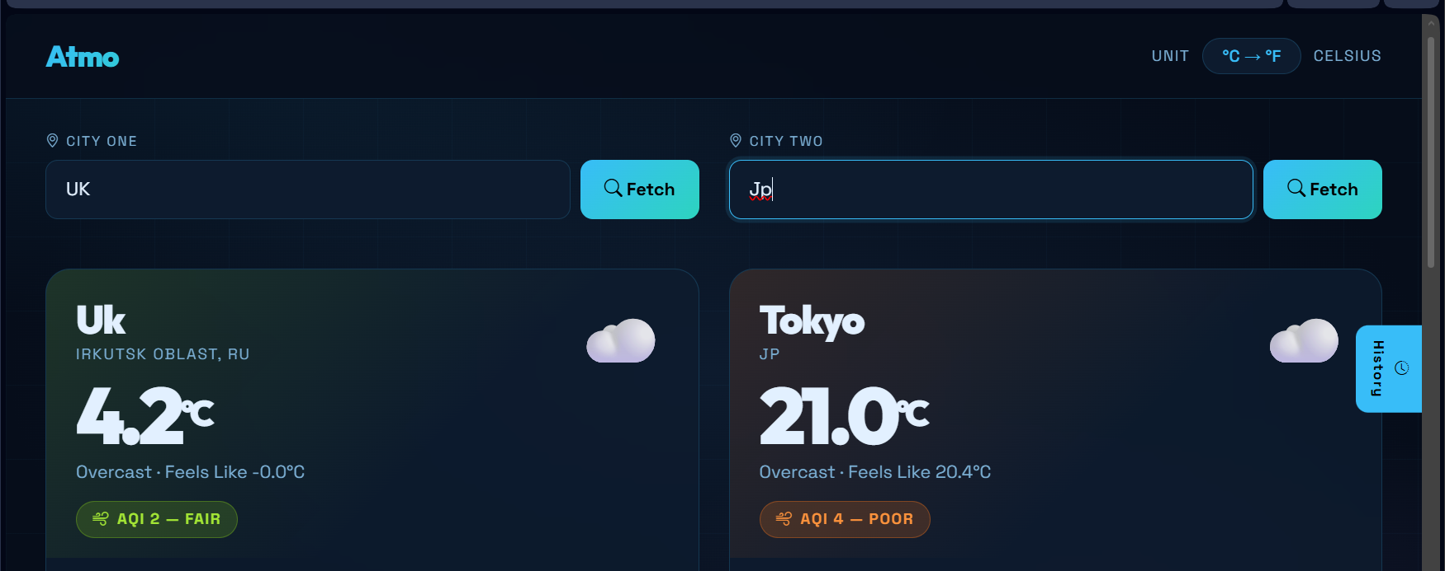
2:
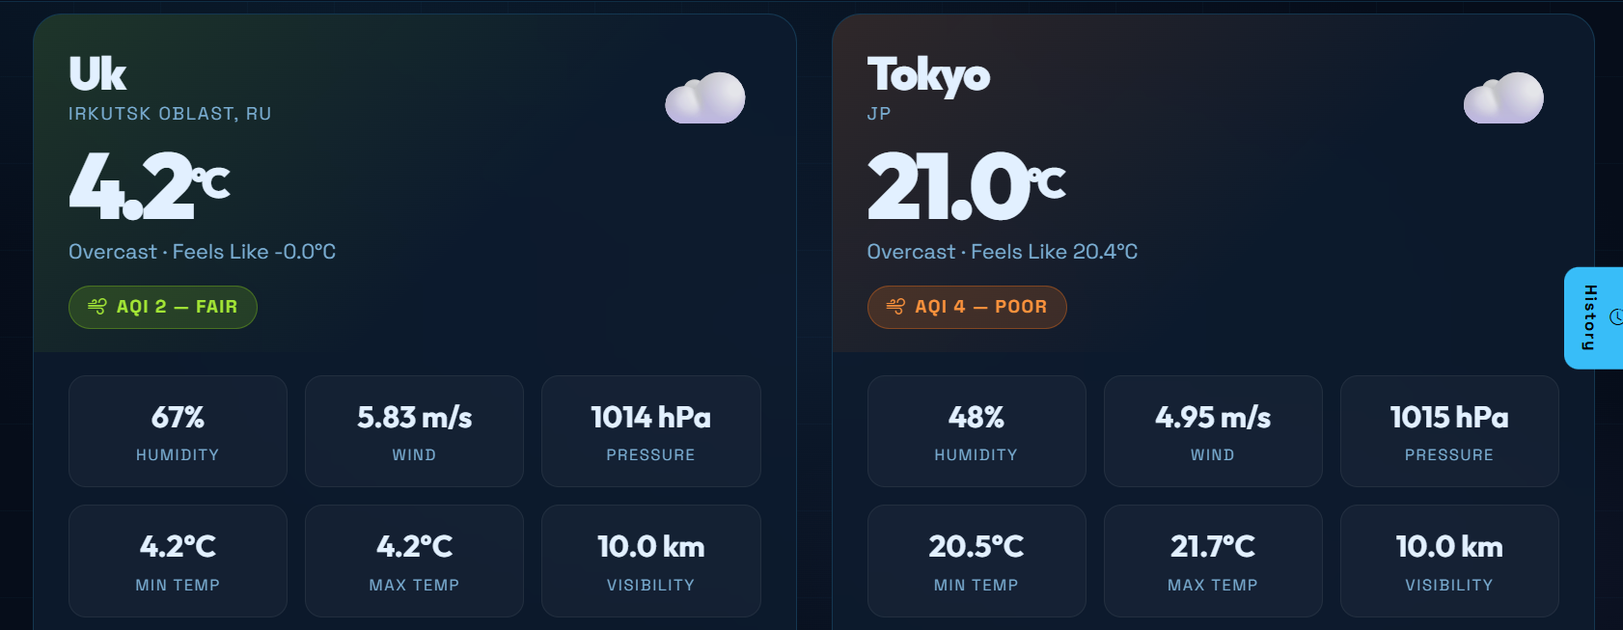

3:
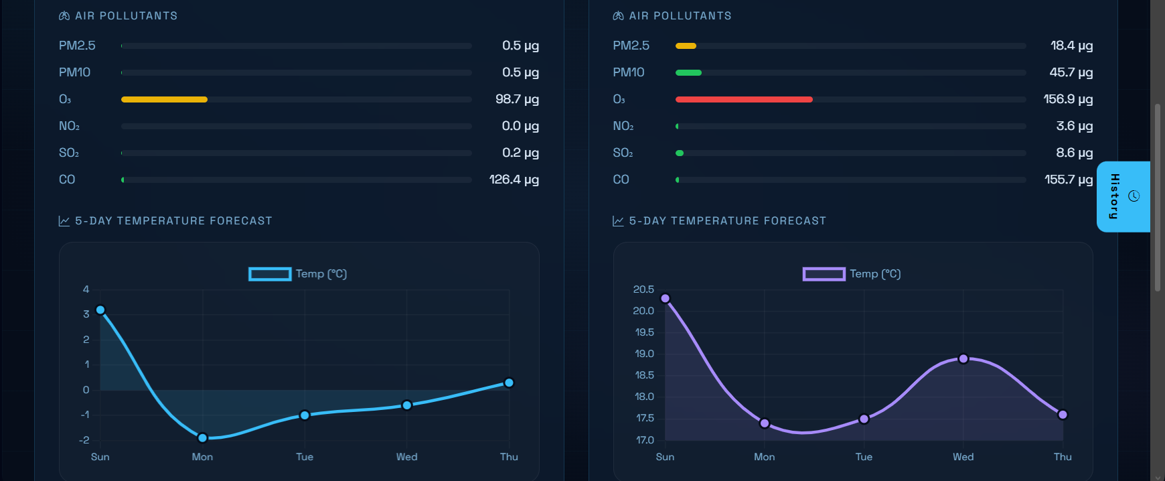

4:
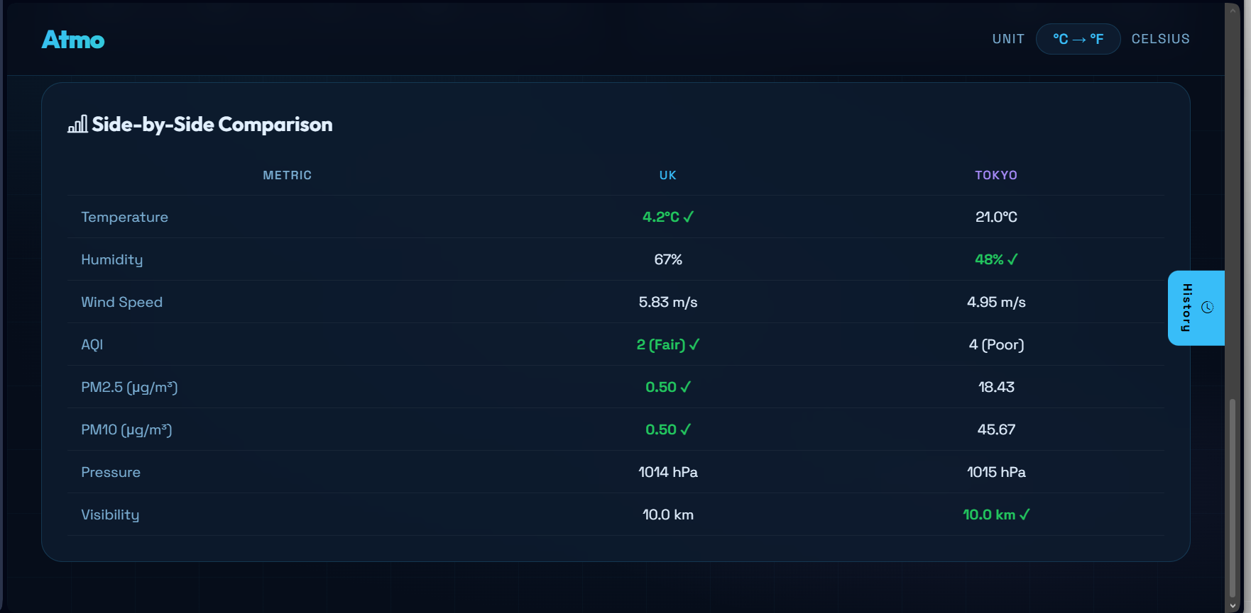s

