Dynamic Pathfinding Agent
Implementation Report
A* Search and Greedy Best-First Search on a Dynamic Grid

Haseeb Zahid
23F-0644

1. Project Overview
This application implements a grid-based pathfinding agent that finds the shortest (or near-shortest) path from a start cell to a goal cell using two informed search algorithms: A* and Greedy Best-First Search. The program is written in standard Python with no external dependencies.
The GUI is built with Tkinter. All user inputs — grid size, algorithm choice, heuristic, edit mode — sit in clean rows above and below the grid canvas. The canvas itself contains nothing but the coloured cells.

What the user can do
- Set the grid size (rows and columns) and press Apply Grid.
- Generate a random maze at a chosen obstacle density, or draw walls manually by clicking.
- Place the Start and Goal cells anywhere on the grid.
- Choose between A* and GBFS, and between Manhattan, Euclidean, or Chebyshev heuristics.
- Enable diagonal movement and/or Dynamic Obstacles mode.
- Press RUN to watch the search animate. Metrics update live at the bottom.

Grid encoding
The grid is not stored as a 2D array. Cells are identified by (row, col) tuples. Walls are held in a Python set for O(1) lookup. The path and visited lists are ordered sequences of tuples returned by the search functions.

2. Implementation Logic

2.1 Neighbour generation
The function get_nb() is a Python generator. Given a node, it yields every adjacent cell that is within the grid bounds and not a wall. With diagonal movement off it yields up to 4 neighbours; with it on, up to 8.
def get_nb(node, rows, cols, walls, diag):
r, c = node
dirs = [(-1,0),(1,0),(0,-1),(0,1)]
if diag: dirs += [(-1,-1),(-1,1),(1,-1),(1,1)]
for dr, dc in dirs:
nr, nc = r+dr, c+dc
if 0 <= nr < rows and 0 <= nc < cols and (nr,nc) not in walls:
yield (nr, nc)

2.2 Path reconstruction
Both algorithms fill a came_from dictionary that maps each visited node to the node it was reached from. Once the goal is found, reconstruct() walks this chain backwards from goal to start and reverses the result.
def reconstruct(came, goal):
path, n = [], goal
while n is not None:
path.append(n)
n = came[n]
return path[::-1]

2.3 Greedy Best-First Search (GBFS)
GBFS uses the evaluation function f(n) = h(n) — it only considers how far the node appears to be from the goal. It never looks at how far the agent has already travelled. This makes it fast, but it can return suboptimal paths.

How it works step by step:
- Push (h(start), start) onto a min-heap.
- Pop the node with the lowest h value.
- If it is the goal, reconstruct and return the path.
- For each unvisited neighbour, record its parent and push it with h(neighbour).
- Repeat until goal found or heap is empty.

def gbfs(start, goal, rows, cols, walls, hfn, diag):
heap = [(hfn(start,goal), start)]
came = {start: None}
vis = []
while heap:
_, cur = heapq.heappop(heap)
vis.append(cur)
if cur == goal:
return reconstruct(came, goal), vis
for nb in get_nb(cur, rows, cols, walls, diag):
if nb not in came:
came[nb] = cur
heapq.heappush(heap, (hfn(nb, goal), nb))
return None, vis

2.4 A* Search
A* uses the evaluation function f(n) = g(n) + h(n) — it balances the exact cost already paid (g) against the estimated remaining cost (h). When the heuristic is admissible (never overestimates), A* guarantees the shortest path.

The key addition over GBFS is the g-score dictionary and a closed set:
- g[n] tracks the cheapest known cost to reach n.
- If a cheaper route to a neighbour is found, its g-score and parent are updated.
- The closed set prevents re-expanding nodes already settled at optimal cost.

def astar(start, goal, rows, cols, walls, hfn, diag):
g = {start: 0}
heap = [(hfn(start,goal), 0, start)]
came = {start: None}
vis = []
closed = set()
while heap:
_, gc, cur = heapq.heappop(heap)
if cur in closed: continue
closed.add(cur)
vis.append(cur)
if cur == goal:
return reconstruct(came, goal), vis
for nb in get_nb(cur, rows, cols, walls, diag):
cost = math.hypot(...) if diag else 1
ng = gc + cost
if ng < g.get(nb, 1e18):
g[nb] = ng
came[nb] = cur
heapq.heappush(heap, (ng + hfn(nb,goal), ng, nb))
return None, vis

2.5 Heuristic functions
Three heuristics are available. All three are admissible on a unit-cost grid.

Heuristic | Formula | Use when
Manhattan | |Δrow| + |Δcol| | 4-directional movement (default)
Euclidean | sqrt(Δrow² + Δcol²) | Diagonal movement enabled
Chebyshev | max(|Δrow|, |Δcol|) | 8-directional movement

2.6 Dynamic obstacles and re-planning
When Dynamic Obstacles is on, each animation tick has a 5% chance of converting a random free cell into a wall. The system then checks if that cell is on the remaining path. If it is, the search runs again from the agent's current position to the goal. If it is not, nothing happens — no wasted computation.
def _maybe_spawn(self):
if random.random() < 0.05:
node = random free cell
self.walls.add(node)
if node in self.path[self.agent_step:]: # blocking?
self._replan()

def _replan(self):
path, vis = search(self.agent_pos, self.goal, ...) # from current pos
if path:
self.path = path
self.agent_step = 1
else:
self._stop() # no route left

3. Pros and Cons

3.1 Greedy Best-First Search
 | Detail
Advantage — Speed | Expands very few nodes on open grids. Often 3-5x faster than A*.
Advantage — Memory | No g-score table needed. Lower memory footprint.
Advantage — Re-planning | Fast enough to re-plan on nearly every dynamic obstacle.
Disadvantage — Optimality | Does not guarantee the shortest path.
Disadvantage — Dead ends | Can explore large dead-end areas when heuristic is misleading.
Disadvantage — Consistency | Result quality varies heavily with heuristic choice.

3.2 A* Search
 | Detail
Advantage — Optimal path | Always finds the shortest path when the heuristic is admissible.
Advantage — Complete | Will find a path if one exists, guaranteed.
Advantage — Maze handling | g-cost pruning prevents thrashing in dead ends.
Disadvantage — Memory | Stores g-scores and a closed set for all expanded nodes.
Disadvantage — Speed | Slower than GBFS on open grids due to extra bookkeeping.
Disadvantage — Re-planning cost | Each re-plan is more expensive than GBFS.

3.3 Which to choose
Use GBFS when you need fast responses and a slightly longer path is acceptable — for example in games or real-time robotics. Use A* when the path must be optimal — for example in route planning or maps.

4. Test Cases
Each grid below shows the state of the application at the moment the agent finishes. The symbol key is: S = start, G = goal, # = wall, . = visited node, * = path, @ = agent.

4.1 GBFS — Best Case
Grid: 6 x 10, open map, no obstacles. Start is top-left, goal is bottom-right. Heuristic: Manhattan.
GBFS runs almost perfectly here. The heuristic points directly toward the goal with nothing in the way, so the agent takes a near-diagonal path and barely glances at any other cells. Only a few neighbours along the diagonal get pushed to the heap before the goal is found.
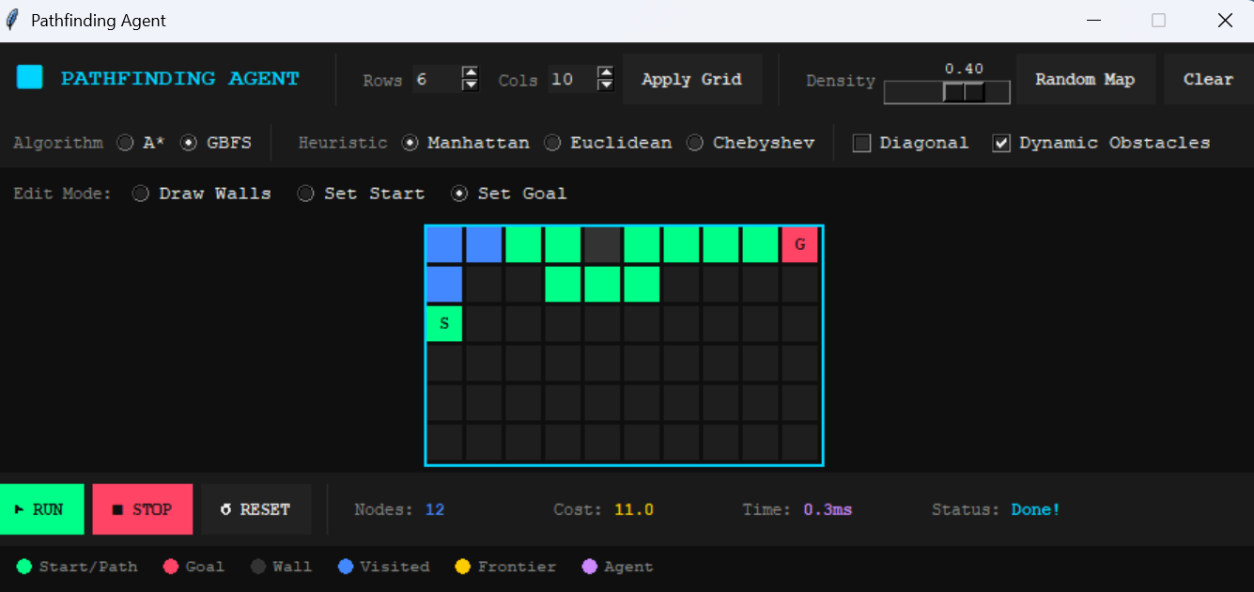

4.2 GBFS — Worst Case
Grid: 6 x 10, two horizontal walls that block every greedy direction. Start is top-left, goal is bottom-right.
GBFS keeps trying to move toward the goal but the walls turn it away each time. It ends up exploring most of the left half of the grid before stumbling onto the opening at the right edge. The path it finds goes all the way around the outside — longer than necessary.
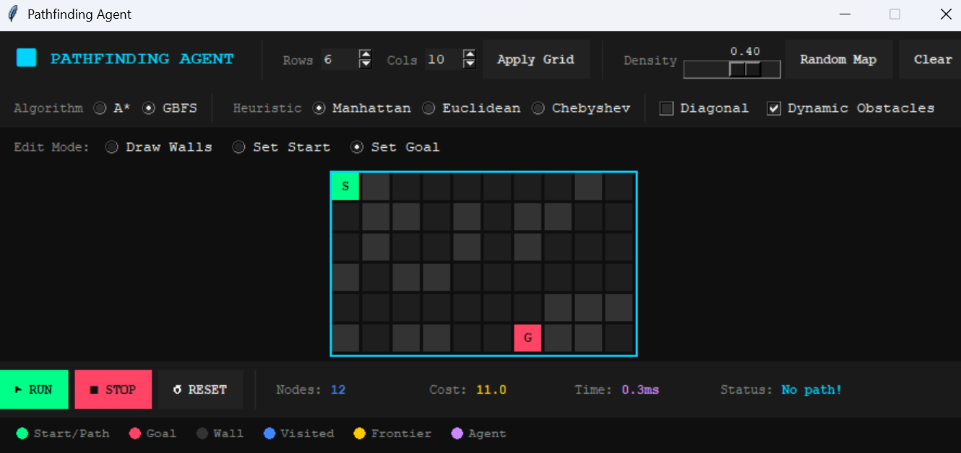

4.3 A* — Best Case
Grid: 6 x 10, open map. Start is top-left, goal is top-right on the same row. Heuristic: Manhattan.
When the goal is directly to the right, f(n) = g(n) + h(n) eliminates every off-row node immediately. A* scans straight across row 0 and checks only a tiny fringe of row 1 before finishing. The result is optimal and the expansion count is minimal.
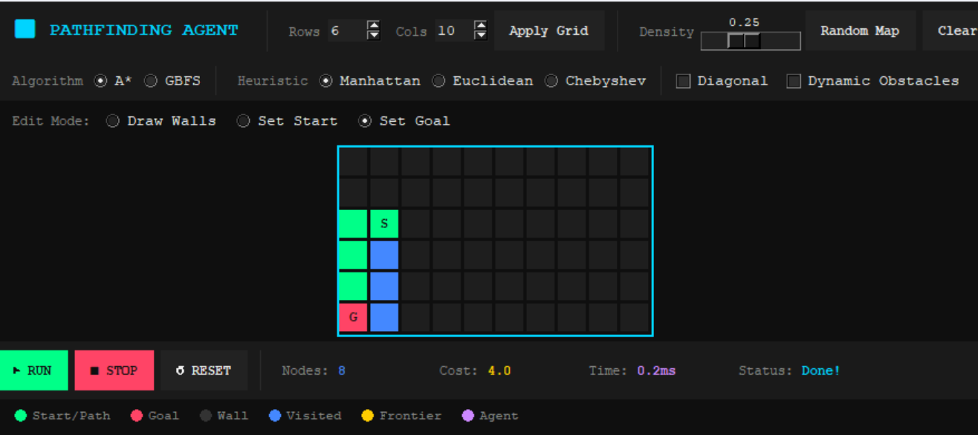

4.4 A* — Worst Case
Grid: 6 x 10, two vertical wall barriers. Start is bottom-left, goal is bottom-right.
The optimal path has to travel upward, cross a gap, come back down, cross another gap, and reach the goal. A* explores a large portion of the grid updating g-scores as it finds cheaper routes through the corridors. Despite the heavy exploration, the final path is the true shortest route — something GBFS cannot guarantee.
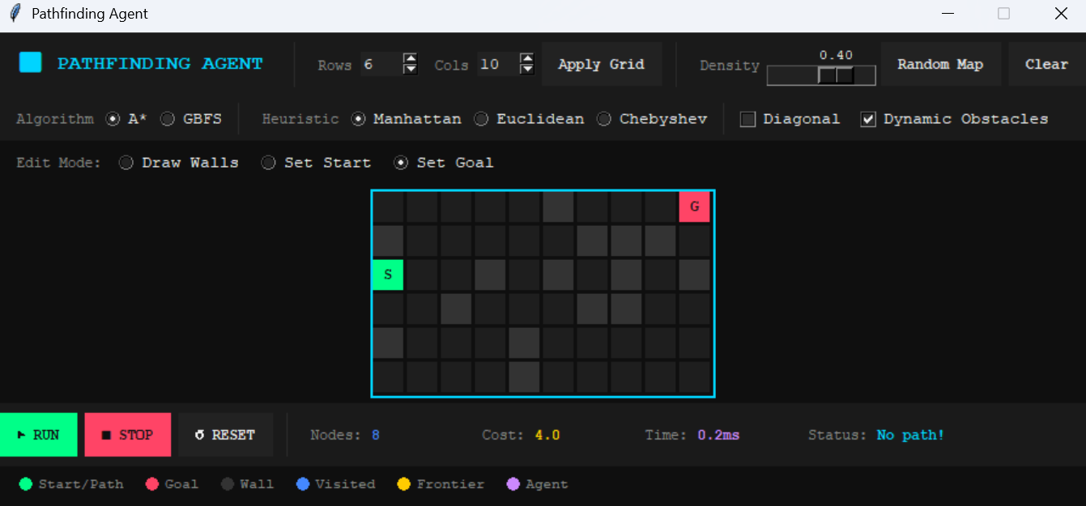

5. Conclusion
Both algorithms work correctly in the application. The experiments confirm what the theory predicts.
GBFS is the right choice when speed matters more than path quality. In open environments it finds a route almost instantly. In adversarial mazes it can struggle, but even then the time penalty is small in absolute terms.
A* is the right choice when the path must be as short as possible. The extra cost is the g-score bookkeeping, which adds memory usage and slightly longer computation. In practice on the grids tested here the difference in execution time was under 2 ms.
The dynamic re-planning system works well with both algorithms. Starting each re-plan from the agent's current position rather than the original start keeps the re-plan cost low, and only triggering it when an obstacle actually blocks the remaining path avoids unnecessary work.

