AI GITHUB PROJECT REVIEWER
Project Report & Technical Documentation

Author | Haseeb Raza
GitHub | github.com/Haseebzahid9
LinkedIn | linkedin.com/in/haseebraza4998
Email | haseebzahid4998@gmail.com
Report Date | June 28, 2026

Powered by Google Gemini AI · FastAPI · React 18 · Tailwind CSS

1. Project Overview

AI GitHub Project Reviewer is a full-stack web application that analyses the quality of any public GitHub repository and delivers a structured, data-dense report in under 60 seconds. The user pastes a repository URL and receives a weighted score across five dimensions — Project Structure, Documentation, Code Quality, Security, and AI Assessment — alongside a full Gemini AI narrative, per-language static analysis, README grading, and a downloadable PDF report.
The application is targeted at developers evaluating open-source dependencies, hiring managers auditing candidate portfolios, and engineers conducting pre-integration due diligence on third-party codebases.
Key Highlights
- Instant 0–100 quality score with letter grade (A+ to F)
- Five weighted scoring dimensions with transparent breakdown
- Static analysis across 14+ programming languages
- 14-section README quality checker
- Security anti-pattern detection (hardcoded secrets, injection risks, eval() usage)
- Google Gemini AI review: strengths, weaknesses, next steps
- Downloadable 6-page PDF report via ReportLab
- Full review history stored in SQLite with delete support
- Graceful degradation — works without Gemini API key
- Responsive dark-theme dashboard built with React 18 + Tailwind CSS

2. Technology Stack

2.1 Backend
Package | Version | Purpose
FastAPI | ≥ 0.115 | Async REST API framework
Uvicorn | ≥ 0.30 | ASGI server
SQLAlchemy + aiosqlite | ≥ 2.0 | Async ORM with SQLite
httpx | ≥ 0.27 | Async HTTP client for GitHub API
google-genai | ≥ 1.0 | Official Google Gemini SDK
ReportLab | ≥ 4.2 | PDF report generation
Pydantic v2 | ≥ 2.10 | Request / response validation
python-dotenv | ≥ 1.0 | Environment variable loading
Python | 3.10+ | Runtime (3.14 confirmed working)

2.2 Frontend
Package | Version | Purpose
React | 18 | UI framework
Vite | 5 | Build tool with HMR
Tailwind CSS | 3 | Utility-first styling
React Router DOM | 6 | Client-side routing
Recharts | 2 | Language distribution donut chart
Axios | 1 | HTTP client with error interceptor
Inter (Google Fonts) | — | Primary typeface

2.3 Infrastructure & Deployment
Service | Role
GitHub | Source repository — github.com/Haseebzahid9/ai-github-reviewer
Render | Backend deployment (Procfile + render.yaml pre-configured)
Vercel | Frontend deployment (vercel.json SPA rewrites + API proxy)
SQLite | Local persistence for review history (zero-setup)

3. System Architecture

3.1 High-Level Flow
The application follows a clean client–server architecture:
- 1. User enters a GitHub URL in the React frontend.
- 2. Frontend sends POST /api/review to the FastAPI backend.
- 3. Backend validates the URL and calls the GitHub REST API to fetch: repo metadata, file tree, README, and up to 20 source files.
- 4. Analyzer services run multi-language static analysis, README grading, and project-structure checks synchronously.
- 5. Gemini AI review is requested asynchronously (degraded gracefully on failure).
- 6. A weighted final score is computed and the full report is persisted to SQLite.
- 7. The JSON report is returned to the frontend and rendered as a data-dense dashboard.
- 8. User can download a 6-page PDF or revisit the report via the History page.
3.2 Project Structure
ai-github-reviewer/
├── backend/
│ ├── app/
│ │ ├── main.py # FastAPI app, CORS, middleware
│ │ ├── models/database.py # SQLAlchemy models + async migrations
│ │ ├── routers/review.py # All API endpoints
│ │ ├── services/
│ │ │ ├── github.py # GitHub REST API client
│ │ │ ├── analyzer.py # Multi-language static analyzer
│ │ │ ├── gemini.py # Google Gemini AI integration
│ │ │ ├── report.py # Score aggregation + SQLite persistence
│ │ │ └── pdf_report.py # 6-page PDF generator (ReportLab)
│ │ └── utils/
│ │ ├── helpers.py # Score calculation helpers
│ │ └── validators.py # GitHub URL validation
│ ├── tests/test_review.py # 25 pytest unit tests
│ ├── .env.example # Environment variable template
│ ├── requirements.txt
│ ├── Procfile # Render deployment config
│ └── render.yaml
│
├── frontend/
│ ├── src/
│ │ ├── App.jsx # Router, navbar, toast context
│ │ ├── pages/
│ │ │ ├── Home.jsx # Hero + repo input + progress loader
│ │ │ ├── Dashboard.jsx # Full report dashboard (8 sections)
│ │ │ ├── History.jsx # Saved reports table
│ │ │ └── About.jsx # Scoring methodology explained
│ │ ├── components/ # Shared UI components
│ │ ├── services/api.js # Axios client + error interceptor
│ │ └── hooks/useToasts.js
│ ├── tailwind.config.js
│ ├── vite.config.js
│ └── vercel.json
│
├── .gitignore
├── LICENSE # MIT
└── README.md # 466-line professional readme

4. Features & Functionality

5-Dimension Scoring: Structure (20%) · Documentation (20%) · Code Quality (30%) · Security (15%) · AI Assessment (15%). Each dimension is calculated independently and combined into a single weighted 0–100 score.
14+ Language Support: Python, JavaScript, TypeScript, Java, C, C++, C#, Go, Rust, PHP, Swift, Kotlin, Ruby, SQL, HTML, CSS. Per-language issue detection with error/warning/info severity levels.
Static Code Analysis: Per-file issue detection. Issues are counted and density-normalised per 100 LOC to produce a fair per-language score regardless of file size.
README Grading: 14-section checklist: title, description, badges, installation, usage, screenshots, contributing, license, code of conduct, changelog, FAQ, roadmap, contact, and examples.
Security Detection: Keyword-matched anti-patterns including hardcoded API keys, SQL injection risks, eval() usage, deprecated API calls, and missing Subresource Integrity (SRI) attributes.
File Structure Analysis: 22 rules checking for the presence of CI configs (GitHub Actions, CircleCI, Travis), Dockerfile, .gitignore, test directories, package manifests, and documentation files.
Google Gemini AI Review: Project overview, tech-stack assessment, strengths list, weaknesses list, security suggestions, performance suggestions, maintainability suggestions, beginner-friendliness score, production-readiness score, and actionable next steps.
PDF Export: Full 6-page formatted report generated server-side with ReportLab. Downloaded via a single button click.
Review History: All reports persisted to SQLite via SQLAlchemy async ORM. Viewable and deletable from the History page.
Graceful Degradation: If the Gemini API key is absent or the AI call fails, the application continues to function. The AI Review section displays a fallback notice instead of crashing.

5. Scoring System

5.1 Dimension Weights
Dimension | Weight | Measurement Approach
Project Structure | 20% | 22 file-presence and organisation rules
Documentation | 20% | README completeness across 14 sections
Code Quality | 30% | Issues per 100 LOC, density-normalised per language
Security | 15% | Keyword-matched anti-patterns in analyzed source files
AI Assessment | 15% | Google Gemini holistic quality score (0–10 → 0–100)

5.2 Grade Thresholds
Grade | Score Range | Meaning
A+ | 90 – 100 | Excellent — production-ready quality
A | 80 – 89 | Very Good
B+ | 70 – 79 | Good
B | 60 – 69 | Above Average
C+ | 50 – 59 | Average
C | 40 – 49 | Below Average
D | 30 – 39 | Needs significant improvement
F | 0 – 29 | Major issues detected

6. API Reference

Base URL (local): http://localhost:8000
Method | Endpoint | Description
POST | /api/review | Analyse a public GitHub repository. Returns full report JSON.
GET | /api/history | List all saved reports, newest first (last 20).
GET | /api/report/{id} | Fetch a full saved report by database ID.
DELETE | /api/history/{id} | Delete a saved report by ID.
GET | /api/report/{id}/download | Download the 6-page PDF report (application/pdf).
GET | /api/health | Service liveness check — returns {status: ok, version: 1.0.0}.
GET | /health | Root health check for load-balancer probes.
GET | /docs | Interactive Swagger UI — auto-generated by FastAPI.

6.1 POST /api/review — Request Body
{
"repo_url": "https://github.com/owner/repository"
}

6.2 Error Codes
HTTP Status | Code | Cause
400 | INVALID_URL | Not a valid GitHub repository URL
403 | FORBIDDEN | Repository is private
404 | NOT_FOUND | Repository does not exist
429 | RATE_LIMIT | GitHub API rate limit reached
504 | TIMEOUT | Analysis exceeded 60-second pipeline timeout
500 | INTERNAL_ERROR | Unexpected server error

7. Frontend Design System

7.1 Design Tokens (CSS Custom Properties)
Variable | Value | Usage
--bg | #0f1117 | Page background
--surface | #181c27 | Navbar / footer / secondary surfaces
--card | #1e2333 | All card components
--border | #2a3047 | Borders, dividers, progress tracks
--muted | #8892a4 | Secondary text, labels, metadata
--text | #e8ecf4 | Primary text
--accent | #7c5cfc | Violet — buttons, icons, rings
--accent-lt | #a78bfa | Light violet — links, hover states
--success | #22d3a5 | Green — passing scores, found sections
--warning | #f59e0b | Amber — moderate issues
--danger | #f4606c | Red — errors, delete actions

7.2 Component Library
.card Dark card with border-radius 12px and var(--card) background.
.btn-primary Violet accent button with glow shadow on hover, disabled at 45% opacity.
.btn-ghost Transparent button with border, fills var(--surface) on hover.
.section-title 0.75rem uppercase tracking-wide label used as section headers.
.animate-bar CSS animation for score bars — expands from 0 to var(--bar-width).
.animate-fade-in Opacity 0 → 1 entrance animation, 350ms ease-out.
.animate-slide-up Combined opacity + translateY(12px → 0) entrance animation.
7.3 Pages
Page | Content
Home (/) | Hero section with animated eyebrow pill, headline, RepoInput component, step-by-step progress loader during analysis, 6-feature grid.
Dashboard (/dashboard) | 8-section report view: repo header + stats → score ring → language chart → file structure tree → README quality → code analysis → AI review → PDF download.
History (/history) | Sortable table of all saved reports with score badges and per-row delete.
About (/about) | Scoring methodology documentation with dimension weights and grade thresholds.

8. Installation & Setup

8.1 Prerequisites
Requirement | Minimum | Notes
Python | 3.10 | 3.14 confirmed working
Node.js | 18 | 20 LTS recommended
npm | 9 | Bundled with Node.js
Git | Any | —

You also need a GitHub Personal Access Token and a Google Gemini API Key.
8.2 Clone & Install
# 1. Clone the repository
git clone https://github.com/Haseebzahid9/ai-github-reviewer.git
cd ai-github-reviewer
# 2. Backend setup
cd backend
python -m venv .venv
.venv\Scripts\activate # Windows
# source .venv/bin/activate # macOS/Linux
pip install -r requirements.txt
cp .env.example .env # then fill in your API keys
# 3. Frontend setup (new terminal)
cd frontend
npm install

8.3 Environment Variables (backend/.env)
Variable | Required | Default | Description
GITHUB_TOKEN | Yes | — | GitHub PAT (public_repo scope)
GEMINI_API_KEY | Yes | — | Google Gemini API key
DATABASE_URL | No | sqlite+aiosqlite:///./github_reviewer.db | SQLite DB connection string
MAX_FILE_SIZE_KB | No | 150 | Max KB per source file
MAX_FILES_TO_ANALYZE | No | 20 | Max files per repository
CORS_ORIGINS | No | http://localhost:5173,... | Comma-separated allowed origins

8.4 Running Locally
# Terminal 1 — Backend (from backend/, venv active)
uvicorn app.main:app --reload --host 127.0.0.1 --port 8000
# Terminal 2 — Frontend (from frontend/)
npm run dev
# Open in browser
http://localhost:5173
# Health check
http://localhost:8000/health → {"status":"ok","version":"1.0.0"}

9. Testing

The backend includes 25 pytest unit tests covering all core logic modules. Tests are located in backend/tests/test_review.py.
Test Suites
Test Class | Coverage Area | Test Count
TestValidateGithubUrl | GitHub URL format validation (valid/invalid patterns) | 6
TestClamp | Score clamping to 0–100 range | 4
TestCalculateFinalScore | Weighted score aggregation with all five dimensions | 5
TestAnalyzeReadme | README section detection across 14 categories | 5
TestAnalyzeStructure | Project structure rule evaluation (22 rules) | 3
TestParseGithubUrl | URL parsing — both full URL and owner/repo shorthand | 2

cd backend
.venv\Scripts\activate
pip install pytest pytest-asyncio
pytest tests/ -v

10. Deployment

10.1 Backend — Render
- Push repository to GitHub.
- Go to render.com → New Web Service.
- Connect the repository; set root directory to backend/.
- Set Start Command: uvicorn app.main:app --host 0.0.0.0 --port $PORT
- Add environment variables: GITHUB_TOKEN and GEMINI_API_KEY.
- Click Deploy.
backend/Procfile and backend/render.yaml are pre-configured and committed to the repository.
10.2 Frontend — Vercel
- Go to vercel.com → New Project.
- Import the GitHub repository; set Root Directory to frontend/.
- Add environment variable: VITE_API_URL = your Render backend URL.
- Click Deploy.
frontend/vercel.json is pre-configured with SPA rewrites and an API proxy.

11. Security Considerations

API Keys never committed: backend/.env is explicitly listed in .gitignore. The repository contains only .env.example with placeholder values. API keys are loaded exclusively at runtime via python-dotenv.
CORS restriction: CORS_ORIGINS environment variable restricts allowed origins. In production the Vercel frontend origin should be the only allowed value. A regex also allows Vercel preview deployments.
Read-only GitHub Token: Only the public_repo scope is required. No write access is requested or needed.
Input validation: All GitHub URLs are validated against a strict regex before any HTTP request is made. owner/repo shorthand is also normalised through the same validator.
Rate limit protection: RateLimitError from the GitHub API is surfaced as HTTP 429 with a human-readable retry hint.
No secrets stored: The SQLite database stores only report metadata and JSON payloads. No user credentials, tokens, or PII are persisted at any point.
Pipeline timeout: The full review pipeline is wrapped in asyncio.wait_for with a 60-second timeout to prevent resource exhaustion on very large repositories.

12. Known Issues & Limitations

- Private repositories are not supported — a GitHub token with full repo access and additional OAuth flow would be required.
- Analysis is limited to the first 20 source files (configurable via MAX_FILES_TO_ANALYZE) to keep response times under 60 seconds.
- Files larger than 150 KB (configurable via MAX_FILE_SIZE_KB) are skipped to avoid memory pressure.
- Gemini AI review is subject to the Google Gemini free-tier rate limits. Heavy usage may trigger temporary degradation.
- The SQLite database is local — review history is not shared between deployments or users.
- The frontend requires JavaScript to function (React SPA — no server-side rendering).
- Browser cache can cause a blank page on first load after a hard refresh. Opening in an Incognito window or clearing cache resolves this.
12.1 Potential Future Improvements
- OAuth flow for private repository support.
- PostgreSQL support for multi-user cloud deployments.
- Real-time WebSocket progress streaming instead of client-side timers.
- GitHub Actions CI badge generation based on analysis results.
- Comparative analysis — score a repo against a baseline or a category average.
- Browser extension for one-click analysis from any GitHub page.

13. Author & License

Author
Name | Haseeb Raza
GitHub | https://github.com/Haseebzahid9
LinkedIn | https://www.linkedin.com/in/haseebraza4998/
Email | haseebzahid4998@gmail.com

Repository
https://github.com/Haseebzahid9/ai-github-reviewer
License
MIT License
Copyright (c) 2024 Haseeb Raza
Permission is hereby granted, free of charge, to any person obtaining a copy
of this software and associated documentation files (the "Software"), to deal
in the Software without restriction, including without limitation the rights
to use, copy, modify, merge, publish, distribute, sublicense, and/or sell
copies of the Software, and to permit persons to whom the Software is
furnished to do so, subject to the following conditions:
The above copyright notice and this permission notice shall be included in all
copies or substantial portions of the Software.
THE SOFTWARE IS PROVIDED "AS IS", WITHOUT WARRANTY OF ANY KIND, EXPRESS OR
IMPLIED, INCLUDING BUT NOT LIMITED TO THE WARRANTIES OF MERCHANTABILITY,
FITNESS FOR A PARTICULAR PURPOSE AND NONINFRINGEMENT.

14. UI Screens Reference

Below is a description of each screen in the application. Add your own screenshots by inserting images at the placeholder positions.
Home Page
Dark hero section with violet eyebrow pill ('Powered by Google Gemini & FastAPI'), large headline 'Instant code review for any GitHub repository', description paragraph, URL input box with violet focus ring, Analyze button, and 3 quick-pick chips (fastapi, react, vscode). Below the input: 6-card feature grid showing what is analyzed.
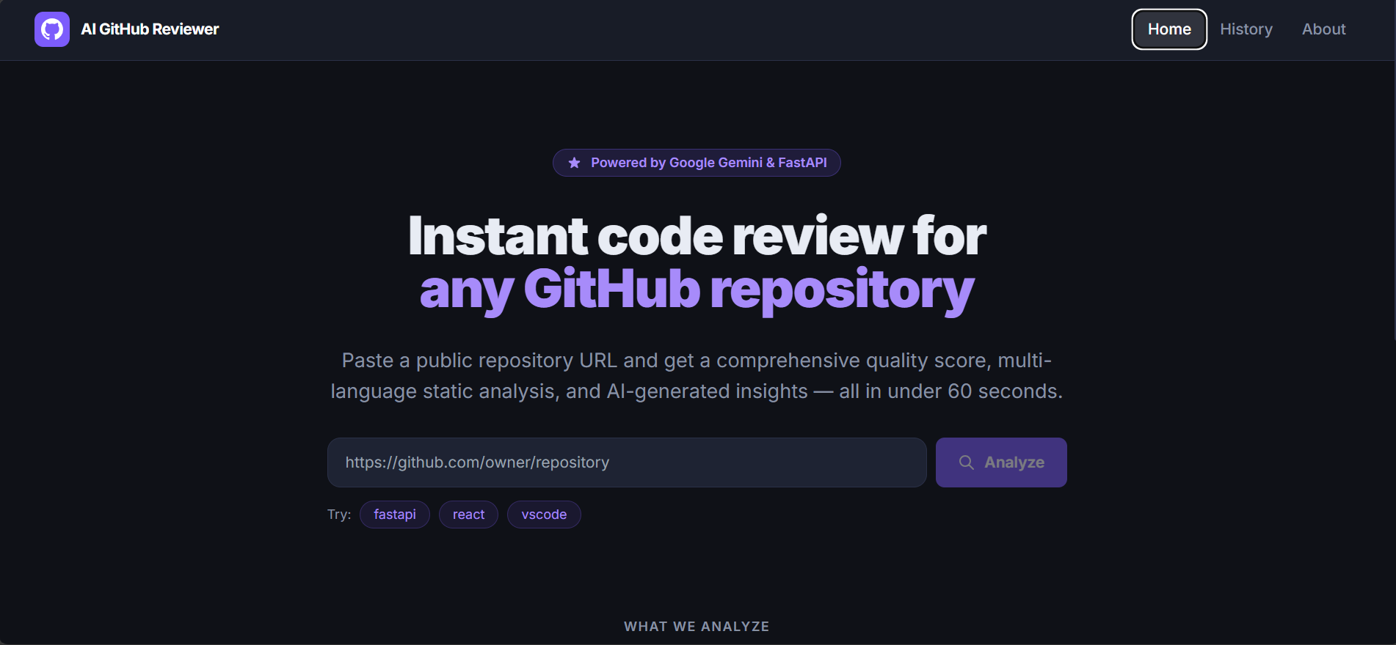
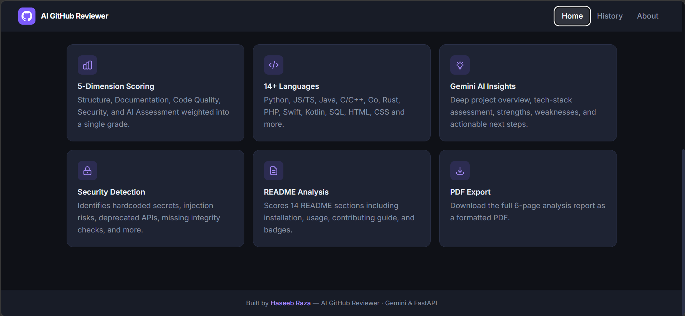
Analysis Progress
While the backend pipeline runs, the input area is replaced by an animated step list showing: Validating → Fetching data → Analyzing code → Running AI review → Calculating scores → Report ready. Each step shows a spinner (current), checkmark (done), or muted dot (pending). A progress bar fills from 0% to 100%.
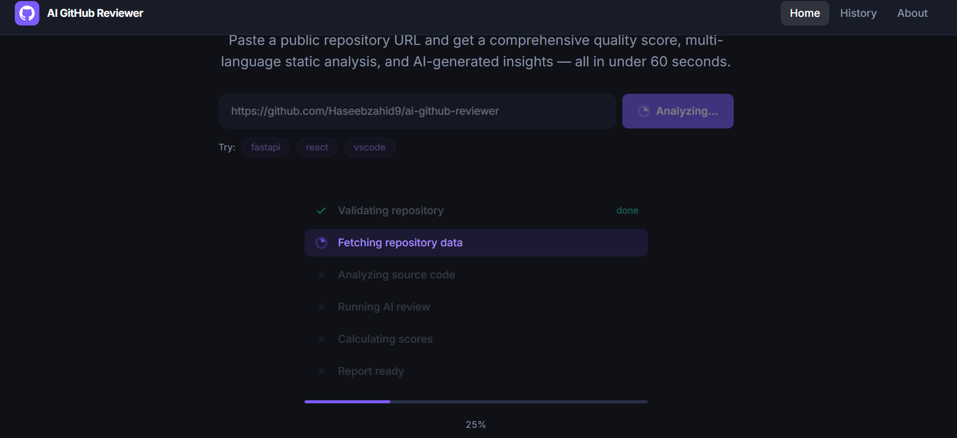
Dashboard — Top
Repository header card: full_name, description, language badges, license/branch/year metadata. GitHub link and PDF Report buttons top-right. Below: 4 stat cards — Stars, Forks, Open Issues, Watchers.
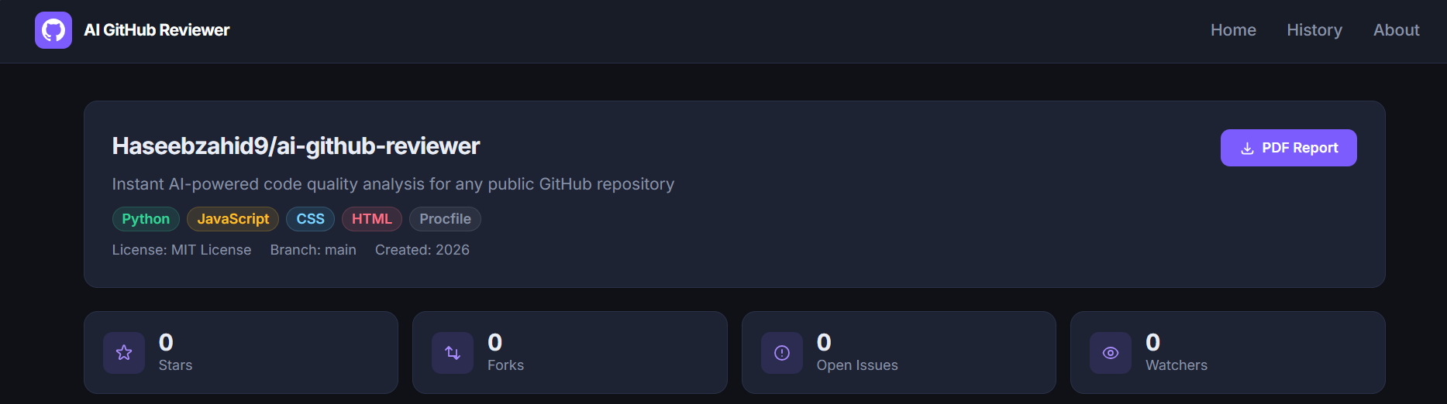
Dashboard — Score + Languages
Side-by-side cards on large screens. Left: SVG animated ring showing 0–100 score with letter grade, 5 dimension bars each with a colored progress bar and weight percentage. Right: Recharts donut chart of language distribution with per-language mini-bars.
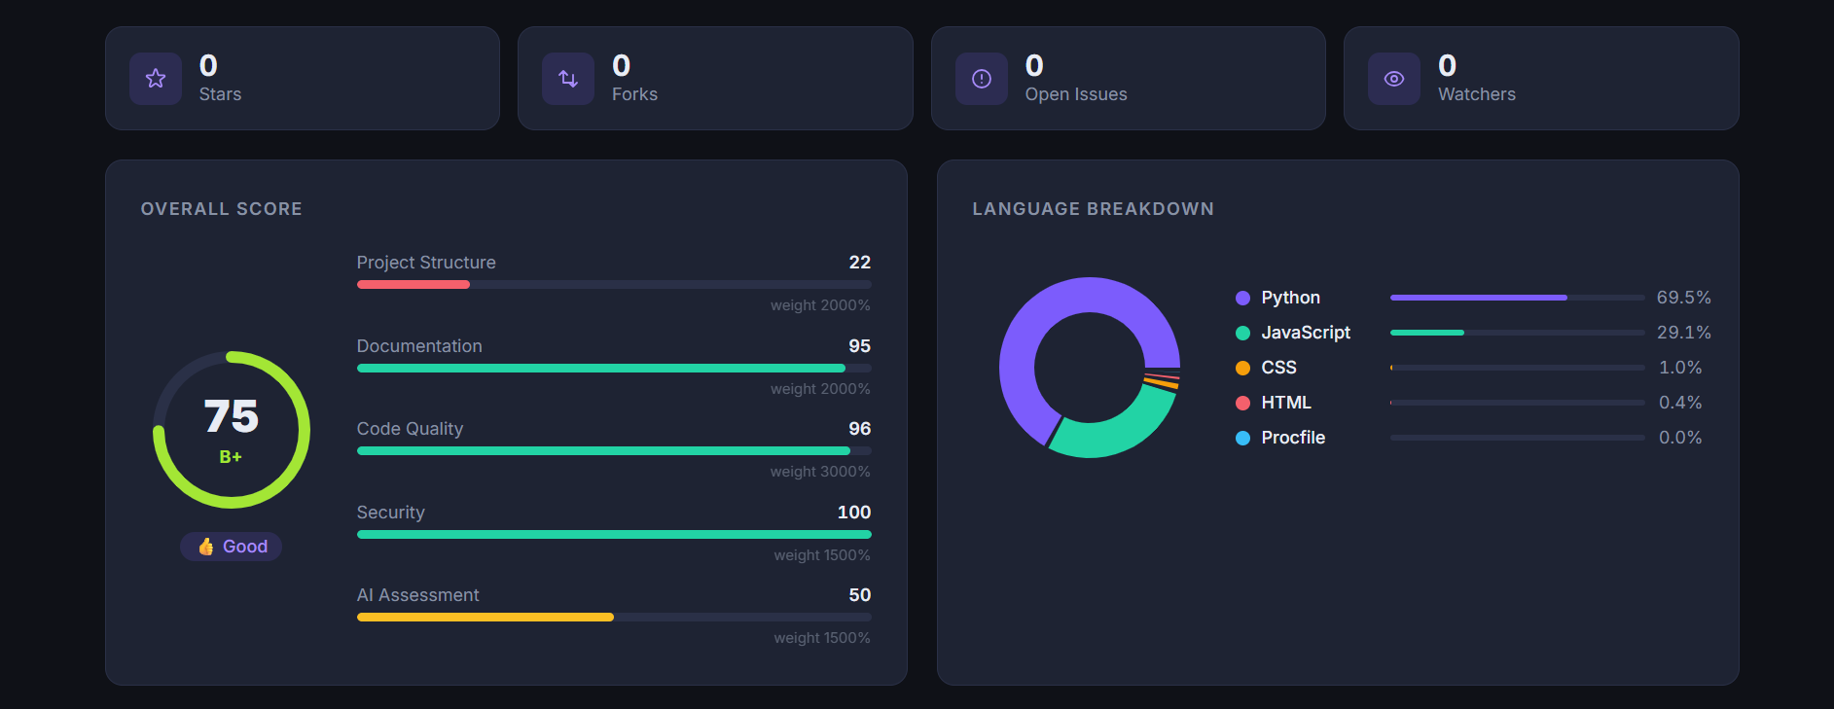

Dashboard — File Structure + README
Side-by-side. Left: file presence tree with green ticks and red crosses for each of the 22 rules. Right: README quality score bar, two-column list of found sections (green ticks) and missing sections (amber crosses), plus suggestion items.
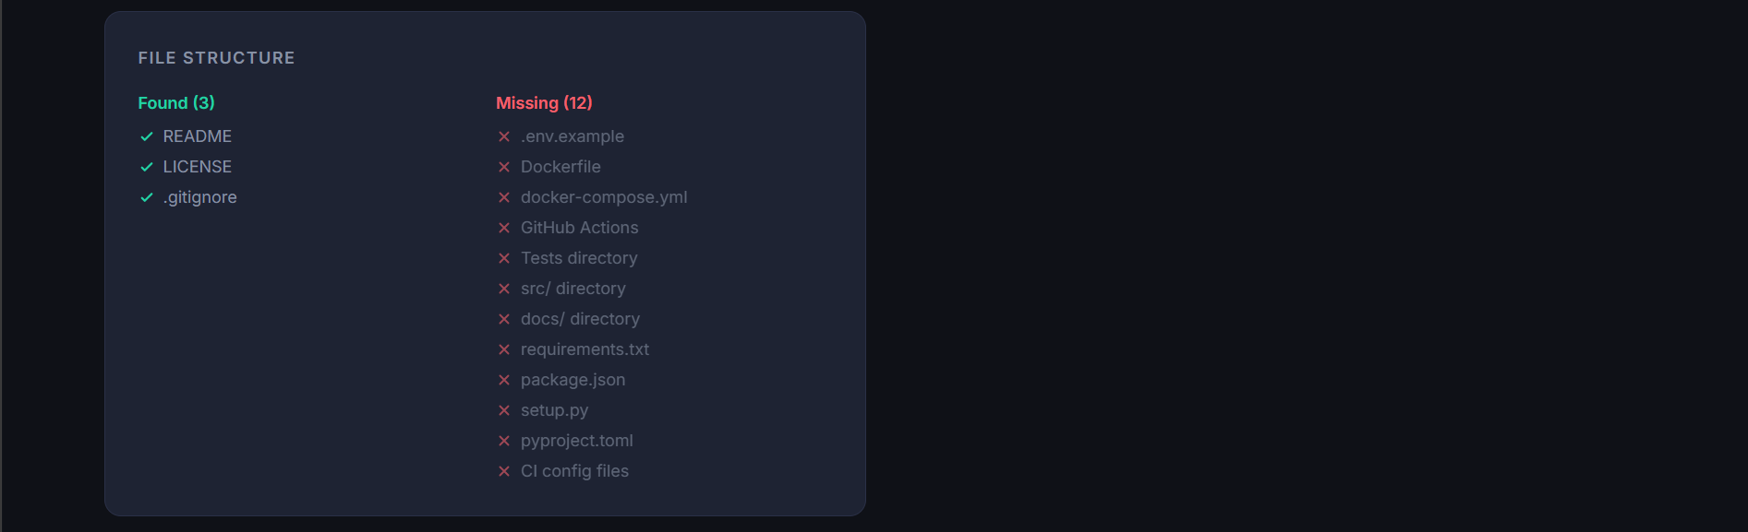
Dashboard — Code Analysis
Grid of per-language cards. Each card shows language name, total LOC, error count (red), warning count (amber), and scrollable list of up to 10 issues with severity dots and file:line references.
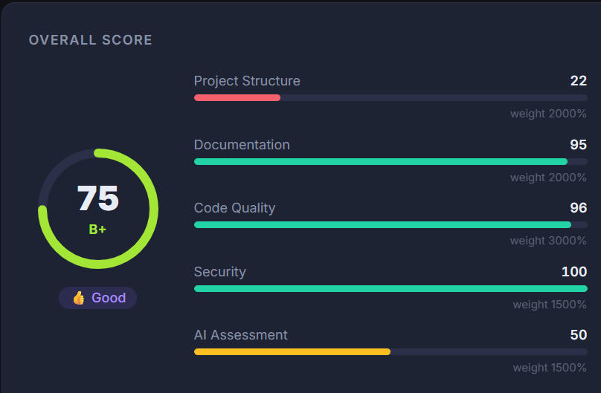

Dashboard — AI Review
Full-width card with Beginner Friendly and Production Readiness mini-bars, violet project overview box, tech-stack assessment paragraph, strengths/weaknesses grid, security/performance/maintainability suggestion columns, overall review paragraph, and recommended next steps list.
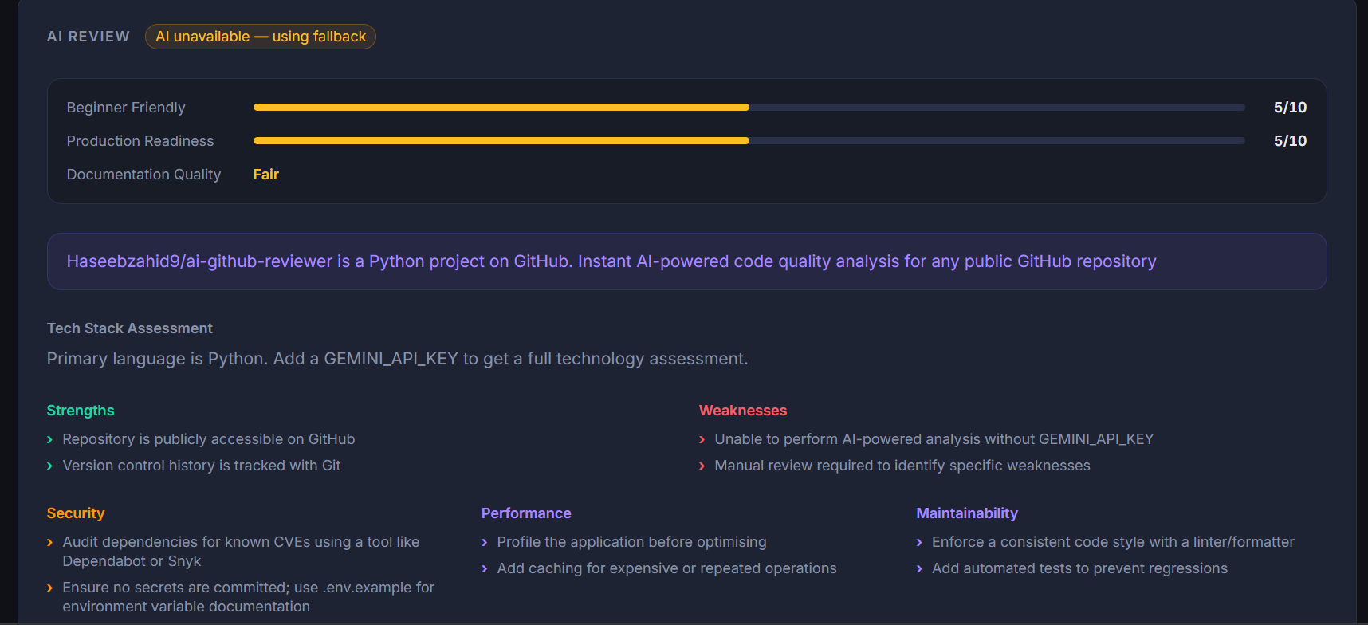

History Page
Table of past analyses: repo name, score badge (color-coded by grade), grade letter, language, date. Each row has a red delete button.
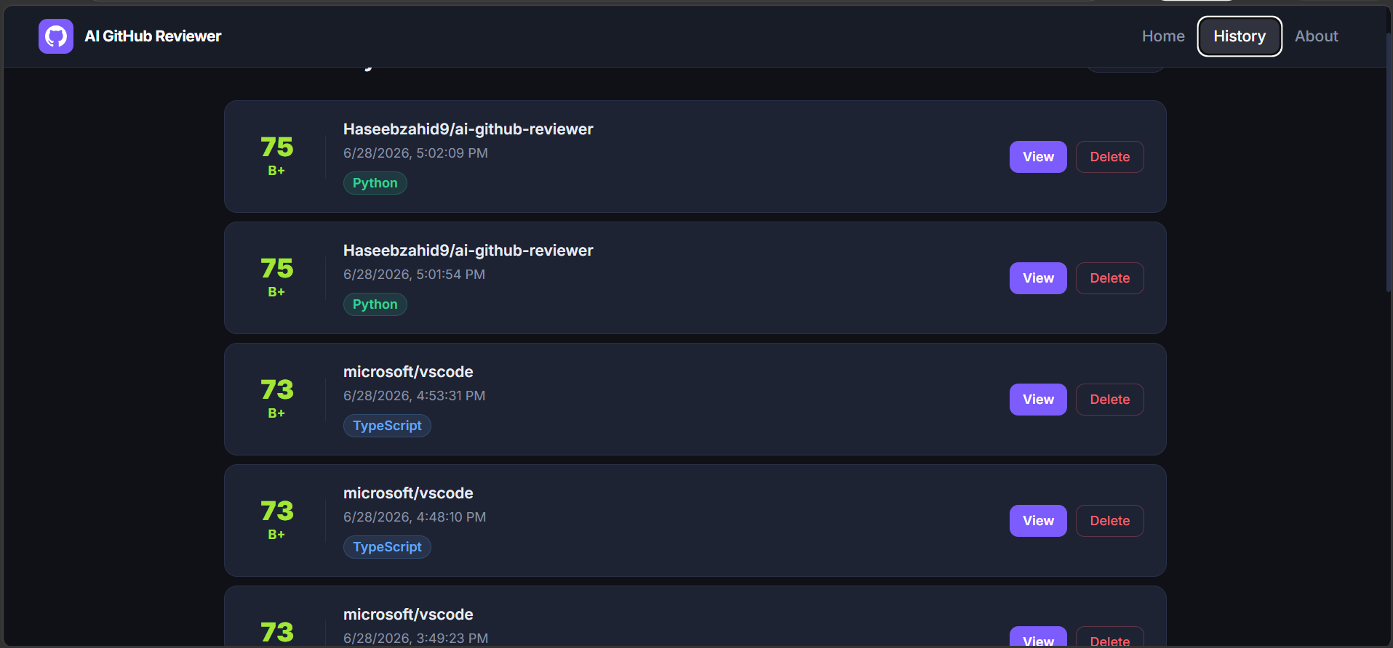

About Page
Scoring methodology documentation: dimension table with weights, grade thresholds table, and explanation of the calculation approach.
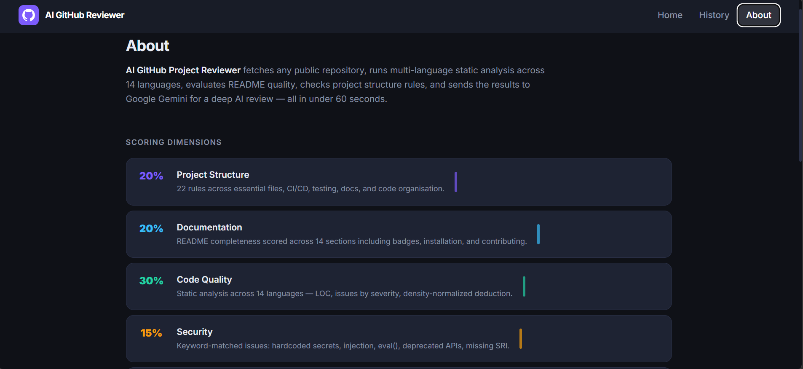

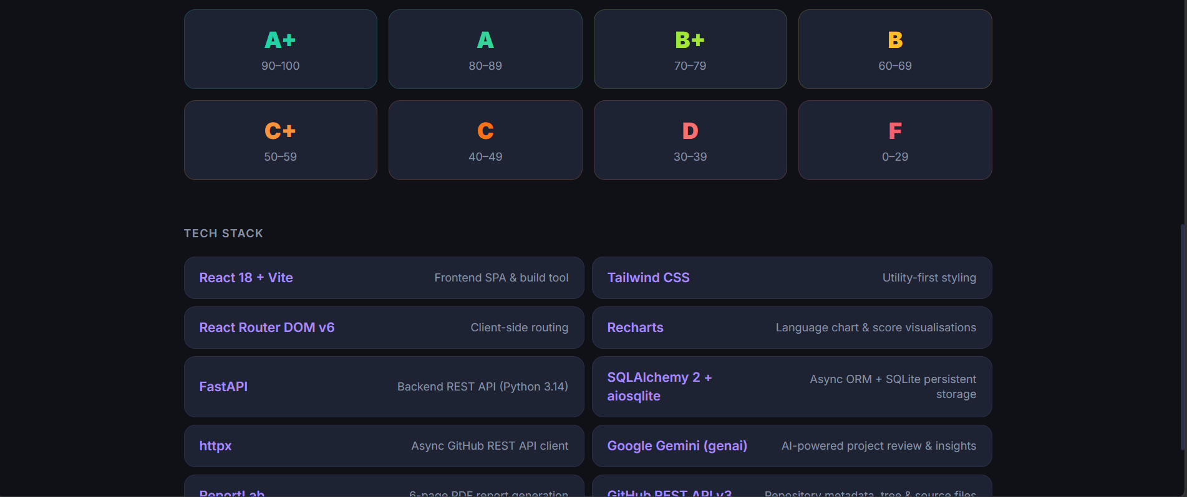

— End of Report —
AI GitHub Project Reviewer · Built by Haseeb Raza · MIT License

