|  |
| --- |
| ENGINEERING DRAWING |
| LAB 11 |

 

**BESE 27-C**

INSTRUCTOR:

***MAAM SEHRISH FIRDOUS***

NAME:

SOFTWARE USED:

# LAB 11: Creating layers and dimensions in AutoCAD

**Your final drawing should look like this:**

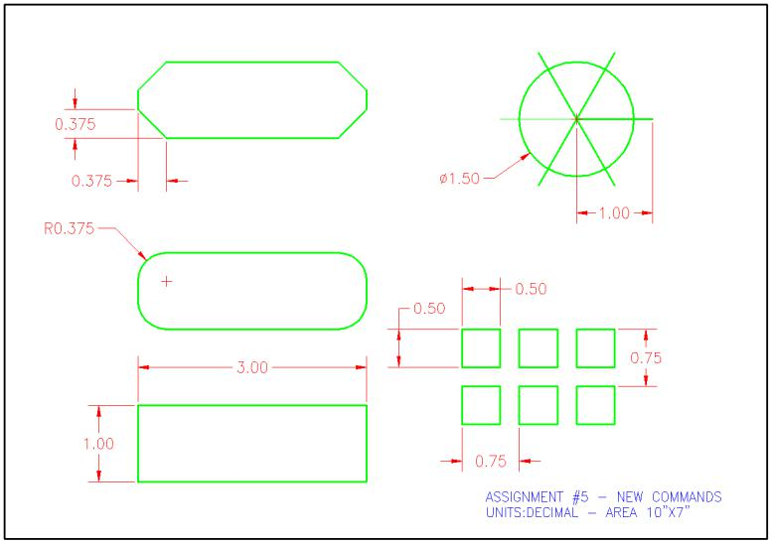

**COMMAND LINE:**

Command:

Command: _arrayrect

Select objects: *Cancel*

Command:

Command: _arrayrect

Select objects: *Cancel*

Command:

Command: _arrayrect

Select objects: Specify opposite corner: 4 found

Select objects: array

*Invalid selection*

Expects a point or Window/Last/Crossing/BOX/ALL/Fence/WPolygon/CPolygon/Group/Add/Remove/Multiple/Previous/Undo/AUto/SIngle

Select objects:

Type = Rectangular Associative = Yes

Command:

Command:

Command: _move 1 found

Specify base point or [Displacement] <Displacement>:

Specify second point or <use first point as displacement>: *Cancel*

Command: Specify opposite corner or [Fence/WPolygon/CPolygon]:

Command:

Command:

Command: _move 1 found

Specify base point or [Displacement] <Displacement>:

Specify second point or <use first point as displacement>:

Command: _move 1 found

Specify base point or [Displacement] <Displacement>:

Specify second point or <use first point as displacement>:

Command: Specify opposite corner or [Fence/WPolygon/CPolygon]:Select objects or specify first extension line origin or [Angular/Baseline/Continue/Ordinate/aliGn/Distribute/Layer/Undo]:

Command:

Command: _dim

Select objects or specify first extension line origin or [Angular/Baseline/Continue/Ordinate/aliGn/Distribute/Layer/Undo]:

Command: _dim

Select objects or specify first extension line origin or [Angular/Baseline/Continue/Ordinate/aliGn/Distribute/Layer/Undo]:

Command: _dim

Select objects or specify first extension line origin or [Angular/Baseline/Continue/Ordinate/aliGn/Distribute/Layer/Undo]:

Command:

Command: _dim

Select objects or specify first extension line origin or [Angular/Baseline/Continue/Ordinate/aliGn/Distribute/Layer/Undo]:

Specify first extension line origin or [Angular/Baseline/Continue/Ordinate/aliGn/Distribute/Layer/Undo]:

Specify second extension line origin or [Undo]:

Specify dimension line location or second line for angle [Mtext/Text/text aNgle/Undo]:

Select objects or specify first extension line origin or [Angular/Baseline/Continue/Ordinate/aliGn/Distribute/Layer/Undo]:

Select objects or specify first extension line origin or [Angular/Baseline/Continue/Ordinate/aliGn/Distribute/Layer/Undo]:

Command:

Command: _dim

Select objects or specify first extension line origin or [Angular/Baseline/Continue/Ordinate/aliGn/Distribute/Layer/Undo]:

Command:

Command: _dim

Select objects or specify first extension line origin or [Angular/Baseline/Continue/Ordinate/aliGn/Distribute/Layer/Undo]:

Specify first extension line origin or [Angular/Baseline/Continue/Ordinate/aliGn/Distribute/Layer/Undo]:

Specify second extension line origin or [Undo]:

Specify dimension line location or second line for angle [Mtext/Text/text aNgle/Undo]:

Select objects or specify first extension line origin or [Angular/Baseline/Continue/Ordinate/aliGn/Distribute/Layer/Undo]:

Select objects or specify first extension line origin or [Angular/Baseline/Continue/Ordinate/aliGn/Distribute/Layer/Undo]:

Command:

Command: _dim

Select objects or specify first extension line origin or [Angular/Baseline/Continue/Ordinate/aliGn/Distribute/Layer/Undo]:

Command:

Command: _dim

Select objects or specify first extension line origin or [Angular/Baseline/Continue/Ordinate/aliGn/Distribute/Layer/Undo]:

Select objects or specify first extension line origin or [Angular/Baseline/Continue/Ordinate/aliGn/Distribute/Layer/Undo]:

Command:

Command: _dim

Select objects or specify first extension line origin or [Angular/Baseline/Continue/Ordinate/aliGn/Distribute/Layer/Undo]:

Command:

Command: _dim

Select objects or specify first extension line origin or [Angular/Baseline/Continue/Ordinate/aliGn/Distribute/Layer/Undo]:

Specify first extension line origin or [Angular/Baseline/Continue/Ordinate/aliGn/Distribute/Layer/Undo]:

Specify second extension line origin or [Undo]:

Select objects or specify first extension line origin or [Angular/Baseline/Continue/Ordinate/aliGn/Distribute/Layer/Undo]:

Select objects or specify first extension line origin or [Angular/Baseline/Continue/Ordinate/aliGn/Distribute/Layer/Undo]:

Command:

Command: _dim

Select objects or specify first extension line origin or [Angular/Baseline/Continue/Ordinate/aliGn/Distribute/Layer/Undo]:

Select objects or specify first extension line origin or [Angular/Baseline/Continue/Ordinate/aliGn/Distribute/Layer/Undo]:

Command: _dim

Select objects or specify first extension line origin or [Angular/Baseline/Continue/Ordinate/aliGn/Distribute/Layer/Undo]:

Command:

Command: _dim

Select objects or specify first extension line origin or [Angular/Baseline/Continue/Ordinate/aliGn/Distribute/Layer/Undo]:

Command: _dim

Select objects or specify first extension line origin or [Angular/Baseline/Continue/Ordinate/aliGn/Distribute/Layer/Undo]:

Command:

Command: _dim

Select objects or specify first extension line origin or [Angular/Baseline/Continue/Ordinate/aliGn/Distribute/Layer/Undo]:

Specify first extension line origin or [Angular/Baseline/Continue/Ordinate/aliGn/Distribute/Layer/Undo]:

Specify second extension line origin or [Undo]:

Specify dimension line location or second line for angle [Mtext/Text/text aNgle/Undo]:

Command: _dim

Select objects or specify first extension line origin or [Angular/Baseline/Continue/Ordinate/aliGn/Distribute/Layer/Undo]:

Command: _dim

Select objects or specify first extension line origin or [Angular/Baseline/Continue/Ordinate/aliGn/Distribute/Layer/Undo]:

Specify first extension line origin or [Angular/Baseline/Continue/Ordinate/aliGn/Distribute/Layer/Undo]:

Specify second extension line origin or [Undo]:

Command: _dim

Command: _dim

Select objects or specify first extension line origin or [Angular/Baseline/Continue/Ordinate/aliGn/Distribute/Layer/Undo]:

Select objects or specify first extension line origin or [Angular/Baseline/Continue/Ordinate/aliGn/Distribute/Layer/Undo]:

Specify second extension line origin or [Undo]:

Command: _dim

Select objects or specify first extension line origin or [Angular/Baseline/Continue/Ordinate/aliGn/Distribute/Layer/Undo]:

Command:

Command: _dim

Select objects or specify first extension line origin or [Angular/Baseline/Continue/Ordinate/aliGn/Distribute/Layer/Undo]:

Specify second extension line origin or [Undo]:

Command: _dim

Select objects or specify first extension line origin or [Angular/Baseline/Continue/Ordinate/aliGn/Distribute/Layer/Undo]:

Specify first extension line origin or [Angular/Baseline/Continue/Ordinate/aliGn/Distribute/Layer/Undo]:

Specify second extension line origin or [Undo]:

Specify dimension line location or second line for angle [Mtext/Text/text aNgle/Undo]:

Select objects or specify first extension line origin or [Angular/Baseline/Continue/Ordinate/aliGn/Distribute/Layer/Undo]:

Select objects or specify first extension line origin or [Angular/Baseline/Continue/Ordinate/aliGn/Distribute/Layer/Undo]:

Command: _dim

Select objects or specify first extension line origin or

Command: _dim

Select objects or specify first extension line origin or [Angular/Baseline/Continue/Ordinate/aliGn/Distribute/Layer/Undo]:

Select circle to specify diameter or [Radius/Jogged/Angular]:

Specify diameter dimension location or [Radius/Mtext/Text/text aNgle/Undo]:

Select objects or specify first extension line origin or [Angular/Baseline/Continue/Ordinate/aliGn/Distribute/Layer/Undo]:

Specify first extension line origin or [Angular/Baseline/Continue/Ordinate/aliGn/Distribute/Layer/Undo]:

Specify second extension line origin or [Undo]:

Command:

Command:

Command: _dim

Select objects or specify first extension line origin or [Angular/Baseline/Continue/Ordinate/aliGn/Distribute/Layer/Undo]:

Command:

Command: _dim

Command: _dim

Select objects or specify first extension line origin or [Angular/Baseline/Continue/Ordinate/aliGn/Distribute/Layer/Undo]:

Command:

Command: _dim

Select objects or specify first extension line origin or [Angular/Baseline/Continue/Ordinate/aliGn/Distribute/Layer/Undo]:

Specify first extension line origin or [Angular/Baseline/Continue/Ordinate/aliGn/Distribute/Layer/Undo]:

Specify second extension line origin or [Undo]:

Command: _dim

Select objects or specify first extension line origin or [Angular/Baseline/Continue/Ordinate/aliGn/Distribute/Layer/Undo]:

Specify first extension line origin or [Angular/Baseline/Continue/Ordinate/aliGn/Distribute/Layer/Undo]:

Command:

Command: _dim

Select objects or specify first extension line origin or [Angular/Baseline/Continue/Ordinate/aliGn/Distribute/Layer/Undo]:

Select line to specify extension lines origin:*Cancel*

Command: _dim

Select objects or specify first extension line origin or [Angular/Baseline/Continue/Ordinate/aliGn/Distribute/Layer/Undo]:

Specify first extension line origin or [Angular/Baseline/Continue/Ordinate/aliGn/Distribute/Layer/Undo]:

Specify second extension line origin or [Undo]:

Specify dimension line location or second line for angle [Mtext/Text/text aNgle/Undo]:

Command: _dim

Select objects or specify first extension line origin or [Angular/Baseline/Continue/Ordinate/aliGn/Distribute/Layer/Undo]:

Command: _dim

Select objects or specify first extension line origin or [Angular/Baseline/Continue/Ordinate/aliGn/Distribute/Layer/Undo]:

Command:

Command: _dim

Select objects or specify first extension line origin or [Angular/Baseline/Continue/Ordinate/aliGn/Distribute/Layer/Undo]:

Specify first extension line origin or [Angular/Baseline/Continue/Ordinate/aliGn/Distribute/Layer/Undo]:

Specify second extension line origin or [Undo]:

Command: *Cancel*

Command: _u DIM GROUP

Command: _quit

OUTPUT/DIAGRAM:

