**Title**

**A Simple Scientific Calculator**

**Objective**

The goal of this project work is to utilize the concepts and knowledge of Assembly Language and use them in the Project. That is what I have learned so far and use the concepts of different **Instructions** in this project. And to understand the working of instructions and the code of Assembly Language using emulator **EMU8086.**

**Theory**

The calculator that I build performs simple Mathematical Operations such as **Addition, Subtraction, Multiplication** and **Division**. Further it can perform **NEG** operation (changes the sign of the input), find the **Modulus**, calculate binary **OR**, binary **AND**, binary **XOR**, binary **NOT**, calculate **Square** and calculate **Cube** of the number.

**Implementation**

I used EMU8086.inc Library which provides built in functions such as:

print ‘STRING’ – For printing String

scan_num – For taking Integer Input

print_num – For displaying value stored in register

printn – For printing New Line

0dh and 0ah as well as print10 and print13 can also be used to move to new line.

**Interrupts used:**



I have made functions of different operations of the Calculator, such as

**Addition:**

….

..code..

….

**Subtraction:**

….

..code..

….

Etc.,

In data segment I have declared some variables as Uninitialized and some strings with string values.

**Different Functions of Operations:**

* **Addition**

Addition of two numbers.

* **Subtraction**

Subtraction of two numbers.

* **Multiplication**

Multiplication of two numbers.

* **Division**

Division of two numbers.

* **Modulus**

Modulus of two numbers.

* **Negate**

Negation of a number.

* **Square**

Square of a number.

* **Cube**

Cube of a number.

* **Binary OR**

OR of two numbers.

* **Binary AND**

AND of two numbers.

* **Binary XOR**

XOR of two numbers.

* **Binary NOT**

NOT of two numbers.

* **Continue**

Asks the user whether to use again or exit.

* **Exit**

Exits from the program.

**Debugging-Test-Run**

When the user runs the program, a **main menu** will display as below in **graphics mode.**

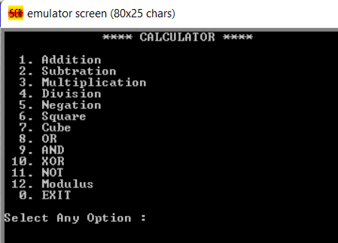

The user will now input the **operation number** he would like to perform, such as 1 for **addition**, 2 for **subtraction** and so on,

Then the user will be asked to **enter two numbers** to perform the selected operation after entering the number the operation will be performed and the **answer** will be **displayed** on the screen.

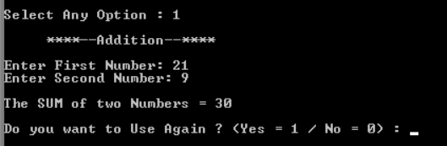

With the answer displayed the **option of using** the **calculator again** will also be displayed. If the user **enters 1** then the calculator will start **again** from **beginning**.

If the user **enters 0** then the program will jump to **exit** **function** and then display the message and **terminates** the program.

After this the emulator will be **halted** and the program is **executed**.

x THE END x