#### The Problem Description

Suppose we have been given the task of creating a program that will keep track of all the accounts for a bank. There are a number of different kinds of accounts that the bank supports.

* Regular Account - This account charges a fee of which is the smaller of 10 or 10% of the balance at the end of the month. There is no interest. There is a penalty of 10.00 if the balance falls below a minimum of 500.00.
* Interest Account - This account charges a fee of which is the smaller of 10 or 10% of the balance at the end of the month. There is interest of 7% paid monthly. There is no minimum balance required.
* Checking Account - This account charges a fee of which is the smaller of 10 or 10% of the balance at the end of the month. There is annual interest of 7% paid monthly . There is a penalty of 10.00 if the balance falls below a minimum of 100.00. There is a charge of 0.10 for each transaction.
* CD Account - This account charges a fee of which is the smaller of 10 or 10% of the balance at the end of the month. There is interest of 15% paid yearly. There is no minimum balance required, but if there is a withdrawal before 12 months have gone by there will be a penalty of 20% of the current balance.

Each of these accounts has a personal identification number (PIN) with it to provide protection.

#### Attributes and Methods

Our first task is to identify the attributes and methods that each of the classes will need. At first look, we can identify the following attributes for each of the classes:

|  |  |  |
| --- | --- | --- |
| Attributes for Regular Account | Type | Description |
| name | String | the name of the account holder |
| balance | double | balance in the account |
| pin | String | personal identification number |
| minimum balance | double | minimum balance for the account |
| penalty | double | penalty if balance falls below the minimum balance |

|  |  |  |
| --- | --- | --- |
| Attributes for Interest Account | Type | Description |
| name | String | the name of the account holder |
| balance | double | balance in the account |
| pin | String | personal identification number |
| interest | double | yearly interest |

|  |  |  |
| --- | --- | --- |
| Attributes for Checking Account | Type | Description |
| name | String | the name of the account holder |
| balance | double | balance in the account |
| pin | String | personal identification number |
| interest | double | yearly interest |
| minimum balance | double | minimum balance for the account |
| penalty | double | penalty if balance falls below the minimum balance |
| transactions | int | the number of deposits and withdrawals in a month |

|  |  |  |
| --- | --- | --- |
| Attributes for CD Account | Type | Description |
| name | String | the name of the account holder |
| balance | double | balance in the account |
| pin | String | personal identification number |
| interest | double | yearly interest |
| penalty | double | penalty if early withdrawal |
| months | int | number of months since the creation of the account |

All of these classes need to have basically the same methods

* Create the account.
* Deposit an amount.
* Withdraw an amount.
* Access the balance.
* Access the name.
* Check the validity of the PIN.
* Compute the fees.
* Compute the interest.

#### Generalization and Specialization

We could implement each of these classes separately. But that would mean that we would need to implement the same or similar code in each of the classes. We want to take the common code and attributes and place them in a single general class. This process is known as *generalization*. Examining the above tables, we see that all of the classes have name, balance, and pin. This suggests that we want a base class that encapsulates these attributes and the methods that work with them. We also notice that three of the four classes have interest. Since it is relatively easy to implement no interest as a rate of 0% and we expect most account classes to have interest, we will also add this into our base account.

Besides using generalization to decide on a class hierarchy, we often think in terms of layers of code. Thinking about our problem we realize that there are two kinds of things that our base class does. It provides features for handling the account (withdraw, deposit, compute interest) and it provides a security feature. In the future, we may wish to add additional security features like tracking the withdrawals to look for suspicious patterns. To make a place to implement those kinds of features, we will add a second class. It is in this class that we will put the pin number.

Currently our class hierarchy looks like:

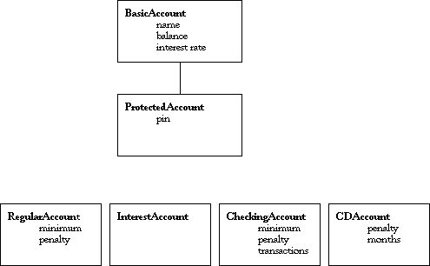

ProtectedAccount will inherit the attributes of the BasicAccount and has an additional attribute.

The methods in BasicAccount will correspond to the list of methods we wrote down previously. The only methods that don't correspond are monthly_update() and setRate(). It is convenient to have the notion of a monthly update that we know every kind of account will respond to. In addition, we might want to eventually have an account for which the rate varies so we include a method by which we can change the rate. Our methods are:

BasicAccount ( String name)

String name ()

double balance ()

double rate ()

void deposit( double amount)

void withdraw( double amount)

void setRate( double rate)

void monthly_update()

double computeFees()

double computeInterest()

String toString()

We have to make some decisions about which of these methods should be accessible to the public. This is not a trivial decision. If we make a method public, then it will be inherited by every subclass and we are committed to those methods being in the interface. Certainly it is appropriate for the accessor to name to be public. But what about deposit()? For this it is not so clear. In particular, we would like our ProtectedAccount to have two additional methods:

void deposit( double amount, String pin)

void withdraw( double amount, String pin)

which implement the checking of the pin number. If we make deposit(double) public, then everyone will be able to use this method and bypass the security. If we make deposit(double) private, then our subclass will not be able to use the method. We need another kind of protection. If we make the method protected, then it will be public for every subclass and private for all other classes. This is what we will do for the two methods deposit() and withdraw() in the BasicAccount class. We also do not want to allow others to be able to invoke the setRate() method and so will make that protected as well.

Question: "Do we want it to be possible for an instance of a BasicAccount to be created?"

Answer: No. We always want the protection services to be in place and therefore do not want instances of BasicAccount to be created. We can accomplish this by making the class BasicAccount to be abstract. If any code attempts to construct a BasicAccount, it will result in a compile time error.

If we look at our partial hierarchy, we see that there are a couple of classes that share the attributes minimum balance and penalty. Clearly these two classes can share these attributes and the code for computing the fees if the minimum is reached. We will generalize these into a new class MinimumAccount resulting in a new hierarchy:

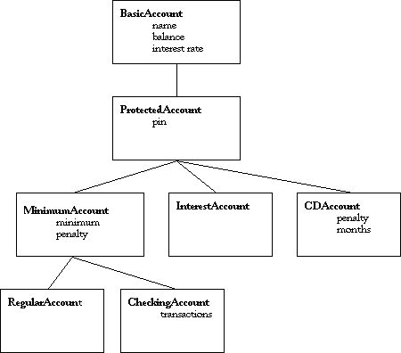

At the top of the hierarchy is the most general class that we have. As we go farther down, the classes become more specialized. All of our classes commit themselves to the public interface in BasicAccount and ProtectedAccount. Do realize, however, that some of our subclasses will want to change the action of those methods. For example, if an instance of the CDAccount receives the withdraw() message, it will want to check and see if there is a penalty because of an early withdraw.

One of the advantages of have a class hierarchy like this is that we can write code that uses variables whose type is the generalized class. For example, we could create an array of type BasicAccount. Each of members of this array would have to be an instance of this class or *any* of its subclasses. We could safely loop over such an array and send each account the monthly_update() message. Each subclass is committed to implementing this method in an appropriate way for that class. Each instance will invoke the version of the method appropriate to the class of which it belongs.

### The Experimental Laboratory

Begin by creating a Bank project as appropriate for your environment. Copy the file [AccountDemo.java](https://cs.calvin.edu/activities/books/java/intro/1e/HandsOnJava/IncludedCode/AccountDemo.java) and the folder AccountKinds ( which contains the class files for [BasicAccount.java](https://cs.calvin.edu/activities/books/java/intro/1e/HandsOnJava/IncludedCode/AccountKinds/BasicAccount.java), [ProtectedAccount.java](https://cs.calvin.edu/activities/books/java/intro/1e/HandsOnJava/IncludedCode/AccountKinds/ProtectedAccount.java), [MinimumAccount.java](https://cs.calvin.edu/activities/books/java/intro/1e/HandsOnJava/IncludedCode/AccountKinds/MinimumAccount.java), and [RegularAccount.java](https://cs.calvin.edu/activities/books/java/intro/1e/HandsOnJava/IncludedCode/AccountKinds/RegularAccount.java) as well as classes for exceptions that our classes may throw) into your project and add them as appropriate for your environment. The RegularAccount class and all of its parent classes have been implemented and we will be using them as a software laboratory for the experiments in this exercise.