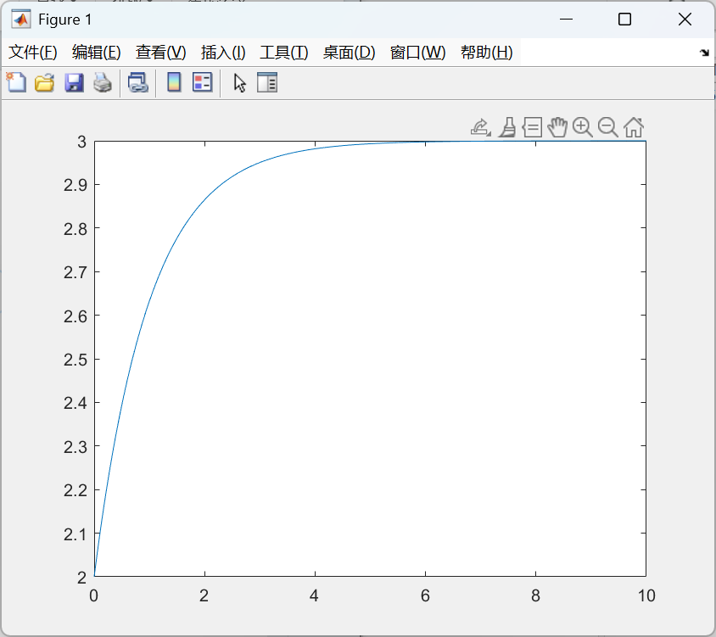

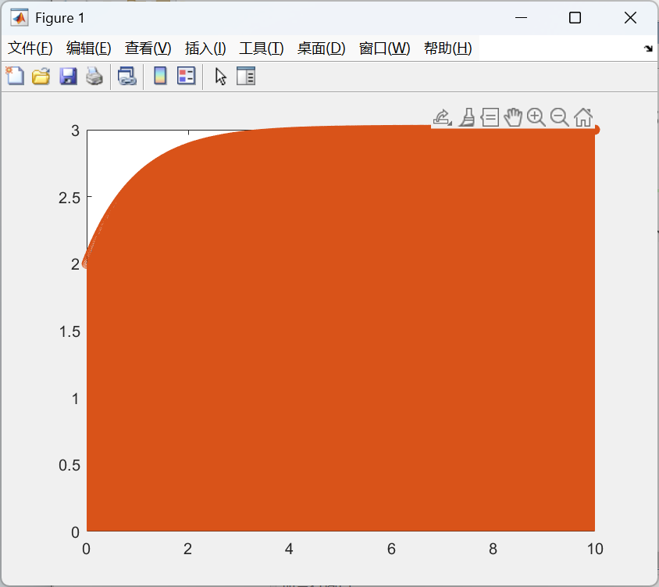

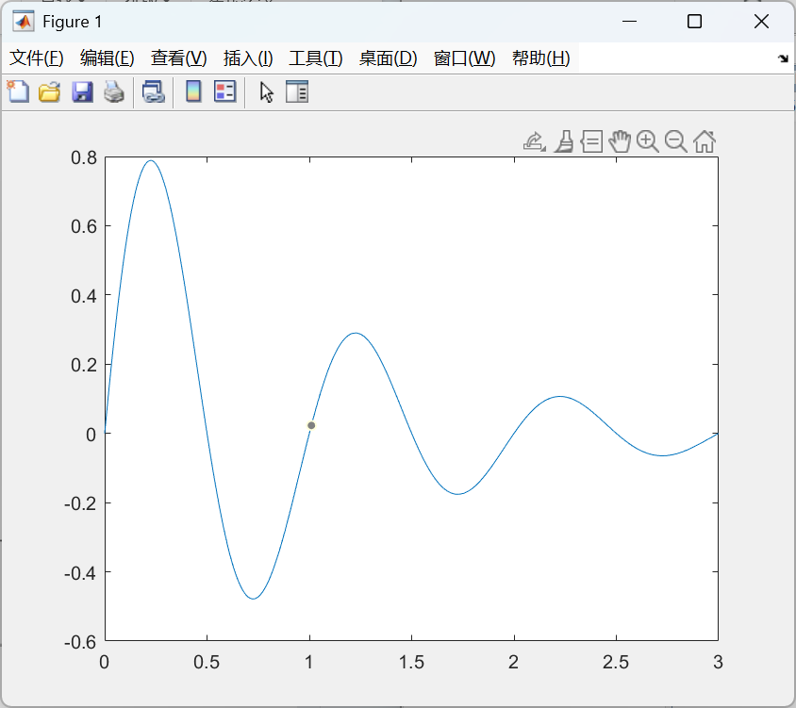

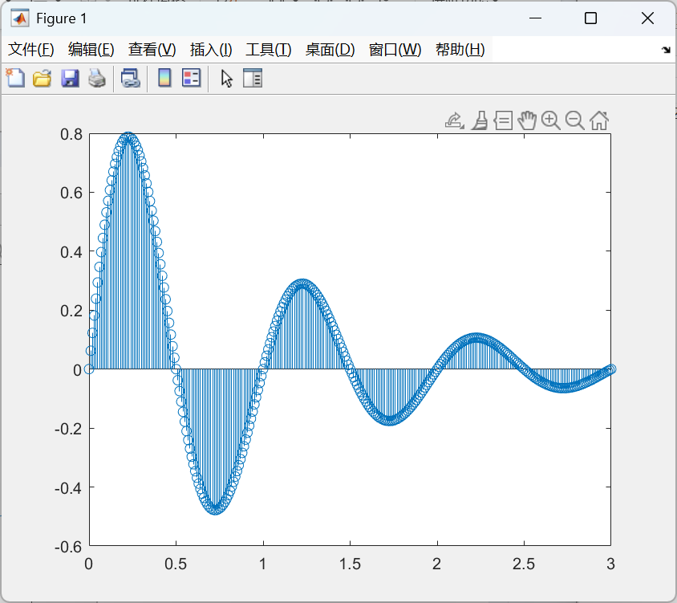

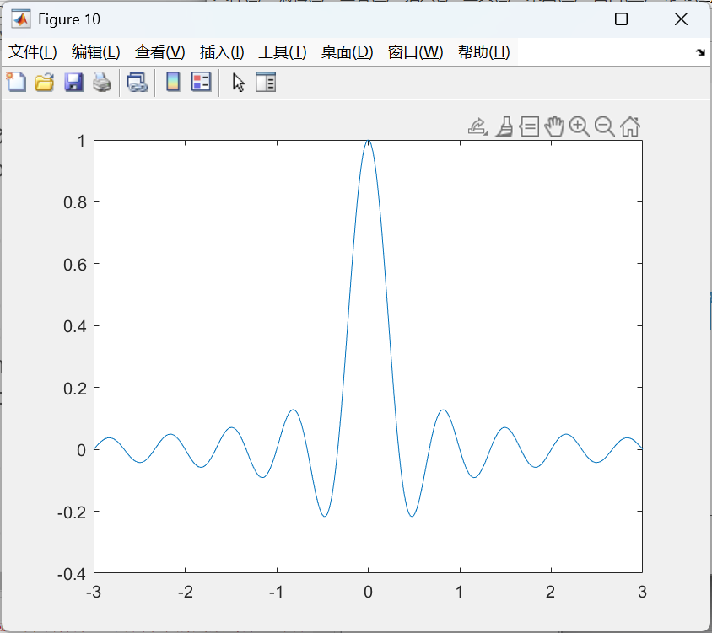

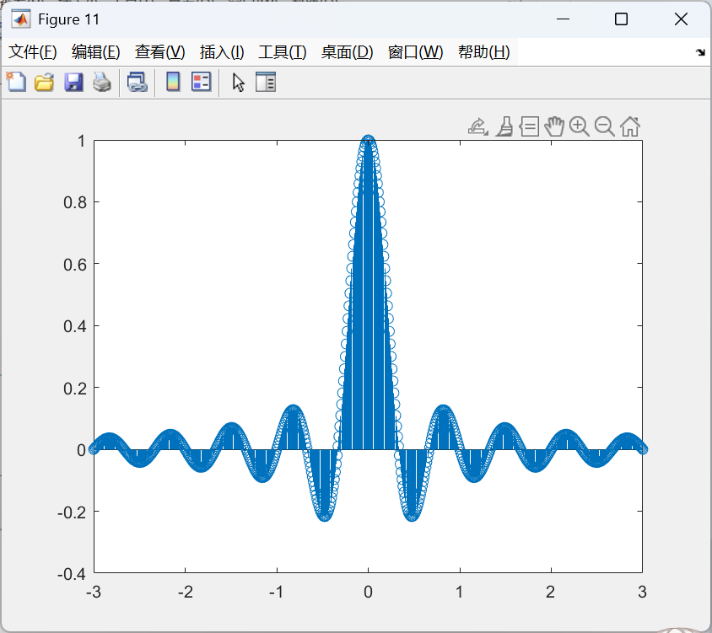

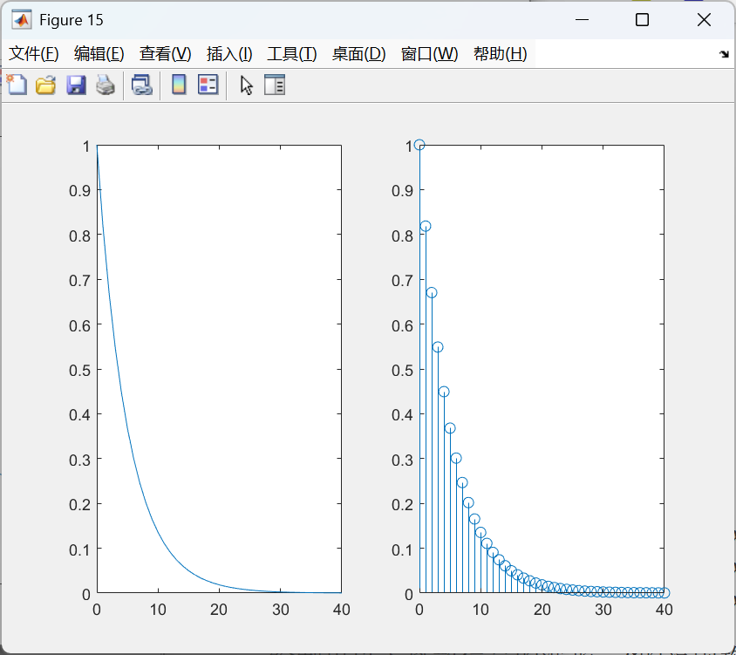

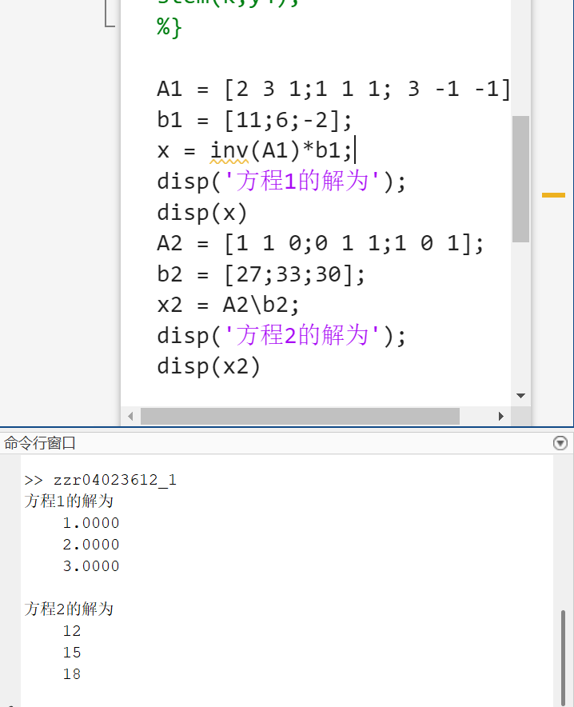

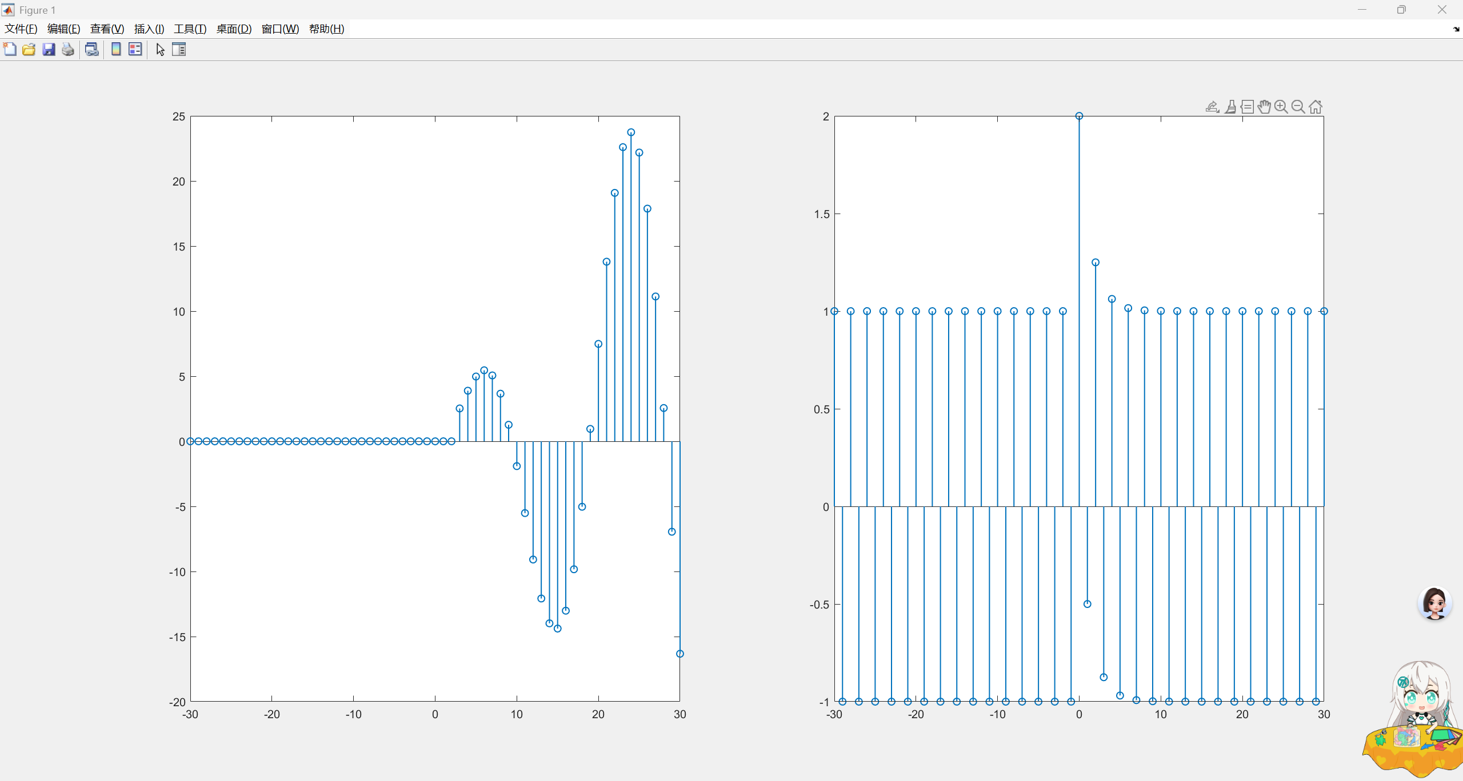

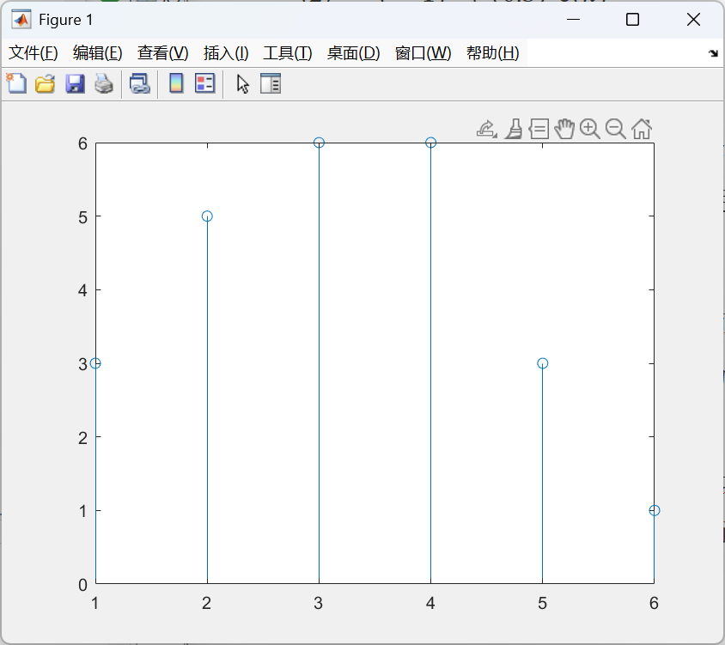

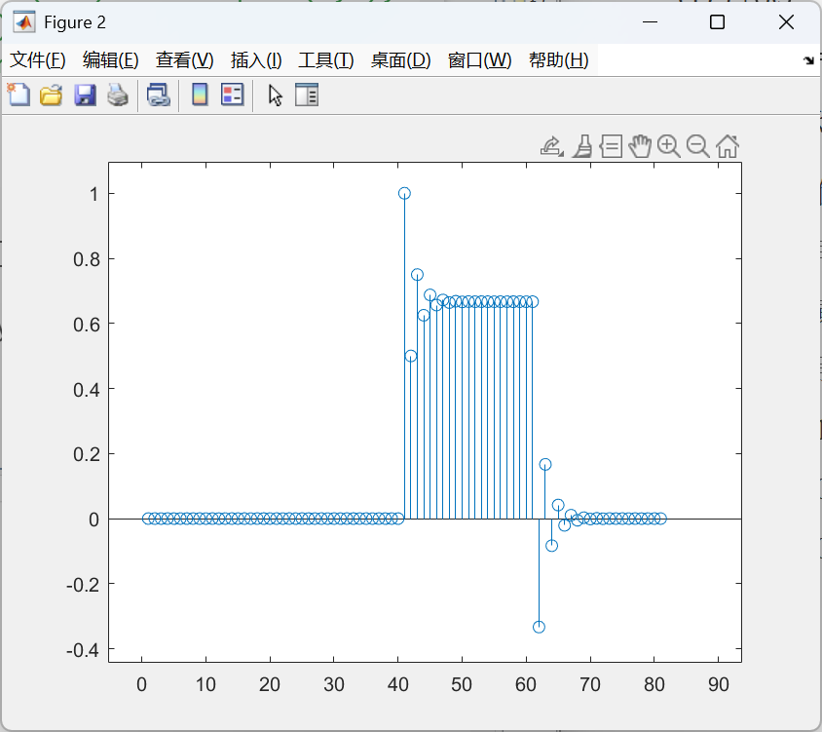

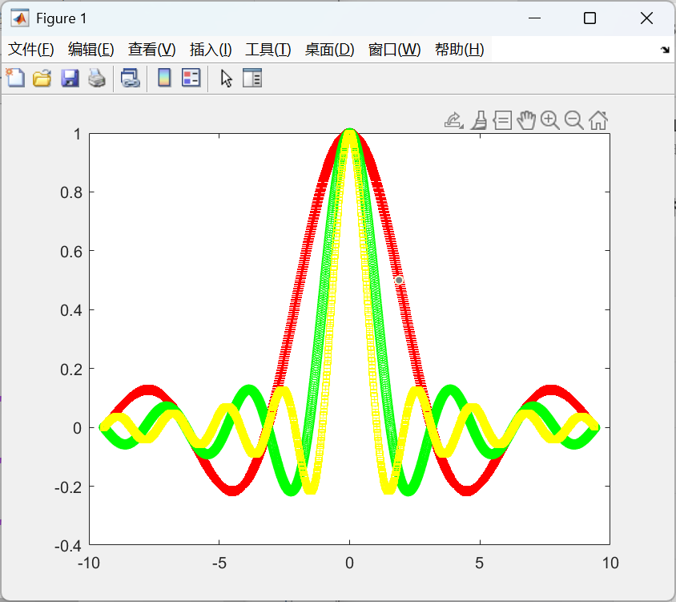

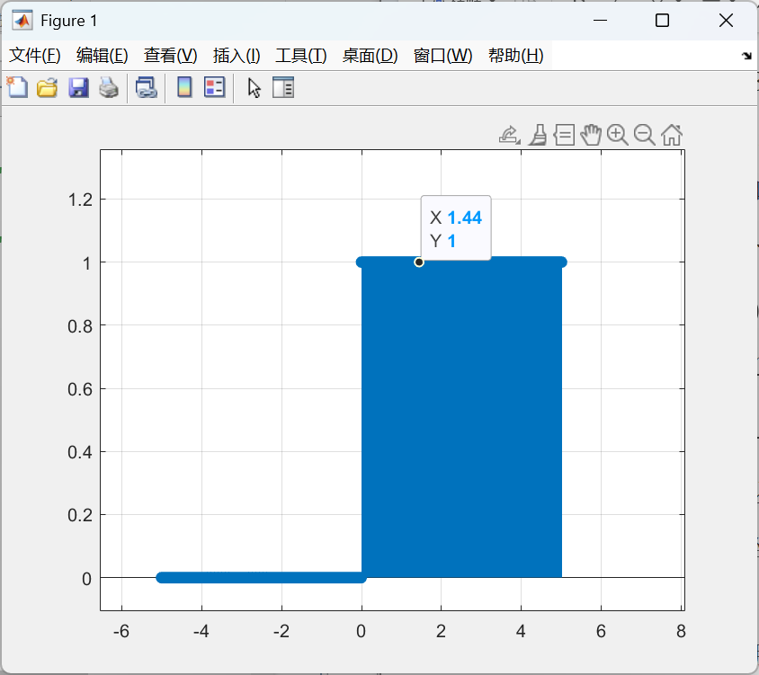

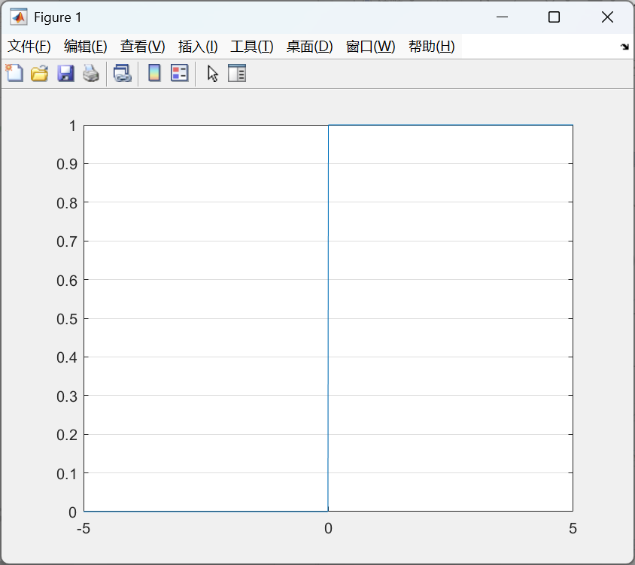

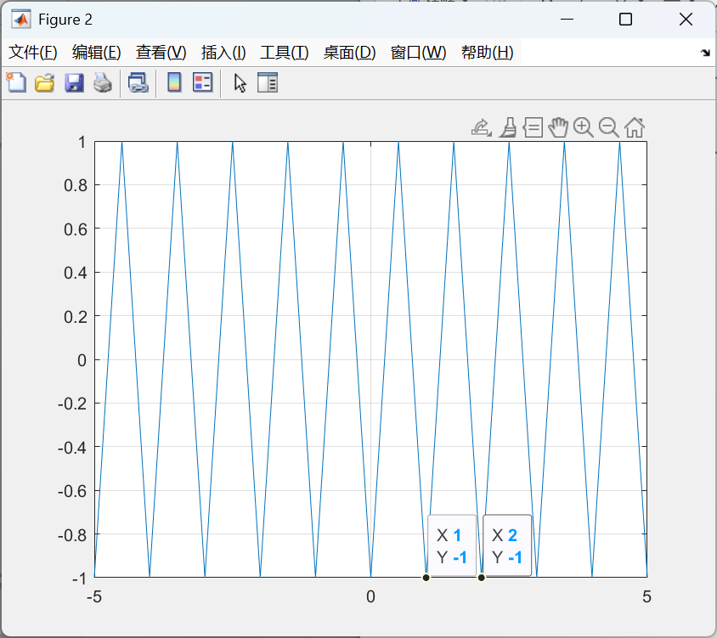

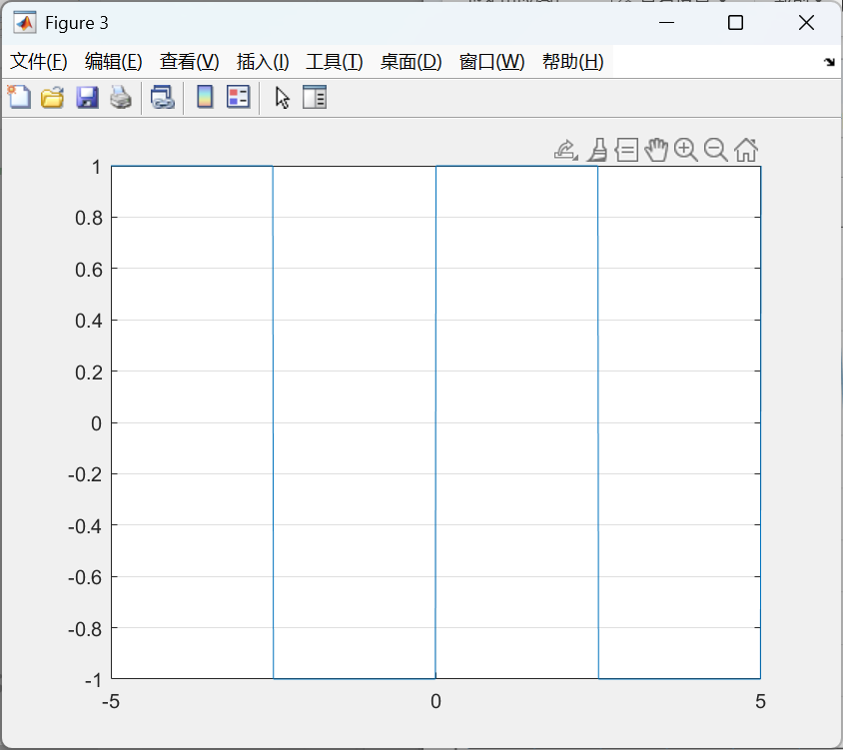

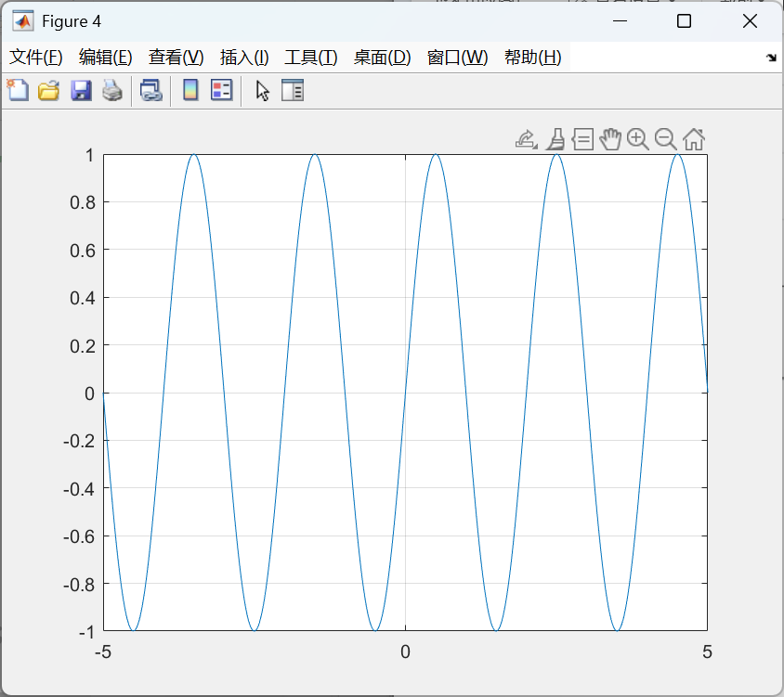

%{

%Q1

figure

t1 = 0:0.01:10;

y1 = 3 - exp(-t1);

plot(t1,y1)

figure

stem(t1,y1);

t2 = 0:0.01:3;

y2 = exp(-t2).\*sin(2\*pi\*t2);

figure

plot(t2,y2);

figure

stem(t2,y2);

t3 = -3:0.01:3;

y3 = sin(3\*pi\*t3)./(3\*pi\*t3);

y3(abs(t3)<1e-10) = 1;

figure

plot(t3,y3)

figure

stem(t3,y3)

k = 0:1:40;

y4 = exp(-k/5);

subplot(1,2,1);

plot(k,y4)

subplot(1,2,2);

stem(k,y4);

%}

%Q2

%{

A1 = [2 3 1;1 1 1; 3 -1 -1];

b1 = [11;6;-2];

x = inv(A1)\*b1;

disp('方程1的解为');

disp(x)

A2 = [1 1 0;0 1 1;1 0 1];

b2 = [27;33;30];

x2 = A2\b2;

disp('方程2的解为');

disp(x2)

%}

%Q3

%{

k = -30:30;

L = 3;

y1 = k.\*sin(k/3).\*stepfun(k,L);

subplot(1,2,1);

stem(k,y1,'LineWidth',1);

y2 = (-1).^k + (0.5).^k.\*stepfun(k,0);

subplot(1,2,2);

stem(k,y2,'LineWidth',1)

%}

%Q4

%{

y1 = [1;1;1;1];

y2 = [3;2;1];

y3 = conv(y1,y2);

stem(y3);

figure

k = -20:20;

f1 = stepfun(k,0);

f2 = (-0.5).^k.\*stepfun(k,0);

f3 = conv(f1,f2);

stem(f3);

%}

%Q5

%{

t = -3\*pi:0.01:3\*pi;

y1 = sin(t)./t;

y2 = sin(2\*t)./(2\*t);

y3 = sin(3\*t)./(3\*t);

%y1(abs(t)<1e-10) = 1;

plot(t,y1,'Color','r','LineStyle','-','Marker','+')

hold on;

plot(t,y2,'Color','g','LineStyle','--','Marker','o')

hold on;

plot(t,y3,'Color','y','LineStyle','-.','Marker','s')

%}

%Q6

t= -5:0.01:5;

axis([-5 5 -1.2 1.2]);

y1 = stepfun(t,0);

plot(t,y1);

grid on

figure

f = 2\*pi\*1;

y2 = sawtooth(f\*t,0.5);

plot(t,y2);

grid on

figure

f = (2\*pi\*0.2);

y3 = square(f\*t,50);

plot(t,y3);

grid on;

figure

y4 = sin(2\*pi\*0.5\*t);

plot(t,y4);

grid on;