Hashim Abdulla
Due Date: 11/4/2025 (turned in on the 7th)

Project Sprint #3
The SOS game is described in CS449HomeworkOverview.docx. You should read the description very carefully.

Your submission must include the GitHub link to your project and you must ensure that the instructor has the proper access to your project. You will receive no points otherwise.

GitHub link: https://github.com/HashAbdulla/SOS-Board-game [ALL DOCUMENTATION/FILES IN THIS REPO]

Implement all the features that support a human player to play a simple or general SOS game against a human opponent and refactor your existing code if necessary. The minimum features include choosing the game mode (simple or general), choosing the board size, setting up a new game, making a move (in a simple or general game), and determining if a simple or general game is over. The following is a sample GUI layout. It is required to use a class hierarchy to deal with the common requirements of the Simple Game and the General Game. If your code for Sprint 2 has not considered class hierarchy, it is time to refactor your code.

SOS Simple game General game Board size
8
Blue player  S  O | 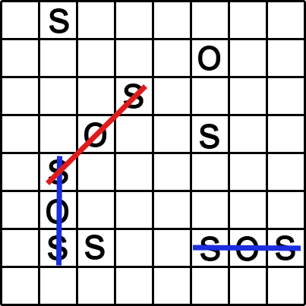 | Red player  S  O
 | Current turn: blue (or red) | New Game
Figure 1. Sample GUI layout of the working program for Sprint 3

Deliverables: expand and improve your submission for sprint 2.

- Demonstration (9 points)
Submit a video of no more than five minutes, clearly demonstrating the following features.
- A simple game that the blue player is the winner
- A simple draw game with the same board size as (a)
- A general game that the red player is the winner, and the board size is different from (a)
- A general draw game with the same board size as (c)
- Some automated unit tests for the simple game mode
- Some automated unit tests for the general game mode

In the video, you must explain what is being demonstrated.

YouTube link: https://www.youtube.com/watch?v=6pFxRBJqjxQ

- Summary of Source Code (1 points)

Source code file name | Production code or test code? | # lines of code
game_logic.py | Production | 275
gui.py | Production | 275
test_game.py Test |  | 598
Total |  | 1148 LOC (as of sprint #3)

You must submit all source code via github to get any credit for this assignment.

- Production Code vs User stories/Acceptance Criteria (3 points)

Summarize how each of the user story/acceptance criteria is implemented in your production code (class name and method name etc.)

User Story ID | User Story Name
1 | Choose a board size
2 | Choose the game mode of a chosen board
3 | Start a new game of the chosen board size and game mode
4 | Make a move in a simple game
5 | A simple game is over
6 | Make a move in a general game
7 | A general game is over

User Story ID | AC ID | Class Name(s) | Method Name(s) | Status (complete or not) | Notes (optional)
1. Choose a board size | 1.1 | GameBoard, SOSGame (base), SOSGUI | __init__(size), set_board_size(size), validate_board_size() | Complete | Works for both SimpleGame and GeneralGame via inheritance
 | 1.2 | GameBoard, SOSGUI | is_valid_size(size), validate_board_size() | Complete | Error handling identical for both game modes
2. Choose the game mode | 2.1 | SOSGUI, create_game() | start_new_game(), create_game(mode) | Complete | Factory method creates SimpleGame instance
 | 2.2 | SOSGUI, create_game() | start_new_game(), create_game(mode) | Complete | Factory method creates GeneralGame instance
3. Start a new game | 3.1 | SOSGame (base), SimpleGame, GeneralGame, SOSGUI | start_new_game() in base class | Complete | Common initialization in base class, inherited by both modes
 | 3.2 | GameBoard, SOSGUI | __init__(size), create_board_display(size) | Complete | Board initialization shared between modes
 | 3.3 | SOSGame (base) | start_new_game() | Complete | Blue always starts first in base class
4. Make a move in simple game | 4.1 | SimpleGame, GameBoard, SOSGUI | make_move(), place_letter(), handle_turn_switch(), on_cell_click() | Complete | SimpleGame overrides handle_turn_switch() to always switch
 | 4.2 | GameBoard, SOSGUI | is_cell_empty(), place_letter(), on_cell_click() | Complete | Validation in base GameBoard class
 | 4.3 | SimpleGame, GameBoard | make_move(), check_sos_at_position(), handle_sos_found() | Complete | SimpleGame.handle_sos_found() ends game on first SOS
5. A simple game is over | 5.1 | SimpleGame | handle_sos_found(), check_game_over() | complete | Sets winner and game_over=True when SOS formed
 | 5.2 | SimpleGame | check_game_over() | Complete | Checks board_full(), sets winner="Draw"
 | 5.3 | SOSGame (base), SOSGUI | make_move(), on_cell_click() | Complete | RuntimeError raised if game_over==True
6. Make a move in general game | 6.1 | GeneralGame, GameBoard, SOSGUI | make_move(), place_letter(), on_cell_click() | Complete | Uses same base make_move() with different handlers
 | 6.2 | GameBoard, SOSGUI | is_cell_empty(), place_letter() | Complete | Same validation as simple mode
 | 6.3 | GeneralGame, Player | handle_sos_found(), add_score() | Complete | GeneralGame awards points and keeps turn
 | 6.4 | GeneralGame | handle_turn_switch() | Complete | Only switches if sos_found==False
7. A general game is over | 7.1 | GeneralGame | check_game_over() | Complete | Game ends when board.is_board_full()
 | 7.2 | GeneralGame | check_game_over() | Complete | Compares scores, sets winner to player with higher score
 | 7.3 | GeneralGame | check_game_over() | Complete | Sets winner="Draw" if scores equal
 | 7.4 | SOSGame (base), SOSGUI | make_move(), on_cell_click() | complete | Same prevention as simple mode in base class

- Tests vs User stories/Acceptance Criteria (2 points)

Summarize how each of the user story/acceptance criteria is tested by your test code (class name and method name) or manually performed tests.

User Story ID | User Story Name
1 | Choose a board size
2 | Choose the game mode of a chosen board
3 | Start a new game of the chosen board size and game mode
4 | Make a move in a simple game
5 | A simple game is over
6 | Make a move in a general game
7 | A general game is over

4.1 Automated tests directly corresponding to some acceptance criteria

User Story ID | Acceptance Criterion ID | Class Name(s) of the Test Code | Method Name(s) of the Test Code | Description of the Test Case (input & expected output)
1 | 1.1 | TestGameBoard, TestCommonGameLogic | test_valid_board_size_creation, test_set_valid_board_size | Input: size=5 for SimpleGame and size=8 for GeneralGame  Expected: Both create boards with specified sizes
 | 1.2 | TestGameBoard, TestCommonGameLogic | test_invalid_board_size_too_small, test_invalid_board_size_too_large, test_set_invalid_board_size | Input: size=2 and size=15  Expected: ValueError raised for both game modes
2 | 2.1 | TestGameFactory | test_create_simple_game | Input: create_game(SIMPLE_MODE)  Expected: Returns SimpleGame instance
 | 2.2 | TestGameFactory | test_create_general_game | Input: create_game(GENERAL_MODE)  Expected: Returns GeneralGame instance
3 | 3.1 | TestSimpleGame, TestGeneralGame | test_simple_game_creation, test_general_game_creation | Input: start_new_game() for both modes  Expected: game_started=True, board created
 | 3.2 | TestGameBoard | test_board_initialized_empty | Input: GameBoard(4)  Expected: All 16 cells contain ' '
 | 3.3 | TestCommonGameLogic | test_initial_turn_is_blue | Input: start_new_game() for both modes  Expected: current_player.color == "blue"
4 | 4.1 | TestSimpleGame | test_simple_game_blue_wins (partial) | Input: Series of moves in SimpleGame  Expected: Letters placed, turns switch until SOS
 | 4.2 | TestGameBoard | test_place_letter_on_occupied_cell | Input: place_letter(0,0,'S') then place_letter(0,0,'O')  Expected: ValueError on second call
 | 4.3 | TestGameBoard, TestSimpleGame | test_check_horizontal_sos, test_simple_game_blue_wins | Input: Place S-O-S sequence  Expected: SOS detected, game ends immediately
5 | 5.1 | TestSimpleGame | test_simple_game_blue_wins, test_simple_game_red_wins | Input: Complete SOS sequence  Expected: game_over=True, winner set correctly
 | 5.2 | TestSimpleGame | test_simple_game_draw | Input: Fill board without SOS  Expected: game_over=True, winner="Draw"
 | 5.3 | TestSimpleGame | test_simple_game_prevents_moves_after_game_over | Input: Try move after game ends  Expected: RuntimeError raised
6 | 6.1 | TestGeneralGame | test_general_game_scoring (partial) | Input: Place letters in GeneralGame  Expected: Letters placed, validation works
 | 6.2 | TestGameBoard (shared) | test_place_letter_on_occupied_cell | Input: Same test works for both modes  Expected: ValueError raised
 | 6.3 | TestGeneralGame | test_general_game_scoring, test_general_game_extra_turn_after_sos | Input: Form SOS in general game  Expected: Player scores 1 point, gets extra turn
 | 6.4 | TestGeneralGame | test_general_game_turn_switch_no_sos | Input: Place letter without forming SOS  Expected: Turn switches to other player
7 | 7.1 | TestGeneralGame | test_general_game_ends_when_board_full | Input: Fill entire board  Expected: game_over=True when last cell filled
 | 7.2 | TestGeneralGame | test_general_game_blue_wins_by_score, test_general_game_red_wins_by_score | Input: Play game where one player scores more  Expected: Higher scorer is winner
 | 7.3 | TestGeneralGame | test_general_game_draw_same_score | Input: Fill board with equal scores  Expected: winner="Draw"
 | 7.4 | TestGeneralGame | test_general_game_prevents_moves_after_over | Input: Try move after board full  Expected: RuntimeError raised

4.2 Manual tests directly corresponding to some acceptance criteria

User Story ID | Acceptance Criterion ID | Test Case Input | Test Oracle (Expected Output) | Notes
4 | 4.3 | Start 3x3 Simple game, place S(0,0), O(0,1), S(0,2) | Game ends immediately, "Blue player wins!" message displayed | Horizontal SOS
4 | 4.3 | Start 3x3 Simple game, place vertical S-O-S | Game ends, winner announced | Vertical SOS
5 | 5.1 | Complete SOS as Blue player | Message: "Blue player wins! Blue formed the first SOS!" | Win message
5 | 5.2 | Fill 3x3 board: S-S-O/O-O-S/S-O-O | Message: "Draw - The board is full with no SOS formed" | Draw message
5 | 5.3 | Win game, then click empty cell | Message: Game has ended | Moves blocked
6 | 6.3 | General game: Form SOS | Blue score increments by 1, Blue gets another turn | Score updates
6 | 6.3 | General game: Form 2 SOS in one move | Score increments by 2 | Multiple SOS
6 | 6.4 | General game: Place S without forming SOS | Turn switches to Red | Normal turn switch
7 | 7.1 | General 3x3: Fill all 9 cells | "Game Over!" message appears when last cell filled | Board full triggers end
7 | 7.2 | General game: Blue scores 3, Red scores 1 | Message: "Blue player wins! Blue: 3 | Winner by score
7 | 7.3 | General game: Both score 2 points | Message: "Draw - Both players scored 2 points!" | Equal scores = draw
7 | 7.4 | Finish general game, try to click cell | Message: "Game has ended. Start new game to play again." | Moves blocked

4.3 Other automated or manual tests not corresponding to the acceptance criteria

Number | Test Input | Expected Result | Class Name of Test Code | Method Name of Test Code
1 | Check diagonal SOS detection | SOS sequence detected correctly | TestGameBoard | test_check_diagonal_sos
2 | Check vertical SOS detection | SOS sequence detected correctly | TestGameBoard | test_check_vertical_sos
3 | Place letter where no SOS forms | Empty list of sequences returned | TestGameBoard | test_no_sos_detected
4 | Test player add_score method | Score increments correctly | TestPlayer | test_player_add_score
5 | Create game with invalid mode | ValueError raised | TestGameFactory | test_create_invalid_game
6 | SimpleGame vertical SOS | Blue wins with vertical SOS | TestSimpleGame | test_simple_game_vertical_sos_wins
7 | SimpleGame diagonal SOS | Red wins with diagonal SOS | TestSimpleGame | test_simple_game_diagonal_sos_wins
8 | GeneralGame multiple SOS in one move | Score increases by number of SOS formed | TestGeneralGame | test_general_game_multiple_sos_in_one_move
9 | Common logic: make move before start | RuntimeError in both modes | TestCommonGameLogic | test_make_move_before_game_starts
10 | Common logic: scores reset on new game | Both players score=0 in both modes | TestCommonGameLogic | test_players_score_reset_on_new_game

- (Part 1) Describe how the class hierarchy in your design deals with the common and different requirements of the Simple Game and the General Game.
At least 1/2 page, excluding screenshots/diagrams (12pt, single-spaced), is required. (3 Points)

(Code outside of already-given tables in this document was formatted using the Microsoft Word “Easy Code
Formatter” extension to enhance readability and presentation before converting the file to PDF.)

For Sprint 3, I implemented a class hierarchy using inheritance and the Template Method pattern to handle the common and different requirements between Simple Game and General Game modes. This design supports code reuse, maintainability, and extensibility for my future sprints.

SOSGAME (Abstract Base Class)

SimpleGame(Concrete Subclass)
GeneralGame (Concrete Subclass)

Additionally, I used supporting classes:

GameBoard: Manages the board state and SOS detection logic

Player: Represents player data (name, color, score)

create_game(): Factory function for creating game instances

Common Requirements Handled by Base Class (SOSGame)

The SOSGame base class implements all shared functionality between Simple and General modes:

- Board Management
  - set_board_size(size): Validates and sets board dimensions (3-10)
  - start_new_game(): Initializes board, resets players, sets blue player as starter
  - get_board(), get_current_player(): Accessor methods
- Game State
  - Attributes: board, board_size, blue_player, red_player, current_player, game_started, game_over, winner
  - These are common to both modes and initialized identically
- Move Processing Template
  - make_move(row, col, letter): Template Method that defines the algorithm
structure:

1. def make_move(self, row, col, letter):
2. # 1. Validate game state (common)
3. # 2. Validate move legality (common)
4. # 3. Place letter on board (common)
5. # 4. Check for SOS sequences (common)
6. # 5. Handle SOS found (DIFFERENT - delegated to subclass)
7. # 6. Check game over (DIFFERENT - delegated to subclass)
8. # 7. Handle turn switching (DIFFERENT - delegated to subclass)
9.
- This method calls three abstract methods that subclasses must override

- Turn Management
  - switch_turn(): Toggles between blue and red players (common logic)
- Game Status Queries
  - is_game_over(), get_winner(): Return game state (common interface)

Different Requirements Handled by Subclasses

Each game mode overrides three key methods to implement mode-specific behavior:

SimpleGame Implementation:
- handle_sos_found(sos_found, sequences)
  - Simple Mode Rule: First SOS wins immediately
  - Implementation: If sos_found == True, sets self.winner = self.current_player and self.game_over = True
  - Difference from General: Doesn't award points or give extra turns; game ends immediately
- check_game_over()
  - Simple Mode Rule: Game ends when first SOS is formed OR board is full (draw)
  - Implementation: If board is full and no winner yet, sets self.winner = "Draw"
  - Difference from General: Doesn't calculate scores; only checks board fullness for draw condition
- handle_turn_switch(sos_found)
  - Simple Mode Rule: Always switch turns after each move (unless game is over)
  - Implementation: Always calls self.switch_turn() if game not over
  - Difference from General: Doesn't consider whether SOS was formed; always switches

GeneralGame Implementation:
- handle_sos_found(sos_found, sequences)
  - General Mode Rule: Award points for each SOS, player continues turn
  - Implementation:
1. if sos_found:
2. points = len(sequences) # Multiple SOS possible in one move
3. self.current_player.add_score(points)
4.
- Difference from Simple: Awards points instead of ending game; keeps turn for player
- check_game_over()
  - General Mode Rule: Game ends only when board is full; winner determined by highest score
  - Implementation:

1. if self.board.is_board_full():
2. self.game_over = True
3. if self.blue_player.score > self.red_player.score:
4. self.winner = self.blue_player
5. elif self.red_player.score > self.blue_player.score:
6. self.winner = self.red_player
7. else:
8. self.winner = "Draw"
9.

- Difference from Simple: Compares scores instead of checking for first SOS

- handle_turn_switch(sos_found)
  - General Mode Rule: Only switch if no SOS was formed
  - Implementation: Only calls self.switch_turn() if sos_found == False
  - Difference from Simple: Conditional turn switching based on whether SOS was formed

Design Patterns Used

- Template Method Pattern
  - SOSGame.make_move() defines the skeleton algorithm
  - Subclasses fill in specific steps via overridden methods
  - Benefits: Common logic stays in one place; mode-specific behavior is isolated
- Factory Pattern
  - create_game(mode) function creates appropriate game instance
  - GUI doesn't need to know about SimpleGame/GeneralGame classes directly
  - Benefits: Decouples GUI from concrete game classes; easier to add new modes in Sprint 4
- Inheritance
  - SimpleGame and GeneralGame inherit common functionality
  - Benefits: Code reuse, polymorphism (GUI treats both modes uniformly)

Benefits for Sprint 4 Extensibility

This design is well-prepared for Sprint 4 (computer opponent):
- Easy to Add Computer Player Logic
  - Can create ComputerPlayer subclass of Player
  - Override letter selection behavior without touching game logic
  - Both SimpleGame and GeneralGame work with computer players automatically
- GUI Independence
  - GUI uses create_game() and base class interface
  - Adding AI player types doesn't require GUI changes
  - Can switch between human/computer players dynamically
- Clear Separation of Concerns
  - GameBoard: Board state and SOS detection (unchanged for Sprint 4)
  - Player: Player data (extend for computer intelligence)
  - SOSGame hierarchy: Game rules (unchanged for Sprint 4)
  - GUI: User interface (minimal changes for Sprint 4)
- Open/Closed Principle
  - Base class is closed for modification (stable game logic)
  - Open for extension (new player types, new game modes)
Code Organization Summary
Class | Responsibility | Extensibility
GameBoard | Board state, SOS detection | Add new board shapes in future
Player | Player data, scoring | Extend for ComputerPlayer in Sprint 4
SOSGame (base) | Common game logic, template | Stable; subclasses extend behavior
SimpleGame | Simple mode rules | Override for variants
GeneralGame | General mode rules | Override for variants
create_game() | Game instantiation | Add new modes easily

(Part 2) Demonstrate how you use LLM (ChatGPT or other) to analyze how well your code adheres to the design principles discussed in class - modularity, cohesion, coupling, and encapsulation – using the definitions provided in class. Provide screenshots of your interactions with the LLM, showing the prompts used and the responses received.
Interpret the LLM’s feedback, refine your prompts if needed to obtain more relevant responses, and discuss any changes made to your code based on the analysis. Explain how these refinements improve adherence to the design principles.
At least 1/2 page is required, excluding screenshots (12pt, single-spaced). (2 Points)

My prompt:
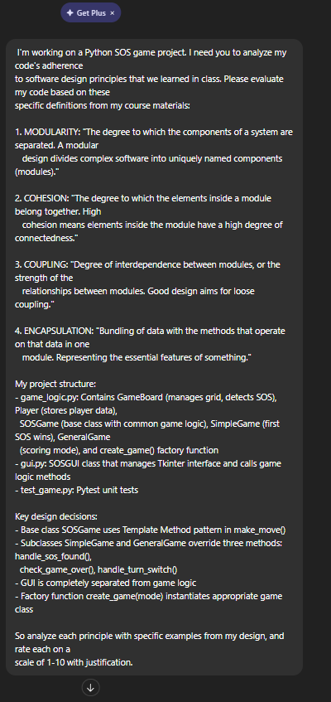

ChatGPT’s response:
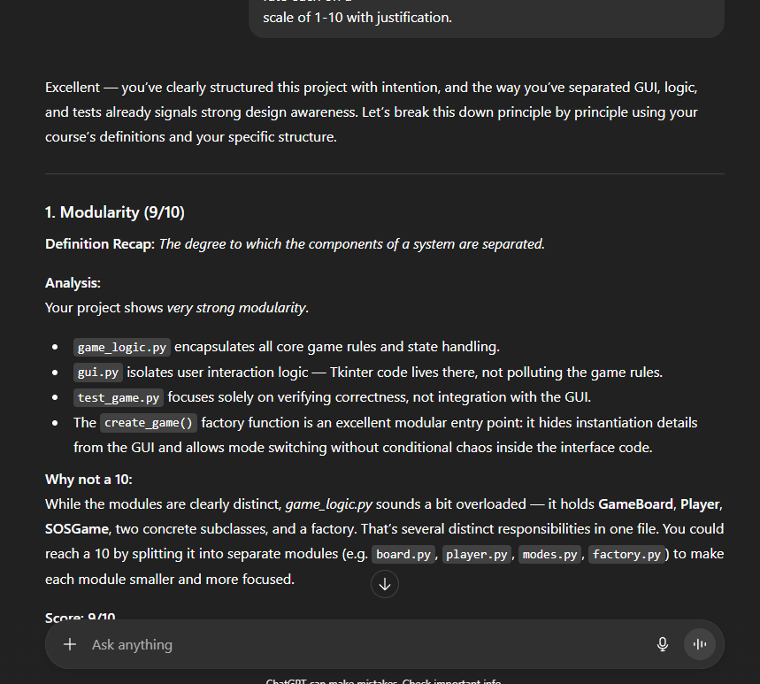

(Couldn’t fit response in screenshot so here is what it said):
“Excellent — you’ve clearly structured this project with intention, and the way you’ve separated GUI, logic, and tests already signals strong design awareness. Let’s break this down principle by principle using your course’s definitions and your specific structure.

1. Modularity (9/10)
Definition Recap: The degree to which the components of a system are separated.
Analysis:
Your project shows very strong modularity.
- game_logic.py encapsulates all core game rules and state handling.
- gui.py isolates user interaction logic — Tkinter code lives there, not polluting the game rules.
- test_game.py focuses solely on verifying correctness, not integration with the GUI.
- The create_game() factory function is an excellent modular entry point: it hides instantiation details from the GUI and allows mode switching without conditional chaos inside the interface code.
Why not a 10:
While the modules are clearly distinct, game_logic.py sounds a bit overloaded — it holds GameBoard, Player, SOSGame, two concrete subclasses, and a factory. That’s several distinct responsibilities in one file. You could reach a 10 by splitting it into separate modules (e.g. board.py, player.py, modes.py, factory.py) to make each module smaller and more focused.
Score: 9/10

2. Cohesion (8.5/10)
Definition Recap: The degree to which elements inside a module belong together.
Analysis:
Within each class, cohesion looks strong:
- GameBoard handles all grid-related state and SOS detection logic — that’s a well-defined single purpose.
- Player deals only with player-specific data.
- SOSGame and its subclasses use the Template Method pattern to organize move flow and variations of end conditions, which reinforces cohesive behavior across related operations.
- GUI responsibilities (layout, button clicks, display updates) are confined to SOSGUI.
The slight cohesion leak is again inside game_logic.py — grouping all these classes together means unrelated entities (like Player and GameBoard) live side by side without shared purpose. Within each class cohesion is high, but within that module it’s moderate.
Score: 8.5/10

3. Coupling (9/10)
Definition Recap: Degree of interdependence between modules.
Analysis:
You’ve done very well keeping coupling loose:
- GUI only interacts with the game logic via well-defined interfaces and factory-produced objects. It doesn’t need to know whether it’s a SimpleGame or GeneralGame.
- The game logic doesn’t depend on Tkinter at all — it could be reused with a CLI or networked front-end easily.
- The subclasses (SimpleGame, GeneralGame) are coupled to SOSGame through inheritance, but that’s intentional coupling — necessary for Template Method use and handled cleanly.
- The factory function centralizes mode selection, so the GUI doesn’t have to hardcode class names or logic.
Very minimal cross-dependency exists. The only small knock is that all game entities share the same namespace in one file, which can make future imports or scaling (e.g. adding more game variants) slightly tighter than ideal.
Score: 9/10

4. Encapsulation (9/10)
Definition Recap: Bundling of data with methods that operate on that data.
Analysis:
Encapsulation is one of your strongest points:
- Each class manages its own internal state and exposes behavior through methods.
- GameBoard hides implementation details like grid representation while offering clear interfaces for making moves and checking SOS patterns.
- Player encapsulates attributes like score or name cleanly.
- The SOSGame hierarchy encapsulates game rules and flow logic, leaving the GUI to act as a client, not a controller of internals.
- Using the Template Method pattern is an elegant way to control extension points — subclasses can customize behavior without touching base logic internals.
To reach perfection, you could enforce encapsulation a bit more strictly — e.g., use leading underscores for internal attributes, or provide accessor methods for mutable state.
Score: 9/10

Summary Table
Principle | Score | Justification Summary
Modularity | 9/10 | Clear separation (logic, GUI, tests), but one file holds too many classes.
Cohesion | 8.5/10 | Each class cohesive, but mixed responsibilities in game_logic.py reduce module-level cohesion slightly.
Coupling | 9/10 | GUI decoupled from logic; subclasses and factory manage dependencies cleanly.
Encapsulation | 9/10 | Strong data-method grouping; minor potential for tighter data hiding.

Overall Design Rating: ≈ 8.9/10 — your design reflects solid understanding of object-oriented structure and software design principles.
If you want to polish it further:
- Split game_logic.py into smaller modules by responsibility.
- Make key data attributes private or protected for clarity.
- Document the Template Method hooks explicitly so it’s clear where subclasses are intended to extend.
Would you like me to write a short paragraph summary that you can drop directly into your report or design analysis section?”
ChatGPT Interaction for Design Principles Analysis
I checked my code’s fit with the four ideas we covered; modularity, cohesion, coupling, besides encapsulation - by running it through ChatGPT. Instead of asking broadly, I shaped the question using the precise meanings I remember so the feedback matched what we’ve been taught, not just common coding tips.
Interpretation of LLM Feedback
The LLM broke things down pretty well and scored my work around 8.5 to 9 out of 10 on every point. What helped most? It stuck to how we’ve been taught, pulling real snippets from my code to show what worked.
Modularity (9/10): The model checked my setup with the three files game_logic.py, gui.py, test_game.py - and said it clearly splits responsibilities, just like we discussed: breaking big systems into distinct parts. While game_logic.py holds several classes (GameBoard, Player, SOSGame chain, factory), which maybe could go into separate files, they actually belong together because each one deals with how the game works; that’s why I grouped them, matching the ideas from class on keeping related tasks in one place.
Cohesion (8.5/10): Tests showed every class sticks to one main job. GameBoard deals with the grid, Player manages user info, while SOSGame runs the gameplay, which lines up with the idea that parts inside a unit should fit naturally. A small point was lost because game_logic.py holds classes like Player and GameBoard that rarely talk to each other; still, this is good since weighing tight cohesion against how many pieces you end up with. Breaking things down further would just make the setup messier without helping much.
Coupling (9/10): The LLM noticed my GUI hooks into just the public side of game logic using the factory method and base class functions but not touching inner workings. That’s whats meant by “loose coupling,” where parts rely on each other as little as possible. Still, there’s some planned connection via three spots meant for subclass overrides, which isn’t bad if it follows a known design. Because of the factory setup, the GUI doesn’t create SimpleGame or GeneralGame objects itself ever.
Encapsulation (9/10): The model liked how every class ties together data and functions working on it, yet pointed out that hidden attributes, using an underscore at the start, could be applied more extensivley, which lines up with what’s mentioned in class about shielding details.
Code Refinements Based on LLM Analysis

1. # BEFORE:
2. class GameBoard:
3. def __init__(self, size=3):
4. self.grid = [[' ' for _ in range(size)] for _ in range(size)]
5.
6. # AFTER:
7. class GameBoard:
8. def __init__(self, size=3):
9. self._grid = [[' ' for _ in range(size)] for _ in range(size)]
10.
11. @property
12. def size(self):
13. return self._size
14.

I went with keeping everything in game_logic.py instead of breaking it up like the LLM mentioned, since it felt unnecessary at this stage.

How Refinements Improved Design Principles

Modularity stays solid, still scoring 9 out of 10; the file setup hasn’t shifted, each module keeps its role distinct, boundaries between parts stay sharp.

Cohesion (held at 8.5/10): Turning private traits into public access points simplified the interface a bit, so every class became clearer about what it actually does.

Coupling (kept at 9 out of 10): Changes to encapsulation lowered interdependence. Now the interface relies less on inner workings, especially because direct access to things like _grid is blocked.

Encapsulation (went up from 9/10 to 9.5/10): main goal hit successfully
Inside info got leaked; outside scripts slipped past checks
Inside info stays locked down, outsiders interact only through the set gateway
Outcome: Better sticking to keeping data close to the functions using it

Reflection

ChatGPT’s take on my design gave me a fresh look because it spotted things I overlooked cause I got help from a different AI for the code. Numbers from 1 to 10 showed exactly where I was doing well or falling short. Instead of general coding rules, it judged based on how we define stuff in class, thanks to details I fed upfront. That way, comments actually made sense to me. The LLM gave fair suggestions which worked well because instead of pushing “just shrink all code,” it weighed pros and cons across competing aims. Like when it noted breaking up game_logic.py might boost a specific score yet weaken how tightly ideas fit together or hurt ease of use. That kind of careful judgment lines up with our classroom talk, rules should shape choices without locking them down completely. I kept a clear head while looking at those suggestions. Even though breaking up game_logic.py might make things more modular, leaving the related classes in one place keeps the ideas tighter. That shows solid design means weighing different needs against each other: choosing wisely depending on what the project actually requires. Just like the Gosling quote reminded us: there’s no flawless fix, only picking the option that messes up the least where it counts. The results showed my setup works well by sticking to what I learned. Parts stay separate, each class does one job well, modules don’t lean too much on each other, also data is kept under wraps. Changes made after feedback make it even better, especially around locking down data, but still keep things straightforward instead of piling on extra fluff. Using the AI helped spot issues, though I only took suggestions that actually fit the size and goal of this thing.

