Hashim Abdulla
Due Date: 11/18/2025 (turned in on the 21st )

Project Sprint #4
The SOS game is described in CS449HomeworkOverview.docx. You should read the description very carefully.

Your submission must include the GitHub link to your project and you must ensure that the instructor has the proper access to your project. You will receive no points otherwise.

GitHub link: https://github.com/HashAbdulla/SOS-Board-game [ALL
DOCUMENTATION/FILES IN THIS REPO]

Implement all the features that support a player (human or computer) to play a simple or general SOS game against another player (human or computer). The minimum features include choosing human or computer for red and/or blue players, choosing the game mode (simple or general), choosing the board size, setting up a new game, making a move (in a simple or general game), and determining if a simple or general game is over. The computer component must be able to play complete simple and general games. You are encouraged to consider basic strategies for winning simple or general games (e.g., against a poor human player). Optimal play is not required.

The following is a sample GUI layout. You must use a class hierarchy to deal with the computer opponent requirements. If your current code has not yet considered class hierarchy, it is time to refactor your code.

SOS Simple game General game Board size
8
Blue player  Human  S  O  Computer | 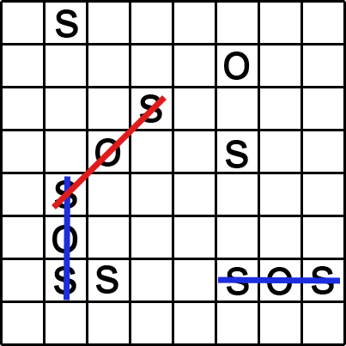 | Red player  Human  S  O  Computer
 | Current turn: blue (or red) | New Game

Figure 1. Sample GUI layout of the working program for Sprint 4
Total points: 24

- Demonstration (8 points)

Submit a link to a video of no more than five minutes, clearly demonstrating that you have implemented the computer opponent features and written some automated unit tests. No points will be given without a video link.
YouTube/Panopto link: https://youtu.be/JQsaNdXwCBw
- A complete simple game where the blue player is a human, the red player is the computer, and there is a winner
- A complete general game where the blue player is the computer, the red player is a human, and there is a winner
- A complete simple game where both sides are played by the computer
- A complete general game where both sides are played by the computer
- Some automated unit tests for the computer opponent.

In the video, you must explain what is being demonstrated.

- User Stories for the Computer Opponent Requirements (1 points)

- User Story Template: As a <role>, I want <goal> [so that <benefit>]

ID | User Story Name | User Story Description | Priority | Estimated effort (hours)
8 | Select player types | As a game player, I want to choose whether Blue and Red players are human or computer so that I can play against AI or watch AI vs AI games | High | 2
9 | Computer makes valid moves | As a game player, I want the computer to automatically make valid moves so that the game progresses without my input for computer players | High | 4
10 | Computer plays simple game | As a game player, I want the computer to play complete simple games following the first-SOS-wins rule so that I can play or watch simple mode games | High | 3
11 | Computer plays general game | As a game player, I want the computer to play complete general games with scoring so that I can play or watch general mode games with proper strategy | High | 3
12 | Computer uses basic strategy | As a game player, I want the computer to attempt winning moves when possible so that games are challenging and interesting | Medium | 4

- Acceptance Criteria (AC) for the Computer Opponent Requirements (4 points)
Add or delete rows as needed.

User Story ID and Name | AC ID | Description of Acceptance Criterion | Status (completed,toDo,inPprogress)
8. Select player types | 8.1 | AC 8.1 Select Blue player as Human  Given: Game setup screen is displayed  When: User selects “Human” radio button for Blue player  Then: Blue player should be controlled by user clicking cells | Complete
 | 8.2 | AC 8.2 Select Blue player as Computer  Given: Game setup screen is displayed  When: User selects “Computer” radio button for Blue player  Then: Blue player moves should be automated | Complete
 | 8.3 | AC 8.3 Select Red player as Human  Given: Game setup screen is displayed  When: User selects “Human” radio button for Red player  Then: Red player should be controlled by user clicking cells | Complete
 | 8.4 | AC 8.4 Select Red player as Computer  Given: Game setup screen is displayed  When: User selects “Computer” radio button for Red player  Then: Red player moves should be automated | Complete
9. Computer makes valid moves | 9.1 | AC 9.1 Computer selects empty cell  Given: It is computer player’s turn  When: Computer makes a move  Then: Computer should place letter only in empty cells | Complete
 | 9.2 | AC 9.2 Computer selects S or O  Given: It is computer player’s turn  When: Computer makes a move  Then: Computer should place either ‘S’ or ‘O’ on the board | Complete
 | 9.3 | AC 9.3 Computer move triggers automatically  Given: It is computer player’s turn and game is not over  When: Previous move completes  Then: Computer should make its move within 1 second automatically | Complete
10. Computer plays simple game | 10.1 | AC 10.1 Computer recognizes simple game rules  Given: Simple game mode with computer player  When: Computer forms first SOS  Then: Game should end with computer as winner | Complete
 | 10.2 | AC 10.2 Computer plays until game ends  Given: Simple game with computer player(s)  When: Game is in progress  Then: Computer should continue making moves until game ends (SOS formed or board full) | Complete
11. Computer plays general game | 11.1 | AC 11.1 Computer scores points in general game  Given: General game mode with computer player  When: Computer forms SOS  Then: Computer’s score should increase by number of SOS formed | Complete
 | 11.2 | AC 11.2 Computer takes extra turn after SOS  Given: General game with computer player  When: Computer forms SOS  Then: Computer should immediately take another turn | Complete
 | 11.3 | AC 11.3 Computer plays until board full  Given: General game with computer player(s)  When: Game is in progress  Then: Computer should continue until board is completely filled | Complete
12. Computer uses basic strategy | 12.1 | AC 12.1 Computer detects winning moves  Given: Computer’s turn with available winning move  When: Computer analyzes board  Then: Computer should identify and make move that forms SOS | Complete
 | 12.2 | AC 12.2 Computer blocks opponent wins (optional)  Given: Computer’s turn with opponent one move from winning in Simple mode  When: Computer analyzes board  Then: Computer may attempt to block opponent’s winning opportunity | Complete
 | 12.3 | AC 12.3 Computer prefers scoring moves in General  Given: General game computer turn  When: Multiple valid moves available  Then: Computer should prefer moves that form SOS over random moves | Complete

- Summary of All Source Code (1 points)

Source code file name | Production code or test code? | # lines of code
game_logic.py | Production | 444
gui.py | Production | 395
test_game.py | Test | 1019
Total |  | 1858

- Production Code vs New User stories/Acceptance Criteria (2 points)

Summarize how each of the new user story/acceptance criteria is implemented in your production code (class name and method name etc.)

User Story ID and Name | AC ID | Class Name(s) | Method Name(s) | Status (complete or not) | Notes (optional)
8. Select player types | 8.1 | HumanPlayer, SOSGUI | __init__(), on_cell_click() | Complete | HumanPlayer created via factory, moves via GUI clicks
 | 8.2 | ComputerPlayer, SOSGUI | __init__(), make_move(), schedule_computer_move() | Complete | ComputerPlayer created via factory, moves automated
 | 8.3 | HumanPlayer, SOSGUI | __init__(), on_cell_click() | Complete | Same as 8.1 for Red player
 | 8.4 | ComputerPlayer, SOSGUI | __init__(), make_move(), schedule_computer_move() | Complete | Same as 8.2 for Red player
9. Computer makes valid moves | 9.1 | ComputerPlayer | make_move(), get_valid_moves() | Complete | Filters board for empty cells only
 | 9.2 | ComputerPlayer | make_move(), choose_letter() | Complete | Randomly selects ‘S’ or ‘O’
 | 9.3 | SOSGUI | schedule_computer_move(), execute_computer_move() | Complete | Uses root.after(500ms) for automated moves
10. Computer plays simple game | 10.1 | ComputerPlayer, SimpleGame | make_move(), find_winning_move(), handle_sos_found() | Complete | Computer detects and makes winning moves
 | 10.2 | ComputerPlayer, SOSGUI | make_move(), schedule_computer_move() | Complete | Loop continues until game_over==True
11. Computer plays general game | 11.1 | ComputerPlayer, GeneralGame | make_move(), find_scoring_move(), handle_sos_found() | Complete | Computer’s score increments via parent add_score()
 | 11.2 | ComputerPlayer, GeneralGame | make_move(), handle_turn_switch() | Complete | Computer retains turn when sos_found==True
 | 11.3 | ComputerPlayer, SOSGUI | make_move(), schedule_computer_move() | Complete | Continues until board.is_board_full()
12. Computer uses basic strategy | 12.1 | ComputerPlayer | find_winning_move(), simulate_move() | Complete | Checks all empty cells for SOS-forming moves
 | 12.2 | ComputerPlayer | find_blocking_move(), simulate_move() | Complete | In Simple mode, checks opponent’s potential wins
 | 12.3 | ComputerPlayer | find_scoring_move() | Complete | Prioritizes SOS-forming moves in General mode

- Tests vs New User stories/Acceptance Criteria (2 points)
Summarize how each of the new user story/acceptance criteria is tested by your test code (class name and method name) or manually performed tests.

6.1 Automated tests directly corresponding to some acceptance criteria

User Story ID and Name | Acceptance Criterion ID | Class Name (s) of Test Code | Method Name(s) of the Test Code | Description of the Test Case (input & expected output)
8 Select player types | 8.1 | TestPlayerFactory | test_create_human_player | Input: create_player("Human", "Blue", "blue")  Expected: Returns HumanPlayer instance
8 Select player types | 8.2 | TestPlayerFactory | test_create_computer_player | Input: create_player("Computer", "Red", "red")  Expected: Returns ComputerPlayer instance
9 Computer makes valid moves | 9.1 | TestComputerPlayer | test_computer_makes_valid_move | Input: Computer move on partially filled board  Expected: Move placed only in empty cell
9 Computer makes valid moves | 9.2 | TestComputerPlayer | test_computer_chooses_s_or_o | Input: Computer makes 20 moves  Expected: All moves are either 'S' or 'O'
10 Computer plays simple game | 10.1 | TestComputerSimpleGame | test_computer_wins_simple_game | Input: Setup board where computer can win  Expected: Computer forms SOS and game ends
10 Computer plays simple game | 10.2 | TestComputerSimpleGame | test_computer_plays_complete_simple_game | Input: Computer vs Computer simple game  Expected: Game reaches completion (win or draw)
11 Computer plays general game | 11.1 | TestComputerGeneralGame | test_computer_scores_in_general_game | Input: Computer forms SOS in general game  Expected: Computer's score increases by 1
11 Computer plays general game | 11.2 | TestComputerGeneralGame | test_computer_extra_turn_after_sos | Input: Computer forms SOS  Expected: current_player unchanged
11 Computer plays general game | 11.3 | TestComputerGeneralGame | test_computer_plays_until_board_full | Input: Computer vs Computer general game  Expected: Game ends when board.is_board_full()
12 computer uses basic strategy | 12.1 | TestComputerStrategy | test_computer_detects_winning_move | Input: Board with one move to SOS  Expected: Computer selects that exact move
12  computer uses basic strategy | 12.2 | TestComputerStrategy | test_computer_blocks_opponent_simple | Input: Opponent one move from win in Simple  Expected: Computer blocks or makes own SOS
12  computer uses basic strat | 12.3 | TestComputerStrategy | test_computer_prefers_scoring_moves | Input: Board with scoring and non-scoring moves  Expected: Computer selects scoring move

6.2 Manual tests directly corresponding to some acceptance criteria

User Story ID and Name | Acceptance Criterion ID | Test Case Input | Test Oracle  (Expected Output) | Notes
8 select player types | 8.1 to 8.4 | Start game, set Blue=Human, Red=Computer | Blue waits for clicks, Red moves auto | Player type selection works
9 Computer makes valid moves | 9.3 | Set both players to Computer | Moves alternate automatically every ~500ms | Automated timing works
10Computer plays simple game | 10.2 | Computer vs Computer simple 3x3 | Game completes in <30 moves | Full game completion
11 Computer plays general game | 11.3 | Computer vs Computer general 4x4 | Game ends when all 16 cells filled | Board full detection
12 Computer uses basic strategy | 12.1 | Setup winning opportunity for computer | Computer makes winning move | Strategy works visually

6.3 Other automated or manual tests not corresponding to the acceptance criteria

Number | Test Input | Expected Result | Class Name of the Test Code | Method Name of the Test Code
1 | Computer player inherits from Player | Computer has name, color, score attributes | TestComputerPlayer | test_computer_player_inheritance
2 | Human player inherits from Player | Human has name, color, score attributes | TestHumanPlayer | test_human_player_inheritance
3 | Invalid player type to factory | ValueError raised | TestPlayerFactory | test_create_invalid_player_type
4 | Computer makes 100 consecutive moves | All moves valid, no crashes | TestComputerPlayer | test_computer_reliability
5 | Mixed human/computer simple game | Game progresses correctly | TestMixedGame | test_human_vs_computer_simple
6 | Mixed human/computer general game | Scores tracked correctly | TestMixedGame | test_human_vs_computer_general

- Present the class diagram of your production code (3 points) and describe how the class hierarchy in your design deals with the computer opponent requirements (3 points)?
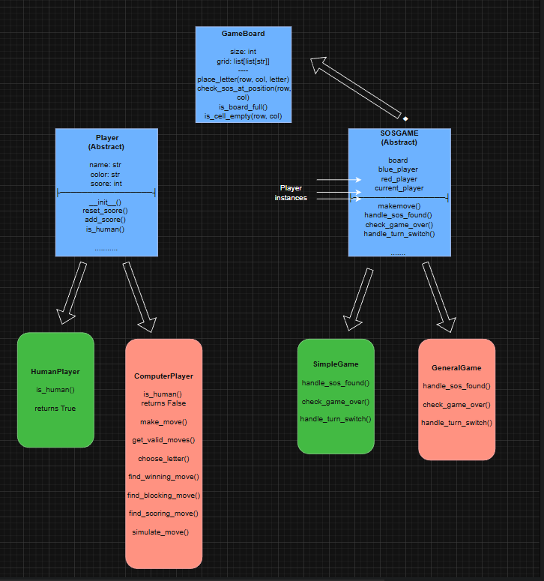

(made in draw.io)

In Sprint 4, I built on the current setup by adding a Player class system that handles humans and computer opponents. Instead of mixing actions into the main rules, behaviors are kept separate using a flexible approach like plugging in different styles without changing core code.

Player Hierarchy Implementation
The Player abstract base class sets up the shared structure:
- Name, color, and score are common across every kind of player
- Ways to handle points: reset_score() and add_score(), both work the same no matter which type you use
- Abstract Method: is_human() - makes child classes confirm what they are
HumanPlayer and ComputerPlayer inherit from Player:
- HumanPlayer: Returns True when checking if it's human. Picking moves works through clicking on screen, that's why no extra functions are required.
- ComputerPlayer: Returns False when you check is_human(). Uses smart thinking inside through actions like make_move(), find_winning_move(), find_blocking_move(), and simulate_move(). Holds a link to the SOSGame so it can study the current board setup.

Integration with Game Hierarchy
The SOSGame base class got tweaked so it can take any Player subclass instead:
- set_players(blue_player, red_player) swaps fixed player setup
- Game rules handle every player the same way using the Player setup
- blue_player alongside red_player might mix in any way: Human-Human, Human-Computer, or Computer-Computer
This sets up two side-by-side layers:
- Game Mode Hierarchy: SOSGame -> SimpleGame / GeneralGame (what rules to apply)
- Player Type Hierarchy: Player -> HumanPlayer / ComputerPlayer (who is playing)

Computer AI Strategy
ComputerPlayer.make_move() uses a system that picks moves by what matters most:
- First thing: find_winning_move() checks if any move makes an SOS - ends the game in Simple mode or earns points in General mode
- Second focus: find_blocking_move() in Simple mode only - stops rival's winning chance
- Priority 3: find_scoring_move() when in General mode, it looks for actions that grab points
- Pick any legal action if nothing else works
The simulate_move() function puts letters on the board for a moment, sees if an SOS forms, then reverts everything back - so the AI tries moves safely. While testing, it doesn't mess up the actual game setup; each check runs in isolation. After every trial, the board looks just like before, no changes stuck. Because of this reset trick, choices are explored freely, without lasting impact.

Factory Pattern Usage
Two factory functions handle object creation in one spot to keep things focused yet flexible by design:
- create_player(type, name, color, game) -> Returns HumanPlayer or ComputerPlayer
- create_game(mode) -> Returns SimpleGame or GeneralGame
This hides setup steps from the interface, so expanding features like slotting in an "ExpertComputerPlayer" means tweaking just the factory plus one extra class.

Design Principles
- Encapsulation: Wrapping up all AI smarts inside ComputerPlayer so the main game code stays clueless about move choices
- Polymorphism: Lets GUI and game classes work through the Player interface so that different player kinds fit together without issues
- Separation of Concerns: Keeping things apart - how players act depends on them alone, while what happens follows its own logic, yet showing it works separately from both
- Open/Closed Principle: New player types can be added without modifying existing SOSGame or GUI code

Extensibility for Sprint 5
This setup lets you capture or play back actions since it's built right in:
- Moves get recorded like this: (player, row, col, letter, timestamp) - all packed into one group
- A ReplayPlayer type might pull data from past moves
- Player kind - human or computer - gets saved in the recordings
- Game rules stay the same - simply plays back stored moves
The two-level setup keeps the game rules apart from the players, so things stay organized and easier to update.

