Configure the Hadoop/hdfs-site.xml

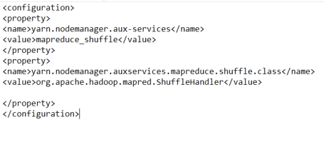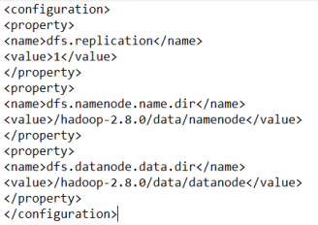

Open CMD and change the Directory for the Access