import numpy as np

import matplotlib.pyplot as plt

# Compute the x and y coordinates for points on a sine curve x = np.arange(0, 3 * np.pi, 0.1)

y = np.sin(x)

plt.title("sine wave form")

# Plot the points using matplotlib

plt.plot(x, y)

plt.show()

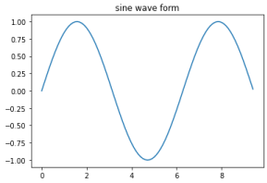

import matplotlib.pyplot as plt

import numpy as np

import pandas as pd

# Plotting a Line

plt.plot([1,2,3,4], [1,2,3,4])

plt.xlabel('Some numbers')

plt.ylabel('Some more numbers')

plt.show()

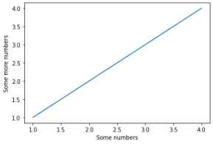

#Plotting using X axis only

plt.plot([4,3,8,9])

plt.xlabel('Some numbers')

plt.ylabel('Some more numbers')

plt.show()

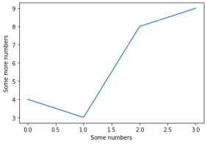

#Plotting with Tweaking Colors and Symbols plt.plot([1,2,6,8], [9,16,2,3], 'c')

plt.xlabel('Some numbers')

plt.ylabel('Some more numbers')

plt.show()

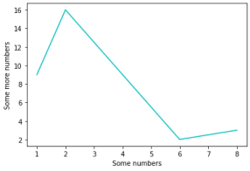

plt.plot([1,2,6,8], [9,16,2,3], 'm+')

plt.xlabel('Some numbers')

plt.ylabel('Some more numbers')

plt.show()

#Red dashes, blue squares and green triangles t = np.arange(0., 5., 0.2) 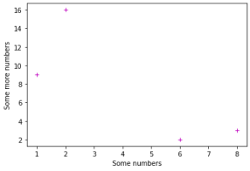

plt.plot(t, t, 'r--', t, t**2, 'bs', t, t**3, 'g^') plt.show()

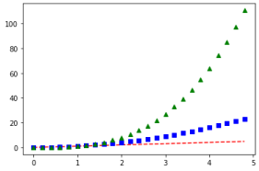

#By using Formula

data = np.arange(0, 10, 0.5)

y = 1 * data + 5

plt.plot(data, y, '*')

plt.show()

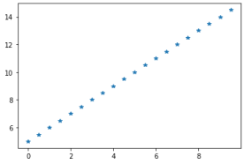

#Plotting with Categorical Data

names = ['GroupA', 'GroupB', 'GroupC']

values = [1, 10, 100]

plt.figure(1, figsize=(10,4))

plt.subplot(131)

plt.bar(names, values)

plt.subplot(132)

plt.scatter(names,values)

plt.subplot(133)

plt.plot(names, values)

plt.suptitle('Categorical Plotting')

plt.show()

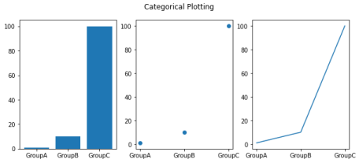

#Plotting over 3D Axes

import matplotlib as mpl

from mpl_toolkits.mplot3d import Axes3D

mpl.rcParams['legend.fontsize'] = 10

fig = plt.figure()

ax = fig.add_subplot(111, projection='3d')

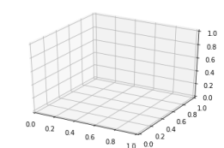

#Parametric Curve

mpl.rcParams['legend.fontsize'] = 10

fig = plt.figure()

ax = fig.gca(projection='3d')

theta = np.linspace(-4 * np.pi, 4 * np.pi, 100)

z = np.linspace(-2, 2, 100)

r = z**2 + 1

x = r * np.sin(theta)

y = r * np.cos(theta)

ax.plot(x, y, z, label='Parametric Curve')

ax.legend()

plt.show()

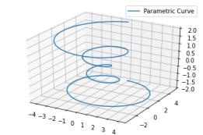

#Subplots of Sine and Cosine

x = np.arange(1, 5 * np.pi, 0.01)

y = np.sin(x)

plt.title('Sine Wave')

plt.plot(x, y)

plt.show()

x = np.arange(0, 3* np.pi, 0.1)

y_sin = np.sin(x)

y_cos = np.cos(x)

plt.subplot(1, 2, 1)

plt.plot(x, y_sin)

plt.title('Sine Wave')

plt.subplot(1, 2, 2)

plt.plot(x, y_cos)

plt.title('Cosine Wave')

plt.suptitle('Waveforms')

plt.show()

x1 = [5, 8, 10] 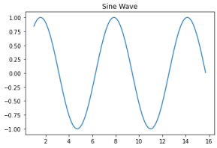

y1 = [12, 16, 6]

x2 = [6, 9, 11]

y2 = [6, 15, 7]

plt.bar(x1, y1, color = 'b')

plt.bar(x2, y2, color = 'g', align='center') plt.title('Bar Graph')

plt.ylabel('Y Axis') 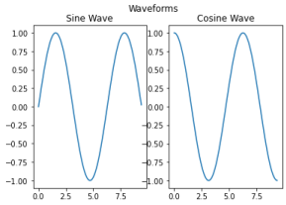

plt.xlabel('X Axis')

plt.show()

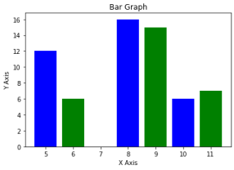

import matplotlib.pyplot as plt

# x-coordinates of left sides of bars

left = [1, 2, 3, 4, 5]

# heights of bars

height = [10, 24, 36, 40, 5]

# labels for bars

tick_label = ['one', 'two', 'three', 'four', 'five']

# plotting a bar chart

plt.bar(left, height, tick_label = tick_label, width = 0.8, color = ['red', 'green'])

# naming the x-axis

plt.xlabel('x - axis')

# naming the y-axis

plt.ylabel('y - axis')

# plot title

plt.title('My bar chart!')

# function to show the plot

plt.show()

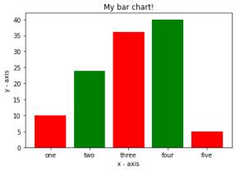

Colab paid products - Cancel contracts here

check 0s completed at 4:03 PM