Install Suggested plugins
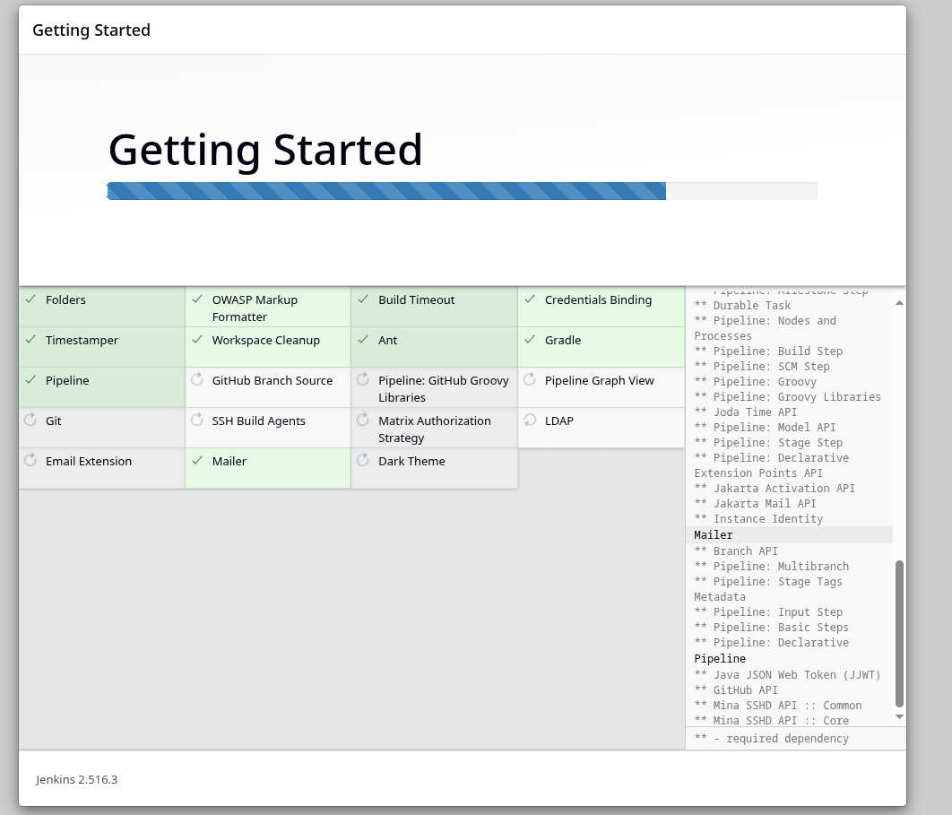
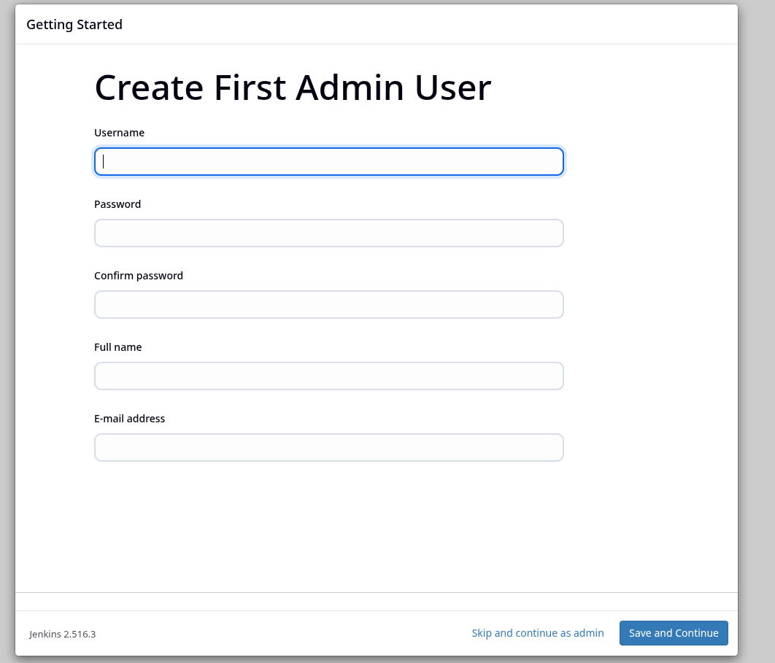
Create user
Save and finish after creating user
in nodes go to build in nodes and make number of executors 0.
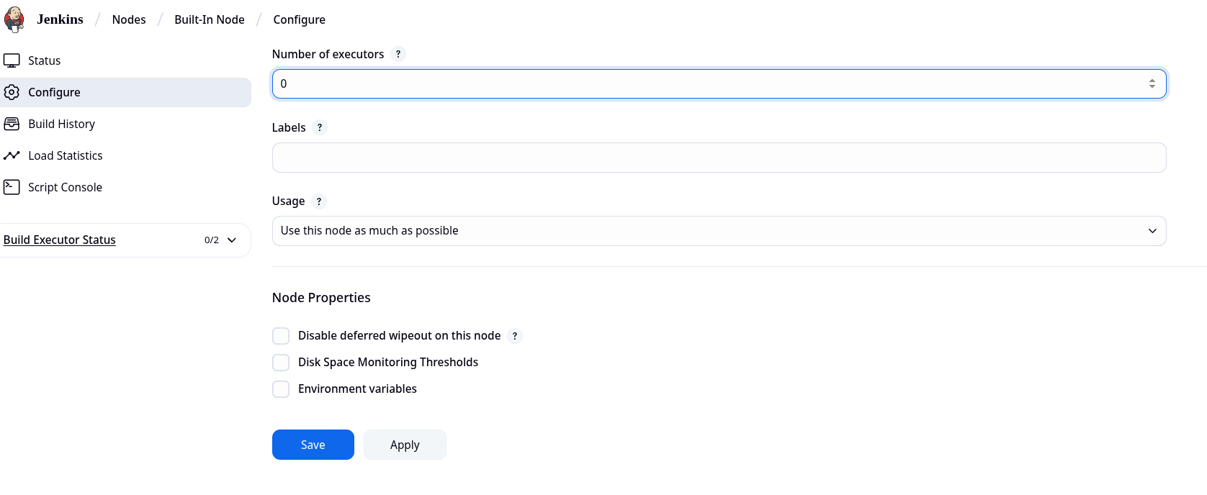
Make a new node called jenkins-agent – should be a permanent node

Configurations of the Node

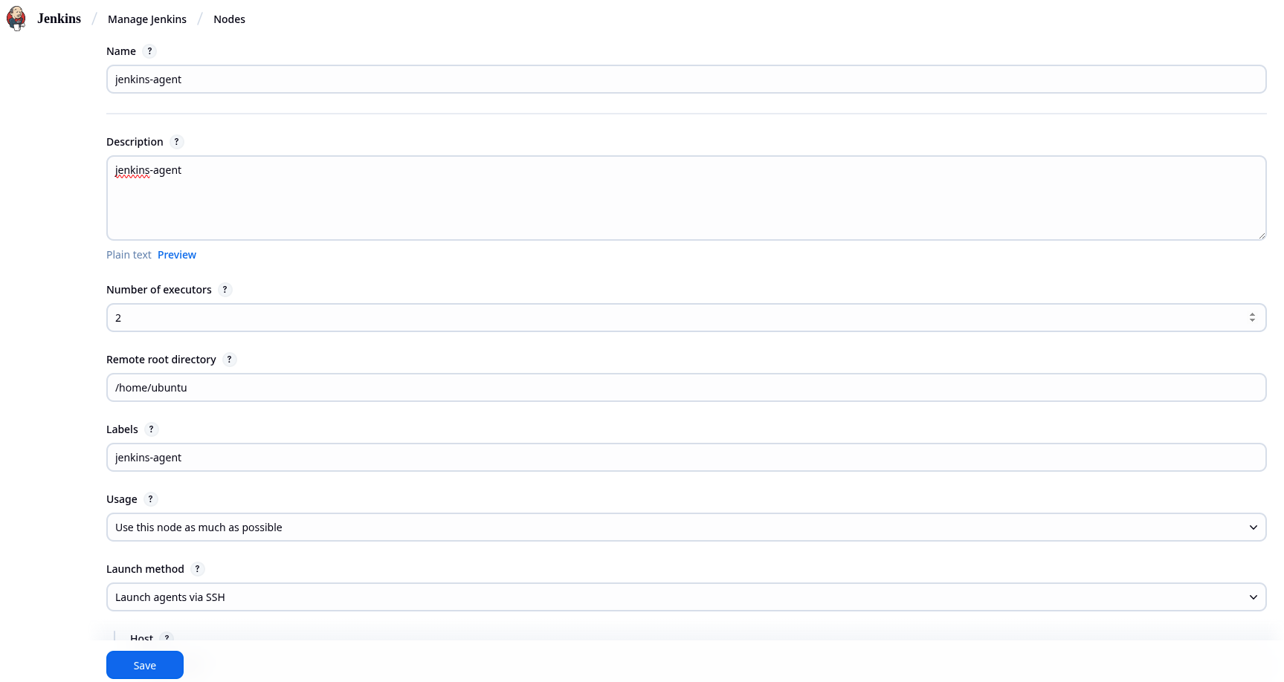
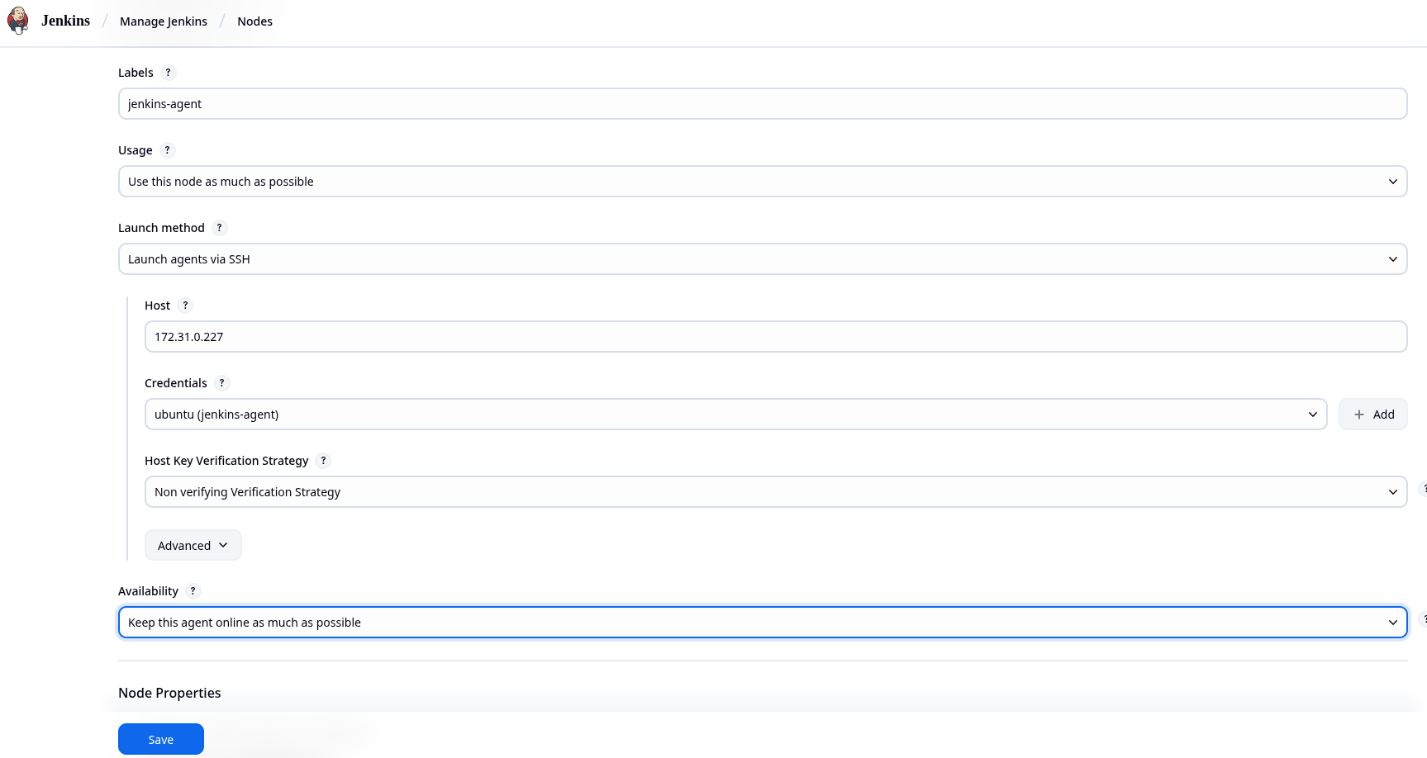

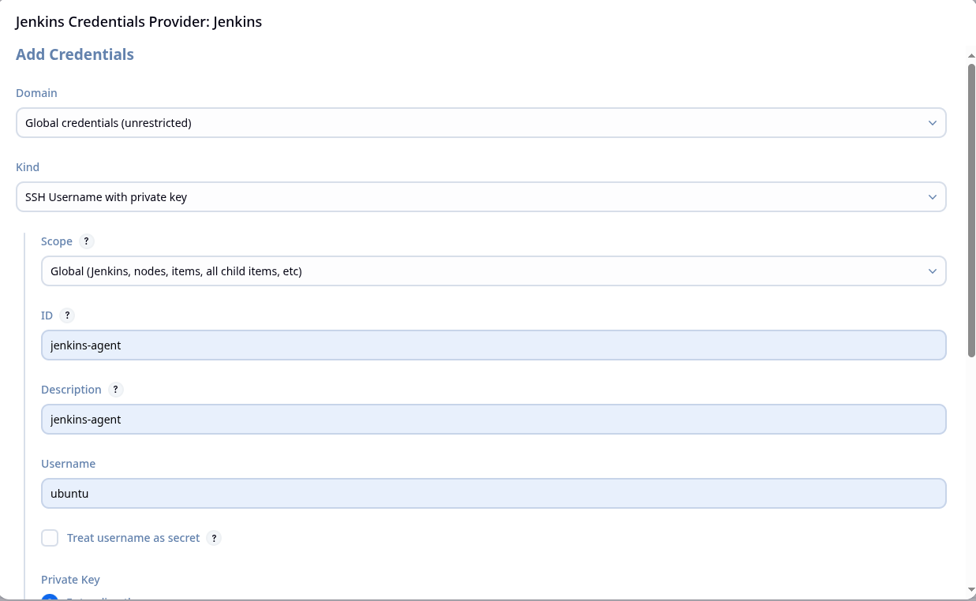
Credentials Configuration , click on add +

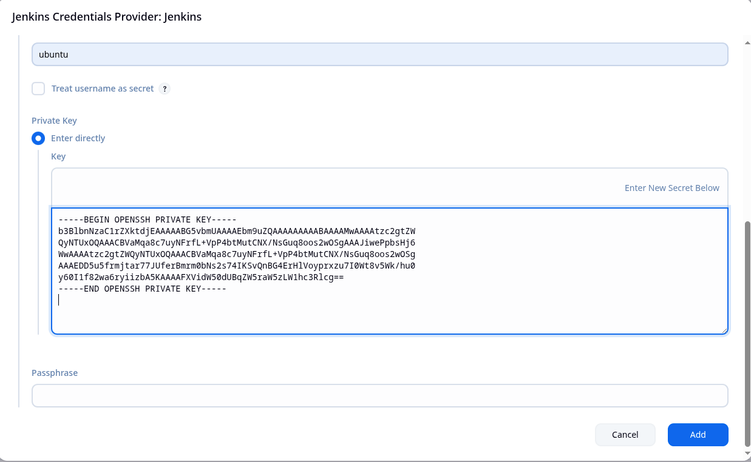
Enter the private ssh key from the jenkins-master instance
Click refresh and make sure agent is added
