After logging into sonar qube create a token like this

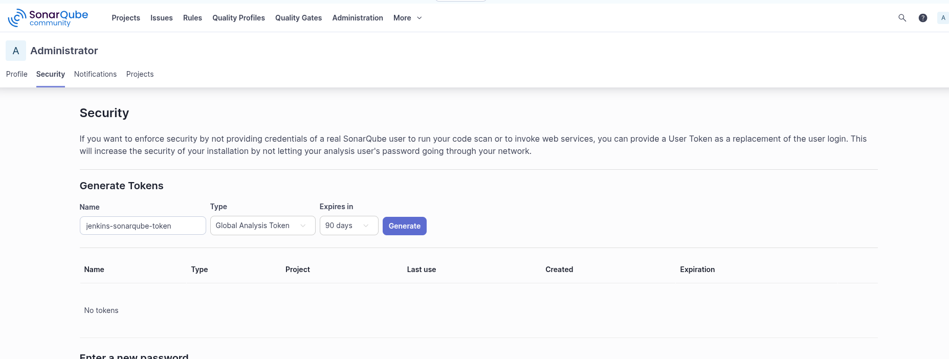

Go to jenkins credentials and add another global secret

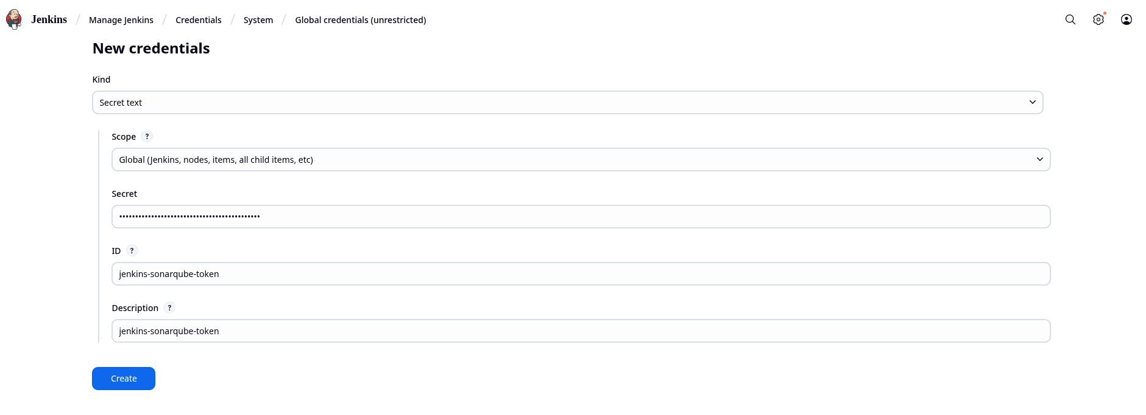

Install plugins in jenkins

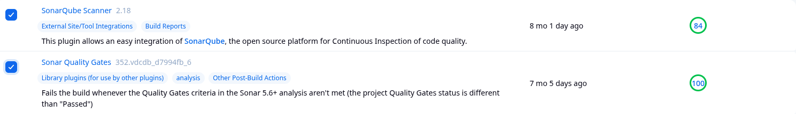

Make sure you click on restart jenkins

Now go to manage jenkins then into system scroll to SonarQube Installations.

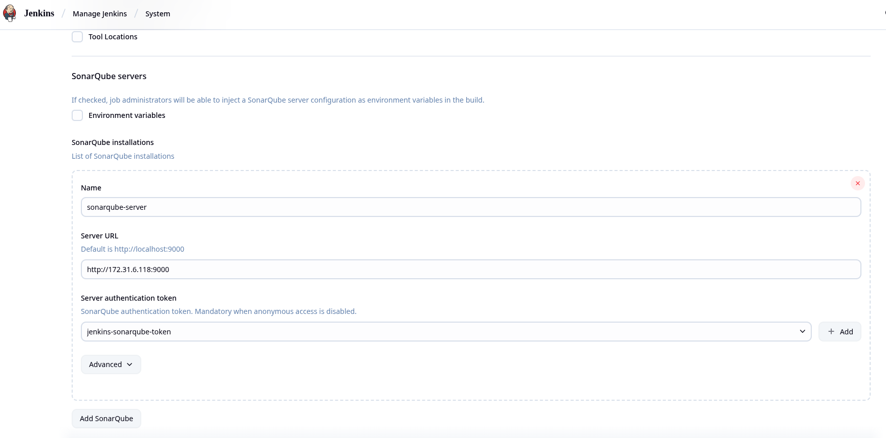

Write the private IP address of the sonarqube if both instances are in the same vpc if not give the public IP address instead

Now we will put the sonarqube scanner in jenkins

Head to tools in jenkins and scroll to sonarqube scanner installations

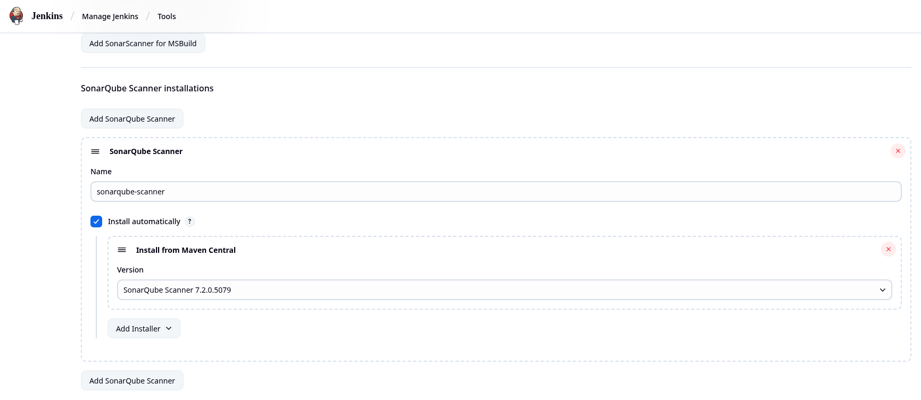

After doing all this run build and it should be successful

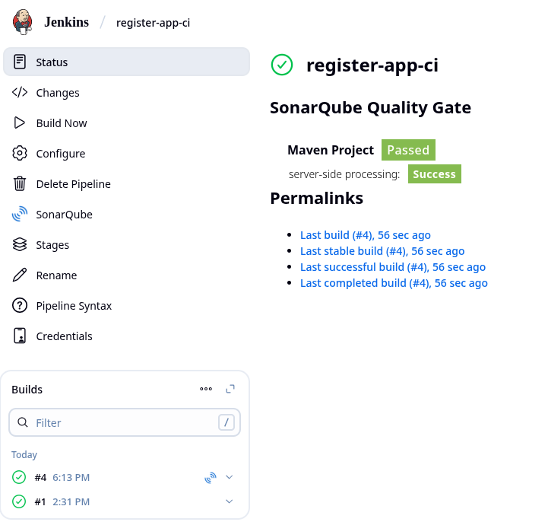

SonarQube success

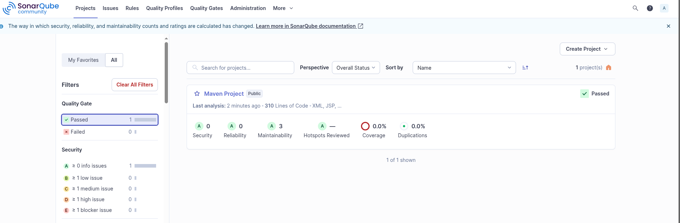

Now we will make the sonarqube webhook

Go to administration and then click on configuration drop down and click on webhooks

make web with these configurations , note the IP address here is the Jenkins master instance private address

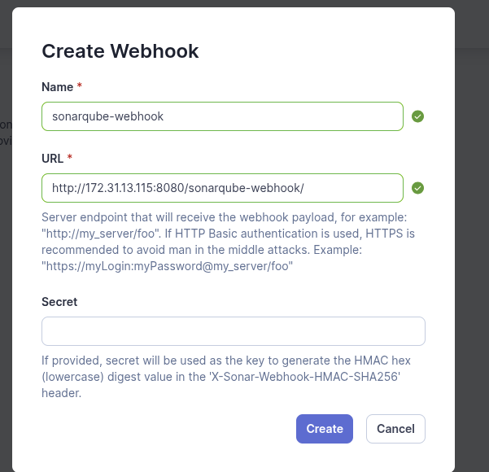

There is a check for this in the jenkins file.