Telnet命令行详解

Telnet Command line details

NPDU提供Telnet二次开发接口，需要使用第三方工具或者自己编写软件，通过输入指令返回数据；

NPDU provides telnet two development interface, requires third party tools, or writes software on its own, and returns data through input instructions.

以下内容全部是通过putty.exe工具登陆截图；

All of the following is a screenshot of landing through the putty.exe tool

首先打开putty.exe工具

First open the putty.exe tool

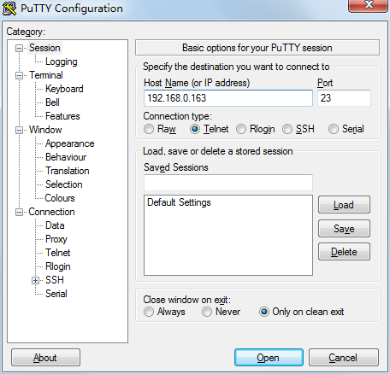

输入NPDU 设备IP地址，选择Telnet ，点击按钮Open

Enter the npdu device IP address, select telnet, and click the button open

打开如下图所示：

Open as shown in the following figure:

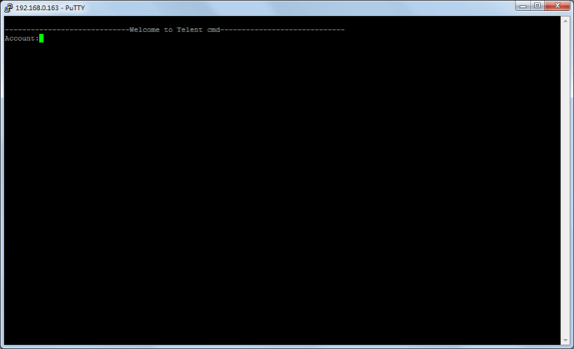

在WEB中，配置Telnet账号密码，重启设备，重新登陆即可；

In web, configure the telnet account password, restart the device, re-login can;

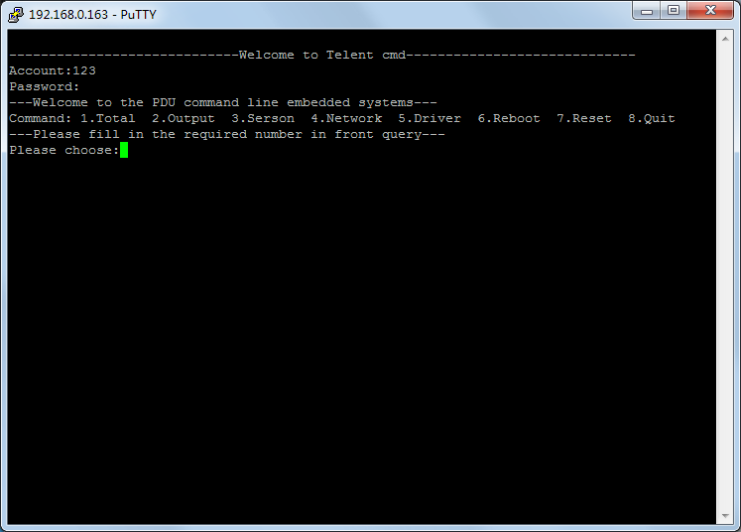

Telnet 指令有 Total Output Serson Network Driver Reboot Reset Quit

The telnet directive has the total output serson network driver reboot reset quit

1. Total指令 total instruction

|  |  |  |  |
| --- | --- | --- | --- |
| 步骤  step | 输入  input | 显示截图  Display screenshots | 注意项  Attention item |
| 选择  Select  Total | 1 回车  enter |  |  |
| 选择主机或者副机Select host or sub-computer | 1 回车  enter |  | 查看主机输入1  View host input 1  查看副机输入  2-5View secondary input 2-5  2为副机1  2 for sub-machine 1  5为副机4  5 is secondary 4 |
| 选择查看第一相信息  Select View First Phase Information | 1 回车  enter |  | 查看第一相  输入1View first phase input 1  查看第二相  输入2View second phase input 2  查看第三相  输入3View third phase input 3 |
| 查看结果  View the results | | PHASE-1 第一相信息First phase information  Voltage:201.9V[0-276] 总电压：201.9V[阀值0（最小值）-276（最大值）]  Total voltage: 201.9v[threshold 0 (minimum) -276 (max)  Currect:0.0A[0-32] 总电流：0.0A[阀值0（最小值）-32（最大值）]  Total current: 0.0a [threshold 0 (minimum value) -32 (maximum)]  Power：0.0W 总功率：0.0WTotal power: 0.0w  PF:0.00 功率因素：0.00Power factor: 0.00  Energy:0.0KWh 总电能:0.0KWhTotal electric energy: 0.0kwh | |

注：每一级菜单0为退出当前菜单，返回上一次菜单；

Note: each level menu 0 returns the previous menu to exit the current menu

1. Output指令 2n output instruction

2.1）查询输出单元Query output unit

|  |  |  |  |
| --- | --- | --- | --- |
| 步骤  step | 输入  enter | 显示截图Display screenshots | 注意项  Attention item |
| 选择Output  Select output | 2 回车  enter |  |  |
| 选择主机或者副机  Select host or sub-computer | 1 回车  enter |  | 查看主机输入1  View host input 1  查看副机输入2-5  View secondary input 2-5  2为副机1  2 for sub-machine 1  5为副机45 is secondary 4 |
| 选择状态Status  Select status | 1 回车  enter |  | 1为状态  1 as a state  2为控制  2 for control |
| 选择需要查询的输出单元编号Select the output unit number that you want to query | 1 回车  enter |  | 1为输出单元1  1 for output unit 1  24为输出单元24  24 is the output unit 24  请根据具体PDU单元数量选择Select according to the number of specific pdu units |
| 查看结果  View the results | | Output1 输出单元1Output unit 1  Status：1[1-OFF 2-ON] 状态：1[1为关闭，2为开启]State: 1 [1 is closed / 2 is on]  Currect: 0.0A[0-10] 电流：0.0A[阀值0（最小值）-10（最大值）]  Current: 0.0a [threshold 0 (minimum value) -10 (maximum)]  Energy:0.0KWh 电能：0.0 KWhElectric energy: 0.0 kwh | |

2.2）控制输出单元 Control output unit

|  |  |  |  |
| --- | --- | --- | --- |
| 步骤  step | 输入  enter | 显示截图Display screenshots | 注意项  Attention item |
| 选择Output  Select output | 2 回车  enter |  |  |
| 选择主机或者副机  Select host or sub-computer | 1 回车  enter |  | 查看主机输入1  View host input 1  查看副机输入2-5  View secondary input 2-5  2为副机1  2 for sub-machine 1  5为副机45 is secondary 4 |
| 选择状态Switch  Select status switch | 2 回车  enter |  | 1为状态  1 as a state  2为控制  2 for control |
| 选择需要查询的输出单元编号Select the output unit number that you want to query | 1 回车  enter |  | 1为输出单元1  1 for output unit 1  24为输出单元24  24 is the output unit 24  请根据具体PDU单元数量选择  Select according to the number of specific pdu units |
| 选择关门输出单元Selective closing output unit | 1 回车  enter |  | 1为关闭  1 for closing  2为开启  2 for opening  3位循环  3-bit cycle |
| 查看结果  View the results | | 输出单元发出关闭命令The output unit sends out the shutdown command | |

、

1. Serson指令serson instruction

|  |  |  |  |
| --- | --- | --- | --- |
| 步骤  step | 输入  entry | 显示截图Display screenshots | 注意项  Attention item |
| 选择Serson  Select serson | 3 回车  enter |  |  |
| 选择主机或者副机  Select host or sub-computer | 1 回车  enter |  | 查看主机输入1  View host input 1  查看副机输入2-5  View secondary input 2-5  2为副机1  2 is a vice machine 1  5为副机4  5 is secondary 4 |
| 选择查看温度  Select view temperature | 1 回车  enter |  | 1为温度  1 for temperature  2为湿度  2 humidity  3为门禁3 for entrance control  4为烟雾4 smoke  5为水浸5 is water - immersed |
| 查看结果View the results | | Temperature1:25.6[0-40] 温度1:25.6[阀值0（最小值）-40（最大值）]  Temperature 1: 25.6 [threshold 0 (minimum value -40)  Temperature2:25.7[0-40] 温度2:25.7[阀值0（最小值）-40（最大值）]  Temperature 2: 25.7 [threshold 0 (minimum value -40)  Temperature3:0.0[0-40] 温度3:0.0[阀值0（最小值）-40（最大值）]  Temperature 3: 0.0 [threshold 0 (minimum value -40)  Temperature4:0.0[0-40] 温度4:0.0[阀值0（最小值）-40（最大值）]  Temperature 4: 0.0 [threshold 0 (minimum value -40) | |

1. Network

|  |  |  |  |
| --- | --- | --- | --- |
| 步骤  step | 输入  entry | 显示截图Display screenshots | 注意项  Attention item |
| 选择Network  Select network | 4 回车  enter |  |  |
| 选择主机或者副机  Select host or sub-computer | 1 回车  enter |  | 1为IPV4  1 is ipv4 |
| 查看结果  View the results | | Driver IP：192.168.0.163 设备IP地址：192.168.0.163  Subnet Mask:255.255.255.0 子网掩码：255.255.255.0  GateWay:192.168.0.1 网关：192.168.0.1 | |

1. 设备名字5, device name

|  |  |  |  |
| --- | --- | --- | --- |
| 步骤  step | 输入  entry | 显示截图Display screenshots | 注意项Attention item |
| 选择Network  Select network | 4 回车  enter |  |  |
| 选择主机或者副机Select host or sub-computer | 1 回车  enter |  | 1为名字  1 as the name |
| 查看结果View the results | | 设备名称：pdu Device name: PDU | |

1. Reboot

设备重启命令Device restart command

1. Reset

设备恢复出厂设置命令Equipment recovery Factory setup order

1. Quit

退出命令exit command