**Learning Management System – Back Office Module**

**Login Screen**

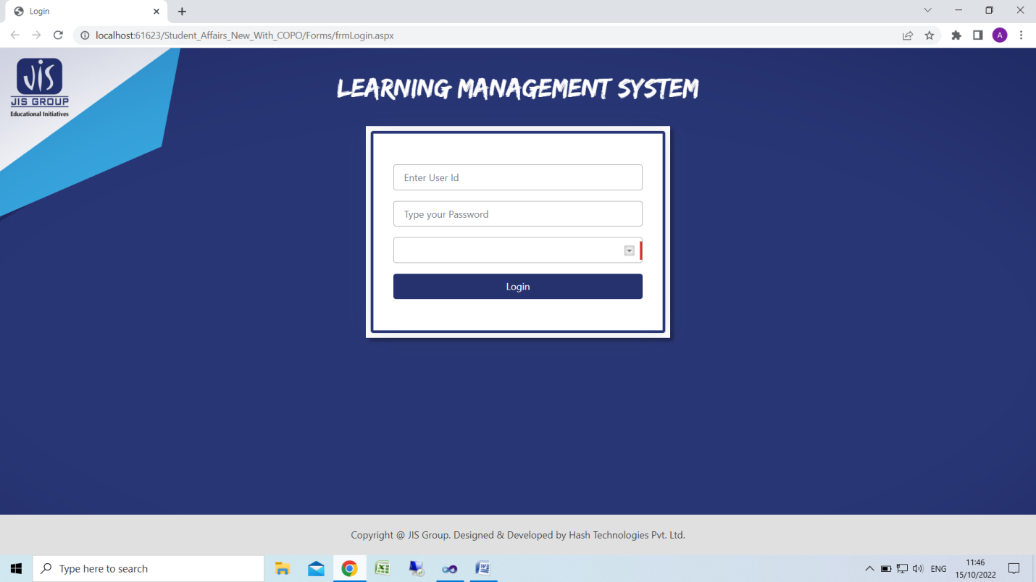

Select Academic Session

Enter Password

Enter User Id

**Home Screen**

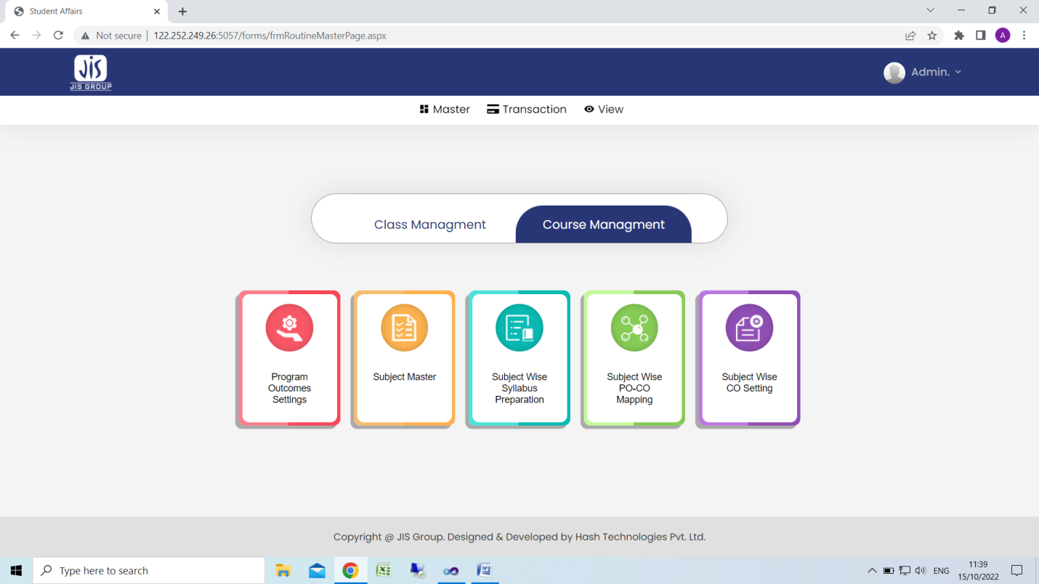

**Course Management**

1. **Program Outcome Setting**

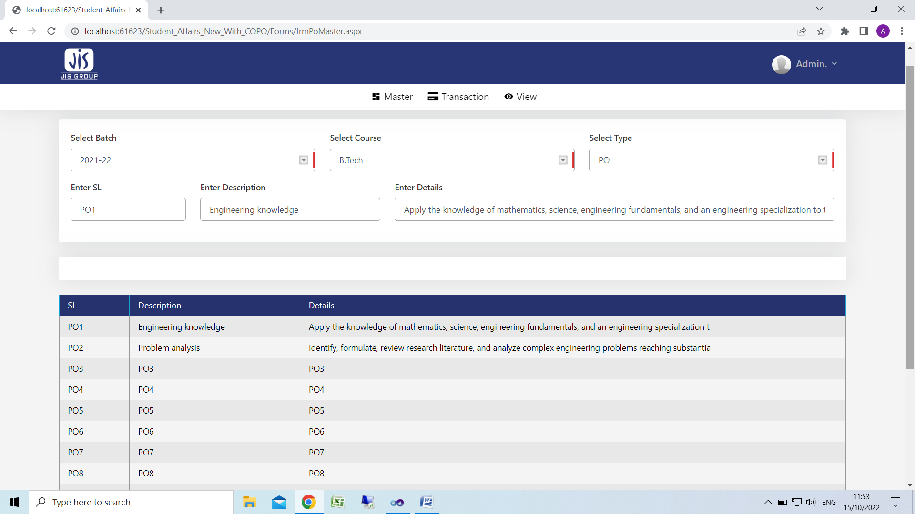

**For New Entry**

1. Select Batch (Admission Year)
2. Select Course
3. Select Type(PO/PSO/PEO)
4. Enter Sl starting with PO( Eg. PO1, PO2…)
5. Enter Description
6. Enter details
7. Click Save

**For Edit**

1. Click on Row
2. Edit information
3. Click save
4. **Subject Master**

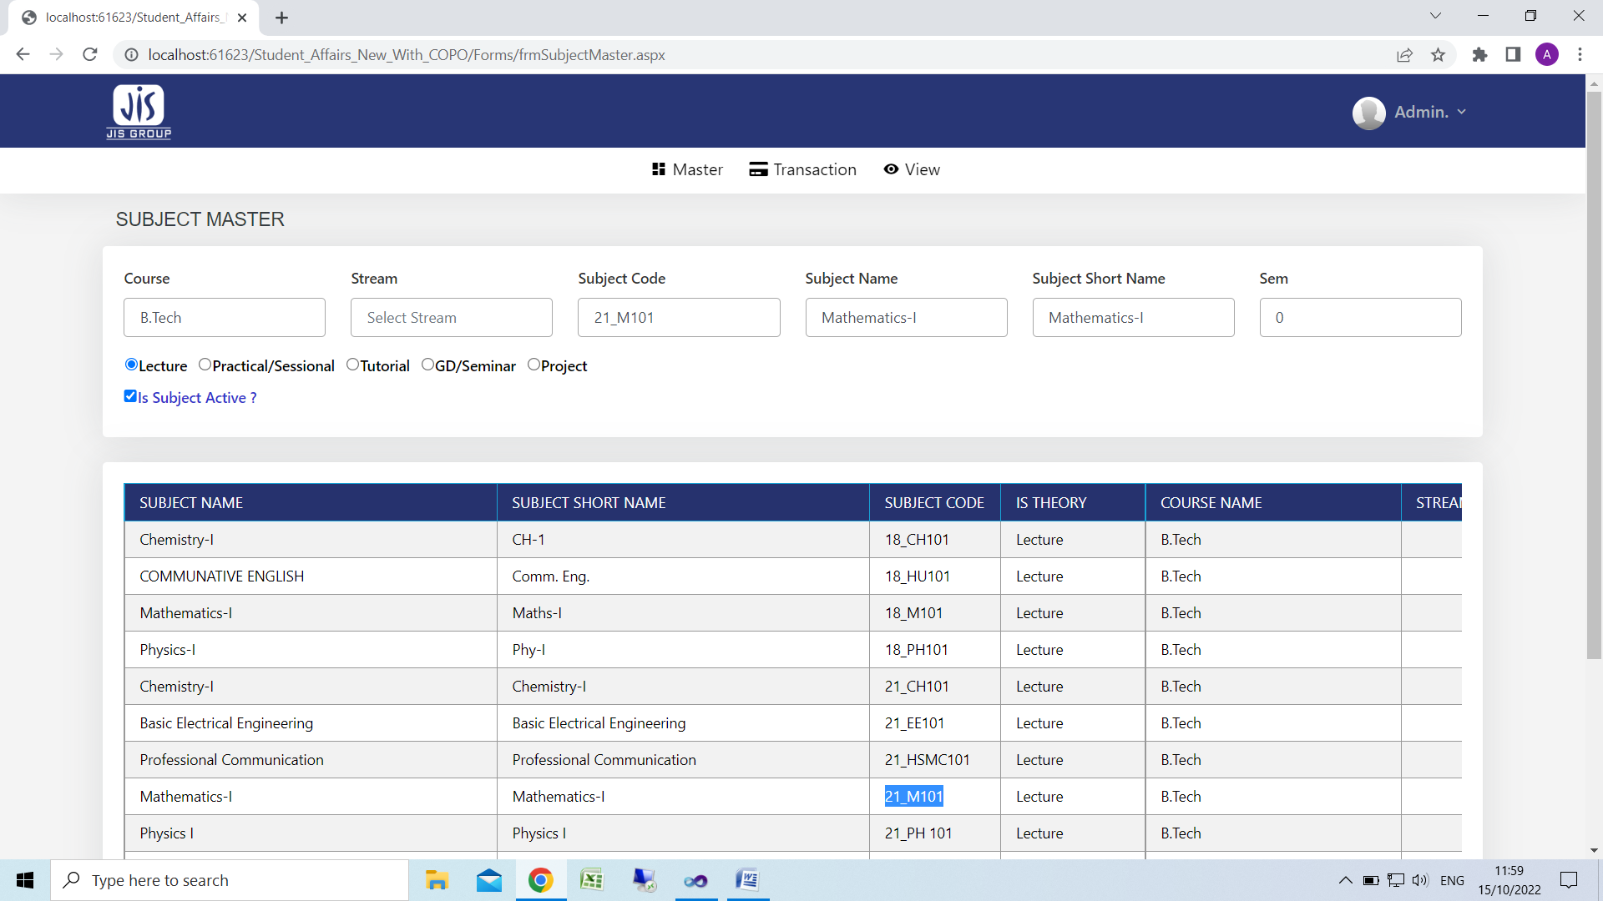

For New Entry

1. Select course
2. Select stream for exclusively stream dependent subject or keep it blank(eg. Subject for 1st year B.tech subject)
3. Subject Code it should be unique
4. Subject name
5. Subject short name if any
6. Semester no for exclusively semester dependent subject or keep it blank(eg. Subject for 1st year B.tech subject)
7. Select subject type(eg. Lecture/Practical)
8. Click Save

For Edit

1. Click on subject row
2. Edit related information
3. **Subject syllabus preparation/upload**

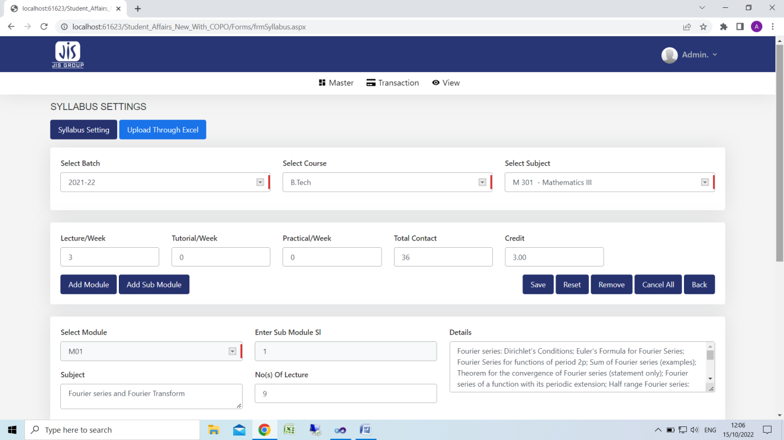

**For manual entry.**

For Details

1. Select batch
2. Select course
3. Select subject
4. Enter lecture/week
5. Enter tutorial
6. Enter practical
7. Enter total contact hours
8. Enter total credit
9. Click save

For Modules

1. Click on Add Module button
2. Select module no.(eg. MO1 for module one)
3. Enter subject
4. Click save

For Sub Modules

1. Click on Add Sub Module button
2. Select module no.(eg. MO1 for module one)
3. Enter sub module no.(eg.1,2,3)
4. Enter subject
5. Enter details
6. Enter lecture no
7. click save

Kindly note Sub Module preparation is mandatory under any module. Lecture number should enter against any sub-module.

**For Upload through Excel**

Click on upload through excel button

Click on download format button for excel template & help doc

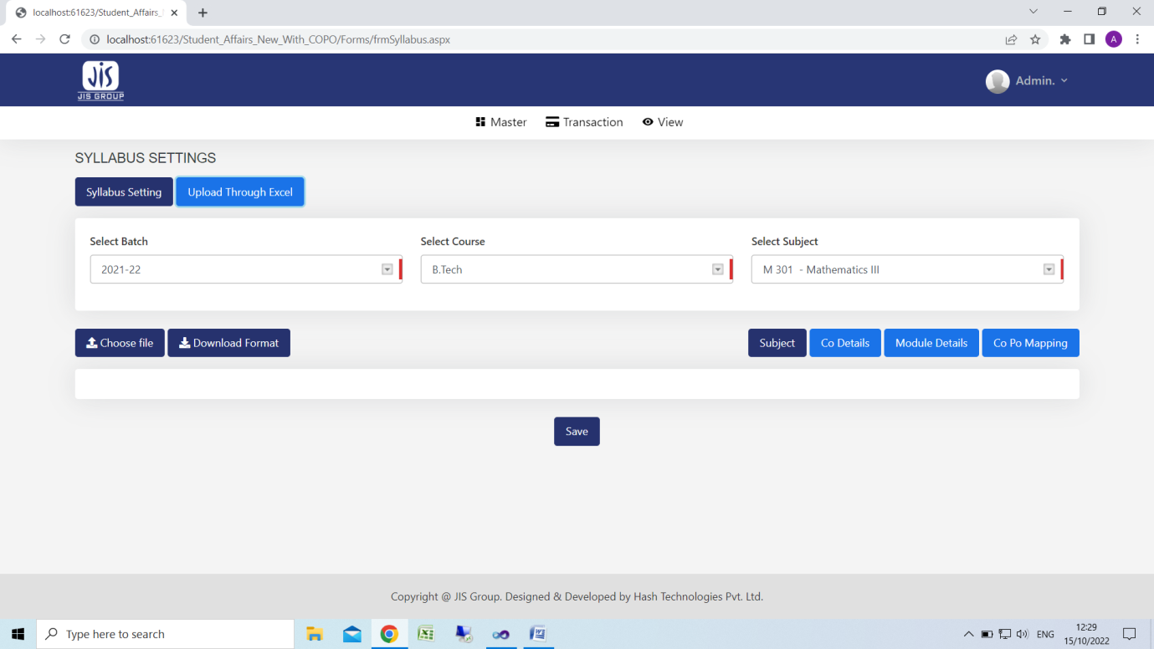

Click on choose file button

Click on “Subject” button check & save for subject details

Click on “CO Details” button check & save for CO details

Click on “Module Details” button check & save for Module details

Click on “COPO Mapping” button check & save for COPO Mapping

**D. SUBJECT WISE PO-CO MAPPING**

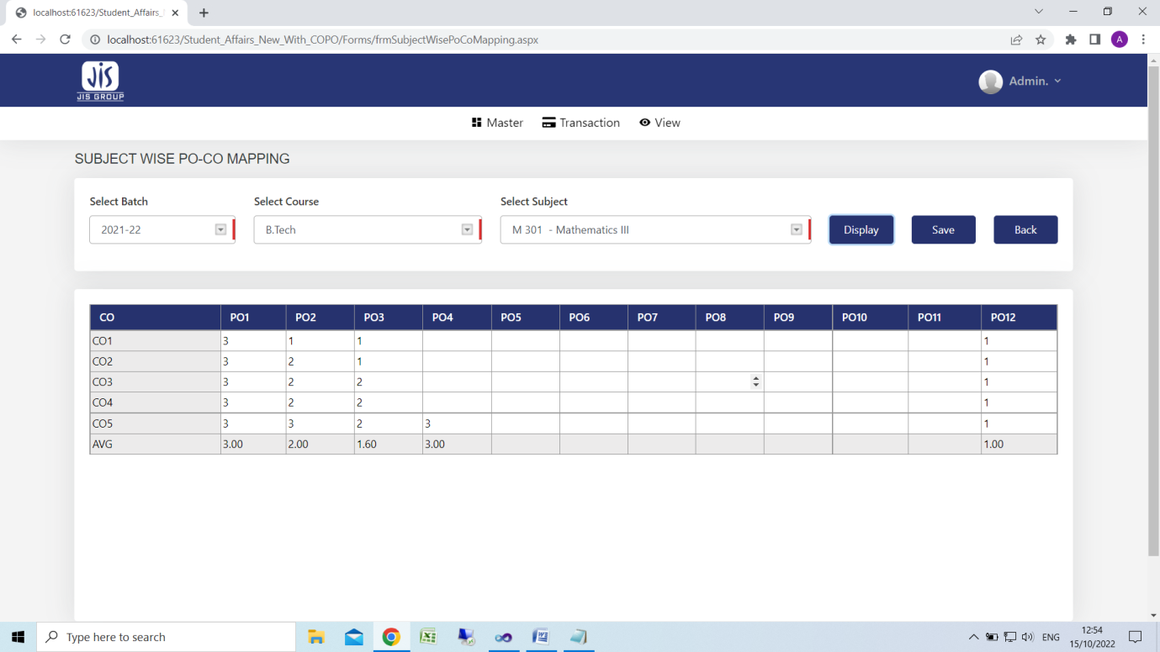

1. select batch
2. select course
3. select subject
4. click display
5. enter value
6. click save
7. **Eubject wise CO Setting**

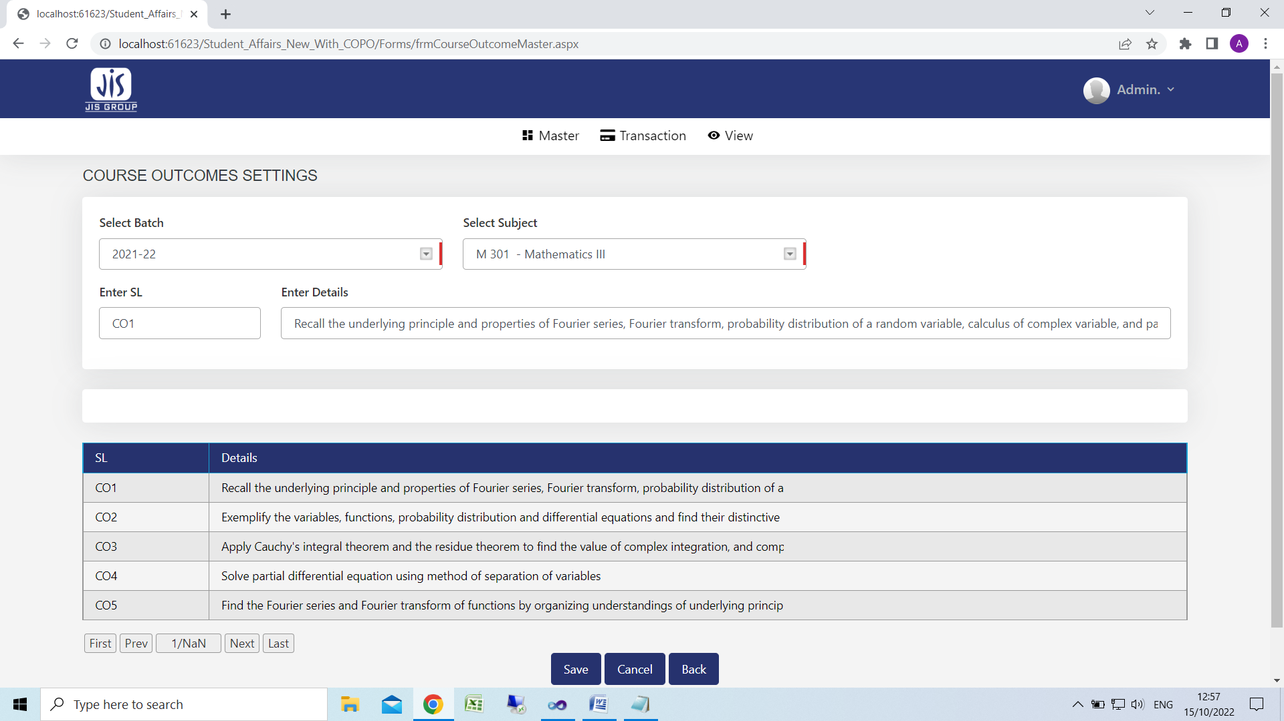

1. Select batch
2. Select subject
3. Enter Sl starting with CO(eg. CO1,CO2)
4. Enter details
5. Click save

Class Management

Home Screen

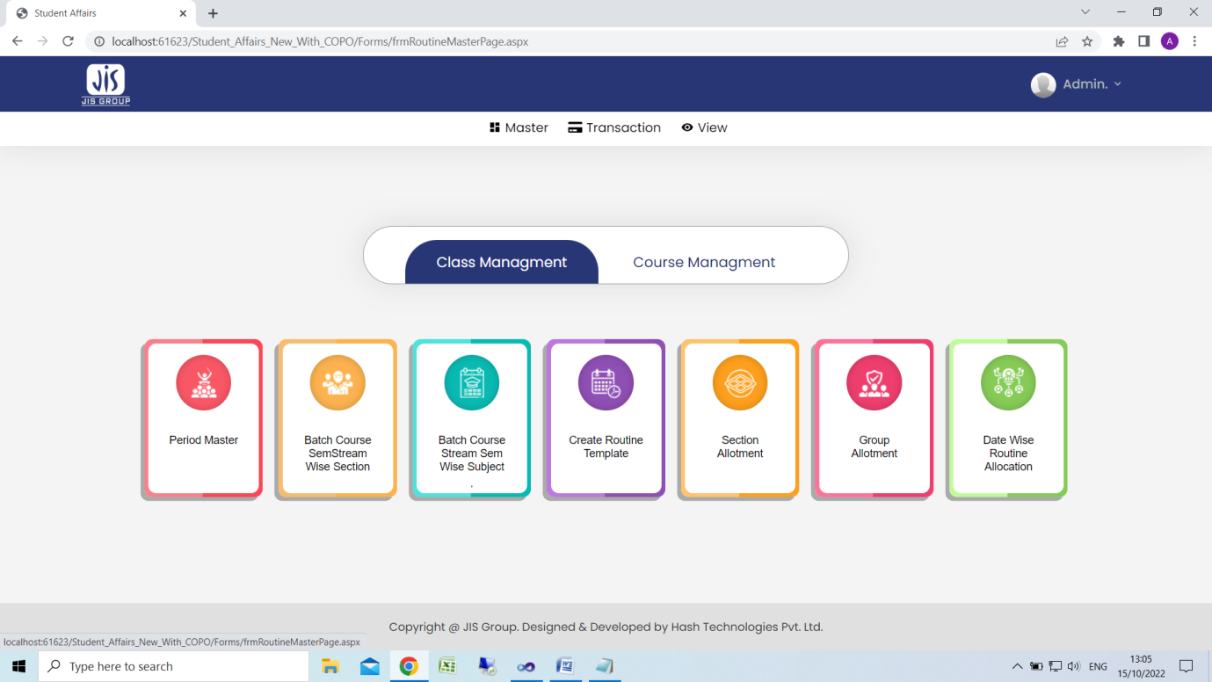

1. Period Master

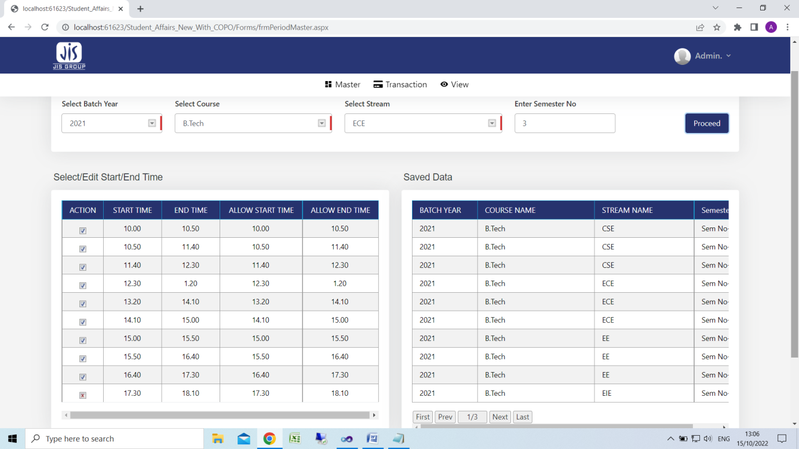

1. Select batch
2. Select course
3. Select stream
4. Enter Sem & click Proceed Button
5. Change start & end time if required
6. Click save
7. Batch, course, stream & sem wise section setting

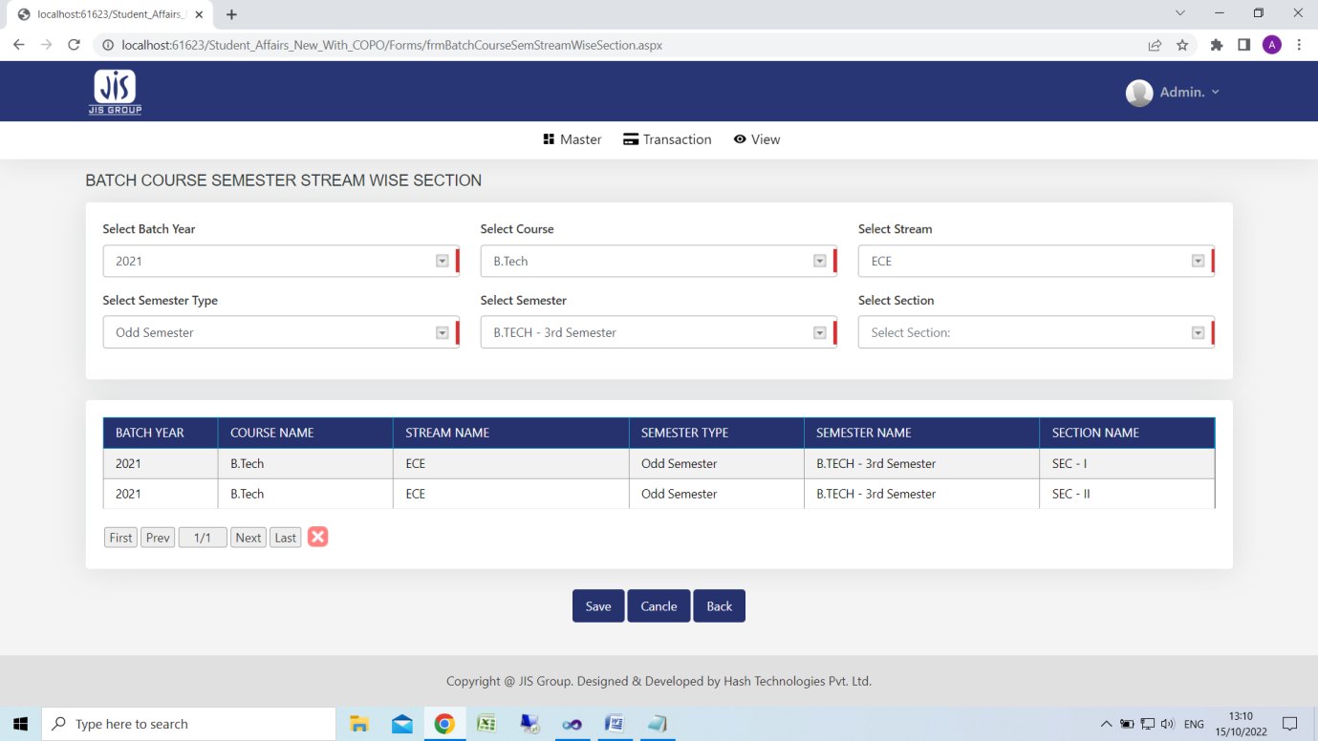

1. Select batch
2. Select course
3. Select stream
4. Select semester type
5. Select semester
6. Select section
7. Click save
8. Batch, course, stream & sem wise Subject setting

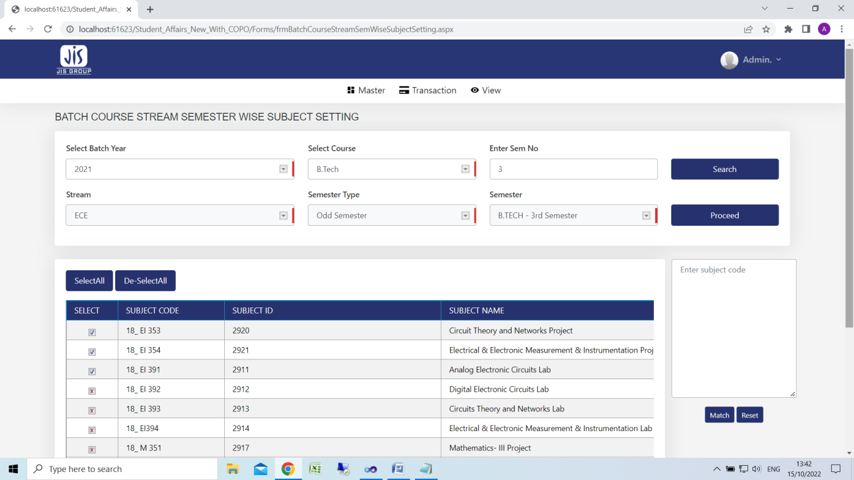

1. Select batch
2. Select course
3. Select semester
4. Click search & select stream+section
5. Click proceed
6. Click here to select subject
7. Click save
8. Create routine

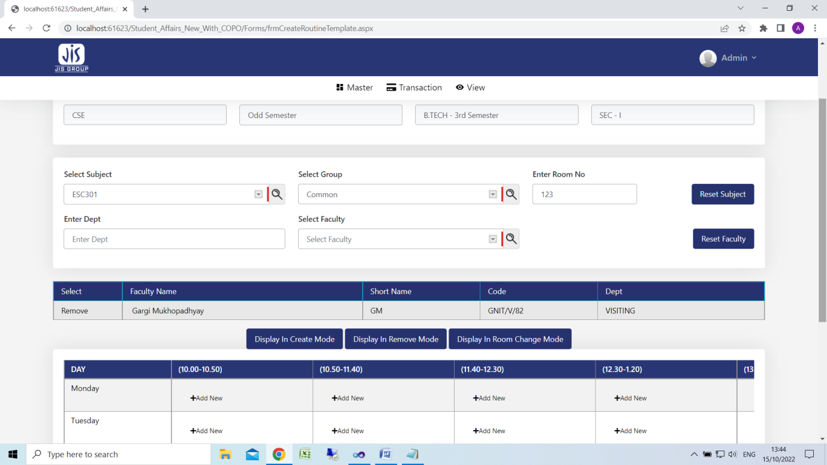

1. Select batch
2. Select course
3. Select semester
4. Click search & select stream+section
5. Select subject
6. Select group
7. Enter room no
8. Select faculty
9. Click on “Add New” Icon
10. For remove particular subject click on “Display on remove mode button” and click red colour cross button
11. Section Allotment

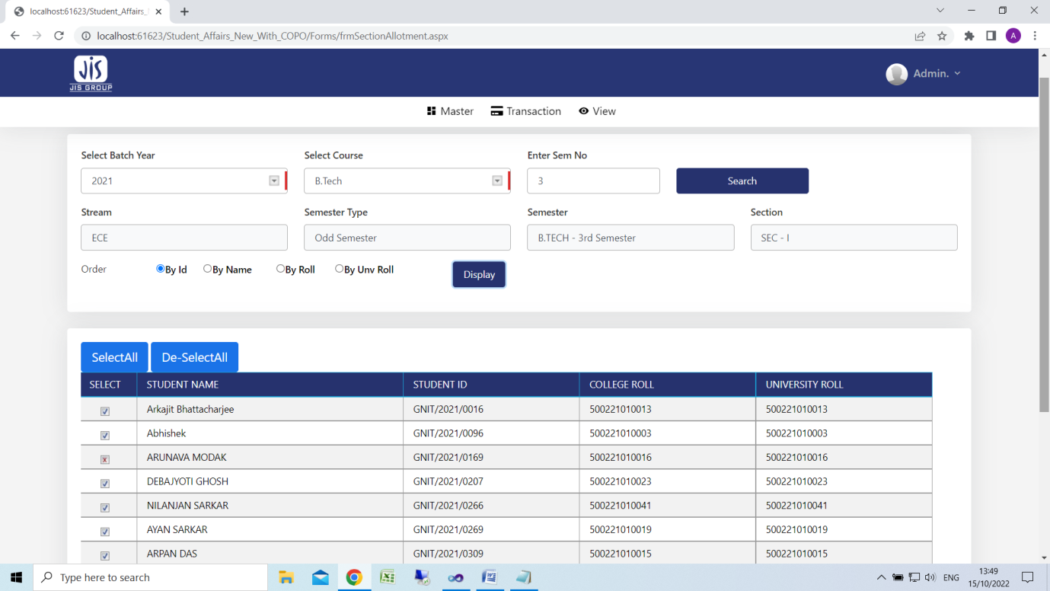

1. Select batch
2. Select course
3. Select semester no
4. Click search & select stream+section
5. Click Search
6. Select stream & section
7. Click display
8. Select student by clicking select all button or by clicking check box
9. Click save
10. Group Allotment

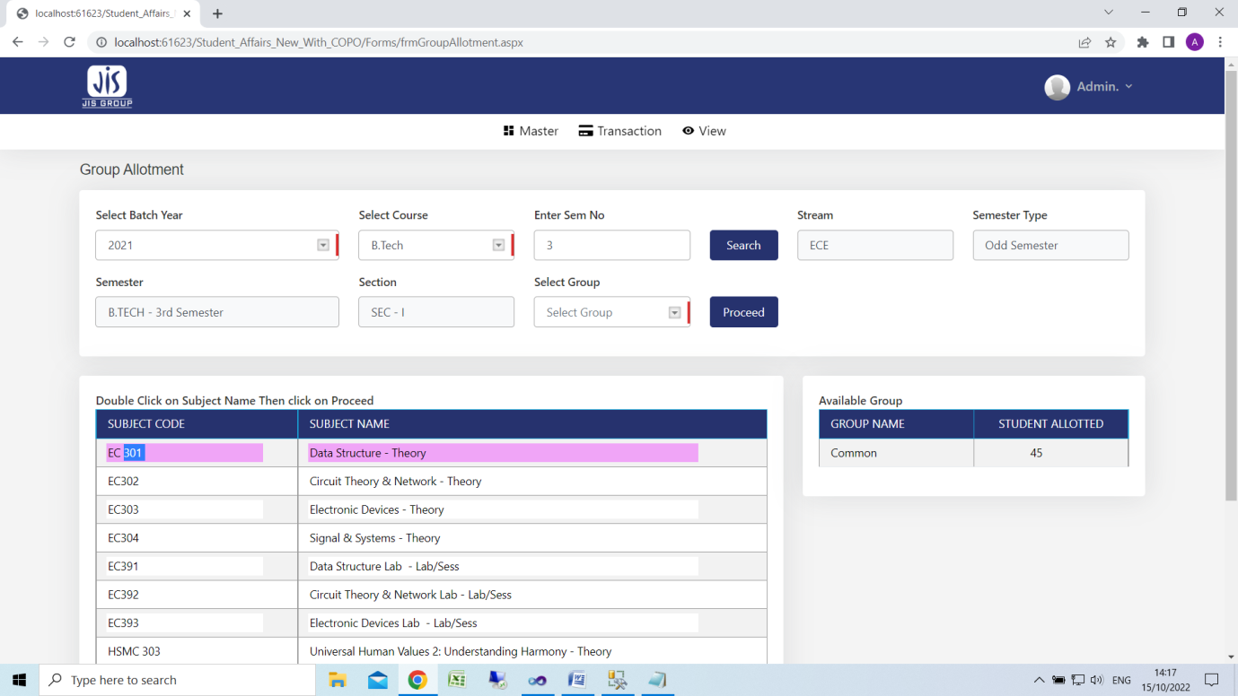

1. Select batch
2. Select course
3. Select semester no
4. Click search & select stream+section
5. Click Search
6. Select stream & section
7. Click on subject
8. Click on subject group
9. Select student
10. Click button
11. Date wise routine allocation

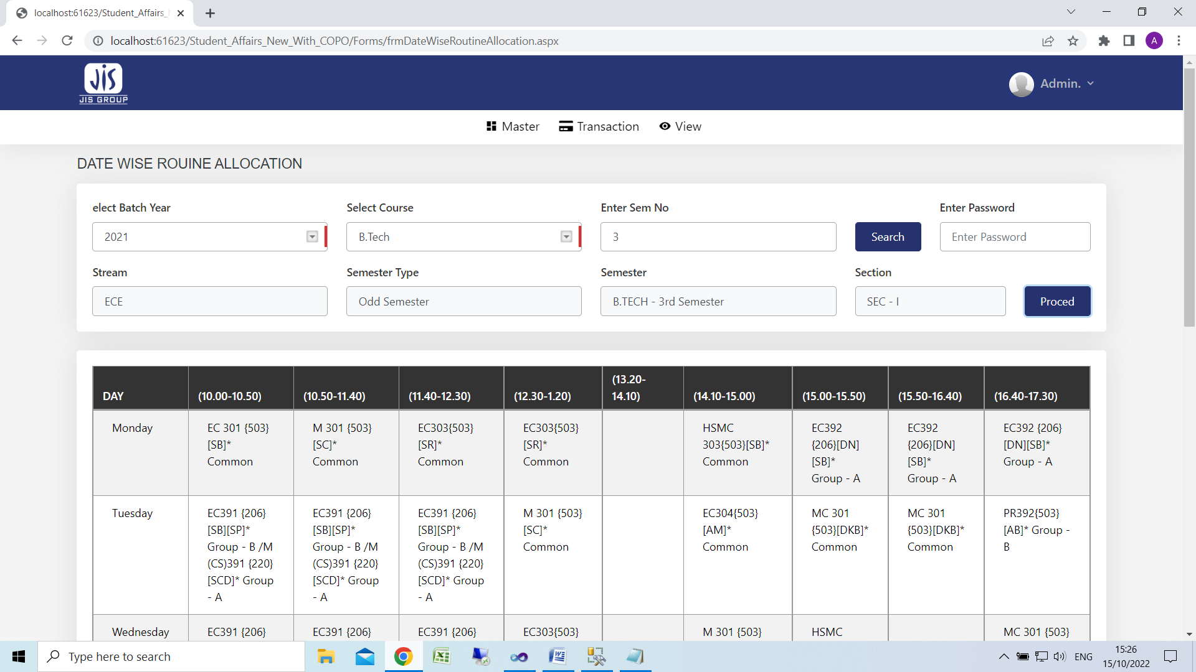

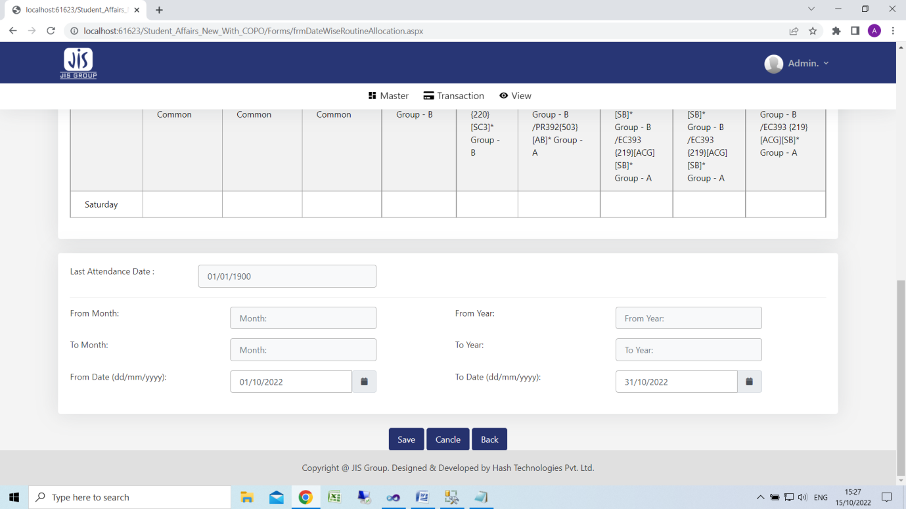

1. Select batch
2. Select course
3. Select semester no
4. Click search & select stream+section
5. Click Search
6. Select stream & section
7. Click proceed
8. Enter from & to date
9. Click save