**Sheet – 01SUBJECT**

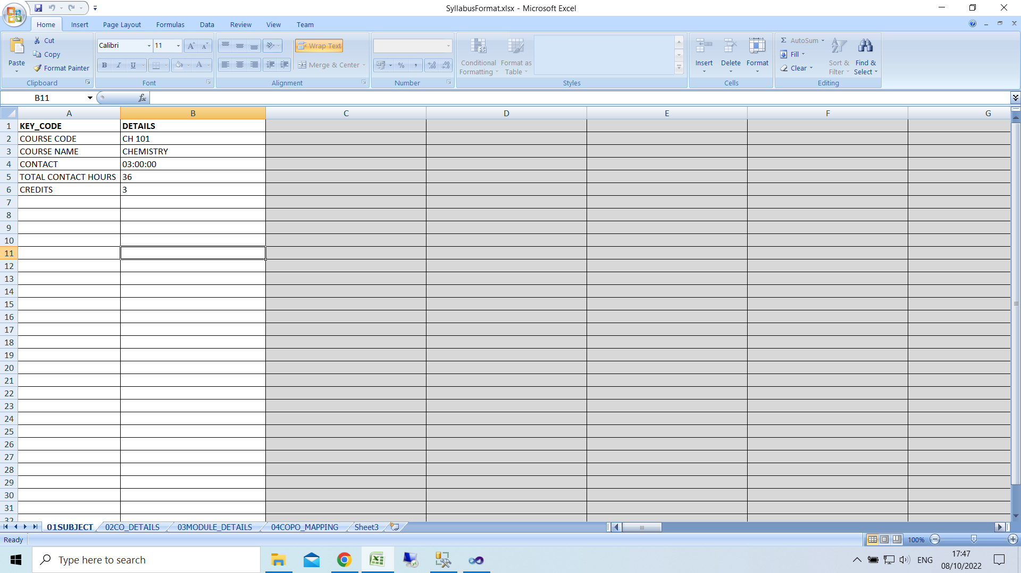

Enter Subject Code

Enter Name

Enter Contact (LTP)/week): count of lecture, tutorial & practical separated by **:**

Enter Contact hours

Enter Credit

Sheet - 02CO_DETAILS

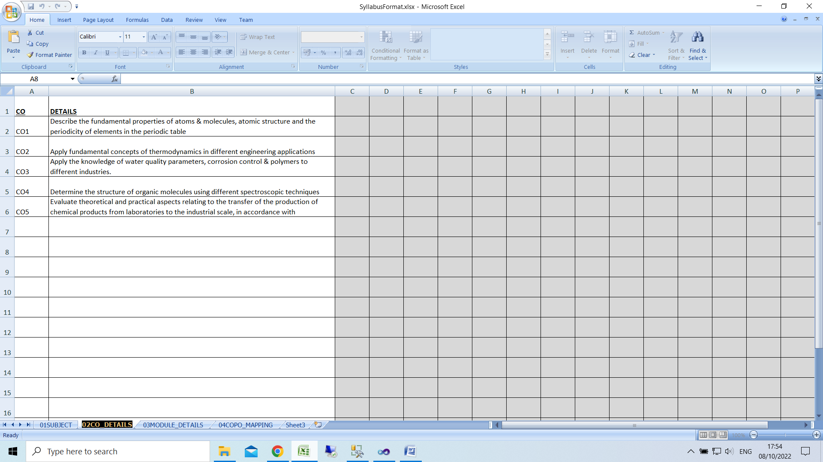

Enter CO1 to CO(n) in CO column

Enter CO Details

Sheet - 03MODULE_DETAILS

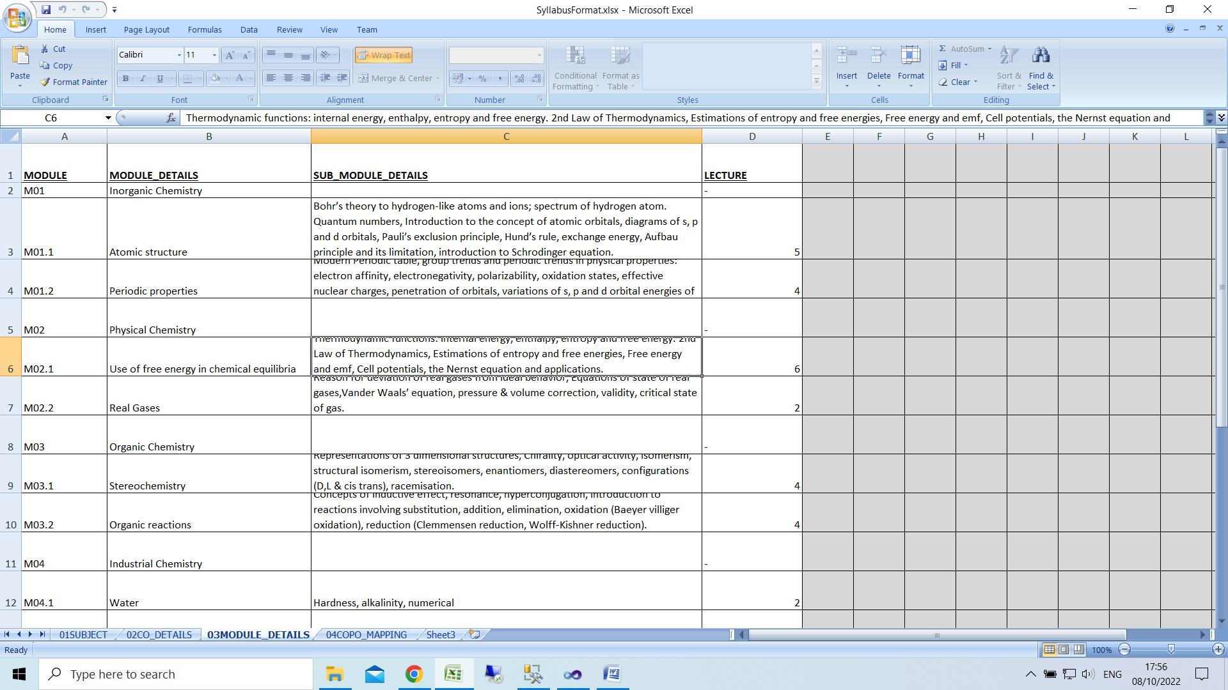

Enter module name as M01,M02 like that

Enter Sub Module name as M01.1, M01.2,M01.3 in case of module M01

For Module

Column MODULE_DETAILS: enter module details

Column SUB_MODULE_DETAILS: keep it blank

Column LECTURE: enter –

For Sub Module

Column MODULE_DETAILS: enter sub module topic

Column SUB_MODULE_DETAILS: enter sub module details

Column LECTURE: enter lecture no

Sheet - 04COPO_MAPPING

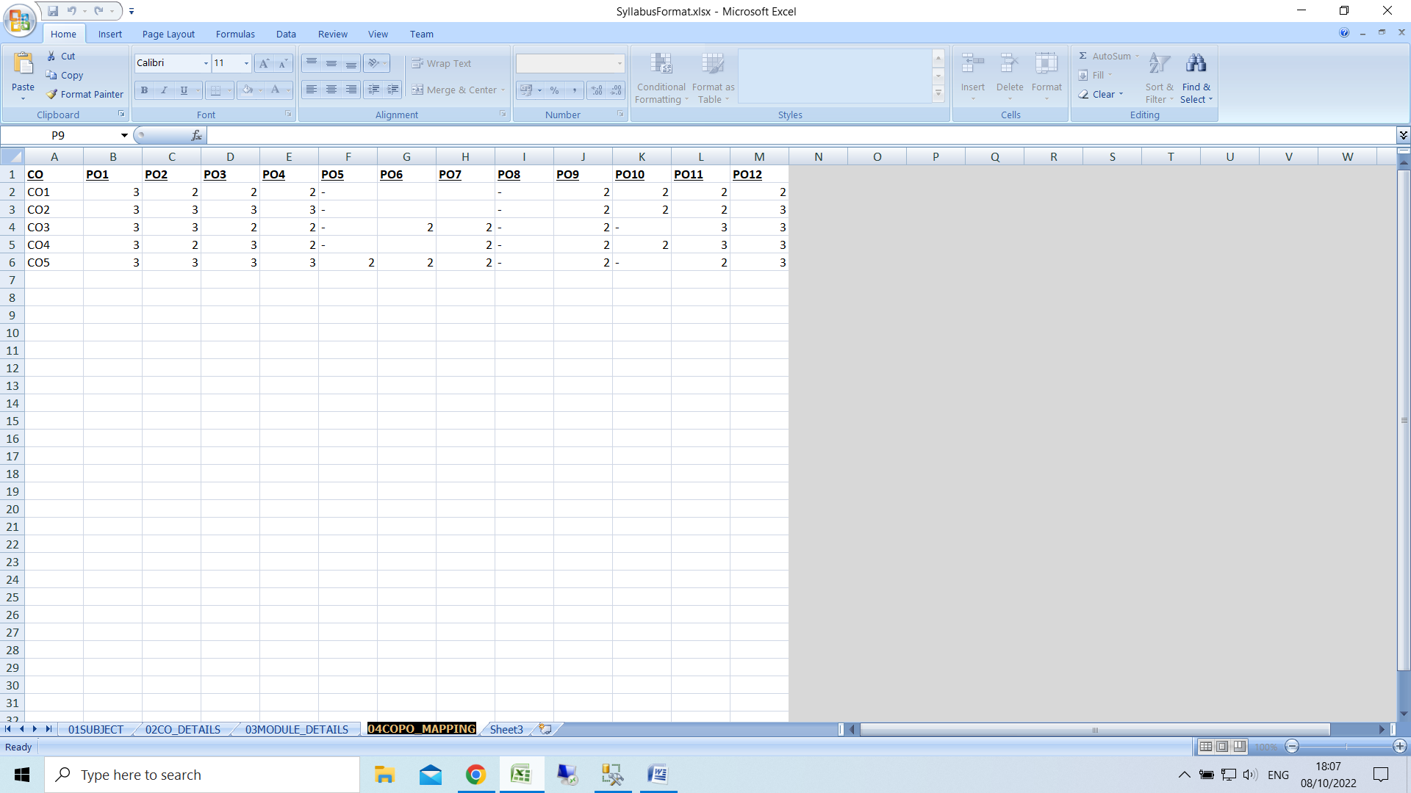

Enter scale as numeric

Enter - if not applicable