**Attendance Dashboard Help Documents.**

Type following url in browser address bar

<http://122.252.249.26:118/> or

<http://59.162.182.138:118/>

**Description of Student Dashboard**

Click here for Faculty Attendance Dashboard Click here for Logout

Click here for weekly navigation

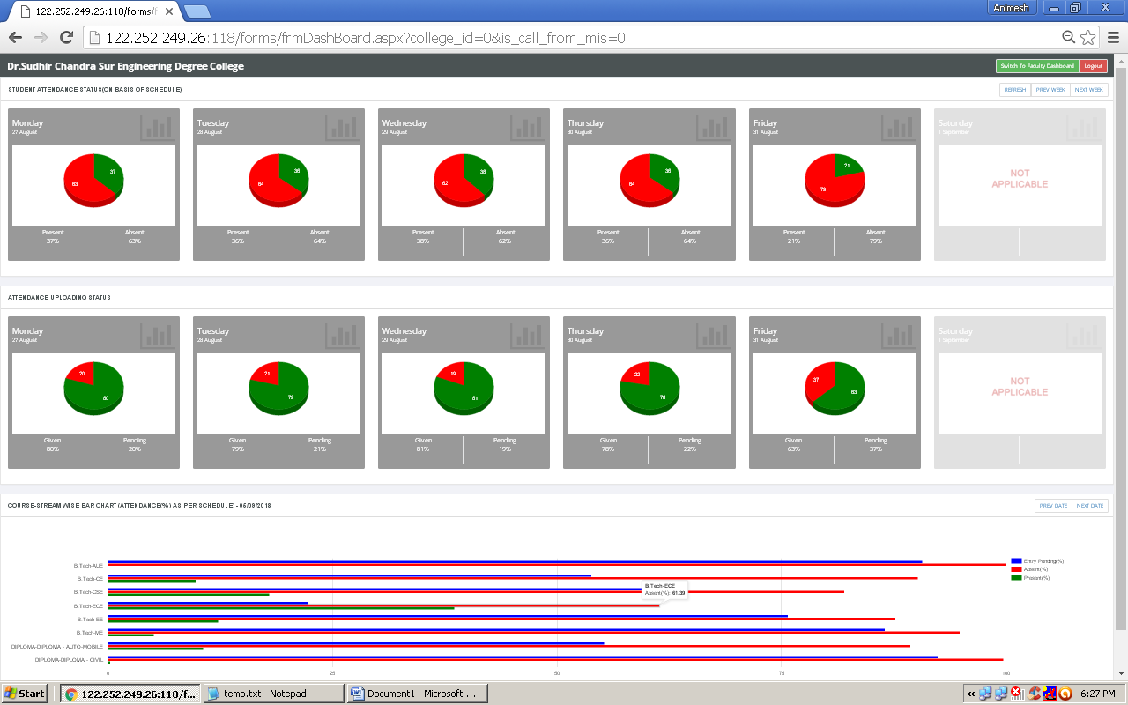

**Fig.01**

Graphical representation of date wise student attendance

%=(Present/Total Schedule Class) X 100

Graphical representation of date wise attendance uploading status

Course+Stream wise attendance Bar Chart for current date

**For details report you can click on any of the chart(refer Fig.03).**

**Description of Faculty Dashboard**

Click here for weekly navigation

Click here for refresh

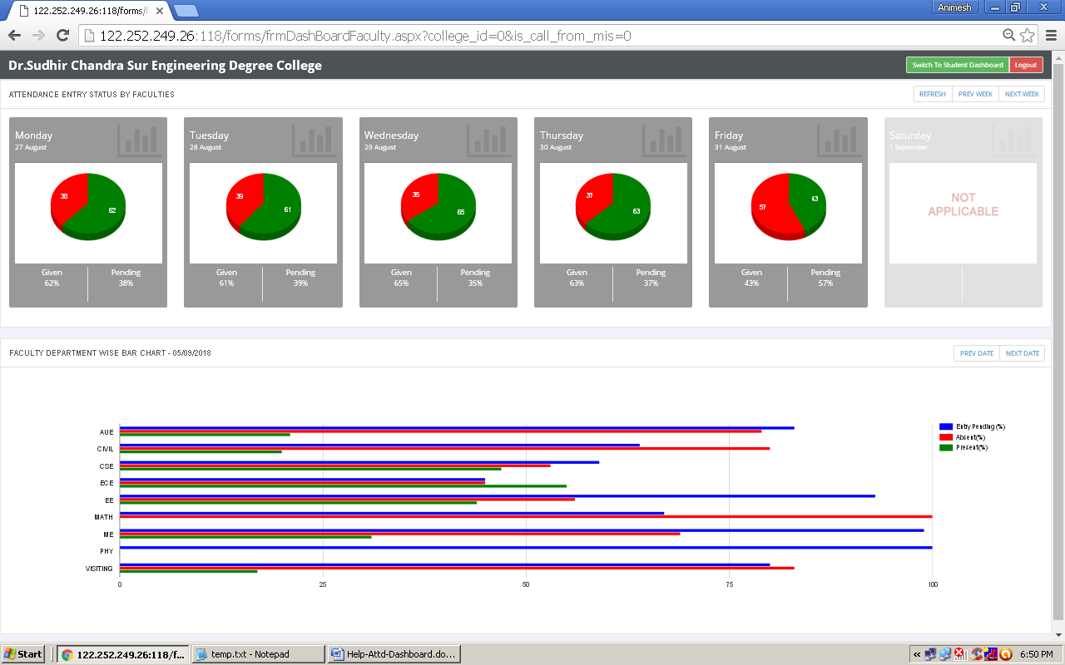

**Fig.02**

Graphical representation of attendance entered by faculties

Bar chart for faculty department wise attendance for current date

**For details report you can click on any of the chart(refer Fig.04).**

**Student attendance details**

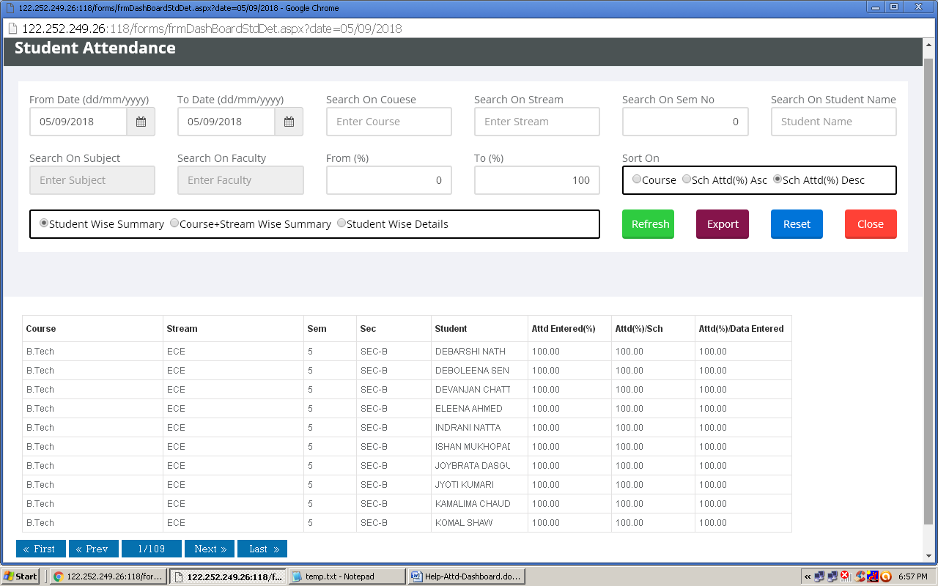

**Fig.03**

**Faculty attendance details**

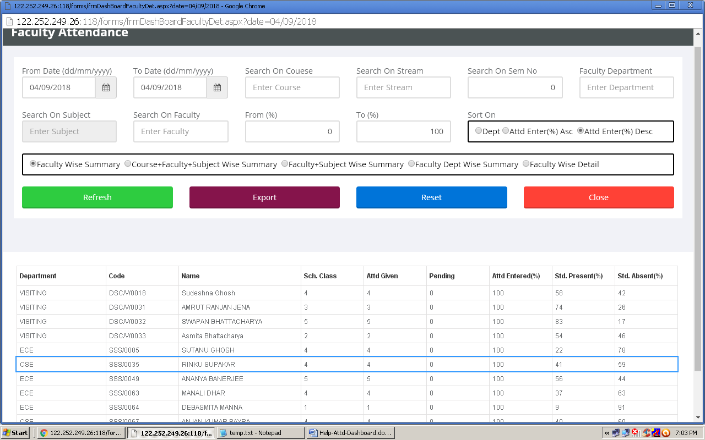

**Fig.04**

You can view/export student attendance details using given filter criteria

You have to click refresh button to regenerate reports after using filter or report type