**Login Screen**

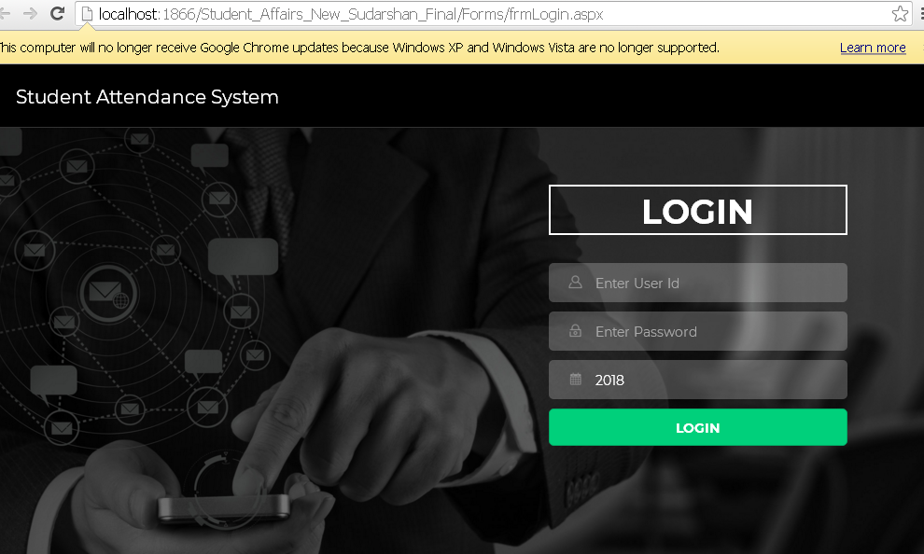

**Fig. 01**

1. Open browser (preferably Chrome/Firefox)
2. Type <http://122.252.249.26:118/forms/frmlogin.aspx> in address bar
3. Enter login and Password
4. Click Login
5. Go to Fig. 02

**Main Menu**

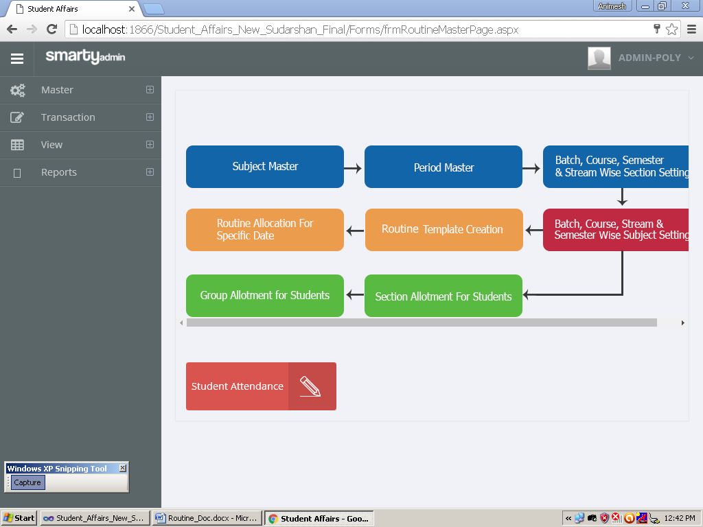Create SubjectMaster

Create Period Master

Create Section

Linking Subject

Create Routine Template

Linking Student with section

Linking Student with subject + group

Date wise Routine Allocation **Fig. 02**

**Subject Master**

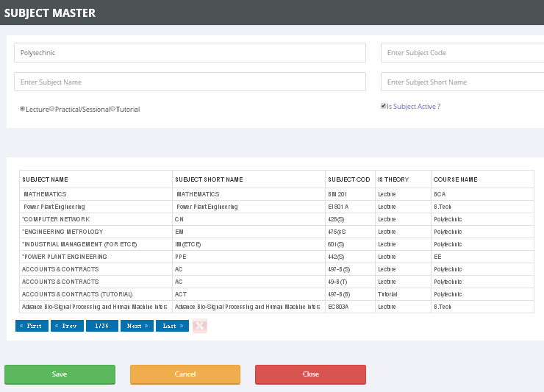

**Fig. 03**

1. Select Course
2. Enter Subject Code
3. Enter Subject Name
4. Enter Subject Short Name
5. Select Subject type
6. Select Subject status
7. Click Save
8. For Edit click on row
9. Follow steps 1 to 7

**Period Master**

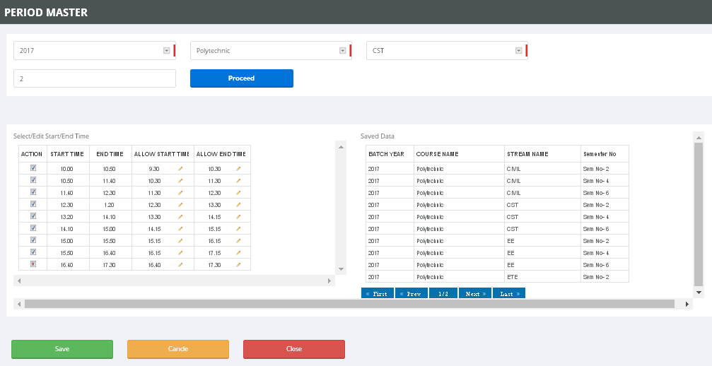

**Fig. 04**

Select batch

Select course

Select Stream

Enter semester no

Click proceed

You can un-check the period which is not required

You can change start time & end time.

Click Save

**Section Creation**

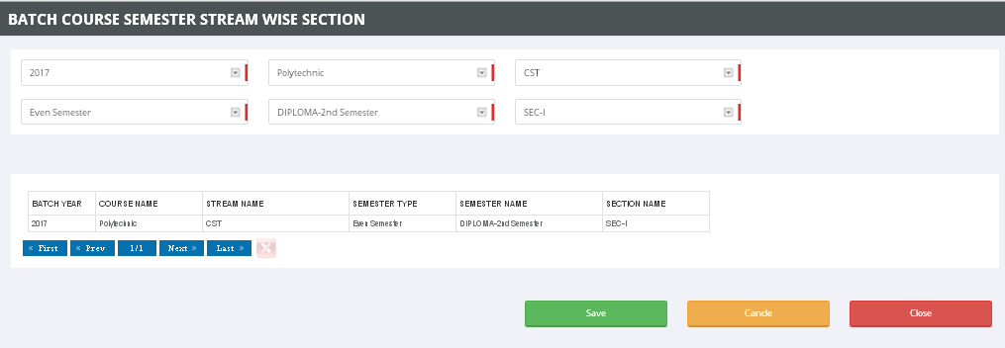

**Fig. 05**

1. Select Batch
2. Select Course
3. Select Stream
4. Select semester type (Even/Odd)
5. Select semester
6. Select section
7. Click Save

**Batch,course,stream and semester wise subject mapping**

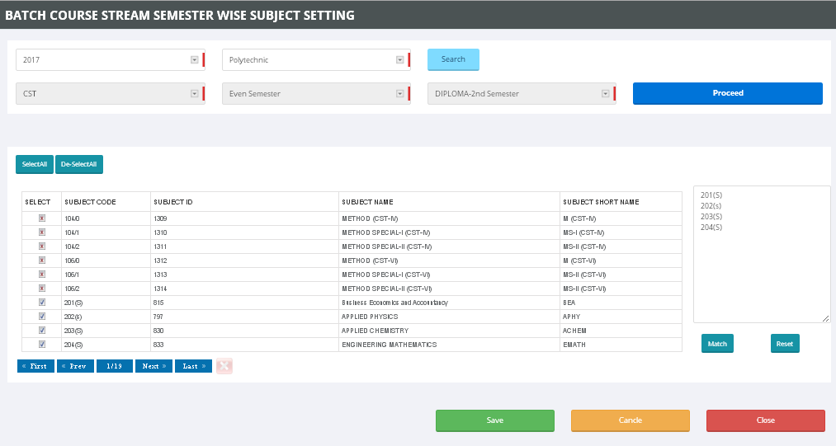

**Fig. 06**

1. Select Batch 2.Select Course 3.Click Search 4.Select stream from list

5.Click Proceed 6.Select subject from list 7. You can copy subject code list in box

8.Click match, subject will automatically selected. 9. Click Save

**Routine Template**

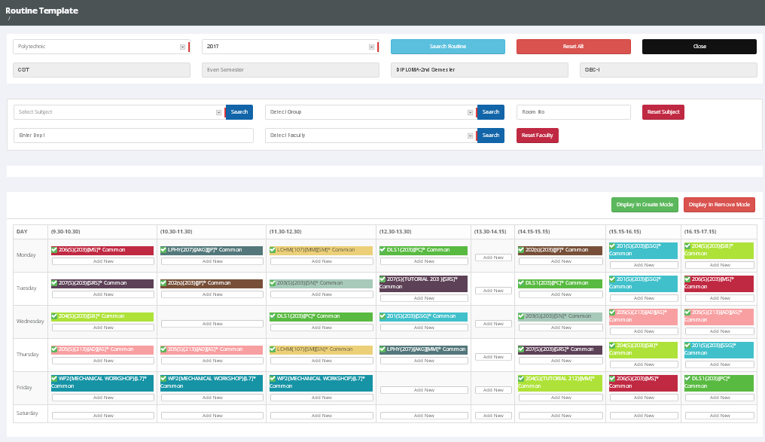

**Fig. 07**

1. Select Course
2. Select Batch
3. Click search routine & select stream
4. Select Subject
5. Select subject group (Common for all students, Group – A/B for student grouping)
6. Enter Room No
7. Select Faculty (You can choose multiple faculty in case of lab)
8. Click on Add New button in period matrix.

Section wise student linking

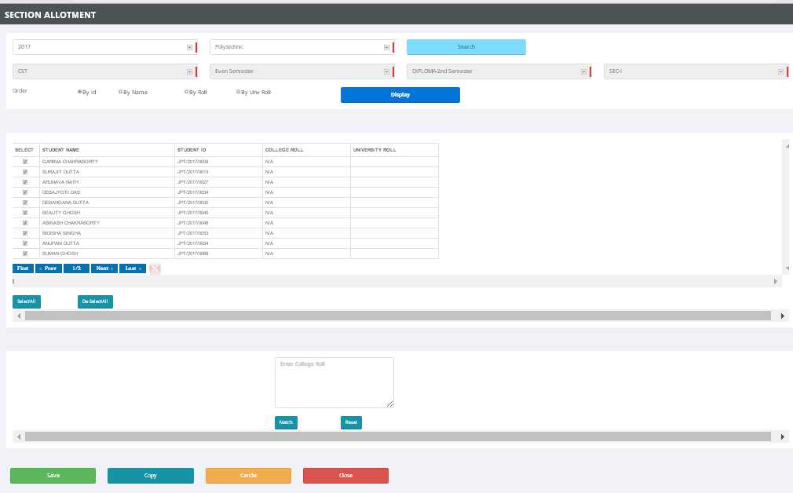

**Fig. 08**

1. Select Batch
2. Select Course
3. Click search & select stream
4. Select/Un-select student
5. You can also copy student roll no in the box & then match
6. Click save

Subject Group Wise Student mapping

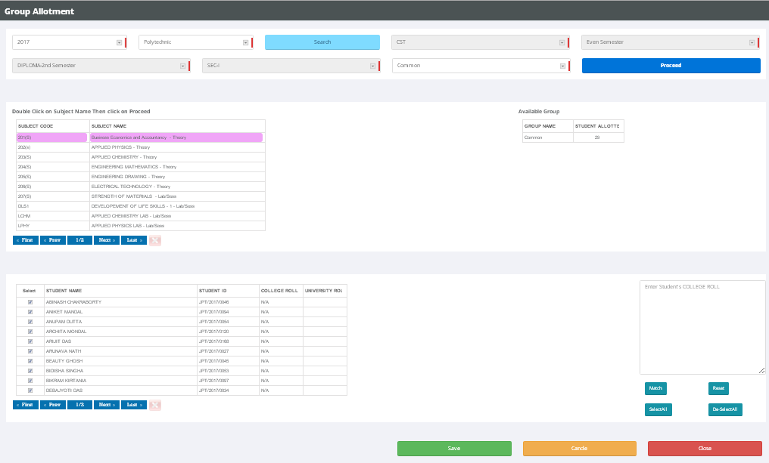

**Fig. 09**

1. Select Batch
2. Select Course
3. Double click on subject
4. Click group
5. Select/Un-select student
6. You can also copy student roll no in the box & then match
7. Click save

Date wise Routine Allocatin

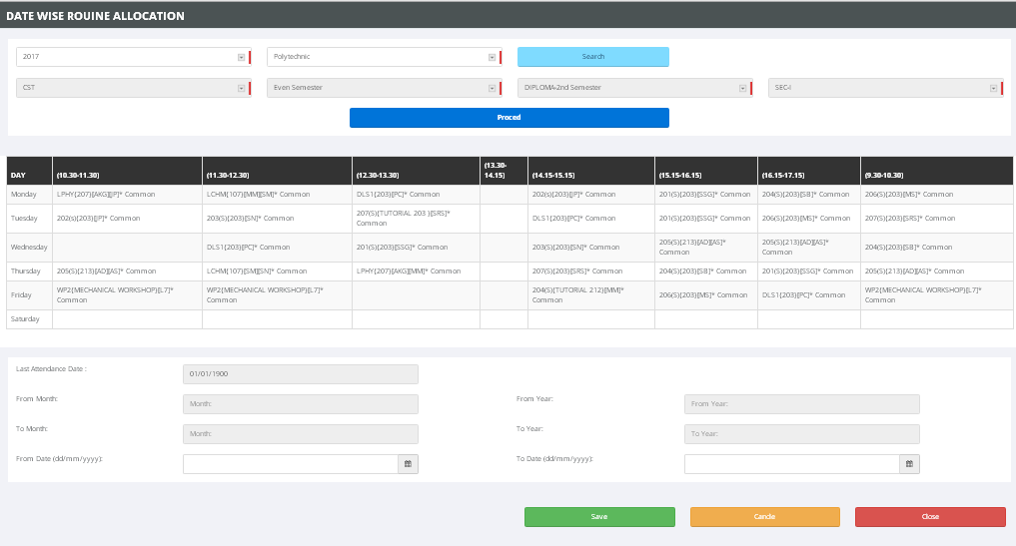

**Fig. 10**

1. Select Batch
2. Select Course
3. Click proceed
4. Enter from date & to date
5. Click save

**Add Visiting Faculty**

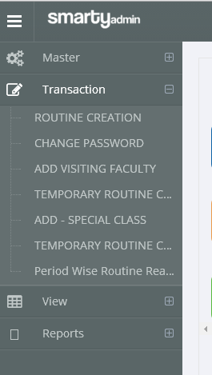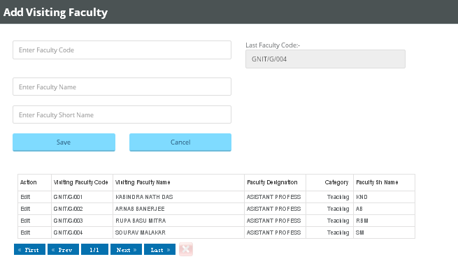

**Fig.11**

1. Click Transaction->Click Add Visiting Faculty
2. Enter faculty code,name & short name
3. Click save

Report s

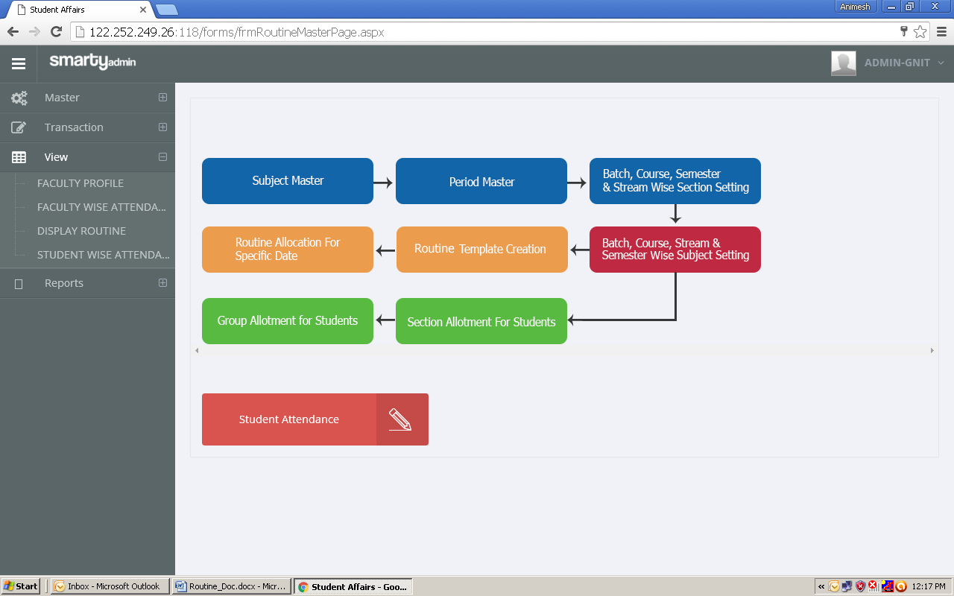

Student Attendance

Faculty Attendance

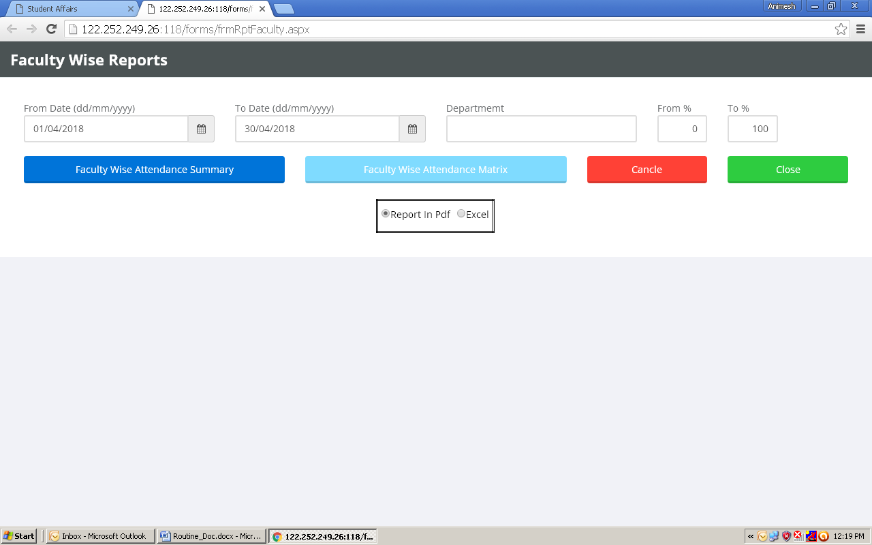

1. Enter from & to date
2. Click Summary for summary
3. Click Attendance matrix for date & period wise attendance status

Student Attendance Matrix

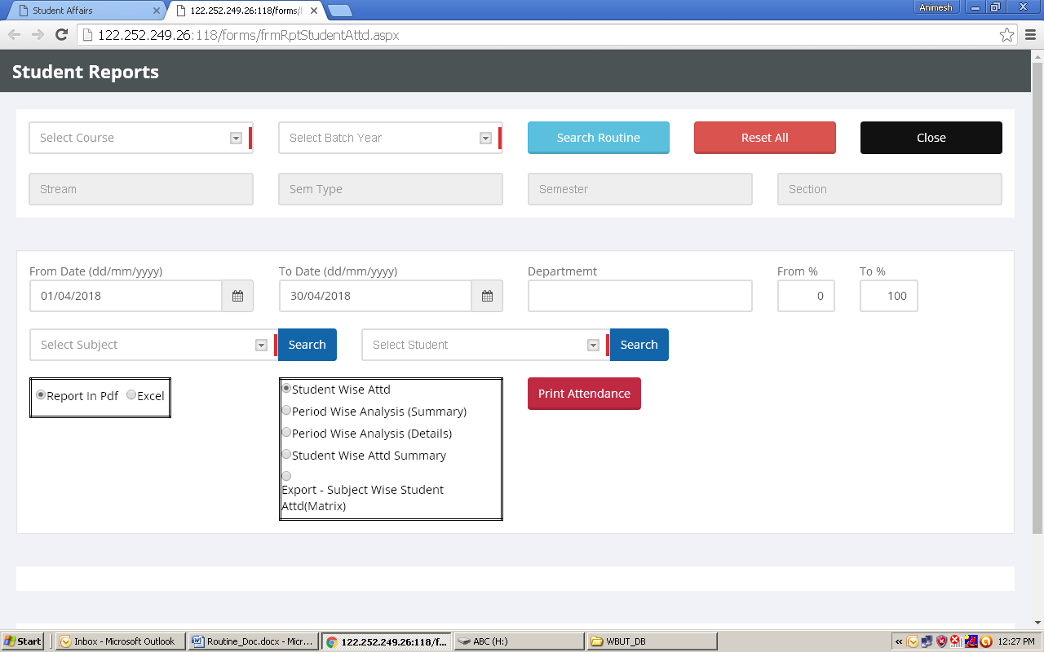

1. Select routine
2. Select from & to date
3. Select report type
4. Click print