Open browser (best other than IE)

Type <http://122.252.249.26:118/>

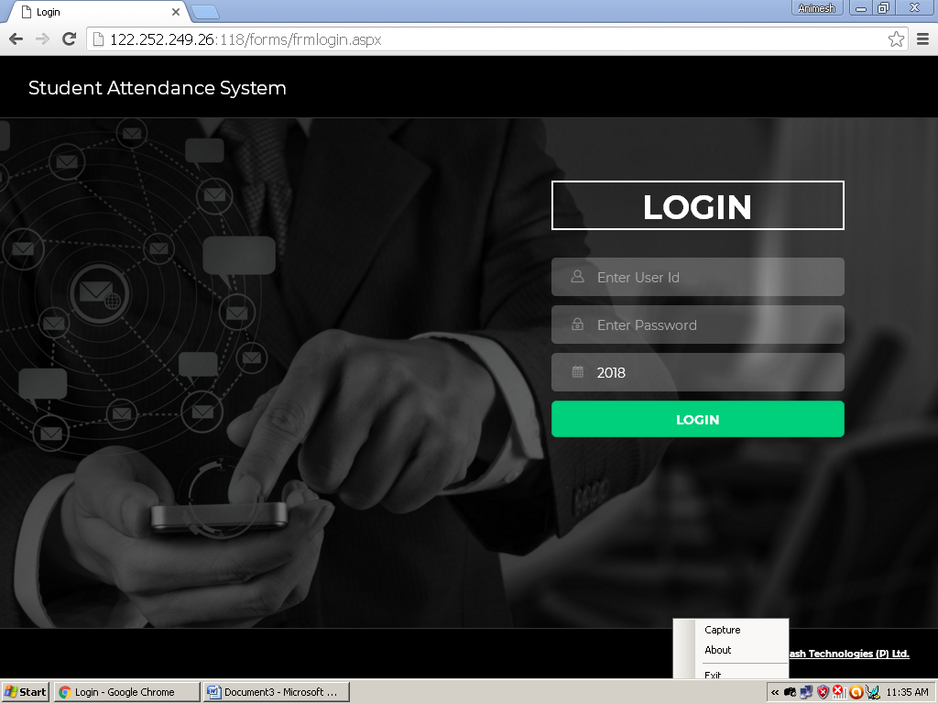

1. Enter user name

2. Enter Password

3. Click login

*User name & Password will be provided by your routine coordinator*

Fig. 01

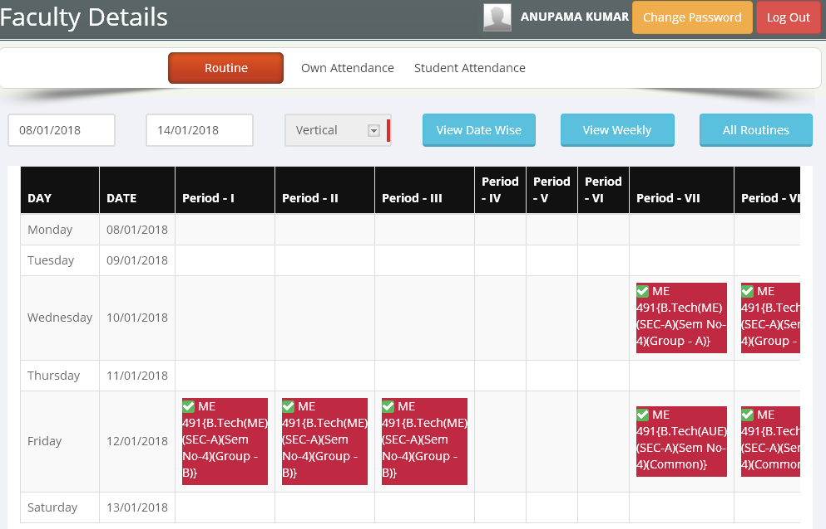

Fig.02

To giving particular class attendance click the check box. Go to next fig.03

After clicking if student details not appear then contact your routine coordinator, because subject group wise student linking is pending from their side

For back date entry, change date range & click view date wise button

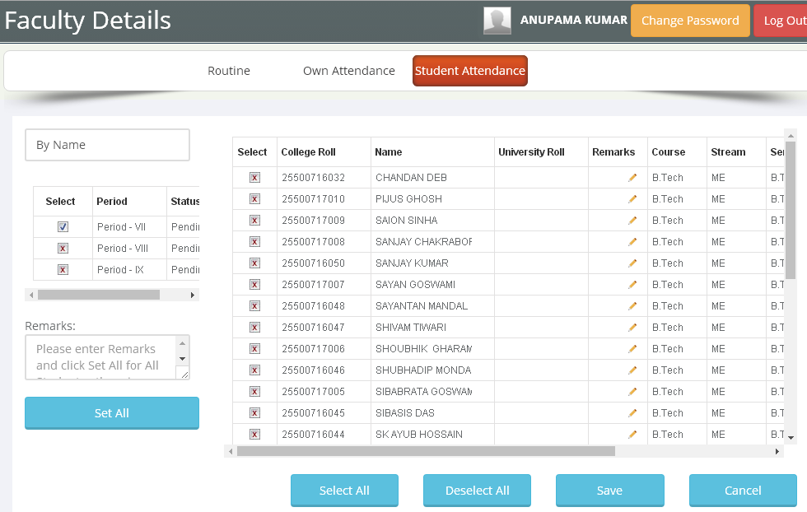

Fig.03

To give attendance to particular student click the check box

You can put individual remarks in remarks column

If remarks is same for all students you can enter remarks in remarks box & click set all button

You have to click save button to save entire student status

For consecutive periods (Lab) you can on this check boxes

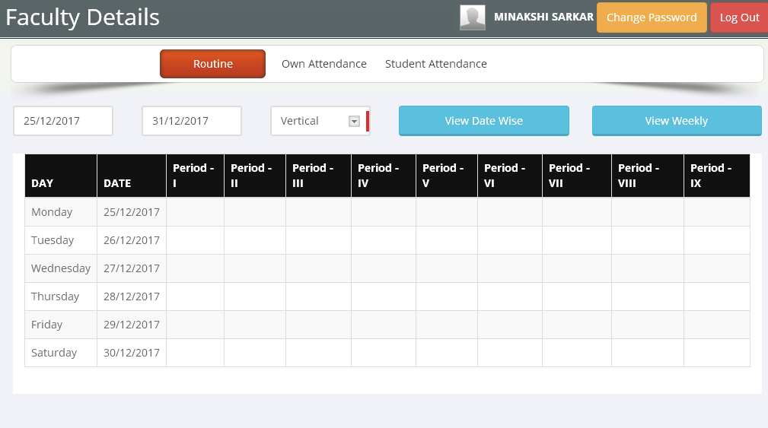

Click Here

Go to Fig. 03

Fig. 04

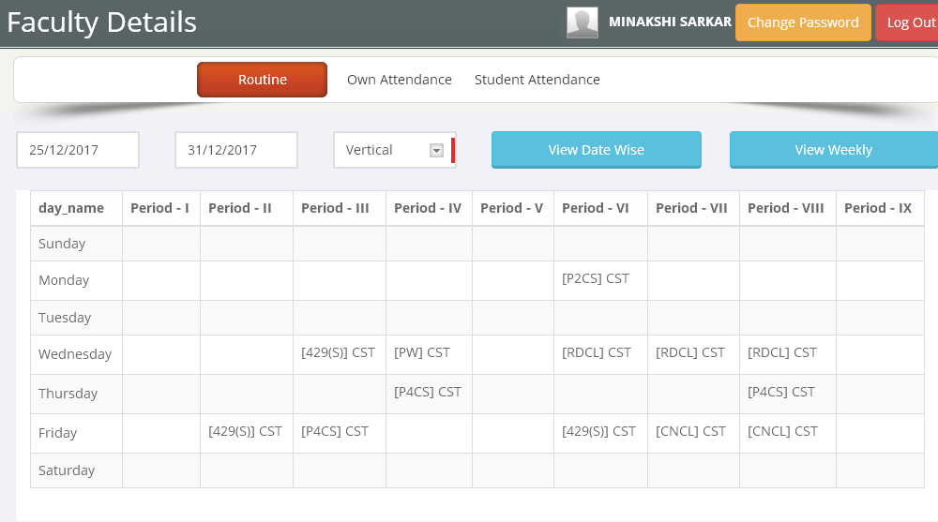

Fig. 05

***Check your day wise load, kindly contact your routine coordinator if you find any discrepancies.***

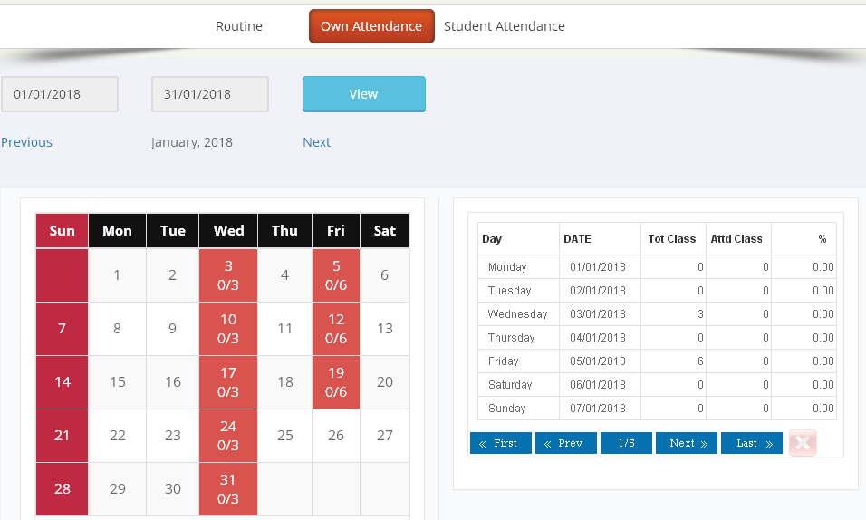

Fig.06

To view own attendance status click here

Then click view

For day status you can click on day