# Temporary routine change & Add special class

Add Special Class

Temporary routine change - Approval

Temporary routine change - Preparation

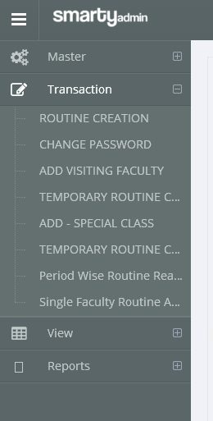

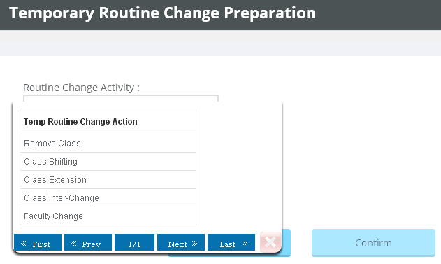

There are 5 options (Select your choice)

**For Removing Class**

Select Faculty

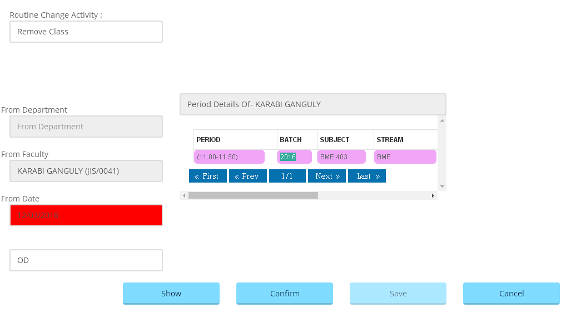

Click Save

Click Confirm

Double Click on Period want to remove

Enter date

Click Show

Enter Reason

**For Class Shifting**

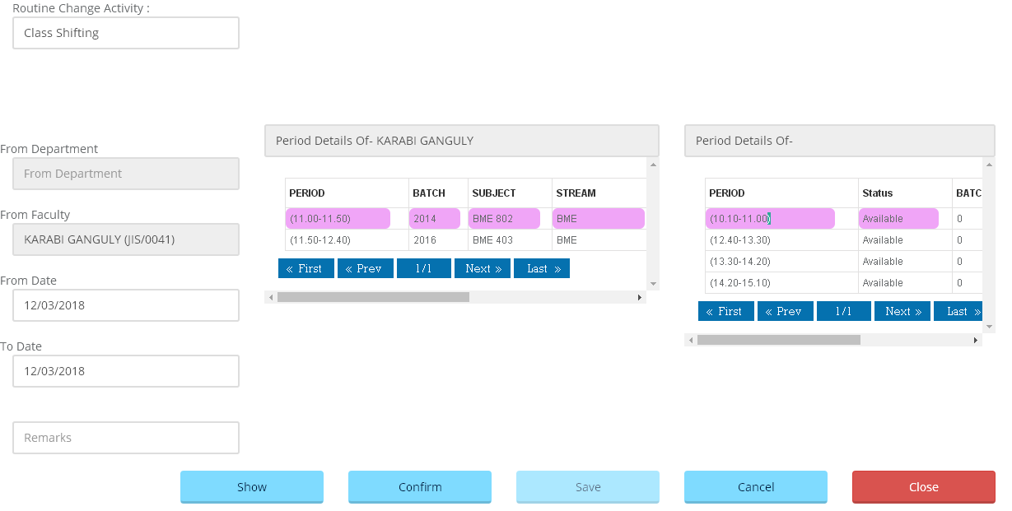

Double Click on Period target period

Click Confirm

Click Save

Select Faculty

Double Click on Period want to shift

Click Show

Enter Reason

Enter from & to date

**For Class Extension**

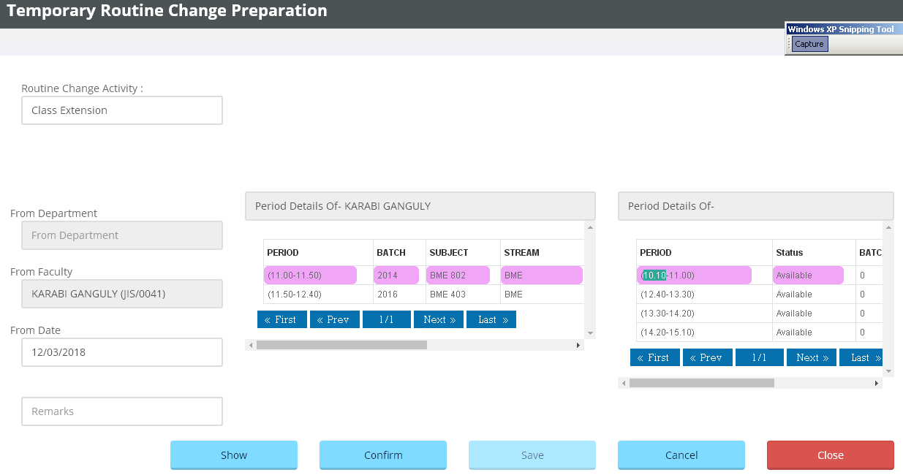

Click Confirm

Double Click On Period want to extend

Click Show

Enter Reason

Enter date

Select Faculty

Double Click On Period target period

Click Save

**For Class Inter-Change**

Enter from & to date

Select From & To Faculty

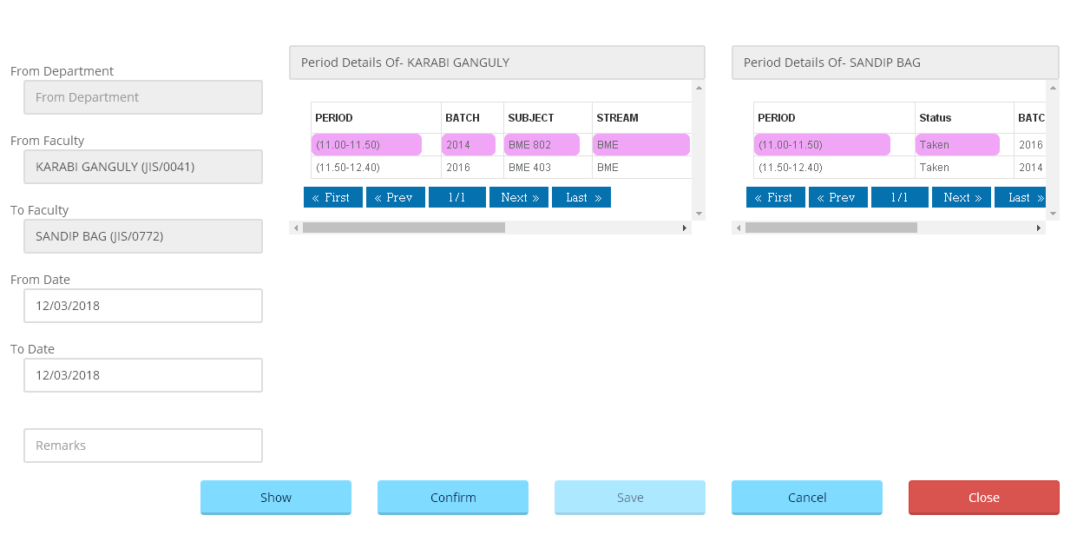

Click Save

Click Confirm

Double Click On to Period

Double Click On from Period

Click Show

Enter Reason

**For Faculty Change**

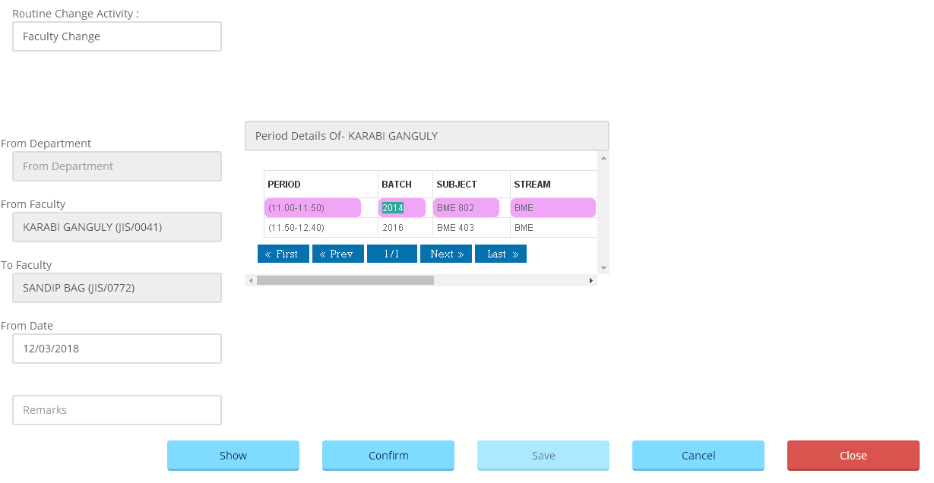

Click Save

Click Confirm

Double Click On Period want to change

Click Show

Enter Reason

Enter date

Select From & To Faculty

**For Approval of Routine Change request**

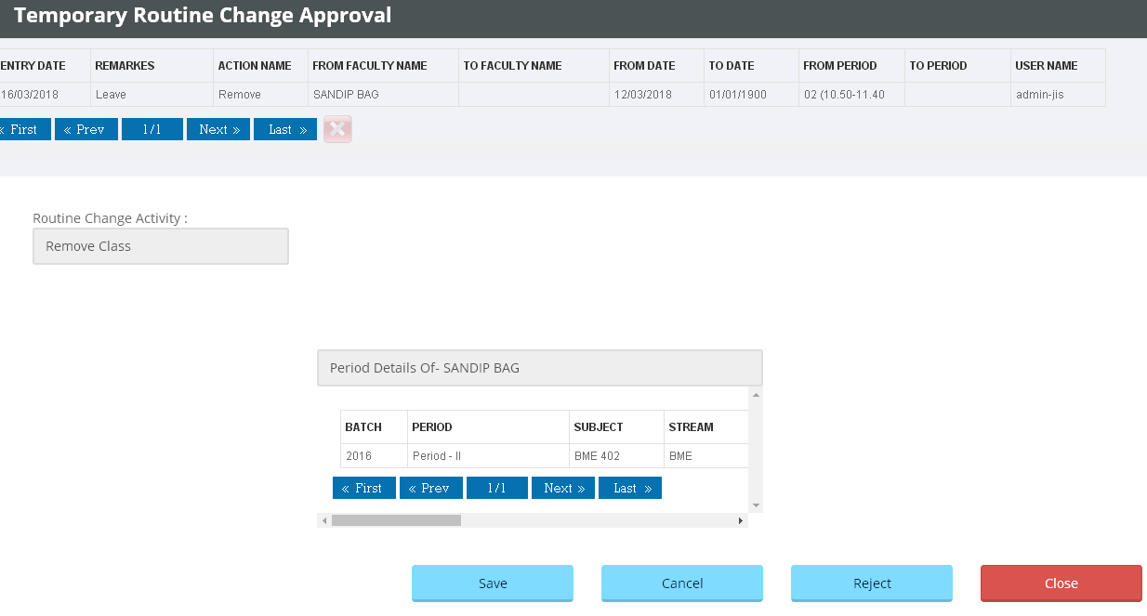

Click Save

Double click on Row

**For Add – Special Class**

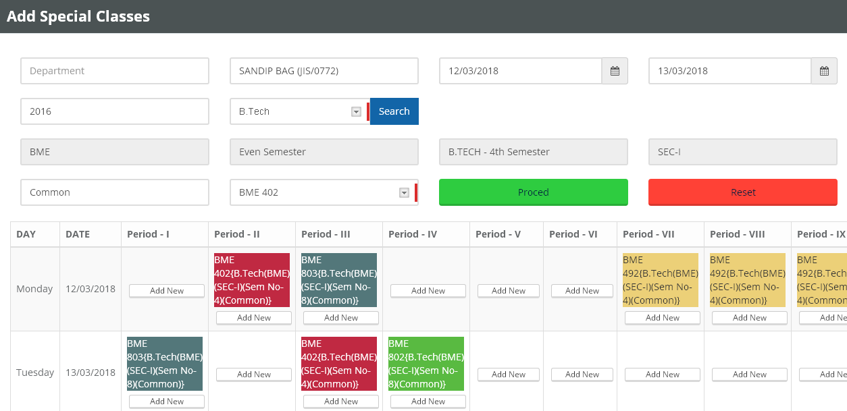

Select faculty

Select from & to date

Select routine

Click proceed

Click Add New button to Add

Select Group & Subject to add