Name: Muhammad Hasham Munir Qazi

Roll NO: 2024-SE-32

Course Code: CS-3112

Submission Date: 23rdOct,2026

Instructor Name: Engr.Fahad Nisar

Course Title:Digital Image Processing

Department of Software Engineering
Task 01: Installation of Python and Pip Verification

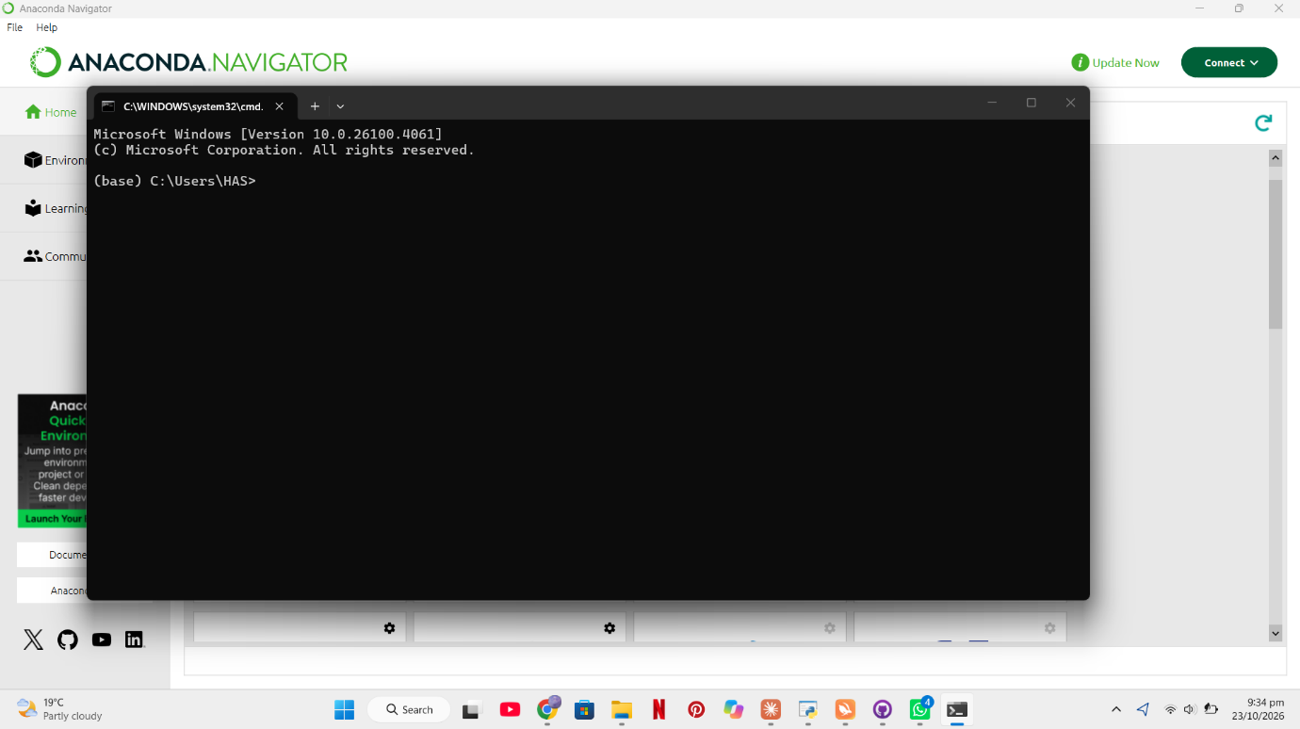
Task 02: VS Code Setup / Jupitor Notebook

➡️ I already install jupitor notebook that’s why I worked on Jupitor Notebook.
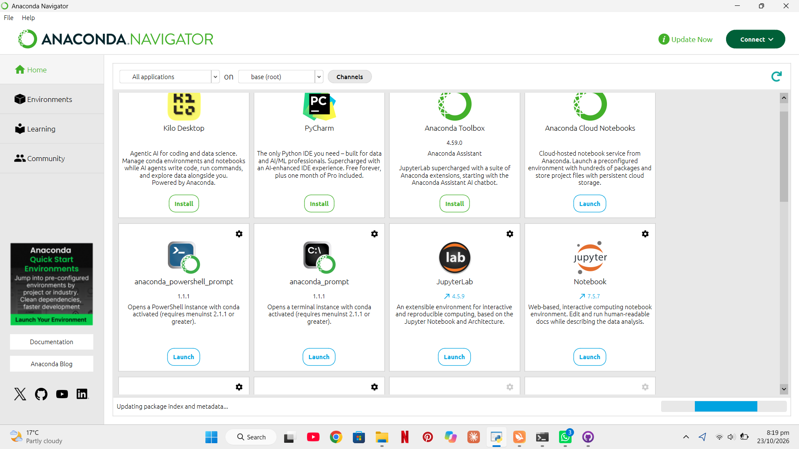

Task 03: My First Code

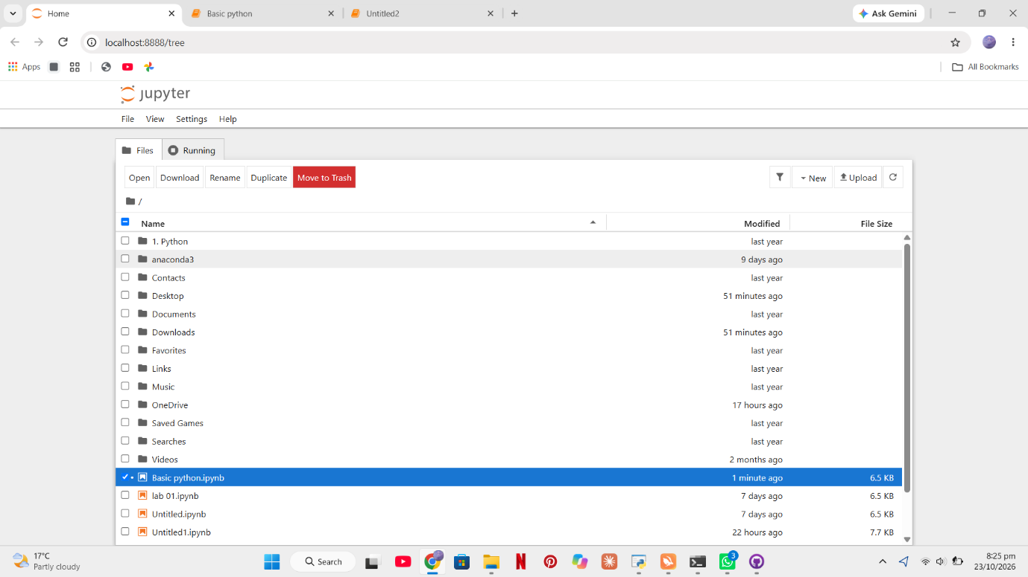

PRACTICE EXERCISES
Exercise 1: Variables and Data Types
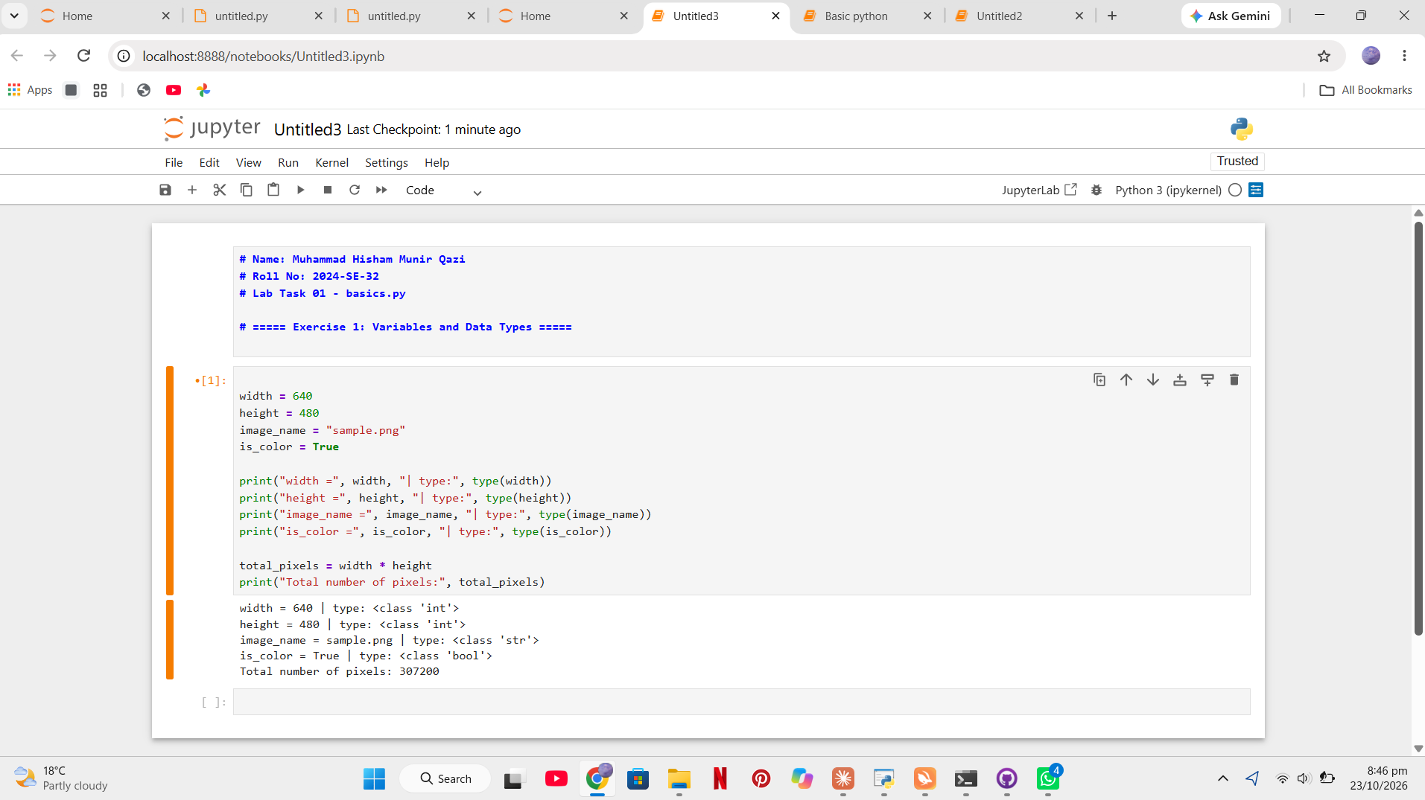

Exercise 2: if, elif, and else
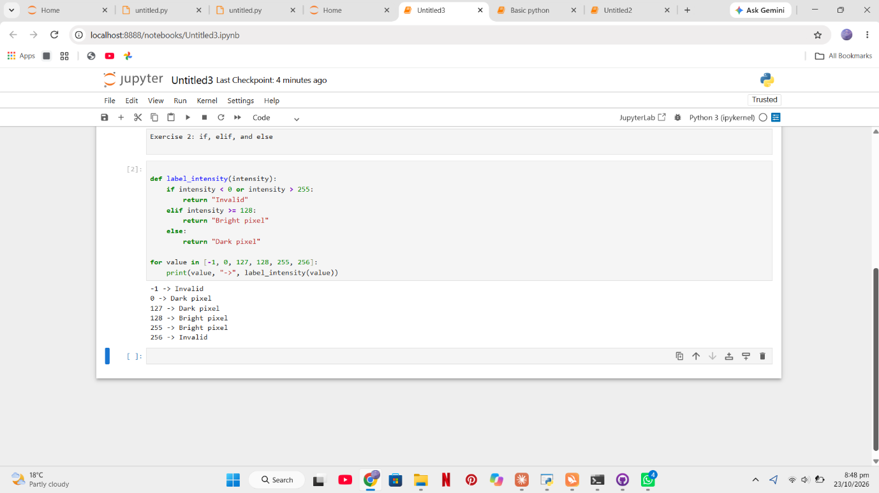
Exercise 3: for and while Loops
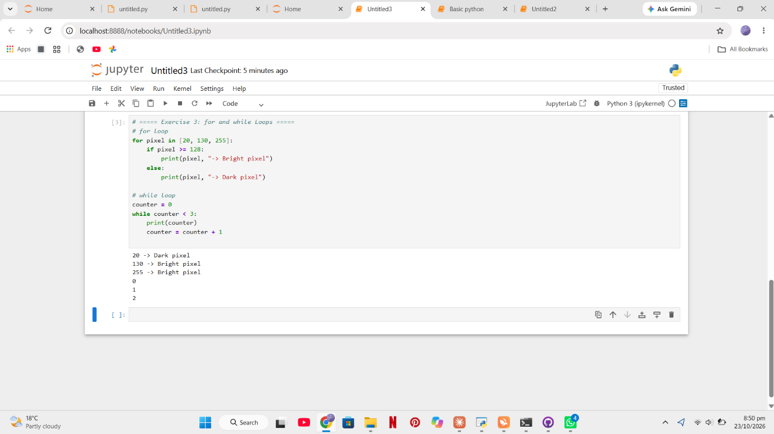
Exercise 4: Functions
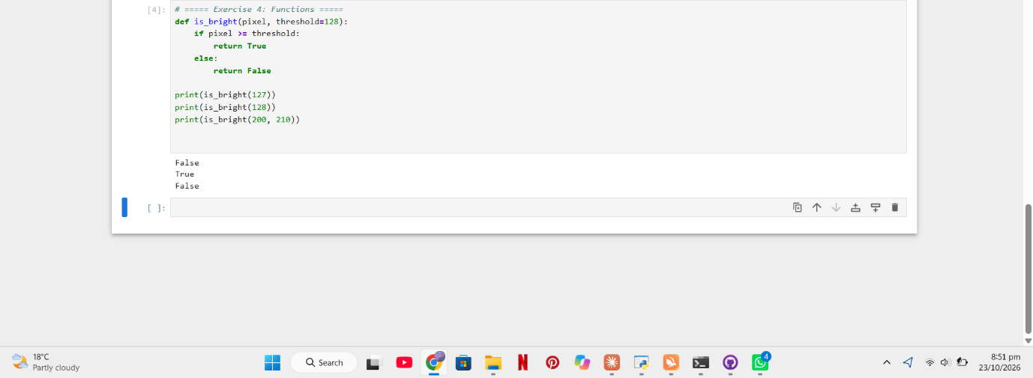
Exercise 5: Lists and Tuples
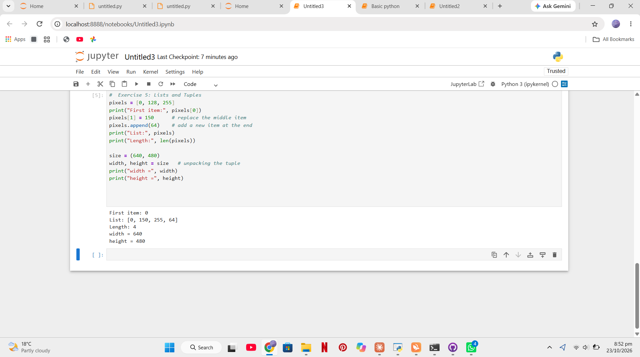

Exercise 6: Dictionaries and Sets
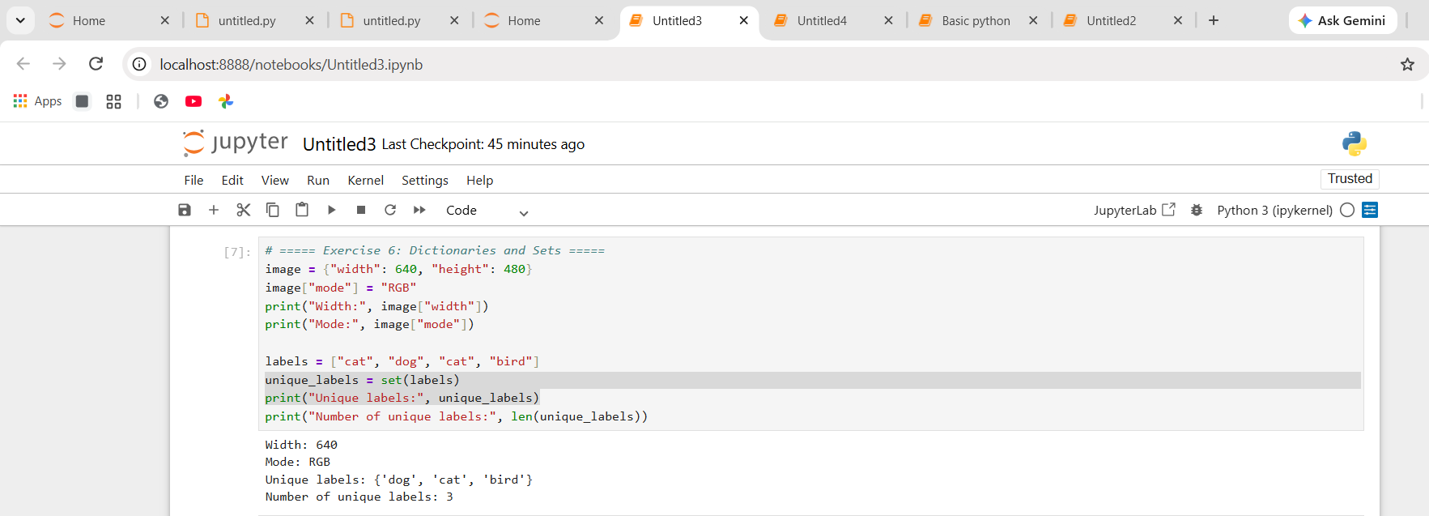
Task 04: Evidence of Installation of NumPy, Pillow aur Matplotlib
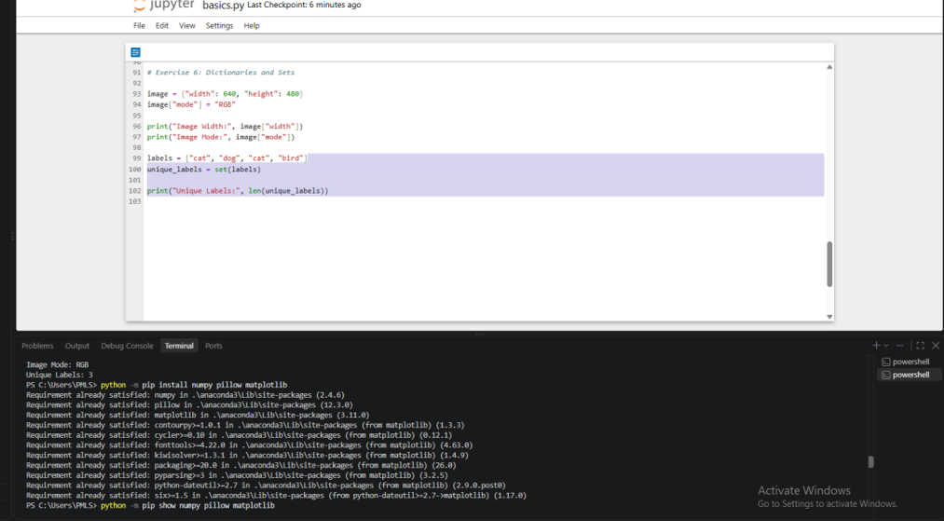

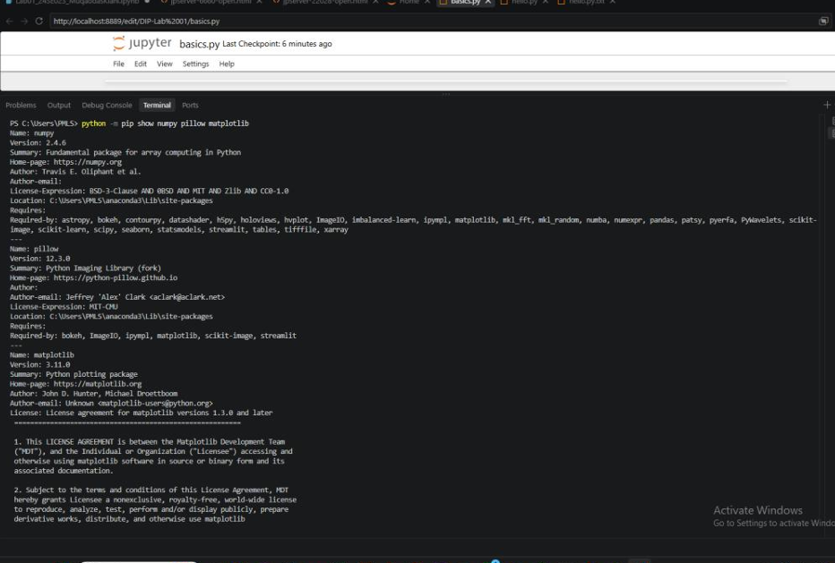
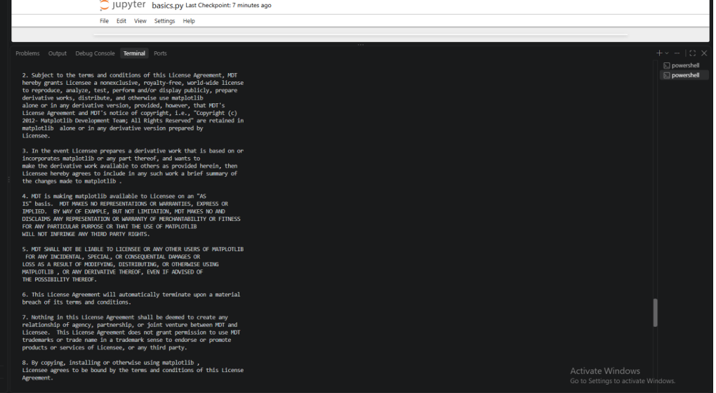

Task 05: Import Statements

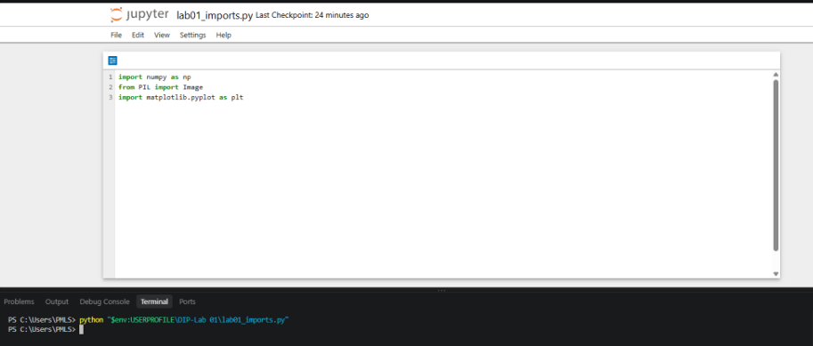
Successful Verification of Python Import Statements

Task 06: Python versus pip and the purpose of the import statements
Python vs pip: Python is the programming language, and it is also the program that runs our code. pip is Python’s package manager, which downloads and installs extra libraries such as NumPy, Pillow and Matplotlib. In short, Python runs our programs and pip adds the tools we need.
Purpose of the import statements: Import statements load a library into our program so we can use its tools. import numpy as np gives us arrays and number calculations. from PIL import Image lets us open and work with images. import matplotlib.pyplot as plt lets us draw plots and show images.

