***Library Management System***

* ***Use Case Diagram:***

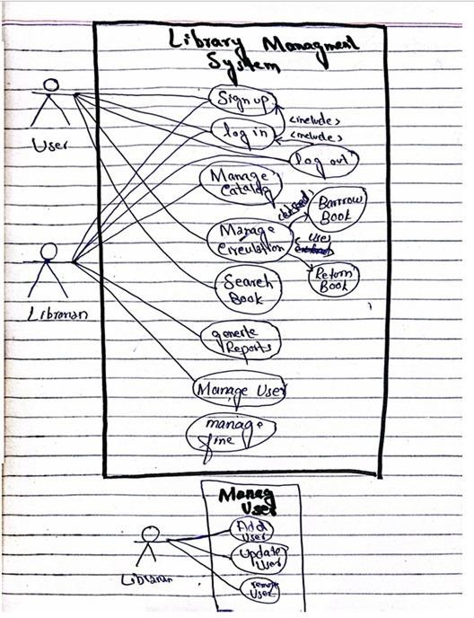G

* ***Fully Dressed use Case of*** *Return Book****:***
* **Use Case Name**: Return Book •
* **Actors**:
  + **Primary Actor**: Member
  + **Secondary Actor**: Librarian
* **Goal in Context**: Enable a library member to successfully return a borrowed book.

* **Preconditions**:
  + The member must be registered in the library system.
  + The member must have borrowed the book they wish to return.
* **Postconditions**:
  + The book is marked as returned in the system.
  + The transaction record is updated to reflect the return.
  + The book's availability is updated to indicate it is available for borrowing.
* **Main Success Scenario (MSS)**:
  + The member selects the book they wish to return.
  + The member requests to return the book through the library system.
  + The system verifies the member’s borrowing history.
  + The system confirms the book is eligible for return.
  + The librarian is notified of the return request.
  + The librarian confirms the return.
  + The system updates the transaction record to reflect the return. o
  + The system updates the book’s availability status.
  + The system provides the member with a confirmation receipt for the return.
* **Extensions**:
  + **E1: Book Not Borrowed**:
    - If the book was not borrowed by the member, the system informs the member and cancels the return process.
  + **E2: Late Return**:
    - If the book is returned after the due date, the system may apply late fees. ▪ The system informs the member of any fees incurred.
  + **E3: Transaction Failure**:
    - If an error occurs during the return process, the system informs the librarian. ▪ The transaction is aborted, and the member is notified.
* **Special Requirements**:

o The system must handle concurrent return requests efficiently.

* + Maintain data integrity during the return process.
  + Provide clear and user-friendly notifications for all scenarios.
* **Frequency of Use**: Expected to occur multiple times daily as members return books.
* **Open Issues**:

o What is the policy for lost or damaged books during the return process?

* + How will the system handle reservations for books that are returned and have pending requests?
* ***Class Diagram:***

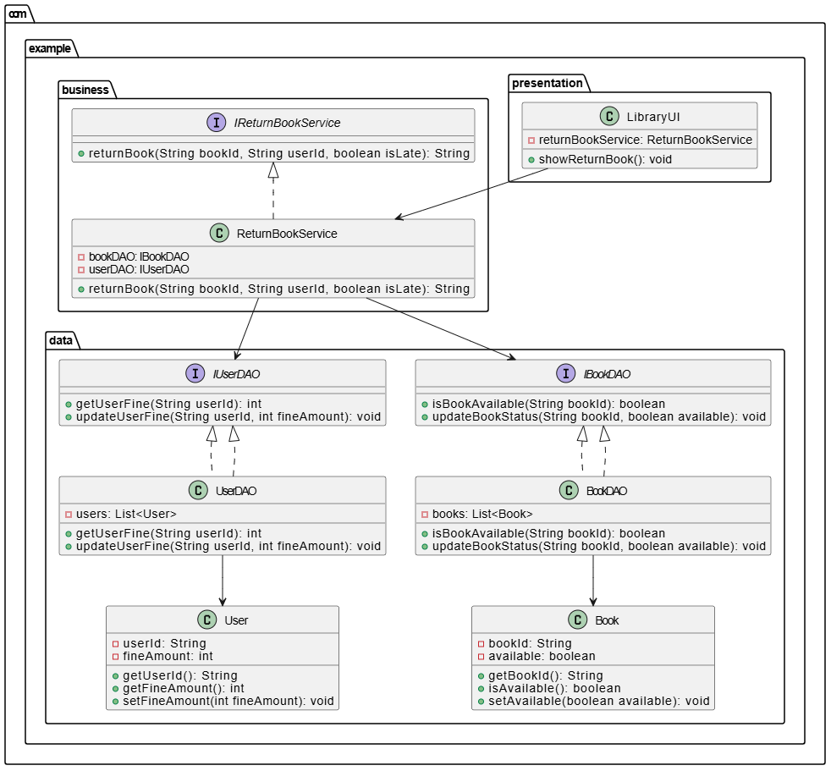

* ***System Sequence Diagram:***

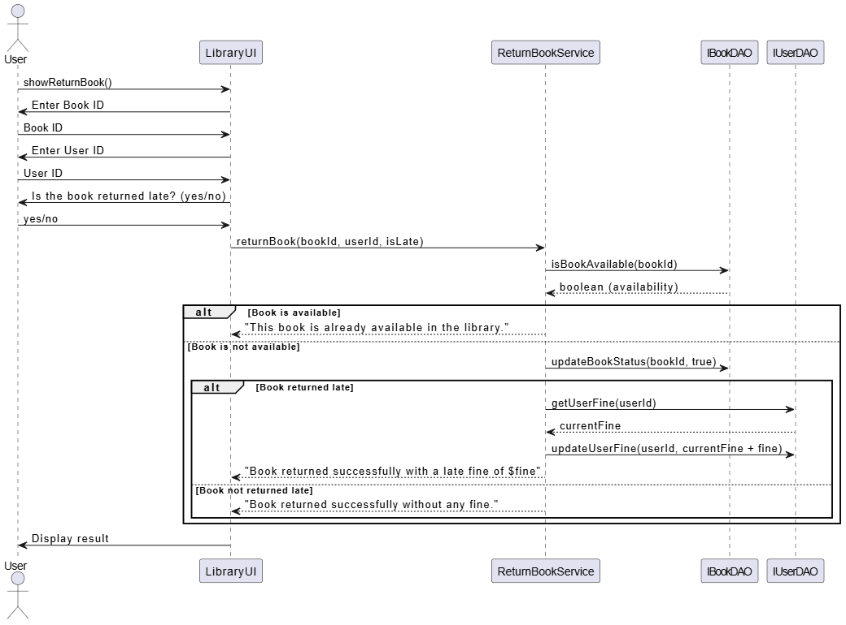

* ***Package Diagram:***

