**Multilingual AI-Based Translation Application**

**Abstract**

This report documents the development and implementation of a robust AI-powered multilingual translation application designed to bridge communication gaps across diverse languages. The application supports four core translation modes: speech-to-speech, speech-to-text, text-to-speech, and text-to-text. It leverages advanced natural language processing (NLP) techniques, speech recognition, and text-to-speech synthesis to provide seamless translation experiences in real-time. Combining online and offline capabilities, it ensures reliable operation across variable connectivity environments. The modular architecture enhances maintainability and future extensibility, supporting educational, professional, and social use cases. This report details the design, methodology, implementation, and scope of the project with emphasis on the application of artificial intelligence in multilingual communication.

**1. Introduction**

In an increasingly globalized world, the need for efficient, real-time multilingual communication tools has become paramount. Whether in international business, academic collaboration, travel, or online interaction, language barriers continue to hinder seamless human communication. While traditional translation tools offer basic support for text translation, they often lack integration with speech technologies or real-time responsiveness. The application presented in this report addresses these challenges through a unified multilingual translation platform incorporating artificial intelligence.

This AI-based translation application provides end-users with four essential modes of interaction:

* **Speech-to-Speech (S2S)**: Converts live spoken language into audible translated output.
* **Speech-to-Text (S2T)**: Transcribes spoken input and translates it into readable text.
* **Text-to-Speech (T2S)**: Translates written text and synthesizes speech in the target language.
* **Text-to-Text (T2T)**: Offers rapid language translation of textual content.

The application dynamically handles language changes and device management, ensuring compatibility with various microphones and speakers. Built with PyQt6 for the user interface and powered by a hybrid translation engine stack (Google, MarianMT, and LLaMA), it demonstrates how modern AI models can be harmonized for practical, real-world translation needs.

**2. Project Scope**

The project encapsulates the design and development of a multilingual translation tool that integrates voice and text processing capabilities for real-time communication. The scope of the application covers the following:

**2.1 Services Layer**

* **Text-to-Speech Engine (TTSEngine)**: Enables hybrid (online/offline) speech synthesis. Utilizes gTTS for internet-based TTS and pyttsx3 for offline fallback. Supports playback through user-selected audio devices.
* **Translation Services**:
  + **GoogleTranslator**: Leverages Google Translate API for fast, lightweight translation.
  + **MarianTranslator**: Uses HuggingFace’s MarianMT models for deterministic, offline-compatible translation.
  + **LLaMA Translator**: Integrates the LLaMA model via CLI for deep contextual translation and arbitration between candidates.
* **Translation Manager**: Coordinates translation tasks across all engines using parallel threads and best-output logic with chunked input handling.
* **SpeechWorker**: Captures audio input via microphone and transcribes it using Google’s speech recognition API. Emits results via signals and handles errors gracefully.

**2.2 GUI Pages Layer**

* **Speech-to-Speech Page**: Captures speech, translates it, and plays the translated speech aloud. Displays recognized and translated text.
* **Speech-to-Text Page**: Captures speech and displays both recognized and translated text without audio playback.
* **Text-to-Speech Page**: Accepts text input, translates it, and produces spoken output automatically or on user command.
* **Text-to-Text Page**: Provides instant or delayed textual translation with manual and auto-triggered modes.

**2.3 Main Window Layer**

* Central hub managing language selection, page navigation, and device configuration.
* Allows dynamic language switching with signal-based updates to all active pages.
* Lists and filters compatible microphones and speakers for input/output operations.

**2.4 Application Shell and Initialization**

* **Admin Window**: Implements singleton controller pattern to ensure a single GUI instance.
* **Startup Logic**: Boots the application, initializes UI via QApplication, and starts the event loop for real-time interaction.

**3. System Features and Functional Modules**

This section details each functional component of the application from a feature and implementation perspective.

**3.1 Speech-to-Speech Module**

The Speech-to-Speech (S2S) module allows users to speak into the microphone in one language and hear the translated version spoken aloud in the target language. It combines live voice recognition, multi-engine translation, and audio synthesis.

* **Recognition**: Uses SpeechWorker to capture microphone input and convert it into text using Google’s speech API.
* **Translation**: Text is sent to the TranslationManager which consults three translation engines (Google, Marian, LLaMA).
* **Synthesis**: Translated text is spoken using TTSEngine, with device output dynamically configurable.
* **User Interface**: Features include live feedback areas for recognized and translated text, and controls to pause/resume listening and replay translations.

**3.2 Speech-to-Text Module**

The Speech-to-Text (S2T) module focuses on transcription and translation for scenarios where voice is the input but only textual output is required.

* **Voice Input**: Captured via SpeechWorker with user-specified mic selection.
* **Display**: Displays live recognition and translation results in real-time.
* **Usability**: Handles microphone initialization issues gracefully with user alerts.

**3.3 Text-to-Speech Module**

The Text-to-Speech (T2S) module converts typed input into spoken output in the target language.

* **Typing Detection**: Automatically detects pauses in typing to trigger translation and playback.
* **Translation**: Uses TranslationManager to process text through the AI engines.
* **Playback**: Outputs audio through the TTSEngine with support for both automatic and manual control.
* **Device Output**: Output speaker can be chosen by the user for environment-specific playback.

**3.4 Text-to-Text Module**

This module allows for traditional text-based translation with enhanced flexibility.

* **Input**: Users enter text directly into a text area.
* **Auto and Manual Modes**: Translation is triggered either after a delay (auto) or via a button (manual).
* **Language Adaptation**: Adjusts translation dynamically if the language settings change mid-session.

**3.5 Device and Language Management**

* **Microphone and Speaker Selection**: Lists compatible hardware devices, filtering out virtual ones to avoid noise or non-functional setups.
* **Language Switching**: Dynamically updates all pages and modules when user changes source/target languages.
* **Signal Binding**: PyQt6 signals and slots architecture ensures seamless communication across components.

**4. System Architecture and Design**

The system adopts a layered, modular architecture that ensures scalability, separation of concerns, and maintainability. The architecture is logically divided into four main layers:

**4.1 Presentation Layer (GUI)**

Implemented using PyQt6, the graphical user interface comprises modular pages, each representing a translation mode. The main window manages layout stacking, user navigation, device selection, and language configuration.

* **Components**:
  + MainWindow: Hosts language selectors, device lists, and navigation buttons.
  + SpeechToSpeechPage, SpeechToTextPage, TextToSpeechPage, TextToTextPage: Functional pages bound to the services via signals.

**4.2 Application Control Layer**

Handles inter-page coordination, singleton instantiation, and session-wide control.

* **Admin Class**: Implements singleton pattern to avoid redundant application states.
* **Startup Logic**: Initializes the Qt environment, boots the Admin window, and manages application lifecycle.

**4.3 Service Layer**

Abstracts core translation, speech recognition, and text-to-speech services:

* **TranslationManager**: Manages translation pipelines across multiple engines.
* **SpeechWorker**: Manages microphone access and live recognition.
* **TTSEngine**: Handles hybrid TTS capabilities and playback control.

**4.4 External Integrations Layer**

Handles connectivity with external APIs and local model inference systems:

* **Google Translate API**: For fast, online translation.
* **HuggingFace MarianMT Models**: For deterministic, offline translation.
* **Ollama CLI with LLaMA**: For large language model translation.
* **Google Speech Recognition**: For speech-to-text transcription.
* **gTTS and pyttsx3**: For TTS synthesis based on connectivity status.

This layered approach ensures that each part of the application can evolve independently, facilitates unit testing, and enhances the maintainability of the codebase.

**5. Methodology**

The methodology for developing this application was driven by modularity, adaptability, and user-centric interaction. Each module was independently developed and tested to ensure scalability and maintainable integration. The development process followed a systematic, iterative cycle structured around the following principles:

**5.1 Modular Design Approach**

Each translation mode (S2S, S2T, T2S, T2T) was implemented as a standalone page with clear boundaries between the user interface and underlying service logic. This enabled focused development and testing, while allowing integration through common interfaces.

**5.2 Hybrid AI Translation Strategy**

The translation engine stack was architected to combine online and offline translation services:

* **Primary Translators**: Google and MarianMT handle real-time and deterministic tasks.
* **Validation Engine**: LLaMA is used to confirm the accuracy of results by evaluating multiple candidates.
* **Voting Logic**: Implemented to select the most probable and fluent translation by comparing Google and MarianMT outputs with LLaMA arbitration.

**5.3 Asynchronous Processing and Responsiveness**

Multithreading was used to prevent blocking operations in translation and speech recognition:

* Parallel threads execute translators to speed up responses.
* Real-time signal emission from SpeechWorker allows UI updates without lag.
* Thread-safe UI operations ensured via PyQt6 signal-slot mechanism.

**5.4 Offline and Online Fallback Logic**

To support both connected and disconnected environments:

* **Speech Recognition**: Requires network access for Google's API.
* **Text-to-Speech**: gTTS (online) is used by default, with fallback to pyttsx3 (offline) when no connection is detected.
* This redundancy improves system robustness and availability.

**5.5 Device-Aware UI and Adaptive Configuration**

* The application dynamically scans for audio input/output devices at launch.
* Only relevant, non-virtual devices are shown.
* Output devices can be changed mid-session without restarting.

**5.6 Signal-Driven Language Configuration**

* Centralized language management ensures that all pages receive updated language settings via custom PyQt signals.
* GUI components respond instantly to language changes, resetting or reinitializing translation contexts accordingly.

This methodology not only facilitated a reliable and feature-rich implementation but also laid a solid foundation for future extension and integration of additional translation models and interface enhancements.

**6. System Features and Functional Modules**

This section elaborates on each primary module of the application, outlining their functionality, workflow, and user interactions.

**6.1 Speech-to-Speech Module**  
The Speech-to-Speech (S2S) module enables real-time oral translation, converting spoken input into audible translated output seamlessly.

* **Input:** Live audio is captured from the user’s selected microphone.
* **Processing:** The audio stream is passed to the SpeechWorker, which performs speech-to-text transcription using Google’s Speech Recognition API.
* **Translation:** The transcribed text is forwarded to the TranslationManager where three translation engines (Google, MarianMT, LLaMA) process it concurrently. A voting mechanism selects the optimal translated text.
* **Output:** The resulting translation is synthesized into speech via the TTSEngine using either gTTS or pyttsx3 depending on connectivity.
* **UI:** The module provides real-time display of both recognized and translated texts, with controls to start, pause, and replay translations. Users can dynamically switch source and target languages and configure audio devices.

**6.2 Speech-to-Text Module**  
The Speech-to-Text (S2T) module captures voice input and provides textual translation without audio output.

* **Input:** Captured via microphone through the SpeechWorker.
* **Processing:** Transcription and translation occur in the same manner as S2S but only textual output is displayed.
* **UI:** Displays recognized speech and translated text side-by-side. Error handling alerts users to microphone or network issues.

**6.3 Text-to-Speech Module**  
The Text-to-Speech (T2S) module translates typed text into audible speech in the chosen target language.

* **Input:** Users enter text in an input field.
* **Processing:** Translation is triggered automatically after typing pauses or manually via a button.
* **Output:** The translated text is synthesized to speech via TTSEngine.
* **UI:** Allows user selection of output audio device and control over playback (auto/manual).

**6.4 Text-to-Text Module**  
This module facilitates traditional text translation.

* **Input:** Text is typed directly into a translation box.
* **Modes:** Supports both automatic translation triggered after a timeout and manual translation via a button.
* **Dynamic Language Adaptation:** Changes in source or target language immediately refresh the translation.
* **Output:** Translated text is displayed for user reading or copying.

**6.5 Language and Device Management**  
The application includes comprehensive device and language management features:

* **Device Selection:** Microphone and speaker lists are dynamically populated at runtime. Virtual or unusable devices are filtered out.
* **Language Switching:** Source and target language selectors update all modules in real-time via PyQt signal/slot bindings.
* **UI Feedback:** Device and language changes propagate throughout the GUI without restarting the application.

**7. System Architecture and Design**

The system employs a modular, layered design promoting scalability and ease of maintenance.

**7.1 Architecture Overview**  
The application is logically divided into four layers:

* **Presentation Layer:** PyQt6-powered GUI with modular pages and main window for navigation and configuration.
* **Application Control Layer:** Centralized singleton controller for session management.
* **Service Layer:** TranslationManager, SpeechWorker, and TTSEngine services abstract core functionalities.
* **External Integrations Layer:** Interfaces with Google APIs, HuggingFace models, LLaMA CLI, and local TTS engines.

**7.2 Component Interaction**  
Components communicate primarily via PyQt’s signal-slot mechanism enabling asynchronous, thread-safe updates. The MainWindow coordinates UI components and device/language selections.

**7.3 Technology Stack**

| **Component** | **Technology / Library** |
| --- | --- |
| GUI Framework | PyQt6 |
| Speech Recognition | Google Speech Recognition API |
| Translation Engines | Google Translate API, MarianMT (HuggingFace), LLaMA (Ollama CLI) |
| Text-to-Speech | gTTS (online), pyttsx3 (offline fallback) |
| Multithreading | Python threading, PyQt signals |
| Model Arbitration | Custom voting logic for translation results |

**8. Challenges and Limitations**

During the development and testing of the Multilingual AI-Based Translation Application, several challenges and limitations were identified, impacting both performance and user experience:

* **Continuous Live Translation:**  
  Handling continuous real-time audio input while simultaneously producing translated speech output poses synchronization challenges. Maintaining low latency without cutting off ongoing speech requires careful buffering and threading management.
* **Runtime Performance:**  
  Translation and synthesis runtimes may increase notably with longer input texts or complex sentences, especially when multiple translation engines are queried concurrently. This can cause noticeable delays impacting the user experience.
* **Offline Strategy for Online Features:**  
  Implementing reliable offline alternatives for features that primarily depend on online APIs (e.g., Google Translate, Google Speech Recognition) remains a complex task. Current offline solutions are limited in language coverage and model size, leading to performance and accuracy trade-offs.
* **Limitations of MarianMT Models:**  
  MarianMT models from HuggingFace, while effective for offline translation, struggle with very large or lengthy paragraphs, causing degraded translation quality or increased processing time. This limitation impacts the ability to handle bulk text translation smoothly.
* **User Experience Shortcomings:**  
  The current application UI lacks interactive animations or progress indicators, leading to user uncertainty during translation delays. No visual feedback explicitly signals ongoing translation or processing, which can be confusing during longer wait times.
* **Potential Application Freezes:**  
  Running the LLaMA model in the background for translation arbitration is resource-intensive. Under certain conditions, this can lead to application freezes or reduced responsiveness, particularly on systems with limited CPU or memory resources.

**9. Future Enhancements**

* **Multimodal Input Support:** Integrate image-based text recognition (OCR) to allow users to translate text captured from photos or screenshots, expanding usability beyond audio and typed input.
* **Personalized Language Profiles:** Enable user-specific preferences such as dialect selection, speech speed, and vocabulary customization to improve translation relevance and user comfort.
* **Context-Aware Translation:** Incorporate contextual understanding by leveraging conversation history or domain-specific language models to improve accuracy in specialized fields such as medical, legal, or technical translations.
* **Collaborative Translation Sessions:** Develop real-time multi-user translation rooms enabling multiple participants to communicate simultaneously with synchronized translations and shared device controls.
* **Accessibility Features:** Implement support for hearing-impaired users with captioning, adjustable font sizes, and color contrast themes to make the application more inclusive.
* **Cloud Synchronization and User Settings Backup:** Allow users to save preferences and translation histories in the cloud for seamless access across devices and sessions.

**10. Conclusion**

This multilingual AI-based translation application represents a significant step toward breaking down language barriers by combining advanced AI-driven speech and text processing technologies. Its versatile architecture enables users to communicate effortlessly across languages in multiple modes, enhancing global connectivity. While certain challenges remain, particularly in handling complex inputs and optimizing user experience, the foundation laid by this project offers a robust platform for continued innovation. The application underscores the transformative role of artificial intelligence in facilitating cross-cultural communication and sets the stage for future advancements in real-time translation technology.

11.Screenshots:

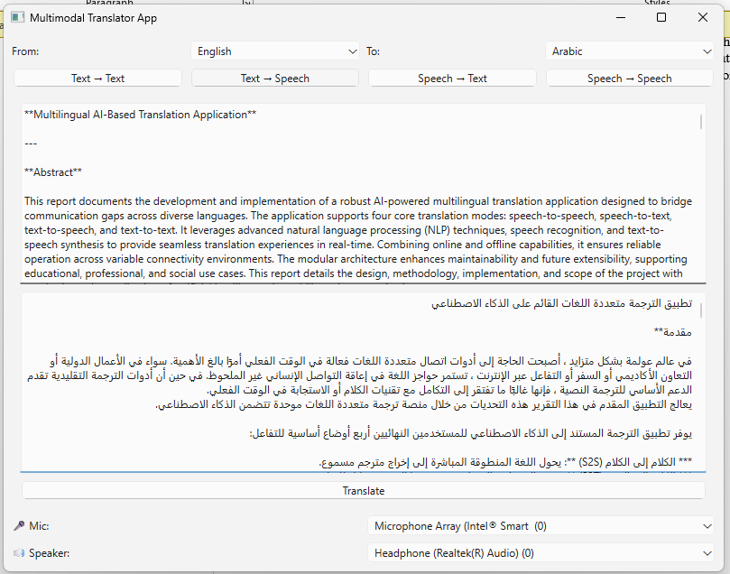

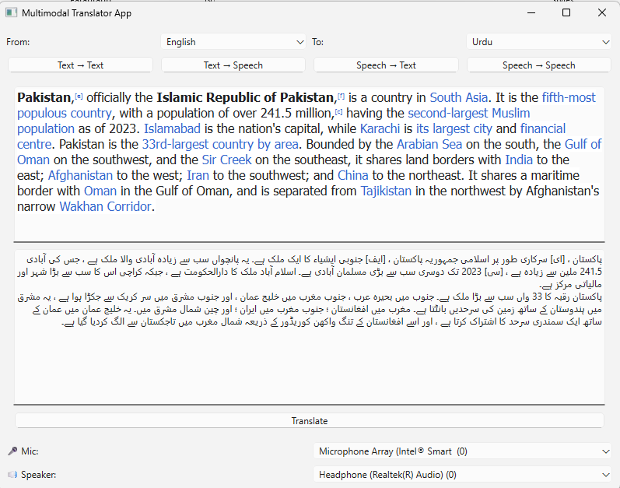

To download the application see this GitHub Repository :