UNDERGRADUATE FINAL YEAR PROJECT REPORT
Department of Computer Science


NED University of Engineering and Technology
A Single Window Information System for NED University

Group Number: CT-21004 Batch: 2021– 2022

Group Member Names:

Reham Abdul Aleem CT-21006
Omar Khan CT-21033
Abdullah Suhayb CT-21043
Hiba Faheem CT-21063

Approved by
……………………………………………………………………………………………...
Dr Muhammad Mubashir Chairman CSIT
Co-Project Advisor
Dr Umer Farooq

© NED University of Engineering & Technology. All Rights Reserved – November 202

Author’s Declaration

We declare that we are the sole authors of this project. It is the actual copy of the project that was accepted by our advisor(s) including any necessary revisions. We also grant NED University of Engineering and Technology permission to reproduce and distribute electronic or paper copies of this project.

Signature and Date | Signature and Date | Signature and Date | Signature and Date
................................. | ................................ | ................................ | .................................
26/11/2024 | 26/11/2024 | 26/11/2024 | 26/11/2024
Reham Abdul Aleem | Omar Khan | Abdullah Suhayb | Hiba Faheem Usmani
CT-21006 | CT-21033 | CT-21043 | CT-21063
aleem4402230@cloud.neduet.edu.pk | omarjawaidkhan4430115@cloud.neduet.edu.pk | ahmed4410671@cloud.neduet.edu.pk | usmani4404470@neduet.edu.pk

F/SOP/FYDP 02/06/00

Statement of Contributions

- Reham Abdul Aleem:
- Omar Khan
- Abdullah Suhayb
- Hiba Faheem

- Abdullah: Contributed in front end design for the login page. Also designed the databases, dockerized the databases, and connected to our dashboard tool.

- Reham: designed the front end with hiba on how the dashboard will look to the user. Finding the statistics that will be displayed to the user

- Hiba: contributed to the design of front end with Reham and also our secretary for meetings with supervisor, co-supervisor and external supervisor.

- Omar: Worked with Abdullah on frontend design for login page and also helped with dockerizing of the databases. Contributed to making sure that scripts were compatible across multiple operating systems.

- All team members contributed equally to planning the project documenting the work, and preparing the project report.

Executive Summary

Background:
The report addresses the challenges arising from the decentralized data management system at NED University. Each administrative and academic department operates independent databases, creating significant inefficiencies in cross-departmental collaboration. Tasks requiring data integration, such as generating comprehensive reports, become time-consuming and labor-intensive due to the need for separate data extractions from each department. Additionally, the lack of centralized data access restricts real-time data operations and poses barriers to research and innovation by limiting data availability to departmental working hours.

Resolving issues:
To resolve these issues, the Single Window Information System project proposes the establishment of a centralized data repository. This repository will standardize and store data from all major departments, ensuring that stakeholders have secure and authorized access via an intuitive web-based interface. The system’s design emphasizes adherence to data privacy and security policies, supporting seamless operations and decision-making processes.

Methodology:
The methodology employed in this project involves a phased approach, beginning with the analysis of existing departmental data structures and workflows. This is followed by the design of a unified data model and the development of a Data virtualization POC which will simulate the finalized product. A user-friendly web interface is to be created to facilitate access while ensuring role-based permissions to maintain data integrity and confidentiality. Extensive testing and iterative feedback loops ensured the system met user requirements effectively.

Major Findings:
The major findings of the project highlight the significant reduction in time and effort required for data access and integration. The centralized repository not only streamlines cross-departmental collaboration but also enhances the availability of data for research and decision-making. Furthermore, the system improves operational efficiency by providing real-time data access regardless of departmental schedules.

Conclusion:
In conclusion, the Single Window Information System provides a robust solution to the challenges posed by decentralized data management at NED University. By enabling unified, secure, and efficient access to data, the system supports the university’s administrative and academic functions, fostering a culture of innovation and collaboration. This centralized approach represents a transformative step toward optimizing data-driven operations and supporting future growth.

F/SOP/FYDP 02/06/00

Acknowledgments

We would like to express our deepest gratitude to Dr. Umer, Assistant Professor in the CSIT Department of NED University, for his invaluable guidance and expertise in the data domain.

We also extend our heartfelt thanks to Dr. Mubashir, Chairman of the CSIT Department at NED University, for providing us with the necessary resources and unwavering support. His leadership and encouragement were crucial in guiding us throughout this journey. Additionally, we are grateful to him for connecting us with Mr. Muhammad Sufyan, an esteemed alumnus of NED University.
Mr. Muhammad Sufyan, serving as our external supervisor, has been a pillar of technical expertise and mentorship. His constructive feedback and profound knowledge have greatly enriched our understanding and contributed significantly to the project's outcomes.

Their collective support and guidance have not only enhanced our academic and technical skills but also inspired us to achieve excellence. We are profoundly grateful for their contributions and encouragement throughout this endeavor.

Table of Contents

Contents
Statement of Contributions 3
Executive Summary 4
Background: 4
Resolving issues: 4
Methodology: 4
Major Findings: 4
Conclusion: 5
Acknowledgments 6
Table of Contents 7
Table Of Figures: 9
United Nations Sustainable Development Goals 10
Similarity Index Report 11
Chapter 1 15
Introduction 15
1.1 Background Information 15
1.2 Significance and Motivation 15
1.3 Aims and Objectives 16
1.4 Methodology 16
1.5 Report Outline 17
Chapter 2 18
Literature Review 18
2.1 Introduction 18
18
2.2 Decentralized Data Management in Academia 18
2.3 Centralized Databases and Data Lakes 19
20
2.4 Web-based interfaces for data access 20
2.5 Data Analytics and Visualization Tools 21
2.6 Data security and Privacy 21
2.7 Summary 21
Chapter 3 23
Comparison of Data Lake and Data Virtualization Solutions 23
3.1 Introduction 23
3.2 Data Lake Solutions 23
3.3 Data Virtualization Solutions 24
3.4 Comparison of Data Lake and Data Virtualization 24
3.5 Summary 24
Chapter 4 26
System Design for Data Virtualization 26
4.1 Introduction 26
4.2 Components of the System Design 26
4.2.1 Departmental Databases 26
4.2.2 Apache Trino 26
4.3 Integration with Apache Superset 27
27
4.4 System Workflow 28
28
4.5 Advantages of the System Design 28
4.6 Summary 29
Chapter 5 Methodology/ Implemenation 30
5.1 Flowchart 30
5.2 Method /Explanation: 30
5.2.1Tier 0: Requirements Analysis 30
5.2.2Tier 1: System Design 30
5.2.3Tier 2: Implementation 31
5.2.4Tier 3: Testing 31
5.2.5Tier 4: Deployment 31
5.2.6 Tier 5: Maintenance 31
5.2.7 Tier 6: Stakeholder Feedback and Continuous Improvement 31
Chapter 6 Conclusions 32
6.1 Summary 32
6.2 Recommendations for Future Work 32
References: 34

Table Of Figures:

Figure 1Basic concept 18
Figure 2 describes how complicated the data integration task is in decentralized systems which depend on adhoc/solitary solutions. 19
Figure 3 How a centeralised system would look like 20
Figure 4 The dashboard looks like this having containers 21
Figure 5 We created containers in docker to store our data for the POC 21
Figure 6 Flow diagram of how data will be visualised 25
Figure 7Integrating with trino apache 27
Figure 8 Configuring Apache and connecting databases 27
Figure 9 Data Visualisation Architecture 28
Figure 10 Flowdiagram of our Project 30

United Nations Sustainable Development Goals
The Sustainable Development Goals (SDGs) are the blueprint to achieve a better and
more sustainable future for all. They address the global challenges we face, including
poverty, inequality, climate change, environmental degradation, peace and justice. There
is a total of 17 SDGs as mentioned below. Check the appropriate SDGs related to the
project.
□ No Poverty
□ Zero Hunger
□ Good Health and Well being
□ Quality Education
□ Gender Equality
□ Clean Water and Sanitation
□ Affordable and Clean Energy
□ Decent Work and Economic Growth
□ Industry, Innovation and Infrastructure
□ Reduced Inequalities
□ Sustainable Cities and Communities
□ Responsible Consumption and Production
□ Climate Action
□ Life Below Water
□ Life on Land
□ Peace and Justice and Strong Institutions
□ Partnerships to Achieve the Goals

Similarity Index Report
Following students have compiled the final year report on the topic given below for partial fulfillment of the requirement for Bachelor’s degree in Computer Science.

Project Title: A Single Window Information System for NED University

Sr.no Student Name | Seat Number
- Reham Abdul Aleem CT-21006
- Omar Khan CT-21033
- Abdullah Suhayb CT-21043
- Hiba Faheem Usmani CT-21063

This is to certify that Plagiarism test was conducted on complete report, and overall similarity index was found to be less than 20%, with maximum 5% from single source, as required.
Signature and Date

..................................
Dr Muhammad Mubashir

[Attach here the first and last page of the plagiarism report generated by Turnitin.]

F/SOP/FYDP 02/06/00

Chapter 1

Introduction

1.1 Background Information
The Single Window Information System project addresses the challenges stemming from the decentralized data management system at NED University. Currently, each administrative and academic department maintains its independent database, making it somewhat inefficient to work with and much more difficult to cooperate across boundaries. Data integration for comprehensive reporting requires heavy manual labor, as currently need separate extractions from each department. Real-time operations cannot be achieved because there is no centralized access to data, so research and innovation are severely hampered because data is available only during departmental working hours.
The project is intended to bring all this into one central repository. The repository will aggregate and standardize all data for most large departments, and it will provide role-based access through a web-based interface, ensuring its security. For example, we can get access to data from Electrical department and Computer Science department from one platform only. The system will make operational efficiencies, data-driven decision making, and an innovative, collaborative culture possible.

1.2 Significance and Motivation
The significance of this project lies in its potential to transform the data management landscape at NED University. The centralized access and storage of data will lead to constituting an administrative or academic setup where people will mostly carry out their activities without facing the problem of data retrieval and access.
Some benefits of the project are as follows:
- Better Efficiency: Time and effort wastage are reduced in reaching data and data fusion.
- Better Collaboration: Cross-department seamless workflows for data sharing.
- Real-time Access: Availability of current data for research and decision-making.
- Data Security: Role-based permissions and adherence to privacy standards ensure data integrity.
The motivation behind this project is the increasingly compelling case for establishing a common data platform, which would go a long way toward satisfying the changing academic and administrative needs of the university. It will also help to overcome the limitations of the present non-integrated system by enabling stakeholders to make better decisions, resulting in promoting a data-driven culture.

1.3 Aims and Objectives
The project's objectives are:
- Develop a Centralized Repository: Integrate and standardize data from all major departments.
- Create a User-Friendly Interface: Create an intuitive web-based platform for secure, role-based data access.
- Ensure Data Security and Privacy: Develop strong policies to protect sensitive information.
- Support Research and Innovation: Facilitate access to data in real time for academic research.
- Enhance Operational Efficiency: Streamline processes within an organization by managing data centrally.

1.4 Methodology
The phases of systematic development and implementation are :
- Analysis Of The Current Systems: It evaluates department structures and flows data.
- Unified Data Model Design: Defining the common standard framework data collection.
- Development Proof of Concept for Data Virtualization: This is to simulate the central system to determine if it will actually work.
- Implementation of web interface: Construct user-friendly access role-based platform.
- Testing and feedback iterative: Heaving out the heavy tests done to be able to see the in and out of failures followed by user feedback for system improvement.
- Deploy and Train: The system will be rolled out for use by stakeholders and trained on usage.

1.5 Report Outline
- Chapter 1: Introduction: This provides background, significance, aims, methodology, and project outline.
- Chapter 2: Literature Review: Discusses the related works and best practices in centralized data systems.
- Chapter 3: System Analysis and Design: The analysis of existing systems and design of proposed solutions will be detailed.
- Chapter 4: Implementation: Development of centralized repository and web interface is described.
- Chapter 5: Testing and Evaluation: Testing procedures are discussed and system performance evaluation made.
- Chapter 6: Conclusion and Recommendations: Wraps its findings and points out future improvements.

F/SOP/FYDP 02/06/00

Chapter 2

Literature Review

2.1 Introduction
This chapter offers thorough literature covering research and development in centralized data repositories and data lakes as regarding their applications within academic institutions. It also identifies existing limitations of decentralized database systems and presents attempts to implement centralized systems before drawing other researchers' attention to gaps the proposed NED Data Lake project intends to fill. The chapter also discusses progress on bridging web-based data management interfaces with data analysis tools and security. The concept is to assess past research and existing solutions critically for which they can justify considerations in developing the proposed system.
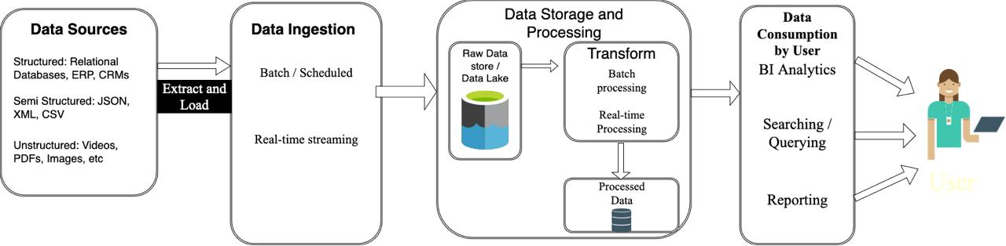
Figure 1Basic concept

2.2 Decentralized Data Management in Academia
Almost all institutions have decentralized data management systems. There were individual departments that had independent databases for administering academic processes. This method affects the sharing of information across departments on administrative decision making as well as complicating procedures and increasing inefficiencies. For example, generating institution-wide reports usually requires manual data extraction from several sources, which results in significant time delays and increased workload.
The extent of department autonomy afforded by decentralized systems comes with the cost of disadvantages that far exceed the benefits in situations that require widespread data access across an institution. It thus reinforces the great need for a unified central system. The extent of department autonomy afforded by decentralized systems comes with the cost of disadvantages that far exceed the benefits in situations that require widespread data access across an institution. It thus reinforces the great need for a unified central system.

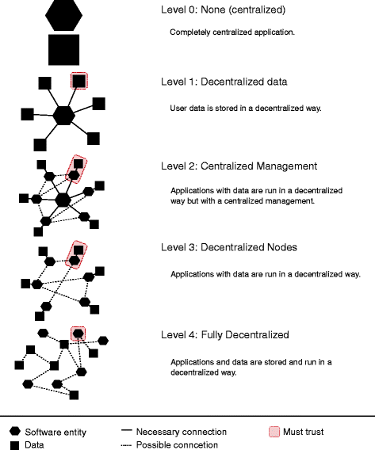
Figure 2 describes how complicated the data integration task is in decentralized systems which depend on adhoc/solitary solutions.

Figure 2 Even though projects have been undertaken to improve collaboration, such systems do not provide real-time access and create barriers for research and innovations because data access was restricted.

2.3 Centralized Databases and Data Lakes
Centralized data repositories, popularly called data lakes, have emerged as a remedy to most of the ills inherent in decentralization. A data lake collects structured, semi-structured, and unstructured data from many sources together in a central repository so that all this data can be used for analysis or decision-making.
This project essentially treats data lake architecture principles to resolve the inefficiency of decentralized systems at NED University by uniting the data of departments and bringing enhanced performance at the institutional level.

Table 1centeralised data can help NED university resolve data collection issue.
Feature | Decentralized Databases | Centralized Data Lakes
Data Integration | Limited | Comprehensive
Scalability | Restricted | High
Real-Time Accessibility | Limited | Extensive
Support for Analytics | Basic | Advanced

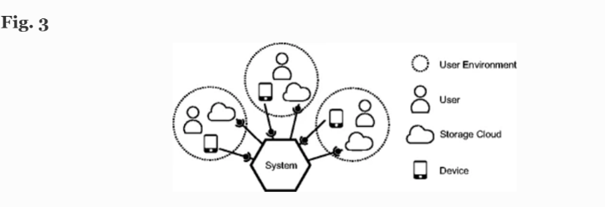

Figure 3 How a centeralised system would look like

2.4 Web-based interfaces for data access
The success of centralized data systems depends greatly on friendly interfaces with which users can interact with it. Research shows that the web implements a way of easy accessing data repositories. It can let the user perform CRUD (Create, Read, Update, Delete) activities on the application within strict constraints of access control.
The use of new web development technologies such as React, HTML, CSS, and JavaScript creates the conditions for developing interactive and responsive user interfaces. The web interface proposed for the NED Data Lake draws on those advances in putting together seamless experience-oriented user interfaces for stakeholders--for example, administrators, faculty, or researchers.

2.5 Data Analytics and Visualization Tools
Tools such as Apache Superset, AWS etc, for instance - facilitate the generation of interactive dashboards and visual reports for actionable insights from huge datasets. NED Data Lake wants to include such components into their system to cater to better data-driven decisions at the university.
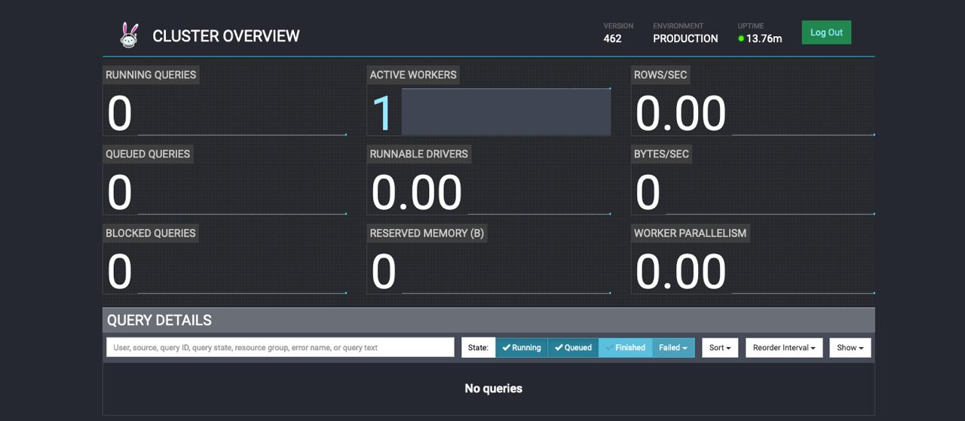
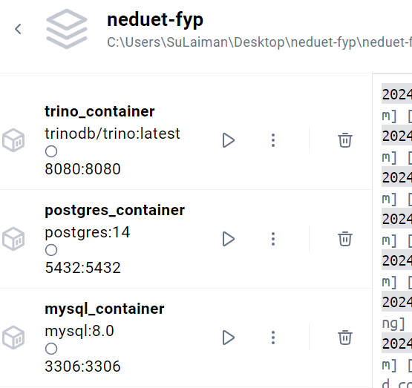
Figure 4 The dashboard looks like this having containers
Figure 5 We created containers in docker to store our data for the POC

2.6 Data security and Privacy
Ensuring data security and privacy is paramount for centralized systems, particularly in academic environments where sensitive information is handled. Studies emphasize the importance of implementing robust security protocols, such as encryption, access control, and compliance with regulations like GDPR. The NED Data Lake incorporates these measures to protect university data and build stakeholder trust.

2.7 Summary
This chapter reviewed the existing literature on decentralized and centralized data management systems, highlighting the limitations of the former and the benefits of the latter. It critically examined past implementations of data lakes, user interfaces, analytics tools, and security measures. The findings underscore the need for the proposed NED Data Lake, which aims to address the shortcomings of current systems through a unified repository, a user-friendly web interface, advanced analytics capabilities, and robust security features. These insights provide a solid foundation for the design and development of the project.

Chapter 3

Comparison of Data Lake and Data Virtualization Solutions

3.1 Introduction
This chapter examines two prominent methods for handling large-scale data management and analysis: Data Lake Solutions and Data Virtualization Approaches. Both methods aim to address the challenges of integrating and utilizing data from diverse sources. However, they differ significantly in their architecture, requirements, and operational methodologies. This comparison provides insights into their suitability for specific use cases, particularly in academic and enterprise environments.

3.2 Data Lake Solutions
A data lake is a centralized repository designed to store structured, semi-structured, and unstructured data at any scale. It allows for data ingestion from various sources and formats, making the data available for analysis, visualization, and machine learning. The architecture of a data lake typically consists of an ingestion layer for batch or streaming data, a scalable storage layer (such as Amazon S3 or Hadoop HDFS), a processing layer for transformation and preparation, a governance layer for metadata management and security, and a consumption layer for user access through APIs or dashboards.
While data lakes provide high scalability and flexibility, they require significant computational and storage resources. They are suited for organizations that need advanced analytics and long-term storage. However, the initial setup costs are high, and data governance can be complex, making it less suitable for applications requiring real-time data integration.

3.3 Data Virtualization Solutions
Data virtualization, on the other hand, enables users to access and query data from multiple sources without physically moving or transforming it. This approach abstracts the
underlying data sources, providing a unified view through a virtual layer. The architecture includes a data access layer for retrieving information, an integration layer for real-time transformations, and a presentation layer for querying and reporting.
Data virtualization solutions offer faster implementation and lower infrastructure costs since they rely on existing systems. They are ideal for real-time data access and integration but have limitations in scalability and handling unstructured data. Performance depends on the underlying data sources, making it less effective for applications requiring large-scale analytics.

3.4 Comparison of Data Lake and Data Virtualization
- Architecture: Data lakes use centralized storage with multiple processing layers, while data virtualization creates a virtual layer for real-time access.
- Scalability: Data lakes support high scalability with distributed storage, whereas data virtualization is limited by the performance of source systems.
- Setup Time: Data lakes require longer setup times due to infrastructure needs, while data virtualization has a quicker implementation.
- Cost: Data lakes have high initial costs with potential long-term savings, while data virtualization incurs lower upfront costs but depends on existing infrastructure.
- Performance: Data lakes excel in batch processing and analytics, while data virtualization is more effective for real-time queries and reporting.

3.5 Summary
The choice between a data lake and a data virtualization approach depends on the specific needs of the organization. Data lakes are more suitable for scenarios requiring advanced analytics, machine learning, and historical data storage. In contrast, data virtualization aligns better with use cases demanding real-time access and lower infrastructure requirements.
For this project, we have chosen the data virtualization approach as it not only meets the business requirements of our stakeholders but also ensures lower maintenance and faster implementation. This method allows us to leverage existing infrastructure effectively while providing real-time data access and integration, making it the optimal choice for our objectives.
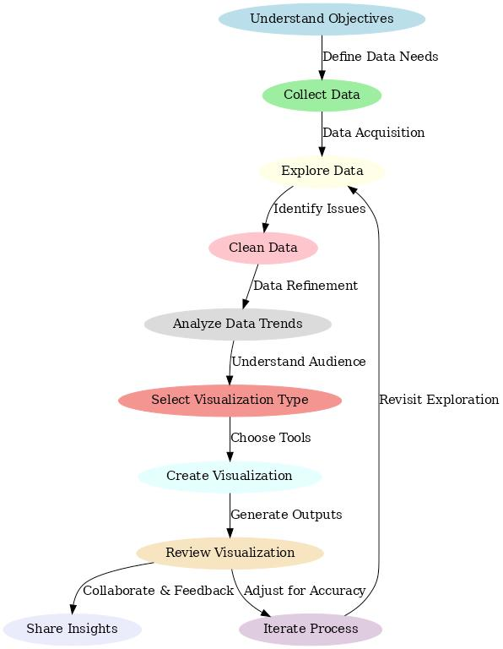
Figure 6 Flow diagram of how data will be visualised

Chapter 4

System Design for Data Virtualization

4.1 Introduction
This chapter details the system design implemented for data virtualization. The solution integrates data from multiple departmental databases, ensuring seamless access and query capabilities. It utilizes an Oracle database for the Examination Department and an SQL Server database for the Finance Department. Both databases are dockerized and connected to Apache Trino for unified querying. Additionally, Apache Superset is employed for data visualization and reporting.

4.2 Components of the System Design

4.2.1 Departmental Databases
The Examination Department’s data is hosted on an Oracle database, containing structured information such as student records, grades, and examination schedules. The database is encapsulated in a Docker container, enabling consistent deployment across environments. Similarly, the Finance Department’s data resides in an SQL Server database, managing structured financial information such as tuition payments and departmental budgets. This database is also dockerized, ensuring portability and ease of management.

4.2.2 Apache Trino
Apache Trino serves as the backbone of the data virtualization system. It allows users to query data from both Oracle and SQL Server databases as though they are part of a single, unified dataset. Trino’s connector framework supports integration with a wide range of data sources, enabling seamless communication between the query engine and the departmental databases. Its distributed architecture ensures efficient handling of complex queries, even as data volumes grow.

4.3 Integration with Apache Superset
Apache Superset is employed as the data visualization and reporting tool. Once Trino retrieves and processes the data, it connects to Superset to provide interactive dashboards and reports for stakeholders. Superset integrates directly with Trino as a data source, enabling real-time visualization of query results.
Stakeholders can use Superset’s user-friendly interface to create customized dashboards, set up alerts, and generate detailed reports. This integration ensures that decision-makers have access to actionable insights derived from real-time data without needing technical expertise in query languages.
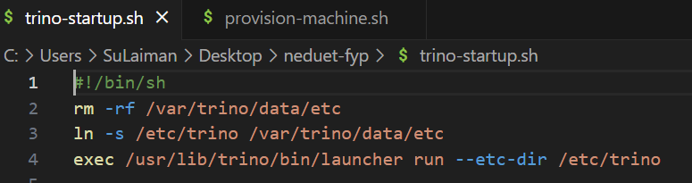
Figure 7Integrating with trino apache

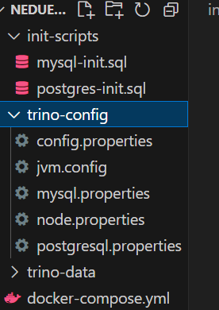

Figure 8 Configuring Apache and connecting databases

4.4 System Workflow
The system operates as follows:
- Dockerized Databases: The Oracle and SQL Server databases are deployed within Docker containers. This setup provides an isolated and consistent environment, ensuring reliability across development, testing, and production stages.
- Trino Integration: Trino connects to the Dockerized databases using built-in connectors. These connectors facilitate secure and efficient data retrieval from the underlying systems.
- Query Execution: Users submit SQL queries to Trino via a client application or API. Trino processes the queries by retrieving the required data from Oracle and SQL Server, combining results when necessary.
- Superset Visualization: Processed data from Trino is sent to Apache Superset, where stakeholders can view real-time visualizations and reports. Superset’s intuitive interface simplifies the creation of dashboards, enhancing accessibility for non-technical users.
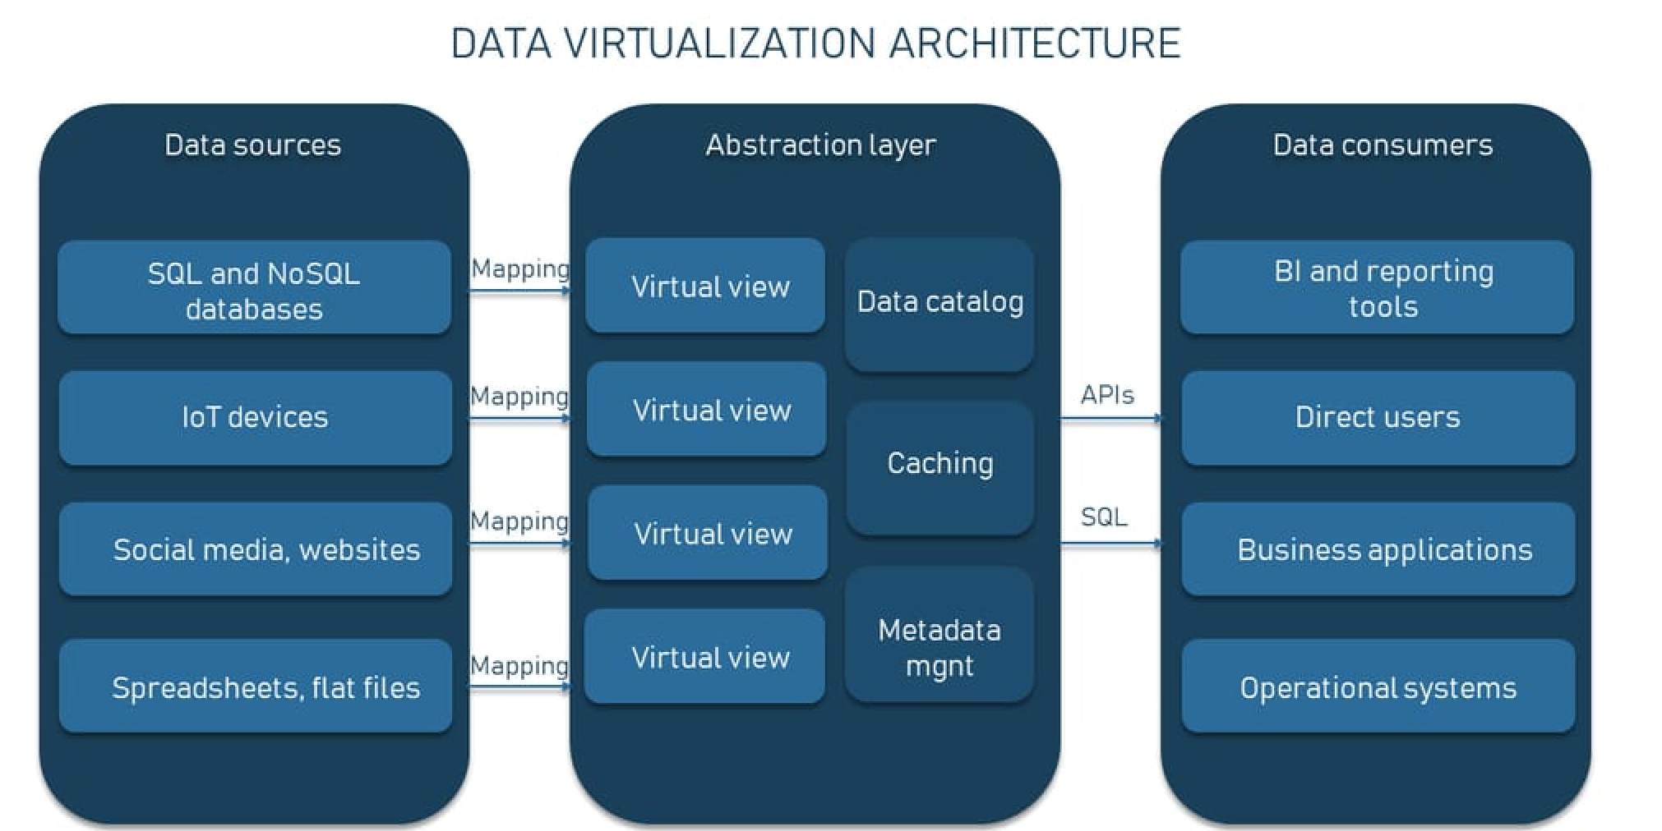
Figure 9 Data Visualisation Architecture

4.5 Advantages of the System Design
The system design offers several advantages:
- Portability: Dockerization ensures consistency and portability across environments.
- Unified Querying: Apache Trino provides a single interface to access and combine data from multiple sources.
- Real-Time Insights: The integration with Apache Superset enables dynamic visualization of real-time data, empowering stakeholders to make informed decisions.
- Scalability: Trino’s distributed architecture supports increasing data volumes and query loads.
- Cost Efficiency: The design leverages existing databases, reducing the need for additional infrastructure.

4.6 Summary
The system design for data virtualization integrates dockerized Oracle and SQL Server databases with Apache Trino and Apache Superset. Trino enables unified data querying, while Superset provides powerful visualization capabilities. This design meets the project’s objectives by offering real-time access, lower maintenance, and actionable insights, ensuring stakeholders can leverage data effectively to drive decision-making.

Chapter 5 Methodology/ Implemenation

Flowchart

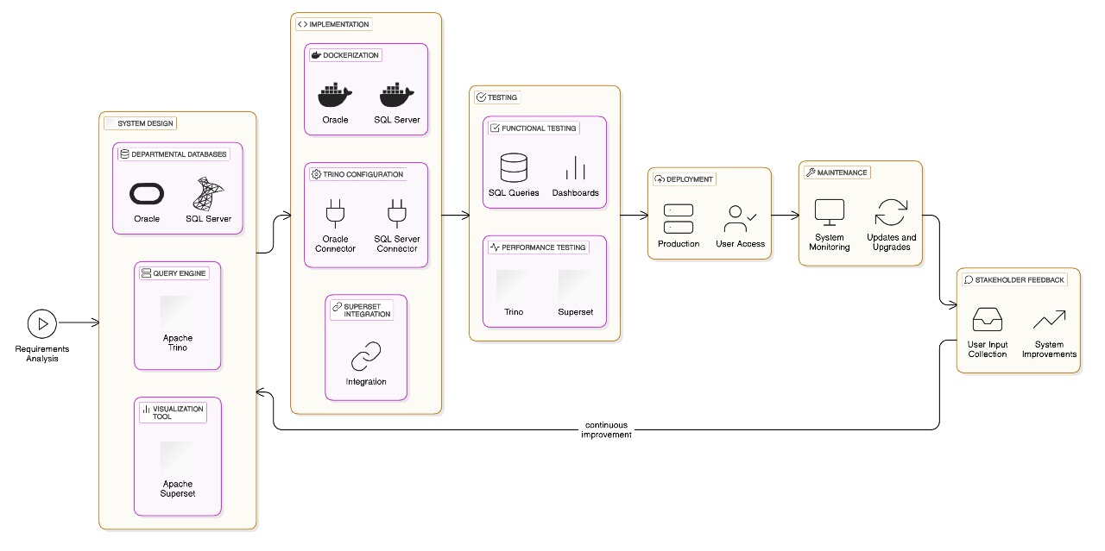
Figure 10 Flowdiagram of our Project

5.2 Method /Explanation:

5.2.1Tier 0: Requirements Analysis
- Objective: Define the core needs of the data virtualization system.
- Integrate Oracle and SQL Server databases for Examination and Finance departments.
- Enable unified querying with Apache Trino.
- Provide real-time visualization and reporting via Apache Superset.

5.2.2Tier 1: System Design
Objective: Architect a robust and scalable system to fulfill requirements.
- Departmental Databases
- Oracle database (Examination Department) and SQL Server database (Finance Department).
- Both databases are encapsulated in Docker containers to ensure consistency and portability.
2. Query Engine (Apache Trino)
Acts as a unified query layer to access data from both Oracle and SQL Server.
Utilizes Trino connectors for efficient integration.
3. Visualization Tool (Apache Superset)
- Connects to Trino for real-time dashboards and reports.
- Offers an intuitive interface for non-technical users.

5.2.3Tier 2: Implementation
Objective: Build and deploy system components for real-world use.
1. Dockerization:Deploy Oracle and SQL Server databases in Docker containers.
2. Trino Configuration:Set up Trino connectors for seamless data retrieval and unified querying.
3. Superset Integration:Link Trino to Superset for dynamic visualization and reporting.

5.2.4Tier 3: Testing
Objective: Validate functionality, performance, and reliability.
1. Functional Testing
Ensure correct data retrieval from Oracle and SQL Server through Trino.
Verify dashboards and reports in Superset.
2. Performance Testing
Measure Trino's query efficiency.
Assess Superset’s responsiveness and scalability.

5.2.5Tier 4: Deployment
Objective: Roll out the system for production use.
Deploy Dockerized databases, Trino, and Superset on production servers.
Provide user access to Trino and Superset interfaces.

5.2.6 Tier 5: Maintenance
Objective: Ensure long-term reliability and scalability.
Monitor system performance and address any issues.
Update database schemas, Trino connectors, or Superset dashboards as needed.

5.2.7 Tier 6: Stakeholder Feedback and Continuous Improvement
Objective: Incorporate user feedback to refine the system.
Gather feedback on Trino queries and Superset visualizations.
Enhance usability, efficiency, and scalability based on stakeholder needs.

Chapter 6 Conclusions

6.1 Summary
This Project has been developed to address the inefficiencies and limitations of decentralized data management systems currently employed by NED University. By connecting data from various departmental databases through a virtualized framework, the project achieves significant improvements in data accessibility, integration, and analytics. The implementation of Apache Trino ensures seamless interaction for diverse stakeholders, including administrators, faculty, and researchers. The integration of Apache Superset enables advanced data visualization, empowering data-driven decision-making processes. Robust security measures and the use of containerization safeguard sensitive university data while ensuring system reliability.
This project has successfully met its objectives by providing a virtualized data access solution, enhancing operational efficiency, and demonstrating the viability of transitioning from traditional database systems to modern virtualization architectures. The approach effectively leverages existing infrastructure to meet evolving academic and administrative needs. Challenges such as ensuring user adaptability and integrating disparate data sources have been addressed to a significant extent.

6.2 Recommendations for Future Work
While the NED Data Virtualization Project has successfully accomplished its foundational objectives, it still offers potential directions for further enhancements aimed at strengthening its functionality and impact:
- Enhanced Cloud Integration: Extending the system into cloud services could improve scalability, availability, and support for advanced analytics and machine learning capabilities. Cloud-native tools can further reduce dependence on on-premises hardware.
- Advanced Security Measures: As technology evolves, implementing new protocols for enhanced network and data security is crucial. Adopting cutting-edge security frameworks will ensure the system remains robust against emerging threats.
- Institutional Collaboration: Expanding the system’s framework to support data integration across multiple universities can foster greater collaboration and resource sharing. This model can benefit similar institutions by demonstrating the feasibility of shared virtualized data systems.
- Continuous Monitoring and Feedback: Regular system audits and stakeholder feedback sessions should be conducted to address emerging issues and align the system with user needs. This iterative approach will ensure the system evolves effectively over time.

References:

- Müller, A. Ludwig, and B. Franczyk, "Data security in decentralized cloud systems – system comparison, requirements analysis and organizational levels," Journal of Cloud Computing, vol. 6, no. 15, pp. 1–15, Jun. 2017.

- P. Colombo and E. Ferrari, "Access control technologies for Big Data management systems: literature review and future trends", Cybersecur, vol. 2, no. 3, 2019.

- Software-Cluster (2015) Emergente Software, http://www.software-cluster.com/de/forschung/themen/emergente-software. Accessed 24 Nov 2015

- https://trino.io/trino-the-definitive-guide.html

- 03 2024, [online] Available: https://data.wust/edu/data-warehouse/new-security-model1.



