

**Cairo University**

**Faculty of Computers and**

**Information**



CS352 Software Engineering II

Assignment 2

By

[Hashem Hesham] [20160274] [G_5] [hashemhesham798@gmail.com]

[Youssef Ahmed Ali] [20160292] [G_6] [youssefelhefnawy@gmail.com]

[Alaa Sayed ] [20160149] [G_5] [sayedalaa447@gmail.com]

[10/3/2019]

Department of Computer Science

Faculty of Computers and Information

Cairo University

# 

1. Introduction: In this Assignment we implement the P2P architecture in our use case.

1. Implemented use case: We have chosen the Second use case “Block chain application”.
2. System Architecture

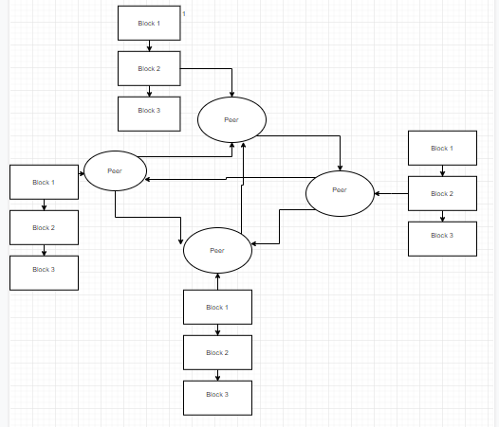

This Diagram shows how our peers is connected to the block chains and how each peer is connected with all the other peers.

1. System Design:

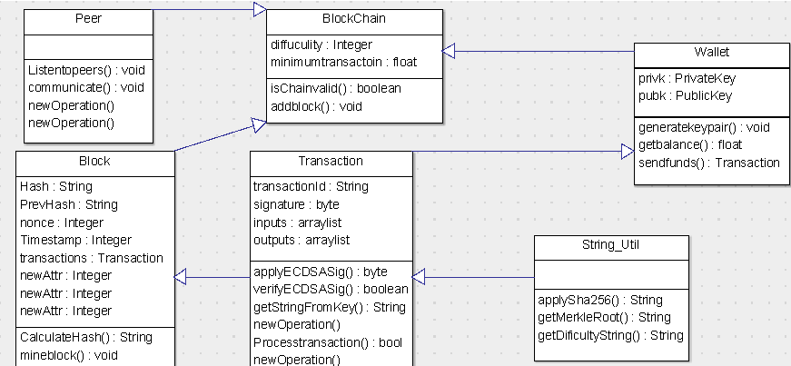

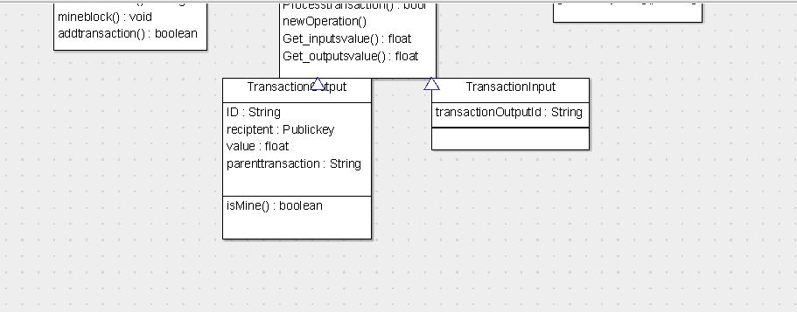

This diagram has all the classes and its attributes and its methods.

1. Description:

Block chain: It has a series of blocks and have two methods the first one add new block to the chain and the other validate the chain.

Peer:

A peer represents one person that have a copy of the block chain and it’s used in the validation process.

Block: A block carries the data of the transaction and it also have a hash that identifies, a series of blocks make a block chain.

Transaction: A transaction has the recipient public key and the sender public key, it also have the sender signature and the value of the money sent.

Wallet: A wallet has a private and a public key, it also has a method that returns the balance, and a method that send funds.

String_Util: This class has a method that apply SHA256 to our transaction.

Transaction_output: This class contains the information about the end of the transaction example the new coin owner and the amount of money.

Transaction_Input: This class contains the transaction Output Id.

1. Installation Guide

You have to install the “javax-json”library.

You have to install the “org.bouncycastle”package.

* Git Hub Link:

https://github.com/youssefelhefnawy/peer-to-peer-architecture_Assignment2

1