MANG3108
Assignment

ID: 34074759
Word Count: 2824

1. Executive Summary
The aim of this project is to predict which UK customers are likely to make a repeat purchase, and then segmenting customers into groups to support segmented and targeted marketing
Using 2010-2011 retail data, customer features based on RFM (Recency, Frequency and Monetary) values were engineered. For classification models; Logistic Regression, Decision Tree, Random Forest, k-NN, XGBoost and HistGB were trained using cross-validated hyper-parameter tuning and then evaluated against a test set using ROC-AUC and F1 Scores. Along with evaluation, k-means clustering on the RFM features were used to identify distinct customer segments.
From the analysis, the HistGB model performed the best, with an F1 of ~0.83 and ROC-AUC of ~0.84. Most repeat customers were identified with the least false positives. Logistic regression acts as a baseline (F1 ~ 0.82, ROC-AUC ~ 0.83).
The clustering analysis showed 3 segments, a high-value active group (14.85% of customers) accounting for 54.71% of revenue, a mid-value occasional group (46.12%) accounting 38.87% of revenue and a low-value group (39.03%) accounting for 6.42% of revenue, though the latter group has a more likely chance of being a repeat customer than the mid-value group.
Overall, the high-value segment should be prioritised for retention-based actions such as loyalty rewards. The mid-value group should be targeted with upsell strategies to improve repeat purchases, while marketing spend should be modest on the low-value group. The HistGB model should be integrated to CRM systems to enable accurate repeat-purchase probabilities regularly, automatically triggering campaigns.

2. Introduction & Business Problem
The data is based on a UK online retailer’s historical transaction from 2010-2011. Though the data is historical, the methods used in this analysis are to be applied to the current customer base.
The first objective is to predict whether each customer is likely to make a repeat purchase in a later period, and the second objective segments customers into distinct behavioural groups to allow for differentiated marketing.
Accurate repeat customer predictions allow the retailer to efficiently spend marketing resources on customers where the retention strategies are more likely to pay off.
This analysis uses a process of CRISP-DM (Holtz, 2024), the analysis begins from data understanding to preparation, then predictive modelling and clustering is conducted to provide business insights. Feature engineering was based off RFM, with 5 classification models used as well as clustering.

3. Data Understanding
The period of the dataset is roughly December 2010 to December 2011. The data is transaction-level, where each row is an invoiced item.
Key fields: InvoiceNo, StockCode, Description, Quantity, InvoiceDate, UnitPrice, CustomerID, Country.
The focus of this report is on UK customers only.
This analysis required the data to be transformed to customer-level data, therefore rows with missing CustomerID (~27% of rows had missing CustomerID) were dropped as they could not be used to engineer features like RFM.
Figure 1
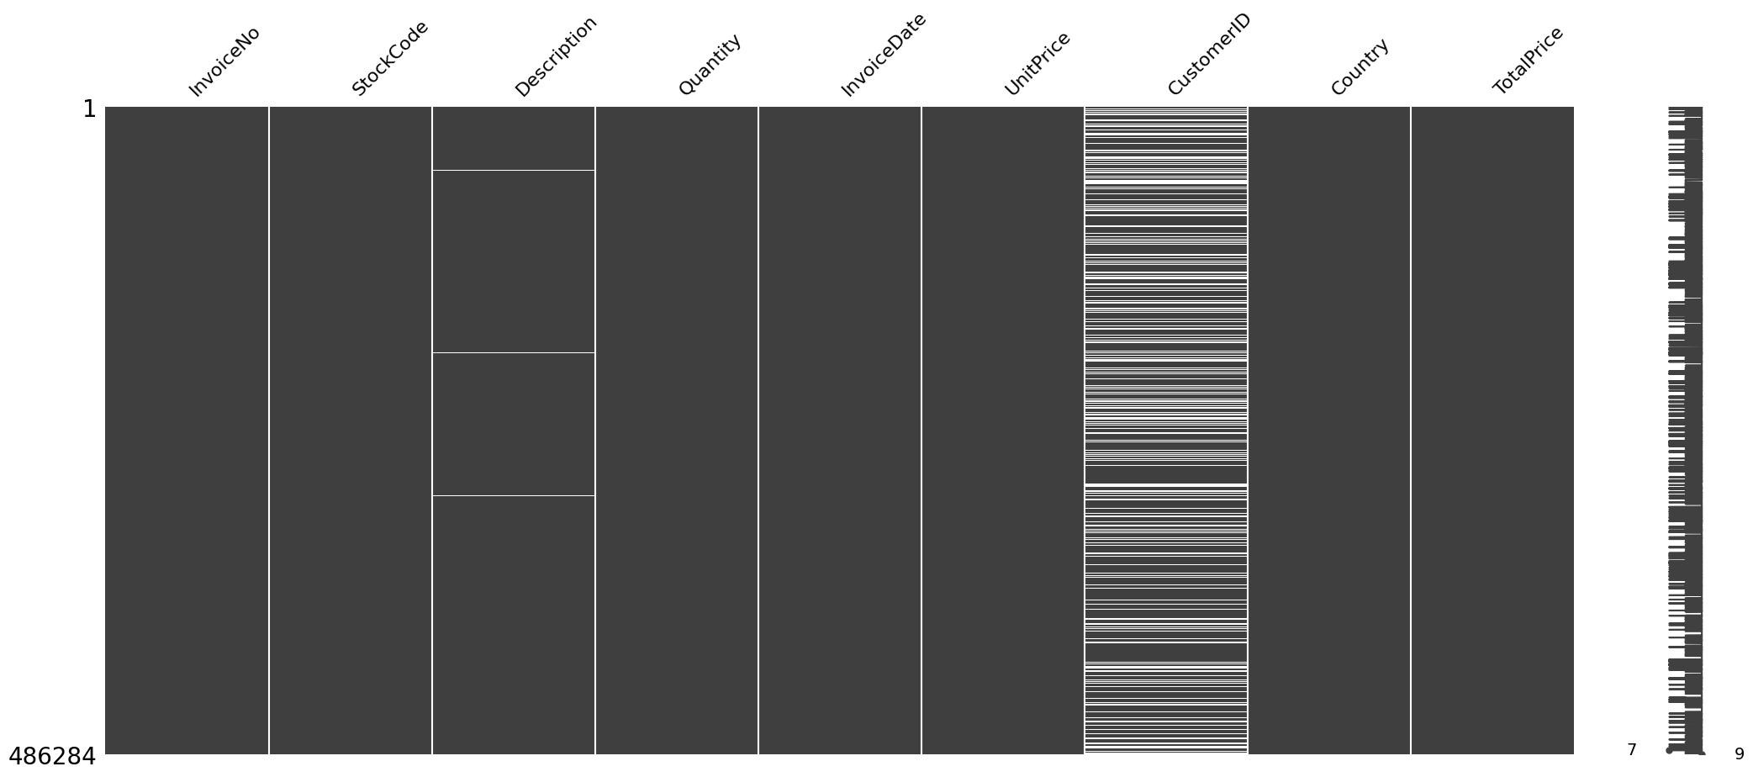
This shows that missing values are mostly within CustomerID.
Apart from missing values, there were also anomalies, such as negative quantities (pertaining to returns and cancellations), as well as non-positive UnitPrice; these are errors or unusual records so they have been removed as they can distort the purchase volumes.
After these issues were handled in data preparation, the remaining data was appropriate for constructing customer-level features for modelling as data quality and cleaning are crucial for accurate modelling (James et al., 2021).
To understand the data enough, time series analysis was also conducted:
Figure 2
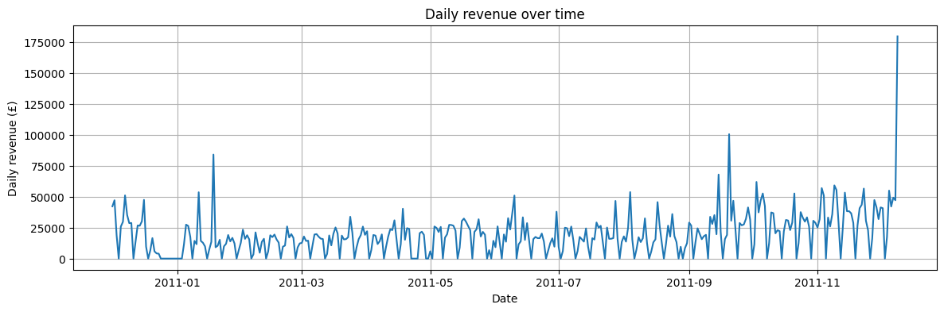
The daily revenue plot (using TotalPrice grouped by InvoiceDate), from this alone, seasonality can be inferred, though trend and noise analysis will also be included:
Figure 3
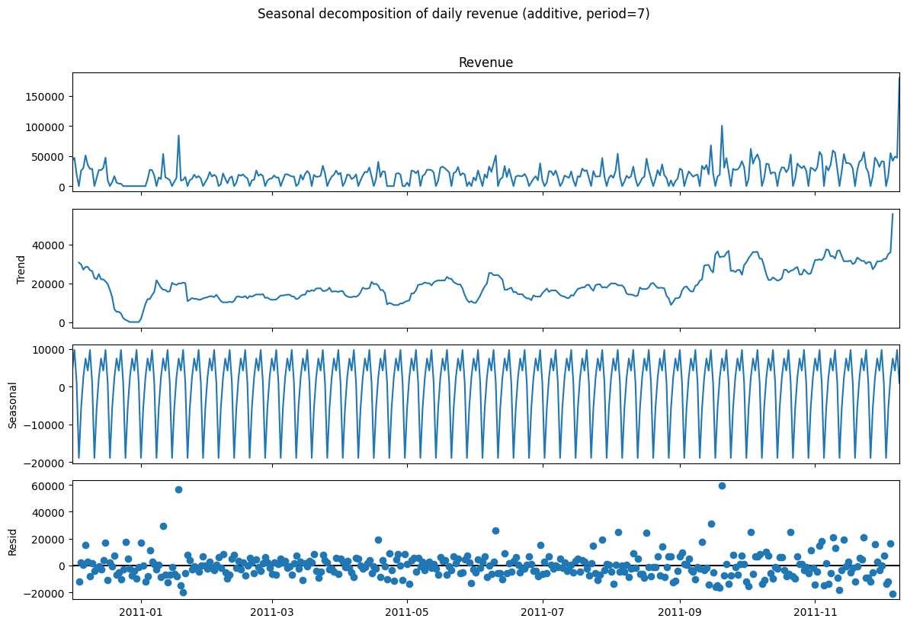
From this decomposition, the trend tends to be central to 20,000 with inconsistencies, and a slight upward trend at the tail end of 2011.
Figure 4
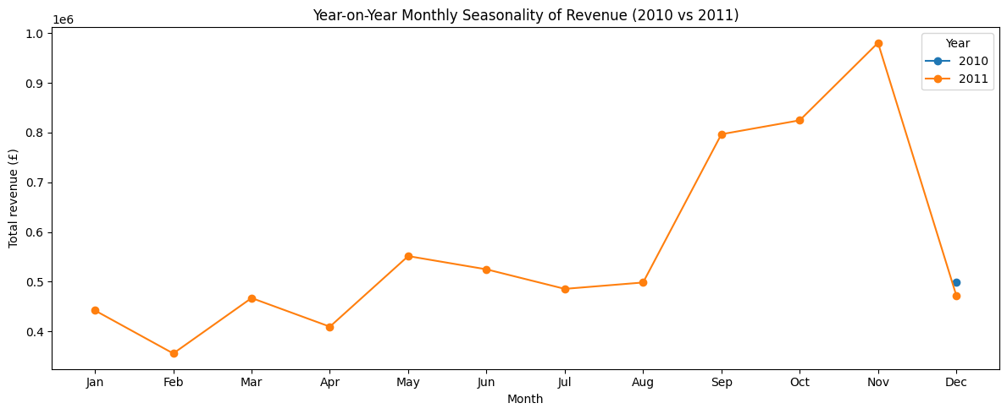
With this plot, it can be deduced that there is a seasonality despite the lack of 2010 data for reference as the there seems to be a peak in purchases in November, with a fall in revenue in December, like 2010’s December revenues.
Therefore, peak yearly revenues are from September-November.

4. Data Preparation
Transaction-level engineering was first conducted, with InvoiceDate converted to datetime, this allowed for a generalised time variable for customer-level modelling.
TotalPrice was created via Quantity x UnitPrice, where BasketValue was then aggregated as the sum of TotalPrice per Invoice, therefore each Invoice contains a basket value.
The distribution of basket amounts was then plotted:
Figure 5
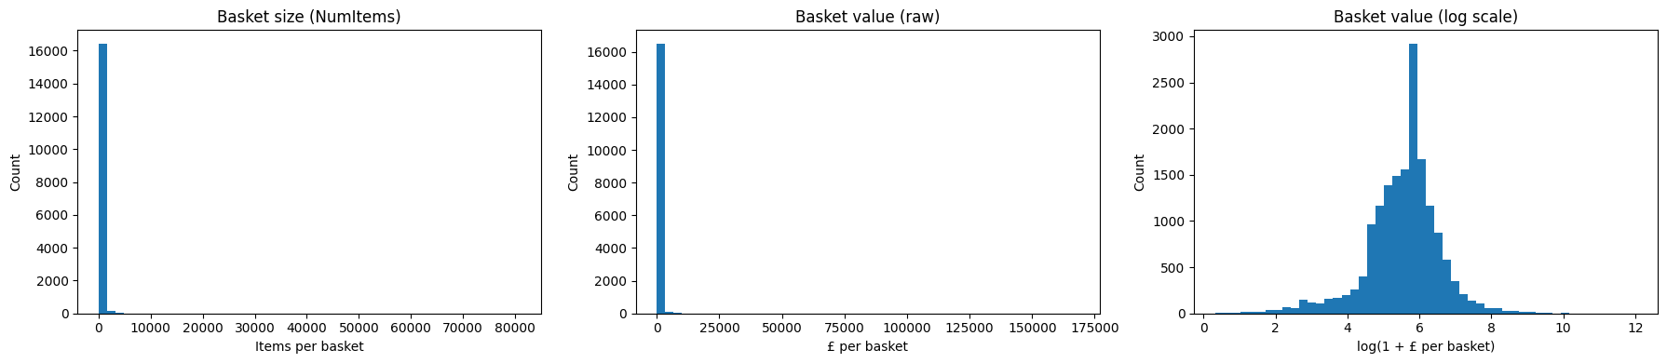
This shows that raw basket values and size are heavily right-skewed and most baskets are values around 0-£2000, the log transformation of basket value makes the distribution more symmetrical.
This supported by the fact that the top 10% of baskets account for 43% of revenue, and 1% accounting for 17.7% of revenue, while top 50% of baskets account for 82.5%, showing that a minority of customers account for significant revenue, which is supported by the clustering findings.
Figure 6
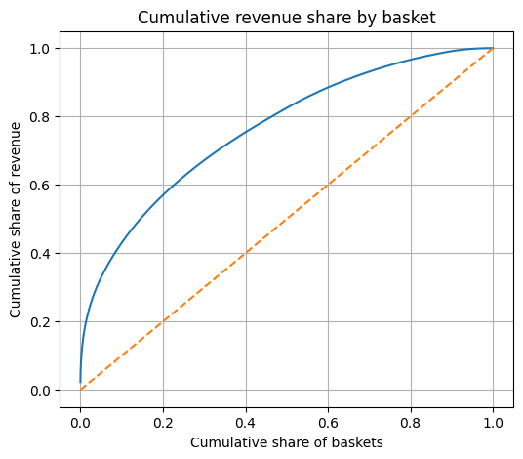

4.1 Temporal Stability Check
The end of the feature window (and start of target window) is 1st September 2011. After defining, a temporal stability check was made:

Figure 7
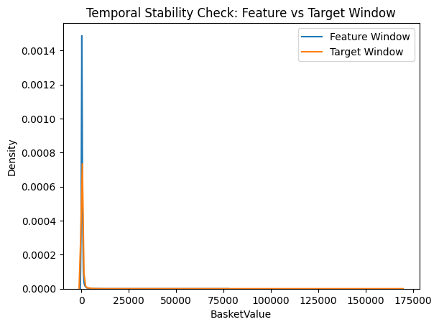
This plot shows that distribution of basket value between target and feature windows is similar, there are likely no structural breaks.

4.2 RFM Summary Statistics
Figure 8
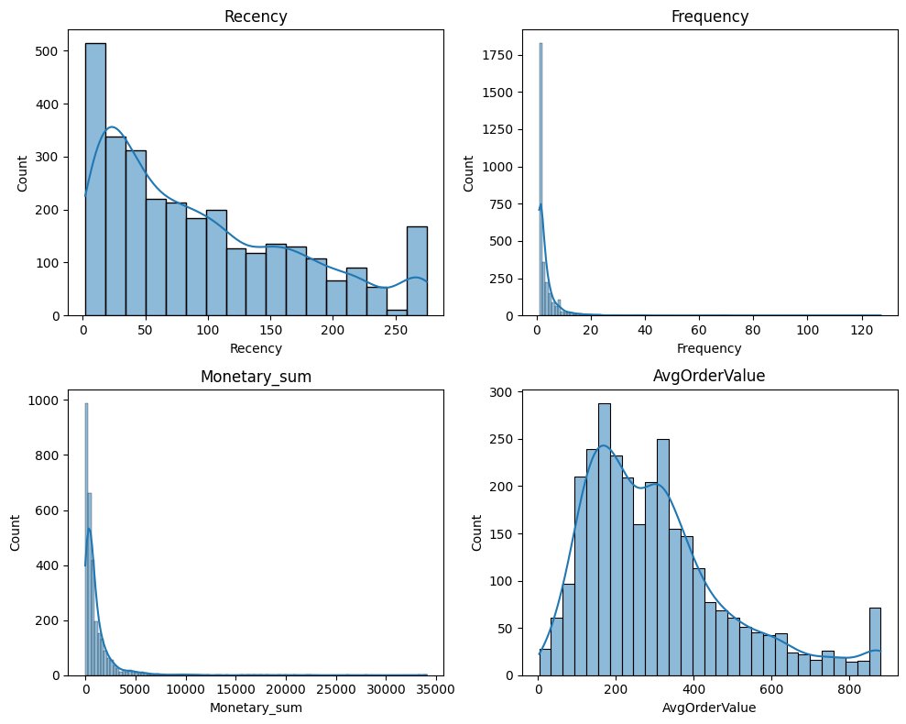
With these descriptive plots, recency shows that most purchases are recent in this dataset. The monetary sum and frequency plots show a correlation (0.83 Pearson), suggesting that most purchases are relatively small in value and most customers have infrequent purchases, with a minority purchasing up to 120+ times.
The average order value plot supports the clustering analysis as there is a significant rise in order values above £800, following a falling trend of count past the peak of £200 in order value.
Table 1
Correlation matrix
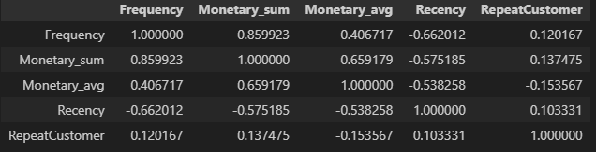

5. Exploratory Data Analysis
Figure 9
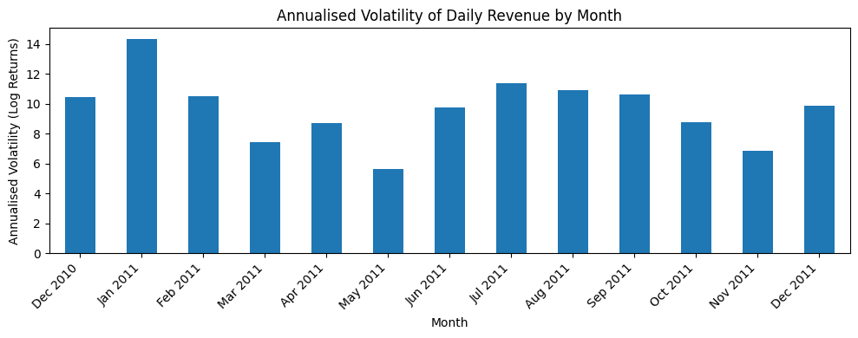
This chart shows high volatility during winter, especially January 2011, with relative stability following January. The increased volatility in summer suggests periods of chaotic growth as people spend more.
Figure 10
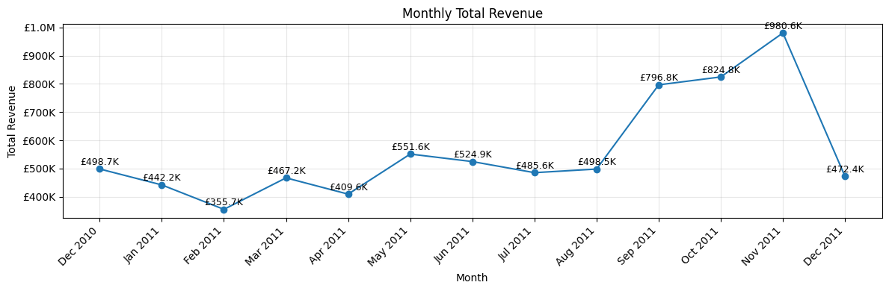
This chart represents a period where there is much greater revenue between September-November, likely for the Christmas period ahead, the retailer must keep this in mind for upcoming winter months, as promotions will provide the most winnings during this period.
Figure 11
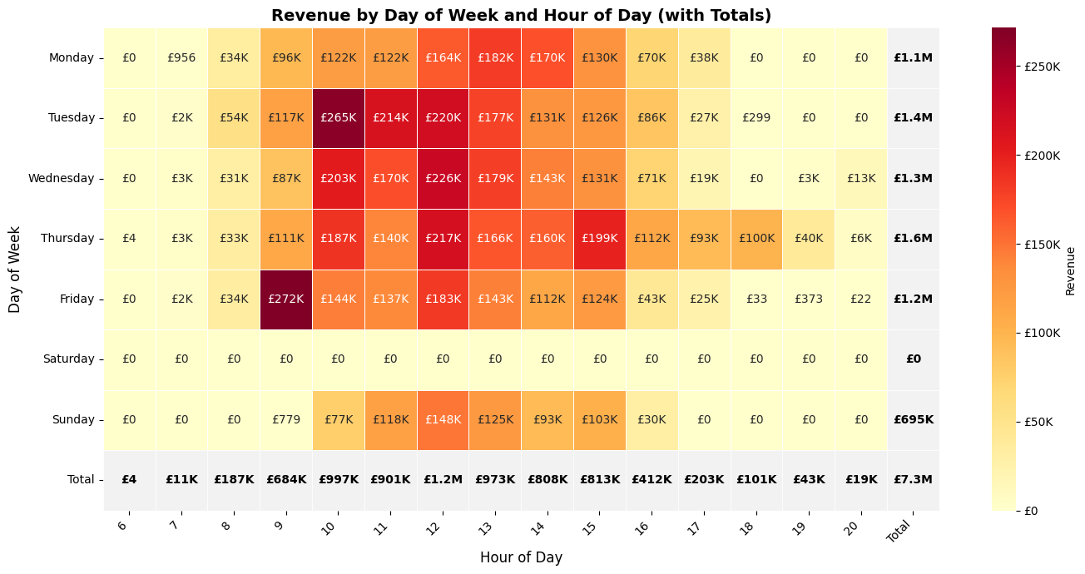
At a more granular scale, this chart shows that most sales occur between 09:00-16:00 at a given day. Thursday averages as the day with the highest revenue, followed by Tuesday and Wednesday.
An outlier can be seen at 9am Fridays as people tend to spend the most on average on this timeslot of the week. This can be attributed to the fact that this is when most people receive their paycheck for the week/month.
Table 2
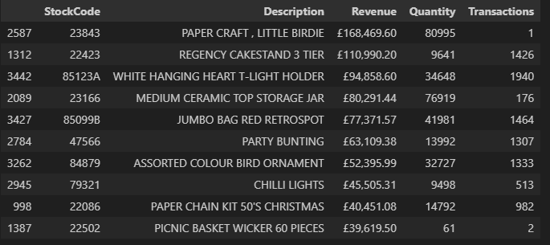
These products are the top 10 highest selling items for this retailer and thus these should be observed carefully, especially when creating campaigns for dedicated customer segments.

6. Methodology

6.1 Predictive Analytics
For the classification models, each model chosen will be justified.
The logistic regression model was chosen for its interpretable baseline (linear), which can provide a reference point to understand how features influence the prediction. This is crucial before diving into more complex models. For a more comprehensive analysis, Decision Tree, Random Forest, kNN, XGBoost and HistGB were then used, with their scores compared in Table 2.
Decision Tree was chosen for its ability to capture non-linear relationships across features; unlike logistic regression it can model feature interactions and threshold-based decisions. The tree structure visualisation is intuitive in explaining how predictions are made, resulting in understanding model behaviour beyond linear assumptions.
Random Forest complements decision trees as they address overfitting tendencies of decision trees, as multiple trees are aggregated different subsets. This improves generalisation and model robustness compared to decision trees, while also providing feature importance metrics that enhance insight into which variables contribute most to predicting repeat purchases.
kNN was chosen for its non-parametric baseline that makes minimal assumptions on data distribution, relying on local similarity between each data point rather than a global decision boundary. This is effective for capturing complex patterns. Comparing kNN with parametric models allows for assessing whether prediction performance benefits most from locality-based decision-making.
XGBoost was chosen as it performs strongly in tabular data to model complex non-linear relationships. Unlike Random Forest which builds trees independently, XGBoost builds them sequentially. This allows the model to capture subtle patterns and interactions, with L1 and L2 regularisation preventing overfitting.
Histogram Gradient Boosting (HistGB) was chosen as a computationally efficient boosting-based alternative to XGBoost which discretises continuous features into bins. This is advantageous for large datasets where scalability is an important consideration. It also has sequential boosting like XGBoost, but has faster convergence and lower memory usage.
These models allow for a spectrum of interpretability and complexity, providing a balanced comparison between simple baseline methods and advanced machine learning techniques.
Each model is evaluated with a function evulate_classifier, outputting a confusion matrix, classification report and ROC curve.
The primary optimisation metric is F1

6.2 Descriptive Analytics
For the clustering analysis, the standardised RFM features were used. These are behaviour-based features, ideal for modelling customer behaviour as a result. These features are proven in marketing analytics. These features capture how recently, frequently and how much customers spend (Wei et al., 2010, Christy et al., 2021).
As the RFM features are scaled, there are no dimensions that dominate distance.
For choosing clusters, k=2-7 was used. Using silhouette scores, the clustering was best at k=3, suggesting 3 distinct behavioural groups.
Figure 12
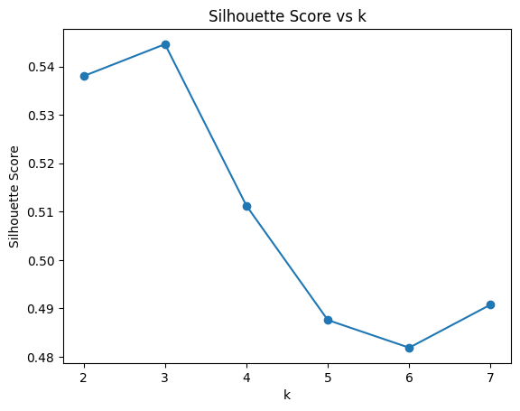
Though it is important to note that while k=3 is optimal, clustering with k=2 may also have promising insights, this can be considered for an expansion of this analysis in the future.

7. Results & Analysis

7.1 Predictive Analytics
Overall, 6 models were analysed and tuned
Table 3
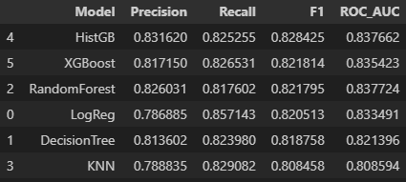
The HistGB model achieved the highest F1 and ROC-AUC score.
Figure 13
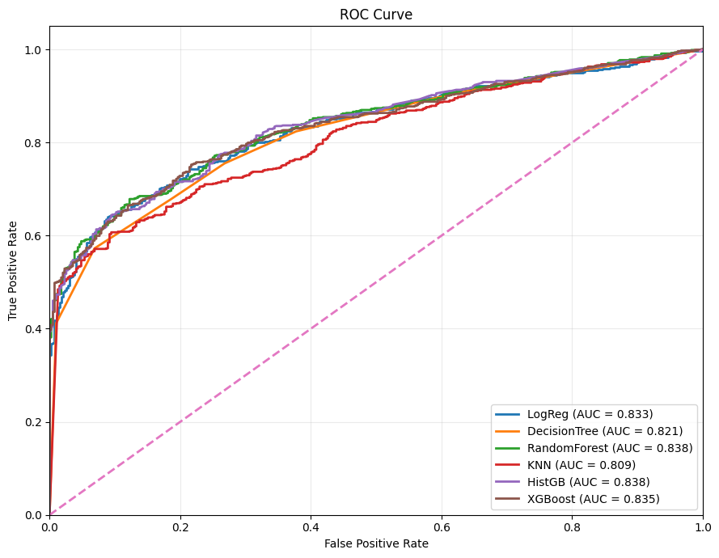
K-NN visually appears to under-perform the most here, with most models aligning in AUC-ROC, though Decision Tree also lags slightly.
Figure 14
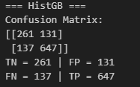
Using the confusion matrix displayed with each model, the HistGB model had 647 true repeat purchasers identified, with 137 repeaters missed (false negative) and 131 repeaters incorrectly identified (false positives) and 261 correctly identified non-repeaters.

7.2 Descriptive Analytics
The three clusters identified display highly contrasting behaviour.
Cluster 0 can be described as high-value and active, with high frequency, low recency, high monetary sum and most likely to be a repeat customer, dominating total revenue across clusters, accounting for 54.71% of total revenue.
Cluster 1 contains 1530 customers, however, these customers are infrequent, high recency, spend by far the least, though they are more likely to make a repeat purchase than cluster 2, suggesting potential for higher frequency.
Cluster 2 has the biggest size of customers, with moderate frequency and recency, and higher spending habits than cluster 1, though this group is the least likely to make a repeat transaction.
This is evidenced by analysing the proportion of customers and revenue for each cluster:
Table 4
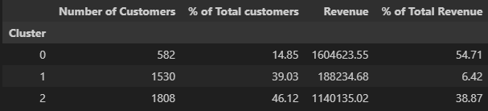
As well as the RFM figures and repeat likelihood for all customers:
Table 5
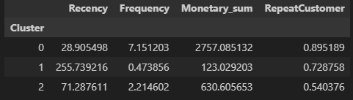

8. Business Recommendations

8.1 Actions for high-value cluster
The business should capitalise on this cluster’s loyalty and purchase quantity. This can be by further incentivising loyalty through VIP programmes that provide benefits for those who shop in large quantities frequently.
These benefits could be early product release which can amplify their recency and frequency, along with exclusive offers. These offers would still be profitable considering their purchase frequency and quantity of purchase. A personalised service will make the high-value customers feel more appreciated and thus will be more likely to stay loyal to the business.
Considering this cluster’s likely high average income, the offers do not need to be discounts. This could instead be upselling newer or unreleased products, while also focusing on retention through the VIP programme.

8.2 Actions for mid-value cluster
This cluster has the largest share of customers and acts as a growth pipeline to the high-value group. Customers here have stable purchase behaviour but low repeat rate, thus they present the strongest opportunity for upselling.
Customers here should receive bundled offers and limited-time promotions to increase their frequency and basket size. Structured campaigns for this group should seek to primarily increase their repeat purchase rate as this is the lowest out of the three clusters.
Investment in this group can offer the highest potential return considering its potential for growth.

8.3 Actions for low-value cluster
This cluster contains many customers that contribute minimally to overall revenue. This makes broad marketing campaigns inefficient for this group, instead, their relatively high repeat purchase rate should be looked at and target the most likely to repeat customers with win-back initiatives.
These customers have high potential as a pipeline for higher value clusters through low-cost communications such as email and SMS. Due to this group’s size, regular model re-scoring should be done to ensure customers who’s predicted value to repeat purchase is reclassified to further bring in high-potential low-value customers through targeted emails, rather than receiving low-cost newsletters that low-potential customers in this segment should receive.

8.4 Model Threshold Tuning
Using the HistGB model, the business should maintain a flexible workflow for their 3 clusters.
For the high-value cluster, a lower classification threshold (e.g. 0.35-0.45) is recommended to maximise recall and minimise risk of missing any high-value repeat purchaser, even if precision is sacrificed slightly. Due to this cluster contributing over half of total revenue, the cost of false positives is outweighed by the risk of false negatives.
For the mid-value cluster, a moderate threshold of 0.5-0.6 should be used to balance recall and precision, allowing the business to target customers with likely chances to repeat purchase while still taking advantage of this cluster’s profitability.
For the low-value cluster, a high threshold of 0.65-0.75 should be used to maximise precision. This saves marketing expenditure for higher-value customers and only targeting to customers with the highest chance of repeat purchases, playing to this cluster’s advantage over the mid-value cluster of having a higher average repeat purchase rate.

9. Reflection on use of Generative AI
For this project, AI was used to help generate code structure ideas, such as the function evulate_classifier which generates model metrics in the form of a report and chart.
Additionally, its insight was particularly helpful for feature engineering, such as suggesting the use of RFM as the customer-level features for model building, as they are a widely used framework within marketing analytics. Generative AI was also helpful as a tool to expedite understanding of package documentation such as the HistGB package, a previously foreign package to my understanding.
However, the experimental design was still my idea, as generative AI could have only been an assistant in my model building and exploratory data analysis. Outputs were all verified by me, as well as interpretation of results.
Generative AI can bring many benefits to market analysis projects such as these, as they make debugging significantly faster, as well as being able to search the internet for alternative methods on model building and evaluation.
While generative AI can come with many benefits, it must be supervised heavily as there is risk of code hallucination, resulting in outputs being either incorrect or deviating from the objective entirely. One example of this was its parameter choices for the HistGB model as it did not define industry standard learning rates of [0.01, 0.05, 0.1]. Code should always be validated by a human who is knowledgeable in the domain generative AI is working with.
Along with this, generative AI dependence is a breach of academic integrity, and should only be used as a tool, rather than an author of work.
Overall, AI must be used critically, with all its outputs scrutinised for potential bias and hallucinations. It must also be used ethically as over-dependence results in plagiarism through AI.

10. Conclusion
In conclusion, through this analysis we have found that the HistGB model achieves the optimal score of an F1 of ~0.828 and ROC-AUC of 0.838 in predicting whether a customer is likely to make a repeat purchase. Through cluster analysis, 3 clusters were identified, being a small cluster of high-value customers, a large cluster of mid-value occasional customers and a large cluster of low-value customers.
Though this analysis ensured the data was cleaned effectively, it comes with limitations as the historic period is relatively small, being only from 2010-11. If the business operates internationally, this further limits findings as the data only focuses on UK customer behaviour. Furthermore, the model could only work with originally transaction-level features, with no product categories, web behaviour such as times added to basket nor any customer demographics such as gender, income and ethnicity.
For more rigorous analysis in the future, there must be more features included such as browsing data and product mix. For descriptive analysis, there should more granular segmentation through providing more data if the business would have liked more than 3 clear clusters, along with sentiment analysis to further understand their purchase behaviour and psychology.

11. References
Hotz, N., 2024. What is CRISP DM? [online] DataScience-PM.com. Available at: https://www.datascience-pm.com/crisp-dm-2/ [Accessed 11 December 2025]
James, G., Witten, D., Hastie, T. and Tibshirani, R. (2021) An Introduction to Statistical Learning: with Applications in R. 2nd edn. New York: Springer.

