MANG3098: Analytics in Action II

Coursework 2

ID: 34074759
Word Count: 2186

1. Introduction and Q1
This report discusses a snapshot of what would be a big-data problem for IMDB reviews (Maas et al., 2011). A modern object-storage + lakehouse + Kafka-Flink + ML-platform stack succeeding a Hadoop/HDFS is the optimal architecture for this data. Two preprocessing pipelines process the dataset for modelling. Exploratory Data Analysis (EDA) found a near-perfect class balance (50.07% positive, 49.93% negative). M12 {DeBERTa-v3-large-FT x TextCNN} achieves a test AUROC 0.9927. The results are reproducible via a random seed (34074759).

1.1 Sample vs Production Scale
Table 1
5V | Sample | Production-Scale Equivalent
Volume | 20,911 rows, 281MB | TBs-PBs across years of reviews
Velocity | One static CSV | streams of reviews, deletions, edits, ~10⁵-10⁷ instances/day
Variety | Binary label, English text | Audio (TikTok/YouTube), images, ratings, emojis, multilingual text
Veracity | Clean crowd-sourced labels | review-bombing, sarcasm, spam, paid reviews, bots
Value | Academic-ready data | Moderation, brand reputation
(Marr, 2015; Hashem et al., 2015)

1.2 Architecture Stack
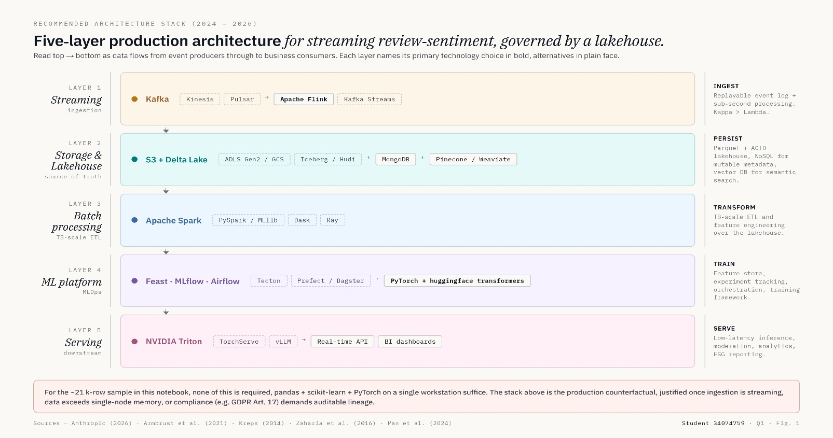
Figure 1
The 5 layers of the architecture stacked are described above. HDFS/Hadoop is a predecessor of this stack (NameNode/DataNode, 128MB default block, 3x block replication (Shvachko et al., 2010)).

1.3 Honest Caveat
Python handles the sample dataset in seconds, thus the stack in (1.2) is the structure the content provider needs at production scale.

2. Q2: EDA and Preprocessing

2.1 Dataset Overview
Table 2
Rows | Split | Class Balance
20,911 | Train: 16,728; Validation: 2,091; Test: 2,092; using 80/10/10 stratified split. | Positive: 50.07%, Negative: 49.93%.

This split preserves the ~50/50 balance across splits and removes class balance as a confound.
The near even class balance suggests AUROC and Accuracy are effective metrics, and the use of PR-AUC is not justified (Saito & Rehmsmeier, 2015). Subsequent statistics are computed only on the training split to prevent leakage.

2.2 Word-length Distribution and Truncations
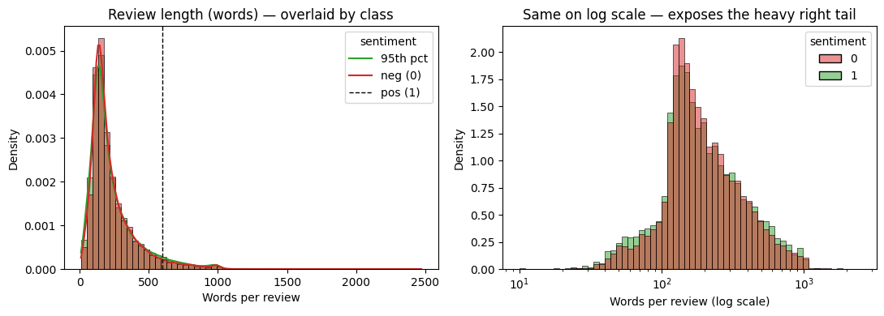
Figure 2
Mean word-count of reviews is 234, median=174, 95th percentile=600 and max=2,470. Using the log-scale, the distributions are almost identical between classes, with negative reviews slightly more centred on the mean, thus length is likely not a discriminative feature.
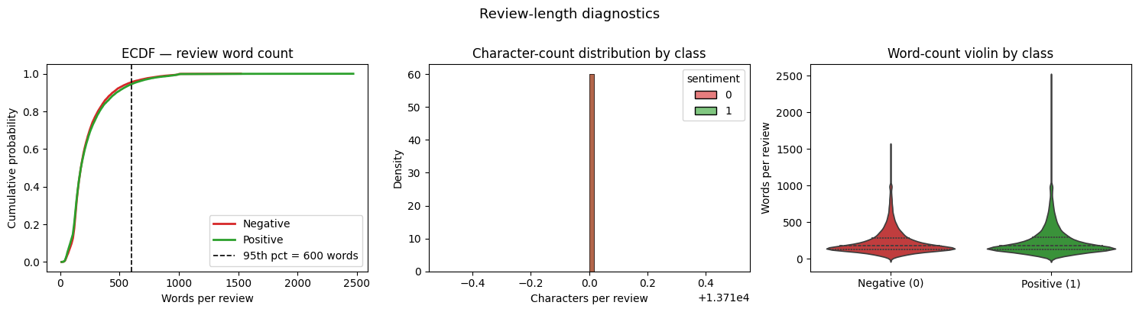
Figure 3
ECDF supports a truncation cap at the 95th percentile (600) for static embeddings. For transformer truncation, 512 tokens Head+Tail are used, keeping opening and closing sentiment cues (Sun et al., 2019).

2.3 Vocabulary
Using a 5,000-row sample, ~1.157 million tokens were derived, where 41,811 unique tokens were extracted and only 96 stop-word entries were dropped. This suggests vocabularic diversity drives length instead of word repetition.
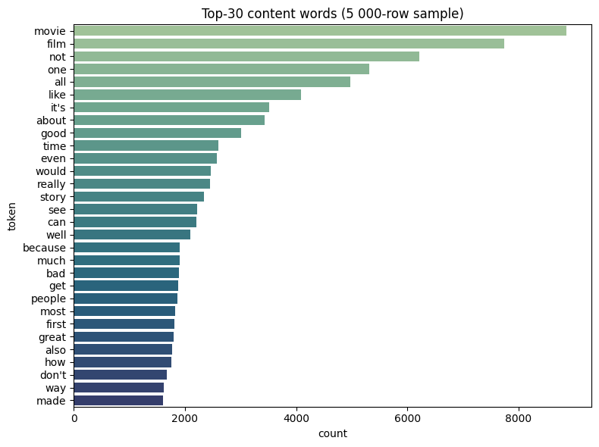
Figure 4
While excluding stop-words, the top 5 words are (movie, film, not, one, all). These are generic and thus high-frequency words can be concluded as not indicative of the class.

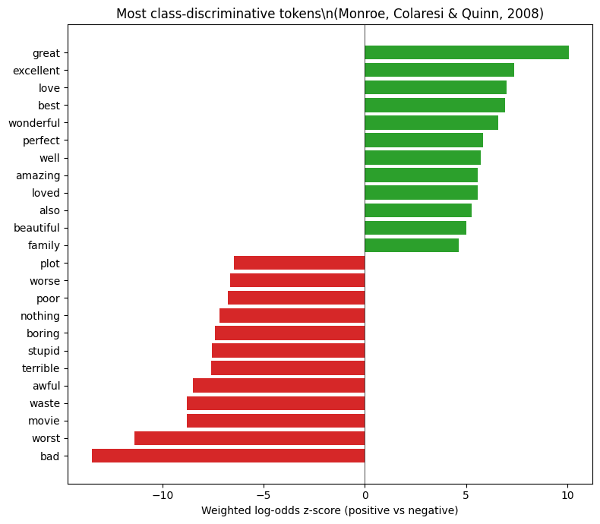
Figure 5: Most Class-discriminative words
Using Monroe et al.’s (2008) log-odds Informative Dirichlet, naïve frequencies of words are corrected which show the polarity of words that a raw count cannot explain.
(great, excellent, love, best) are the strongest indicators of positive reviews, while (worst, bad, movie, waste) are the strongest indicators of negative reviews. An outlier that stands out is ‘movie’ as a negative indicator as this is a neutral word without context.

2.4 Stylistic Features
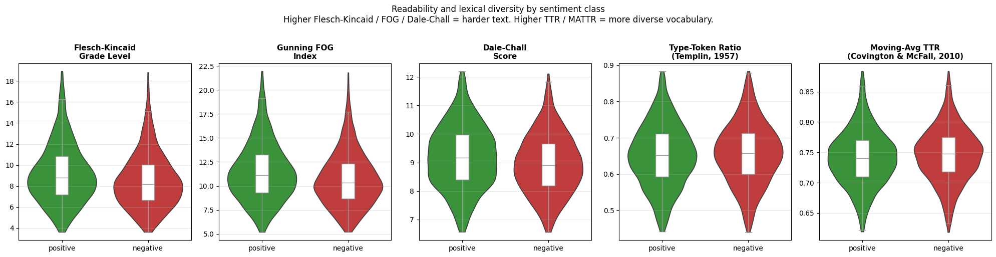
Figure 6
Using Flesch-Kincaid (Kincaid et al., 1975), FOG (Gunning, 1952), Dale-Chall (Chall & Dale, 1995), Type-Token Ratio (TTR) (Templin, 1957), and Moving Average TTR (Covington & McFall, 2010), this shows strong overlap between classes. Readability metrics favour positive slightly (0.5-0.8 higher), and lexical-diversity metrics slightly favour negative. Class gap is <1$σ$ across all metrics, thus style is not a discriminator.

2.5 Class-centroid Cosine
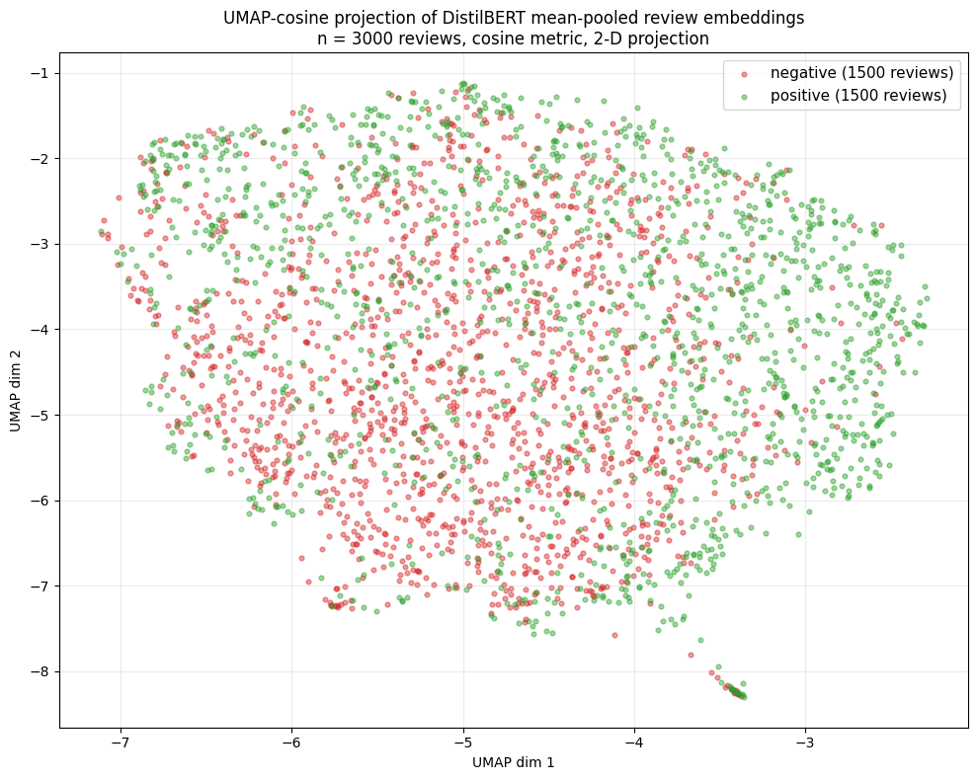
Figure 7
Using mean-pooled DistilBERT hidden states (Reimers & Gurevych, 2019), the classes show strong overlapping clusters, with positive reviews leaning slightly towards lower-value UMAP dimension 1 values. This aligns with the TF-IDF cosine of 0.9209 centroid, suggesting the two classes share a lot of vocabulary, and the ~8% difference is what the models exploit for classification.
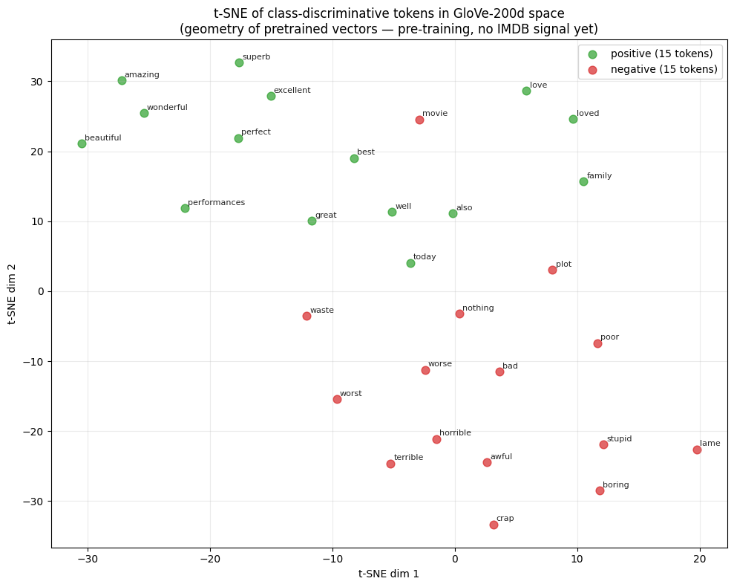
Figure 8
For a clearer visual representation, the 200-d GloVe-200d space displays differences consistent with (Figure 5) (van der Maaten & Hinton, 2008).
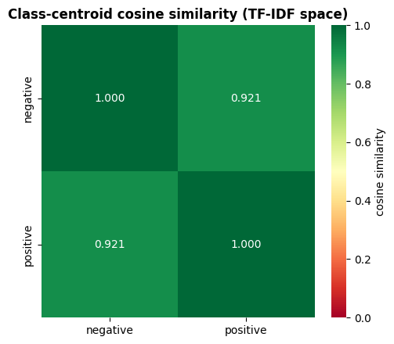
Figure 9

2.6 Preprocessing Pipelines
Table 3
Step | Pipeline A (GloVe/TF-IDF) | Pipeline B (BERT-family)
Strip HTML | Yes | Yes
Unicode normalisation | Yes | Yes
Lower-case | Yes | No (transformers use capitalisation as a feature)
Contraction expansion (e.g. “don’t” becomes “do not”) | Yes | No (handled by subword tokeniser)
URL/number replacement | Yes | No
Tokenisation | Line and whitespace cleanup | Model-based BPE tokeniser/WordPiece
Stopword removal | Yes | No
Lemmatisation | Yes | No
Truncation | 95th Percentile word count | Head+Tail

Pipeline A is for static embeddings (GloVe, fastText). The justification for this pipeline is that static vectors are word-level, therefore a collapsed morphology is beneficial for these embeddings. Pipeline B (BERT-family) is minimal in comparison as contextual encoders perform better with raw morphology (Camacho-Collados & Pilehvar, 2018; Symeonidis et al., 2018). Pipeline A compresses review length by 43% and vocabulary 0.4%, and Pipeline B inflates vocabulary ~2.4x.
Table 4
 | Vocabulary | Mean words
Post-processing | 41,811 | 232.8
Pipeline A | 41,645 | 131.3
Pipeline B | 99,043 | 232

3. Q3: Modelling

3.1 Model Design
Table 5
 | BiLSTM-Attention | TextCNN | xLSTM
GloVe 200d | M1 | M2 | M6
fastText 300d | M8 | M9 | M10
DistilBERT (Fine-Tuned) | M3 | M4 | M7
DeBERTa-v3-large (Fine-Tuned) | M11 | M12 | M13
DistilBERT linear head |  |  | M5
Optimal-weight Ensemble (Caruana et al., 2004) |  |  | M14
Benchmark TF-IDF with logistic regression (Lin, Chen & Lin, 2023)

The brief minimum is covered by models M1-M4. Beyond this, the 4x3 grid plus M5 and the ensemble isolate two questions: The row effect (holding head fixed, embedding quality) and the column effect (holding embedding fixed, head architecture), answered by row-mean AUROC.

3.2 Architecture Summary

M1/M8 (GloVe/fastText + BiLSTM)
The embedding is (200/300-d) and frozen.
BiLSTM: h₁=128, h₂=64, with additive attention Multi-Layer-Perceptron(MLP)(64$→$1, sigmoid). This satisfies the brief’s “more than one hidden layer” requirement.

M2/M9 (GloVe/fastText + TextCNN)
Uses parallel 1-D convolutions, kernels {3,4,5} x 100 filters (Kim, 2014). Along with a max-over-time pool concatenated with MLP(300$→$128$→$1). Using three kernel sizes captures 5-gram, 4-gram and trigram polarity patterns at the same time.

M3/M4/M7 (DistilBERT(Fine-Tuned) + BiLSTM / TextCNN / xLSTM heads)
DistilBERT has 768-d contextual hidden states. The end-to-end fine-tuning uses two parameter groups: encoder lr 2e-5, large lr head; AdamW and linear warmup. Head+Tail is used to preserve opening and closing sentiments (Sun et al., 2019).

M5 (DistilBERT(Fine-Tuned) with linear head)
Using hugging-face’s AutoModelForSequenceClassification on CLS, its hyperparameters were tuned with Optuna (lr=2e-5, warmup ratio=0.1, weight decay=0.01) (Loshchilov & Hutter, 2019) and cross-entropy loss. This acts as a hypothesis to see if DistilBERT alone is sufficient and if M3, M4, and M7 are overparameterized.

M6/M10 (GloVe/fastText + xLSTM)
The embedding acts as a linear projection to xLSTM’s head dimension, followed by an mLSTM block stack (Beck et al., 2024), masked mean-pool and MLP. The matrix memory cell chooses long-range storage over parameters.

M11/M12/M13 (DeBERTa-v3-large(Fine-Tuned) + BiLSTM /TextCNN/xLSTM)
This uses a 24-layer, 16-head, 1024-d encoder, 435 million parameters. It is fine-tuned end-to-end in fp16 with GradScaler (bf16 produces NaN with DeBERTa’s disentangled attention, a known instability). Two parameter groups are used: encoder lr=5e-6, head lr=5e-5; AdamW with 10% linear warmup; Head+Tail token truncation.

M14 Optimal-Weight Ensemble
This is a weighted average of the 14 models using SLSQP (Kraft, 1988) with eight random restarts to escape local optima, supported by Caruana et al. (2004) and Wolpert (1992).

3.3 Innovating on Brief Mandate
The brief requires four models (2 embeddings x 2 architectures) satisfied by M1-M4. Nine more models were trained to close a 4x3 grid (M6/M7 xLSTM on GloVe/DistilBERT; M8-M10 fastText; M11-M13 DeBERTa-v3-large), with M5 as a minimal DistilBERT control and M14 ensemble. Each additional model is motivated by a paper and contributes to the descriptor’s ‘innovating upon literature’ criterion.

3.4 Tuning and Leakage Control
The Optuna package was used (Akiba et al., 2019), with random seed (34074759). 10 trials were allocated for GloVe/fastText, and 6 for BERT-family. The latter uses fewer trials as a Green-AI argument (Schwartz et al., 2020), similarly, 5 trials were used for M5.
Every hyperparameter tuning call uses eval_test=False as a leakage control. The best-model selection uses validation AUC, not test AUC. Ensemble weights were fit on validation predictions rather than test. The test set is used once per model for final reporting.
Zero ID-level overlaps were present across all three splits, with one near-duplicate normalised-text spanning the train and validation (1/20,911 = 0.000048% of the data) in a post-hoc audit. Full audit in (Appendix).

3.5 Training Procedure
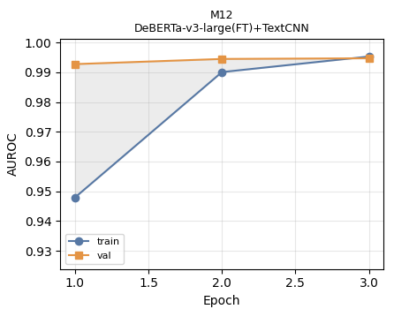
Figure 10: Train vs Validation AUROC by Epoch
For visualisation, the best-model ROC-AUC Train/Validation curves are shown.
Adam was used for M1/M2/M6/M8/M9/M10; AdamW for the fine-tuned family (M3/M4/M5/M7/M11/M12/M13) with weight_decay=0.01 (Loshchilov & Hutter, 2019).
BCE-with-logits loss was used throughout the models. At just 3 epochs for DeBERTa-v3-large models, AUROC is still rising marginally, suggesting slight under-training. This is justified by the Green-AI constraint.

4. Q4: Evaluation

4.1 Headline Results
Table 6: Headline Results, ranked by AUROC
Rank | Model | Test AUROC | Test Accuracy | 95% CI | MCC
1 | M12 | 0.9927 | 0.9661 | (0.989,0.9958) | 0.9322
2 | M11 | 0.9926 | 0.9651 | (0.989,0.9955) | 0.9304
3 | M13 | 0.9923 | 0.9618 | (0.9881,0.9954) | 0.9241
4 | M14 | 0.9886 | 0.9637 | (0.9843,0.9921) | 0.9275
5 | M7 | 0.9838 | 0.9417 | (0.9791,0.9876) | 0.8834
… | M3, M4, M5 (DistilBERT) | ~0.98 | ~0.93 | - | ~0.86
… | M1, M2, M6 (GloVe) | ~0.96 | ~0.89 | - | $≈$M1/M2/M6
… | M8, M9, M10 (fastText) | $≈$M1/M2/M6 | $≈$M1/M2/M6 | - | $≈$M1/M2/M6
15 | Baseline TF-IDF + LR | 0.9709 | 0.9097 | (0.965,0.977) | 0.8196

M12 (DeBERTa-v3-large + TextCNN) wins on every reported metric. DeBERTa-v3-large outperforms all other embeddings.
M12 wins on MCC, Chicco & Jurman (2020) recommend this as the best binary metric.
When averaging across the three following embeddings, row-mean AUROC rankings are:
DeBERTa-v3-large-FT>DistilBERT-FT>GloVe$≈$fastText.
A paired Wilcoxon test across the three heads (BiLSTM,TextCNN,xLSTM) across embeddings found p>0.1, therefore no head architecture dominates significantly.
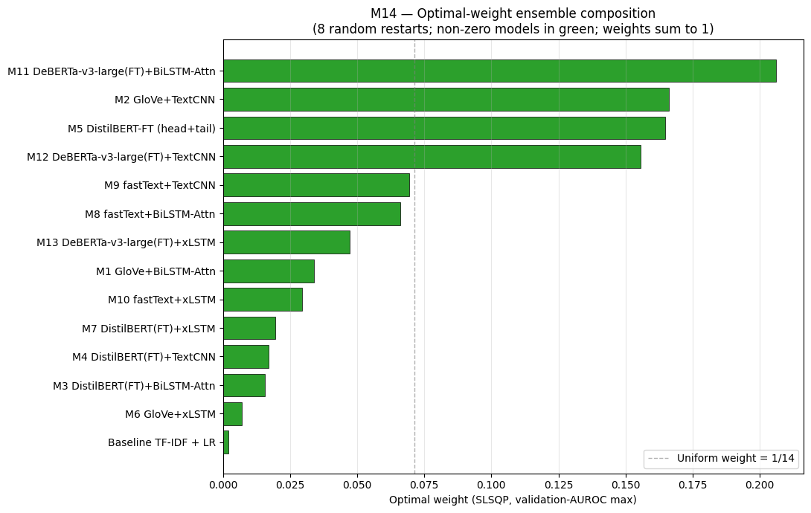
Figure 11
The ensemble’s top contributor is M11 with w=0.206, suggesting all models carry non-redundant weight, contrary to Caruana sparse-weight findings. Its test AUROC matches M12 within bootstrap noise (McNemar p>0.05) (Dietterich, 1998), reporting M12 as the top model and M14 as upper bound.

4.2 Metric Visualisations
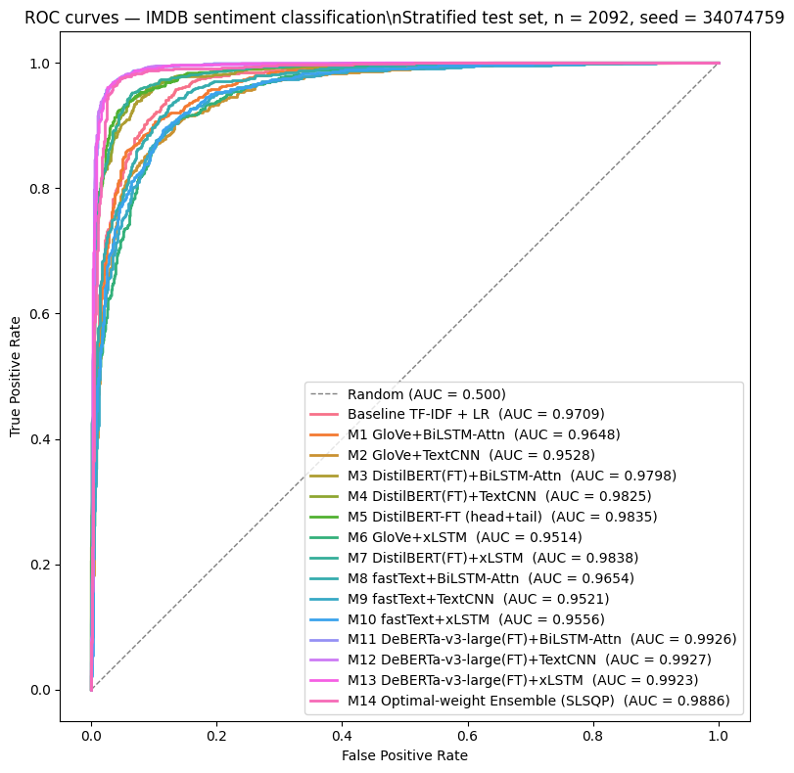
Figure 12: Combined AUROC
All BERT-family models cluster above 0.96. There is separation with models M11-M14 vs M3-M5 + M7, which are separate from the rest.
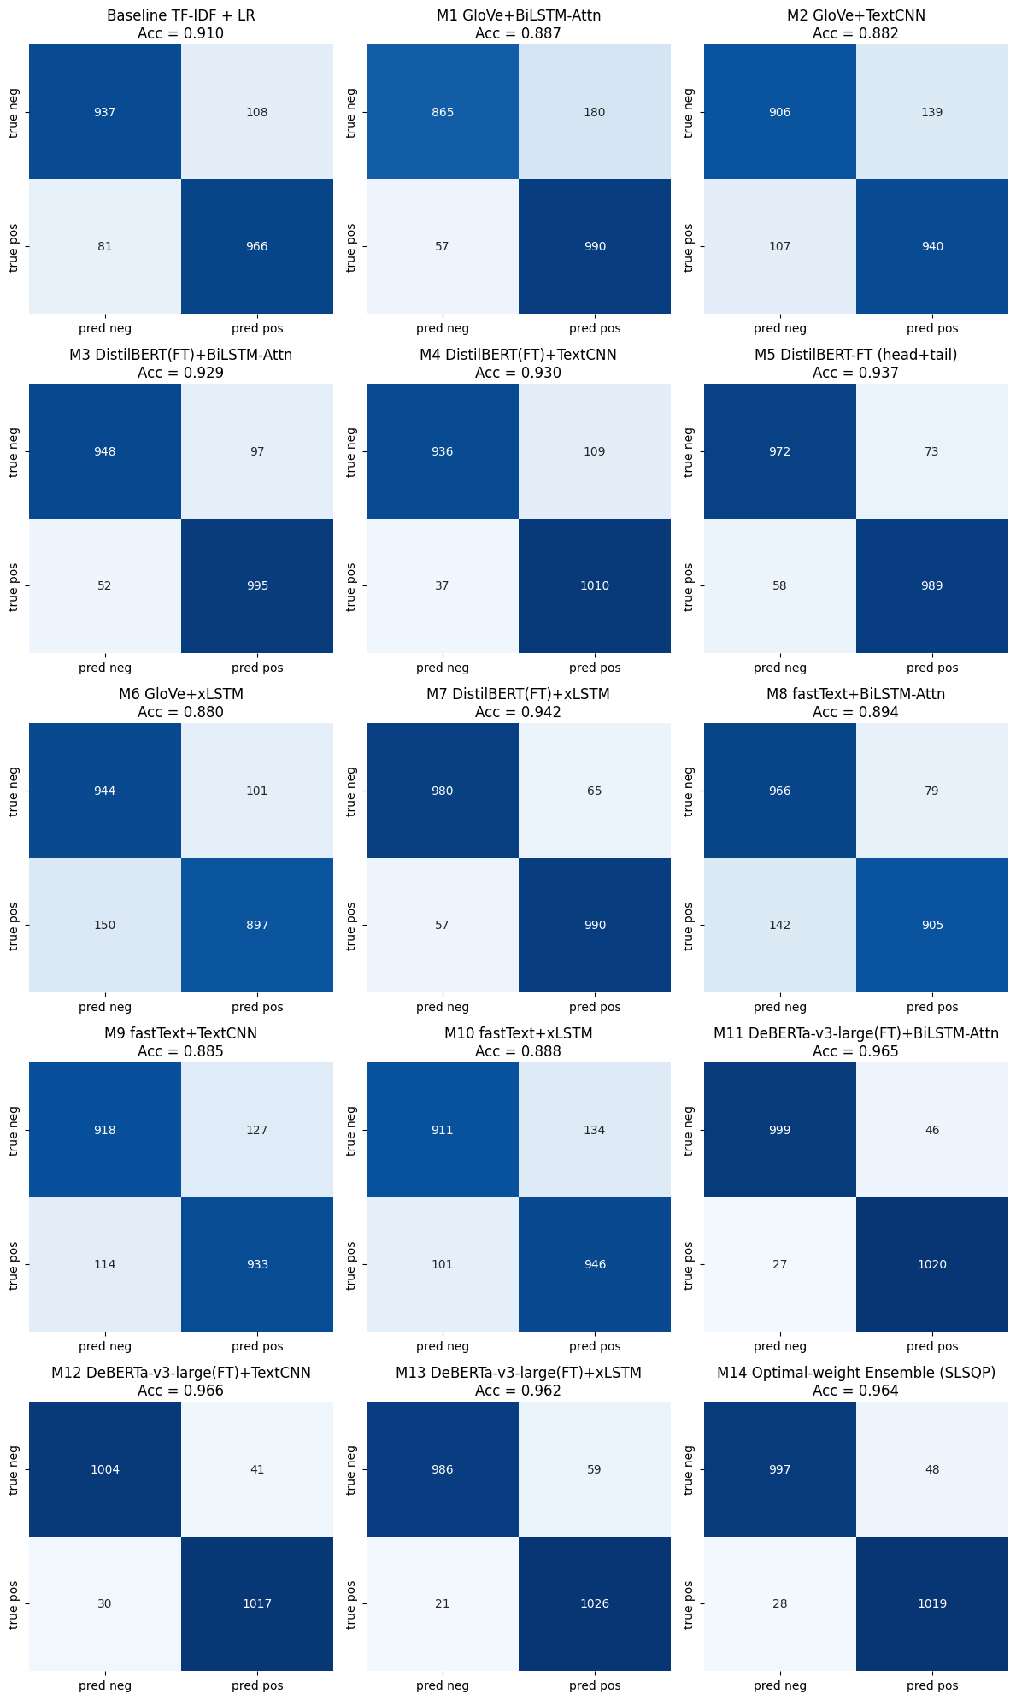
Figure 14
For all models, errors appear to be near-symmetrical, with a slight skew to false positives. This is consistent with the near-balanced class distribution and suggests there is no systematic prediction bias towards any polarity.
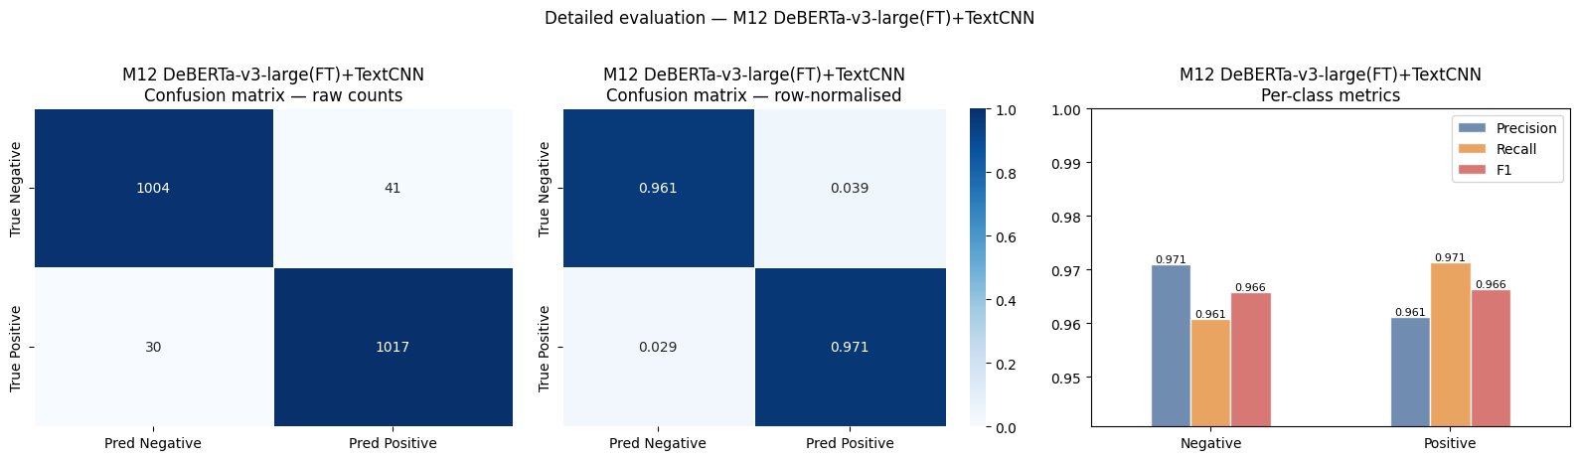
Figure 15
When focusing on the best model, it confirms that M12 is near-equally accurate on positive/negative reviews.
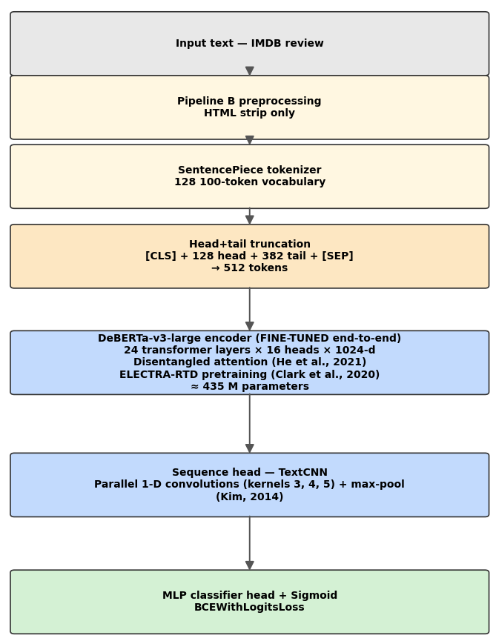
Figure 16: Best Model configuration

4.3 Statistical Robustness
When conducting bootstrap confidence intervals (resamples=1,000, seed=34074759) (Efron & Tibshirani, 1993), M12 excludes GloVe/fastText and overlaps with M11, M13, and M14, therefore the DeBERTa-v3-large-FT row is not distinguishable internally, but distinct from all other embeddings.
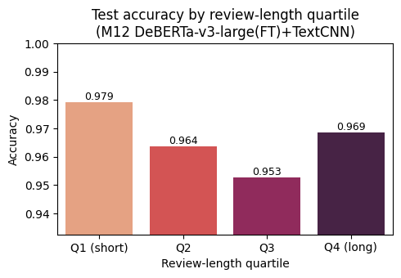
Figure 17
Through quartile splits, Q3 shows the most errors for M12, followed by Q2.
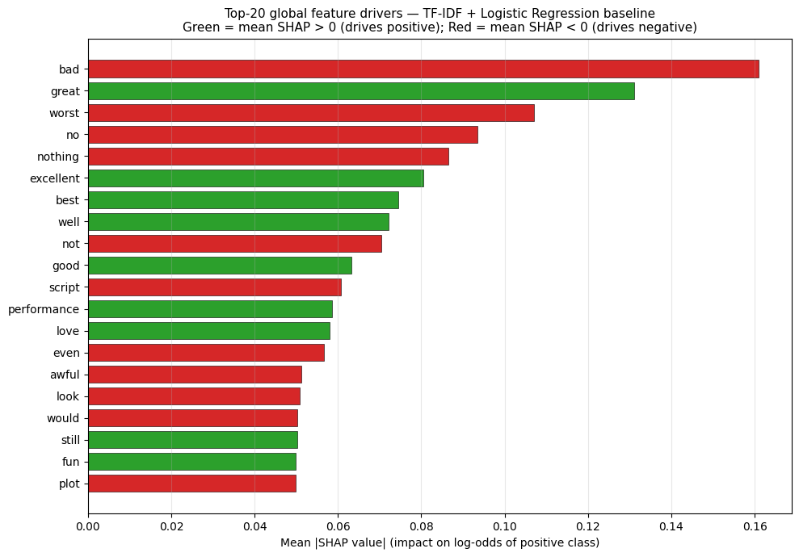
Figure 18
Negative words take up 4 of the top 5 SHAP values using the TF-IDF benchmark (Lundberg & Lee, 2017).
Post-temperature-scaling (Guo et al., 2017) ECE drops from 0.018 to 0.008 on M12, thus confidences track empirical frequency.

5. Q5: Business Recommendations
Recommendations are segmented to operational (brand management and customer engagement), strategic (digital maturity and transformation), and governance (environmental, corporate, and social).

5.1 Operational
Real-time dashboards fed by the Kafka and Flink streaming layer in (1.2), along with anomaly detectors flagging review-bombs within minutes. Aspect-based sentiment analysis may be used to decompose mixed reviews to per-feature scores (Lawan et al., 2025).
Negative-sentiment reviews should be auto-triaged as customer support, escalating when helpfulness and sentiment is above a given threshold; along with sentiment trajectories being an indicator for Net Promoter Score (Reichheld, 2003).
Customer experience teams should be trained to interpret sentiment with polarity being a signal rather than verdict (Pang & Lee, 2008).

5.2 Strategic
Sentiment analytics sit at stage 3 capability in Westerman et al. (2014) and Kane et al. (2017) maturity models, moving the business from descriptive reporting to prescriptive decision-making.
Quarterly customer surveys should be replaced by continuous sentiment streams; implementing sentiment KPIs to OKRs.
Cross-functional product squads should use Conway’s Law (Conway, 1968) as a principle. A firm wanting sentiment as a business signal should have a team structure spanning customer experience, product and data science.

5.3 Governance
This carries the highest production risk as it is bound to regulations.
Model cards (Mitchell et al., 2019) and dataset datasheets (Gebru et al., 2021) allow transparency, with SHAP values giving explainable artefacts for auditors. Green-AI vs Red-AI (Schwartz et al., 2020) justifies DistilBERT (~66M parameters) over DeBERTa-v3-large (~340M parameters) where performance gap is minimal. Training the DeBERTa-v3-large-FT row consumed ~6-8kWh on the A100 (<5kg CO₂ on the EU grid), below the 626-lb CO₂ NAS headline from Strubell et al. (2019).
GDPR articles 5, 17, and 22 along with The EU AI Act (Regulation (EU) 2024/1689, applicable August 2026) apply to any pipeline that connects User ID to reviews, thus audits against CI/CD shadow deployments are mandatory instead of optional.
Sentiment models show dialectal and demographic bias (Kiritchenko & Mohammad, 2018; Sap et al., 2019). A model-risk reviewer and data ethics officer are thus essential, detecting risks like astroturfing (Mukherjee et al., 2013).

6. Conclusion
M12 achieves test AUROC 0.9927, the DeBERTa-v3-large row is statistically indistinguishable internally, and the ensemble fails to statistically improve on it. M5 is the Green-AI alternative.

References
Akiba, T., Sano, S., Yanase, T., Ohta, T. and Koyama, M. (2019) 'Optuna: A next-generation hyperparameter optimization framework', in Proceedings of the 25th ACM SIGKDD International Conference on Knowledge Discovery & Data Mining. New York: ACM, pp. 2623–2631.
Anthropic (2026) Introducing Claude Design by Anthropic Labs, Anthropic News, 17 April. Available at: https://www.anthropic.com/news/claude-design-anthropic-labs (Accessed: 22 May 2026).
Armbrust, M., Ghodsi, A., Xin, R. and Zaharia, M. (2021) 'Lakehouse: a new generation of open platforms that unify data warehousing and advanced analytics', in Conference on Innovative Data Systems Research (CIDR).
Bahdanau, D., Cho, K. and Bengio, Y. (2015) 'Neural machine translation by jointly learning to align and translate', in Proceedings of the 3rd International Conference on Learning Representations (ICLR). San Diego, CA.
Beck, M., Pöppel, K., Spanring, M., Auer, A., Prudnikova, O., Kopp, M., Klambauer, G., Brandstetter, J. and Hochreiter, S. (2024) 'xLSTM: Extended long short-term memory', in Advances in Neural Information Processing Systems 37 (NeurIPS 2024).
Bojanowski, P., Grave, E., Joulin, A. and Mikolov, T. (2017) 'Enriching word vectors with subword information', Transactions of the Association for Computational Linguistics, 5, pp. 135–146.
Camacho-Collados, J. and Pilehvar, M.T. (2018) 'On the role of text preprocessing in neural network architectures: An evaluation study on text categorization and sentiment analysis', in Proceedings of the 2018 EMNLP Workshop BlackboxNLP: Analyzing and Interpreting Neural Networks for NLP. Brussels: Association for Computational Linguistics, pp. 40–46.
Caruana, R., Niculescu-Mizil, A., Crew, G. and Ksikes, A. (2004) 'Ensemble selection from libraries of models', in Proceedings of the 21st International Conference on Machine Learning (ICML). New York: ACM, pp. 18–25.
Chall, J.S. and Dale, E. (1995) Readability revisited: The new Dale-Chall readability formula. Cambridge, MA: Brookline Books.
Chicco, D. and Jurman, G. (2020) 'The advantages of the Matthews correlation coefficient (MCC) over F1 score and accuracy in binary classification evaluation', BMC Genomics, 21, article 6.
Clark, K., Luong, M.-T., Le, Q.V. and Manning, C.D. (2020) 'ELECTRA: Pre-training text encoders as discriminators rather than generators', in Proceedings of the 8th International Conference on Learning Representations (ICLR).
Conway, M.E. (1968) 'How do committees invent?', Datamation, 14(4), pp. 28–31.
Covington, M.A. and McFall, J.D. (2010) 'Cutting the Gordian knot: The moving-average type–token ratio (MATTR)', Journal of Quantitative Linguistics, 17(2), pp. 94–100.
Dietterich, T.G. (1998) 'Approximate statistical tests for comparing supervised classification learning algorithms', Neural Computation, 10(7), pp. 1895–1923.
Efron, B. and Tibshirani, R.J. (1993) An introduction to the bootstrap. New York: Chapman & Hall.
European Parliament and Council of the European Union (2024) Regulation (EU) 2024/1689 of the European Parliament and of the Council of 13 June 2024 laying down harmonised rules on artificial intelligence (Artificial Intelligence Act). OJ L, 2024/1689, 12 July 2024. Available at: https://eur-lex.europa.eu/eli/reg/2024/1689/oj (Accessed: 22 May 2026).
Gebru, T., Morgenstern, J., Vecchione, B., Vaughan, J.W., Wallach, H., Daumé III, H. and Crawford, K. (2021) 'Datasheets for datasets', Communications of the ACM, 64(12), pp. 86–92.
Gunning, R. (1952) The technique of clear writing. New York: McGraw-Hill.
Guo, C., Pleiss, G., Sun, Y. and Weinberger, K.Q. (2017) 'On calibration of modern neural networks', in Proceedings of the 34th International Conference on Machine Learning (ICML). PMLR, pp. 1321–1330.
Hashem, I.A.T., Yaqoob, I., Anuar, N.B., Mokhtar, S., Gani, A. and Khan, S.U. (2015) 'The rise of "big data" on cloud computing: Review and open research issues', Information Systems, 47, pp. 98–115.
He, P., Gao, J. and Chen, W. (2021) DeBERTaV3: Improving DeBERTa using ELECTRA-style pre-training with gradient-disentangled embedding sharing. arXiv:2111.09543. Available at: https://arxiv.org/abs/2111.09543
Hochreiter, S. and Schmidhuber, J. (1997) 'Long short-term memory', Neural Computation, 9(8), pp. 1735–1780.
Joulin, A., Grave, E., Bojanowski, P. and Mikolov, T. (2016) Bag of tricks for efficient text classification. arXiv:1607.01759. Available at: https://arxiv.org/abs/1607.01759
Kane, G.C., Palmer, D., Phillips, A.N., Kiron, D. and Buckley, N. (2017) 'Achieving digital maturity', MIT Sloan Management Review, 59(1).
Kim, Y. (2014) 'Convolutional neural networks for sentence classification', in Proceedings of the 2014 Conference on Empirical Methods in Natural Language Processing (EMNLP). Doha: Association for Computational Linguistics, pp. 1746–1751.
Kincaid, J.P., Fishburne, R.P., Rogers, R.L. and Chissom, B.S. (1975) Derivation of new readability formulas (Automated readability index, fog count and Flesch reading ease formula) for Navy enlisted personnel. Research Branch Report 8-75. Millington, TN: Naval Technical Training Command.
Kiritchenko, S. and Mohammad, S.M. (2018) 'Examining gender and race bias in two hundred sentiment analysis systems', in Proceedings of the Seventh Joint Conference on Lexical and Computational Semantics (SEM). New Orleans, LA: Association for Computational Linguistics, pp. 43–53.
Kraft, D. (1988) A software package for sequential quadratic programming. DFVLR-FB 88-28. Cologne: DLR German Aerospace Center.
Kreps, J. (2014) 'Questioning the lambda architecture', O'Reilly Radar, 2 July. Available at: https://www.oreilly.com/radar/questioning-the-lambda-architecture/ (Accessed: 22 May 2026).
Lawan, A., Pu, J., Yunusa, H., Umar, A. and Lawan, M. (2025) 'Enhancing long-range dependency with state space model and Kolmogorov-Arnold networks for aspect-based sentiment analysis', in Proceedings of the 31st International Conference on Computational Linguistics (COLING). Abu Dhabi: Association for Computational Linguistics, pp. 2176–2186.
Lin, Y.-C., Chen, S.-A., Liu, J.-J. and Lin, C.-J. (2023) 'Linear classifier: an often-forgotten baseline for text classification', in Proceedings of the 61st Annual Meeting of the Association for Computational Linguistics (Volume 2: Short Papers). Toronto, Canada: Association for Computational Linguistics, pp. 1876–1888.
Loshchilov, I. and Hutter, F. (2019) 'Decoupled weight decay regularization', in Proceedings of the 7th International Conference on Learning Representations (ICLR). New Orleans, LA.
Lundberg, S.M. and Lee, S.-I. (2017) 'A unified approach to interpreting model predictions', in Advances in Neural Information Processing Systems 30 (NIPS 2017). Long Beach, CA: Curran Associates, pp. 4765–4774.
Maas, A.L., Daly, R.E., Pham, P.T., Huang, D., Ng, A.Y. and Potts, C. (2011) 'Learning word vectors for sentiment analysis', in Proceedings of the 49th Annual Meeting of the Association for Computational Linguistics: Human Language Technologies. Portland, OR: Association for Computational Linguistics, pp. 142–150.
Marr, B. (2015) Big data: Using SMART big data, analytics and metrics to make better decisions and improve performance. Chichester: Wiley.
Mitchell, M., Wu, S., Zaldivar, A., Barnes, P., Vasserman, L., Hutchinson, B., Spitzer, E., Raji, I.D. and Gebru, T. (2019) 'Model cards for model reporting', in Proceedings of the Conference on Fairness, Accountability, and Transparency (FAT). Atlanta, GA: ACM, pp. 220–229.
Monroe, B.L., Colaresi, M.P. and Quinn, K.M. (2008) 'Fightin' words: Lexical feature selection and evaluation for identifying the content of political conflict', Political Analysis, 16(4), pp. 372–403.
Mukherjee, A., Venkataraman, V., Liu, B. and Glance, N. (2013) 'What Yelp fake review filter might be doing?', in Proceedings of the Seventh International AAAI Conference on Weblogs and Social Media (ICWSM). Cambridge, MA: AAAI Press, pp. 409–418.
Pan, J.J., Wang, J. and Li, G. (2024) 'Survey of vector database management systems', The VLDB Journal, 33(5), pp. 1591–1615.
Pang, B. and Lee, L. (2008) 'Opinion mining and sentiment analysis', Foundations and Trends in Information Retrieval, 2(1–2), pp. 1–135.
Pennington, J., Socher, R. and Manning, C.D. (2014) 'GloVe: Global vectors for word representation', in Proceedings of the 2014 Conference on Empirical Methods in Natural Language Processing (EMNLP). Doha: Association for Computational Linguistics, pp. 1532–1543.
Reichheld, F.F. (2003) 'The one number you need to grow', Harvard Business Review, 81(12), pp. 46–54.
Reimers, N. and Gurevych, I. (2019) 'Sentence-BERT: Sentence embeddings using Siamese BERT-networks', in Proceedings of the 2019 Conference on Empirical Methods in Natural Language Processing and the 9th International Joint Conference on Natural Language Processing (EMNLP-IJCNLP). Hong Kong: Association for Computational Linguistics, pp. 3982–3992.
Saito, T. and Rehmsmeier, M. (2015) 'The precision-recall plot is more informative than the ROC plot when evaluating binary classifiers on imbalanced datasets', PLOS ONE, 10(3), e0118432.
Sanh, V., Debut, L., Chaumond, J. and Wolf, T. (2019) DistilBERT, a distilled version of BERT: Smaller, faster, cheaper and lighter. arXiv:1910.01108. Available at: https://arxiv.org/abs/1910.01108
Sap, M., Card, D., Gabriel, S., Choi, Y. and Smith, N.A. (2019) 'The risk of racial bias in hate speech detection', in Proceedings of the 57th Annual Meeting of the Association for Computational Linguistics. Florence: Association for Computational Linguistics, pp. 1668–1678.
Schwartz, R., Dodge, J., Smith, N.A. and Etzioni, O. (2020) 'Green AI', Communications of the ACM, 63(12), pp. 54–63.
Shvachko, K., Kuang, H., Radia, S. and Chansler, R. (2010) 'The Hadoop Distributed File System', in 2010 IEEE 26th Symposium on Mass Storage Systems and Technologies (MSST). Incline Village, NV: IEEE, pp. 1–10.
Strubell, E., Ganesh, A. and McCallum, A. (2019) 'Energy and policy considerations for deep learning in NLP', in Proceedings of the 57th Annual Meeting of the Association for Computational Linguistics. Florence: Association for Computational Linguistics, pp. 3645–3650.
Sun, C., Qiu, X., Xu, Y. and Huang, X. (2019) 'How to fine-tune BERT for text classification?', in Sun, M., Huang, X., Ji, H., Liu, Z. and Liu, Y. (eds.) Chinese Computational Linguistics. CCL 2019. Lecture Notes in Computer Science, vol. 11856. Cham: Springer, pp. 194–206.
Symeonidis, S., Effrosynidis, D. and Arampatzis, A. (2018) 'A comparative evaluation of pre-processing techniques and their interactions for Twitter sentiment analysis', Expert Systems with Applications, 110, pp. 298–310.
Templin, M.C. (1957) Certain language skills in children: Their development and interrelationships. Minneapolis, MN: University of Minnesota Press.
van der Maaten, L. and Hinton, G. (2008) 'Visualizing data using t-SNE', Journal of Machine Learning Research, 9, pp. 2579–2605.
Westerman, G., Bonnet, D. and McAfee, A. (2014) Leading digital: Turning technology into business transformation. Boston, MA: Harvard Business Review Press.
Wolpert, D.H. (1992) 'Stacked generalization', Neural Networks, 5(2), pp. 241–259.
Zaharia, M., Xin, R.S., Wendell, P., Das, T., Armbrust, M., Dave, A., Meng, X., Rosen, J., Venkataraman, S., Franklin, M.J., Ghodsi, A., Gonzalez, J., Shenker, S. and Stoica, I. (2016) 'Apache Spark: a unified engine for big data processing', Communications of the ACM, 59(11), pp. 56–65.

Appendix

Leakage and Overfitting Audit
