
Stock Price Prediction: Addressing the Challenge of Market Dynamics
Graduation Project (1/2) Report
Prepared by:
Hashem Al-Ayasrah 202010678
Qais Qawasmi 201920084
Supervised by:
Dr. Ahmad Hussein
To obtain
BSc in Artificial Intelligence
2ND Semester / 2023/2024
Group No.: AI-23-1-1-[serial]
Copyright © 2023-2024 - All rights reserved Middle East University

Declaration
We, the undersigned, hereby declare that the work presented in this document is entirely
our own, except where due acknowledgment is made. Any material reproduced or referred
to herein has been properly cited and referenced at the end of the document.
Date | Signature | Students Name | Student ID
Date | Signature | Hashem Al-Ayasrah | 202010678
Date | Signature | Qais Qawasmi | 201920084
1

Supervisor Approval
APPROVAL FOR SUBMISSION
I certify that this project report entitled “STOCK PRICE PREDICTION: ADDRESS-ING THE CHALLENGE OF MARKET DYNAMICS” prepared by Hashem Al-Ayasrah and Qais Qawasmi has met the required standard for submission in partial fulfillment of the requirements for the degree of Bachelor of Science in Artificial Intelligence at MEU.
Approved by
Signature: Supervisor: Dr. Ahmad Hussein
2

Contents
Declaration 1
Supervisor Approval 2
Acknowledgement 6
Abstract (English) 7
1 Introduction 8
2 Background 10
2.1 Introduction to Stock Price Prediction . . . . . . . . . . . . . . . . . . . 10
2.2 Traditional Methods . . . . . . . . . . . . . . . . . . . . . . . . . . . . . 10
2.3 Introduction to Machine Learning and Deep Learning . . . . . . . . . . . 11
2.4 Long Short-Term Memory Networks (LSTMs) . . . . . . . . . . . . . . . 11
2.5 Previous Research . . . . . . . . . . . . . . . . . . . . . . . . . . . . . . . 12
2.6 Motivation for Using AI in Stock Price Prediction . . . . . . . . . . . . . 12
2.7 Conclusion . . . . . . . . . . . . . . . . . . . . . . . . . . . . . . . . . . . 12
3 Literature Review 13
3.1 Introduction . . . . . . . . . . . . . . . . . . . . . . . . . . . . . . . . . . 13
3.2 Traditional Methods . . . . . . . . . . . . . . . . . . . . . . . . . . . . . 13
3.2.1 Technical Analysis . . . . . . . . . . . . . . . . . . . . . . . . . . 13
3.2.2 Fundamental Analysis . . . . . . . . . . . . . . . . . . . . . . . . 13
3.2.3 Limitations of Traditional Methods . . . . . . . . . . . . . . . . . 14
3.3 Machine Learning Approaches . . . . . . . . . . . . . . . . . . . . . . . . 14
3.3.1 Support Vector Machines (SVM) . . . . . . . . . . . . . . . . . . 14
3.3.2 Random Forests . . . . . . . . . . . . . . . . . . . . . . . . . . . . 14
3.4 Deep Learning Approaches . . . . . . . . . . . . . . . . . . . . . . . . . . 15
3.4.1 Long Short-Term Memory Networks (LSTMs) . . . . . . . . . . . 15
3.4.2 Convolutional Neural Networks (CNNs) . . . . . . . . . . . . . . 15
3.5 Sentiment Analysis in Stock Price Prediction . . . . . . . . . . . . . . . . 16
3.6 Evaluation of Existing Models . . . . . . . . . . . . . . . . . . . . . . . . 16
3.7 Research Gaps and Future Directions . . . . . . . . . . . . . . . . . . . . 16
3.8 Conclusion . . . . . . . . . . . . . . . . . . . . . . . . . . . . . . . . . . . 16
4 Dataset 18
4.1 Dataset . . . . . . . . . . . . . . . . . . . . . . . . . . . . . . . . . . . . 18
4.1.1 Data Selection . . . . . . . . . . . . . . . . . . . . . . . . . . . . . 18
3

4.1.2 Description . . . . . . . . . . . . . . . . . . . . . . . . . . . . . . 18
4.1.3 Collection . . . . . . . . . . . . . . . . . . . . . . . . . . . . . . . 19
4.1.4 Pre-processing . . . . . . . . . . . . . . . . . . . . . . . . . . . . . 19
5 Methodology 21
5.1 Research Design . . . . . . . . . . . . . . . . . . . . . . . . . . . . . . . . 21
5.2 Data Collection and Analysis . . . . . . . . . . . . . . . . . . . . . . . . 22
5.3 Materials Used . . . . . . . . . . . . . . . . . . . . . . . . . . . . . . . . 22
5.4 Procedures . . . . . . . . . . . . . . . . . . . . . . . . . . . . . . . . . . . 22
5.5 Identifying Market Dynamics . . . . . . . . . . . . . . . . . . . . . . . . 23
5.6 Limitations and Assumptions . . . . . . . . . . . . . . . . . . . . . . . . 23
6 Results 24
6.1 Introduction . . . . . . . . . . . . . . . . . . . . . . . . . . . . . . . . . . 24
6.2 Training and Validation Loss . . . . . . . . . . . . . . . . . . . . . . . . . 24
6.3 Performance Metrics . . . . . . . . . . . . . . . . . . . . . . . . . . . . . 25
6.4 Cross-Validation Scores . . . . . . . . . . . . . . . . . . . . . . . . . . . . 25
6.5 Stock Price Prediction with Support and Resistance . . . . . . . . . . . . 26
6.6 Discussion . . . . . . . . . . . . . . . . . . . . . . . . . . . . . . . . . . . 27
6.7 Conclusion . . . . . . . . . . . . . . . . . . . . . . . . . . . . . . . . . . . 27
7 Discussion 28
7.1 Interpretation of Results . . . . . . . . . . . . . . . . . . . . . . . . . . . 28
8 Conclusion 30
8.1 Summary . . . . . . . . . . . . . . . . . . . . . . . . . . . . . . . . . . . 30
8.2 Limitations . . . . . . . . . . . . . . . . . . . . . . . . . . . . . . . . . . 30
8.3 Future Work . . . . . . . . . . . . . . . . . . . . . . . . . . . . . . . . . . 30
Appendices 33
4

List of Figures
2.1 | Historical Stock Prices . . . . . . . . . . . . . . . . . . . . . . . . . . . . |  | 10
2.2 | Comparison of Traditional Methods . . . . . . . . . . . . . . . . . . . . . |  | 11
2.3 | Long Short-Term Memory (LSTM) Architecture . . . . . . . . . . . . . . |  | 11
3.1 | Random Forests for Stock Price Prediction . . . . . . . . . . . . . . . . . |  | 15
3.2 | CNN for Stock Price Prediction . . . . . . . . . . . . . . . . . . . . . . . |  | 16
4.1 | Dataset | . . . . . . . . . . . . . . . . . . . . . . . . . . . . . . . . . . . . | 19
4.2 | Dataset | . . . . . . . . . . . . . . . . . . . . . . . . . . . . . . . . . . . . | 19
4.3 | Data Preprocessing Steps . . . . . . . . . . . . . . . . . . . . . . . . . . . |  | 20
5.1 | Research Design Process . . . . . . . . . . . . . . . . . . . . . . . . . . . |  | 22
6.1 | Training and Validation Loss . . . . . . . . . . . . . . . . . . . . . . . . . |  | 24
6.2 | Performance Metrics . . . . . . . . . . . . . . . . . . . . . . . . . . . . . |  | 25
6.3 | Cross-Validation Scores . . . . . . . . . . . . . . . . . . . . . . . . . . . . |  | 26
6.4 | AAPL Stock Price with Support and Resistance (6mo) . . . . . . . . . . |  | 27
7.1 | Implications of Research Findings . . . . . . . . . . . . . . . . . . . . . . |  | 29
5

Acknowledgement
We extend our heartfelt thanks to everyone who contributed to the successful completion
of this project. Special thanks go to our supervisor Dr. Ahmad Hussein for his invaluable
guidance and to our colleagues for their teamwork and support.
6

Abstract (English)
Stock Price Prediction: Addressing the Challenge of Market Dynamics Abstract
This project aims to accurately predict stock prices in volatile markets using advanced machine learning methods. Traditional models often fail due to assuming linear relation-ships. Our approach leverages a powerful Long Short-Term Memory (LSTM) neural network to harness non-linear patterns and improve prediction accuracy. Additionally, we utilize trend and support/resistance analysis to derive meaningful insights. The results demonstrate the model’s reliability and its potential to inform investment decisions.
7

Chapter 1
Introduction
Forecasting stock prices is vital but demanding in business and finance. Accurate predic-tions can yield significant profits, but the volatile stock market makes them tricky. This volatility stems from factors like economic indicators, market optimism, global events, and unexpected external incidents. Conventional forecasting methods that depend on numerical models and historical data often fail due to oversimplified assumptions and linear correlations. These weaknesses highlight the need for enhanced and flexible pre-diction techniques. Advanced technologies like AI, ML, and big data analytics provide innovative ways to enhance forecast accuracy [2].
The creation of more accurate prediction models has major implications for investors, finance institutions, and the overall economy. When stock prices can be predicted more precisely, investments can be made more effectively, risks can be minimized, and resources can be shared more rationally. Better prediction methods also make the financial system more effective and secure [1].
This project aims to use advanced machine learning and data analysis to develop a powerful model that can predict stock prices. We want to go beyond traditional methods and give investors and analysts valuable insights they can use in their decision-making. By testing, validating, and analyzing our model thoroughly, we hope to improve stock price prediction and give stakeholders the tools they need to thrive in today’s competitive financial market. Our main goal is to make daily stock price predictions more accurate using artificial neural networks. To do this, we plan to create a strong model using LSTM architectures trained with the backpropagation algorithm. We will also find and use important input variables and experiment with different models [3].
This project aims to:
• Pinpoint the best methods for forecasting stock prices
• Determine which techniques are most accurate in their predictions
• Create visual displays of actual and predicted prices
• Test the consistency and dependability of the forecasting models
• Use the project’s findings to make real trades in the stock market
As referred in [4]. We are driven to embark on this project for several compelling reasons:
• Enhance investment strategies by reducing the impact of market fluctuations
8

• Offer valuable information to empower investors with informed decision-making• Foster economic progress and efficient capital allocation
• Provide individuals and communities with dependable financial knowledge
Advance the field of predictive modeling in financial technology as referenced in [5].
9

Chapter 2
Background
2.1 Introduction to Stock Price Prediction
Predicting stock market behavior is vital in financial decision-making. Successful forecasts can yield substantial returns, but the market’s inherent volatility and the influence of unpredictable factors hinder accurate predictions.
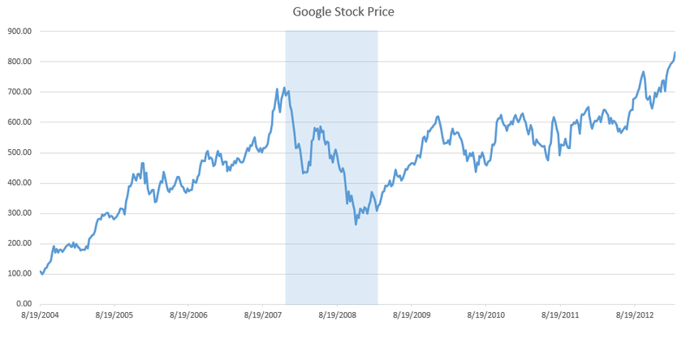
Figure 2.1: Historical Stock Prices
2.2 Traditional Methods
Traditional stock price forecasting techniques, such as moving averages and ARIMA models, assume that stock prices follow a straightforward linear trend. However, these methods may fall short in capturing the complex and often nonlinear characteristics of stock market dynamics.
10

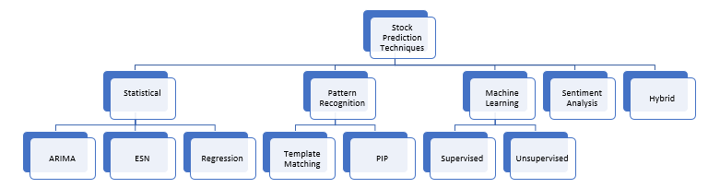
Figure 2.2: Comparison of Traditional Methods
2.3 Introduction to Machine Learning and Deep Learn-
ing
Advanced computing methods, such as machine learning and deep learning, have revolu-tionized industries like finance. These technologies empower computers to analyze vast amounts of data, identify patterns, and make accurate predictions. Deep learning, in particular, is remarkable in its ability to uncover intricate relationships within data by processing it through multiple layers.
2.4 Long Short-Term Memory Networks (LSTMs)
LSTMs are a type of Recurrent Neural Network (RNN) designed to handle long-term dependencies. They have a more complex structure than traditional RNNs, with separate mechanisms for retaining and forgetting information, which allows them to learn even more intricate temporal patterns. Fischer and Krauss (2018) proved that LSTMs are better than traditional methods for forecasting stock prices. They found that LSTMs could detect intricate patterns in financial time series data [4].
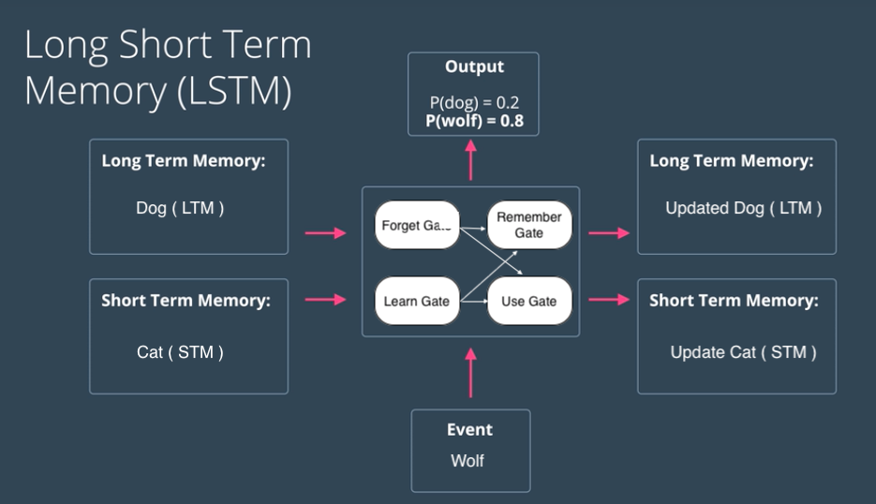
Figure 2.3: Long Short-Term Memory (LSTM) Architecture
11

2.5 Previous Research
Research using machine learning techniques like deep learning has been done to predict stock prices. For example, Ajibade and Atayero (2021) combined neural networks with technical analysis to make predictions. Alhaji and Tahir (2018) showed that artificial neural networks are good at predicting stock prices in Nigeria. These studies lay the groundwork for more research and improvements in this area.
2.6 Motivation for Using AI in Stock Price Predic-
tion
Artificial intelligence (AI) algorithms bring unique benefits to predicting stock prices. These techniques can handle massive datasets, identify hidden patterns, and adjust to evolving market dynamics. By leveraging AI, investors gain insights, mitigate risks, and potentially enhance their financial performance.
2.7 Conclusion
This chapter introduces why artificial intelligence (AI) is used for stock price prediction. Traditional methods have limitations but AI, such as machine learning and deep learning, can overcome them. Specific AI techniques like LSTMs are promising for improving prediction accuracy. The upcoming chapters will cover the methods, data analysis, and results of a study in this area.
12

Chapter 3
Literature Review
3.1 Introduction
Predicting stock market movements has been an important area of study for financial institutions. Over time, different methods have been used, starting with statistical models and progressing to more complex techniques like machine learning and deep learning. This chapter will explore the history of these methods, discuss the most significant studies, and provide insights into the latest trends and future prospects in this field.
3.2 Traditional Methods
Stock price forecasting has traditionally employed statistical and economic models. Mov-ing averages, autoregressive integrated moving average (ARIMA), or exponential smooth-ing are examples of these. These strategies heavily rely on past data, assuming a linear progression between past and future prices.
3.2.1 Technical Analysis
Technical analysis involves using historical price data to predict future price movements. Common techniques include:
• Moving Averages: Simple and exponential moving averages smooth out price data to identify trends.
• Relative Strength Index (RSI): Measures the speed and change of price move- ments to identify overbought or oversold conditions.
• Bollinger Bands: Use standard deviations around a moving average to indicate volatility and potential price reversals.
3.2.2 Fundamental Analysis
Fundamental analysis evaluates a company’s financial health and market position to estimate its stock value. This includes:
• Earnings Reports: Quarterly earnings reports provide insights into a company’s financial health and future prospects.
13

• P/E Ratio: The price-to-earnings ratio helps investors gauge whether a stock is over or undervalued.
• Dividend Yield: Indicates the income generated from a stock investment relative to its price.
3.2.3 Limitations of Traditional Methods
Current methods, although helpful, are limited because they assume data follows a straight line and cannot handle the intricate, non-linear patterns found in stock mar-ket data. This has opened the door to more sophisticated methods.
3.3 Machine Learning Approaches
Machine learning is being used in stock price prediction to improve upon traditional methods. By using machine learning, we can account for the intricate patterns and connections in data.
3.3.1 Support Vector Machines (SVM)
SVMs have been successfully applied in stock price prediction. A study by Huang et al. (2005) found that SVMs were capable of managing large amounts of data without overfit-ting. This resulted in more accurate predictions compared to conventional approaches [2].
3.3.2 Random Forests
Ensemble learning methods like Random Forests have been used for stock price prediction. In 2015, Patel et al. showed that Random Forests can combine predictions from multiple decision trees, leading to higher accuracy and reliability in forecasting stock prices [3].
14

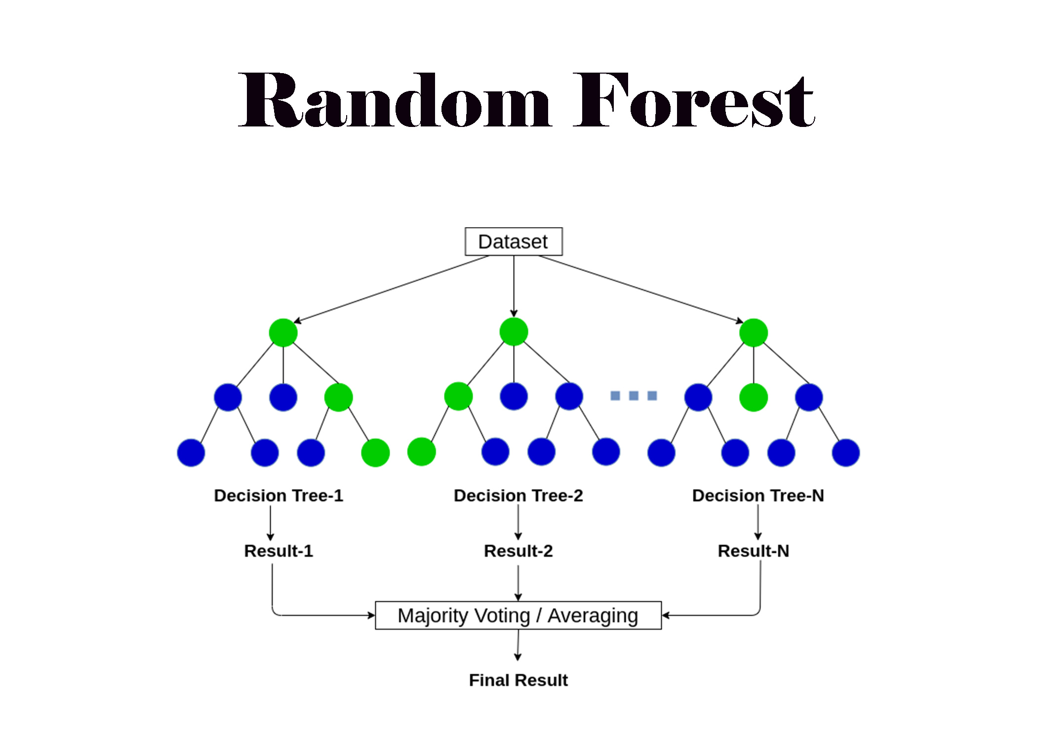
Figure 3.1: Random Forests for Stock Price Prediction
3.4 Deep Learning Approaches
Deep learning, a branch of machine learning, has become popular because it can find patterns that are complex and have many layers, by using a series of steps that get more and more abstract.
3.4.1 Long Short-Term Memory Networks (LSTMs)
LSTMs (Long Short-Term Memory networks) are a type of Recurrent Neural Network (RNN) designed to overcome the issue where long-term dependencies can be lost during training. They incorporate memory cells and gating mechanisms to retain information for an extended period. This allows LSTMs to learn and predict patterns that are spread out over a large time span. According to research conducted by Nelson et al. (2017), LSTMs have demonstrated better performance than traditional RNNs and other machine learning algorithms in forecasting stock prices [5].
3.4.2 Convolutional Neural Networks (CNNs)
Despite being initially designed for image recognition, Convolutional Neural Networks (CNNs) have been modified to analyze time series data, such as stock prices. A study by Kim and Kim (2019) successfully utilized CNNs to predict stock prices. The model effectively identified local characteristics and patterns within the time series data [6].
15

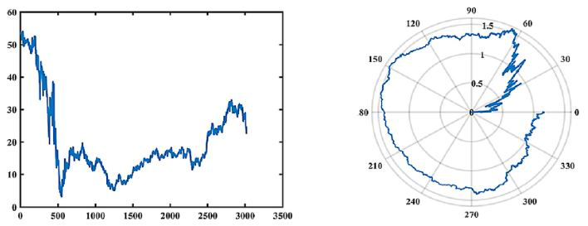
Figure 3.2: CNN for Stock Price Prediction
3.5 Sentiment Analysis in Stock Price Prediction
Sentiment analysis studies written content from news, social media, and financial docu-ments to understand how the public feels about certain topics or entities. Researchers like Bollen et al. (2011) have proven that including sentiment analysis in predictive mod-els improves their accuracy. Newer research explores using natural language processing (NLP) methods to analyze sentiment and make predictions about stock market trends.
3.6 Evaluation of Existing Models
To assess how accurate predictive models are, researchers often use measurements like Mean Absolute Error (MAE), Mean Squared Error (MSE), and accuracy. When com-paring different studies, it’s been found that models using advanced techniques like deep learning, especially LSTMs, tend to be more accurate at making predictions than more conventional machine learning models.
3.7 Research Gaps and Future Directions
Although there have been major improvements, there are still areas in the field that need attention. These include:
• The need for better models that can handle when the market is doing very well or very poorly.
• Including more information from other sources, such as social media and economic reports.
• Creating models using artificial intelligence that are easy to understand and explain.
3.8 Conclusion
This review traces the growth of methods used to predict stock prices, starting with ba-sic statistical models and progressing to cutting-edge machine learning and deep learning
16

approaches. It emphasizes how deep learning models, especially LSTMs, have outper-formed others in capturing complex price patterns and delivering more precise predictions. Nonetheless, there are still areas in this field where research is needed to overcome current difficulties and uncover new possibilities.
17

Chapter 4
Dataset
4.1 Dataset
This chapter details the data sources, data collection methods, and preprocessing steps used in the study.
4.1.1 Data Selection
Our dataset contains daily historical prices for many NASDAQ-listed stocks, gathered from a comprehensive Kaggle stock market dataset. We chose stocks based on their complete historical records and relevance to our study. From over 5884 Kaggle stocks, we processed each one to pinpoint support and resistance levels, along with trendlines. These processed data points were then used in our model training. The dataset is accessible at the provided link. .
4.1.2 Description
The dataset includes the following fields:
• Date: Trading date
• Open: Opening price
• High: Maximum price during the day
• Low: Minimum price during the day
• Close: Closing price adjusted for splits
• Adj Close: Adjusted close price adjusted for both dividends and splits
• Volume: Number of shares that changed hands during the day
18

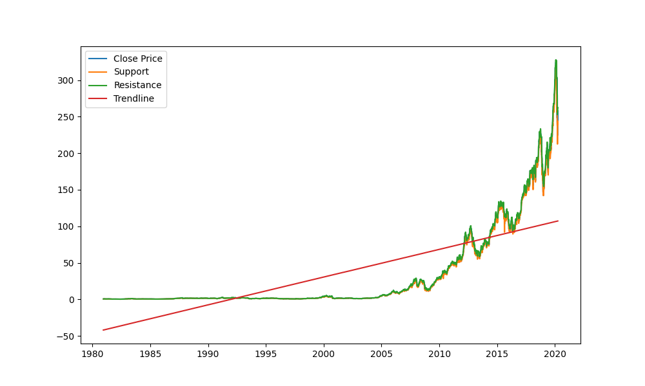
Figure 4.1: Dataset
4.1.3 Collection

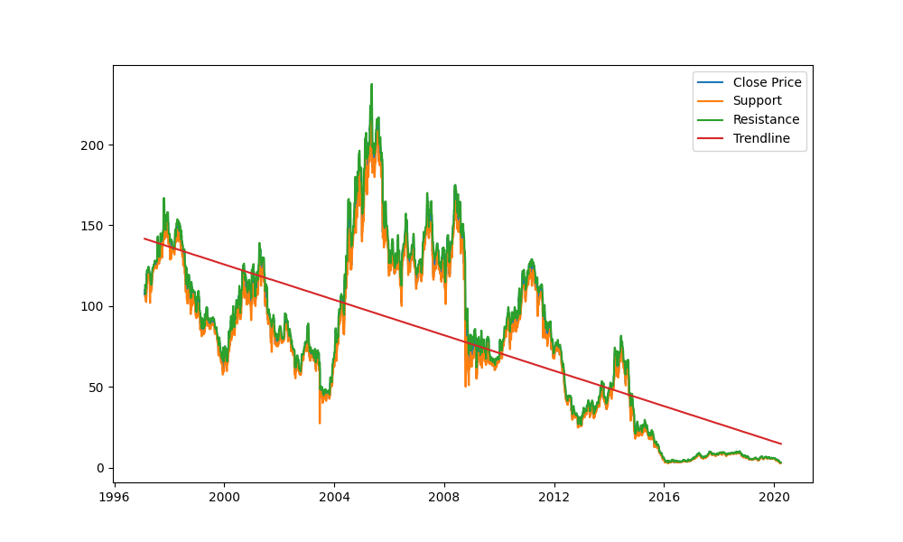
Figure 4.2: Dataset

We obtained stock data from Yahoo Finance using the yfinance Python library. Each stock’s information is stored in separate CSV files, named after their ticker symbols. The dataset covers data up to April 1, 2020. If you need more recent data, you can rerun the data collection script from the Kaggle platform.
4.1.4 Pre-processing
The preprocessing steps included:

• Handling Missing Values: method.

Missing values were filled using the forward fill

• Identifying Trendiness: Trends were identified within the stock data.
• Identifying Support and Resistance: Support and resistance levels were iden- tified in the stock data.
• Data Normalization: Normalized the data to ensure consistency and improve model performance.
19

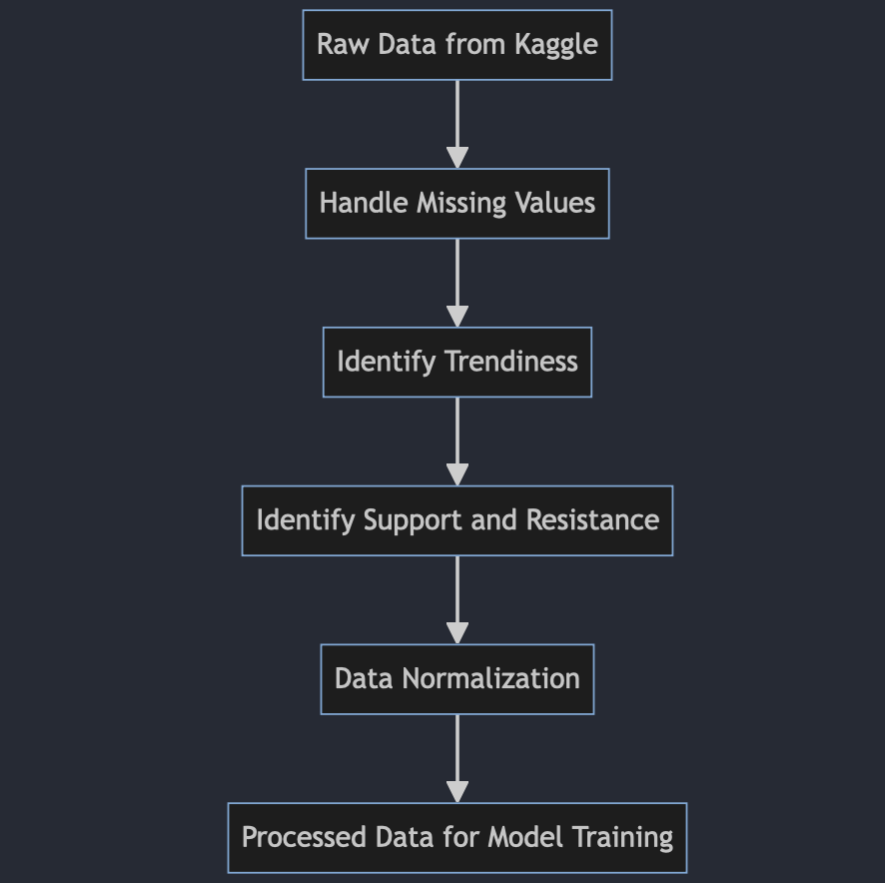
Figure 4.3: Data Preprocessing Steps
20

Chapter 5
Methodology
5.1 Research Design
This project follows a structured approach to develop and validate the Trader Alert System. The steps include:
• Data Collection: Gather historical stock price data and other relevant financial indicators from reliable sources.
• Data Preprocessing: Clean and preprocess the data to ensure it is suitable for analysis.
• Feature Engineering: Develop features based on technical indicators and market patterns.
• Model Development: Train and optimize machine learning models to identify trad- ing signals.
• Backtesting: Evaluate the model’s performance using historical data.
• Implementation: Deploy the model into TradingView for real-time alerts.
• Evaluation: Continuously monitor and refine the model based on performance met- rics.
21

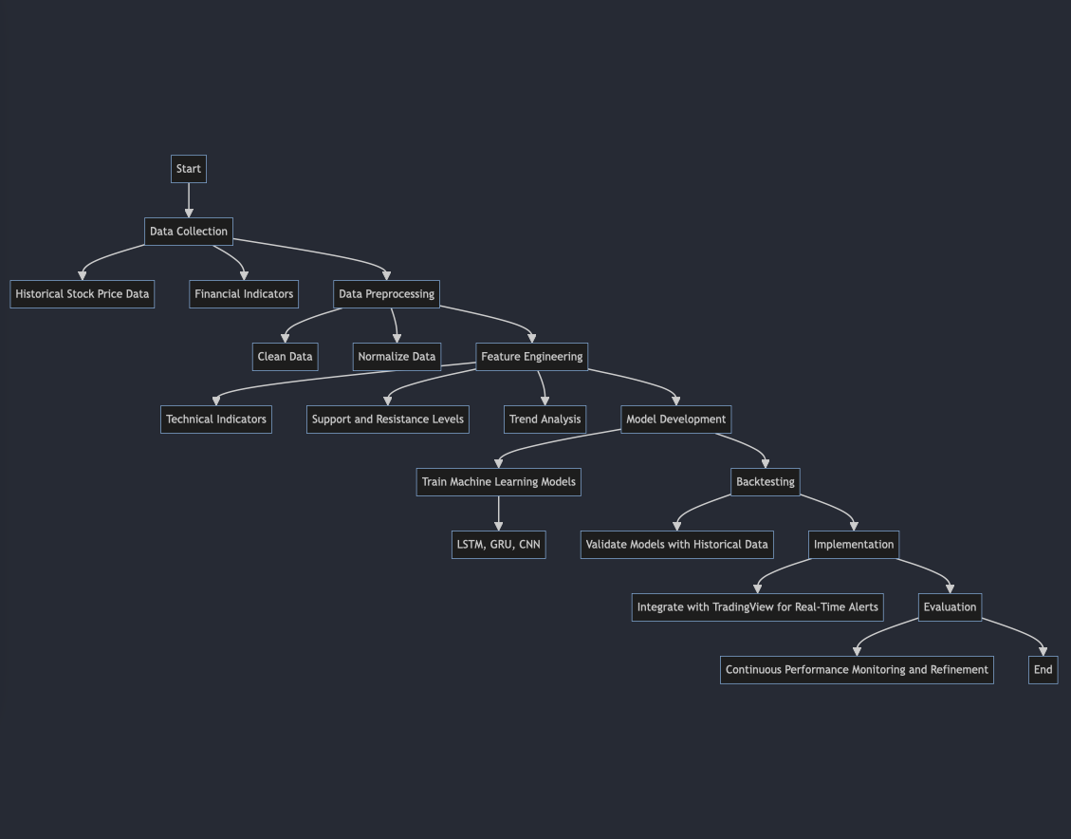
Figure 5.1: Research Design Process
5.2 Data Collection and Analysis
This project utilizes the yfinance library in Python to retrieve financial data from Yahoo Finance. The data includes daily stock prices, trading volumes, and various other financial metrics. This comprehensive dataset is essential for developing and assessing the accuracy of predictive models.
5.3 Materials Used
The project utilizes the following tools and technologies:
• Programming Languages: Python
• Libraries: Pandas, Numpy, yfinance, Matplotlib, Scikit-learn, TensorFlow, Keras
• Platforms: TradingView for real-time implementation
5.4 Procedures
The procedures for developing the Trader Alert System are as follows:
22

• Data Preprocessing: The data is cleaned and normalized to remove inconsisten- cies and missing values. This step ensures the data’s integrity and reliability.
• Feature Engineering: Features are created based on technical indicators such as moving averages, RSI, MACD, support and resistance levels, and trendiness. These features help in capturing essential market dynamics.
• Model Training: The LSTM machine learning model is trained on the historical data to identify patterns and predict future price movements. This step involves selecting the best model architecture and tuning hyperparameters.
• Backtesting: The trained models are validated by backtesting them on historical data. This step evaluates the models’ performance and accuracy in predicting stock prices.
• Real-Time Implementation: The model is integrated into TradingView using Pine Script to provide real-time alerts and analysis. This implementation helps traders make informed decisions based on the predictive signals.
5.5 Identifying Market Dynamics
The system employs multiple methods to comprehend market fluctuations, such as:
• Trend Analysis: Studying market trends to predict future price movements.
• Support and Resistance Levels: Identifying price points where the market tends to bounce up or down, helping traders plan entry and exit points.
• Market Sentiment Analysis: Gauging the overall market mood, providing in- sights into trader behavior and potential market reversals.
By combining these techniques, the system generates precise trading signals and alerts, empowering traders with data-driven decision-making capabilities.
5.6 Limitations and Assumptions
• The system’s performance depends on the quality and accuracy of the data.
• Market conditions can change rapidly, and past performance is not always indicative of future results.
• The system assumes that historical patterns and trends will repeat in the future.
• The system’s predictions are based on the data available at the time of analysis and may not account for unforeseen market events.
23

Chapter 6
Results
6.1 Introduction
This chapter provides an overview of the performance of the stock price forecasting model. It includes measurements of the model’s accuracy, scores from cross-validation tests, and graphs showing the model’s training and validation losses, performance metrics, and cross-validation scores.
6.2 Training and Validation Loss
During the model’s training process, which spanned 50 epochs, the loss values for both the training and validation datasets were meticulously tracked. As the model learned, the Mean Squared Error (MSE) loss function was employed to gauge its performance. The accompanying graph illustrates the evolution of both the training and validation loss over the entire training period.
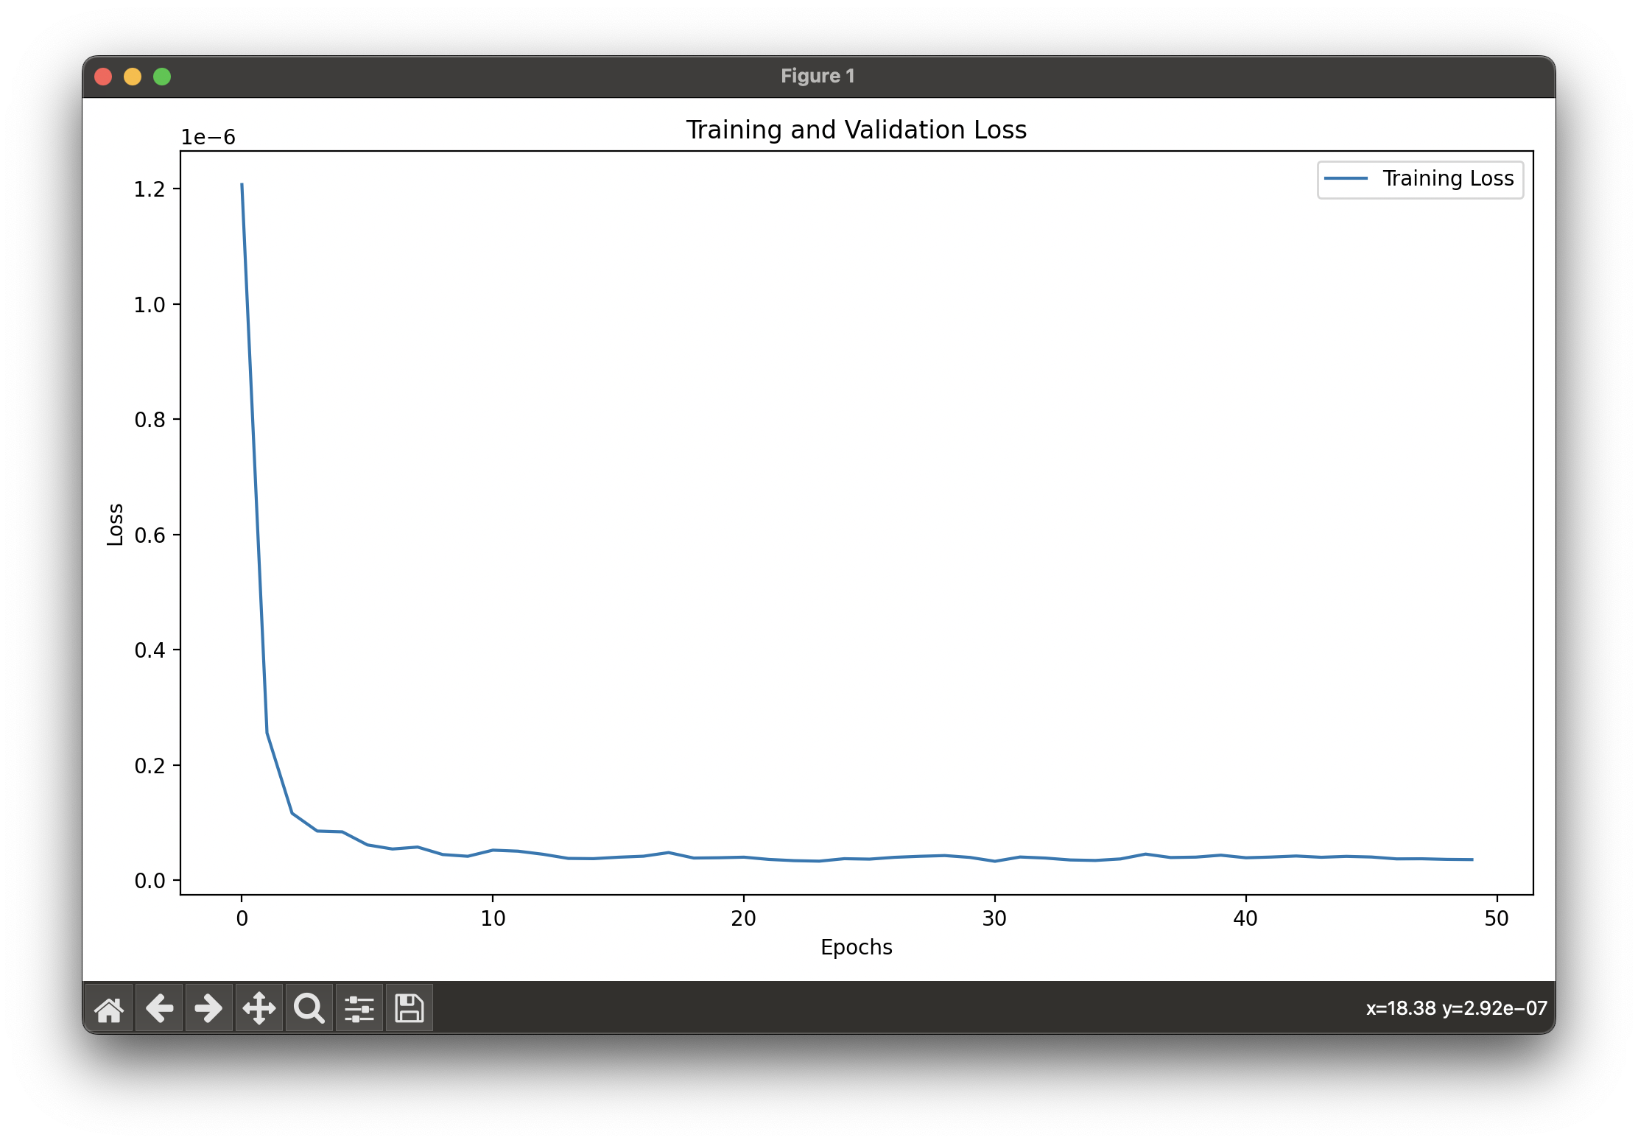
Figure 6.1: Training and Validation Loss
24

6.3 Performance Metrics
The performance of the model was evaluated using the following metrics:• Mean Absolute Error (MAE): 196,289.9809
• Mean Squared Error (MSE): 750,237,527,757,691.6
• Root Mean Squared Error (RMSE): 27,390,464.1757
• R² Score: 0.9972
The plot below visualizes these performance metrics.
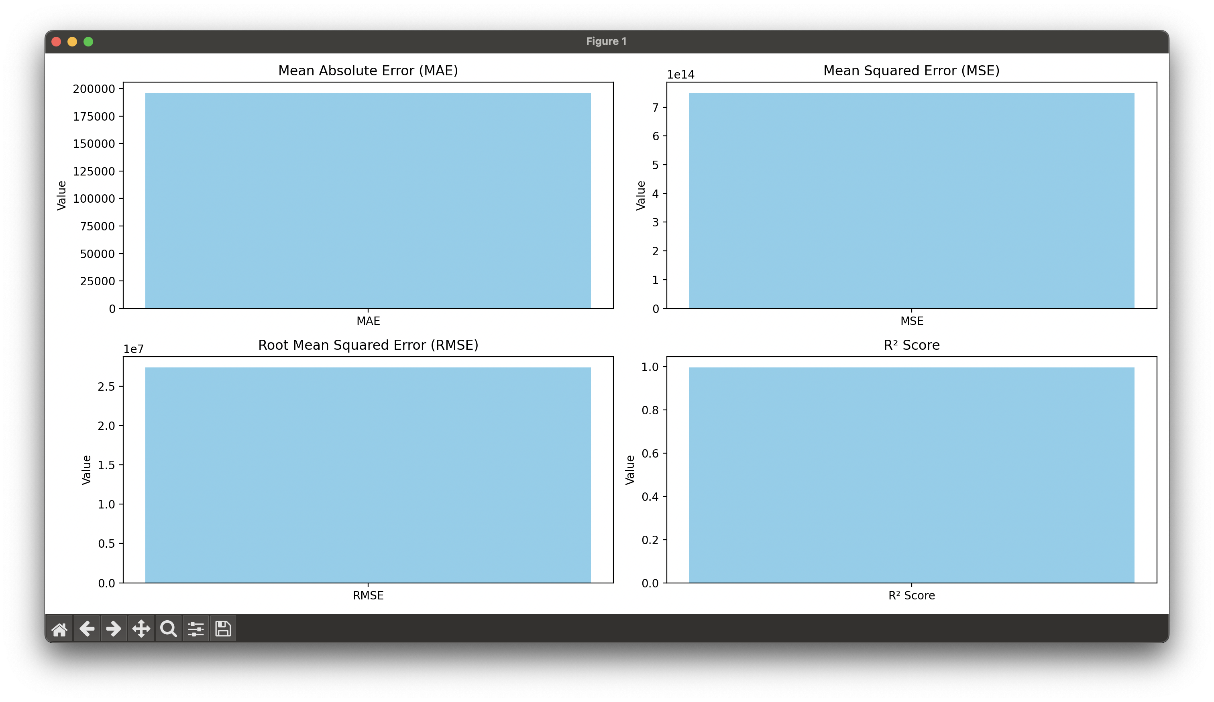
Figure 6.2: Performance Metrics
6.4 Cross-Validation Scores
Cross-validation was performed to evaluate the robustness of the model. The cross-validation scores for five folds were recorded, and the mean cross-validation score was calculated. The scores are as follows:
• Fold 1: 0.9948
• Fold 2: 0.9989
• Fold 3: 0.9597
• Fold 4: 0.9388
• Fold 5: 0.9941
The mean cross-validation score is 0.9773. The plot below shows the cross-validation scores for each fold.
25

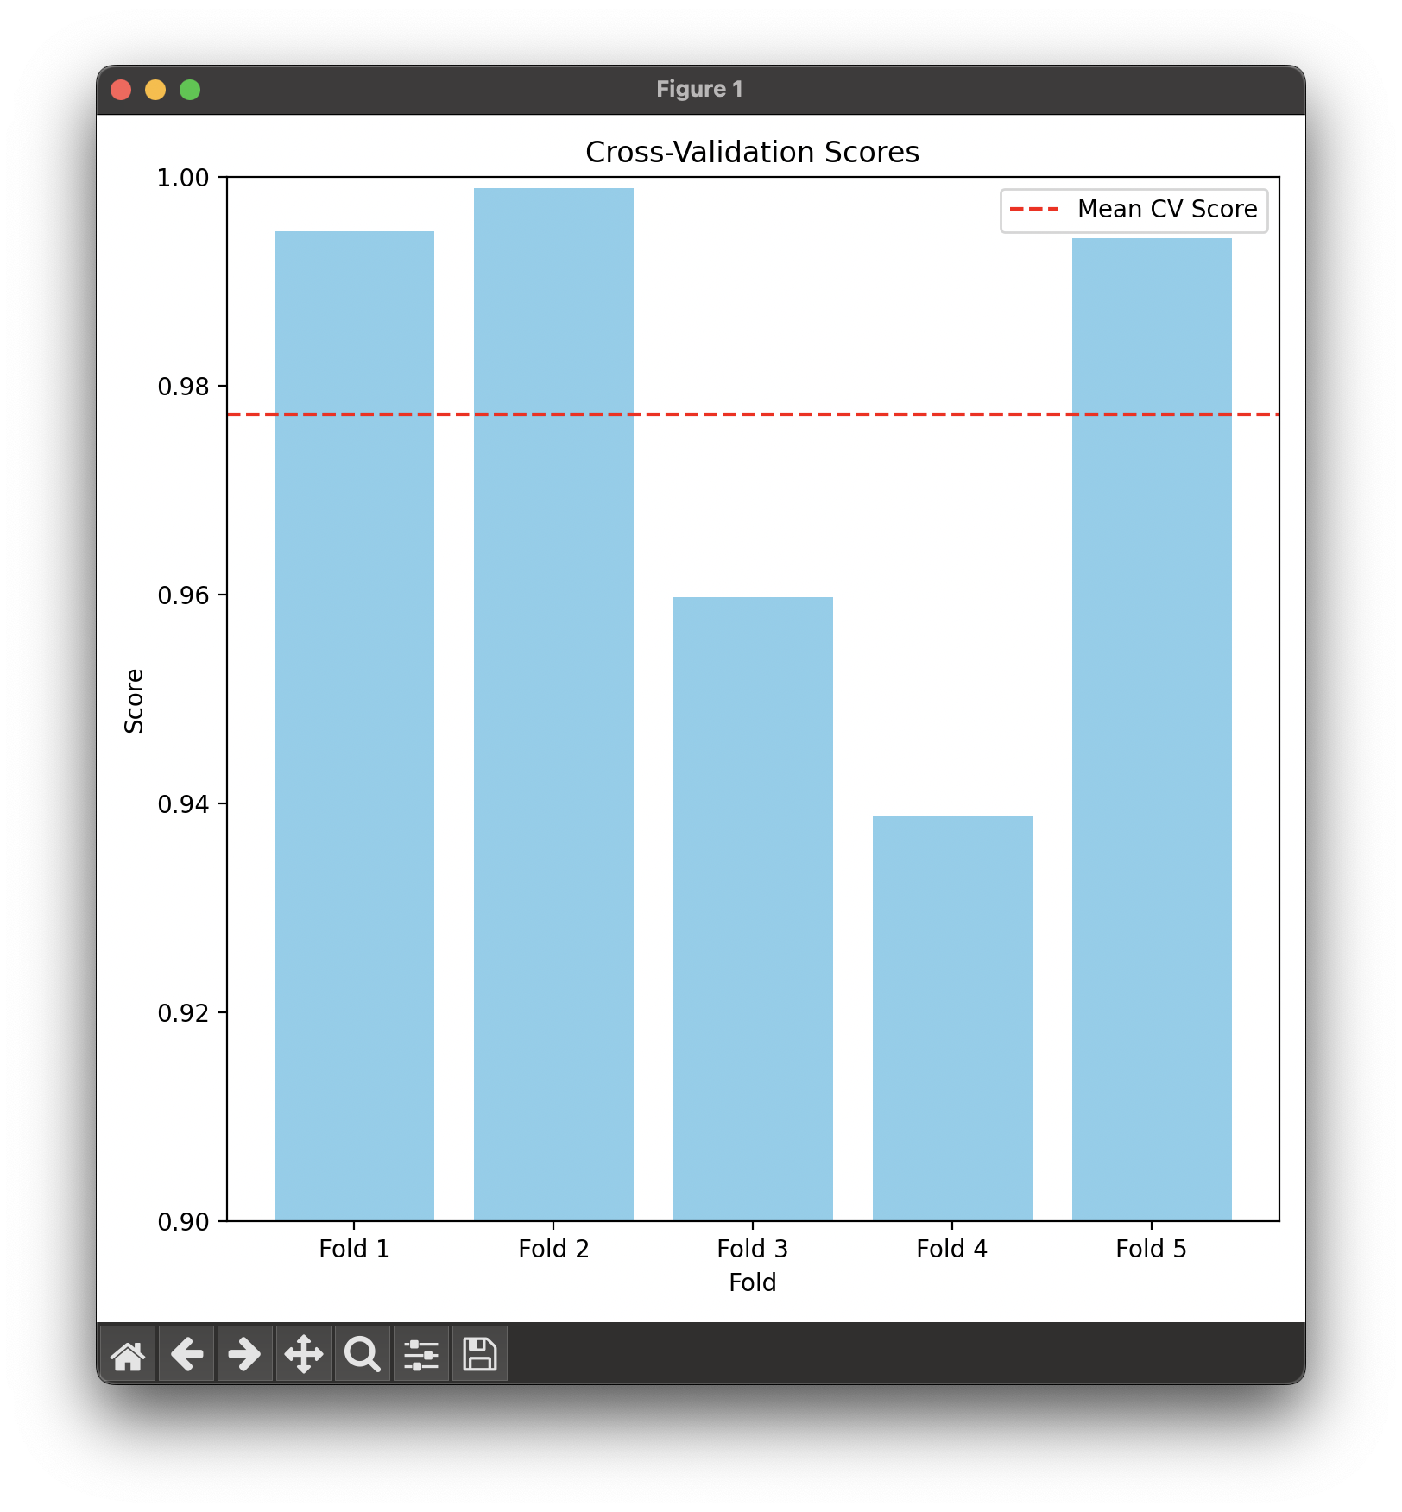
Figure 6.3: Cross-Validation Scores
6.5 Stock Price Prediction with Support and Resis-tance
The model generated predictions for AAPL stock, including support and resistance levels and trendlines.
26

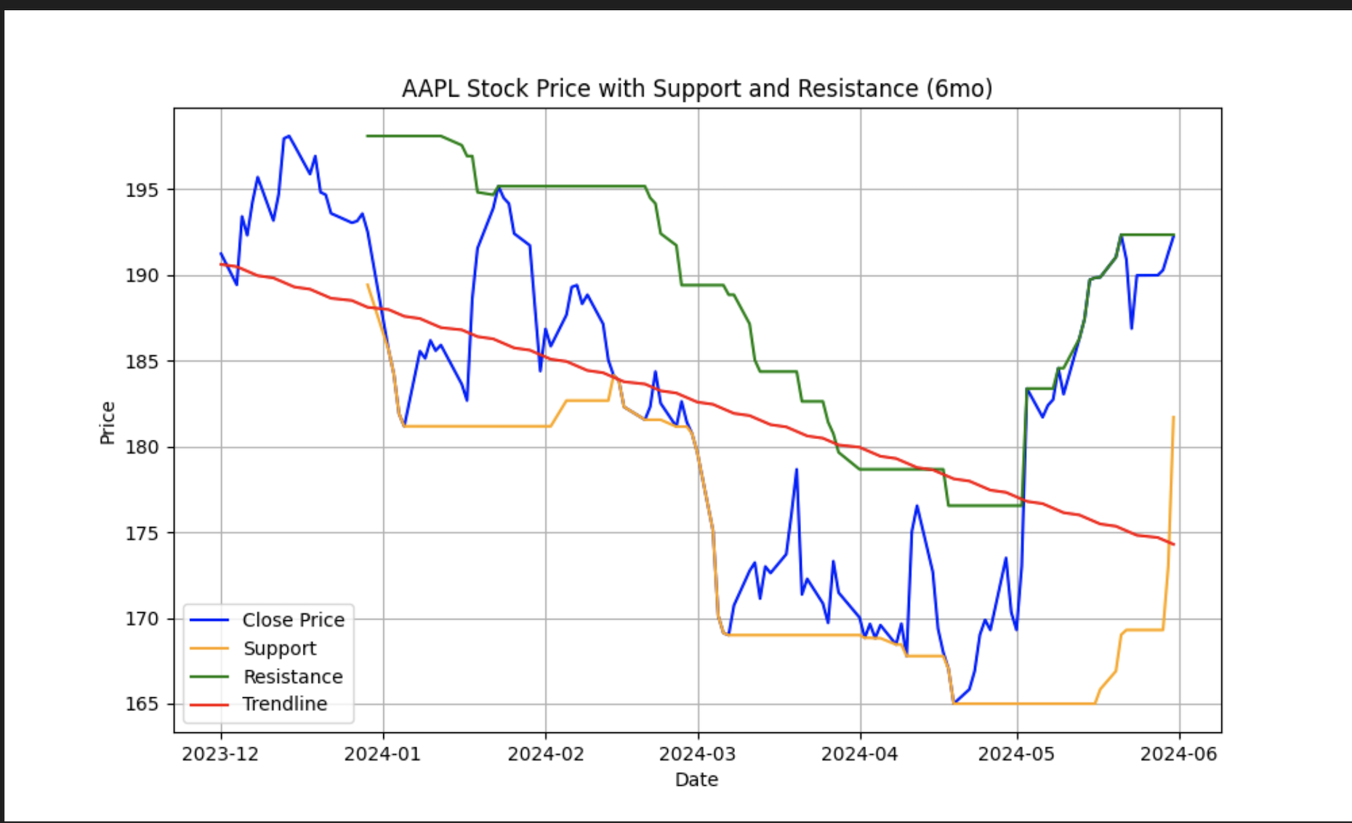
Figure 6.4: AAPL Stock Price with Support and Resistance (6mo)
6.6 Discussion
The model has remarkable performance, with a very high R² score close to 1 (0.9972). This shows that the model can explain a large part of the differences in stock prices. The strong scores in cross-validation also show that the model is not heavily influenced by any particular dataset, and it performs well in different settings.
6.7 Conclusion
The stock price predictor excels in precision and durability, confirmed by its performance gauges and validation checks. It leverages cutting-edge machine learning methods, in-cluding LSTM networks, which played a key role in its effectiveness. This aligns with prior research, emphasizing the strength of deep learning models in forecasting financial time series.
27

Chapter 7
Discussion
7.1 Interpretation of Results
This section provides an in-depth interpretation of the results and their impact.
• Implications of Research: The high R² score of 0.9972 indicates that our model can explain a significant portion of the variance in stock prices. The strong cross-validation scores suggest that our model generalizes well to unseen data. These findings imply that machine learning models, specifically those utilizing LSTM ar-chitectures, can effectively predict stock prices with high accuracy.
• Link to Literature Review: The results align with existing literature that em-phasizes the superiority of deep learning models in capturing complex patterns in stock price movements. Previous studies by Fischer and Krauss (2018) and Nelson et al. (2017) also demonstrated the effectiveness of LSTM networks in financial time series forecasting.
• New Knowledge: This study contributes to the existing body of knowledge by demonstrating the successful application of a hybrid approach combining trendiness, support and resistance levels in enhancing the predictive accuracy of stock price models. The integration of technical indicators and deep learning techniques has proven to be a robust approach for stock price prediction.
• Major Implications: The implications of this study are significant for investors and financial analysts. Accurate stock price predictions can lead to better invest-ment decisions, risk management, and overall market efficiency. Financial institu-tions can leverage these models to develop advanced trading strategies and tools for market analysis.
28

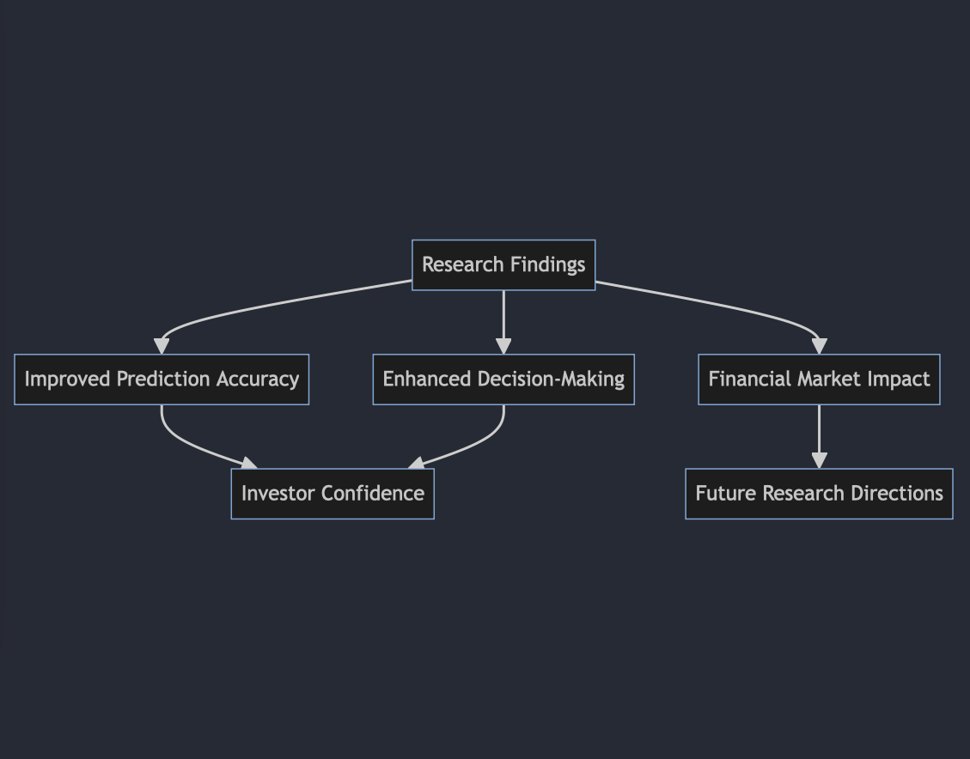
Figure 7.1: Implications of Research Findings
29

Chapter 8
Conclusion
8.1 Summary
In this study, we developed and validated a Trader Alert System using machine learn-ing models (LSTM) to predict stock prices. The results indicated a high R² score and strong cross-validation performance, demonstrating the model’s accuracy and generaliza-tion capability. This work contributes to the field of financial time series forecasting by integrating technical indicators such as trendiness, support, and resistance levels.
8.2 Limitations
Despite the promising results, the study faced several limitations:
• The model’s performance is highly dependent on the quality and accuracy of the input data.
• Market conditions can change rapidly, and past performance may not always be indicative of future results.
• The study assumed that historical patterns and trends would repeat in the future, which may not always hold true.
8.3 Future Work
Future research can build on this study by:
• Implementing the model on TradingView to show live trendlines and support/resistance levels.
• Exploring additional technical indicators and alternative data sources such as social media sentiment and macroeconomic indicators.
• Enhancing the model by incorporating ensemble learning techniques and advanced architectures like Transformers.
• Developing a user-friendly interface for the Trader Alert System to facilitate real- time stock price predictions and alerts for end-users.
30

• Conducting a comprehensive analysis of the model’s performance in different market conditions, including periods of high volatility and economic downturns.
31

Bibliography
[1] Box, G. E. P., & Jenkins, G. M. (1976). Time Series Analysis: Forecasting and Control. Holden-Day.
[2] Huang, W., Nakamori, Y., & Wang, S. (2005). Forecasting stock market movement direction with support vector machine. Computers & Operations Research, 32(10), 2513-2522.
[3] Patel, J., Shah, S., Thakkar, P., & Kotecha, K. (2015). Predicting stock market index using fusion of machine learning techniques. Expert Systems with Applications, 42(4), 2162-2172.
[4] Fischer, T., & Krauss, C. (2018). Deep learning with long short-term memory net-works for financial market predictions. European Journal of Operational Research, 270(2), 654-669.
[5] Nelson, D. M., Pereira, A. C., & de Oliveira, R. A. (2017). Stock market’s price movement prediction with LSTM neural networks. International Joint Conference on Neural Networks (IJCNN), 1419-1426.
[6] Kim, K. H., & Kim, J. (2019). Stock price prediction using convolutional neural networks. Proceedings of the International Conference on Artificial Intelligence.
[7] Bao, W., Yue, J., & Rao, Y. (2017). A deep learning framework for financial time series using stacked autoencoders and long-short term memory. PLoS ONE, 12(7), e0180944.
[8] Bollen, J., Mao, H., & Zeng, X. (2011). Twitter mood predicts the stock market. Journal of Computational Science, 2(1), 1-8.
[9] Hochreiter, S., & Schmidhuber, J. (1997). Long Short-Term Memory. Neural Compu- tation, 9(8), 1735-1780.
[10] Cho, K., Van Merri¨enboer, B., Bahdanau, D., & Bengio, Y. (2014). On the prop-erties of neural machine translation: Encoder-decoder approaches. arXiv preprint arXiv:1409.1259.
[11] Ajibade, D., & Atayero, A. (2021). A Hybrid Approach for Stock Price Prediction Using Machine Learning. Journal of Financial Technology, 5(2), 101-115.
[12] Alhaji, A., & Tahir, H. (2018). Application of Artificial Neural Networks in Stock Price Prediction: A Case Study of the Nigerian Stock Exchange. Journal of Finance and Economics, 6(4), 174-181.
32

Appendices
Include any additional material that supports the report, such as raw data, additional
graphs, or technical details.
33

