ProcessHub
Process handbook
S.01 · Procure to Pay
Working version (may contain changes not yet approved)
Generated on 31 October 2026 by Omar Owner
Contents
S.01 Procure to Pay
S.01.01 Purchase Requisition
S.01.02 Purchase approval
S.01.03 Purchase request (from EPC)

S.01 Procure to Pay

Place in the value chain
VC-001 Enterprise value chain › Support processes › Procure to Pay

Description
Purchasing goods and services and paying suppliers.

Process details
Code | S.01
Category | Support
Status | Published
Owner | Omar Owner
Department | Procurement
Version | v1
Version label | v1.0
Approved on | 31 July 2026
Approved by | Rami Reviewer, Omar Owner
Published on | 2 August 2026

Process diagram
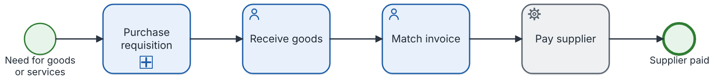

Steps
# | Step | Type | Role | IT system | Description | Attributes
1 | Purchase requisition | Other | — | — | See the sub-process S.01.01. | —
2 | Receive goods | Task | — | — | The warehouse checks the delivery against the purchase order. | —
3 | Match invoice | Task | — | — | Three-way match of order, receipt and invoice. | —
4 | Pay supplier | System step | — | — | — | —

Linked documents
No linked documents.

SIPOC
No SIPOC for this process.

Decision tables
No business rule step is linked to a decision table.

Organisation (positions performing the steps)
No position of an organisation chart performs the steps.

Procedures and instructions

Purchase Requisition Procedure
1. Purpose
Define how employees request goods and services and how requests are approved.
2. Responsibilities
Role
Responsibility
Requester
Creates the purchase requisition in the ERP.
Department Manager
Reviews and approves or rejects the requisition.
Procurement Officer
Creates the purchase order.
3. Procedure
Create the requisition in the ERP.
The ERP checks the available budget automatically.
The manager approves the requisition (limits below).
Procurement creates the purchase order.
Approval limits
Amount
Approver
Up to 10,000
Department Manager
Above 10,000
Finance Director
Approved by the quality committee.

S.01.01 Purchase Requisition

Place in the value chain
VC-001 Enterprise value chain › Support processes › Purchase Requisition

Description
Raising and approving internal purchase requests.

Process details
Code | S.01.01
Category | Support
Status | In review
Owner | Omar Owner
Department | Procurement
Version | v2
Version label | —
Approved on | 12 April 2026
Approved by | Rami Reviewer, Omar Owner
Published on | 14 April 2026

Process diagram
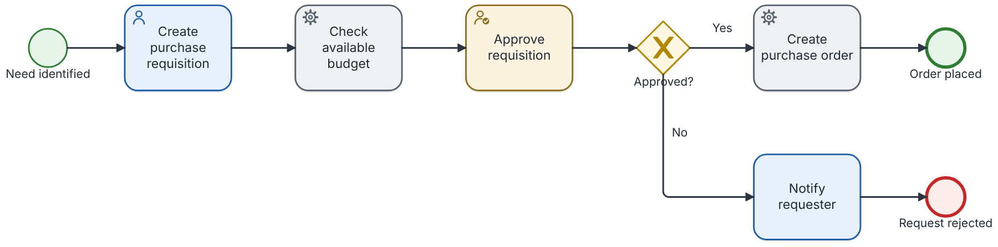

Steps
# | Step | Type | Role | IT system | Description | Attributes
1 | Create purchase requisition | Task | Requester | ERP (SAP S/4HANA) | The requester fills in the requisition form in the ERP: items, quantities, estimated cost and cost centre. | —
2 | Check available budget | System step | — | — | The ERP checks the remaining budget of the cost centre automatically. | —
3 | Approve requisition | Approval | Department Manager | ERP (SAP S/4HANA) | The department manager checks the need and the budget and approves or rejects the requisition within two working days. | —
4 | Create purchase order | System step | Procurement Officer | ERP (SAP S/4HANA) | Procurement selects the supplier and issues the purchase order. | —
5 | Notify requester | Task | — | Email | — | —

Linked documents
No linked documents.

SIPOC
SIPOC-001 SIPOC — Purchase requisition
Suppliers | Inputs | Process | Outputs | Customers
— | Purchase need | 1. Create purchase requisition | Purchase order | Requesting department
— | — | 2. Check available budget | — | —
— | — | 3. Approve requisition | — | —
— | — | 4. Create purchase order | — | —

Decision tables
No business rule step is linked to a decision table.

Organisation (positions performing the steps)
Position | Organisational unit | Reports to | Organisation chart
Department Manager | Executive Office | Executive Office | ORG-001 Organisation chart
Procurement Officer | Procurement | Procurement | ORG-001 Organisation chart
Requester | Procurement | Procurement | ORG-001 Organisation chart

Procedures and instructions

Purchase Requisition Procedure
1. Purpose
Define how employees request goods and services and how requests are approved.
2. Responsibilities
Role
Responsibility
Requester
Creates the purchase requisition in the ERP.
Department Manager
Reviews and approves or rejects the requisition.
Procurement Officer
Creates the purchase order.
3. Procedure
Create the requisition in the ERP.
The ERP checks the available budget automatically.
The manager approves the requisition (limits below).
Procurement creates the purchase order.
Approval limits
Amount
Approver
Up to 10,000
Department Manager
Above 10,000
Finance Director
Approved by the quality committee.

S.01.02 Purchase approval

Place in the value chain
VC-001 Enterprise value chain › Support processes › Procure to Pay › S.01.02 Purchase approval

Description
Finds the approver of a purchase with the approval authority table and gets the approval.

Process details
Code | S.01.02
Category | Support
Status | Draft
Owner | Omar Owner
Department | Procurement
Version | v1
Version label | —
Approved on | —
Approved by | —
Published on | —

Process diagram
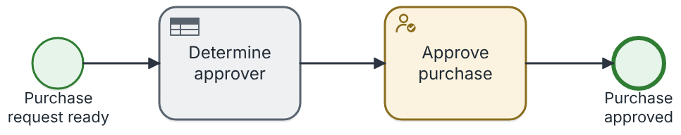

Steps
# | Step | Type | Role | IT system | Description | Attributes
1 | Determine approver | System step | — | — | The approval authority table gives the approver for the amount and category. | —
2 | Approve purchase | Approval | — | — | — | —

Linked documents
No linked documents.

SIPOC
No SIPOC for this process.

Decision tables
DMN-001 Approval authority by amount
Step: Determine approver · Hit policy: FIRST
Amount (AED) | Purchase category | Approver | Annotation
< 10000 | - | "Department Manager" | Small purchases: the line manager approves
[10000..250000] | "IT" | "IT Director" | IT purchases need the IT director
[10000..250000] | - | "Finance Director" | Medium purchases: the finance director approves
> 250000 | - | "Chief Executive Officer" | Large purchases: the CEO approves

Organisation (positions performing the steps)
No position of an organisation chart performs the steps.

S.01.03 Purchase request (from EPC)

Place in the value chain
VC-001 Enterprise value chain › Support processes › Procure to Pay › S.01.03 Purchase request (from EPC)

Description
Converted from EPC-001.

Process details
Code | S.01.03
Category | Support
Status | Draft
Owner | Omar Owner
Department | Procurement
Version | —
Version label | —
Approved on | —
Approved by | —
Published on | —

Process diagram
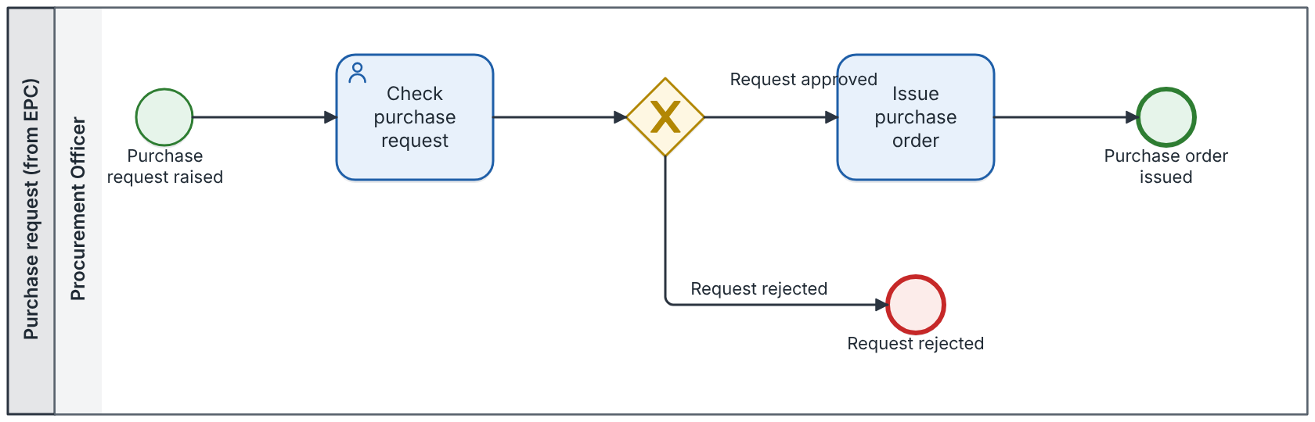

Steps
# | Step | Type | Role | IT system | Description | Attributes
1 | Check purchase request | Task | Procurement Officer | ERP (SAP S/4HANA) | — | —
2 | Issue purchase order | Task | Procurement Officer | — | — | —

Linked documents
No linked documents.

SIPOC
No SIPOC for this process.

Decision tables
No business rule step is linked to a decision table.

Organisation (positions performing the steps)
Position | Organisational unit | Reports to | Organisation chart
Procurement Officer | Procurement | Procurement | ORG-001 Organisation chart

