ProcessHub
Process handbook
C.09 · Program Request Approval
Working version (may contain changes not yet approved)
Generated on 29 October 2026 by Omar Owner
Contents
C.09 Program Request Approval

C.09 Program Request Approval

Description
No description.

Process details
Code | C.09
Category | Core
Status | Draft
Owner | Omar Owner
Department | —
Version | —
Version label | —
Approved on | —
Approved by | —
Published on | —

Process diagram
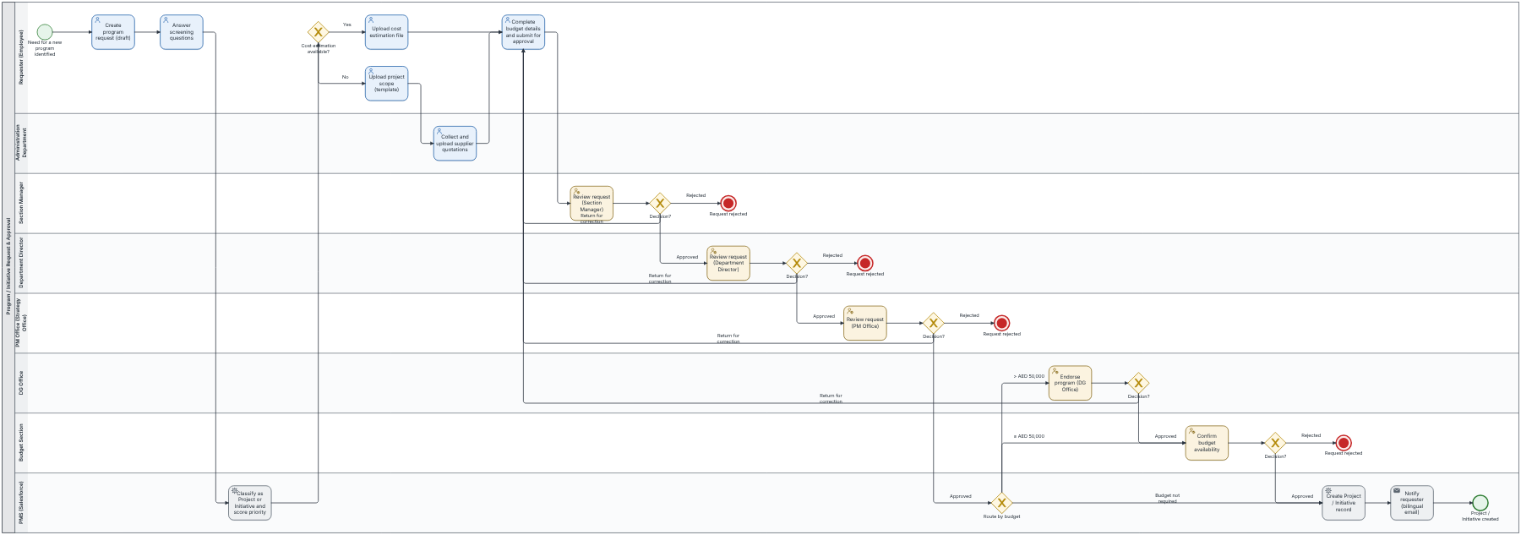

Steps
# | Step | Type | Role | IT system | Description | Attributes
1 | Create program request (draft) | Task | Requester (Employee) | CRM (Salesforce) | In Program Requests > New: program name, description, justifications, strategic objective, program type (digital / non-digital), source of suggestion, nature (new / continuation), delivery options with advantages and disadvantages, link to internal operations or services, and the four 1–5 priority criteria. | Processing: 30 min  Waiting: 0 min  SLA: 1 h  Frequency: 4 / month  Cost: 20
2 | Answer screening questions | Task | Requester (Employee) | — | — | Processing: 20 min  Waiting: 0 min  SLA: 40 min  Frequency: 4 / month  Cost: 15
3 | Classify as Project or Initiative and score priority | System step | PMS (Salesforce) | — | Project when all screening answers are Yes and the approximate budget is at least AED 50,000 (threshold maintained by PM Office); otherwise Initiative. Evaluation Score and priority band are calculated from the four criteria. | —
4 | Upload cost estimation file | Task | Requester (Employee) | — | Cost Estimation File action: upload the available quotation and enter the estimated budget with Year 1–4 costs (must equal the estimated budget) and expected start and end dates (within 3 years). | Processing: 1 h  Waiting: 1 d  SLA: 2 d 2 h  Frequency: 2 / month  Cost: 40
5 | Upload project scope (template) | Task | Requester (Employee) | Document Management | Download the Project Scope template, complete it and upload it. The Administration Department is notified by email to collect quotations. | Processing: 2 h  Waiting: 1 d  SLA: 2 d 4 h  Frequency: 2 / month  Cost: 60
6 | Complete budget details and submit for approval | Task | Requester (Employee) | CRM (Salesforce) | Fill the budget breakdown, cost sharing, operating costs and expected financial return, then Submit for Approval with a comment. Also used to resubmit after a return for correction. | Processing: 15 min  Waiting: 0 min  SLA: 30 min  Frequency: 4 / month  Cost: 10
7 | Collect and upload supplier quotations | Task | Administration Department | Document Management | Open the request from the email link, use Upload Quotations to attach all quotations with a comment. Status becomes Quotations Uploaded and the request returns to the requester. | Processing: 4 h  Waiting: 2 d  SLA: 4 d 8 h  Frequency: 2 / month  Cost: 90
8 | Review request (Section Manager) | Approval | Section Manager | — | Check section-level alignment and completeness. Approve, Reject or Return for Correction (comment required). | Processing: 1 h  Waiting: 1 d  SLA: 2 d 2 h  Frequency: 4 / month  Cost: 80
9 | Review request (Department Director) | Approval | Department Director | — | Validate departmental priority and resource alignment. Approve, Reject or Return for Correction. | Processing: 1 h  Waiting: 2 d  SLA: 4 d 2 h  Frequency: 4 / month  Cost: 100
10 | Review request (PM Office) | Approval | PM Office (Strategy Office) | — | Check methodology adherence, classification, evaluation score and strategic alignment. Approve, Reject or Return for Correction. | Processing: 2 h  Waiting: 2 d  SLA: 4 d 4 h  Frequency: 4 / month  Cost: 150
11 | Create Project / Initiative record | System step | PMS (Salesforce) | — | PMS Project created automatically (ID PROJ-SPMO-YYYY-NNN), stage Initiation, linked to the request. | —
12 | Confirm budget availability | Approval | Budget Section | — | Validate financial feasibility and record the Approved Budget. Approve or Reject. | Processing: 1 h 30 min  Waiting: 2 d  SLA: 4 d 3 h  Frequency: 2 / month  Cost: 120
13 | Endorse program (DG Office) | Approval | DG Office | — | Strategic endorsement of programs above AED 50,000. Approve, or return for correction. | Processing: 1 h  Waiting: 3 d  SLA: 6 d 2 h  Frequency: 1 / month  Cost: 250
14 | Notify requester (bilingual email) | Notification | PMS (Salesforce) | — | Approval outcome and link to the new project, in English and Arabic. | —

Linked documents
No linked documents.

