FINAL REPORT
Predicting Home Prices with Linear Regression
USA Housing Dataset — Results, Diagnostics & Business Recommendations
Date: July 18, 2026

1. Executive Summary
A multiple linear regression model was built to predict home price from five area-level characteristics: average area income, average house age, average number of rooms, average number of bedrooms, and area population. The model was trained on 4,000 records (80%) and tested on 1,000 held-out records (20%, random_state = 42).
The model explains roughly 92% of the variation in home price on the test set (R² = 0.918) and its typical prediction is off by about $80,900 on average (MAE), against a mean home price of about $1.23M — an average error of roughly 6.6% of price. This is a strong result for a simple linear baseline and confirms the business hypothesis that area income, house age, room count, and population are meaningful, largely linear drivers of price.
Avg. Area Income and Avg. Area House Age are the two strongest positive drivers of price. Avg. Area Number of Bedrooms adds comparatively little once rooms and income are accounted for. The residual diagnostics support the linear regression assumptions well enough for this model to be used for pricing guidance, with the caveats noted in Section 6.

2. Business Problem Recap
The business needs a fast, consistent, data-driven way to estimate a home's fair market price using readily available area-level statistics, in order to reduce reliance on slower manual comparable-sales pricing and to flag listings that are priced significantly away from the model's estimate.

3. Data Overview & Exploratory Analysis
The dataset contains 5,000 records with no missing values and no duplicates. The Address field was excluded from modeling since it is free text and not usable as a numeric predictor; the remaining five columns were used as features, with Price as the target.

3.1 Feature Relationships with Price
Each predictor was plotted individually against Price to check for a linear relationship before modeling:
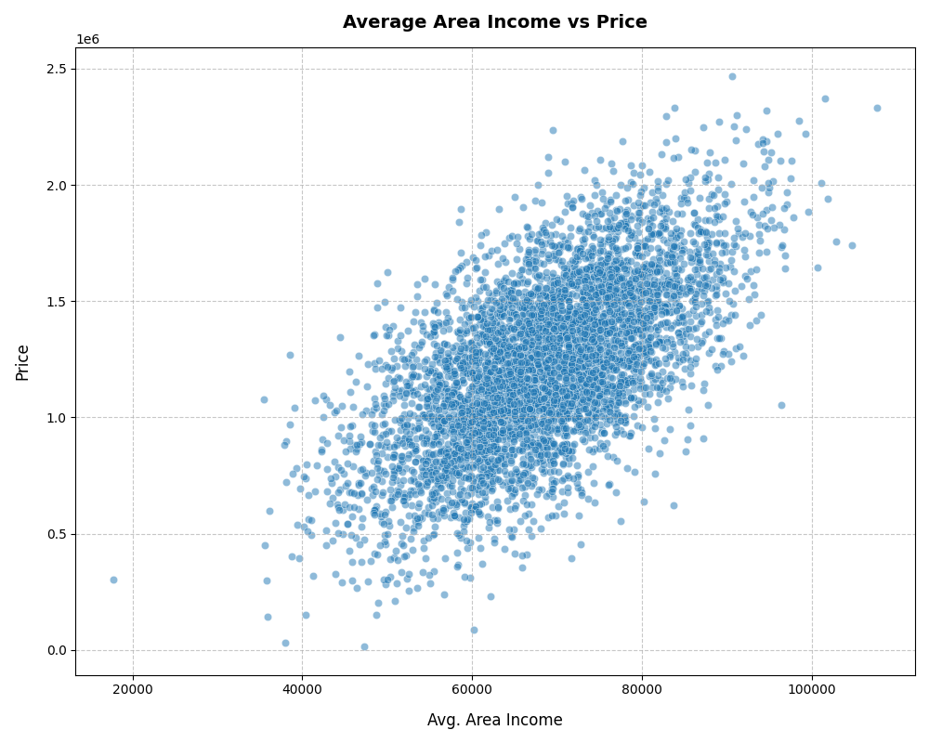  Avg. Area Income vs Price | 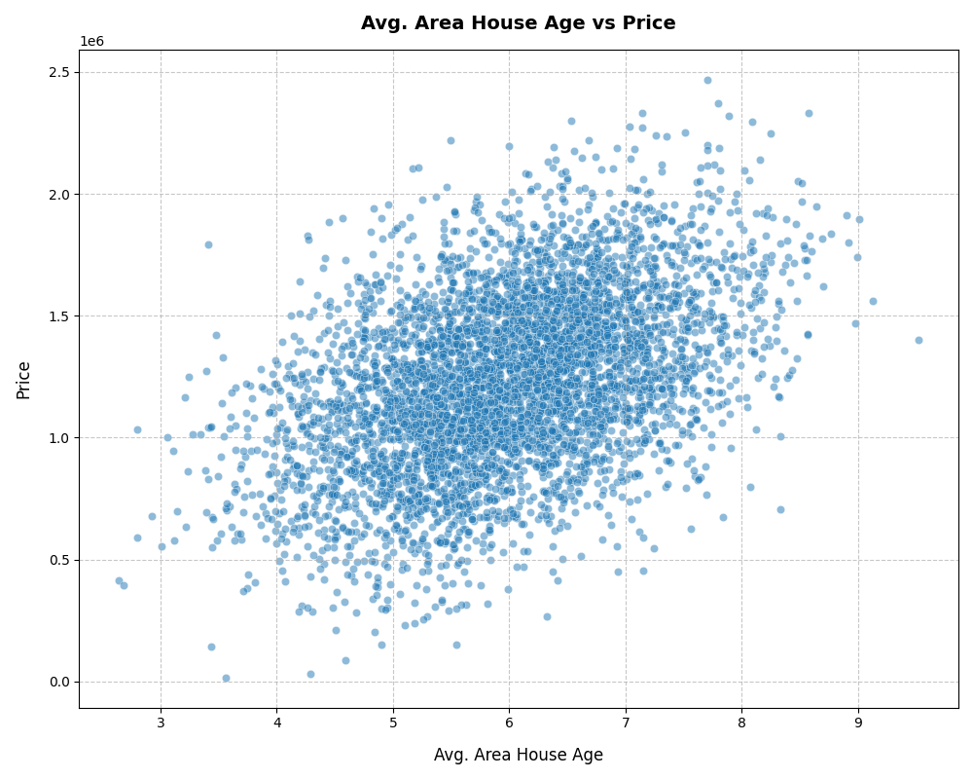  Avg. Area House Age vs Price
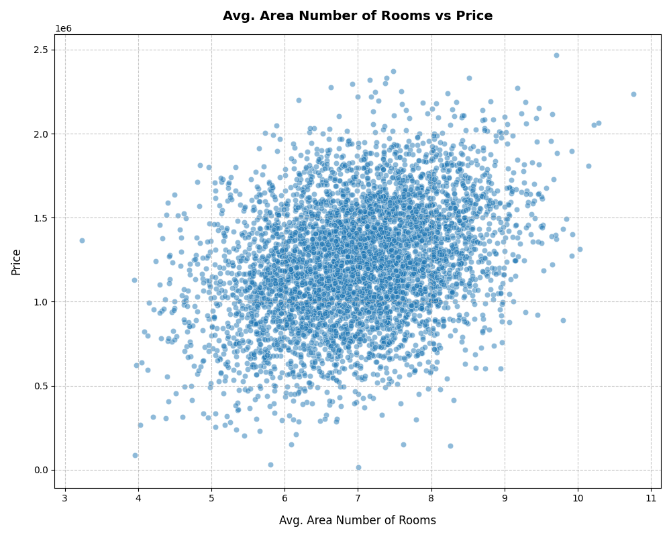  Avg. Area Number of Rooms vs Price | 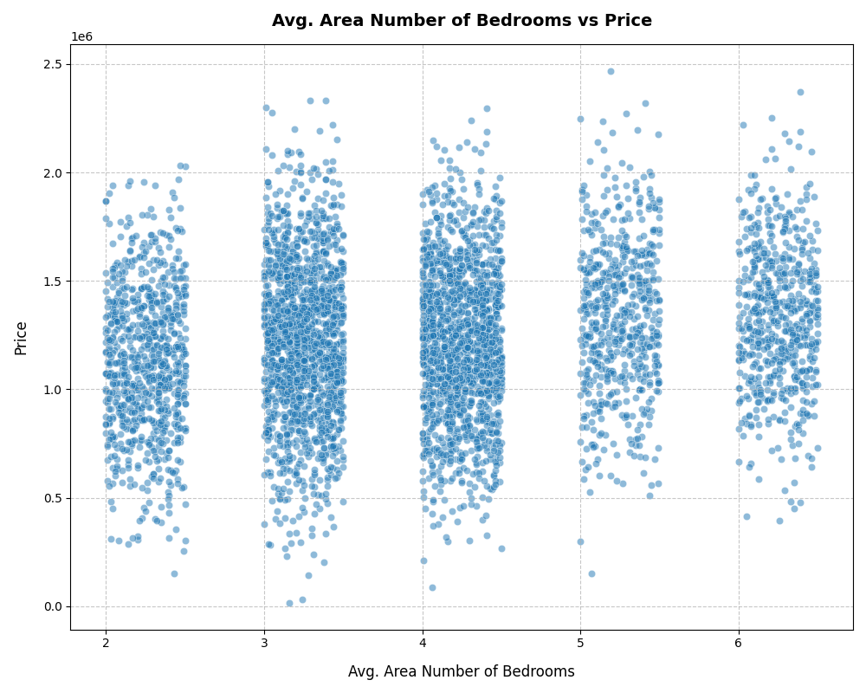  Avg. Area Number of Bedrooms vs Price

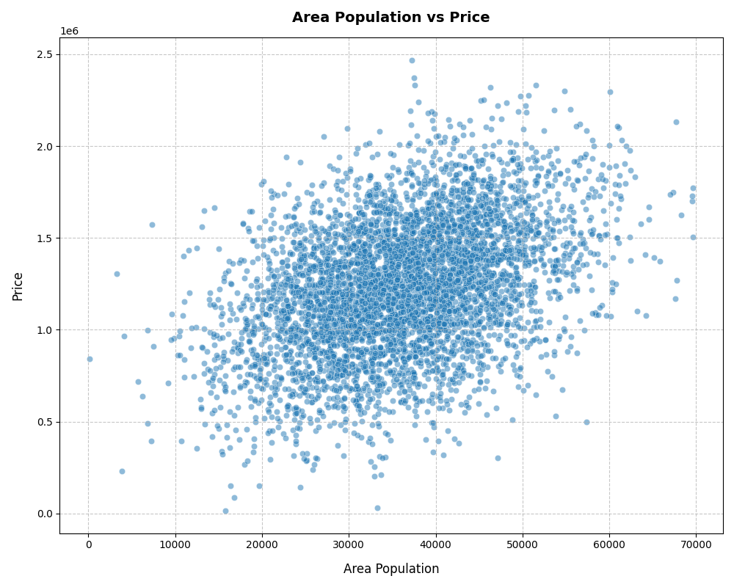
Area Population vs Price
Avg. Area Income and Avg. Area House Age show the clearest upward linear trends with Price. Area Population also trends upward but with more spread. Avg. Area Number of Rooms shows a weaker positive trend, and Avg. Area Number of Bedrooms shows almost no visible relationship with Price — its values cluster in discrete bands (2, 3, 4, 5, 6 bedrooms) with wide price ranges at every level.

3.2 Correlation Analysis
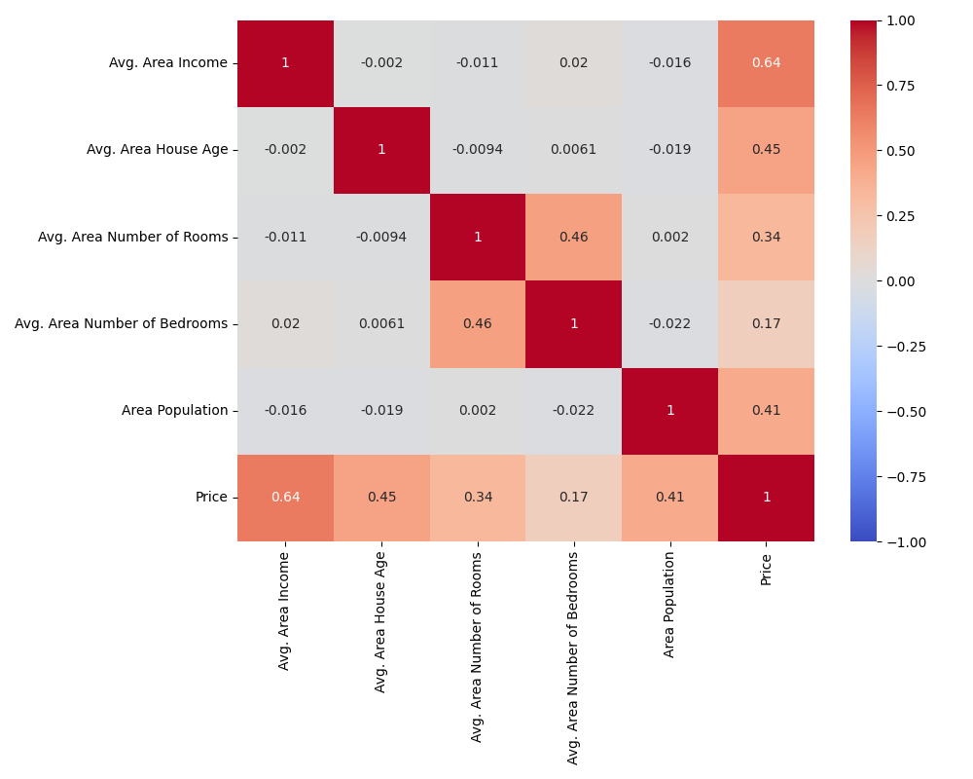
Correlation heatmap of numeric variables
Price correlates most strongly with Avg. Area Income (r = 0.64), followed by Avg. Area House Age (r = 0.45) and Area Population (r = 0.41). Avg. Area Number of Rooms is moderately correlated (r = 0.34), and Avg. Area Number of Bedrooms is weakly correlated (r = 0.17). Importantly, the predictors are only weakly correlated with each other (the largest is 0.46, between rooms and bedrooms), which suggests multicollinearity is not a major concern for this model.

4. Methodology
- Features (X): Avg. Area Income, Avg. Area House Age, Avg. Area Number of Rooms, Avg. Area Number of Bedrooms, Area Population.
- Target (y): Price.
- Split: 80% train / 20% test using scikit-learn's train_test_split, random_state = 42 (4,000 training rows, 1,000 test rows).
- Model: Ordinary Least Squares Linear Regression (scikit-learn LinearRegression).
- Evaluation metrics: MAE, MSE, RMSE, and R² on the held-out test set.

5. Model Results

5.1 Fitted Equation
Price = −2,635,072.90 + 21.65 × (Avg. Area Income) + 164,666.48 × (Avg. Area House Age) + 119,624.01 × (Avg. Area Number of Rooms) + 2,440.38 × (Avg. Area Number of Bedrooms) + 15.27 × (Area Population)

5.2 Coefficients
Feature | Coefficient | Direction
Intercept | -2,635,072.90 | —
Avg. Area Income | 21.65 | +
Avg. Area House Age | 164,666.48 | +
Avg. Area Number of Rooms | 119,624.01 | +
Avg. Area Number of Bedrooms | 2,440.38 | +
Area Population | 15.27 | +

5.3 Business Interpretation of Coefficients
- Avg. Area Income: holding other factors constant, each additional $1 of average area income is associated with a $21.65 increase in price — equivalently, about $21,650 more price per $1,000 of area income.
- Avg. Area House Age: each additional year of average house age is associated with a $164,666 increase in price. This is an area-level average (not the age of an individual house), and likely reflects that older, more established neighborhoods in this dataset carry a price premium rather than depreciation.
- Avg. Area Number of Rooms: each additional average room is associated with a $119,624 increase in price.
- Avg. Area Number of Bedrooms: each additional average bedroom is associated with a comparatively small $2,440 increase in price once rooms and income are already accounted for.
- Area Population: each additional resident in the area is associated with a $15.27 increase in price.

6. Model Evaluation

6.1 Test Set Performance
Metric | Value | Interpretation
R² | 0.918 | The model explains ~91.8% of the variance in Price on unseen data
Adjusted R² | 0.918 | Essentially unchanged from R², confirming all 5 features are pulling their weight
MAE | $80,879 | Average absolute prediction error, in dollars
MSE | ~1.01 × 10¹⁰ | Squared-dollar error; mainly used to derive RMSE
RMSE | $100,444 | Typical prediction error, in the same units as Price

With an average home price of about $1.23M and a mean absolute error of about $80,900, the model's typical error is roughly 6.6% of price — a reasonable margin for an initial pricing-guidance tool, though not tight enough to replace a full appraisal on its own.

6.2 Residual Diagnostics
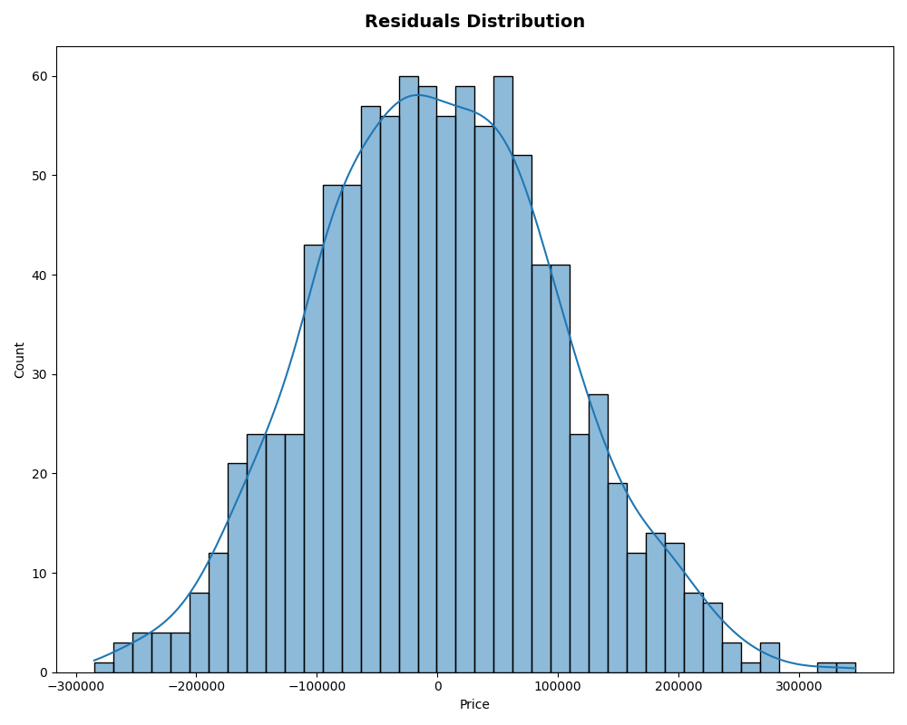  Residuals distribution | 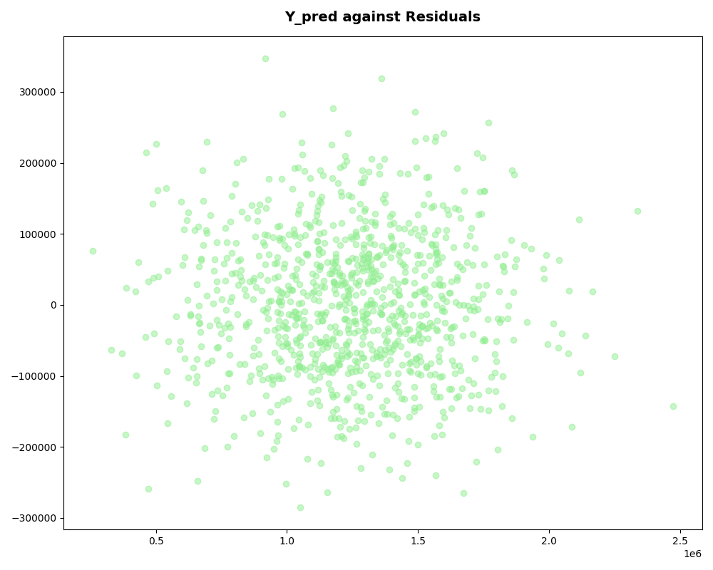  Predicted values vs. residuals

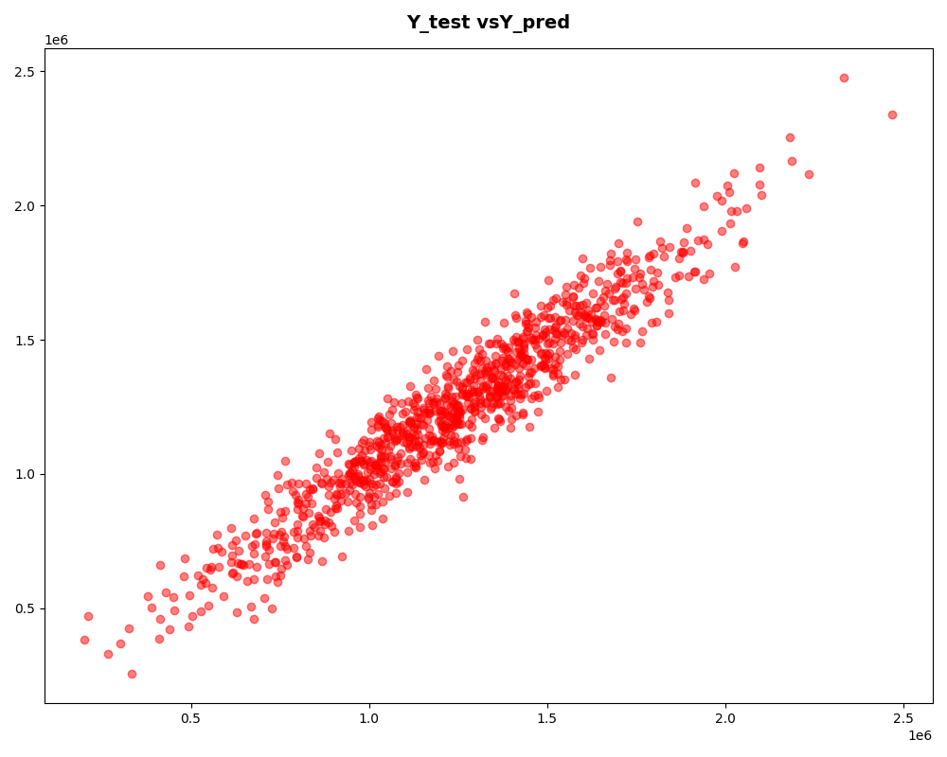
Actual price (Y_test) vs. predicted price (Y_pred)
The residuals are approximately bell-shaped and centered around zero, supporting the normality assumption. The residuals-vs-predicted plot shows no strong funnel or curved pattern, supporting homoscedasticity and linearity, though the spread widens slightly at the high and low ends, where a handful of larger errors occur. The actual-vs-predicted plot shows points tracking closely to the diagonal across the full price range, confirming the model performs consistently for both lower- and higher-priced homes without a systematic bias.

7. Business Insights & Recommendations
- Deploy as a first-pass pricing tool: given R² ≈ 0.92 and a ~6.6% typical error, the model is strong enough to generate an initial price estimate for agents to sanity-check and refine, cutting down manual comparable-sales work.
- Prioritize income and house-age data quality: since Avg. Area Income and Avg. Area House Age are the largest drivers of price, ensure these area statistics are accurate and refreshed regularly, since errors here will propagate directly into price estimates.
- De-emphasize bedroom count in messaging: Avg. Area Number of Bedrooms has the weakest effect on price; marketing or pricing narratives that lean heavily on bedroom count are not well supported by this data once room count and income are considered.
- Use the model to flag outliers: listings whose actual price deviates well beyond the ~$100K RMSE band from the model's estimate are good candidates for manual review — they may be mispriced, or may have distinguishing characteristics the model doesn't capture.
- Treat estimates as guidance, not final valuation: with a ~$80,900 average error, the model should support pricing decisions alongside agent judgment and comparable sales, not replace them, especially for high-value properties where a $100K error matters more in relative terms.

8. Limitations & Future Work
- All predictors are area-level averages, not attributes of the specific property (e.g., its own age, its own room count), which limits precision for any single home.
- The Address field, and any location/geospatial signal it could provide (e.g., city, state, proximity to amenities), was not used and could add predictive power.
- No categorical property features (e.g., property type, condition, renovations) were available in this dataset.
- Only a linear model was tested; comparing against non-linear approaches (e.g., random forest, gradient boosting) in a future iteration could reveal whether relationships like house age are truly linear or better captured with more flexible models.
- A small number of larger residuals at the price extremes suggest the model may be less reliable for unusually low- or high-priced properties; a segmented or robust-regression approach could be explored.

9. Conclusion
The linear regression model meets the goals set out in the project charter: it produces a statistically meaningful, interpretable estimate of home price (R² = 0.918), identifies area income and house age as the leading price drivers, and its residual diagnostics are consistent with the assumptions of linear regression. The model is ready to support pricing guidance in its current form, with the limitations above informing a roadmap for future refinement.

