**Experiment 8**

To have familiarize with trigger functions

# Question

Create a Trigger for employe table it will update another table salary while updating values

## OBJECTIVE

To develop and execute a Trigger for After update/Delete/Insert operations on a table

## PROCEDURE

step 1: start

step 2: initialize the trigger.

step 3: On update the trigger has to be executed. step 4: execute the trigger procedure after updation

step 5: carryout the operation on the table to check for trigger execution. step 6: stop

## PROGRAM

Sql>CREATE TABLE `employe` (

`emp_id` int(11) NOT NULL,

`emp_name` varchar(45) DEFAULT NULL,

`dob` date DEFAULT NULL,

`address` varchar(45) DEFAULT NULL,

`designation` varchar(45) DEFAULT NULL,

`mobile_no` int(11) DEFAULT NULL,

`dept_no` int(11) DEFAULT NULL,

`salary` int(11) DEFAULT NULL, PRIMARY KEY (`emp_id`));

Sql>CREATE TABLE `salary` (

`employee_id` int(11) NOT NULL,

`old_sal` int(11) DEFAULT NULL,

`new_sal` int(11) DEFAULT NULL,

`rev_date` date DEFAULT NULL, PRIMARY KEY (`employee_id`));

Sql>CREATE DEFINER=`root`@`localhost` TRIGGER

`employee_db`.`employe_AFTER_UPDATE` AFTER UPDATE ON `employe`

FOR EACH ROW BEGIN

if(new.salary != old.salary) then

INSERT INTO salary (employee_id,old_sal,new_sal,rev_date) values (new.emp_id,old.salary,new.salary,sysdate());

END if;

END

Sql>update employe set salary=234569 where emp_id=1; select * from salary;

# OUTPUT

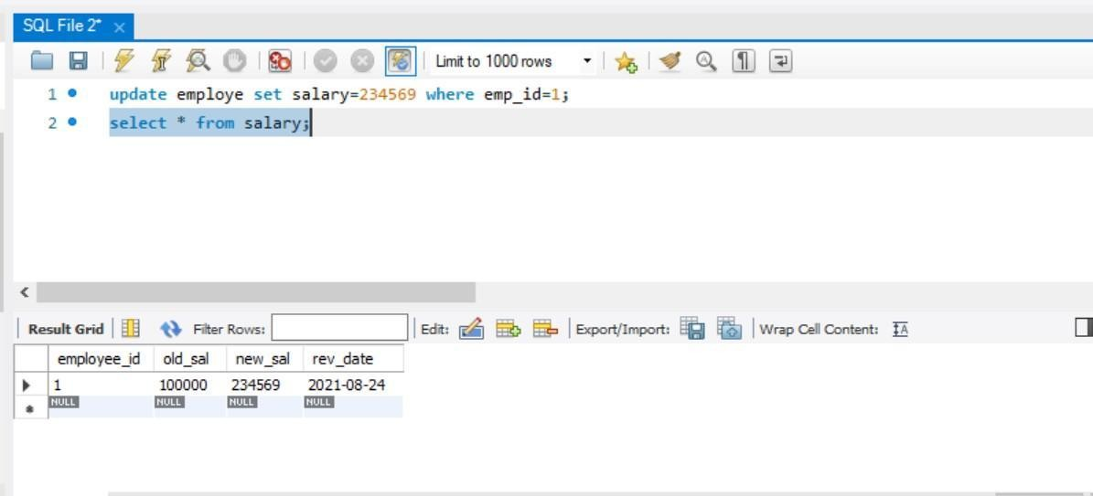

Create a Trigger for employe table it will update another table personal_updations while updating values

## OBJECTIVE

To develop and execute a Trigger for Before and After update/Delete/Insert operations on a table

PROCEDURE

step 1: start

step 2: initialize the trigger.

step 3: On update the trigger has to be executed. step 4: execute the trigger procedure after updation

step 5: carryout the operation on the table to check for trigger execution. step 6: stop

## PROGRAM

**sql>**CREATE TABLE `employe` (

`emp_id` int(11) NOT NULL,

`emp_name` varchar(45) DEFAULT NULL,

`dob` date DEFAULT NULL,

`address` varchar(45) DEFAULT NULL,

`designation` varchar(45) DEFAULT NULL,

`mobile_no` int(11) DEFAULT NULL,

`dept_no` int(11) DEFAULT NULL,

`salary` int(11) DEFAULT NULL, PRIMARY KEY (`emp_id`)

);

**Sql>**CREATE TABLE `personal_updations` (

`old_phoneno` int(11) DEFAULT NULL,

`new_phoneno` int(11) DEFAULT NULL,

`rev_date` date DEFAULT NULL, PRIMARY KEY (`emp_id`)

);

**Sql**>CREATE DEFINER=`root`@`localhost` TRIGGER

`employe_AFTER_UPDATE_1` AFTER UPDATE ON `employe` FOR EACH ROW BEGIN

if(new.mobile_no != old.mobile_no) then

INSERT INTO personal_updations (emp_id,old_phoneno,new_phoneno,rev_date) values (new.emp_id,new.mobile_no,old.mobile_no,sysdate()); END if;

END

**sql>**update employe set mobile_no=34566 where emp_id=4 ; select * from personal_updations;

# OUTPUT

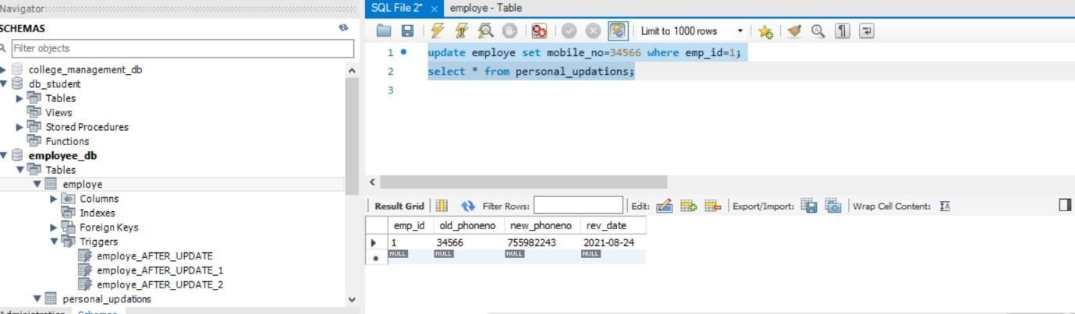

Create a Trigger for employe table it will update another table promotions while updating values

## OBJECTIVE

To develop and execute a Trigger for Before and After update/Delete/Insert operations on a table

## PROCEDURE

step 1: start

step 2: initialize the trigger.

step 3: On update the trigger has to be executed. step 4: execute the trigger procedure after updation

step 5: carryout the operation on the table to check for trigger execution. step 6: stop

## PROGRAM

**sql**>CREATE TABLE `employe` (

`emp_id` int(11) NOT NULL,

`emp_name` varchar(45) DEFAULT NULL,

`dob` date DEFAULT NULL,

`address` varchar(45) DEFAULT NULL,

`designation` varchar(45) DEFAULT NULL,

`mobile_no` int(11) DEFAULT NULL,

`dept_no` int(11) DEFAULT NULL,

`salary` int(11) DEFAULT NULL, PRIMARY KEY (`emp_id`)

);

**Sql**>CREATE TABLE `promotions` (

`old_designation` varchar(11) DEFAULT NULL,

`new_designation` varchar(11) DEFAULT NULL,

`rev_date` date DEFAULT NULL, PRIMARY KEY (`emp_id`)

);

**sql**>CREATE DEFINER=`root`@`localhost` TRIGGER

`employe_AFTER_UPDATE_2` AFTER UPDATE ON `employe` FOR EACH ROW BEGIN

if(new.designation != old.designation) then

INSERT INTO promotions (emp_id,old_designation,new_designation,rev_date) values (new.emp_id,new.designation,old.designation,sysdate());

END if;

END

**sql**>update employe set designation='clk' where emp_id=1; select * from promotions;

# OUTPUT

