Experiment 1

**Aim**

To study various DDL commands - CREATE

**Question**

Create the following Tables

Create database exp1;

Use exp1;

create table BRANCH (Bname varchar(20)primary key,

City varchar(30) check (City in ('Nagpure','Delhi','Bangalore','Bombay'))not null);

insert into Branch (Bname, City) values('VRCE','Nagpure');

insert into Branch (Bname, City) values('AJNI','Nagpure');

insert into Branch (Bname, City) values(KAROLE BAGH','Delhi');

insert into Branch (Bname, City) values('CHADNI','Delhi');

insert into Branch (Bname, City) values('MG ROAD','Bangalore');

insert into Branch (Bname, City) values('ANDHERI','Bombay');

insert into Branch (Bname, City) values('NEHRU PALACE',Delhi);

insert into Branch (Bname, City) values('POWAI','Bombay');

Select *from Branch

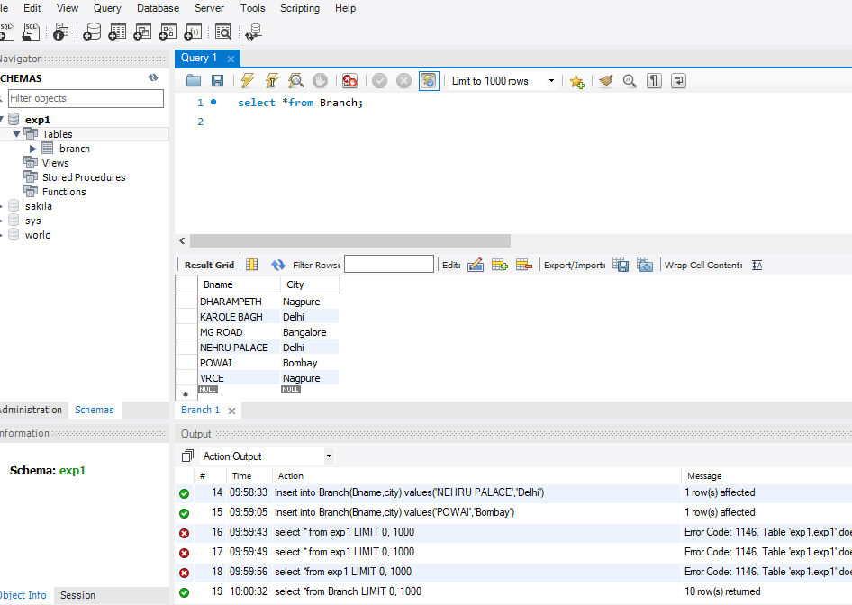

create table Borrow(LoanNo varchar(10) check (LoanNo like 'L%') primary key,Cname varchar(15) references Costomer(Cname),Bname varchar(20) references Branch(Bname),Amount float(8) check(Amount>0)not null);

create table Deposit (ActNo varchar(5) CHECK (ActNo LIKE 'D%') PRIMARY KEY, Cname varchar(15) references Customer(Cname), Bname varchar(20) references Branch(Bname), Amount float(8) CHECK(Amount>0)not null, Adate date);

create table Customer (Cname varchar(20) PRIMARY KEY, City varchar(30)NOT NULL);

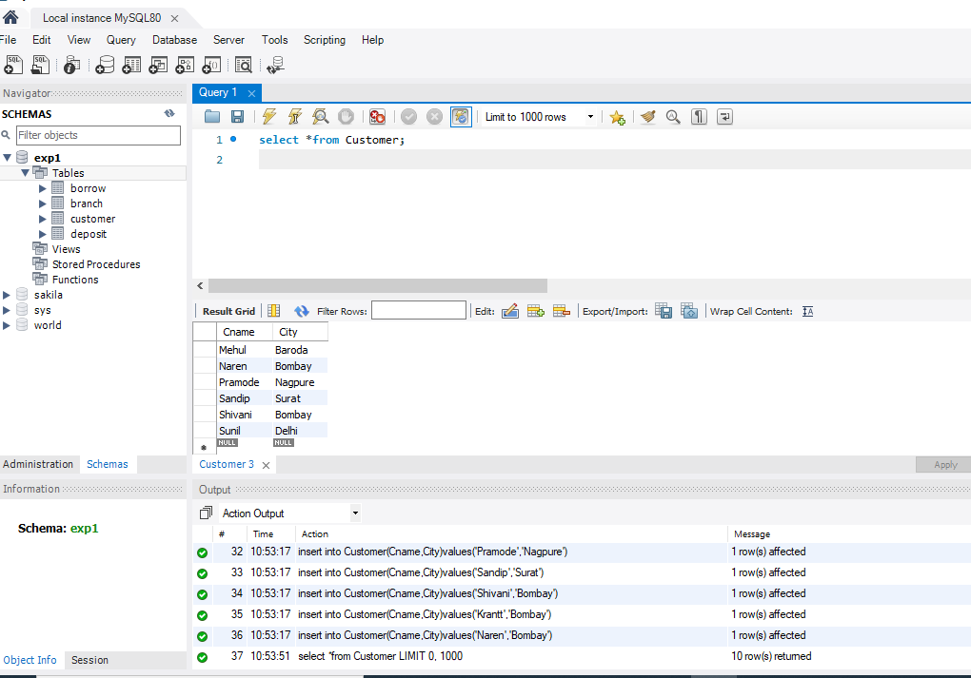

insert into BRANCH (BNAME, CITY) values('VRCE','NAGPUR');

insert into BRANCH (BNAME, CITY) values('AJNI','NAGPUR');

insert into BRANCH (BNAME, CITY) values('KAROL BAGH','DELHI');

insert into BRANCH (BNAME, CITY) values('CHANDNI','DELHI');

insert into BRANCH (BNAME, CITY) values('DHARAMPETH','NAGPUR');

insert into BRANCH (BNAME, CITY) values('MG ROAD','BANGLORE');

insert into BRANCH (BNAME, CITY) values('ANDHERI','BOMBAY');

insert into BRANCH (BNAME, CITY) values('NEHRU PALACE','DELHI');

insert into BRANCH (BNAME, CITY) values('POWAI','BOMBAY');

select * from BRANCH;

insert into DEPOSIT (ACTNO, CNAME, BNAME, AMOUNT, ADATE) values ('D100', 'ANIL', 'VRCE', '1000.00','1995-03-1');

insert into DEPOSIT (ACTNO, CNAME, BNAME, AMOUNT, ADATE) values ('D101','SUNIL','ANJNI','500.00','1996-01-4');

insert into DEPOSIT (ACTNO, CNAME, BNAME, AMOUNT, ADATE) values ('D102','MEHUL','KAROLBAGH','3500.00','1995-11-17');

insert into DEPOSIT (ACTNO, CNAME, BNAME, AMOUNT, ADATE) values ('D104','MADHURI','CHANDNI','1200.00','1995-12-17');

insert into DEPOSIT (ACTNO, CNAME, BNAME, AMOUNT, ADATE) values ('D105','PRAMOD','MG ROAD','3000.00','1996-03-27');

insert into DEPOSIT (ACTNO, CNAME, BNAME, AMOUNT, ADATE) values ('D106','SANDIP','ANDHERI','2000.00','1996-03-31');

insert into DEPOSIT (ACTNO, CNAME, BNAME, AMOUNT, ADATE) values ('D107', 'SHIVANI', 'VIRAR', '1000.00', '1995-09-5');

insert into DEPOSIT (ACTNO, CNAME, BNAME, AMOUNT, ADATE) values ('D108', 'KRANTI', 'NEHRU PLACE', '5000.00', '1995-07-02');

insert into DEPOSIT (ACTNO, CNAME, BNAME, AMOUNT, ADATE) values ('D109', 'MINU', 'POWAI', '7000.00', '1995-08-10');

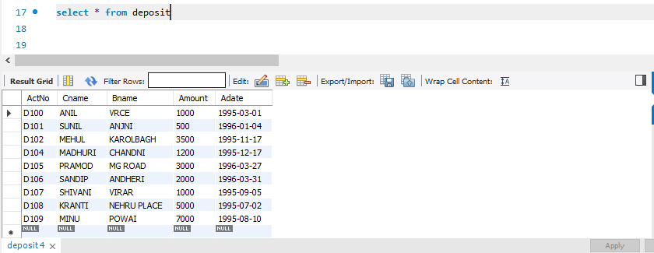

insert into BORROW (LOANNO, BNAME, CNAME, AMOUNT) values('L201', 'ANIL', 'VRCE', '1000.00');

insert into BORROW (LOANNO, BNAME, CNAME, AMOUNT) values('L206', 'MEHUL', 'AJNI', '5000.00');

insert into BORROW (LOANNO, BNAME, CNAME, AMOUNT) values('L311', 'SUNIL', 'DHARAMPETH', '3000.00');

insert into BORROW (LOANNO, BNAME, CNAME, AMOUNT) values('L321', 'MADHURI' ,'ANDHERI', '2000.00');

insert into BORROW (LOANNO, BNAME, CNAME, AMOUNT) values('L371', 'PRAMOD', 'VIRAR', '8000.00');

insert into BORROW (LOANNO, BNAME, CNAME, AMOUNT) values('L481', 'KRANTI', 'NEHRU', 'PLACE', '3000.00');

