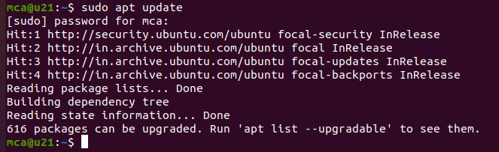sudo apt update

sudo su

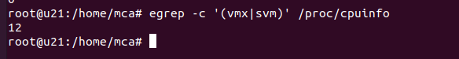egrep -c '(vmx|svm)' /proc/cpuinfo

sudo apt install cpu-checker

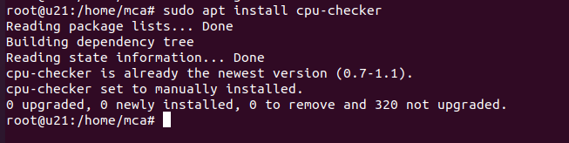

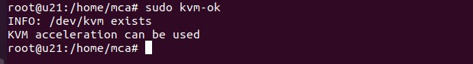sudo kvm-ok

sudo apt install -y qemu qemu-kvm libvirt-daemon libvirt-clients bridge-utils virt-manager

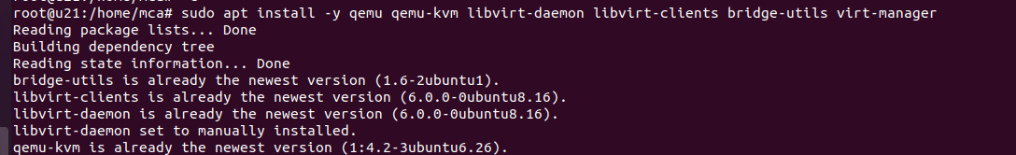

virsh list --all :- To verify

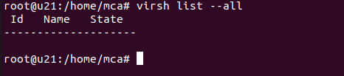

sudo apt install virt-manager

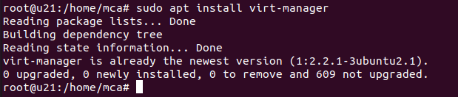

sudo systemctl enable --now libvirtd



sudo virt-manager



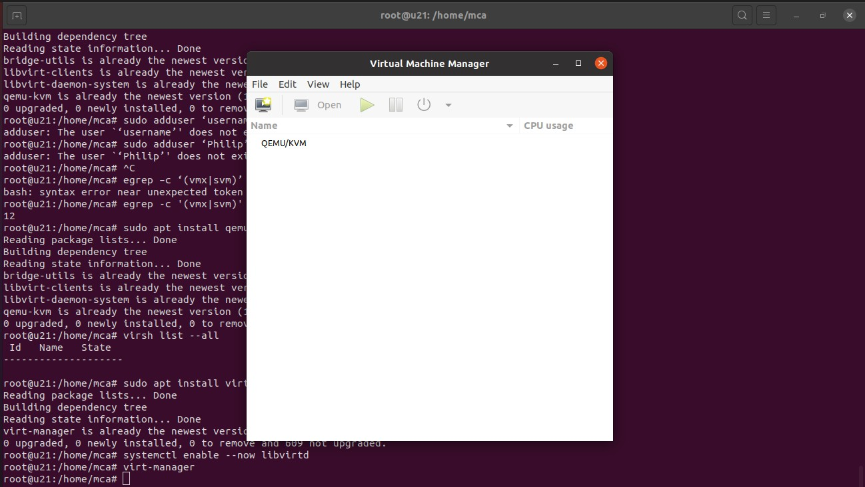

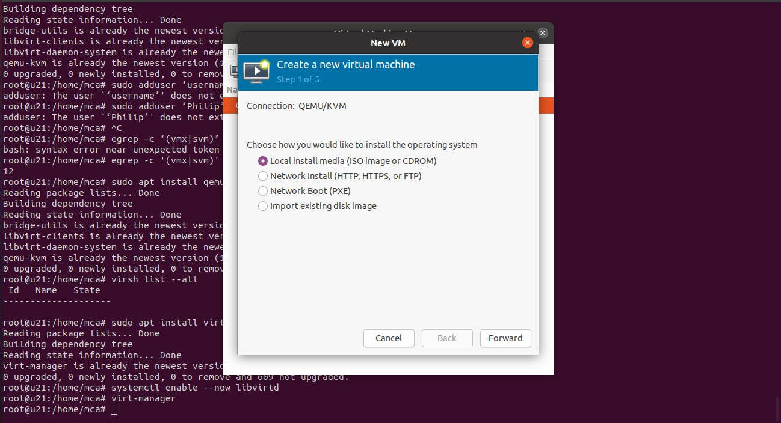

**2. Installing VM - using ISO image**

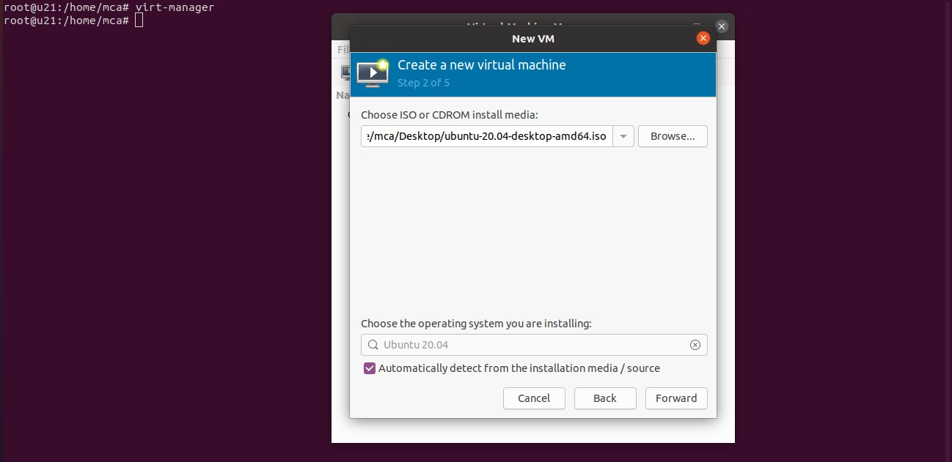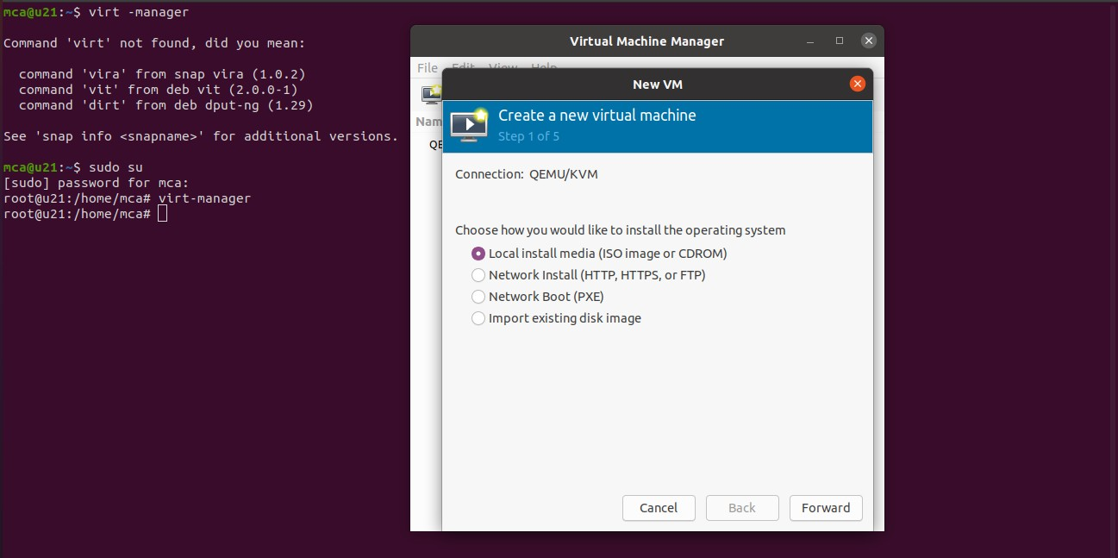

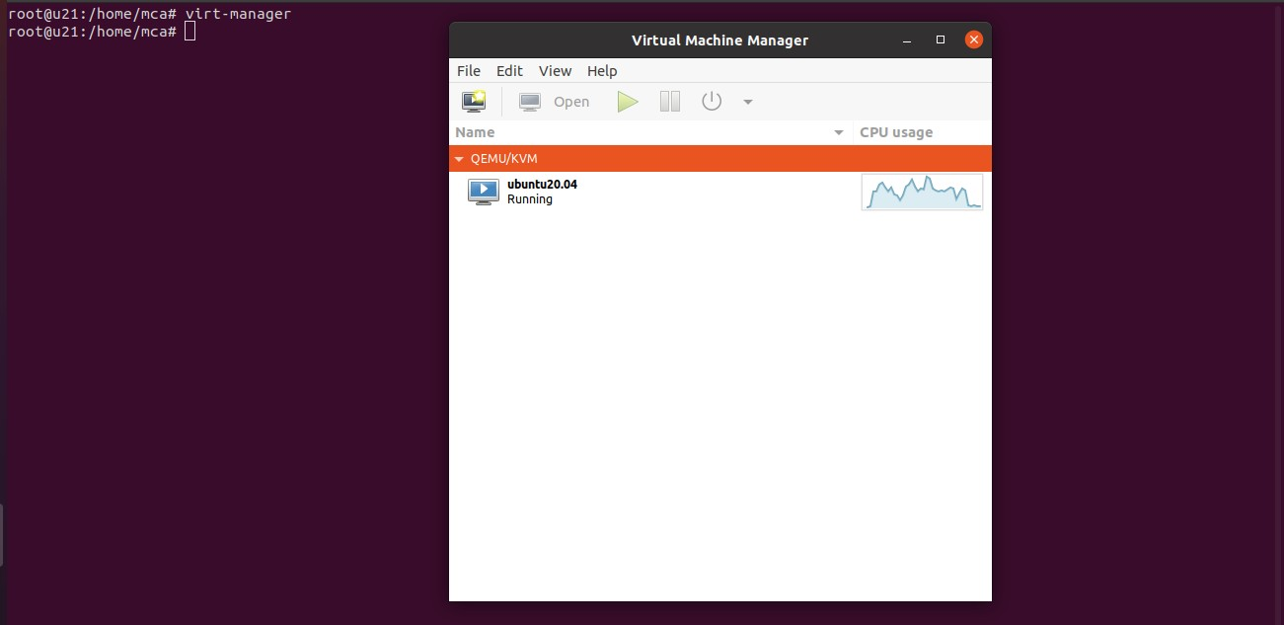

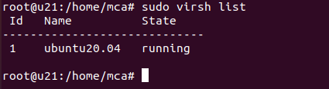**sudo virsh list**

**sudo virsh list –all**

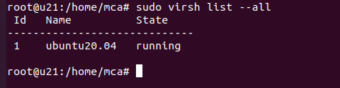

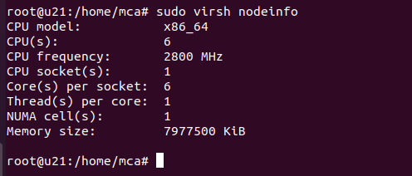**sudo virsh nodeinfo**

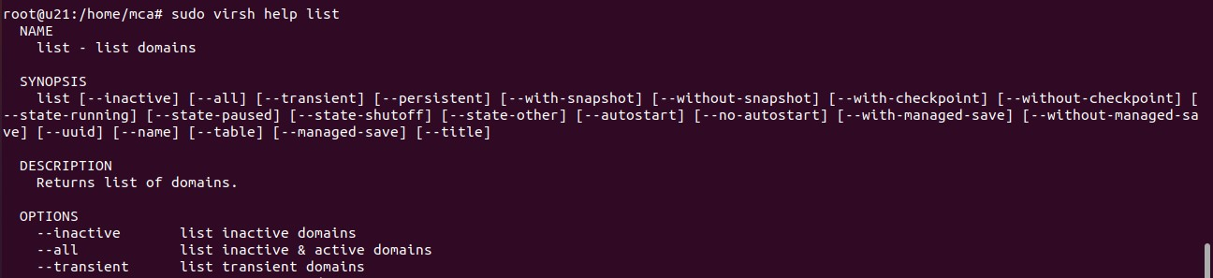**sudo virsh help list**

**sudo virsh start <vmname>**

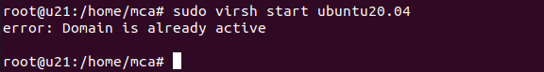

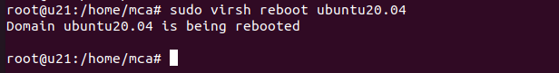sudo virsh reboot <vmname>

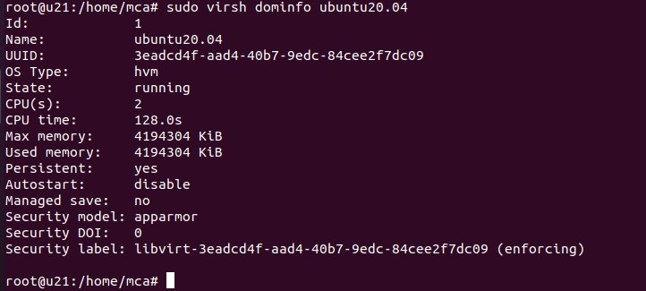sudo virsh dominfo <vmname>

