**HURLEY DAVE HAMAC   
BSIT2-B**

**CW REPORT AND TOPIC**

**Two (2) most pressing issues in the Philippines**

**Unending Drug War  
Drugs-** are substances that change a person's mental or physical state. They can affect the way your brain works, how you feel and behave, your understanding and your senses. This makes them unpredictable and dangerous, especially for young people. The effects of drugs are different for each person and drug.

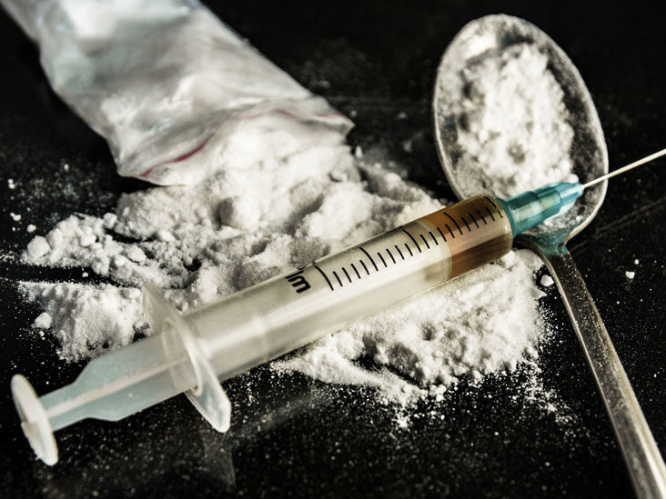

**Teenage pregnancy**

* Teenage pregnancy is when a woman under 20 gets pregnant. It usually refers to teens between the ages of 15-19. But it can include girls as young as 10. It's also called teen pregnancy or adolescent pregnancy. In the U.S., teen birth rates and number of births to teen mothers have dropped steadily since 1990.

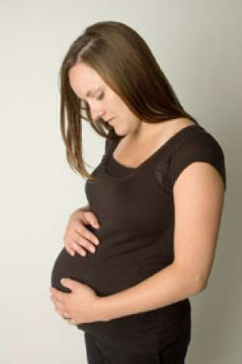

**Two (2) Kinds of Migrants**

* **Voluntary migration** - is **migration based on one's free will and initiative**. People move for a variety of reasons, and it involves weighing options and choices. Individuals who are interested in moving often analyze the push and pull factors of two locations before making their decision.
* **Involuntary migrants** - are **those people who are forced to move--by organized persecution or government pressure**.

**Six (6) Types of Migration**

**INTERNAL MIGRATION** - is when people migrate within the same country or region.

**INTERNATIONAL MIGRATION -** is when people migrate from one country to another.

**IMMIGRATION** - when someone leaves a country. The people moving away are called emigrants.

**EMIGRATION -** when someone enters a country. The people entering a country are called immigrants.

**COUNTER-URBANIZATION** - is a demographic and social process whereby people move from urban areas to rural areas.

**RURAL-URBAN MIGRATION -** the population shift from rural to urban areas, the corresponding decrease in the proportion of people living in rural areas, and the ways in which societies adapt to this change.