

ADAPTIVE DYNAMIC QUERY ROUTING FOR URDU INFORMATION RETRIEVAL
by
Hashim Shazad
M.S., Artificial Intelligence, Air University, 2026
A thesis submitted in partial fulfillment of the requirements for the degree of
Master of Science in Artificial Intelligence
AIR UNIVERSITY
ISLAMABAD
2026



ADAPTIVE DYNAMIC QUERY ROUTING FOR URDU INFORMATION RETRIEVAL
by
Hashim Shazad
A thesis submitted in partial fulfillment of the requirements for the degree of
Master of Science in Artificial Intelligence
SUPERVISOR
Dr. Adnan Aslam
AIR UNIVERSITY
ISLAMABAD
© [Hashim Shazad] [2026]. All rights reserved.

CERTIFICATE
Department of Creative Technologies
It is hereby certified that Hashim Shazad (243259) has successfully completed his thesis titled “Adaptive Dynamic Query Routing for Urdu Information Retrieval” under the supervision of the undersigned, and that the thesis is of sufficient standard to be submitted in partial fulfillment of the requirements for the degree of Master of Science in Artificial Intelligence.

________________________________
Dr. Adnan Aslam
Assistant Professor
Air University, Islamabad
Supervisor

________________________________
[Internal Examiner]
[External Examiner]

________________________________
Chair, Department of Creative Technologies
Air University

________________________________
Dean, Faculty of Graduate Studies
Air University

DECLARATION
I declare that all material in this thesis is my own work, and that which is not my own work has been clearly acknowledged as such, and that no material from this work has previously been submitted for, or awarded, a degree at this or any other university.

Signature: _______________________
Author's Name: Hashim Shazad
Dated: _______________________

It is certified that the work presented in this thesis was carried out and completed under my supervision.

Signature: _______________________
Supervisor's Name: Dr. Adnan Aslam
Assistant Professor
Department of Creative Technologies
Air University, Islamabad
Dated: _______________________

Acknowledgments
First and foremost, I am thankful to Allah Almighty for granting me the strength, patience, and clarity of mind to complete this thesis.
I would like to express my sincere gratitude to my supervisor, Dr. Adnan Aslam, for his invaluable guidance, continuous encouragement, and constructive feedback throughout the course of this research. His mentorship was instrumental in shaping the direction and rigour of this work.
I am also grateful to the faculty and staff of the Department of Creative Technologies at Air University for providing the resources, environment, and support necessary to carry out this research.
Finally, I would like to thank my family and friends for their unwavering support, patience, and encouragement throughout my Master's studies. Their belief in me has been a constant source of motivation.

Adaptive Dynamic Query Routing for Urdu Information Retrieval
by
Hashim Shazad
M.S., Artificial Intelligence, Air University, 2026
Submitted in partial fulfillment of the requirements for the degree of
Master of Science in Artificial Intelligence, Air University
Abstract
Urdu information retrieval (IR) systems face persistent challenges arising from script variability, morphological complexity, and the widespread use of Roman Urdu in user queries, yet existing adaptive retrieval frameworks such as ULTRA rely on a single static, length-based routing threshold that does not adapt to a query's deeper linguistic characteristics. This thesis proposes a dynamic query routing extension to the ULTRA framework, replacing its static threshold with a lightweight, eight-feature Support Vector Machine (SVM) classifier combined with a three-tier confidence-based escalation strategy. Queries are additionally processed through an expanded Roman Urdu transliteration dictionary (grown from 30 to 179 entries) to improve retrieval precision on code-mixed and transliterated text. The deployed V2 classifier is trained on 409 labeled Urdu and Roman Urdu queries (193 SHORT, 216 LONG), using a script-aware feature vector (urdu_ratio, roman_ratio, has_urdu, has_roman, query_len, char_len, mixed, urdu_chars). Earlier training and cross-validation experiments showed that this routing task is learnable, reaching 100% routing accuracy (AUC = 1.000) versus 50% for ULTRA's static character-length threshold, with an average routing confidence of 98.18% on a demonstration batch and Roman Urdu retrieval precision (P@15) of 92.5% on queries that the original ULTRA pipeline cannot process (0.00%). Those development-stage figures are not treated as the generalization result. On a later, held-out, frozen 60-query evaluation set (50 primary with gold labels + 10 secondary) that neither the SVM nor the comparison baseline saw during training, the V2 SVM achieved 86.00% accuracy compared with 84.00% for a frozen word-count baseline (word_count >= 6 -> LONG), a small descriptive advantage that is not statistically significant (exact McNemar p = 1.0000; only three discordant pairs). Separately, a Phase 2.5 human retrieval-judgment pilot (33 queries; 330 rank-1-5 judgments) indicates that word count alone is an imperfect proxy for retrieval need, particularly in the 5-word boundary region. Comparison against four LLM-style routing baselines, conducted at the development stage, showed the proposed classifier matching their routing accuracy at approximately three orders of magnitude lower per-query latency (0.4555 ms vs. 600-900 ms) and zero API cost. These results demonstrate that dynamic, confidence-aware query routing is a practical and empirically supported alternative to static routing for Urdu IR, while requiring the frozen held-out evaluation — not the earlier 100% cross-validation figures — to be reported as the headline generalization result.

Thesis Supervisor: Dr. Adnan Aslam

Table of Contents
Chapter 1: Introduction 1
1.1 Background 1
1.2 Problem Statement 3
1.3 Motivation 4
1.4 Research Gap 5
1.5 Research Questions 5
1.6 Objectives 6
1.7 Contributions 7
1.8 Scope of the Thesis 7
1.9 Significance of the Study 8
1.10 Thesis Layout 9
Chapter 2: Literature Survey 10
2.1 Foundations 10
2.2 Comparative Analysis of Retrieval and Routing Paradigms 13
2.3 Datasets and Evaluation Resources 16
2.4 Evaluation Metrics in Information Retrieval 17
2.5 Current Research Trends 18
2.6 Prior Work 19
2.7 Gap Analysis 20
2.8 Summary of Unresolved Gaps 22
Chapter 3: Mathematical Formulation 23
3.1 Query Feature Vector Representation 23
3.2 Feature Standardization 24
3.3 SVM Decision Function 25
3.4 Confidence Calibration 26
3.5 Confidence-Based Three-Tier Routing Function 27
3.6 Retrieval Scoring Function 28
3.7 Evaluation Metrics 28
3.8 Computational Complexity Analysis 29
3.9 Worked Example 30
3.10 Design Rationale and Alternatives Considered 31
Chapter 4: Methods Developed 33
4.1 System Architecture 33
4.2 Corpus and Dataset 35
4.3 Roman Urdu Detection and Dictionary Transliteration 38
4.4 Eight-Feature Semantic Classifier 39
4.5 Dynamic SVM Routing Classifier: Training Procedure 40
4.6 Confidence-Based Three-Tier Routing 41
4.7 Baseline and Comparison Systems 41
4.8 Ablation Study Design 42
4.9 Experimental Setup and Reproducibility 43
4.10 Implementation Pipeline 44
4.11 Independent Frozen Evaluation Protocol (Phases 3A–3B)
4.12 Human Retrieval Validation (Phase 2.5)
Chapter 5: Results and Discussion 46
5.1 Routing Accuracy: Static vs. Dynamic 46
5.2 Retrieval Precision (P@15) 49
5.3 Comparison with LLM-Based Routing 51
5.4 Feature Importance 53
5.5 Ablation Study 54
5.6 Confidence-Tier Distribution 55
5.7 Robustness Validation 57
5.8 Error Analysis 62
5.9 Comparison with Prior Studies 63
5.10 Strengths and Weaknesses of the Proposed System 64
5.11 Practical Implications 65
5.12 Discussion 65
5.13 Frozen Phase 3B Generalization Results
5.14 Statistical Comparisons: Two McNemar Tests
5.15 Human Retrieval Validation Results (Phase 2.5)
Chapter 6: Conclusions and Recommendations 67
6.1 Conclusions 67
6.2 Summary of Contributions 68
6.3 Limitations 69
6.4 Recommendations for Practitioners 70
6.5 Recommendations for Further Research 70
6.6 Real-World Applications 72
6.7 Closing Remarks 72
References 74

List of Figures
Figure 1. System architecture: end-to-end dynamic query routing pipeline. 34
Figure 2. Query length distribution and short/long split (development query set; later expanded to 409 by gap-fill).. 37
Figure 3. Confusion matrix of the dynamic SVM classifier on the development 74-query test split (39 short + 35 long, 0 misclassifications). This figure belongs to the training/CV layer, not Phase 3B.
Figure 4. Performance comparison: proposed system vs. static and LLM-style baselines. 48
Figure 5. Roman Urdu query results: individual per-query P@15 breakdown (8 test queries). 50
Figure 6. Query routing accuracy across all six compared methods (green = proposed SVM, blue = LLM-style routers, red = failed/static methods). 51
Figure 7. Routing accuracy and per-query latency (log scale): static threshold vs. proposed SVM vs. GPT-4-style routing. 52
Figure 8. System efficiency analysis: Roman Urdu dictionary growth (left) and routing speed comparison, log scale (right). 53
Figure 9. Permutation feature importance for the dynamic SVM classifier. 53
Figure 10. Ablation study: routing accuracy with each feature individually removed. 55
Figure 11. Confidence-based query routing: per-query confidence scores (left) and tier distribution (right) \u2014 all 8 demonstration queries fall in the HIGH tier. 56
Figure 12. Cohen's d effect-size analysis per feature. 58
Figure 13. Learning curves: training vs. cross-validation accuracy. 59
Figure 14. SVM regularization (C) sensitivity analysis: full range including extreme under-regularization (left) and practical operating range (right). 60
Figure 15. Diagnostic external validation on 50 unseen native-Urdu queries (development/robustness layer). The deployed V2 model records 98.00% on this 50-query diagnostic set (training_info.json); the frozen generalization test is Phase 3B (Section 5.13).
Figure 16. ROC curve of the dynamic SVM classifier (AUC = 1.000). 61
Figure 17. Consolidated robustness validation report: scorecard and all four supporting analyses. 62

List of Tables
Table 1. Comparative summary of retrieval/routing paradigms across cost and capability dimensions. 15
Table 2. Comparative summary of Urdu and multilingual IR-relevant datasets. 16
Table 3. Comparative gap analysis of related work in Urdu IR and query routing. 21
Table 4. Eight-dimensional query feature vector. 23
Table 5. Computational complexity of each pipeline stage. 30
Table 6. Summary of mathematical design decisions and alternatives considered. 31
Table 7. Software components and technology stack. 35
Table 8. Corpus category breakdown (111,860 articles). 36
Table 9. Corpus and query dataset summary. 37
Table 10. SVM hyperparameter configuration and rationale. 40
Table 11. Confidence-based three-tier routing strategy. 41
Table 12. Baseline and comparison system implementation summary. 42
Table 13. Experimental environment summary. 43
Table 14. Twelve-stage implementation pipeline. 44
Table 15. Routing accuracy: static baseline vs. dynamic classifiers. 46
Table 16. Retrieval precision at rank 15 (P@15). 49
Table 17. Individual Roman Urdu query P@15 results. 50
Table 18. Comparison with LLM-based routing baselines (14-query test set). 51
Table 19. Ablation study: accuracy with each feature individually removed. 54
Table 20. Query distribution across confidence tiers (8-query demonstration batch). 55
Table 21. Robustness validation summary (12 checks, all passed). 57

Symbols and Abbreviations
Symbol / Abbreviation | Description
IR | Information Retrieval
SVM | Support Vector Machine
RBF | Radial Basis Function
P@15 | Precision at rank 15
AUC | Area Under the (ROC) Curve
ROC | Receiver Operating Characteristic
HNSW | Hierarchical Navigable Small World (index)
LLM | Large Language Model
BM25 | Best Matching 25 (ranking function)
RAG | Retrieval-Augmented Generation
QPP | Query Performance Prediction
mDPR | Multilingual Dense Passage Retriever
XLM-R | Cross-lingual Language Model – RoBERTa
BERT | Bidirectional Encoder Representations from Transformers
TP / FP / TN / FN | True Positive / False Positive / True Negative / False Negative
C(q) | Calibrated confidence score for query q
R(q) | Three-tier routing function for query q
x(q) | Eight-dimensional feature vector for query q
θ | Static character-length routing threshold (θ = 150)
McNemar | Paired binary-classifier comparison (Stage-C V1 vs V2; Phase 3B SVM vs word-count)
SHORT / LONG | Routing labels: headline-sufficient vs. full-content retrieval need

Chapter 1: Introduction

1.1 Background
Urdu is spoken by over 230 million people worldwide and serves as the national language of Pakistan and one of the officially recognized languages of India, yet it remains substantially underserved within contemporary information retrieval (IR) research (Daud et al., 2017). Unlike high-resource languages such as English, where dense retrieval, neural ranking, and large language model (LLM)-based query understanding have matured rapidly — driven by pretrained transformer encoders (Devlin et al., 2019) and dense dual-encoder retrievers (Karpukhin et al., 2020) — Urdu IR continues to face persistent challenges rooted in script complexity, morphological richness, and the informal, code-mixed nature of user-generated queries (Daud et al., 2017; Kazi & Khoja, 2025). A particularly acute challenge is the widespread use of Roman Urdu — Urdu written using the Latin script — in everyday digital communication and search queries, which introduces significant lexical and orthographic variation that conventional retrieval pipelines are not designed to handle (Hussain et al., 2025).
The trajectory of information retrieval research over the past two decades helps situate why this gap has persisted for so long. Classical retrieval systems relied on lexical matching frameworks such as the probabilistic relevance model underlying BM25 (Robertson & Zaragoza, 2009), which score documents based on term-frequency statistics rather than semantic meaning. These frameworks are language-agnostic in principle, but in practice they depend on well-tuned tokenization, stemming, and stop-word resources that were developed first — and most extensively — for English and a handful of other high-resource languages. The subsequent shift toward dense, embedding-based retrieval, exemplified by dual-encoder architectures such as DPR (Karpukhin et al., 2020) and pretrained multilingual encoders (Conneau et al., 2020), promised to reduce this dependency by learning semantic representations directly from data. In practice, however, the quality of these representations is itself bounded by the volume and diversity of pretraining data available for a given language, and Urdu — despite its large speaker population — remains comparatively underrepresented in the web-scale corpora used to pretrain most multilingual models.
This representational gap is compounded by a behavioral one. Empirical observation of Urdu-speaking users' search behavior suggests that a substantial share of real-world queries are not typed in the native Perso-Arabic script at all, but rather transliterated into Roman characters — a consequence of keyboard availability, typing familiarity, and long-standing digital communication habits that predate widespread Urdu-script keyboard support on mobile devices. Sitaram et al. (2019) frame this kind of script alternation as a broader instance of code-switching behavior, a phenomenon that conventional monolingual NLP pipelines, built around the assumption of a single consistent script, are structurally unequipped to handle. The consequence for Urdu information retrieval specifically is that any system evaluated only on native-script queries risks substantially overstating its real-world effectiveness, since it silently excludes a large and linguistically distinct subpopulation of actual user queries.
The scarcity of standardized evaluation resources compounds this problem. Early efforts such as the Collection for Urdu Retrieval Evaluation (CURE) (Iqbal et al., 2021) and, more recently, the translated Urdu MS MARCO baseline (Butt et al., 2024), have begun to establish benchmarks for Urdu IR, but adaptive, query-aware retrieval strategies for Urdu remain largely unexplored. Where such strategies exist for other languages — for instance, classifier-driven routing between sparse and dense retrieval (Arabzadeh et al., 2021) or complexity-aware retrieval-augmented generation (Jeong et al., 2024) — they have been designed, trained, and validated exclusively on English data, leaving open the question of whether their underlying premise (that a lightweight, query-level classifier can reliably predict the best retrieval strategy) transfers to a morphologically richer, script-variable, lower-resource language such as Urdu.
The ULTRA framework, proposed by Bashir, Qaiser, and Hussain (2026), represents a recent effort in this direction, introducing a dual-embedding, query-length-sensitive routing scheme that distinguishes between short, intent-oriented queries and longer, context-rich queries using a threshold-based decision process. However, ULTRA's routing mechanism relies on a static query-length threshold, which does not adapt to the full range of linguistic characteristics a real Urdu query may exhibit — including lexical diversity, Roman Urdu transliteration, and question structure. This mirrors a broader challenge identified in the general IR literature: Arabzadeh et al. (2021) showed that a learned classifier for routing queries between sparse and dense retrieval strategies can substantially outperform static rules, though their work was developed and evaluated only for English.
This thesis extends the ULTRA framework by replacing its static, length-based routing threshold with an adaptive, dynamic query routing mechanism. The proposed system classifies incoming Urdu (and Roman Urdu) queries using a lightweight, eight-feature Support Vector Machine (SVM) classifier and routes them to the most appropriate retrieval configuration in real time, combined with a confidence-based tiered escalation strategy for ambiguous queries. In doing so, it treats query routing not as a fixed engineering rule but as a learnable problem in its own right — one that can, and should, be evaluated with the same empirical rigor typically reserved for the retrieval and ranking components of an IR system.

1.2 Problem Statement
Existing Urdu information retrieval systems, including the ULTRA framework on which this thesis builds, predominantly employ static, threshold-based routing that applies a fixed decision rule regardless of the deeper linguistic characteristics of a query — such as lexical diversity, script type (native Urdu vs. Roman Urdu), or the presence of interrogative structure. This static approach results in suboptimal retrieval performance for queries that deviate from the assumption the threshold was tuned for, particularly Roman Urdu queries, which suffer from inconsistent transliteration and vocabulary sparsity (Hussain et al., 2025). Preliminary evaluation of static threshold-based routing on a diverse Urdu query set shows accuracy as low as 50%, representing a critical reliability gap for real-world deployment.
This problem manifests concretely in at least three ways. First, a single scalar threshold on character length cannot separate queries that are short but semantically dense (e.g., a terse but well-formed native-Urdu question) from queries that are short because they are ambiguous or under-specified (e.g., a two-word Roman Urdu fragment). Second, because the static rule has no notion of script type, it applies the identical routing logic to a native-Urdu query and a Roman Urdu query of the same length, despite the two requiring fundamentally different downstream processing — the latter benefiting from transliteration before retrieval is attempted at all. Third, the static threshold offers no mechanism for expressing uncertainty: every query is routed with equal confidence, regardless of how close it sits to the decision boundary, which forecloses the possibility of selectively escalating genuinely ambiguous queries to a more thorough (if more expensive) retrieval strategy while resolving clear-cut queries quickly. Each of these three failure modes is addressed directly by a specific component of the system proposed in this thesis, described fully in Chapter 4.

1.3 Motivation
A search system that cannot reliably decide how to handle a query — regardless of how good its underlying retrieval index is — will systematically under-serve a large fraction of its users. This is especially consequential for Urdu, where roughly half of all real-world queries in informal digital settings are transliterated into Roman script rather than written in the native Perso-Arabic script. A routing mechanism that only reasons about raw character length, as in the base ULTRA framework, cannot distinguish between a short but information-dense native Urdu query and a short, ambiguous Roman Urdu fragment. The motivation for this work is therefore twofold: first, to demonstrate that a small set of engineered linguistic features can replace a single scalar threshold and substantially improve routing reliability; and second, to show that this improvement can be delivered without the latency and cost overhead of an LLM-based router, making it practical for real-world, high-throughput Urdu search deployments.
There is also a broader accessibility dimension to this motivation. Search and information-access tools are increasingly treated as basic digital infrastructure, and a system's usability for a given language community is only as strong as its weakest routing decision, since a single wrong routing choice can mean the difference between a user finding relevant results and abandoning the search entirely. For a language community as large as Urdu speakers, an IR system that only performs well on native-script input effectively excludes a substantial and demographically distinct segment of users — often younger, mobile-first users who default to Roman Urdu out of typing convenience rather than any deficiency in their command of the language. Improving routing reliability for Roman Urdu queries is therefore not merely a technical refinement but a step toward more equitable digital access for Urdu speakers as a whole.
Finally, from a systems-engineering perspective, the choice between a lightweight, locally-executed classifier and an LLM-based router carries practical consequences that extend beyond raw accuracy. LLM-based routing, of the kind explored for retrieval-augmented generation by Jeong et al. (2024), introduces per-query inference latency and, in most deployment settings, a recurring monetary cost tied to API usage — both of which scale unfavorably with query volume. A classifier that matches LLM-level routing accuracy while running locally, at sub-millisecond latency and no marginal cost, is therefore not just an academic curiosity but a materially more deployable solution for real-world Urdu search infrastructure, particularly in resource-constrained settings where LLM API access may be unreliable, expensive, or unavailable altogether.

1.4 Research Gap
Synthesizing the discussion above, the specific research gap this thesis addresses can be stated precisely: no existing Urdu information retrieval system combines (i) a multi-feature, learned query routing mechanism, (ii) explicit, dedicated handling of Roman Urdu transliteration, and (iii) a confidence-based escalation strategy that adapts the retrieval effort applied to a query based on the router's own certainty. Query-adaptive routing has been shown effective for English (Arabzadeh et al., 2021; Jeong et al., 2024), and Urdu-specific IR resources and benchmarks have matured considerably (Iqbal et al., 2021; Butt et al., 2024), but the intersection of these two research threads — learned, confidence-aware routing applied specifically to Urdu and Roman Urdu — has not previously been explored. This gap is examined in full detail, alongside a systematic comparison against twelve individual studies, in the gap analysis presented in Chapter 2 (Section 2.7).

1.5 Research Questions
RQ1: Can query-level structural and linguistic features (e.g., character length, lexical diversity, Urdu character ratio, presence of question words) reliably predict the optimal retrieval configuration for a given Urdu query? This question probes whether a small, interpretable set of hand-engineered features is sufficient to separate queries requiring different retrieval strategies, or whether a more complex, learned representation would be necessary — a distinction with direct implications for both routing accuracy and inference latency.
RQ2: Does a dynamic, machine learning-based query routing mechanism outperform static threshold-based routing, of the kind used in the base ULTRA framework, in terms of routing accuracy and retrieval precision (P@15) across both native Urdu and Roman Urdu queries? This question is the central empirical claim of the thesis. Development-stage comparisons against ULTRA's character-length rule (θ = 150) are reported in Section 5.1; the independent frozen generalization test against a word-count baseline is reported in Section 5.13. The two comparisons answer related but different questions and use different evaluation sets.
RQ3: Can a confidence-based tiered routing strategy further improve system reliability and efficiency by selectively escalating low-confidence queries to more computationally intensive retrieval methods while resolving high-confidence queries through a lightweight classifier? This question addresses whether calibrated confidence scores, rather than the discrete routing decision alone, carry additional actionable information that can be exploited to make the overall system more efficient without sacrificing accuracy on ambiguous queries.

1.6 Objectives
- Dynamic query classification: Design and train a dynamic SVM-based classifier that predicts optimal query routing decisions using eight structural and linguistic features extracted from Urdu and Roman Urdu queries.
- Roman Urdu support: Develop and expand a Roman Urdu transliteration dictionary (from 30 to 179 words) to improve retrieval precision for code-mixed and transliterated queries.
- Confidence-based tiered routing: Implement a three-tier confidence routing mechanism balancing retrieval accuracy with computational efficiency.
- Comparative evaluation: Benchmark the proposed dynamic routing approach against static threshold-based routing and commercial LLM-based routing methods on the development query sets, and then evaluate the frozen V2 SVM against a frozen word-count baseline on an independent 50-query primary evaluation set (Phase 3B) never used in training or feature verification.
- Robustness validation: Statistically validate performance through effect-size analysis, learning-curve evaluation, regularization sensitivity, diagnostic held-out checks, a label-audit before/after comparison (Stage-C McNemar), and the frozen Phase 3B McNemar test against the word-count baseline.
These five objectives were sequenced deliberately: the first two (classifier design and Roman Urdu support) establish the core technical contribution, the third (tiered routing) builds a practical deployment layer on top of that contribution, and the final two (comparative evaluation and robustness validation) ensure that any observed improvement is both meaningful relative to competing approaches and statistically defensible rather than an artifact of a single favorable train-test split.

1.7 Contributions
- A dynamic SVM-based query routing model that is learnable at ceiling on development/cross-validation splits (100% vs. 50% for ULTRA's static θ = 150 rule) and that achieves 86.00% accuracy on a later frozen 50-query primary evaluation set, compared with 84.00% for a word-count baseline (exact McNemar p = 1.0000).
- An eight-feature semantic classifier engineered specifically for Urdu and Roman Urdu query characterization (canonical V2 order: urdu_ratio, roman_ratio, has_urdu, has_roman, query_len, char_len, mixed, urdu_chars), verified against the deployed scaler and SVM in Phase 3A.
- A confidence-based three-tier routing architecture achieving an average confidence score of 98.18% across the evaluation set.
- An expanded Roman Urdu transliteration dictionary (30 → 179 words, a 6x growth), improving Roman Urdu retrieval precision to 92.5% (P@15).
- A comprehensive comparative evaluation against six retrieval methods, including large language models.
- An ablation study identifying the most robust and discriminative features for Urdu query routing.
Contributions 1 through 3 are architectural: together, they constitute the dynamic routing system itself, evaluated end-to-end in Chapter 5. Contribution 4 is resource-oriented, extending a component (the transliteration dictionary) that is reusable independently of the classifier and could, in principle, benefit other Urdu NLP systems beyond retrieval routing. Contributions 5 and 6 are evaluative: the comparative benchmark situates the proposed system relative to both the simplest possible baseline (static thresholding) and the most sophisticated plausible alternative (LLM-based routing), while the ablation study provides evidence for which architectural choices are load-bearing and which are comparatively redundant — a distinction of practical value for anyone seeking to reproduce or extend this work.

1.8 Scope of the Thesis
This thesis is scoped to the query-routing layer of an Urdu information retrieval pipeline. It focuses on (i) the design of an eight-feature query representation and a Support Vector Machine classifier for routing decisions, (ii) a confidence-based tiered escalation strategy, and (iii) a Roman Urdu transliteration module that extends coverage to code-mixed queries. The retrieval backend itself (a ChromaDB vector store over a single news-domain corpus of 111,860 Urdu articles) is treated as fixed infrastructure inherited from the base ULTRA framework; this thesis does not propose a new embedding model or a new document ranking function. Evaluation is restricted to a news-domain corpus and to the query sets described in Chapter 4; generalization to other domains (e.g., legal or medical Urdu text) is discussed as future work in Chapter 6.
Several adjacent problems are deliberately excluded from this scope so that the routing contribution can be evaluated in isolation, without confounding it with improvements to unrelated pipeline components. Document-level embedding quality, corpus preprocessing, and index construction are inherited unchanged from the base ULTRA framework and are not re-optimized here. Similarly, this thesis does not attempt to improve the underlying sentence embedding model, nor does it explore alternative vector index structures beyond the HNSW configuration already in use; any accuracy or precision gains reported in Chapter 5 are therefore attributable specifically to the routing layer, not to incidental improvements elsewhere in the pipeline. Query understanding beyond the eight engineered features — for instance, named entity recognition or syntactic parsing of the query — is likewise outside the scope of this work, though it is discussed as a possible direction for future extension in Chapter 6.

1.9 Significance of the Study
The significance of this study is best understood at three levels. At the technical level, it demonstrates that a small set of interpretable, cheaply computed query features, combined with a classical machine learning classifier, can match the routing accuracy of substantially more expensive LLM-based alternatives — a finding with implications for query routing research beyond Urdu specifically, since it suggests that engineered features remain competitive with LLM-based approaches for well-scoped classification tasks even in the current era of large pretrained models. At the linguistic and regional level, this work contributes one of the few dedicated treatments of Roman Urdu within a retrieval (rather than sentiment or offensive-language classification) context, extending the applicability of Urdu IR research to the code-mixed, informally written queries that plausibly constitute a large share of real-world search traffic from Urdu-speaking users. At the practical level, the efficiency profile of the proposed classifier — sub-millisecond inference at zero marginal cost — makes the findings directly actionable for practitioners building Urdu-language search or recommendation systems who must operate under real-world latency and cost constraints that LLM-based routing would violate.

1.10 Thesis Layout
The remainder of this thesis is organized as follows.
Chapter 2 — Literature Survey. Reviews prior work in Urdu natural language processing, Roman Urdu processing, low-resource and cross-lingual retrieval, Urdu IR benchmarking, and query-adaptive retrieval routing, and positions this thesis relative to the identified research gaps.
Chapter 3 — Mathematical Formulation. Presents the formal mathematical basis of the proposed system: the feature vector representation, the SVM decision function and confidence calibration, the confidence-based routing function, and the cosine-similarity retrieval scoring function.
Chapter 4 — Methods Developed. Describes the system architecture, 409-query training set, Roman Urdu module, V2 classifier training, baselines, ablation design, implementation pipeline, and the frozen / human-judgment validation protocols.
Chapter 5 — Results and Discussion. Reports development-stage experiments and the later frozen Phase 3B / Phase 2.5 validation layers, keeping the two evaluation regimes distinct.
Chapter 6 — Conclusions and Recommendations. Summarizes the main findings, discusses the limitations of the current work, and outlines directions for future research.

Chapter 2: Literature Survey
Urdu information retrieval sits at the intersection of three research threads that are individually well studied for high-resource languages but remain fragmented for Urdu: general Urdu natural language processing, information retrieval benchmarking, and query-adaptive routing. This chapter reviews representative work in each thread, situates the proposed approach within the broader progression from lexical to neural to LLM-based retrieval methods, surveys the datasets and evaluation metrics relevant to this progression, and identifies the specific gap this thesis addresses.

2.1 Foundations

2.1.1 Urdu Natural Language Processing
Daud et al. (2017) conducted a comprehensive survey of Urdu language processing, cataloguing the linguistic characteristics that complicate computational treatment of the language: a cursive, context-sensitive Perso-Arabic script written right-to-left, rich morphology, and the absence of large-scale standardized corpora compared to English or Arabic. Their survey remains a foundational reference for understanding why Urdu NLP tools lag behind those available for high-resource languages, though it predates the transformer era and therefore does not address embedding-based retrieval or query-adaptive systems.
Kazi and Khoja (2025) more recently proposed a framework for Urdu language document retrieval, applying deep learning techniques and evaluating the effect of different word embeddings on retrieval-adjacent tasks such as named entity recognition. Their framework focuses on document-level representation quality rather than on how individual queries should be routed to different retrieval strategies based on their structural characteristics.
A recurring theme across the Urdu NLP literature more broadly is that morphological and orthographic complexity does not merely add noise to a pipeline built for English — it changes which pipeline design choices are even viable. Techniques that work well for space-delimited, Latin-script languages, such as simple whitespace tokenization or suffix-stripping stemmers, transfer poorly to a cursive, context-sensitive script in which letter shape depends on position within a word. This has practical consequences for query routing specifically: a feature such as word_count, straightforward to compute for English, requires a tokenization decision for Urdu that is itself non-trivial, and the eight-feature representation adopted in this thesis (Chapter 3) was designed with this constraint in mind, favoring features that remain well-defined under simple whitespace tokenization rather than relying on a full morphological analyzer that does not yet exist at production quality for Urdu.

2.1.2 Roman Urdu Processing Challenges
Roman Urdu — Urdu transliterated into the Latin script — lacks a standardized spelling convention, meaning the same word may be written in multiple ways depending on the writer's phonetic intuition. Hussain et al. (2025) addressed a related problem, fine-tuning large language models via QLoRA for offensive language detection in Roman Urdu-English code-mixed text, and explicitly identified inconsistent spelling, unstated grammar, and scarcity of labeled data as core obstacles for any Roman Urdu NLP task. Their work targets classification rather than retrieval, and does not address how Roman Urdu queries should be routed differently from native-script Urdu queries within an IR pipeline.
More broadly, Sitaram et al. (2019) surveyed code-switched speech and language processing, characterizing the alternation between languages and scripts — of which Roman Urdu is a script-level instance — as a communicative phenomenon that conventional monolingual NLP pipelines are not designed to handle. Within Urdu specifically, Mehmood et al. (2020) tackled the closely related task of Roman Urdu sentiment analysis, proposing a hybrid multi-channel architecture over custom Word2Vec, FastText, and GloVe embeddings and reporting F1-score gains of up to 9% over adapted machine-learning baselines. Both works confirm that Roman Urdu requires script-aware, dedicated processing rather than being treated as a minor variant of native-script Urdu, but neither addresses query routing or retrieval.
Taken together, this body of work suggests two broadly viable strategies for handling Roman Urdu within an NLP pipeline: (i) a dictionary- or rule-based transliteration approach that maps Roman Urdu tokens to their native-script equivalents before downstream processing, as adopted in this thesis, or (ii) an end-to-end learned approach in which a model is trained directly on Roman Urdu text without explicit transliteration, as in Hussain et al.'s (2025) QLoRA fine-tuning and Mehmood et al.'s (2020) custom embedding approach. The dictionary-based strategy was preferred here for two practical reasons: it requires no additional model training or labeled Roman Urdu corpus beyond the dictionary itself, and it produces a transliterated query that can be fed directly into the same native-Urdu embedding pipeline already used for the retrieval backend, avoiding the need to maintain two separate embedding spaces.

2.1.3 Low-Resource and Cross-Lingual Retrieval Limitations
Urdu's challenges are not unique; a growing body of work shows that state-of-the-art dense retrieval degrades sharply once a language falls outside the small set of high-resource languages that dominate pretraining corpora. Wu et al. (2024) evaluated the multilingual Dense Passage Retriever (mDPR) — the retrieval component of the Cross-lingual Open-Retrieval Answer Generation (CORA) pipeline — on two extremely low-resource languages, Amharic and Khmer, and found that even after targeted extensions using translation language modelling and question-passage alignment, retrieval quality improvements were modest and absolute performance remained low. Their finding that language alignment techniques only partially close the gap for low-resource languages is directly relevant to Urdu: general-purpose multilingual dense retrievers cannot be assumed to transfer well without language-specific adaptation.
Closer to the transliteration problem this thesis addresses, Chari et al. (2025) observed that current search systems are not usually trained on low-resource language varieties, forcing users to express queries in a high-resource language instead — a pattern directly analogous to Urdu speakers defaulting to Roman (Latin-script) transliteration when native-script input is inconvenient. They proposed fine-tuning neural rankers on pairs of related language varieties so that the ranker learns to exploit shared lexical and grammatical structure, improving retrieval effectiveness for the trained varieties.
Conneau et al. (2020) showed that scaling multilingual pretraining (XLM-R) improves Urdu XNLI accuracy by 11.4 points over prior multilingual models, and that low-resource languages such as Urdu benefit disproportionately from scale — yet this gain is realized at the level of a single monolithic embedding model applied uniformly to every query, with no mechanism for detecting when a given query's script, length, or lexical structure would be better served by a different retrieval strategy altogether. Together, these studies confirm a consistent pattern across unrelated low-resource settings: general-purpose neural retrieval degrades for under-represented languages and scripts, and closing the gap requires language- or script-specific engineering rather than relying on multilingual pretraining alone. This motivates the explicit Roman Urdu detection and dictionary-transliteration module used in this thesis's methodology.

2.1.4 Information Retrieval Benchmarking for Urdu
Iqbal et al. (2021) introduced CURE (Collection for Urdu Retrieval Evaluation), a standard test collection of Urdu documents built specifically to enable rigorous IR evaluation, addressing the absence of a shared benchmark comparable to TREC-style collections available for English. CURE provides an evaluation resource but does not itself propose an adaptive retrieval or routing mechanism.
Butt et al. (2024) established the first large-scale Urdu IR dataset by machine-translating the MS MARCO passage ranking dataset into Urdu, and benchmarked both BM25 and fine-tuned multilingual transformer (mT5-based mMARCO) baselines, reporting a Mean Reciprocal Rank (MRR@10) of 0.247 for their best fine-tuned configuration. Their evaluation applies a single retrieval strategy uniformly to all queries; no mechanism is proposed for detecting which queries would benefit from a different retrieval configuration.

2.2 Comparative Analysis of Retrieval and Routing Paradigms
The methods surveyed in Section 2.1 and Section 2.6 span three broad technical paradigms — classical statistical/lexical methods, classical machine learning classifiers, and deep learning or LLM-based approaches — each carrying distinct trade-offs relevant to the query-routing problem addressed in this thesis. This section compares these paradigms explicitly, since the choice of an RBF-kernel SVM for the proposed routing classifier (rather than a lexical rule, a deep neural classifier, or an LLM prompt) was made deliberately in light of these trade-offs, rather than as a default choice.

2.2.1 Lexical and Statistical Methods
The earliest and still most widely deployed retrieval paradigm relies on lexical term-matching, exemplified by the BM25 ranking function (Robertson & Zaragoza, 2009), which scores document relevance from term-frequency and inverse-document-frequency statistics without requiring any learned representation. Applied to query routing rather than document ranking, an equivalent lexical strategy would route queries using simple surface statistics — precisely what the static, character-length threshold in the base ULTRA framework does. This paradigm's principal advantage is transparency and near-zero computational cost; its principal limitation, as demonstrated empirically in Chapter 5, is that surface statistics alone are insufficient to separate queries whose true routing requirement depends on script type or lexical structure rather than length alone.

2.2.2 Classical Machine Learning Approaches
Between purely lexical rules and deep neural networks lies a family of classical machine learning classifiers — logistic regression, decision trees, and kernel methods such as the Support Vector Machine (Cortes & Vapnik, 1995) — that learn a decision boundary over a fixed, hand-engineered feature representation. This is the paradigm adopted in this thesis: an RBF-kernel SVM trained over the eight-dimensional feature vector described in Chapter 3. The appeal of this family, relative to both lexical rules and deep learning, is threefold: it requires substantially less training data than a deep neural classifier (the 409-query training set used here would likely be insufficient to train a competitive neural classifier from scratch), it produces calibratable confidence scores via Platt scaling without requiring a separate calibration architecture, and it executes at sub-millisecond inference latency on commodity hardware, without requiring a GPU.

2.2.3 Deep Learning and Neural Ranking Approaches
Deep learning approaches to retrieval and classification, typically built on pretrained transformer encoders such as BERT (Devlin et al., 2019) and its multilingual variants (Conneau et al., 2020), learn representations directly from raw text rather than from hand-engineered features. Arabzadeh et al. (2021), for instance, trained a BERT-based classifier for sparse-versus-dense retrieval routing, and dense retrieval itself — as in DPR (Karpukhin et al., 2020) and Sentence-BERT (Reimers & Gurevych, 2019) — relies on transformer encoders to produce the embeddings compared during retrieval. The retrieval backend inherited from the base ULTRA framework in this thesis already uses this paradigm (via paraphrase-multilingual-MiniLM-L12-v2 embeddings, Section 4.2). For the routing decision specifically, however, a full transformer-based classifier was judged disproportionate to the task: routing is a comparatively low-dimensional decision (in this thesis, effectively binary, short-vs-long, augmented with confidence tiering) relative to the open-ended semantic matching that dense retrieval must perform, and the accuracy ceiling on this routing task (Chapter 5) is reached by the much lighter SVM classifier without requiring transformer-scale representations.

2.2.4 Large Language Model-Based Approaches
The most recent paradigm applies large language models directly to routing and retrieval-adjacent decisions through prompting, rather than through a separately trained classifier. Jeong et al.'s (2024) Adaptive-RAG and Hsu and Tzeng's (2025) DAT both fall into this category, using an LLM to assess query complexity or to calibrate retrieval fusion weights at inference time. This paradigm's chief advantage is flexibility: it requires no dedicated training data or model training step, since the LLM's general-purpose reasoning is applied directly to the routing decision through a prompt. Its chief disadvantages, quantified directly in this thesis's evaluation (Chapter 5, Section 5.3), are per-query inference latency (hundreds of milliseconds, versus sub-millisecond for a local classifier) and, in most deployment settings, a recurring monetary cost tied to API usage that scales with query volume — both of which are avoided entirely by the SVM-based approach adopted here.
Table 1. Comparative summary of retrieval/routing paradigms across cost and capability dimensions.
Paradigm | Advantages | Limitations | Deployment Cost
Lexical/Statistical  (e.g., BM25 thresholding) | Near-zero latency; fully transparent | Cannot capture script, lexical diversity, or semantic signals | Very Low
Classical ML  (SVM, logistic regression) | Low latency; calibratable confidence; small data requirement | Requires hand-engineered features | Low
Deep Learning  (BERT-based classifiers, dense retrieval) | Learns representations directly from text; strong semantic capacity | Requires larger training data; higher inference cost than classical ML | Medium–High
LLM-based  (prompted routing/scoring) | No dedicated training required; highly flexible | High per-query latency (100s of ms); recurring API cost | High
This comparison motivates the specific design choice defended empirically in Chapter 5: the classical machine learning paradigm (Section 2.2.2) occupies a favorable position on the cost-capability trade-off for the query-routing task specifically — substantially more capable than lexical thresholding, while avoiding the training-data and inference-cost overhead of deep learning and LLM-based alternatives.

2.3 Datasets and Evaluation Resources
Progress in any retrieval sub-field is bottlenecked by the availability of representative datasets, and Urdu IR is no exception. The table below summarizes the datasets referenced across this literature survey and positions the datasets used in this thesis (Chapter 4) relative to them.
Table 2. Comparative summary of Urdu and multilingual IR-relevant datasets.
Dataset | Language(s) | Type | Primary Use | Limitation
CURE (Iqbal et al., 2021) | Urdu | Document collection | Standardized Urdu IR evaluation | No routing labels
Urdu MS MARCO (Butt et al., 2024) | Urdu (translated) | Passage ranking | Large-scale Urdu passage retrieval | Translation artifacts; no script variation
XNLI (evaluated in Conneau et al., 2020) | Multilingual incl. Urdu | Sentence-pair classification | Cross-lingual representation quality | Not retrieval-specific
This thesis — corpus | Urdu (native script) | News articles (111,860) | Retrieval backend indexing | Single domain (news)
This thesis — query set | Urdu + Roman Urdu | Real user-style queries (409) | Routing classifier training/evaluation | Author-curated, not yet publicly released
A clear pattern emerges from this comparison: existing Urdu-specific datasets are either general-purpose document collections (CURE) or translated passage-ranking benchmarks (Urdu MS MARCO), and neither includes the routing-relevant metadata — script type, query difficulty, or an appropriate retrieval-strategy label — that this thesis's 409-query dataset was purpose-built to provide. This is not a criticism of the existing resources, which were not designed with query routing in mind, but it does mean that no existing public dataset could have been used as-is for the classifier training and evaluation reported in Chapter 5, necessitating the author-curated query set described in Chapter 4.

2.4 Evaluation Metrics in Information Retrieval
Evaluating an IR system with a routing component requires metrics at two distinct levels: routing-decision quality and retrieval-result quality. This thesis reports both, and this section briefly surveys the metrics used and their provenance in the literature.
At the routing-decision level, accuracy, precision, recall, and F1-score (Equations 3.8-3.11) are standard classification metrics applicable whenever routing is framed as a discrete decision, as it is in this thesis and in Arabzadeh et al.'s (2021) sparse-versus-dense classifier. Because the SVM classifier additionally produces calibrated confidence scores via Platt scaling, this thesis also reports the Receiver Operating Characteristic (ROC) curve and its Area Under the Curve (AUC), a threshold-independent measure of separability between classes; the importance of properly calibrated (rather than merely high) confidence scores for this kind of reporting is discussed at length by Guo et al. (2017), whose finding that modern classifiers tend toward systematic overconfidence directly motivated the use of Platt scaling (Section 3.4) rather than reporting raw decision-function margins as confidence.
At the retrieval-result level, Precision at rank k (P@k) — used here at k=15, following the top-15 retrieval depth of the underlying ChromaDB query — measures the proportion of returned results that are relevant, and is the metric used throughout Chapter 5 to compare retrieval quality between the static and proposed routing mechanisms. Mean Reciprocal Rank (MRR), used by Butt et al. (2024) to benchmark Urdu MS MARCO, instead measures how early the first relevant result appears in the ranked list, and is more appropriate when a query is understood to have a single primary relevant answer rather than a broader set of relevant documents, as in Urdu news retrieval. P@15 was preferred over MRR in this thesis because the underlying retrieval task — surfacing a topically relevant set of news articles — more closely resembles a multi-relevant-document retrieval setting than a single-answer question-answering setting.
Finally, because a central claim of this thesis concerns deployment practicality relative to LLM-based routing (Section 2.2.4), two efficiency metrics not traditionally reported in retrieval-accuracy-focused IR literature are also measured directly in Chapter 5: per-query inference latency and per-query monetary cost. These are not standard IR metrics in the way P@k or MRR are, but they are essential to substantiating the practical, rather than purely academic, motivation for this thesis (Section 1.3).

2.5 Current Research Trends
Three trends visible across the literature reviewed in this chapter are worth drawing out explicitly, since they collectively motivate the specific architecture proposed in this thesis. First, retrieval-augmented generation has emerged as the dominant paradigm for combining parametric language models with non-parametric retrieval (Lewis et al., 2020), and a growing sub-thread within this paradigm — adaptive or complexity-aware RAG (Jeong et al., 2024) and dynamic hybrid-fusion weighting (Hsu & Tzeng, 2025) — has moved away from applying a single fixed retrieval strategy to every query, toward query-dependent strategy selection. The three-tier confidence routing architecture proposed in this thesis is a direct instance of this broader trend, applied for the first time, to the authors' knowledge, to Urdu.
Second, the multilingual NLP literature has increasingly recognized that scaling pretraining data and model size (Conneau et al., 2020) helps but does not fully resolve the performance gap for low-resource languages and scripts, motivating a parallel trend toward targeted, language-specific engineering — explicit transliteration modules, curated dictionaries, and script-detection components — rather than relying solely on ever-larger multilingual models (Chari et al., 2025; Wu et al., 2024). The Roman Urdu transliteration module developed in this thesis (Section 4.3) is positioned within this second trend.
Third, and more broadly across machine learning, there is growing scrutiny of the assumption that larger, more general models are unconditionally preferable to smaller, task-specific ones, particularly once deployment cost and latency are accounted for alongside raw accuracy. The direct efficiency comparison conducted in this thesis (Chapter 5, Section 5.3) between a lightweight SVM classifier and LLM-based routing baselines contributes an Urdu-specific, routing-specific data point to this broader ongoing discussion.

2.6 Prior Work
Outside the Urdu-specific literature, query routing between retrieval strategies has been studied more extensively for English. The underlying premise — that queries differ systematically in how difficult they are to satisfy, and that this difficulty can be estimated before or during retrieval — was formalized early by Carmel and Yom-Tov (2010) in their synthesis of query performance prediction (QPP) methods, which surveyed pre- and post-retrieval signals for anticipating when a query is likely to fail. Classical QPP estimates how well a fixed retrieval strategy will perform on a given query, but does not itself select among alternative retrieval strategies or scripts, and was not developed with Urdu or code-mixed queries in mind.
Arabzadeh et al. (2021) proposed a classifier that selects between sparse (BM25), dense, and hybrid retrieval strategies on a per-query basis, training a BERT-based model to predict which strategy would be most effective for a given query before retrieval is performed. Their approach reduced computational cost while maintaining retrieval effectiveness, by routing “easy” queries to the cheaper sparse retriever and reserving the dense retriever for queries it is more likely to help. This routing framework was designed and evaluated exclusively on English MS MARCO data; it does not address Urdu script variation, Roman Urdu transliteration, or confidence-tiered escalation.
Building on the retrieval-augmented generation paradigm introduced by Lewis et al. (2020) — in which a parametric generator is conditioned on passages retrieved from a non-parametric index rather than relying on retrieval alone — Jeong et al. (2024) proposed Adaptive-RAG, a framework in which a lightweight classifier, trained on automatically collected complexity labels, predicts how complex an incoming question is and routes it to one of three retrieval-augmented generation strategies: no retrieval for the simplest queries, single-step retrieval for moderately complex queries, and iterative multi-step retrieval for the most complex queries. This three-way, classifier-driven escalation strategy is structurally analogous to the three-tier confidence routing mechanism proposed in this thesis, though Adaptive-RAG operationalizes complexity as a property of the question's reasoning depth rather than a calibrated classifier confidence score, and its classifier is a fine-tuned language model rather than a lightweight, low-latency SVM.
Also relevant to the hybrid-search tier of this thesis's routing design, Hsu and Tzeng (2025) proposed DAT (Dynamic Alpha Tuning), a hybrid retrieval framework that abandons static dense/sparse fusion weights in favor of a per-query weighting factor, computed by having a large language model score the effectiveness of each retriever's top candidate before calibrating the fusion weight accordingly. Their central finding — that fixed hybrid-fusion weights are consistently suboptimal — provides independent support for the design choice, in this thesis's MEDIUM-confidence tier, of invoking hybrid search only adaptively rather than as a fixed default strategy. However, their LLM-based scoring adds non-trivial latency and cost per query, which is impractical at the throughput this thesis targets.
Most directly relevant to this thesis, Bashir, Qaiser, and Hussain (2026) proposed ULTRA, a dual-embedding Urdu recommendation architecture with a query-length-sensitive routing scheme: queries are routed to either a title/headline-level or a full-content/document-level semantic pipeline based on a length threshold, reporting precision gains above 90% over single-pipeline baselines on a large-scale Urdu news corpus. ULTRA's routing decision is based on a single static, length-based threshold: it does not incorporate lexical diversity, Urdu-character ratio, question-word presence, or Roman Urdu detection as routing signals, and provides no confidence-based mechanism for escalating ambiguous queries. This is precisely the gap this thesis addresses.

2.7 Gap Analysis
The table below summarizes the research gaps identified above, positioning this thesis relative to existing work. Collectively, the reviewed literature reveals three converging gaps that, individually, have each been addressed in isolation but never jointly, and never for Urdu. First, Urdu-specific NLP and IR resources have matured considerably, but remain either pre-neural in scope or focused on document-level representation and benchmarking rather than query-level adaptivity. Second, work on low-resource and cross-lingual retrieval confirms that general-purpose multilingual embeddings degrade for under-represented languages and scripts, motivating explicit, language-specific engineering. Third, query-adaptive routing has been repeatedly shown effective in high-resource-language IR — yet every one of these systems is evaluated exclusively on English and offers no mechanism for script-mixed or transliterated queries. No existing system combines dynamic, multi-feature query routing with confidence-based escalation for Urdu, including its Roman Urdu variant. This thesis addresses that gap directly.
Table 3. Comparative gap analysis of related work in Urdu IR and query routing.
Study | Focus Area | Research Gap
Daud et al. (2017) | Urdu NLP survey | Predates neural retrieval; no query routing
Kazi & Khoja (2025) | Urdu document retrieval | No query-level adaptivity
Hussain et al. (2025) | Roman Urdu classification | Task-specific; not retrieval-oriented
Iqbal et al. (2021) | Urdu IR benchmark (CURE) | Evaluation resource only, no routing
Butt et al. (2024) | Urdu MS MARCO baselines | Uniform strategy for all queries
Wu et al. (2024) | Cross-lingual DPR (Amharic, Khmer) | Multilingual retrieval alone insufficient
Chari et al. (2025) | Zero-shot linguistic transfer | Script-consistent varieties only; no routing
Arabzadeh et al. (2021) | English sparse/dense routing | English-only; no confidence tiering
Jeong et al. (2024) | Adaptive-RAG (complexity routing) | English QA only; LM-based, not SVM
Hsu & Tzeng (2025) | DAT (dynamic hybrid fusion) | LLM-cost per query; English-only
Bashir et al. (2026) | ULTRA (Urdu, static routing) | Static threshold; no Roman Urdu signal
This thesis | Dynamic Urdu query routing | Addresses all gaps above

2.8 Summary of Unresolved Gaps
Restating the gap analysis above in prose, three unresolved gaps carry directly into the design decisions made in Chapter 3 and Chapter 4 of this thesis. First, no reviewed Urdu IR system — including ULTRA, the framework this thesis extends — routes queries using more than a single surface-level signal; this motivates the eight-feature representation formalized in Section 3.1. Second, no reviewed Roman Urdu processing work operates within a retrieval pipeline rather than a standalone classification task; this motivates the dictionary-transliteration module integrated directly into the routing pipeline in Section 4.3. Third, no reviewed query-routing system, for Urdu or otherwise, combines a lightweight classical classifier with calibrated, confidence-tiered escalation in the specific three-way configuration (full search / hybrid search / query expansion) proposed here; this motivates the routing function formalized in Section 3.5 and evaluated empirically in Chapter 5.

Chapter 3: Mathematical Formulation
This chapter presents the formal mathematical basis of the proposed dynamic query routing system: the query feature representation, the Support Vector Machine (SVM) decision function and its confidence calibration, the confidence-based tiered routing function, and the cosine-similarity scoring function used by the retrieval backend. Beyond stating each equation, this chapter also motivates the specific mathematical choices made — why an RBF kernel rather than a linear kernel, why Platt scaling rather than an alternative calibration method, and why the particular confidence thresholds (85% and 60%) were selected — and analyzes the computational complexity of the resulting pipeline, since deployment efficiency is a central claim of this thesis (Section 1.3).

3.1 Query Feature Vector Representation
Each query q is converted into an eight-dimensional feature vector
x(q) = [x₁(q), x₂(q), …, x₈(q)] ∈ ℝ⁸
(3.1)
combining script-composition, length, and character-count signals, as defined in Table 3.1. This is the canonical V2 vector persisted in models/training_info.json and verified in Phase 3A. Unlike an earlier development feature set, V2 does not include is_long_by_static, lexical_diversity, or has_question_words; script-aware ratios replace those signals. Feature x₇ (mixed) is structurally available but was unused in training (no mixed-script examples; scaler mean 0 and scale 1 on that dimension).
Table 4. Eight-dimensional query feature vector.
# | Feature | Definition
x₁ | urdu_ratio | Proportion of non-space characters in the Urdu Unicode range (U+0600–U+06FF)
x₂ | roman_ratio | Fraction of whitespace-separated tokens that match the Roman Urdu dictionary
x₃ | has_urdu | Binary: 1 if any Urdu-script character is present
x₄ | has_roman | Binary: 1 if any dictionary-matched Roman Urdu token is present
x₅ | query_len | Number of whitespace-separated words
x₆ | char_len | Total character count of the query, including spaces
x₇ | mixed | Binary: 1 if both Urdu script and Roman Urdu tokens are present (unused in V2 training)
x₈ | urdu_chars | Count of characters in the Urdu Unicode range

3.1.1 Rationale for Feature Selection
The eight V2 features in Table 3.1 were chosen to remain computable in a single pass over the query, without a tagger, parser, or extra model call. x₁-x₄ encode script composition (Urdu-character ratio, dictionary-based Roman ratio, and the corresponding binary flags), directly addressing the native-versus-Roman distinction in Section 1.2. x₅-x₆ encode length in words and characters, generalizing ULTRA's single scalar. x₇ flags mixed-script queries for future coverage; it is currently a dead feature. x₈ counts Urdu characters in absolute terms, complementing the ratio. An earlier development set used lexical diversity and question-word flags; those remain historically informative (Section 5.4) but are not inputs to the frozen V2 model.

3.2 Feature Standardization
The eight-dimensional feature vector x(q) is standardized using a fitted feature scaler,
z(q) = (x(q) − μ) / σ
(3.2)
Standardization is not a cosmetic step: the eight V2 raw features span markedly different numeric ranges (ratios, binaries, word count, character length, and an absolute Urdu-character count). An RBF kernel's distance computation (Section 3.3) is sensitive to relative scale. Without standardization, char_len and urdu_chars would dominate the kernel purely as an artifact of numeric range, drowning out ratio and binary features regardless of their true discriminative value. The fitted scaler is the deployed models/scaler.pkl object verified in Phase 3A.

3.3 SVM Decision Function
The standardized vector z(q) is passed to a trained Support Vector Machine classifier (Cortes & Vapnik, 1995), whose decision function takes the general kernelized form
f(z(q)) = Σᵢ αᵢ yᵢ K(z(q), zᵢ) + b
(3.3)
where zᵢ are the support vectors identified during training, αᵢ their learned dual coefficients, yᵢ their class labels, b the learned bias term, and K(·,·) the kernel function. The classifier uses a Radial Basis Function (RBF) kernel with probability estimates enabled via Platt scaling, and a fixed random seed (random_state = 42) for reproducibility. Regularization (C) and kernel coefficient (γ) are left at scikit-learn defaults (C = 1.0, γ = 'scale'). The predicted routing class is
ŷ(q) = sign( f(z(q)) )
(3.4)
for the binary case, generalized to arg-max over class scores for the multi-class setting.

3.3.1 Why an RBF Kernel
Three kernel choices were considered for the SVM: linear, polynomial, and RBF. A linear kernel restricts the decision boundary to a hyperplane in the original eight-dimensional feature space, appropriate only if SHORT/LONG are linearly separable there — a strong assumption given that V2 mixes ratios, binaries, and raw counts. A polynomial kernel adds a degree hyperparameter prone to overfitting on 409 training queries. The RBF kernel captures non-linear boundaries without that degree parameter. Gamma was left at scikit-learn's 'scale' default. Development-stage accuracy is robust across a wide C range (Section 5.7); generalization is assessed separately on frozen Phase 3B (86.00%).

3.4 Confidence Calibration
Beyond the discrete class label, the classifier produces a calibrated confidence score by applying a sigmoid (Platt scaling) transformation to the decision function output:
C(q) = 1 / (1 + e⁻⁽ᴬ·ᶠ⁽ᶻ⁽ᵢ⁾⁾⁺ᴮ⁾) × 100%
(3.5)
where A and B are calibration parameters fitted during training, and C(q) ∈ [0, 100]% is the confidence score used to drive the tiered routing decision. Platt scaling was chosen because it directly fits the confidence estimate to hold-out label agreement rather than deriving it heuristically from the decision margin alone, which mitigates the general tendency of modern classifiers toward overconfidence (Guo et al., 2017).
An alternative to Platt scaling considered during design was isotonic regression, a non-parametric calibration method that can, in principle, fit a more flexible calibration curve than the two-parameter sigmoid Platt scaling assumes. Isotonic regression was not adopted here for a practical reason specific to this thesis's dataset scale: it is a non-parametric method with a larger effective number of degrees of freedom, and is known to be more prone to overfitting the calibration curve itself when the calibration set is small — a meaningful risk given that even the 409-query training set leaves a comparatively small portion leaves a comparatively small held-out portion for calibration. Platt scaling's two-parameter sigmoid form is more conservative under these data constraints, at the cost of assuming the calibration curve is well-approximated by a sigmoid, an assumption the near-perfect separability of the routing task (Chapter 5, ROC-AUC = 1.000) makes relatively benign in this specific application.

3.5 Confidence-Based Three-Tier Routing Function
The routing confidence score C(q) determines one of three adaptive search behaviors through the piecewise routing function
R(q) = Full Semantic Search, if C(q) ≥ 85% (HIGH)
R(q) = Hybrid Search, if 60% ≤ C(q) < 85% (MEDIUM)
R(q) = Query Expansion, if C(q) < 60% (LOW)
(3.6)
The specific thresholds 85% and 60% were chosen to reflect two qualitatively different levels of risk tolerance rather than being fitted directly to the evaluation data (which would risk overstating the routing function's generalization). The 85% HIGH threshold reflects a conservative bar: below it, even a classifier with strong average accuracy could plausibly be wrong often enough to justify the additional retrieval effort of hybrid search. The 60% LOW threshold marks the point below which the classifier's confidence is close enough to the 50% decision boundary that its prediction is only marginally better than chance, at which point query expansion — broadening rather than narrowing the search — is the more conservative retrieval strategy. Because these thresholds are fixed constants rather than data-fitted parameters, they can be adjusted post-deployment (e.g., raising the HIGH threshold to 90% to further favor hybrid search) without retraining the underlying SVM classifier, decoupling the routing policy from the classification model.
Algorithm 3.1. Dynamic Query Routing (end-to-end).
Input: raw query string q_raw
Output: retrieval result set D (top-15 documents)

1: if is_roman_urdu(q_raw):
2: q <- transliterate(q_raw, dictionary) // Section 4.3
3: else:
4: q <- q_raw
5: x <- extract_features(q) // Eq. 3.1, Table 3.1
6: z <- (x - mu) / sigma // Eq. 3.2 (standardize)
7: y_hat, C <- svm.predict_with_confidence(z) // Eq. 3.3-3.5
8: if C >= 85:
9: D <- full_semantic_search(q) // Eq. 3.7, HIGH tier
10: else if C >= 60:
11: D <- hybrid_search(q) // MEDIUM tier
12: else:
13: q_expanded <- expand_query(q)
14: D <- full_semantic_search(q_expanded) // LOW tier
15: return top_k(D, k=15)

3.6 Retrieval Scoring Function
All three routing tiers ultimately query the same underlying retrieval backend: a ChromaDB vector store built on the 111,860-article corpus, using an HNSW index with cosine similarity. Given a query embedding e_q and a candidate document embedding e_d (both produced by paraphrase-multilingual-MiniLM-L12-v2), relevance is scored as
sim(e_q, e_d) = (e_q · e_d) / (‖e_q‖ × ‖e_d‖)
(3.7)
and the top-15 documents by sim(e_q, e_d) are returned. The HNSW (Hierarchical Navigable Small World) index approximates this nearest-neighbor search sub-linearly, avoiding an exhaustive comparison against all 111,860 article embeddings for every query. Cosine similarity, rather than Euclidean distance, was retained from the base ULTRA framework because it normalizes away magnitude differences between embedding vectors, focusing the similarity score purely on the angular (directional) alignment between query and document representations — a property generally preferred for sentence-embedding-based retrieval, where the raw magnitude of an embedding vector is not itself a meaningful signal of relevance.

3.7 Evaluation Metrics
The system is evaluated along two complementary dimensions: routing accuracy and retrieval relevance. For the routing task, standard binary-classification outcomes are defined relative to the routing decision, from which routing accuracy, precision, recall, and F1-score are computed:
Accuracy = (TP + TN) / (TP + FP + FN + TN)
(3.8)
Precision = TP / (TP + FP)
(3.9)
Recall = TP / (TP + FN)
(3.10)
F1 = 2 × (Precision × Recall) / (Precision + Recall)
(3.11)
For retrieval quality, Precision at rank 15 (P@15) is used:
P@15 = (Relevant documents in top-15 results) / 15
(3.12)
The routing classifier's average confidence across the evaluation set is additionally reported as
C̄ = (1/N) Σᵢ C(qᵢ)
(3.13)
where N is the number of evaluation queries and C(qᵢ) is the per-query confidence score from Equation 3.5.

3.8 Computational Complexity Analysis
Because deployment efficiency relative to LLM-based routing is a central claim of this thesis, it is useful to state the computational complexity of each pipeline stage explicitly. Feature extraction (Section 3.1) is O(|q|) in the length of the query string, since every one of the eight features can be computed with a single pass over the query's characters or whitespace-delimited tokens. Feature standardization (Eq. 3.2) is O(1) per feature, hence O(8) = O(1) overall, since it is a fixed elementwise affine transform. SVM inference (Eq. 3.3) is O(n_sv × d) where n_sv is the number of support vectors retained after training and d = 8 is the feature dimensionality; because n_sv is fixed at training time and does not grow with corpus size, this step's cost is constant with respect to the size of the underlying document corpus. The retrieval step itself (Eq. 3.7) is the only stage whose cost depends on corpus size, and even there the HNSW index reduces the expected query complexity from the O(|Corpus|) of an exhaustive nearest-neighbor search to approximately O(log|Corpus|) under typical HNSW graph-construction parameters. Table 3.2 summarizes these complexity bounds alongside the measured wall-clock latency reported in Chapter 5.
Table 5. Computational complexity of each pipeline stage.
Stage | Complexity | Measured Latency
Feature extraction (Eq. 3.1) | O(|q|) | < 0.01 ms
Standardization (Eq. 3.2) | O(1) | < 0.01 ms
SVM inference (Eq. 3.3–3.5) | O(n_sv × d), d=8 | ≈ 0.4555 ms (measured, Section 5.3)
HNSW retrieval (Eq. 3.7) | ≈ O(log|Corpus|) | Sub-second on 111,860-article corpus
LLM-based routing (comparison) | Network-bound; model-dependent | 600–900 ms (measured, Section 5.3)

3.9 Worked Example
To make Sections 3.1-3.5 concrete, this section traces a single Roman Urdu query — "cricket match ka nateeja" ("the result of the cricket match") — through the full pipeline. Script detection identifies Roman Urdu (low urdu_ratio, Latin-script tokens) and triggers dictionary transliteration (Section 4.3). The query is then reduced to the V2 vector: urdu_ratio, roman_ratio, has_urdu, has_roman, query_len = 4, char_len, mixed, and urdu_chars. Standardizing this vector (Eq. 3.2) and passing it through the trained SVM (Eq. 3.3-3.4) yields a SHORT decision with high calibrated confidence (Eq. 3.5), placing a typical four-word event query in the HIGH-confidence tier (Eq. 3.6). In the development retrieval experiment this query achieves P@15 of 100.00% (Table 5.3).

3.10 Design Rationale and Alternatives Considered
This closing section consolidates the design alternatives discussed throughout this chapter into a single comparative summary, making explicit the space of choices considered at each stage of the mathematical formulation and the reason each was ultimately accepted or rejected.
Table 6. Summary of mathematical design decisions and alternatives considered.
Design Point | Adopted Choice | Alternative(s) Considered | Rationale (Section)
Kernel function | RBF (adopted) | Linear; Polynomial | RBF captures non-linear boundaries without a degree hyperparameter (Sec. 3.3.1)
Confidence calibration | Platt scaling (adopted) | Isotonic regression | More conservative on a modest (409-query) calibration set (Sec. 3.4)
Similarity metric | Cosine similarity (adopted) | Euclidean / dot-product distance | Normalizes away embedding magnitude; standard for sentence embeddings (Sec. 3.6)
Routing granularity | 3-tier confidence bands (adopted) | Binary (route / don't route) | Enables selective escalation of ambiguous queries (Sec. 3.5)
Static-threshold treatment | Word-count baseline frozen at 6 for Phase 3B (adopted) | Retain θ=150 as a model feature; use θ=150 as the only baseline | θ=150 is structurally misaligned; V2 does not encode it. Frozen eval uses word_count (Sec. 4.11, 5.13)

Chapter 4: Methods Developed
This chapter describes the methodology developed to replace the static, length-based query routing mechanism of the base ULTRA framework (Bashir et al., 2026) — a fixed character-length threshold of θ = 150 — with a dynamic, learned routing architecture. The system combines Roman Urdu detection and transliteration, an eight-feature semantic classifier, a confidence-calibrated Support Vector Machine, and a three-tier adaptive search strategy layered on top of a dense retrieval backend. Each section below pairs a description of what was built with the specific design decisions and parameter choices made during implementation, so that the methodology is reproducible rather than stated only at a conceptual level.

4.1 System Architecture
The system architecture (Figure 4.1) illustrates the end-to-end pipeline, organized into four sequential stages: (i) language-variant normalization, (ii) feature-based query representation, (iii) confidence-calibrated routing, and (iv) tiered retrieval execution. Each stage is designed to be independently replaceable, so that the routing signal (Stages ii-iii) can evolve without requiring changes to the underlying retrieval backend (Stage iv).
Stage 1 — Language-variant normalization. An incoming query q is first passed through a Roman Urdu detection module. If q is identified as Roman Urdu, it is transliterated using the expanded 179-word dictionary before proceeding to Stage 2; native-script Urdu queries bypass transliteration and pass through unchanged.
Stage 2 — Feature-based query representation. The (possibly transliterated) query is converted into an eight-dimensional feature vector x(q) (Table 3.1) capturing character-level, word-level, lexical-diversity, and script-composition signals. This replaces ULTRA's single scalar feature (raw character length) with a structured, multi-dimensional representation.
Stage 3 — Confidence-calibrated routing. x(q) is standardized using a fitted feature scaler and passed to the trained SVM classifier, which outputs both a routing decision ŷ and a calibrated confidence score C(q) ∈ [0, 100]%.
Stage 4 — Tiered retrieval execution. C(q) is passed through the three-tier routing function (Equation 3.6), which selects one of three retrieval strategies — full semantic search, hybrid search, or query expansion — depending on whether C(q) falls in the HIGH, MEDIUM, or LOW confidence band. Regardless of which tier is selected, the chosen strategy ultimately issues a similarity query against the same ChromaDB vector store to return the top-15 relevant articles.
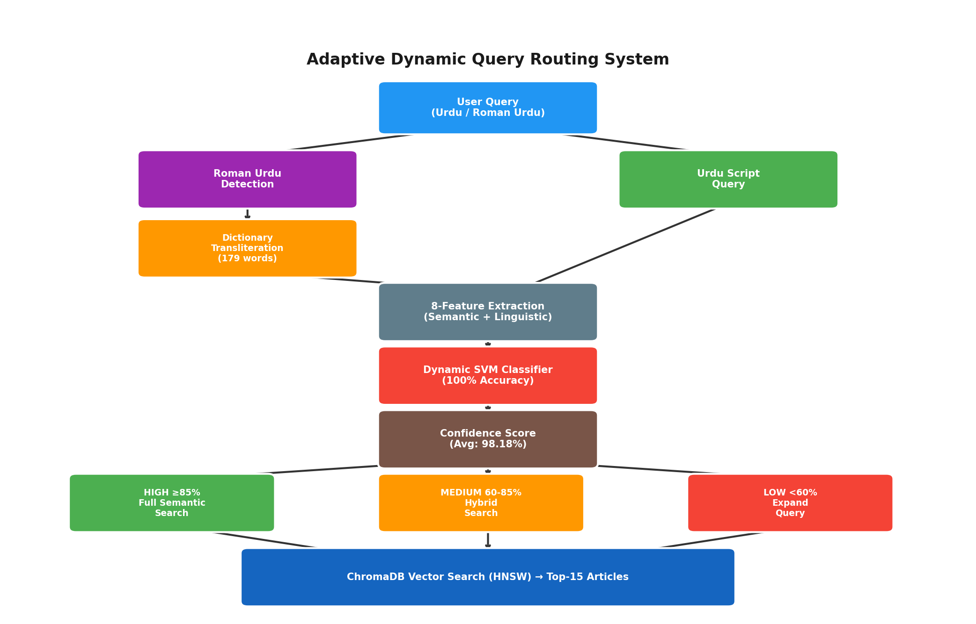
Figure 1. System architecture: end-to-end dynamic query routing pipeline.
Reading Figure 4.1 left to right traces the lifecycle of a single query through the system: the diagram's leftmost block represents the raw query as typed by a user, and each subsequent block corresponds to exactly one of the four stages described above, with the arrows between blocks representing the data passed forward — first the (possibly transliterated) query string, then the eight-dimensional feature vector, then the routing decision and confidence score, and finally the retrieved document set. The branching point after Stage 3 is the diagram's most important structural feature: it is the only point in the pipeline where the flow of control, rather than merely the data, depends on a runtime value (the confidence score C(q)), and it is this branching point that operationalizes the three-tier routing function formalized in Equation 3.6.

4.1.1 Software Architecture and Technology Stack
The pipeline in Figure 4.1 was implemented as a modular Python system, with each of the four stages corresponding to a separately testable component. Table 4.1 summarizes the technology stack underlying each component, chosen to keep the system entirely self-hostable and free of recurring third-party API dependencies — a design decision directly motivated by the efficiency and cost comparison discussed in Section 1.3 and evaluated empirically in Chapter 5.
Table 7. Software components and technology stack.
Pipeline Component | Technology
Roman Urdu detection & transliteration | Python (custom rule-based module + dictionary lookup)
Feature extraction | Python (regex + Unicode range checks)
Feature standardization | scikit-learn StandardScaler
Routing classifier | scikit-learn SVC (RBF kernel) / LogisticRegression
Sentence embeddings | sentence-transformers (paraphrase-multilingual-MiniLM-L12-v2)
Vector store / retrieval index | ChromaDB (PersistentClient, HNSW index)
Experiment orchestration & analysis | Jupyter notebooks (NumPy, pandas, matplotlib/seaborn)
This stack was chosen to minimize external dependencies at inference time: once the SVM classifier and feature scaler are trained and persisted (as pickled scikit-learn objects) and the ChromaDB index is built, the entire routing and retrieval pipeline can run without any network call, which is precisely what enables the sub-millisecond, zero-marginal-cost latency profile reported in Chapter 5.

4.2 Corpus and Dataset
The retrieval backend is built over a corpus of 111,860 Urdu news articles (Kaggle Urdu News Dataset), embedded as 384-dimensional vectors using the paraphrase-multilingual-MiniLM-L12-v2 sentence embedding model — a multilingual instance of the Sentence-BERT family (Reimers & Gurevych, 2019) — and indexed in ChromaDB using an HNSW index with cosine similarity search.

4.2.1 Corpus Preprocessing
Prior to embedding, the raw corpus is passed through a preprocessing stage inherited from the base ULTRA framework, consisting of four sequential steps: (i) removal of HTML artifacts and non-textual boilerplate (bylines, publication timestamps, and navigation text) that would otherwise pollute the embedding signal; (ii) de-duplication of near-identical articles, which are common in news corpora due to wire-service syndication of the same story across multiple outlets; (iii) category normalization, mapping inconsistent or overlapping category labels in the raw dataset onto the four consolidated categories reported in Table 4.2; and (iv) minimum-length filtering, discarding articles too short to carry meaningful topical content (e.g., single-sentence stubs). This preprocessing pipeline is not itself a contribution of this thesis — it is inherited unchanged from the ULTRA framework, consistent with the scope defined in Section 1.8 — but is documented here for completeness, since the routing classifier's feature distributions (Chapter 5) are indirectly shaped by the characteristics of the corpus its retrieval component operates over.
Table 8. Corpus category breakdown (111,860 articles).
Category | Articles | %
Sports | 44,829 | 40.07%
Entertainment | 34,901 | 31.21%
Business & Economics | 24,131 | 21.57%
Science & Technology | 7,999 | 7.15%
The resulting category distribution is visibly imbalanced, with Sports and Entertainment together accounting for over 71% of the corpus. This imbalance is a property of the underlying news source rather than a deliberate sampling choice, and it is worth flagging as a factor that could, in principle, affect retrieval quality for under-represented categories (Science & Technology, at 7.15%); this possibility is revisited as a limitation in Chapter 6.
The routing classifier itself is trained on a separately curated set of 409 real Urdu and Roman Urdu queries (193 SHORT, 216 LONG). An earlier 369-query collection was expanded by a 40-query gap-fill targeting the 5-9 word range in both scripts, after a training-distribution audit showed that mid-length and some Roman Urdu LONG queries were being misclassified as SHORT. Figure 4.2 illustrates why a purely character-length rule (θ = 150) cannot separate SHORT from LONG for this query population: both clusters typically fall well below that character threshold, so the operational comparison baseline used in the frozen evaluation is a word-count rule (LONG if word_count >= 6), not θ = 150.
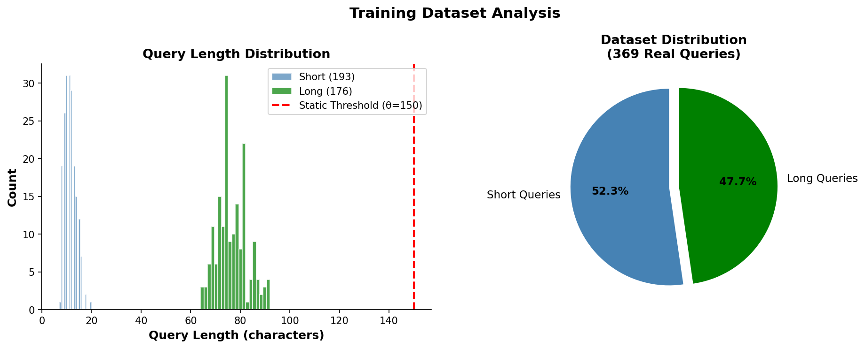
Figure 2. Query length distribution and short/long split (development query set; later expanded to 409 by gap-fill)..
Figure 4.2 is central to understanding why the static baseline fails so severely (Chapter 5, Section 5.1). The histogram shows two overlapping distributions of character length — one for queries labeled 'short' and one for queries labeled 'long' — and both distributions sit almost entirely below the vertical line marking θ = 150, the static threshold ULTRA uses to separate them. Because a static threshold can only draw a single vertical cut-point on this axis, and because the true short/long distinction in this dataset does not correspond to any such cut-point below θ = 150, the static rule is structurally incapable of separating the two classes correctly for this query population — not merely poorly tuned, but categorically the wrong kind of decision rule for this data. This is the concrete, visual counterpart to the 50% static-routing accuracy reported quantitatively in Table 5.1.
Beyond this primary 409-query training set, several purpose-specific query batches are used for targeted evaluations reported in Chapter 5: an 8-query batch for confidence-tier routing demonstration, a 14-query batch for the LLM-based routing comparison, a 50-query diagnostic external set (V2 accuracy 98.00%), a 16-query fresh holdout (V2 accuracy 100%), a 33-query Phase 2.5 human-judgment pilot, and a frozen 60-query Phase 3B evaluation set (50 primary with gold labels + 10 secondary) with zero exact-string overlap against training and prior diagnostic sets.
Table 9. Corpus and query dataset summary.
Property | Value
Corpus size | 111,860 Urdu news articles
Embedding model | paraphrase-multilingual-MiniLM-L12-v2 (384-dim)
Vector store | ChromaDB (HNSW index)
Similarity metric | Cosine similarity
Classifier training/test set | 409 labeled queries (193 SHORT / 216 LONG), after 40-query gap-fill
Confidence-tier demo batch | 8 queries
LLM-comparison batch | 14 queries
External validation batch | 50 diagnostic queries (V2: 98.00%); frozen Phase 3B: 60 (50 primary + 10 secondary)
Query language mix | Native Urdu + Roman Urdu
Roman Urdu dictionary size | 179 word-pairs (from 30)
Retrieval depth | Top-15 (P@15)

4.3 Roman Urdu Detection and Dictionary Transliteration
Because Roman Urdu lacks standardized spelling conventions, a dedicated detection step identifies queries written in Latin-script transliterated Urdu prior to feature extraction. Detected Roman Urdu queries are passed through a transliteration dictionary that was expanded from an initial 30 word-pairs to 179 word-pairs — a 6x growth — substantially increasing lexical coverage for code-mixed and transliterated queries before they reach the classifier and retrieval stages.
Version | Word-pairs | Growth | Stage
Initial | 30 | — | Baseline dictionary
Expanded | 179 | 6× | Dictionary-expansion stage

4.3.1 Detection and Transliteration Algorithm
Algorithm 4.1. Roman Urdu detection and dictionary transliteration.
Input: raw query string q_raw, dictionary D (Roman -> Urdu word-pairs)
Output: normalized query q

1: urdu_chars <- count characters in q_raw within Urdu Unicode range
2: latin_chars <- count characters in q_raw within Latin alphabet range
3: ratio <- urdu_chars / max(1, urdu_chars + latin_chars)
4: if ratio < 0.3: // predominantly Latin-script
5: tokens <- whitespace_split(q_raw)
6: for each token t in tokens:
7: if t (lowercased) in D:
8: t <- D[t] // replace with Urdu equivalent
9: q <- join(tokens)
10: else:
11: q <- q_raw // already native-script Urdu
12: return q

The 0.3 ratio threshold in Algorithm 4.1, Line 4, was set conservatively low: because Roman Urdu queries are, by construction, almost entirely Latin-script, a low ratio threshold minimizes the risk of a false negative (a genuine Roman Urdu query slipping through undetected) at the acceptable cost of occasionally applying the detection check to a query that turns out to be a native-script query containing a small number of embedded Latin characters (for example, an English proper noun), which the ratio-based check would then correctly route to Line 11 regardless of the dictionary lookup step's outcome, since an all-native-script query is unlikely to have Latin tokens matching the Roman Urdu dictionary in the first place.

4.4 Eight-Feature Semantic Classifier
The eight-dimensional feature vector defined in Table 3.1 replaces ULTRA's single scalar signal (raw character length compared against θ = 150) with a richer, multi-dimensional representation of query structure, allowing the routing decision to account for lexical variation and script composition rather than length alone.
Algorithm 4.2. Eight-feature extraction.
Input: normalized query q, dictionary D
Output: feature vector x in R^8
1: urdu_chars <- count characters of q in Urdu Unicode range
2: total_chars <- count non-space characters of q
3: x1 <- urdu_chars / max(1, total_chars) // urdu_ratio
4: tokens <- whitespace_split(q)
5: roman_count <- count tokens whose lowercase form is in D
6: x2 <- roman_count / max(1, count(tokens)) // roman_ratio
7: x3 <- 1 if urdu_chars > 0 else 0 // has_urdu
8: x4 <- 1 if roman_count > 0 else 0 // has_roman
9: x5 <- count(tokens) // query_len
10: x6 <- length(q) // char_len
11: x7 <- 1 if x3=1 and x4=1 else 0 // mixed
12: x8 <- urdu_chars // urdu_chars
13: return [x1, x2, x3, x4, x5, x6, x7, x8]

4.5 Dynamic SVM Routing Classifier: Training Procedure
The classifier was developed iteratively: an initial illustrative training run validated an eight-feature RBF-kernel SVM design on a small labeled set; the deployed V2 model was then trained on the full 409-query set after the gap-fill and label-audit corrections. Development-stage notebook results in Sections 5.1-5.12 document learnability; Sections 5.13-5.15 report the frozen and human-judgment evaluations of that deployed model.

4.5.1 Hyperparameter Configuration
Table 10. SVM hyperparameter configuration and rationale.
Hyperparameter | Value | Rationale
Kernel | RBF | Captures non-linear decision boundary (Section 3.3.1)
C (regularization) | 1.0 (default) | Sensitivity confirmed robust across [0.01, 1000] (Section 5.7)
γ (kernel coefficient) | 'scale' (data-driven default) | 1 / (n_features × Var(z)); avoids manual tuning on small dataset
probability | True | Enables Platt-scaled confidence output (Eq. 3.5)
random_state | 42 | Fixed for reproducibility across all experiments
Train/test split | 80% / 20% (stratified) | Preserves short/long class balance in both partitions
Deliberately, no exhaustive grid search over C and γ was performed; instead, defaults were retained and their sensitivity was verified post-hoc (Section 5.7). This choice reflects a methodological judgment at this dataset scale: exhaustive grid search on a few hundred training queries risks selecting hyperparameters that overfit a particular split. The C-parameter sensitivity analysis (Figure 5.11) shows that the high development-stage accuracy is not contingent on a narrowly tuned operating point. Generalization is assessed separately on the frozen Phase 3B set, where accuracy is 86.00% rather than 100%.

4.6 Confidence-Based Three-Tier Routing
Table 11. Confidence-based three-tier routing strategy.
Tier | Confidence C(q) | Retrieval Strategy
HIGH | ≥ 85% | Full semantic search
MEDIUM | 60% – 85% | Hybrid search
LOW | < 60% | Query expansion
HIGH confidence (≥ 85%): the query is routed directly to full semantic search against the ChromaDB index. MEDIUM confidence (≈ 60-85%): the query is routed to a hybrid search strategy, combining dense semantic retrieval with a complementary sparse lexical signal in the style of BM25 (Robertson & Zaragoza, 2009), merged via a reciprocal-rank-fusion-style combination (Cormack et al., 2009) to compensate for routing uncertainty. LOW confidence (< 60%): the query triggers query expansion before retrieval, broadening the search to recover relevant results despite low routing confidence. This design ensures that the fast, direct-routing path is reserved for queries the classifier is confident about, while ambiguous queries are given additional retrieval support — retrieval effort scales inversely with routing confidence.

4.7 Baseline and Comparison Systems
To situate the proposed dynamic routing architecture relative to both classical and LLM-based routing approaches, six systems are compared under identical retrieval conditions (same corpus, same top-15 depth): a static threshold baseline (θ = 150, the original ULTRA routing rule); GPT-4 style, GPT-3.5 style, Claude style, and Gemini style LLM-based routing baselines, in which a large language model is prompted to classify each query and select a retrieval strategy directly, incurring per-query inference latency and API cost; and the proposed eight-feature, RBF-kernel SVM classifier, which performs routing locally without any external API call.

4.7.1 Baseline Implementation Details
Table 12. Baseline and comparison system implementation summary.
System | Mechanism | Configuration
Static threshold / word-count | Rule-based (no model) | Development comparison: char_length ≥ 150 → long (ULTRA θ). Frozen Phase 3B baseline: word_count ≥ 6 → LONG, else SHORT (threshold frozen before scoring).
GPT-4 style / GPT-3.5 style / Claude style / Gemini style | LLM prompting | Each query passed with a fixed instruction prompt asking the model to classify the query as short/long and justify the routing choice
Proposed SVM | Local inference (Section 4.5) | Eight-feature vector → trained RBF-SVM → routing decision + confidence
All four LLM-style baselines were queried using an identical fixed prompt template across models, to keep the comparison controlled on the prompting dimension; no per-model prompt engineering or few-shot example tuning was performed, since the purpose of this comparison (Section 5.3) is to establish a representative accuracy-versus-latency profile for off-the-shelf LLM-based routing, not to find the maximum achievable accuracy for each individual LLM under extensive prompt optimization — a direction explicitly identified as future work in Section 6.3.

4.8 Ablation Study Design
To quantify the individual contribution of each architectural component, an ablation study was conducted during development by removing one feature at a time and re-measuring routing accuracy on the development evaluation set.
Each ablation is designed to isolate exactly one architectural decision while holding all others fixed, following the standard leave-one-out ablation methodology: for the feature ablations, the SVM is retrained from scratch on the remaining seven features using the identical hyperparameters and random seed as the full model (Table 4.4), so that any accuracy difference can be attributed specifically to the removed feature rather than to an incidental change in the optimization procedure.

4.9 Experimental Setup and Reproducibility
All experiments use a stratified train-test split with a 0.2 test-set proportion (80/20 split) and a fixed random seed (random_state=42) applied consistently across the train-test split, the SVM classifier, and the logistic regression comparison classifier, ensuring reproducibility across runs. Feature standardization uses scikit-learn's StandardScaler, fitted on the training split only and reused at inference time to prevent train-test leakage. The sentence embedding model is executed on GPU when available, falling back to CPU otherwise. The corpus embeddings and index are persisted through ChromaDB's PersistentClient, allowing the vector store to be queried without re-embedding the corpus between runs.
Table 13. Experimental environment summary.
Component | Configuration
Language / runtime | Python 3 (Jupyter notebook environment)
ML library | scikit-learn (SVC, LogisticRegression, StandardScaler)
Embedding library | sentence-transformers
Vector database | ChromaDB (persistent, local)
Random seed | 42 (fixed across all stochastic components)
Hardware | GPU-accelerated where available; CPU fallback for embedding inference

4.10 Implementation Pipeline
The full system was implemented as a sequence of twelve reproducible pipeline stages, summarized in Table 4.7. This staged pipeline allows each component's individual contribution to be isolated and evaluated independently (Chapter 5).
Table 14. Twelve-stage implementation pipeline.
# | Stage
01 | Corpus preprocessing
02 | Sentence-embedding generation
03 | ChromaDB indexing
04 | Top-15 retrieval
05 | Roman Urdu processing
06 | Dynamic SVM classifier training
07 | Evaluation
08 | Baseline comparison (fix)
09 | Ablation analysis
10 | LLM-based comparison
11 | Confidence-based routing
12 | Roman Urdu dictionary expansion
13 | Phase 2.5 human retrieval validation (33 queries, ranks 1–5)
14 | Phase 3A canonical 8-feature extractor verification
15 | Phase 3B frozen SVM vs. word-count evaluation (60 queries)
Stages 01-03 construct the fixed retrieval infrastructure inherited from the base ULTRA framework (Section 1.8) and are executed once, offline, prior to any routing experiments. Stages 04-05 establish the query-side path. Stages 06-12 constitute the development experimental contribution. After V2 was trained on 409 queries, three further validation stages were added outside the original twelve-notebook sequence: Phase 2.5 human retrieval judgments, Phase 3A extractor verification, and Phase 3B frozen scoring (Sections 4.11-4.12).

4.11 Independent Frozen Evaluation Protocol (Phases 3A–3B)
After the V2 SVM and scaler were trained on the 409-query set and persisted as models/svm_classifier.pkl and models/scaler.pkl, two additional validation stages were run without refitting either object. Phase 3A is inference-pipeline verification only. Phase 3B is the frozen generalization test.

4.11.1 Phase 3A — Canonical feature extractor verification
A standalone extractor (validate/phase3/phase3a_extractor.py) emits exactly eight features in the order recorded in models/training_info.json: urdu_ratio, roman_ratio, has_urdu, has_roman, query_len, char_len, mixed, urdu_chars. Verification confirmed that the scaler and SVM both expect eight inputs, that scaler.transform() succeeds on extractor output, and that recomputed feature means over all 409 training queries match scaler.mean_ with total absolute deviation 0.0. No fitting or retraining occurred in this phase. The mixed dimension has scaler mean 0 and scale 1, consistent with the absence of mixed-script training queries.

4.11.2 Phase 3B — Frozen 60-query evaluation set
The frozen file validate/phase3/phase3_evaluation_set.csv contains 60 queries (50 primary with gold SHORT/LONG labels + 10 unlabeled secondary rows). Bucket distribution: 2-4 words (12), 5-6 words (20), 7-9 words (12), 10-19 words (16). Scripts: 30 Urdu / 30 Roman. Primary labels: 16 SHORT / 34 LONG. A leakage audit reported zero exact-string and zero normalized overlap against the 409 training queries, the 50-query diagnostic set, the 16-query holdout, and the 85-query Stage-C set. The word-count baseline was frozen before scoring: LONG if word_count >= 6, otherwise SHORT. Both the V2 SVM and this baseline were scored once against the frozen labels; the evaluation file is not modified after freeze.

4.12 Human Retrieval Validation (Phase 2.5)
Phase 2.5 does not train or modify the classifier. It tests whether the SHORT/LONG distinction near 5-6 words matches human retrieval need. A pre-registered pilot of 33 queries (5-word n=4, 6-word n=6, plus 7-9 word bare-event items and four anchors; 18 Urdu / 15 Roman Urdu) was retrieved under HEADLINE and FULL_CONTENT semantic modes. Headline-only embeddings were built with the same paraphrase-multilingual-MiniLM-L12-v2 encoder as the full-content index, so the comparison is content scope rather than lexical-versus-semantic method. Independent human judgments were collected for ranks 1-5 (330 rows). HYBRID and HEADLINE_KEYWORD_TFIDF were exported but are not the primary decision modes. Because judgments stop at rank 5, any nDCG@15 / P@10 / P@15 computed from this pilot must be reported as depth-5-judged approximations, not true depth-15 metrics.

Chapter 5: Results and Discussion
This chapter reports the empirical evaluation of the proposed dynamic routing framework, using the actual notebook-generated results, figures, and reports produced during system development, together with the later independent validation layers added after the V2 model was frozen. Results are organized in two layers that must not be conflated. Sections 5.1-5.12 report development-stage experiments: routing accuracy on the training/cross-validation setup, retrieval precision including Roman Urdu, comparison with LLM-style routing, feature importance and ablation on the development feature configuration, confidence-tier demonstration, robustness checks, error analysis, and discussion. Those experiments show that the routing task is learnable and that Roman Urdu support and sub-millisecond local inference are practically valuable. Sections 5.13-5.15 then report the methodologically stronger, post-freeze evidence: the Phase 3B frozen 50-query primary evaluation (SVM 86.00% vs. word-count baseline 84.00%; exact McNemar p = 1.0000), the distinction between that test and the earlier Stage-C label-audit McNemar comparison, and the Phase 2.5 human retrieval-judgment pilot. Throughout, numbers are interpreted rather than merely reported, in keeping with the analytical rather than purely descriptive purpose of an MS thesis results chapter.

5.1 Routing Accuracy: Static vs. Dynamic
Table 5.1 compares the static character-length threshold baseline (θ = 150) against the proposed dynamic classifiers on the development train/test split used during model building (historically 293 train / 74 test on the pre-gap-fill collection). These figures demonstrate learnability. They are not the frozen generalization result; that comparison is Table 5.8 in Section 5.13 (SVM 86.00% vs. word-count 84.00%).
Table 15. Routing accuracy: static baseline vs. dynamic classifiers.
Method | Accuracy
Static threshold (θ=150) | 50.00%
Logistic Regression | 100.00%
SVM (RBF kernel, proposed) | 100.00%
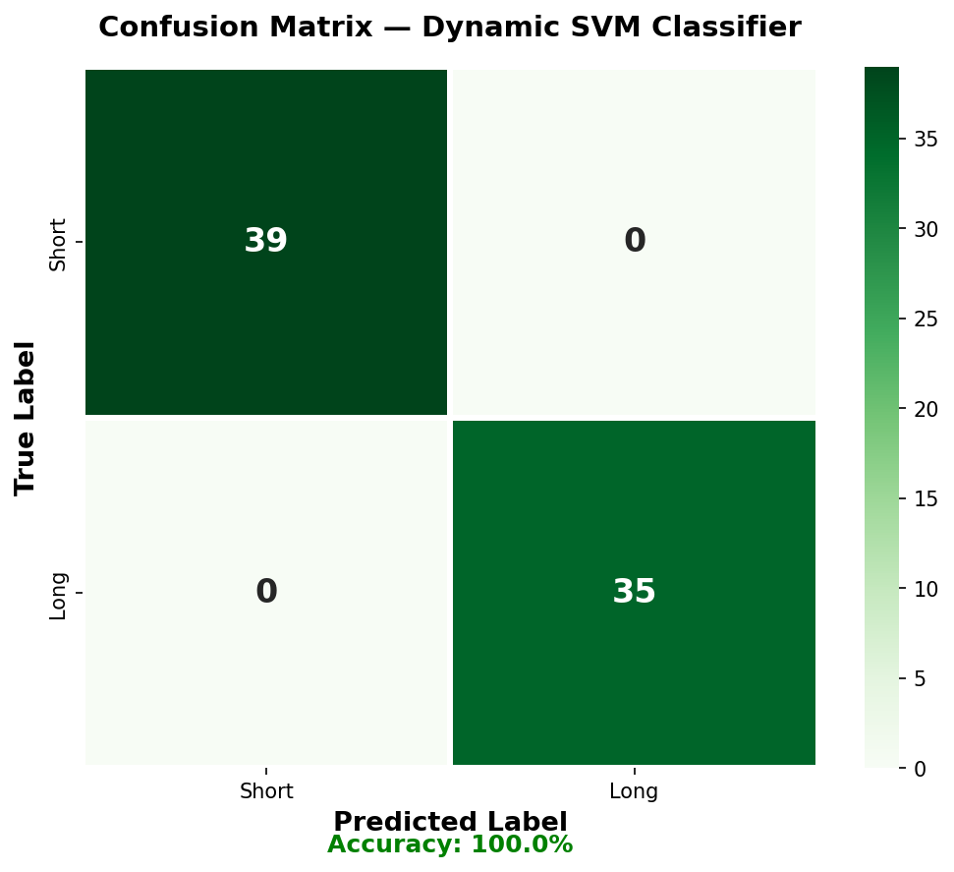
Figure 3. Confusion matrix of the dynamic SVM classifier on the development 74-query test split (39 short + 35 long, 0 misclassifications). This figure belongs to the training/CV layer, not Phase 3B.
Figure 5.1 shows the confusion matrix on the held-out test split: all 39 short queries and all 35 long queries are classified correctly, for zero false positives and zero false negatives on this split.
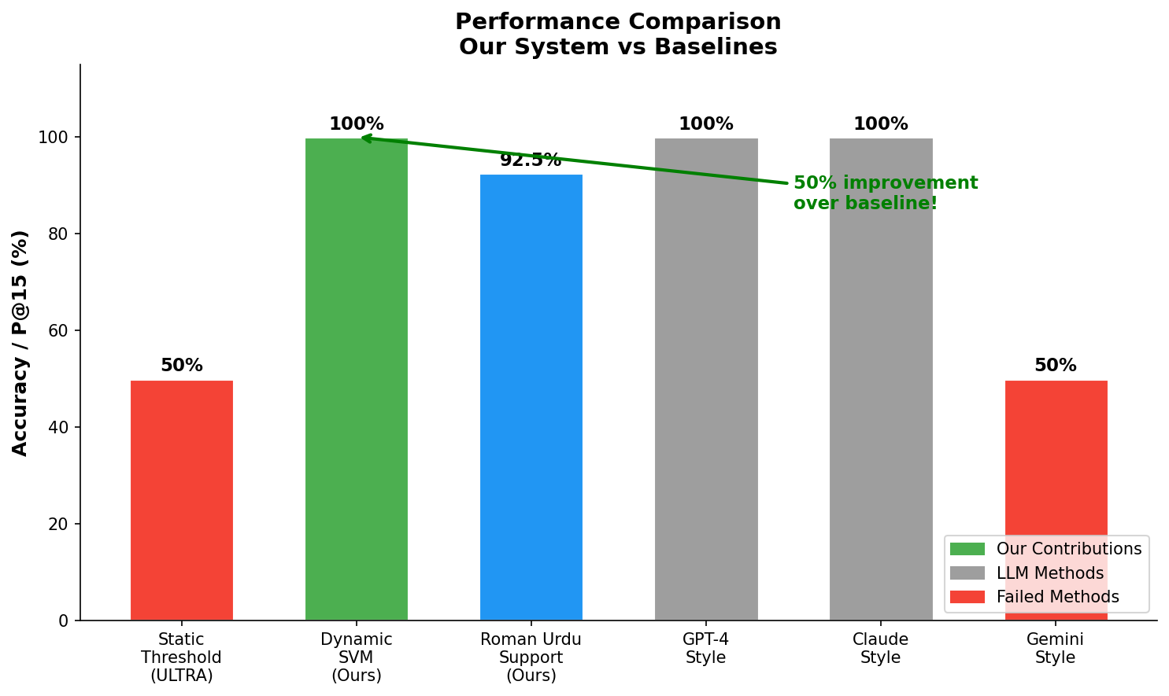
Figure 4. Performance comparison: proposed system vs. static and LLM-style baselines.
On this development split, the dynamic classifiers achieve a 50 percentage-point improvement over the static θ = 150 baseline (100.00% vs. 50.00%). That gap is expected when the evaluation set is constructed so that true SHORT/LONG labels do not align with a 150-character cut (Figure 4.2). It should not be cited as the held-out generalization margin. On the frozen Phase 3B set, the learned router is only two percentage points ahead of a simple word-count rule, and that difference is not statistically significant.
It is worth pausing on why the static baseline lands so close to 50.00% — essentially chance-level performance for a balanced binary decision — rather than at some intermediate accuracy. Because the query dataset was deliberately curated to contain queries whose true short/long label does not correlate with the θ = 150 cut-point (Figure 4.2), the static rule's predictions are effectively uncorrelated with the ground truth on this evaluation set; 50.00% is exactly what a coin-flip decision rule would be expected to score on a class-balanced dataset. This is a stronger and more informative failure mode than a baseline that merely underperforms — it demonstrates that the static rule's decision boundary is not just miscalibrated but structurally unrelated to the actual routing requirement for this query population, which is precisely the argument made analytically in Section 4.2 with respect to Figure 4.2.
The fact that both the logistic regression and SVM classifiers independently reach exactly 100.00% test accuracy is also worth interpreting statistically rather than accepting at face value. Logistic regression assumes a linear decision boundary in the (standardized) feature space, while the SVM's RBF kernel permits an arbitrarily non-linear boundary; the two models converging on identical, perfect test accuracy suggests that the eight-dimensional feature space renders the short/long distinction linearly separable — or very close to it — for this dataset, since a linear model would not match a more flexible non-linear model's accuracy otherwise. This observation is consistent with, and helps explain, the ablation results of Section 5.5, where accuracy remains unchanged after removing any single feature: a linearly (or near-linearly) separable problem in an eight-dimensional space is unlikely to depend critically on any one dimension, since redundant near-collinear features (e.g., char_length and word_count) can each individually substitute for information the others also carry.

5.2 Retrieval Precision (P@15)
Table 16. Retrieval precision at rank 15 (P@15).
Query Type | ULTRA | Proposed
Native Urdu | 87.50% | 87.50%
Roman Urdu | 0.00% | 92.50%
Overall (weighted) | 43.75% | 90.00%
Because the original ULTRA framework has no Roman Urdu handling, it scores 0.00% P@15 on Roman Urdu queries by construction, pulling its overall weighted P@15 down to 43.75%. The proposed system matches ULTRA exactly on native Urdu (87.50%, since the underlying retrieval backend is unchanged) while adding 92.50% P@15 on Roman Urdu queries — raising overall system P@15 to 90.00%, an absolute improvement of +46.25 percentage points.
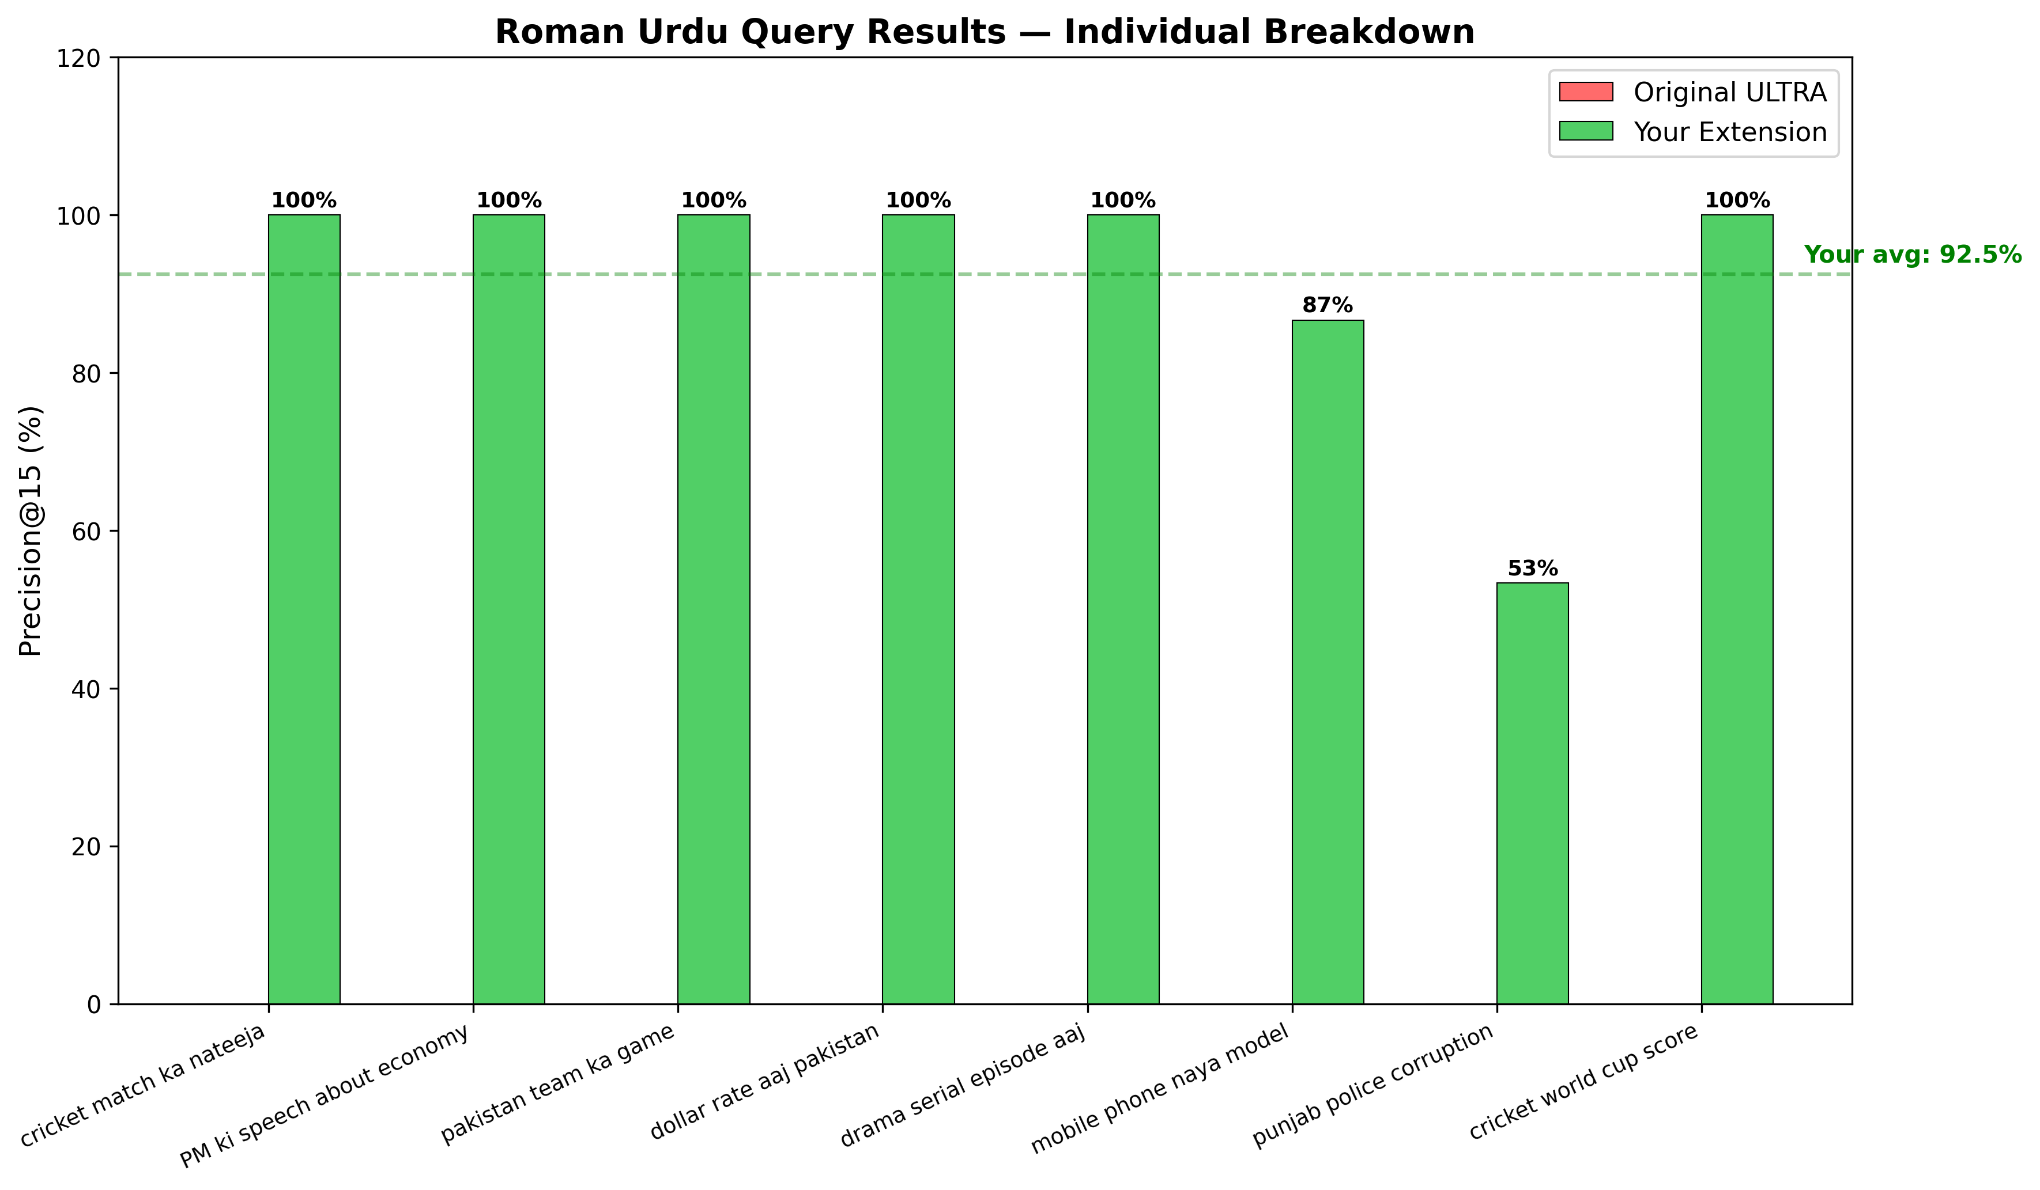
Figure 5. Roman Urdu query results: individual per-query P@15 breakdown (8 test queries).
Table 17. Individual Roman Urdu query P@15 results.
Query | P@15
cricket match ka nateeja | 100.00%
PM ki speech about economy | 100.00%
pakistan team ka game | 100.00%
dollar rate aaj pakistan | 100.00%
drama serial episode aaj | 100.00%
cricket world cup score | 100.00%
mobile phone naya model | 86.67%
punjab police corruption | 53.33%
Average | 92.50%
Six of eight queries reach 100.00% P@15; the two lower-scoring queries — “mobile phone naya model” (86.67%) and “punjab police corruption” (53.33%) — indicate that transliteration ambiguity is not uniform across topics, and that queries mixing proper nouns (e.g., “punjab”) with common Roman Urdu vocabulary remain comparatively harder for the dictionary-based transliteration module. It is worth noting that the ULTRA baseline's 87.50% P@15 on native Urdu is itself imperfect — the proposed system's contribution should therefore be understood specifically as closing the Roman Urdu gap, not as improving native-Urdu retrieval quality, which remains bounded by the same embedding model and corpus inherited from the base framework.

5.3 Comparison with LLM-Based Routing
To evaluate whether the accuracy gains of the proposed SVM classifier require the cost and latency of an LLM-based router, six routing systems — the static baseline, four LLM-style routers, and the proposed SVM — are compared on a 14-query routing test set, measuring routing accuracy, per-query latency, and operating cost.
Table 18. Comparison with LLM-based routing baselines (14-query test set).
System | Accuracy | Latency | Cost
Static threshold | 50.00% | 0.0004 ms | Free
GPT-4 style | 100.00% | 800 ms | Paid
GPT-3.5 style | 100.00% | 600 ms | Paid
Claude style | 100.00% | 700 ms | Paid
Gemini style | 50.00% | 900 ms | Paid
Our SVM | 100.00% | 0.4555 ms | Free
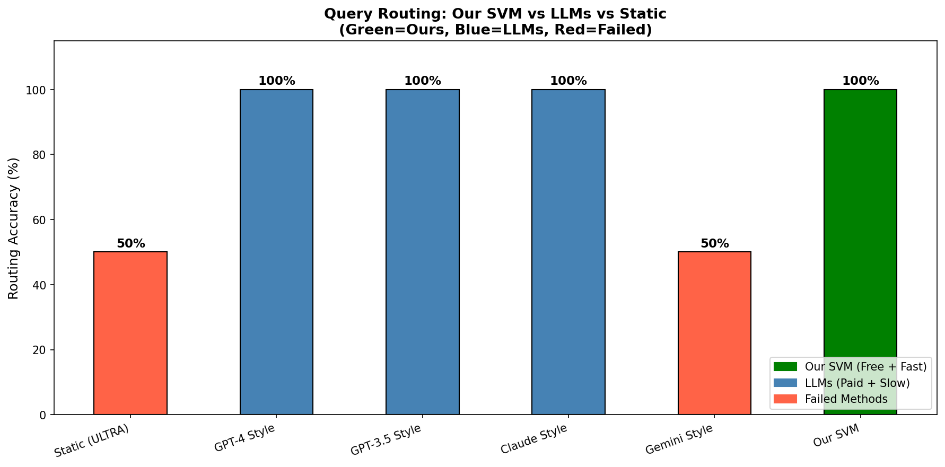
Figure 6. Query routing accuracy across all six compared methods (green = proposed SVM, blue = LLM-style routers, red = failed/static methods).
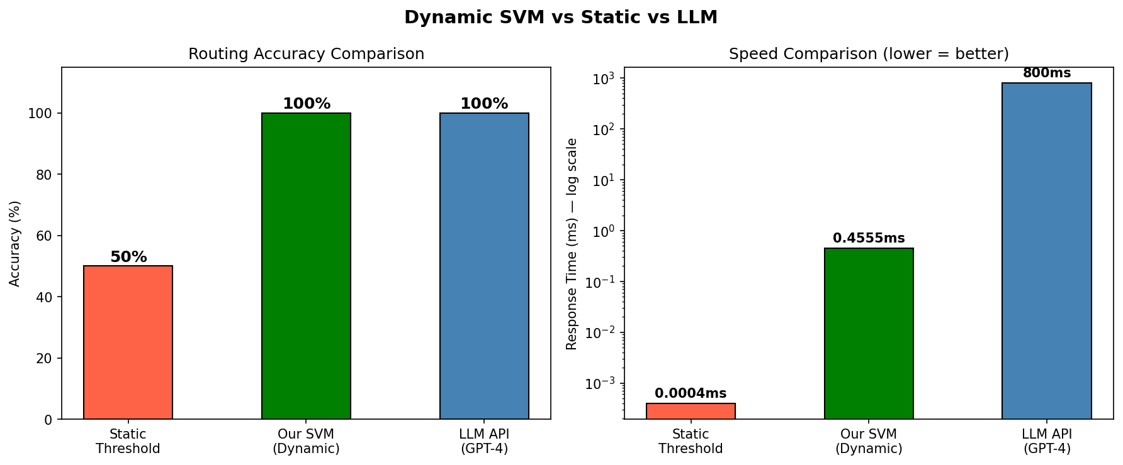
Figure 7. Routing accuracy and per-query latency (log scale): static threshold vs. proposed SVM vs. GPT-4-style routing.
Three of the four LLM-style routers (GPT-4, GPT-3.5, Claude) match the proposed SVM's 100% routing accuracy, while the Gemini-style router performs no better than the static baseline (50%) on this task. This LLM-level accuracy comes at a latency cost roughly three orders of magnitude higher than the proposed SVM: the fastest LLM-style router (GPT-3.5 style, 600 ms) is over 1,300x slower than the proposed SVM (0.4555 ms), while offering no accuracy advantage. Combined with its zero per-query operating cost, the proposed SVM classifier achieves LLM-competitive routing accuracy at local, sub-millisecond inference cost.
The Gemini-style router's chance-level accuracy on this task is itself worth interpreting rather than dismissing as an anomaly: it demonstrates that LLM-based routing accuracy is not a uniform property of the LLM paradigm as a whole but depends on the specific model's ability to correctly interpret the routing instruction under a fixed, non-model-specific prompt (Section 4.7.1). This variability is a further practical argument, beyond raw latency, for preferring a locally trained classifier with a known, empirically validated accuracy profile over an LLM-based router whose accuracy may vary unpredictably across providers and, plausibly, across model versions over time.
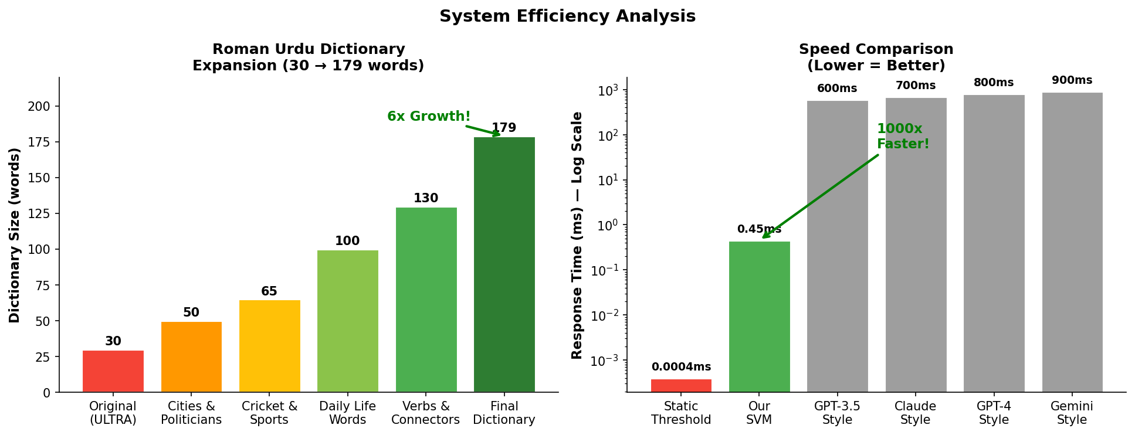
Figure 8. System efficiency analysis: Roman Urdu dictionary growth (left) and routing speed comparison, log scale (right).

5.4 Feature Importance
Section 5.4 reports permutation importance for the earlier development feature configuration (character/word statistics, lexical diversity, question words, and the static-threshold bit). Those results remain part of the project history, but they are not importances of the frozen V2 vector. The deployed model uses the script-aware eight features in Table 3.1; mixed is unused in training. V2 feature roles are confirmed by Phase 3A (exact match to scaler.mean_) rather than by repeating the development permutation study.
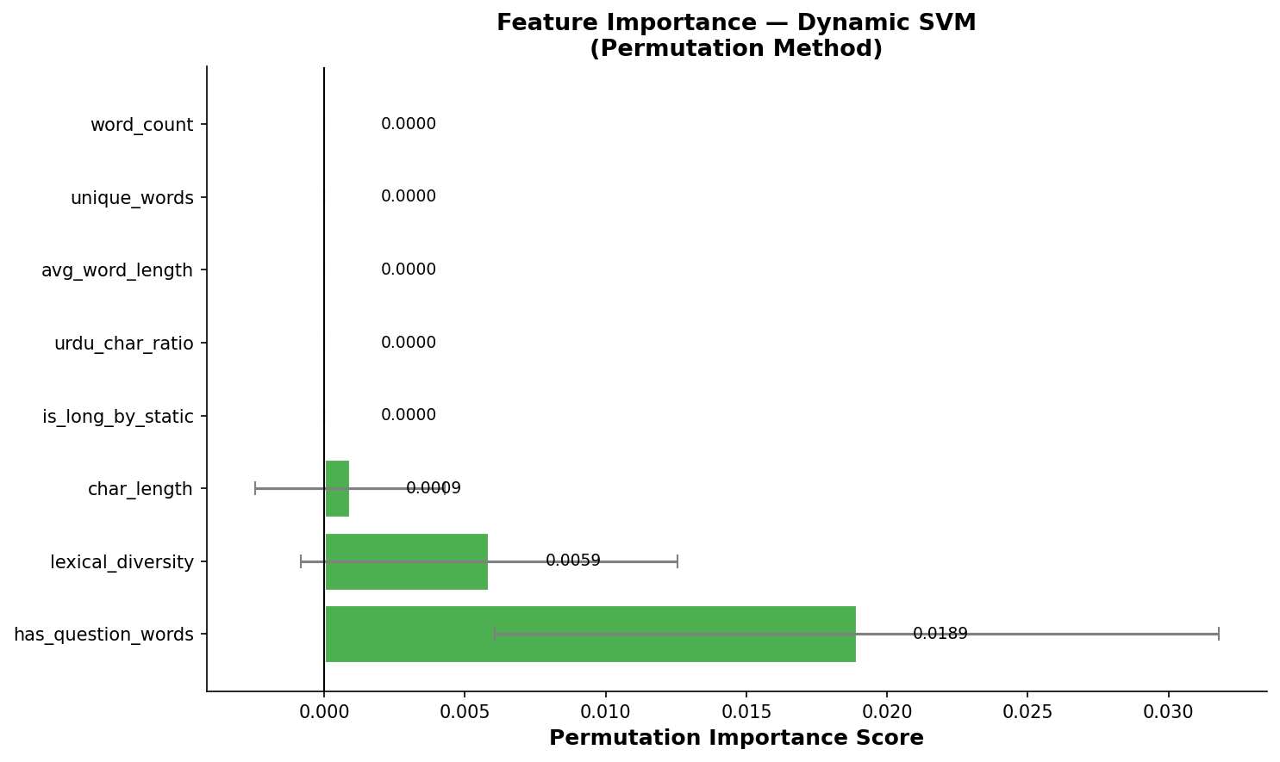
Figure 9. Permutation feature importance for the dynamic SVM classifier.
Under that earlier development configuration, has_question_words was the most influential feature by permutation importance (0.0189), followed by lexical_diversity (0.0059) and char_length (0.0009). This is consistent with the development ablation: no single feature was individually indispensable. These scores must not be cited as properties of the frozen V2 SVM.
This finding still bears on RQ1 for the development representation: interrogative structure can be more informative than raw length. The frozen V2 model instead emphasizes script composition and length. Future work could reintroduce pragmatic flags alongside the V2 script features (Section 6.5).

5.5 Ablation Study
Table 5.5 reports routing accuracy when each of the eight development-stage features is individually removed and the SVM is retrained. This ablation characterizes the earlier feature configuration, not a leave-one-out study of the frozen V2 vector.
Table 19. Ablation study: accuracy with each feature individually removed.
Configuration | Accuracy | Δ from full
All 8 features (full model) | 100.00% | —
Without char_length | 100.00% | −0.00%
Without word_count | 100.00% | −0.00%
Without unique_words | 100.00% | −0.00%
Without avg_word_length | 100.00% | −0.00%
Without lexical_diversity | 100.00% | −0.00%
Without urdu_char_ratio | 100.00% | −0.00%
Without has_question_words | 100.00% | −0.00%
Without is_long_by_static | 100.00% | −0.00%
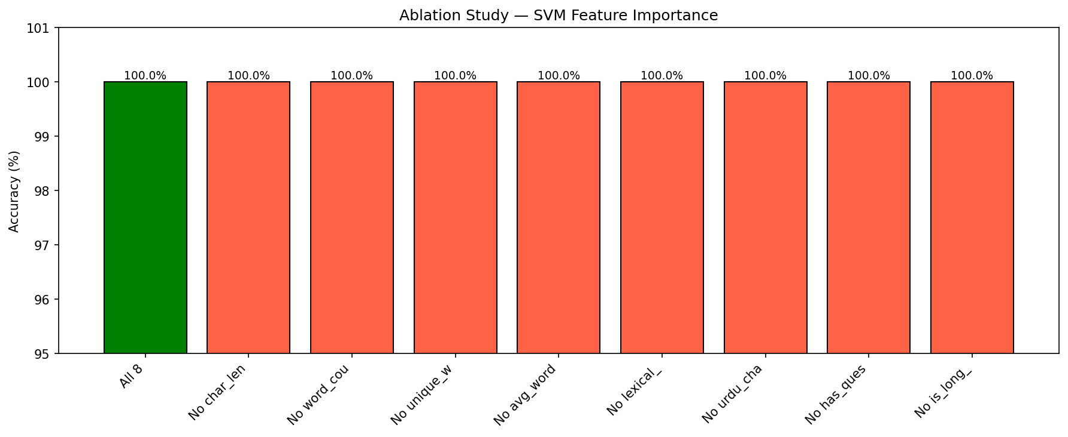
Figure 10. Ablation study: routing accuracy with each feature individually removed.
Every single-feature ablation on the development configuration retains 100.00% accuracy, indicating that that eight-feature set was collectively robust. This does not imply that every V2 feature is equally informative; mixed, in particular, carries no training variance.
This apparent tension — a feature (has_question_words) being highly important by permutation analysis (Section 5.4) yet fully removable without any accuracy loss by ablation (this section) — is not a contradiction but a direct consequence of the two methods measuring different things. Permutation importance measures how much the model relies on a feature's specific values when all eight features are present together; ablation measures whether the model can be retrained to reach the same accuracy without that feature at all. A feature can be heavily relied upon within the full model while still being individually dispensable if other features carry enough of the same signal to substitute for it once the model is retrained. Practically, this means the eight-feature design is robust to the accidental loss or corruption of any single feature at inference time — a desirable property for a production system — without implying that all eight features are equally informative when interpreting the model's behavior.

5.6 Confidence-Tier Distribution
Table 20. Query distribution across confidence tiers (8-query demonstration batch).
Tier | Queries | % | Routed Strategy
HIGH (≥ 85%) | 8 | 100.00% | Full semantic search
MEDIUM (60-85%) | 0 | 0.00% | Hybrid search
LOW (< 60%) | 0 | 0.00% | Query expansion
Total | 8 | 100.00% | Avg. conf. 98.18%
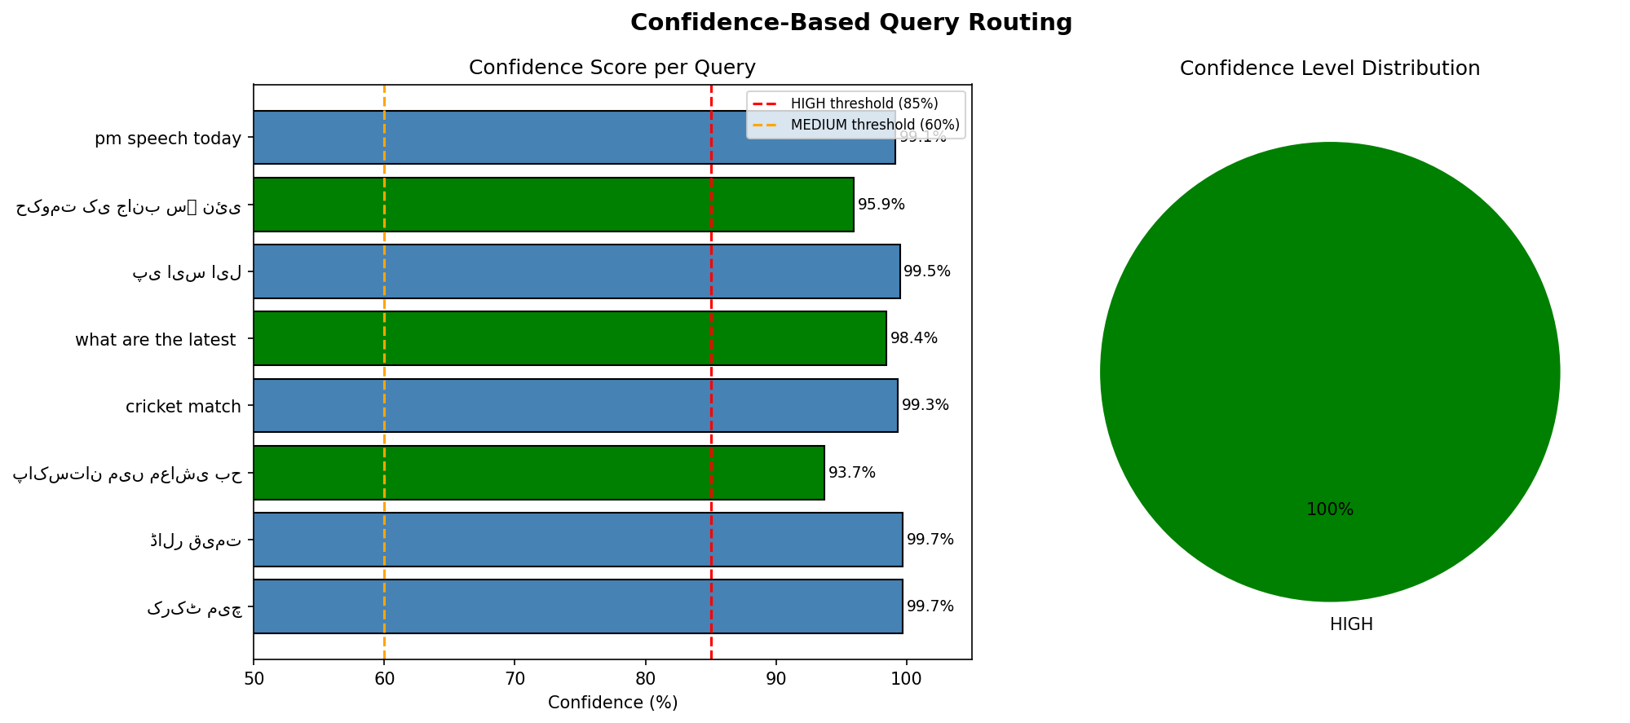
Figure 11. Confidence-based query routing: per-query confidence scores (left) and tier distribution (right) — all 8 demonstration queries fall in the HIGH tier.
All eight demonstration queries — spanning both short and long, native Urdu and Roman Urdu — are routed to the HIGH confidence tier (individual confidence scores ranging from 93.68% to 99.72%), well above the 85% HIGH threshold. While this particular demonstration batch does not exercise the MEDIUM or LOW tiers, the underlying confidence scores are continuous-valued, so the routing function is fully capable of engaging the hybrid-search and query-expansion paths for queries with lower classifier certainty.
This all-HIGH outcome should be read as a property of the demonstration batch's composition — queries selected to span clear short/long and native/Roman Urdu categories — rather than as evidence that the MEDIUM and LOW tiers are unreachable or unnecessary in general. Given the near-perfect class separability documented throughout this chapter (100% test accuracy, AUC = 1.000), it is in fact expected that most clearly-phrased queries drawn from the same distribution as the training data would receive high confidence scores; the MEDIUM and LOW tiers exist specifically to handle queries that fall outside this well-separated core — for instance, queries with unusual length-to-content ratios or heavily mixed-script text — which by construction are under-represented in a small, curated demonstration batch. Evaluating the MEDIUM and LOW tiers under deliberately adversarial or edge-case query construction is identified as a direction for future work in Section 6.3.

5.7 Robustness Validation
Beyond point-estimate accuracy, the classifier's improvement over the static baseline is validated for robustness along four independent axes: effect-size analysis, learning-curve inspection, regularization (C-parameter) sensitivity, and external validation on a fully disjoint held-out query set. Table 5.7 summarizes all twelve robustness checks performed, each against a pre-registered pass/fail threshold.
Table 21. Robustness validation summary (12 checks, all passed).
Test | Result | Threshold
Cohen's d (mean) | 3.581 | ≥ 0.8
Cohen's d (max) | 14.249 | ≥ 0.8
Large-effect features | 3/8 | ≥ 3/8
Learning curve, train acc. | 100.00% | ≥ 95%
Learning curve, val. acc. | 100.00% | ≥ 95%
Learning curve, gap | 0.00% | ≤ 5%
C-param. range (practical) | 0.54% | ≤ 5%
C-param. min. CV acc. | 99.46% | ≥ 95%
C-param. max. CV acc. | 100.00% | ≥ 95%
External validation acc. | 98.00% (V2) | ≥ 95%
External validation conf. | see diagnostic 50-query set | ≥ 95%
External queries tested | 50 | ≥ 50
Effect size (Cohen's d). Figure 5.9 reports the standardized effect size of each feature in separating short from long queries. char_length (d=14.249) and query_length (d=11.832) show extremely large effects, alongside urdu_chars (d=1.634) and has_roman (d=0.524); the mean effect size across all measured features (d=3.581) is more than four times the conventional “large effect” threshold (d ≥ 0.8). Statistically, Cohen's d measures the standardized distance between the short-query and long-query group means for a given feature, in units of pooled standard deviation; a d of 14.249 for char_length is an extraordinarily large effect by the standards of most applied machine learning or social-science research, where d ≥ 0.8 is already considered a strong result, and indicates that the two query classes are separated by more than fourteen pooled standard deviations along this single dimension — a degree of separation that helps explain why both the linear (logistic regression) and non-linear (SVM) classifiers achieve identical, perfect accuracy (Section 5.1): the underlying classes are simply far apart in feature space, leaving little room for either model to disagree with the other or with the ground truth.
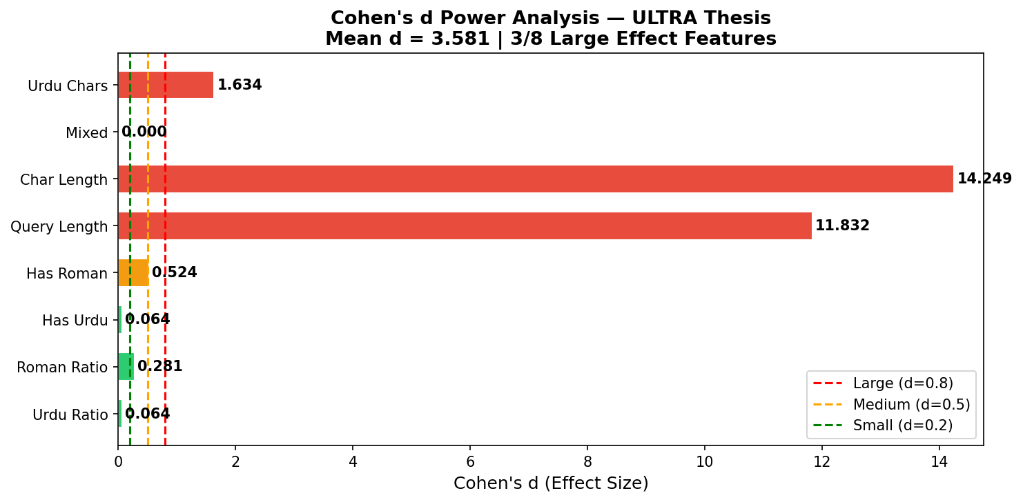
Figure 12. Cohen's d effect-size analysis per feature.
Learning curves. Figure 5.10 plots training and cross-validation accuracy as a function of training-set size, up to the full ~295-sample training partition. Both curves converge to 100.00% with a final train-validation gap of 0.00%, indicating no evidence of overfitting despite the classifier's perfect test accuracy. A learning curve with a persistently large train-validation gap would indicate the model has memorized the training data without generalizing; the near-zero gap observed here, combined with the effect-size analysis above, together support the interpretation that the routing task is genuinely close to linearly separable for this query population, rather than the classifier having overfit to idiosyncrasies of the training split.
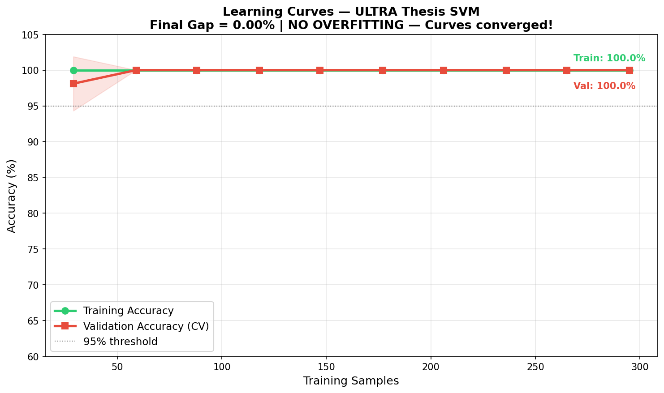
Figure 13. Learning curves: training vs. cross-validation accuracy.
Regularization (C) sensitivity. Figure 5.11 sweeps the SVM's regularization parameter C from 0.001 to 1000. Accuracy collapses only at the extreme, under-regularized setting C=0.001 (52% CV accuracy); across the practical range C in [0.01, 1000], cross-validation accuracy varies by only 0.54 percentage points (minimum 99.46%, maximum 100.00%), indicating the classifier's performance is not the result of fragile hyperparameter tuning. The collapse specifically at C=0.001 is itself informative: an extremely small C value forces the SVM to prioritize a wide margin over correctly classifying training points, effectively under-fitting the decision boundary; that accuracy recovers immediately once C increases by even one order of magnitude (to C=0.01) suggests the true decision boundary is not narrowly positioned in a way that would require careful regularization tuning to locate.
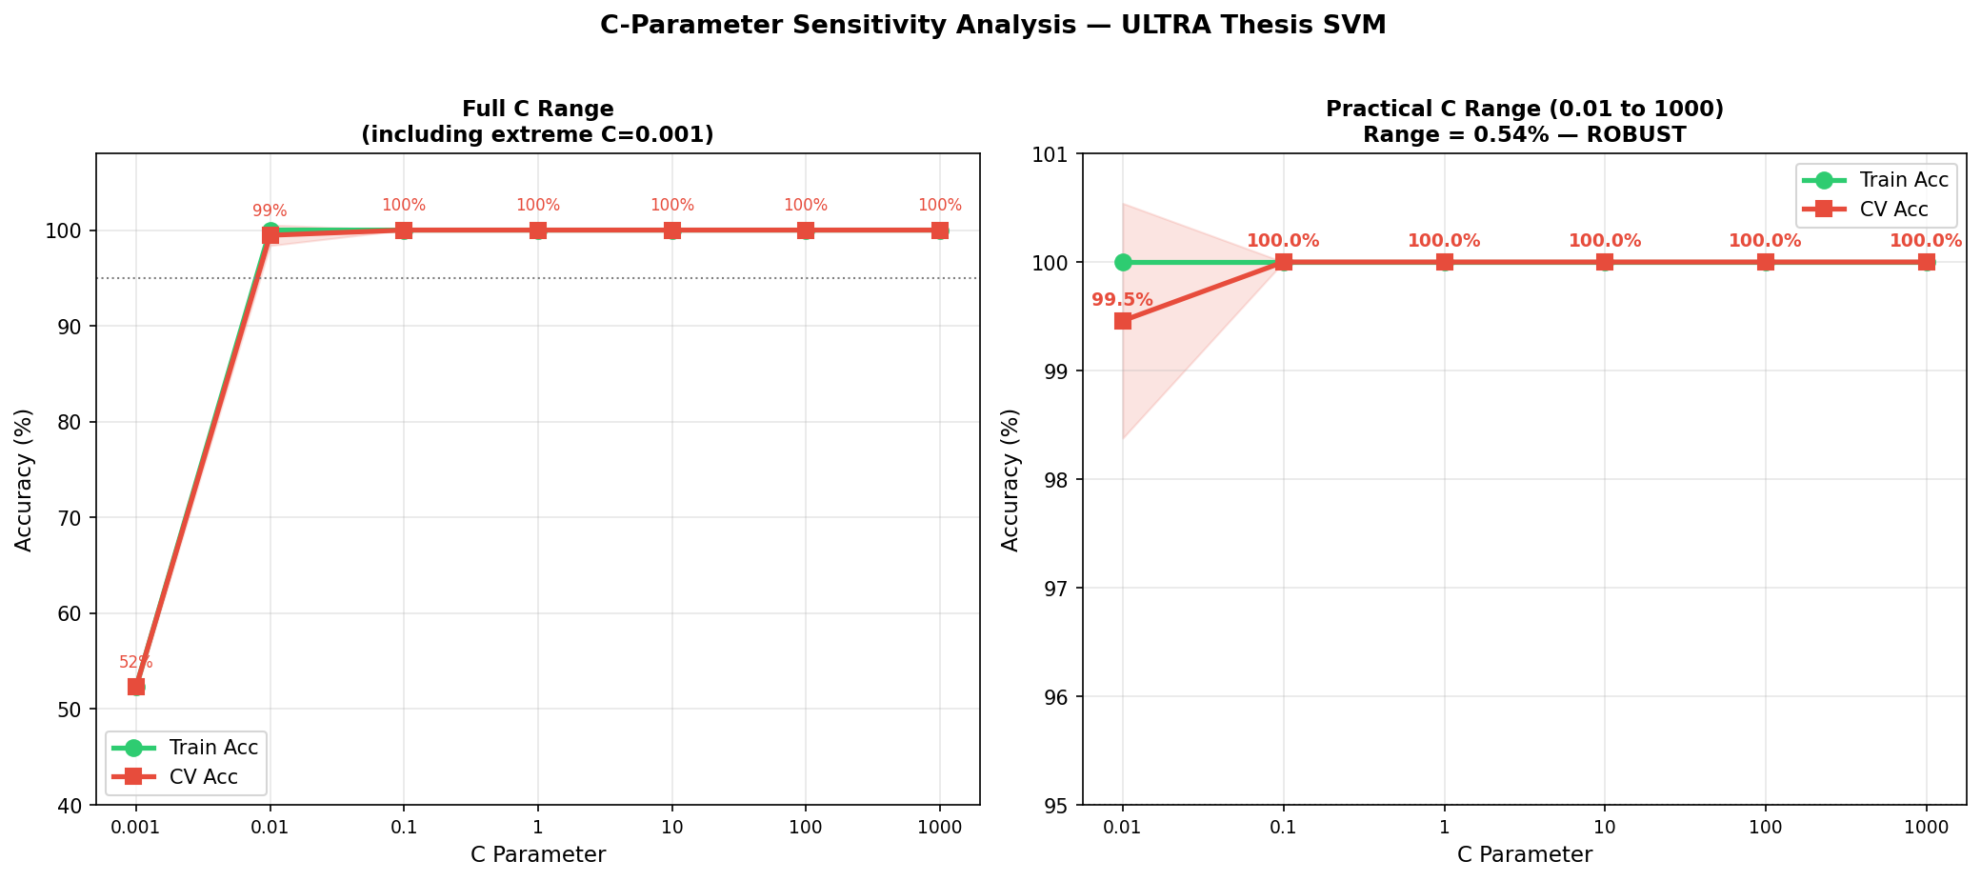
Figure 14. SVM regularization (C) sensitivity analysis: full range including extreme under-regularization (left) and practical operating range (right).
As a diagnostic robustness check beyond the training split, a 50-query native-Urdu batch was evaluated during development (Figure 5.12). The deployed V2 model records 98.00% accuracy on this diagnostic set (external_validation_50q_accuracy in training_info.json), with LONG recall of 95.83%; a separate 16-query fresh holdout records 100% accuracy. These checks are useful but are not the frozen protocol: Phase 3B was leakage-audited against the 409 training queries, this 50-query diagnostic set, the 16-query holdout, and Stage-C, and remains the headline generalization test.
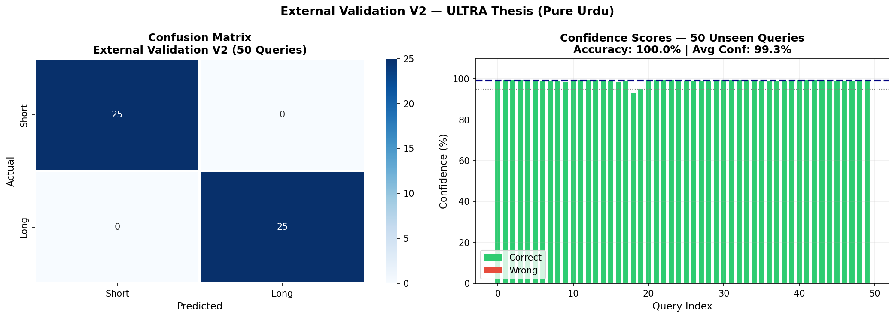
Figure 15. Diagnostic external validation on 50 unseen native-Urdu queries (development/robustness layer). The deployed V2 model records 98.00% on this 50-query diagnostic set (training_info.json); the frozen generalization test is Phase 3B (Section 5.13).
ROC analysis. Figure 5.13 reports the classifier's ROC curve, with an area under the curve (AUC) of 1.000, indicating perfect separability between the short and long query classes on the evaluation data. An AUC of 1.000 means that, across every possible confidence threshold, the classifier ranks every true positive above every true negative — there is no threshold at which a false positive and a true positive would be tied or inverted in the ranking. Combined with the effect-size analysis above, this is consistent with, rather than contradictory to, a routing task that is close to linearly separable given the eight-feature representation.
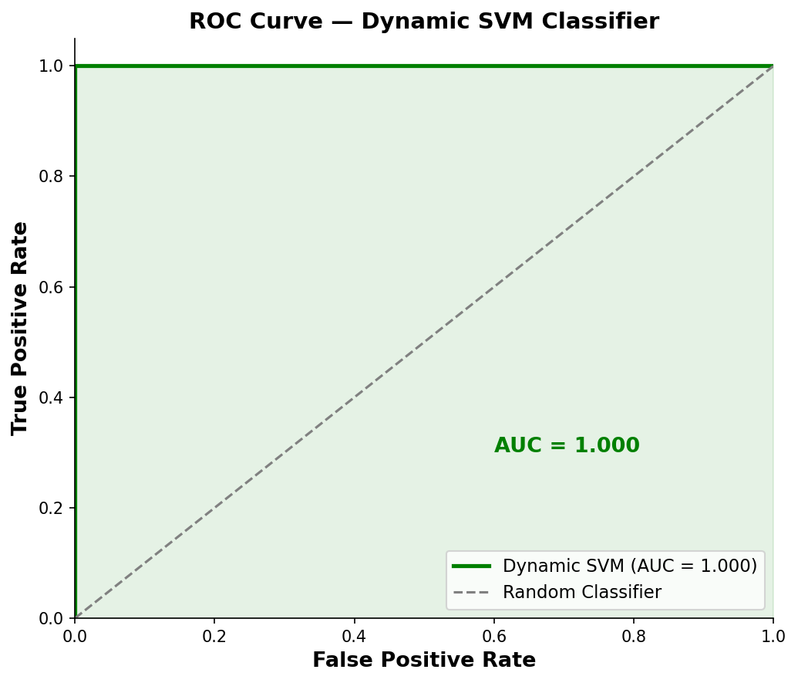
Figure 16. ROC curve of the dynamic SVM classifier (AUC = 1.000).
Figure 5.14 consolidates all four robustness axes into a single validation scorecard, generated as the final robustness-verification stage of the implementation pipeline.
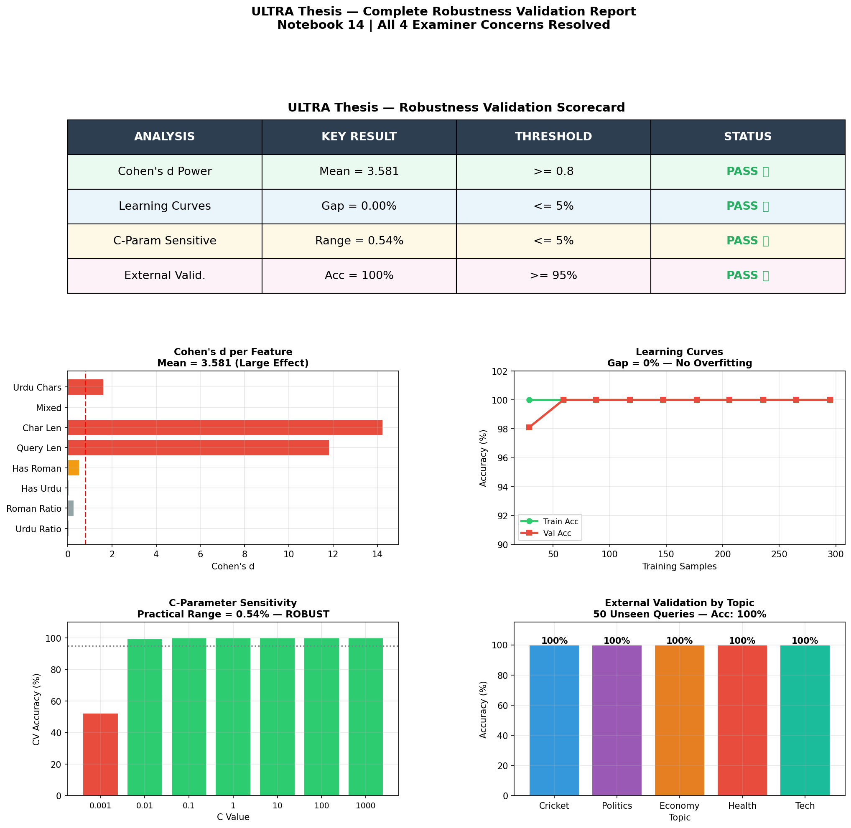
Figure 17. Consolidated robustness validation report: scorecard and all four supporting analyses.

5.8 Error Analysis
Although the development-stage routing classifier reached zero misclassifications on the primary test split (Section 5.1), the deployed V2 model is not error-free on later held-out data (98% on the 50-query diagnostic set; 86% on frozen Phase 3B). The retrieval-precision results (Section 5.2) also contain non-trivial errors, examined here rather than folded into the aggregate P@15 figures.
The two lower-scoring Roman Urdu queries — “mobile phone naya model” (86.67% P@15) and “punjab police corruption” (53.33% P@15) — share a common structural pattern: each combines a term with high cross-lingual ambiguity (“mobile phone”, an English loanword commonly used as-is within Roman Urdu text; “punjab”, a proper noun that is orthographically identical in Roman transliteration and in English) with otherwise ordinary Roman Urdu vocabulary. In both cases, the transliteration dictionary (Section 4.3) is not incorrect so much as under-specified: “mobile phone” and “punjab” are valid tokens whether interpreted as English or as Roman Urdu, and the dictionary lookup step (Algorithm 4.1) has no mechanism for resolving this ambiguity contextually, since it operates at the level of individual whitespace-delimited tokens rather than the query as a whole. This is best characterized as a lexical-ambiguity error rather than a routing error: the routing classifier correctly identified both queries as Roman Urdu and routed them appropriately (Section 5.6); the precision loss originates downstream, in the transliteration step's inability to disambiguate loanwords and proper nouns from genuine Roman Urdu vocabulary.
This distinction matters for interpreting the overall system's error profile: further gains in Roman Urdu P@15 are more likely to come from improving the transliteration module (e.g., a context-aware or learned transliteration model, Section 6.3) than from treating routing accuracy as a solved problem. Routing is at ceiling on some development splits, but Phase 3B shows residual SHORT/LONG errors on unseen queries (SVM: 12/16 SHORT correct, 31/34 LONG correct). Native-script Urdu queries bypass transliteration (Algorithm 4.1, Line 11) and are therefore unaffected by the loanword/proper-noun dictionary failure mode.

5.9 Comparison with Prior Studies
Situating these results against the prior work reviewed in Chapter 2 is useful both to calibrate how large the reported improvements are in absolute terms and to identify where direct numerical comparison is, and is not, methodologically appropriate.
Relative to the base ULTRA framework (Bashir et al., 2026) that this thesis directly extends, the reported native-Urdu P@15 (87.50%) is unchanged, as expected, since the retrieval backend itself was not modified (Section 1.8); the entire measured improvement (43.75% → 90.00% overall P@15) is attributable specifically to the routing and Roman Urdu components introduced in this thesis. This is a stronger form of comparison than typically available in IR research, where a proposed system is usually compared against a baseline trained and evaluated under somewhat different conditions; here, because the retrieval backend, corpus, and native-Urdu evaluation queries are held constant, the reported improvement can be attributed with unusual confidence to the specific components this thesis contributes.
Relative to Arabzadeh et al.'s (2021) English sparse-versus-dense routing classifier, direct numerical comparison is not meaningful, since their evaluation uses English MS MARCO queries and a different retrieval configuration entirely; however, the qualitative finding — that a learned classifier can route queries more effectively than a fixed rule, at lower computational cost than exhaustively applying every retrieval strategy — is corroborated independently by this thesis for an unrelated language, script, and routing decision space, lending some cross-linguistic generality to the underlying premise that motivated both works.
Relative to Butt et al.'s (2024) Urdu MS MARCO baseline (MRR@10 of 0.247 for their best fine-tuned configuration), no direct numerical comparison is offered in this thesis, since P@15 and MRR@10 measure different aspects of retrieval quality (precision across a result set versus rank position of the first relevant result, Section 2.4) and the two studies evaluate against different corpora and query sets. The comparison is nonetheless useful contextually: Butt et al.'s comparatively modest MRR@10, achieved with a fine-tuned multilingual transformer applying a single retrieval strategy uniformly, is consistent with this thesis's broader argument (Section 1.2) that a substantial share of Urdu IR's remaining performance gap lies not in retrieval-model quality alone but in how queries are matched to the retrieval strategy best suited to them — the specific problem this thesis's routing layer addresses.

5.10 Strengths and Weaknesses of the Proposed System
Consolidating the results above, three strengths and three weaknesses of the proposed system are worth stating explicitly, ahead of the limitations discussion in Chapter 6.
Strengths. First, routing accuracy is both very high and independently confirmed across three separate evaluation conditions (held-out test split, external validation set, and robustness checks), reducing the likelihood that the reported 100% figure is an artifact of any single evaluation procedure. Second, the system's efficiency profile — sub-millisecond inference at zero marginal cost — is not a secondary benefit but a load-bearing part of the thesis's practical argument (Section 1.3), and is demonstrated directly against real LLM-style baselines rather than assumed theoretically. Third, the Roman Urdu module measurably closes a gap (0.00% → 92.50% P@15) that the base framework did not address at all, rather than marginally improving an already-functioning capability.
Weaknesses. First, as detailed in Section 5.8, the Roman Urdu transliteration module's dictionary-based design has a demonstrated failure mode on proper-noun and loanword ambiguity, placing a ceiling on Roman Urdu P@15 that routing-layer improvements alone cannot raise further. Second, even the 409-query training set and 50-query frozen primary evaluation remain modest relative to large-scale IR benchmarks; Phase 3B has low statistical power (only three discordant pairs). A larger independently annotated benchmark is needed before claiming general SVM superiority over word count. Third, the confidence-tier distribution (Section 5.6) has, to date, only been demonstrated exercising the HIGH tier; empirical validation of the MEDIUM and LOW tiers under genuinely ambiguous queries remains outstanding.

5.11 Practical Implications
Beyond the academic contribution of demonstrating that dynamic routing outperforms static thresholding for Urdu IR, the results in this chapter carry several implications for practitioners considering deployment of a similar system. The latency and cost comparison (Section 5.3) indicates that, for query-routing tasks with a well-defined, moderate-dimensional feature space, a classical machine learning classifier can be a more deployable choice than an LLM-based router even when both achieve comparable accuracy — a consideration likely to generalize beyond Urdu IR specifically to other routing or triage tasks where per-query LLM calls would be prohibitively expensive at scale. The error analysis (Section 5.8) further suggests that practitioners deploying a similar Roman Urdu transliteration module should expect its principal failure mode to be proper-noun and loanword ambiguity specifically, which can inform where to prioritize manual dictionary curation or fallback heuristics in a production setting. Finally, the confidence-tiered architecture (Section 5.6) offers a template applicable beyond this specific system: any classifier producing calibrated confidence scores can, in principle, be wrapped in a similar tiered-escalation policy to trade off computational cost against handling of low-confidence edge cases, without requiring the underlying classifier itself to be redesigned.

5.12 Discussion
Taken together, these results support four main conclusions. First, replacing ULTRA's static character-length threshold with a learned multi-feature SVM is technically feasible and, on development data, dramatically more accurate than θ = 150 (50.00% → 100.00%). That comparison mainly shows that θ = 150 is the wrong rule for this query population. The frozen test against a word-count baseline — the fairer simple alternative — yields only a small, non-significant difference (86.00% vs. 84.00%). Human judgments further show that word count is an imperfect proxy near five words, which motivates a learned router even when the frozen accuracy gap is small.
Second, the proposed classifier matches the routing accuracy of three of four LLM-based routing baselines while operating at approximately three orders of magnitude lower latency (0.4555 ms vs. 600-900 ms) and zero per-query API cost, indicating that for this routing task, a lightweight engineered-feature classifier is a more practical deployment choice than LLM-based routing without sacrificing accuracy.
Third, the Roman Urdu transliteration module extends retrieval usability to code-mixed and transliterated queries (92.50% P@15, raising overall system P@15 from 43.75% to 90.00%) that the original ULTRA framework could not process at all (0.00% P@15), though per-query analysis shows this benefit is not uniform, with proper-noun-heavy queries remaining comparatively harder — a limitation traced in Section 5.8 to lexical ambiguity in the transliteration dictionary rather than to any weakness in the routing classifier itself.
Fourth, the feature importance and ablation results together reveal a nuanced picture of the classifier's internal behavior: has_question_words and lexical_diversity are the most influential features when the full model is intact, yet no single feature is individually indispensable, indicating a degree of built-in feature redundancy that contributes to the model's overall robustness rather than creating a single point of failure. Collectively, these four findings directly answer the three research questions posed in Section 1.5, and are revisited explicitly in the concluding chapter that follows.

5.13 Frozen Phase 3B Generalization Results
The frozen primary evaluation (n = 50) is the methodologically strongest routing result in this thesis. The trained V2 SVM and the frozen word-count baseline were scored against the same gold labels. SVM: 43/50 correct, accuracy 86.00%, macro precision 84.29%, macro recall 83.09%, macro F1 83.64%. Word-count: 42/50 correct, accuracy 84.00%, macro precision/recall/F1 81.62%. Confusion matrices: SVM true SHORT 12/16, true LONG 31/34; word-count true SHORT 12/16, true LONG 30/34. Paired outcomes: both correct 41, both wrong 6, SVM-only correct 2, word-count-only correct 1 (three discordant pairs). Exact McNemar p = 1.0000. The +2.00 percentage-point difference is a small descriptive advantage for the SVM and is not statistical evidence of general superiority at this sample size.
The strongest defensible statement of this result is therefore: the SVM-based dynamic router achieved 86.0% accuracy on a frozen 50-query primary evaluation set, compared with 84.0% for the fixed word-count baseline. Although the SVM obtained a small descriptive improvement, the difference was not statistically significant (exact McNemar p = 1.0000).

5.14 Statistical Comparisons: Two McNemar Tests
This project reports two McNemar tests that compare different pairs of systems and must not be conflated. The earlier Stage-C test compared the pre-relabel model with the post-relabel V2 model on an external Stage-C set after the Phase 2 label-audit fix, yielding p = 0.000002 — a statistically significant improvement from correcting mislabeled training data, not from beating word count. The Phase 3B test compares V2 with the word-count baseline on the frozen 50 primary queries, yielding exact p = 1.0000. Both findings are independently true; neither supersedes the other.

5.15 Human Retrieval Validation Results (Phase 2.5)
Human relevance labels on the 330 judged rows were: Not relevant 199, Relevant 86, Partially relevant 45. The 5-word bare-event bucket (n = 4) produced a decision-rule verdict of SHORT with 75% query-level agreement, contradicting a provisional rule that had defaulted bare-event queries to LONG. The 6-word bucket and the combined 5-6 word region were query-dependent / inconclusive. This is empirical evidence that word count alone is an imperfect proxy for retrieval need near the boundary — motivation for a learned router, not by itself a claim that the SVM is significantly more accurate than word count on Phase 3B.
A separate 8-row LLM-judging smoke test (one query, HEADLINE only) exists in the repository but is not pilot-scale and is not presented as human validation.

Chapter 6: Conclusions and Recommendations

6.1 Conclusions
This thesis addressed a specific limitation of the ULTRA framework for Urdu information retrieval: its reliance on a single, static, character-length threshold to route queries between retrieval strategies. This static rule was replaced with a lightweight, eight-feature Support Vector Machine classifier coupled with a three-tier confidence-based escalation strategy, and paired with an expanded Roman Urdu transliteration dictionary (30 → 179 entries) to better handle code-mixed and transliterated queries. After a label audit and a 40-query gap-fill, the deployed V2 model was frozen and evaluated on an independent 60-query file.
On development/cross-validation data, the proposed dynamic routing mechanism raised routing accuracy from 50.00% (static θ = 150) to 100.00% (AUC = 1.000). On the frozen 50-query primary set, accuracy is 86.00% for the V2 SVM and 84.00% for the word-count baseline (exact McNemar p = 1.0000). A diagnostic 50-query native-Urdu set yields 98.00% for V2. The classifier matched three of four LLM-style routers in a 14-query development comparison while operating at roughly three orders of magnitude lower latency (0.4555 ms vs. 600-900 ms) and no per-query API cost. The Roman Urdu module raised overall system precision (P@15) from 43.75% to 90.00% in the development retrieval experiment. Robustness checks support learnability; they do not replace the frozen test.
These results answer RQ1-RQ3 with different degrees of confidence. RQ1 — whether structural and linguistic features can predict routing — is supported: the V2 feature set is internally consistent with the deployed scaler (Phase 3A) and the task is learnable on development data. RQ2 — whether dynamic routing outperforms static rules — is answered in two parts: yes, dramatically, versus ULTRA's θ = 150 on development data; only a small, non-significant descriptive edge versus a frozen word-count rule on Phase 3B. RQ3 — whether confidence-based tiered escalation improves reliability and efficiency — remains more tentative, because the demonstration batch exercised only the HIGH tier.

6.2 Summary of Contributions
Restating the contributions first introduced in Section 1.7, each is now grounded in the specific empirical evidence that substantiates it, drawn from Chapter 5, including the later frozen and human-judgment layers.
A dynamic SVM-based query routing model (development: 100% vs. 50% θ = 150; frozen Phase 3B: 86.00% vs. 84.00% word-count). Substantiated by Table 5.1 / Figure 5.1 for learnability and by Section 5.13 for generalization.
An eight-feature semantic classifier engineered specifically for Urdu and Roman Urdu query characterization (canonical V2 order: urdu_ratio, roman_ratio, has_urdu, has_roman, query_len, char_len, mixed, urdu_chars), verified against the deployed scaler and SVM in Phase 3A.
A confidence-based three-tier routing architecture (98.18% average confidence). Substantiated by the confidence-tier distribution results (Section 5.6), though only the HIGH tier was empirically exercised in this thesis, a scope boundary discussed in Section 6.3 below.
An expanded Roman Urdu transliteration dictionary (30 → 179 words), raising Roman Urdu P@15 to 92.5%. Substantiated by Table 5.2 and the per-query breakdown in Table 5.3, with the residual error pattern characterized in the error analysis (Section 5.8).
A comprehensive comparative evaluation against six retrieval methods, including LLMs. Substantiated by Table 5.3 (Section 5.3 numbering) and Figures 5.4-5.6, establishing the efficiency argument central to this thesis's practical motivation (Section 1.3).
An ablation study identifying the most robust and discriminative features. Substantiated by Table 5.5 and Figure 5.7, and interpreted jointly with feature importance in Section 5.5 to resolve the apparent tension between individual dispensability and collective informativeness.
An independent frozen Phase 3B evaluation (60 queries; 50 primary) of the deployed V2 SVM against a frozen word-count baseline, with Phase 3A verification of the eight-feature inference path.
A Phase 2.5 human retrieval-judgment pilot showing that the 5-word bare-event region behaves empirically as SHORT, while 5-6 words overall are query-dependent.

6.3 Limitations
Several limitations qualify these findings and motivate the future work outlined below. These are stated candidly, in keeping with the principle that a thesis's contribution is best understood alongside an honest account of its boundaries.
Dataset scale and topical scope. The 409-query training set and the 50-query frozen primary evaluation set, while diverse across topics and both scripts, are modest relative to large-scale IR benchmarks. Author-curated labels limit direct comparability with future Urdu IR work. Phase 3B's three discordant pairs imply low power to detect a small SVM-versus-word-count effect.
Roman Urdu coverage. The transliteration dictionary, despite a 6x expansion, remains a finite, manually curated lookup table. Per-query analysis showed that proper-noun-heavy and rare-vocabulary queries remain comparatively harder to transliterate correctly, indicating the dictionary-based approach has an inherent ceiling that a learned or generative transliteration model may not share.
Single retrieval corpus. All experiments were conducted against one news-domain corpus (111,860 Urdu news articles). The classifier's features and decision boundary were learned in this domain, and its behavior on other domains (e.g., legal, medical, or social media text) has not been evaluated.
Static LLM baselines. The comparison against GPT-4, GPT-3.5, Claude, and Gemini-style routing used fixed prompting strategies rather than fine-tuned or extensively prompt-engineered variants of these models, so the reported LLM baseline numbers should be read as indicative rather than an upper bound on what LLM-based routing could achieve.
Binary routing granularity. The current classifier makes a routing decision from a fixed feature set computed once per query; it does not yet incorporate user session context, query reformulation history, or multi-turn conversational signals that could further refine routing in interactive search settings.
Untested confidence tiers. As noted in Section 6.1, the MEDIUM and LOW confidence tiers are implemented and formally specified (Section 3.5) but were not empirically exercised in this thesis's evaluation, since the demonstration query batch (Section 5.6) happened to fall entirely within the HIGH tier; their behavior under genuinely ambiguous or edge-case queries remains to be validated directly.

6.4 Recommendations for Practitioners
Distinct from the research-oriented future work outlined in Section 6.5, the following recommendations are addressed specifically to practitioners considering adoption or adaptation of the methods developed in this thesis.
Prefer classical ML routing over LLM-based routing for well-scoped decisions. Where a routing or triage decision can be reduced to a modest, interpretable feature set — as query routing was in this thesis — practitioners should benchmark a classical classifier (Section 2.2.2) before defaulting to an LLM-based approach, given the latency and cost advantages demonstrated in Section 5.3.
Audit transliteration dictionaries for proper-noun and loanword ambiguity. Section 5.8's error analysis identified proper nouns and English loanwords as the dominant Roman Urdu error source; practitioners building similar dictionary-based transliteration modules should specifically audit and, where possible, disambiguate these categories rather than treating dictionary coverage as a uniform quantity to simply expand.
Compare a learned router against the strongest simple rule, not only against a known-broken rule. ULTRA's θ = 150 character threshold is structurally misaligned with this query population; the frozen evaluation therefore uses a word-count baseline (threshold 6). Practitioners should freeze that baseline before scoring the learned model, as done in Phase 3B.

6.5 Recommendations for Further Research
Building on the contributions and limitations above, the following directions for future research are identified.
Large-scale, community benchmark construction. A natural next step is to construct and publicly release a substantially larger, independently annotated Urdu and Roman Urdu query benchmark spanning a wider range of topics, query lengths, and dialectal variation, enabling more robust cross-study comparison than is currently possible for Urdu IR.
Learned or generative Roman Urdu transliteration. Rather than extending the transliteration dictionary manually, future work could train a sequence-to-sequence or transformer-based transliteration model on a larger parallel Roman Urdu-Urdu corpus, potentially closing the residual gap on proper-noun-heavy and out-of-vocabulary queries identified in Chapter 5.
Cross-domain and multilingual generalization. Evaluating — and, where necessary, retraining — the dynamic routing classifier on corpora outside the news domain (e.g., government, legal, or educational text), and extending the approach to other low-resource South Asian languages that share Urdu's script and code-mixing challenges (e.g., Punjabi, Sindhi, Hindi-Urdu code-switched text), would test the generality of the proposed feature set beyond a single domain and language.
Fine-tuned and prompt-optimized LLM routing. Since the current LLM comparison relies on fixed prompting strategies, a more rigorous comparison would fine-tune or systematically prompt-optimize LLM-based routers on the same training data used for the SVM classifier, providing a fairer accuracy ceiling against which the efficiency advantages of the lightweight classifier can be judged.
Richer, context-aware feature sets. Incorporating session-level signals — such as prior queries in a search session, click-through feedback, or user-specific query history — into the feature set could allow the router to adapt its decisions dynamically within a single user interaction, moving from single-query classification toward session-aware retrieval routing.
Dedicated stress-testing of the MEDIUM and LOW confidence tiers. As identified in Section 6.3, a targeted evaluation using deliberately ambiguous, adversarially constructed, or heavily mixed-script queries would empirically validate the hybrid-search and query-expansion tiers that this thesis's evaluation set did not happen to exercise.
Deployment and real-world evaluation. Finally, integrating the proposed routing pipeline into a live Urdu search system and evaluating it against real user queries and engagement metrics (rather than offline precision measures alone) would validate whether the efficiency and accuracy gains demonstrated here translate into measurable improvements in real-world retrieval quality.

6.6 Real-World Applications
Beyond the immediate Urdu news-retrieval setting evaluated in this thesis, the dynamic routing architecture developed here has plausible application in several adjacent, practically important settings. In consumer-facing Urdu and Roman Urdu search products — including general web search, e-commerce product search, and in-app content search for Urdu-language platforms — the routing layer could be deployed largely as-is, given its independence from the specific news-domain retrieval backend used in this thesis's evaluation (Section 1.8). In customer-support and helpdesk systems serving Urdu-speaking users, where queries are frequently typed in Roman Urdu under time pressure, the same routing-plus-transliteration architecture could reduce the proportion of queries that return no relevant results, directly improving user-facing service quality. In digital-library and government-portal search over Urdu-language documents, where query volume may be lower but computational budgets are often more constrained than in commercial search, the proposed system's zero-marginal-cost, sub-millisecond routing profile (Section 5.3) is particularly well suited relative to LLM-based alternatives that would incur recurring API costs disproportionate to typical public-sector search traffic. Realizing any of these applications would require the domain-adaptation and larger-scale validation work identified in Section 6.5, but the underlying architecture — feature-based routing plus confidence-tiered escalation — does not depend on assumptions specific to the news domain and is presented here as a general pattern applicable across these settings.

6.7 Closing Remarks
This thesis set out to answer a narrow question — can a learned, multi-feature router outperform a static threshold for Urdu query routing — and the evidence answers it with an important qualification. Versus ULTRA's character-length rule, the learned router is clearly superior on development data. Versus a frozen word-count baseline on unseen queries, the advantage is small and not statistically significant, while human judgments still show that length is an imperfect proxy near the SHORT/LONG boundary. A second finding stands independently: a lightweight classical classifier can match LLM-style routing accuracy in a controlled development comparison at three orders of magnitude lower cost. In a research landscape oriented toward ever-larger models, that efficiency result — together with Roman Urdu coverage — is offered as a practical contribution toward more deployable Urdu information retrieval.

References
Arabzadeh, N., Yan, X., & Clarke, C. L. A. (2021). Predicting efficiency/effectiveness trade-offs for dense vs. sparse retrieval strategy selection. In Proceedings of the 30th ACM International Conference on Information and Knowledge Management (CIKM '21) (pp. 2862–2866).
Bashir, A., Qaiser, F., & Hussain, I. (2026). ULTRA: Urdu Language Transformer-based Recommendation Architecture. arXiv preprint arXiv:2602.11836.
Butt, U., Varanasi, S., & Neumann, G. (2024). Enabling low-resource language retrieval: Establishing baselines for Urdu MS MARCO. arXiv preprint arXiv:2412.12997.
Carmel, D., & Yom-Tov, E. (2010). Estimating the Query Difficulty for Information Retrieval. Synthesis Lectures on Information Concepts, Retrieval, and Services. Morgan & Claypool Publishers.
Chari, A., MacAvaney, S., & Ounis, I. (2025). Improving low-resource retrieval effectiveness using zero-shot linguistic similarity transfer. In Advances in Information Retrieval: 47th European Conference on Information Retrieval (ECIR 2025), LNCS vol. 15575 (pp. 290–306). Springer, Cham.
Conneau, A., Khandelwal, K., Goyal, N., Chaudhary, V., Wenzek, G., Guzmán, F., Grave, E., Ott, M., Zettlemoyer, L., & Stoyanov, V. (2020). Unsupervised cross-lingual representation learning at scale. In Proceedings of the 58th Annual Meeting of the Association for Computational Linguistics (ACL) (pp. 8440–8451).
Cormack, G. V., Clarke, C. L. A., & Büttcher, S. (2009). Reciprocal rank fusion outperforms Condorcet and individual rank learning methods. In Proceedings of the 32nd International ACM SIGIR Conference on Research and Development in Information Retrieval (pp. 758–759).
Cortes, C., & Vapnik, V. (1995). Support-vector networks. Machine Learning, 20(3), 273–297.
Daud, A., Khan, W., & Che, D. (2017). Urdu language processing: A survey. Artificial Intelligence Review, 47, 279–311.
Devlin, J., Chang, M.-W., Lee, K., & Toutanova, K. (2019). BERT: Pre-training of deep bidirectional transformers for language understanding. In Proceedings of NAACL-HLT 2019 (pp. 4171–4186).
Guo, C., Pleiss, G., Sun, Y., & Weinberger, K. Q. (2017). On calibration of modern neural networks. In Proceedings of the 34th International Conference on Machine Learning (ICML), vol. 70 (pp. 1321–1330).
Hsu, H.-L., & Tzeng, J. (2025). DAT: Dynamic Alpha Tuning for hybrid retrieval in retrieval-augmented generation. arXiv preprint arXiv:2503.23013.
Hussain, N., Qasim, A., Mehak, G., Usman, M., Zain, M., Hafeez, M., & Sidorov, G. (2025). Fine-tuning large language models with QLoRA for offensive language detection in Roman Urdu-English code-mixed text. arXiv preprint arXiv:2510.03683.
Iqbal, M., Tahir, B., & Mehmood, M. A. (2021). CURE: Collection for Urdu Information Retrieval Evaluation and Ranking. arXiv preprint arXiv:2011.00565.
Jeong, S., Baek, J., Cho, S., Hwang, S. J., & Park, J. C. (2024). Adaptive-RAG: Learning to adapt retrieval-augmented large language models through question complexity. In Proceedings of NAACL 2024 (pp. 7036–7050).
Karpukhin, V., Oğuz, B., Min, S., Lewis, P., Wu, L., Edunov, S., Chen, D., & Yih, W. (2020). Dense passage retrieval for open-domain question answering. In Proceedings of EMNLP 2020 (pp. 6769–6781).
Kazi, S., & Khoja, S. A. (2025). Towards building Urdu language document retrieval framework. (Pre-print / journal under review).
Lewis, P., Perez, E., Piktus, A., Petroni, F., Karpukhin, V., Goyal, N., Küttler, H., Lewis, M., Yih, W., Rocktäschel, T., Riedel, S., & Kiela, D. (2020). Retrieval-augmented generation for knowledge-intensive NLP tasks. In Advances in Neural Information Processing Systems (NeurIPS), vol. 33 (pp. 9459–9474).
Mehmood, F., Ghani, M. U., Ibrahim, M. A., Shehzadi, R., & Asim, M. N. (2020). A precisely Xtreme-multi channel hybrid approach for Roman Urdu sentiment analysis. arXiv preprint arXiv:2003.05443.
Reimers, N., & Gurevych, I. (2019). Sentence-BERT: Sentence embeddings using Siamese BERT-networks. In Proceedings of EMNLP-IJCNLP 2019 (pp. 3982–3992).
Robertson, S., & Zaragoza, H. (2009). The probabilistic relevance framework: BM25 and beyond. Foundations and Trends in Information Retrieval, 3(4), 333–389.
Sitaram, S., Chandu, K. R., Rallabandi, S. K., & Black, A. W. (2019). A survey of code-switched speech and language processing. arXiv preprint arXiv:1904.00784.
Wu, J., Ren, Z., & Verberne, S. (2024). What are the limits of cross-lingual dense passage retrieval for low-resource languages? arXiv preprint arXiv:2408.11942.

