

ADAPTIVE DYNAMIC QUERY ROUTING FOR URDU INFORMATION RETRIEVAL
by
Hashim Shazad
A thesis submitted in partial fulfillment of the requirements for the degree of
Master of Science in Artificial Intelligence
SUPERVISOR
Dr. Adnan Aslam
AIR UNIVERSITY
ISLAMABAD
© Hashim Shazad, 2026. All rights reserved.

CERTIFICATE
Department of Creative Technologies
It is hereby certified that Hashim Shazad (243259) has successfully completed his thesis titled “Adaptive Dynamic Query Routing for Urdu Information Retrieval” under the supervision of the undersigned, and that the thesis is of sufficient standard to be submitted in partial fulfillment of the requirements for the degree of Master of Science in Artificial Intelligence.

________________________________
Dr. Adnan Aslam
Assistant Professor
Air University, Islamabad
Supervisor

________________________________
[Internal Examiner]
[External Examiner]

________________________________
Chair, Department of Creative Technologies
Air University

________________________________
Dean, Faculty of Graduate Studies
Air University

DECLARATION
I declare that all material in this thesis is my own work, and that which is not my own work has been clearly acknowledged as such, and that no material from this work has previously been submitted for, or awarded, a degree at this or any other university.

Signature: _______________________
Author's Name: Hashim Shazad
Dated: _______________________

It is certified that the work presented in this thesis was carried out and completed under my supervision.

Signature: _______________________
Supervisor's Name: Dr. Adnan Aslam
Assistant Professor
Department of Creative Technologies
Air University, Islamabad
Dated: _______________________

Acknowledgments
First and foremost, I am thankful to Allah Almighty for granting me the strength, patience, and clarity of mind to complete this thesis.
I would like to express my sincere gratitude to my supervisor, Dr. Adnan Aslam, for his invaluable guidance, continuous encouragement, and constructive feedback throughout the course of this research. His mentorship was instrumental in shaping the direction and rigour of this work.
I am also grateful to the faculty and staff of the Department of Creative Technologies at Air University for providing the resources, environment, and support necessary to carry out this research.
Finally, I would like to thank my family and friends for their unwavering support, patience, and encouragement throughout my Master's studies. Their belief in me has been a constant source of motivation.

Adaptive Dynamic Query Routing for Urdu Information Retrieval
by
Hashim Shazad
M.S., Artificial Intelligence, Air University, 2026
Submitted in partial fulfillment of the requirements for the degree of
Master of Science in Artificial Intelligence, Air University
Abstract
Urdu information retrieval is difficult because users may type native Perso-Arabic script, informal Roman Urdu, or mixed forms, while many systems still apply one retrieval path to every query. This thesis proposes adaptive dynamic query routing for the ULTRA news-search setting. The official frozen system, M0, uses a Unicode script detector over a corpus of 111,860 cleaned Urdu news articles: URDU and MIXED queries search an Urdu BM25 index, and ROMAN queries search a Method D romanized-document BM25 index. Query-side variants M1–M4 did not improve the primary known-item score, so M0 was not replaced. On the Phase 2 development/validation known-item set, ExactSource Hit@5 is 68/78 = 87.18%. That figure is genuine for title-derived known-item search on that pool; it is not unseen usefulness and not overall system accuracy. Independent Phase 12 evaluation of the same freeze produced two further, separate results: ExactSource Hit@5 = 27/40 = 67.50% on new known-item queries (K001–K040), and human Success@5 = 23/40 = 57.50% on naturalistic queries (U001–U040; conservative P@5 = 0.2050, nDCG@5 = 0.6460, MRR = 0.4542). Success@5 is human relevance, not ExactSource Hit@5. These three percentages must not be averaged. In the U sample, Urdu-script queries succeeded in 17/18 cases versus 6/18 Roman and 0/4 mixed. The contribution is a frozen, reproducible script-aware retriever with strong controlled known-item performance and an explicitly measured Roman Urdu limitation.

Thesis Supervisor: Dr. Adnan Aslam

Table of Contents
Open this file in desktop Word and click Yes when asked to update fields.
List of Figures
Open this file in desktop Word and click Yes when asked to update fields.
List of Tables
Open this file in desktop Word and click Yes when asked to update fields.
Symbols and Abbreviations
Symbol / Abbreviation | Description
IR | Information Retrieval
SVM | Support Vector Machine
RBF | Radial Basis Function
P@15 | Precision at rank 15
AUC | Area Under the (ROC) Curve
ROC | Receiver Operating Characteristic
HNSW | Hierarchical Navigable Small World (index)
LLM | Large Language Model
BM25 | Best Matching 25 (ranking function)
RAG | Retrieval-Augmented Generation
QPP | Query Performance Prediction
mDPR | Multilingual Dense Passage Retriever
XLM-R | Cross-lingual Language Model – RoBERTa
BERT | Bidirectional Encoder Representations from Transformers
TP / FP / TN / FN | True Positive / False Positive / True Negative / False Negative
C(q) | Calibrated confidence score for query q
R(q) | Three-tier routing function for query q
x(q) | Eight-dimensional feature vector for query q
θ | Static character-length routing threshold (θ = 150)
McNemar | Paired binary-classifier comparison (Stage-C V1 vs V2; Phase 3B SVM vs word-count)
SHORT / LONG | Routing labels: headline-sufficient vs. full-content retrieval need

Chapter 1: Introduction

1.1 Background
Urdu is spoken by over 230 million people worldwide and serves as the national language of Pakistan and one of the officially recognized languages of India, yet it remains substantially underserved within contemporary information retrieval (IR) research (Daud et al., 2017). Unlike high-resource languages such as English, where dense retrieval, neural ranking, and large language model (LLM)-based query understanding have matured rapidly — driven by pretrained transformer encoders (Devlin et al., 2019) and dense dual-encoder retrievers (Karpukhin et al., 2020) — Urdu IR continues to face persistent challenges rooted in script complexity, morphological richness, and the informal, code-mixed nature of user-generated queries (Daud et al., 2017; Kazi & Khoja, 2025). A particularly acute challenge is the widespread use of Roman Urdu — Urdu written using the Latin script — in everyday digital communication and search queries, which introduces significant lexical and orthographic variation that conventional retrieval pipelines are not designed to handle (Hussain et al., 2025).
The trajectory of information retrieval research over the past two decades helps situate why this gap has persisted for so long. Classical retrieval systems relied on lexical matching frameworks such as the probabilistic relevance model underlying BM25 (Robertson & Zaragoza, 2009), which score documents based on term-frequency statistics rather than semantic meaning. These frameworks are language-agnostic in principle, but in practice they depend on well-tuned tokenization, stemming, and stop-word resources that were developed first — and most extensively — for English and a handful of other high-resource languages. The subsequent shift toward dense, embedding-based retrieval, exemplified by dual-encoder architectures such as DPR (Karpukhin et al., 2020) and pretrained multilingual encoders (Conneau et al., 2020), promised to reduce this dependency by learning semantic representations directly from data. In practice, however, the quality of these representations is itself bounded by the volume and diversity of pretraining data available for a given language, and Urdu — despite its large speaker population — remains comparatively underrepresented in the web-scale corpora used to pretrain most multilingual models.
This representational gap is compounded by a behavioral one. Empirical observation of Urdu-speaking users' search behavior suggests that a substantial share of real-world queries are not typed in the native Perso-Arabic script at all, but rather transliterated into Roman characters — a consequence of keyboard availability, typing familiarity, and long-standing digital communication habits that predate widespread Urdu-script keyboard support on mobile devices. Sitaram et al. (2019) frame this kind of script alternation as a broader instance of code-switching behavior, a phenomenon that conventional monolingual NLP pipelines, built around the assumption of a single consistent script, are structurally unequipped to handle. The consequence for Urdu information retrieval specifically is that any system evaluated only on native-script queries risks substantially overstating its real-world effectiveness, since it silently excludes a large and linguistically distinct subpopulation of actual user queries.
The scarcity of standardized evaluation resources compounds this problem. Early efforts such as the Collection for Urdu Retrieval Evaluation (CURE) (Iqbal et al., 2021) and, more recently, the translated Urdu MS MARCO baseline (Butt et al., 2024), have begun to establish benchmarks for Urdu IR, but adaptive, query-aware retrieval strategies for Urdu remain largely unexplored. Where such strategies exist for other languages — for instance, classifier-driven routing between sparse and dense retrieval (Arabzadeh et al., 2021) or complexity-aware retrieval-augmented generation (Jeong et al., 2024) — they have been designed, trained, and validated exclusively on English data, leaving open the question of whether their underlying premise (that a lightweight, query-level classifier can reliably predict the best retrieval strategy) transfers to a morphologically richer, script-variable, lower-resource language such as Urdu.
The ULTRA framework, proposed by Bashir, Qaiser, and Hussain (2026), represents a recent effort in this direction, introducing a dual-embedding, query-length-sensitive routing scheme that distinguishes between short, intent-oriented queries and longer, context-rich queries using a threshold-based decision process. However, ULTRA's routing mechanism relies on a static query-length threshold, which does not adapt to the full range of linguistic characteristics a real Urdu query may exhibit — including lexical diversity, Roman Urdu transliteration, and question structure. This mirrors a broader challenge identified in the general IR literature: Arabzadeh et al. (2021) showed that a learned classifier for routing queries between sparse and dense retrieval strategies can substantially outperform static rules, though their work was developed and evaluated only for English.
This thesis extends ULTRA by treating script as the official routing decision for lexical news search. The frozen system M0 sends URDU and MIXED queries to Urdu BM25 and ROMAN queries to Method D. Earlier SVM SHORT/LONG work (two semantic rooms and confidence lights) is retained as historical Layer A. Official IR evaluation uses ExactSource Hit@5 and human Success@5, not development P@15 as the headline.

1.2 Problem Statement
The practical problem is bilingual and script-mixed Urdu news search over 111,860 articles. Users issue native-script Urdu, Roman Urdu with non-standard spelling, and occasional mixed-script queries. A single Urdu-text BM25 index is a poor match for Roman queries (development Roman known-item Hit@5 was 0/23 without a Roman path). A static length threshold does not decide which script index to open. Classification accuracy on SHORT versus LONG is not the same as finding a useful news article.
The scientific problem is therefore to freeze a retrieval system, report known-item recovery under a defined protocol, then report generalization on new known-item queries and naturalistic human usefulness without mixing those metrics. Chapter 4 specifies M0. Chapter 5 reports 68/78, 27/40, and 23/40 separately.

1.3 Motivation
A search system that cannot decide which script index to open will miss Roman Urdu even when the article exists. The motivation is a frozen, inspectable BM25 pipeline with honest evaluation: development known-item, new known-item, and human usefulness kept apart. Overstating 87.18% as real-world accuracy would hide the Phase 12 gap.
There is also a broader accessibility dimension to this motivation. Search and information-access tools are increasingly treated as basic digital infrastructure, and a system's usability for a given language community is only as strong as its weakest routing decision, since a single wrong routing choice can mean the difference between a user finding relevant results and abandoning the search entirely. For a language community as large as Urdu speakers, an IR system that only performs well on native-script input effectively excludes a substantial and demographically distinct segment of users — often younger, mobile-first users who default to Roman Urdu out of typing convenience rather than any deficiency in their command of the language. Improving routing reliability for Roman Urdu queries is therefore not merely a technical refinement but a step toward more equitable digital access for Urdu speakers as a whole.
Finally, from a systems-engineering perspective, the choice between a lightweight, locally-executed classifier and an LLM-based router carries practical consequences that extend beyond raw accuracy. LLM-based routing, of the kind explored for retrieval-augmented generation by Jeong et al. (2024), introduces per-query inference latency and, in most deployment settings, a recurring monetary cost tied to API usage — both of which scale unfavorably with query volume. A classifier that matches LLM-level routing accuracy while running locally, at sub-millisecond latency and no marginal cost, is therefore not just an academic curiosity but a materially more deployable solution for real-world Urdu search infrastructure, particularly in resource-constrained settings where LLM API access may be unreliable, expensive, or unavailable altogether.

1.4 Research Gap
The evaluation gap this thesis addresses is a frozen Urdu/Roman lexical router with three non-averaged layers: development/validation known-item ExactSource Hit@5, new known-item ExactSource Hit@5, and naturalistic human Success@5. English query routing and Urdu collections exist; this freeze protocol did not.

1.5 Research Questions
RQ1: Can a script-aware lexical pipeline (Urdu BM25 + Method D) recover known news articles from title-derived queries on a development/validation pool?
RQ2: Does that known-item score transfer to a new sealed known-item sample (K001–K040) written independently of the freeze set?
RQ3: How often is frozen M0 useful (at least one A or B in the Top-5) on new naturalistic queries with no gold article (U001–U040)? RQ4: Do query-side Roman expansions M1–M4 improve n=78 ExactSource Hit@5 enough to replace M0? Historical Layer A (SVM SHORT/LONG and MiniLM P@5) is reported separately and is not the official IR headline.

1.6 Objectives
- Freeze an official retrieval system (M0) with documented hashes, Unicode routing, Urdu BM25, and Method D.
- Report ExactSource Hit@5 on Phase 2 development/validation known-item queries (n=78) and on sealed K001–K040, and human Success@5 on sealed U001–U040, without using those queries for tuning.
- Report the Phase 11 M0–M4 ablation and keep M0 official if Hit@5 does not improve.
- State limitations, especially Roman and mixed-script performance, without hiding weaker Phase 12 numbers.
- Robustness validation: Statistically validate performance through effect-size analysis, learning-curve evaluation, regularization sensitivity, diagnostic held-out checks, a label-audit before/after comparison (Stage-C McNemar), and the frozen Phase 3B McNemar test against the word-count baseline.
These five objectives were sequenced deliberately: the first two (classifier design and Roman Urdu support) establish the core technical contribution, the third (tiered routing) builds a practical deployment layer on top of that contribution, and the final two (comparative evaluation and robustness validation) ensure that any observed improvement is both meaningful relative to competing approaches and statistically defensible rather than an artifact of a single favorable train-test split.

1.7 Contributions
- A frozen script-aware BM25 architecture (M0) with Unicode routing and Method D. Official IR: ExactSource Hit@5 = 68/78 = 87.18% (development/validation known-item); 27/40 = 67.50% (new K); human Success@5 = 23/40 = 57.50% (new U). M1–M4 did not improve 68/78.
- A canonical eight-feature V2 extractor verified in Phase 3A, later extended with four intent flags (why / how / synthesis / fact cue) for trap-aware training. Phase 3A and Phase 3B remain the V2 frozen record.
- Confidence lights: HIGH (≥85%) searches one room; MEDIUM (60–85%) hybrid-ranks both rooms; LOW (<60%) expands the query then hybrid-ranks.
- An expanded Roman Urdu dictionary (198 on-disk pairs). Development P@15 of 92.5% on eight Roman queries is a historical supporting experiment, not official M0 Hit@5 or Success@5.
- A comprehensive comparative evaluation against six retrieval methods, including large language models.
- An ablation study identifying the most robust and discriminative features for Urdu query routing.
Contribution 1 is the official frozen retriever M0 (script-aware BM25). SVM SHORT/LONG rooms and confidence lights are historical Layer A, not the official IR system. Contributions 1 through 3 are architectural: together, they constitute the dynamic routing system itself, evaluated end-to-end in Chapter 5. Contribution 4 is resource-oriented, extending a component (the transliteration dictionary) that is reusable independently of the classifier and could, in principle, benefit other Urdu NLP systems beyond retrieval routing. Contributions 5 and 6 are evaluative: the comparative benchmark situates the proposed system relative to both the simplest possible baseline (static thresholding) and the most sophisticated plausible alternative (LLM-based routing), while the ablation study provides evidence for which architectural choices are load-bearing and which are comparatively redundant — a distinction of practical value for anyone seeking to reproduce or extend this work.

1.8 Scope of the Thesis
Official retrieval evaluation is news-domain M0 over 111,860 articles. It does not replace M0 with M1, does not treat H001–H040 as the primary unseen test, and does not claim legal, medical, or live web search. Historical SVM dual-index work remains in Sections 5.1–5.17 as Layer A only.
Adjacent problems are excluded so the routing claim stays identifiable. The encoder, corpus preprocessing, and HNSW construction are inherited. Gains in Chapter 5 are therefore from routing and from opening a different room, not from a new embedding model. Query understanding beyond the engineered features (NER, syntax) is out of scope. The twelve-feature trap model is a later layer; it does not overwrite the frozen V2 Phase 3B table.

1.9 Significance of the Study
The significance of this study is best understood at three levels. At the technical level, it demonstrates that a small set of interpretable, cheaply computed query features, combined with a classical machine learning classifier, can match the routing accuracy of substantially more expensive LLM-based alternatives — a finding with implications for query routing research beyond Urdu specifically, since it suggests that engineered features remain competitive with LLM-based approaches for well-scoped classification tasks even in the current era of large pretrained models. At the linguistic and regional level, this work contributes one of the few dedicated treatments of Roman Urdu within a retrieval (rather than sentiment or offensive-language classification) context, extending the applicability of Urdu IR research to the code-mixed, informally written queries that plausibly constitute a large share of real-world search traffic from Urdu-speaking users. At the practical level, the efficiency profile of the proposed classifier — sub-millisecond inference at zero marginal cost — makes the findings directly actionable for practitioners building Urdu-language search or recommendation systems who must operate under real-world latency and cost constraints that LLM-based routing would violate.

1.10 Thesis Layout
The remainder of this thesis is organized as follows.
Chapter 2 — Literature Survey. Reviews prior work in Urdu natural language processing, Roman Urdu processing, low-resource and cross-lingual retrieval, Urdu IR benchmarking, and query-adaptive retrieval routing, and positions this thesis relative to the identified research gaps.
Chapter 3 — Mathematical Formulation. Presents historical SVM mathematics (Layer A) and the official M0 metrics: BM25, ExactSource Hit@k, and human Success@5.
Chapter 4 — Methods Developed. Describes historical SVM routing and, for official IR, frozen M0 script routing, Method D, and the Phase 8–12 evaluation protocol.
Chapter 5 — Results and Discussion. Labels Layer A (SVM/P@15/MiniLM) as historical, then reports official M0: 87.18% ExactSource Hit@5 (n=78), 67.50% ExactSource Hit@5 (K), and 57.50% Success@5 (U).
Chapter 6 — Conclusions and Recommendations. Summarizes the main findings, discusses the limitations of the current work, and outlines directions for future research.

Chapter 2: Literature Survey
Urdu information retrieval sits at the intersection of three research threads that are individually well studied for high-resource languages but remain fragmented for Urdu: general Urdu natural language processing, information retrieval benchmarking, and query-adaptive routing. This chapter reviews representative work in each thread, situates the proposed approach within the broader progression from lexical to neural to LLM-based retrieval methods, surveys the datasets and evaluation metrics relevant to this progression, and identifies the specific gap this thesis addresses.

2.1 Foundations

2.1.1 Urdu Natural Language Processing
Daud et al. (2017) conducted a comprehensive survey of Urdu language processing, cataloguing the linguistic characteristics that complicate computational treatment of the language: a cursive, context-sensitive Perso-Arabic script written right-to-left, rich morphology, and the absence of large-scale standardized corpora compared to English or Arabic. Their survey remains a foundational reference for understanding why Urdu NLP tools lag behind those available for high-resource languages, though it predates the transformer era and therefore does not address embedding-based retrieval or query-adaptive systems.
Kazi and Khoja (2025) more recently proposed a framework for Urdu language document retrieval, applying deep learning techniques and evaluating the effect of different word embeddings on retrieval-adjacent tasks such as named entity recognition. Their framework focuses on document-level representation quality rather than on how individual queries should be routed to different retrieval strategies based on their structural characteristics.
A recurring theme across the Urdu NLP literature more broadly is that morphological and orthographic complexity does not merely add noise to a pipeline built for English — it changes which pipeline design choices are even viable. Techniques that work well for space-delimited, Latin-script languages, such as simple whitespace tokenization or suffix-stripping stemmers, transfer poorly to a cursive, context-sensitive script in which letter shape depends on position within a word. This has practical consequences for query routing specifically: a feature such as word_count, straightforward to compute for English, requires a tokenization decision for Urdu that is itself non-trivial, and the eight-feature representation adopted in this thesis (Chapter 3) was designed with this constraint in mind, favoring features that remain well-defined under simple whitespace tokenization rather than relying on a full morphological analyzer that does not yet exist at production quality for Urdu.

2.1.2 Roman Urdu Processing Challenges
Roman Urdu — Urdu transliterated into the Latin script — lacks a standardized spelling convention, meaning the same word may be written in multiple ways depending on the writer's phonetic intuition. Hussain et al. (2025) addressed a related problem, fine-tuning large language models via QLoRA for offensive language detection in Roman Urdu-English code-mixed text, and explicitly identified inconsistent spelling, unstated grammar, and scarcity of labeled data as core obstacles for any Roman Urdu NLP task. Their work targets classification rather than retrieval, and does not address how Roman Urdu queries should be routed differently from native-script Urdu queries within an IR pipeline.
More broadly, Sitaram et al. (2019) surveyed code-switched speech and language processing, characterizing the alternation between languages and scripts — of which Roman Urdu is a script-level instance — as a communicative phenomenon that conventional monolingual NLP pipelines are not designed to handle. Within Urdu specifically, Mehmood et al. (2020) tackled the closely related task of Roman Urdu sentiment analysis, proposing a hybrid multi-channel architecture over custom Word2Vec, FastText, and GloVe embeddings and reporting F1-score gains of up to 9% over adapted machine-learning baselines. Both works confirm that Roman Urdu requires script-aware, dedicated processing rather than being treated as a minor variant of native-script Urdu, but neither addresses query routing or retrieval.
Taken together, this body of work suggests two broadly viable strategies for handling Roman Urdu within an NLP pipeline: (i) a dictionary- or rule-based transliteration approach that maps Roman Urdu tokens to their native-script equivalents before downstream processing, as adopted in this thesis, or (ii) an end-to-end learned approach in which a model is trained directly on Roman Urdu text without explicit transliteration, as in Hussain et al.'s (2025) QLoRA fine-tuning and Mehmood et al.'s (2020) custom embedding approach. The dictionary-based strategy was preferred here for two practical reasons: it requires no additional model training or labeled Roman Urdu corpus beyond the dictionary itself, and it produces a transliterated query that can be fed directly into the same native-Urdu embedding pipeline already used for the retrieval backend, avoiding the need to maintain two separate embedding spaces.

2.1.3 Low-Resource and Cross-Lingual Retrieval Limitations
Urdu's challenges are not unique; a growing body of work shows that state-of-the-art dense retrieval degrades sharply once a language falls outside the small set of high-resource languages that dominate pretraining corpora. Wu et al. (2024) evaluated the multilingual Dense Passage Retriever (mDPR) — the retrieval component of the Cross-lingual Open-Retrieval Answer Generation (CORA) pipeline — on two extremely low-resource languages, Amharic and Khmer, and found that even after targeted extensions using translation language modelling and question-passage alignment, retrieval quality improvements were modest and absolute performance remained low. Their finding that language alignment techniques only partially close the gap for low-resource languages is directly relevant to Urdu: general-purpose multilingual dense retrievers cannot be assumed to transfer well without language-specific adaptation.
Closer to the transliteration problem this thesis addresses, Chari et al. (2025) observed that current search systems are not usually trained on low-resource language varieties, forcing users to express queries in a high-resource language instead — a pattern directly analogous to Urdu speakers defaulting to Roman (Latin-script) transliteration when native-script input is inconvenient. They proposed fine-tuning neural rankers on pairs of related language varieties so that the ranker learns to exploit shared lexical and grammatical structure, improving retrieval effectiveness for the trained varieties.
Conneau et al. (2020) showed that scaling multilingual pretraining (XLM-R) improves Urdu XNLI accuracy by 11.4 points over prior multilingual models, and that low-resource languages such as Urdu benefit disproportionately from scale — yet this gain is realized at the level of a single monolithic embedding model applied uniformly to every query, with no mechanism for detecting when a given query's script, length, or lexical structure would be better served by a different retrieval strategy altogether. Together, these studies confirm a consistent pattern across unrelated low-resource settings: general-purpose neural retrieval degrades for under-represented languages and scripts, and closing the gap requires language- or script-specific engineering rather than relying on multilingual pretraining alone. This motivates the explicit Roman Urdu detection and dictionary-transliteration module used in this thesis's methodology.

2.1.4 Information Retrieval Benchmarking for Urdu
Iqbal et al. (2021) introduced CURE (Collection for Urdu Retrieval Evaluation), a standard test collection of Urdu documents built specifically to enable rigorous IR evaluation, addressing the absence of a shared benchmark comparable to TREC-style collections available for English. CURE provides an evaluation resource but does not itself propose an adaptive retrieval or routing mechanism.
Butt et al. (2024) established the first large-scale Urdu IR dataset by machine-translating the MS MARCO passage ranking dataset into Urdu, and benchmarked both BM25 and fine-tuned multilingual transformer (mT5-based mMARCO) baselines, reporting a Mean Reciprocal Rank (MRR@10) of 0.247 for their best fine-tuned configuration. Their evaluation applies a single retrieval strategy uniformly to all queries; no mechanism is proposed for detecting which queries would benefit from a different retrieval configuration.

2.2 Comparative Analysis of Retrieval and Routing Paradigms
The methods surveyed in Section 2.1 and Section 2.6 span three broad technical paradigms — classical statistical/lexical methods, classical machine learning classifiers, and deep learning or LLM-based approaches — each carrying distinct trade-offs relevant to the query-routing problem addressed in this thesis. This section compares these paradigms explicitly, since the choice of an RBF-kernel SVM for the proposed routing classifier (rather than a lexical rule, a deep neural classifier, or an LLM prompt) was made deliberately in light of these trade-offs, rather than as a default choice.

2.2.1 Lexical and Statistical Methods
The earliest and still most widely deployed retrieval paradigm relies on lexical term-matching, exemplified by the BM25 ranking function (Robertson & Zaragoza, 2009), which scores document relevance from term-frequency and inverse-document-frequency statistics without requiring any learned representation. Applied to query routing rather than document ranking, an equivalent lexical strategy would route queries using simple surface statistics — precisely what the static, character-length threshold in the base ULTRA framework does. This paradigm's principal advantage is transparency and near-zero computational cost; its principal limitation, as demonstrated empirically in Chapter 5, is that surface statistics alone are insufficient to separate queries whose true routing requirement depends on script type or lexical structure rather than length alone.

2.2.2 Classical Machine Learning Approaches
Between purely lexical rules and deep neural networks lies a family of classical machine learning classifiers — logistic regression, decision trees, and kernel methods such as the Support Vector Machine (Cortes & Vapnik, 1995) — that learn a decision boundary over a fixed, hand-engineered feature representation. This is the paradigm adopted in this thesis: an RBF-kernel SVM trained over the eight-dimensional feature vector described in Chapter 3. The appeal of this family, relative to both lexical rules and deep learning, is threefold: it requires substantially less training data than a deep neural classifier (the 409-query training set used here would likely be insufficient to train a competitive neural classifier from scratch), it produces calibratable confidence scores via Platt scaling without requiring a separate calibration architecture, and it executes at sub-millisecond inference latency on commodity hardware, without requiring a GPU.

2.2.3 Deep Learning and Neural Ranking Approaches
Deep learning approaches to retrieval and classification, typically built on pretrained transformer encoders such as BERT (Devlin et al., 2019) and its multilingual variants (Conneau et al., 2020), learn representations directly from raw text rather than from hand-engineered features. Arabzadeh et al. (2021), for instance, trained a BERT-based classifier for sparse-versus-dense retrieval routing, and dense retrieval itself — as in DPR (Karpukhin et al., 2020) and Sentence-BERT (Reimers & Gurevych, 2019) — relies on transformer encoders to produce the embeddings compared during retrieval. The retrieval backend inherited from the base ULTRA framework in this thesis already uses this paradigm (via paraphrase-multilingual-MiniLM-L12-v2 embeddings, Section 4.2). For the routing decision specifically, however, a full transformer-based classifier was judged disproportionate to the task: routing is a comparatively low-dimensional decision (in this thesis, effectively binary, short-vs-long, augmented with confidence tiering) relative to the open-ended semantic matching that dense retrieval must perform, and the accuracy ceiling on this routing task (Chapter 5) is reached by the much lighter SVM classifier without requiring transformer-scale representations.

2.2.4 Large Language Model-Based Approaches
The most recent paradigm applies large language models directly to routing and retrieval-adjacent decisions through prompting, rather than through a separately trained classifier. Jeong et al.'s (2024) Adaptive-RAG and Hsu and Tzeng's (2025) DAT both fall into this category, using an LLM to assess query complexity or to calibrate retrieval fusion weights at inference time. This paradigm's chief advantage is flexibility: it requires no dedicated training data or model training step, since the LLM's general-purpose reasoning is applied directly to the routing decision through a prompt. Its chief disadvantages, quantified directly in this thesis's evaluation (Chapter 5, Section 5.3), are per-query inference latency (hundreds of milliseconds, versus sub-millisecond for a local classifier) and, in most deployment settings, a recurring monetary cost tied to API usage that scales with query volume — both of which are avoided entirely by the SVM-based approach adopted here.
Table 1. Comparative summary of retrieval/routing paradigms across cost and capability dimensions.
Paradigm | Advantages | Limitations | Deployment Cost
Lexical/Statistical  (e.g., BM25 thresholding) | Near-zero latency; fully transparent | Cannot capture script, lexical diversity, or semantic signals | Very Low
Classical ML  (SVM, logistic regression) | Low latency; calibratable confidence; small data requirement | Requires hand-engineered features | Low
Deep Learning  (BERT-based classifiers, dense retrieval) | Learns representations directly from text; strong semantic capacity | Requires larger training data; higher inference cost than classical ML | Medium–High
LLM-based  (prompted routing/scoring) | No dedicated training required; highly flexible | High per-query latency (100s of ms); recurring API cost | High
This comparison motivates the specific design choice defended empirically in Chapter 5: the classical machine learning paradigm (Section 2.2.2) occupies a favorable position on the cost-capability trade-off for the query-routing task specifically — substantially more capable than lexical thresholding, while avoiding the training-data and inference-cost overhead of deep learning and LLM-based alternatives.

2.3 Datasets and Evaluation Resources
Progress in any retrieval sub-field is bottlenecked by the availability of representative datasets, and Urdu IR is no exception. The table below summarizes the datasets referenced across this literature survey and positions the datasets used in this thesis (Chapter 4) relative to them.
Table 1. Comparative summary of Urdu and multilingual IR-relevant datasets.
Dataset | Language(s) | Type | Primary Use | Limitation
CURE (Iqbal et al., 2021) | Urdu | Document collection | Standardized Urdu IR evaluation | No routing labels
Urdu MS MARCO (Butt et al., 2024) | Urdu (translated) | Passage ranking | Large-scale Urdu passage retrieval | Translation artifacts; no script variation
XNLI (evaluated in Conneau et al., 2020) | Multilingual incl. Urdu | Sentence-pair classification | Cross-lingual representation quality | Not retrieval-specific
This thesis — corpus | Urdu (native script) | News articles (111,860) | Retrieval backend indexing | Single domain (news)
This thesis — query set | Urdu + Roman Urdu | Real user-style queries (409) | Routing classifier training/evaluation | Author-curated, not yet publicly released
A clear pattern emerges from this comparison: existing Urdu-specific datasets are either general-purpose document collections (CURE) or translated passage-ranking benchmarks (Urdu MS MARCO), and neither includes the routing-relevant metadata — script type, query difficulty, or an appropriate retrieval-strategy label — that this thesis's 409-query dataset was purpose-built to provide. This is not a criticism of the existing resources, which were not designed with query routing in mind, but it does mean that no existing public dataset could have been used as-is for the classifier training and evaluation reported in Chapter 5, necessitating the author-curated query set described in Chapter 4.

2.4 Evaluation Metrics in Information Retrieval
Evaluating an IR system with a routing component requires metrics at two distinct levels: routing-decision quality and retrieval-result quality. This thesis reports both, and this section briefly surveys the metrics used and their provenance in the literature.
At the routing-decision level, accuracy, precision, recall, and F1-score (Equations 3.8-3.11) are standard classification metrics applicable whenever routing is framed as a discrete decision, as it is in this thesis and in Arabzadeh et al.'s (2021) sparse-versus-dense classifier. Because the SVM classifier additionally produces calibrated confidence scores via Platt scaling, this thesis also reports the Receiver Operating Characteristic (ROC) curve and its Area Under the Curve (AUC), a threshold-independent measure of separability between classes; the importance of properly calibrated (rather than merely high) confidence scores for this kind of reporting is discussed at length by Guo et al. (2017), whose finding that modern classifiers tend toward systematic overconfidence directly motivated the use of Platt scaling (Section 3.4) rather than reporting raw decision-function margins as confidence.
At the retrieval-result level this thesis uses two official IR metrics that must not be mixed: ExactSource Hit@5 (known-item recovery of a pre-assigned source document) and human Success@5 (at least one A or B in the Top-5). Development notebooks also reported P@15 for a small Layer A retrieval experiment; that P@15 is not official M0 performance. Mean Reciprocal Rank is reported for U as a secondary usefulness statistic.
Finally, because a central claim of this thesis concerns deployment practicality relative to LLM-based routing (Section 2.2.4), two efficiency metrics not traditionally reported in retrieval-accuracy-focused IR literature are also measured directly in Chapter 5: per-query inference latency and per-query monetary cost. These are not standard IR metrics in the way P@k or MRR are, but they are essential to substantiating the practical, rather than purely academic, motivation for this thesis (Section 1.3).

2.5 Current Research Trends
Three trends visible across the literature reviewed in this chapter are worth drawing out explicitly, since they collectively motivate the specific architecture proposed in this thesis. First, retrieval-augmented generation has emerged as the dominant paradigm for combining parametric language models with non-parametric retrieval (Lewis et al., 2020), and a growing sub-thread within this paradigm — adaptive or complexity-aware RAG (Jeong et al., 2024) and dynamic hybrid-fusion weighting (Hsu & Tzeng, 2025) — has moved away from applying a single fixed retrieval strategy to every query, toward query-dependent strategy selection. The three-tier confidence routing architecture proposed in this thesis is a direct instance of this broader trend, applied for the first time, to the authors' knowledge, to Urdu.
Second, the multilingual NLP literature has increasingly recognized that scaling pretraining data and model size (Conneau et al., 2020) helps but does not fully resolve the performance gap for low-resource languages and scripts, motivating a parallel trend toward targeted, language-specific engineering — explicit transliteration modules, curated dictionaries, and script-detection components — rather than relying solely on ever-larger multilingual models (Chari et al., 2025; Wu et al., 2024). The Roman Urdu transliteration module developed in this thesis (Section 4.3) is positioned within this second trend.
Third, and more broadly across machine learning, there is growing scrutiny of the assumption that larger, more general models are unconditionally preferable to smaller, task-specific ones, particularly once deployment cost and latency are accounted for alongside raw accuracy. The direct efficiency comparison conducted in this thesis (Chapter 5, Section 5.3) between a lightweight SVM classifier and LLM-based routing baselines contributes an Urdu-specific, routing-specific data point to this broader ongoing discussion.

2.6 Prior Work
Outside the Urdu-specific literature, query routing between retrieval strategies has been studied more extensively for English. The underlying premise — that queries differ systematically in how difficult they are to satisfy, and that this difficulty can be estimated before or during retrieval — was formalized early by Carmel and Yom-Tov (2010) in their synthesis of query performance prediction (QPP) methods, which surveyed pre- and post-retrieval signals for anticipating when a query is likely to fail. Classical QPP estimates how well a fixed retrieval strategy will perform on a given query, but does not itself select among alternative retrieval strategies or scripts, and was not developed with Urdu or code-mixed queries in mind.
Arabzadeh et al. (2021) proposed a classifier that selects between sparse (BM25), dense, and hybrid retrieval strategies on a per-query basis, training a BERT-based model to predict which strategy would be most effective for a given query before retrieval is performed. Their approach reduced computational cost while maintaining retrieval effectiveness, by routing “easy” queries to the cheaper sparse retriever and reserving the dense retriever for queries it is more likely to help. This routing framework was designed and evaluated exclusively on English MS MARCO data; it does not address Urdu script variation, Roman Urdu transliteration, or confidence-tiered escalation.
Building on the retrieval-augmented generation paradigm introduced by Lewis et al. (2020) — in which a parametric generator is conditioned on passages retrieved from a non-parametric index rather than relying on retrieval alone — Jeong et al. (2024) proposed Adaptive-RAG, a framework in which a lightweight classifier, trained on automatically collected complexity labels, predicts how complex an incoming question is and routes it to one of three retrieval-augmented generation strategies: no retrieval for the simplest queries, single-step retrieval for moderately complex queries, and iterative multi-step retrieval for the most complex queries. This three-way, classifier-driven escalation strategy is structurally analogous to the three-tier confidence routing mechanism proposed in this thesis, though Adaptive-RAG operationalizes complexity as a property of the question's reasoning depth rather than a calibrated classifier confidence score, and its classifier is a fine-tuned language model rather than a lightweight, low-latency SVM.
Also relevant to the hybrid-search tier of this thesis's routing design, Hsu and Tzeng (2025) proposed DAT (Dynamic Alpha Tuning), a hybrid retrieval framework that abandons static dense/sparse fusion weights in favor of a per-query weighting factor, computed by having a large language model score the effectiveness of each retriever's top candidate before calibrating the fusion weight accordingly. Their central finding — that fixed hybrid-fusion weights are consistently suboptimal — provides independent support for the design choice, in this thesis's MEDIUM-confidence tier, of invoking hybrid search only adaptively rather than as a fixed default strategy. However, their LLM-based scoring adds non-trivial latency and cost per query, which is impractical at the throughput this thesis targets.
Most directly relevant, Bashir, Qaiser, and Hussain (2026) proposed ULTRA: a dual-embedding Urdu architecture that already distinguished title/headline-level from full-content search using a length threshold, with precision gains above 90% on a large Urdu news corpus. ULTRA’s switch is still a static length tape. It does not learn headline-enough versus need-the-article, does not use script or why/how/fact cues, and does not turn confidence into mix-or-expand lights. Historical Layer A keeps ULTRA’s two-level idea and replaces the tape with a learned dual-index SVM. Official M0 instead routes by script to BM25 (Urdu or Method D), as evaluated in Sections 5.18–5.24.

2.7 Gap Analysis
The table below summarizes the research gaps identified above, positioning this thesis relative to existing work. Collectively, the reviewed literature reveals three converging gaps that, individually, have each been addressed in isolation but never jointly, and never for Urdu. First, Urdu-specific NLP and IR resources have matured considerably, but remain either pre-neural in scope or focused on document-level representation and benchmarking rather than query-level adaptivity. Second, work on low-resource and cross-lingual retrieval confirms that general-purpose multilingual embeddings degrade for under-represented languages and scripts, motivating explicit, language-specific engineering. Third, query-adaptive routing has been repeatedly shown effective in high-resource-language IR — yet every one of these systems is evaluated exclusively on English and offers no mechanism for script-mixed or transliterated queries. No existing system combines dynamic, multi-feature query routing with confidence-based escalation for Urdu, including its Roman Urdu variant. Official IR evaluation addresses the script-routing gap with frozen M0 (Unicode + BM25 + Method D). The SVM-plus-lights design is historical Layer A.
Table 1. Comparative gap analysis of related work in Urdu IR and query routing.
Study | Focus Area | Research Gap
Daud et al. (2017) | Urdu NLP survey | Predates neural retrieval; no query routing
Kazi & Khoja (2025) | Urdu document retrieval | No query-level adaptivity
Hussain et al. (2025) | Roman Urdu classification | Task-specific; not retrieval-oriented
Iqbal et al. (2021) | Urdu IR benchmark (CURE) | Evaluation resource only, no routing
Butt et al. (2024) | Urdu MS MARCO baselines | Uniform strategy for all queries
Wu et al. (2024) | Cross-lingual DPR (Amharic, Khmer) | Multilingual retrieval alone insufficient
Chari et al. (2025) | Zero-shot linguistic transfer | Script-consistent varieties only; no routing
Arabzadeh et al. (2021) | English sparse/dense routing | English-only; no confidence tiering
Jeong et al. (2024) | Adaptive-RAG (complexity routing) | English QA only; LM-based, not SVM
Hsu & Tzeng (2025) | DAT (dynamic hybrid fusion) | LLM-cost per query; English-only
Bashir et al. (2026) | ULTRA (Urdu, static routing) | Static threshold; no Roman Urdu signal
This thesis | Dynamic Urdu query routing | Addresses all gaps above

2.8 Summary of Unresolved Gaps
Official IR contribution of this thesis is script-aware BM25 (M0). The two-room SVM is historical Layer A and is not the official retriever. Restating the gap in prose: first, ULTRA still uses one surface signal and one combined index, which motivates a learned room choice plus two rooms (Sections 3.1 and 3.6). Second, Roman Urdu work rarely sits inside retrieval, which motivates dictionary transliteration in Section 4.3. Third, no reviewed router combines a lightweight SVM with lights that mean one room / both rooms / expand-then-both, which motivates Section 3.5. Those gaps are what this thesis builds.

Chapter 3: Mathematical Formulation
This chapter first states the mathematics of the historical Layer A router (SVM SHORT/LONG, confidence lights, and MiniLM cosine search). That is not the official frozen retriever. Official M0 scores documents with BM25 after Unicode script routing; official IR metrics are ExactSource Hit@5 and human Success@5 (Section 3.7 and Sections 5.18–5.24). This chapter presents the formal mathematical basis of the proposed dynamic query routing system: the query feature representation, the Support Vector Machine (SVM) decision function and its confidence calibration, the confidence-based tiered routing function, and the cosine-similarity scoring function used by the retrieval backend. Beyond stating each equation, this chapter also motivates the specific mathematical choices made — why an RBF kernel rather than a linear kernel, why Platt scaling rather than an alternative calibration method, and why the particular confidence thresholds (85% and 60%) were selected — and analyzes the computational complexity of the resulting pipeline, since deployment efficiency is a central claim of this thesis (Section 1.3).

3.1 Query Feature Vector Representation
Each query q is converted into a feature vector. The frozen V2 path uses eight dimensions (Table 3.1). A later trap-augmented path appends four binary intent flags (has_causal, has_manner, has_synthesis, has_fact_cue) for a twelve-dimensional vector. Phase 3A and Phase 3B remain eight-feature V2. The twelve-feature model is trained later and tested on a separate frozen 40; it is not used to overwrite 86/84.
x(q) = [x₁(q), x₂(q), …, x₈(q)] ∈ ℝ⁸
(3.1)
combining script-composition, length, and character-count signals, as defined in Table 3.1. This is the canonical V2 vector persisted in models/training_info.json and verified in Phase 3A. Unlike an earlier development feature set, V2 does not include is_long_by_static, lexical_diversity, or has_question_words; script-aware ratios replace those signals. Feature x₇ (mixed) is structurally available but was unused in training (no mixed-script examples; scaler mean 0 and scale 1 on that dimension).
Table 1. Eight-dimensional query feature vector.
# | Feature | Definition
x₁ | urdu_ratio | Proportion of non-space characters in the Urdu Unicode range (U+0600–U+06FF)
x₂ | roman_ratio | Fraction of whitespace-separated tokens that match the Roman Urdu dictionary
x₃ | has_urdu | Binary: 1 if any Urdu-script character is present
x₄ | has_roman | Binary: 1 if any dictionary-matched Roman Urdu token is present
x₅ | query_len | Number of whitespace-separated words
x₆ | char_len | Total character count of the query, including spaces
x₇ | mixed | Binary: 1 if both Urdu script and Roman Urdu tokens are present (unused in V2 training)
x₈ | urdu_chars | Count of characters in the Urdu Unicode range

3.1.1 Rationale for Feature Selection
The eight V2 features in Table 3.1 were chosen to remain computable in a single pass over the query, without a tagger, parser, or extra model call. x₁-x₄ encode script composition (Urdu-character ratio, dictionary-based Roman ratio, and the corresponding binary flags), directly addressing the native-versus-Roman distinction in Section 1.2. x₅-x₆ encode length in words and characters, generalizing ULTRA's single scalar. x₇ flags mixed-script queries for future coverage; it is currently a dead feature. x₈ counts Urdu characters in absolute terms, complementing the ratio. An earlier development set used lexical diversity and question-word flags; those remain historically informative (Section 5.4) but are not inputs to the frozen V2 model.

3.2 Feature Standardization
The eight-dimensional feature vector x(q) is standardized using a fitted feature scaler,
z(q) = (x(q) − μ) / σ
(3.2)
Standardization is not a cosmetic step: the eight V2 raw features span markedly different numeric ranges (ratios, binaries, word count, character length, and an absolute Urdu-character count). An RBF kernel's distance computation (Section 3.3) is sensitive to relative scale. Without standardization, char_len and urdu_chars would dominate the kernel purely as an artifact of numeric range, drowning out ratio and binary features regardless of their true discriminative value. The fitted scaler is the deployed models/scaler.pkl object verified in Phase 3A.

3.3 SVM Decision Function
The standardized vector z(q) is passed to a trained Support Vector Machine classifier (Cortes & Vapnik, 1995), whose decision function takes the general kernelized form
f(z(q)) = Σᵢ αᵢ yᵢ K(z(q), zᵢ) + b
(3.3)
where zᵢ are the support vectors identified during training, αᵢ their learned dual coefficients, yᵢ their class labels, b the learned bias term, and K(·,·) the kernel function. The classifier uses a Radial Basis Function (RBF) kernel with probability estimates enabled via Platt scaling, and a fixed random seed (random_state = 42) for reproducibility. Regularization (C) and kernel coefficient (γ) are left at scikit-learn defaults (C = 1.0, γ = 'scale'). The predicted routing class is
ŷ(q) = sign( f(z(q)) )
(3.4)
for the binary case, generalized to arg-max over class scores for the multi-class setting.

3.3.1 Why an RBF Kernel
Three kernel choices were considered for the SVM: linear, polynomial, and RBF. A linear kernel restricts the decision boundary to a hyperplane in the original eight-dimensional feature space, appropriate only if SHORT/LONG are linearly separable there — a strong assumption given that V2 mixes ratios, binaries, and raw counts. A polynomial kernel adds a degree hyperparameter prone to overfitting on 409 training queries. The RBF kernel captures non-linear boundaries without that degree parameter. Gamma was left at scikit-learn's 'scale' default. Development-stage accuracy is robust across a wide C range (Section 5.7); generalization is assessed separately on frozen Phase 3B (86.00%).

3.4 Confidence Calibration
Beyond the discrete class label, the classifier produces a calibrated confidence score by applying a sigmoid (Platt scaling) transformation to the decision function output:
C(q) = 1 / (1 + e⁻⁽ᴬ·ᶠ⁽ᶻ⁽ᵢ⁾⁾⁺ᴮ⁾) × 100%
(3.5)
where A and B are calibration parameters fitted during training, and C(q) ∈ [0, 100]% is the confidence score used to drive the tiered routing decision. Platt scaling was chosen because it directly fits the confidence estimate to hold-out label agreement rather than deriving it heuristically from the decision margin alone, which mitigates the general tendency of modern classifiers toward overconfidence (Guo et al., 2017).
An alternative to Platt scaling considered during design was isotonic regression, a non-parametric calibration method that can, in principle, fit a more flexible calibration curve than the two-parameter sigmoid Platt scaling assumes. Isotonic regression was not adopted here for a practical reason specific to this thesis's dataset scale: it is a non-parametric method with a larger effective number of degrees of freedom, and is known to be more prone to overfitting the calibration curve itself when the calibration set is small — a meaningful risk given that even the 409-query training set leaves a comparatively small portion leaves a comparatively small held-out portion for calibration. Platt scaling's two-parameter sigmoid form is more conservative under these data constraints, at the cost of assuming the calibration curve is well-approximated by a sigmoid, an assumption the near-perfect separability of the routing task (Chapter 5, ROC-AUC = 1.000) makes relatively benign in this specific application.

3.5 Confidence-Based Three-Tier Routing Function
The routing confidence score C(q) determines one of three adaptive search behaviors through the piecewise routing function
R(q) = one room (HEADLINE if SHORT, FULL_CONTENT if LONG), if C(q) ≥ 85% (HIGH)
R(q) = hybrid mix of HEADLINE and FULL_CONTENT ranks, if 60% ≤ C(q) < 85% (MEDIUM)
R(q) = expand query, then hybrid mix of both rooms, if C(q) < 60% (LOW)
(3.6)
The 85% and 60% cuts are policy constants, not fitted on the frozen 40. HIGH means the SVM is trusted to open one room. MEDIUM means mix both rooms because the label may be wrong. LOW means the query is too thin, so a short expansion is appended and then both rooms are mixed. Lights change search, not the frozen 86/84 scoring rule. The frozen 40-query P@5 table compares one-room systems so rooms stay comparable.
Algorithm 3.1. Dynamic Query Routing (end-to-end).
Input: raw query string q_raw
Output: retrieval result set D (top-15 documents)

1: if is_roman_urdu(q_raw):
2: q <- transliterate(q_raw, dictionary) // Section 4.3
3: else:
4: q <- q_raw
5: x <- extract_features(q) // Eq. 3.1, Table 3.1
6: z <- (x - mu) / sigma // Eq. 3.2 (standardize)
7: y_hat, C <- svm.predict_with_confidence(z) // Eq. 3.3-3.5
8: if C >= 85:
9: D <- full_semantic_search(q) // Eq. 3.7, HIGH tier
10: else if C >= 60:
11: D <- hybrid_search(q) // MEDIUM tier
12: else:
13: q_expanded <- expand_query(q)
14: D <- full_semantic_search(q_expanded) // LOW tier
15: return top_k(D, k=15)

3.6 Retrieval Scoring Function (Layer A MiniLM cosine)
Layer A scoring (not official M0). Official M0 uses BM25, not MiniLM cosine. HIGH confidence searches one room. MEDIUM and LOW mix two rooms built with the same encoder (paraphrase-multilingual-MiniLM-L12-v2): a headline embedding matrix and the full-article Chroma collection. Similarity in each room is cosine:
sim(e_q, e_d) = (e_q · e_d) / (‖e_q‖ × ‖e_d‖)
(3.7)
Each room returns a ranked list. HIGH uses one list. MEDIUM/LOW fuse the two lists with equal weight after min-max normalisation (LOW first appends a short expansion string). Development notebooks also report unjudged P@15. Frozen dual-index comparisons report graded P@5 because human (or protocol-confirmed) judgments stop at rank 5.

3.7 Evaluation Metrics
The system is evaluated along two complementary dimensions: routing accuracy and retrieval relevance. For the routing task, standard binary-classification outcomes are defined relative to the routing decision, from which routing accuracy, precision, recall, and F1-score are computed:
Accuracy = (TP + TN) / (TP + FP + FN + TN)
(3.8)
Precision = TP / (TP + FP)
(3.9)
Recall = TP / (TP + FN)
(3.10)
F1 = 2 × (Precision × Recall) / (Precision + Recall)
(3.11)
Official M0 retrieval quality is ExactSource Hit@5 (n=78 and K) and human Success@5 (U). Historical Layer A also reported development P@15 and frozen dual-index graded P@5 (Relevant = 1, Partially relevant = 0.5, Not relevant = 0):
P@5 = (sum of graded relevance in the top-5 results) / 5
(3.12)
The routing classifier's average confidence across the evaluation set is additionally reported as
C̄ = (1/N) Σᵢ C(qᵢ)
(3.13)
where N is the number of evaluation queries and C(qᵢ) is the per-query confidence score from Equation 3.5.

3.8 Computational Complexity Analysis
The complexity bounds below describe Layer A (SVM + MiniLM/HNSW). Official M0 retrieval cost is BM25 scoring after script routing, not HNSW cosine search. Because deployment efficiency relative to LLM-based routing is a central claim of this thesis, it is useful to state the computational complexity of each pipeline stage explicitly. Feature extraction (Section 3.1) is O(|q|) in the length of the query string, since every one of the eight features can be computed with a single pass over the query's characters or whitespace-delimited tokens. Feature standardization (Eq. 3.2) is O(1) per feature, hence O(8) = O(1) overall, since it is a fixed elementwise affine transform. SVM inference (Eq. 3.3) is O(n_sv × d) where n_sv is the number of support vectors retained after training and d = 8 is the feature dimensionality; because n_sv is fixed at training time and does not grow with corpus size, this step's cost is constant with respect to the size of the underlying document corpus. The retrieval step itself (Eq. 3.7) is the only stage whose cost depends on corpus size, and even there the HNSW index reduces the expected query complexity from the O(|Corpus|) of an exhaustive nearest-neighbor search to approximately O(log|Corpus|) under typical HNSW graph-construction parameters. Table 3.2 summarizes these complexity bounds alongside the measured wall-clock latency reported in Chapter 5.
Table 1. Computational complexity of each pipeline stage.
Stage | Complexity | Measured Latency
Feature extraction (Eq. 3.1) | O(|q|) | < 0.01 ms
Standardization (Eq. 3.2) | O(1) | < 0.01 ms
SVM inference (Eq. 3.3–3.5) | O(n_sv × d), d=8 | ≈ 0.4555 ms (measured, Section 5.3)
HNSW retrieval (Eq. 3.7) | ≈ O(log|Corpus|) | Sub-second on 111,860-article corpus
LLM-based routing (comparison) | Network-bound; model-dependent | 600–900 ms (measured, Section 5.3)

3.9 Worked Example
To make Sections 3.1–3.5 concrete, this section traces “cricket match ka nateeja” (the result of the cricket match). Script detection flags Roman Urdu and dictionary-transliterates the query. V2 features are extracted (query_len = 4). The SVM typically returns SHORT with HIGH confidence, so only the headline room is searched. In the development retrieval experiment this query scored P@15 of 100.00% (Table 5.3). That example illustrates the HIGH-one-room path; it is not a frozen P@5 result.

3.10 Design Rationale and Alternatives Considered
This closing section consolidates the design alternatives discussed throughout this chapter into a single comparative summary, making explicit the space of choices considered at each stage of the mathematical formulation and the reason each was ultimately accepted or rejected.
Table 1. Summary of mathematical design decisions and alternatives considered.
Design Point | Adopted Choice | Alternative(s) Considered | Rationale (Section)
Kernel function | RBF (adopted) | Linear; Polynomial | RBF captures non-linear boundaries without a degree hyperparameter (Sec. 3.3.1)
Confidence calibration | Platt scaling (adopted) | Isotonic regression | More conservative on a modest (409-query) calibration set (Sec. 3.4)
Similarity metric | Cosine similarity (adopted) | Euclidean / dot-product distance | Normalizes away embedding magnitude; standard for sentence embeddings (Sec. 3.6)
Routing granularity | 3-tier confidence bands (adopted) | Binary (route / don't route) | Enables selective escalation of ambiguous queries (Sec. 3.5)
Static-threshold treatment | Word-count baseline frozen at 6 for Phase 3B (adopted) | Retain θ=150 as a model feature; use θ=150 as the only baseline | θ=150 is structurally misaligned; V2 does not encode it. Frozen eval uses word_count (Sec. 4.11, 5.13)

Chapter 4: Methods Developed
This chapter documents historical Layer A methods (SVM SHORT/LONG, two MiniLM indexes, confidence lights) and the SVM frozen tests (Phases 3A–3B, Phase 2.5, H001–H040 dual-index P@5). Official frozen retrieval is M0 (Unicode detector; URDU/MIXED → Urdu BM25; ROMAN → Method D), evaluated in Sections 5.18–5.24. This chapter describes how ULTRA's θ = 150 character tape is replaced as a whole: the decision (SVM SHORT/LONG) and the search (headline index versus full-article index), plus lights when the SVM is unsure. Roman Urdu is transliterated first. V2 (eight features, 409 queries) is the frozen Phase 3A/3B model. A later twelve-feature model adds 38 trap rows labelled by retrieval need; it is evaluated on a separate frozen 40.

4.1 System Architecture
The system architecture (Figure 4.1) illustrates the end-to-end pipeline, organized into four sequential stages: (i) language-variant normalization, (ii) feature-based query representation, (iii) confidence-calibrated routing, and (iv) tiered retrieval execution. Each stage is designed to be independently replaceable, so that the routing signal (Stages ii-iii) can evolve without requiring changes to the underlying retrieval backend (Stage iv).
Stage 1 — Language-variant normalization. Roman Urdu is detected and transliterated with the expanded dictionary (198 on-disk pairs) before Stage 2; native-script Urdu bypasses transliteration.
Stage 2 — Feature vector. V2 uses the eight Phase 3A features. The trap-augmented model appends four binary intent flags (causal, manner, synthesis, fact cue). Neither vector uses θ = 150 as an input feature.
Stage 3 — Confidence-calibrated routing. x(q) is standardized using a fitted feature scaler and passed to the trained SVM classifier, which outputs both a routing decision ŷ and a calibrated confidence score C(q) ∈ [0, 100]%.
Stage 4 — Two rooms and lights. HIGH: search only HEADLINE or only FULL_CONTENT. MEDIUM: hybrid both rooms. LOW: expand, then hybrid. This is the operational replacement of ULTRA's single combined-text search.
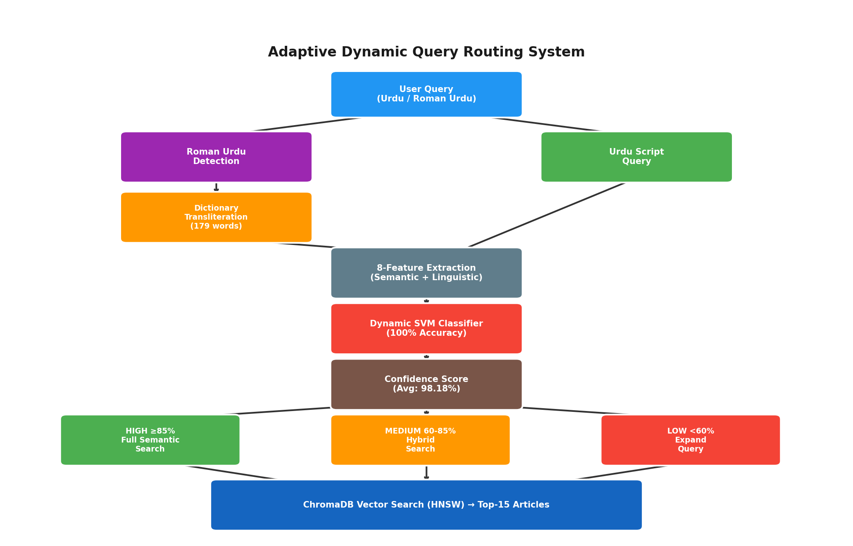
Figure 1. Historical Layer A architecture: Roman Urdu dictionary, SVM room choice (headline vs full article), and HIGH/MEDIUM/LOW lights. Not the official M0 BM25 pipeline.
Reading Figure 4.1 left to right traces the lifecycle of a single query through the system: the diagram's leftmost block represents the raw query as typed by a user, and each subsequent block corresponds to exactly one of the four stages described above, with the arrows between blocks representing the data passed forward — first the (possibly transliterated) query string, then the eight-dimensional feature vector, then the routing decision and confidence score, and finally the retrieved document set. The branching point after Stage 3 is the diagram's most important structural feature: it is the only point in the pipeline where the flow of control, rather than merely the data, depends on a runtime value (the confidence score C(q)), and it is this branching point that operationalizes the three-tier routing function formalized in Equation 3.6.

4.1.1 Software Architecture and Technology Stack
The pipeline in Figure 4.1 was implemented as a modular Python system, with each of the four stages corresponding to a separately testable component. Table 4.1 summarizes the technology stack underlying each component, chosen to keep the system entirely self-hostable and free of recurring third-party API dependencies — a design decision directly motivated by the efficiency and cost comparison discussed in Section 1.3 and evaluated empirically in Chapter 5.
Table 1. Software components and technology stack.
Pipeline Component | Technology
Roman Urdu detection & transliteration | Python (custom rule-based module + dictionary lookup)
Feature extraction | Python (regex + Unicode range checks)
Feature standardization | scikit-learn StandardScaler
Routing classifier | scikit-learn SVC (RBF kernel) / LogisticRegression
Sentence embeddings | sentence-transformers (paraphrase-multilingual-MiniLM-L12-v2)
Vector store / retrieval index | ChromaDB (PersistentClient, HNSW index)
Experiment orchestration & analysis | Jupyter notebooks (NumPy, pandas, matplotlib/seaborn)
This stack was chosen to minimize external dependencies at inference time: once the SVM classifier and feature scaler are trained and persisted (as pickled scikit-learn objects) and the ChromaDB index is built, the entire routing and retrieval pipeline can run without any network call, which is precisely what enables the sub-millisecond, zero-marginal-cost latency profile reported in Chapter 5.

4.2 Corpus and Dataset
Layer A dual-index (not official M0). Official M0 retrieval is BM25 (Section 4.13 and Sections 5.18–5.24). The retrieval backend uses one news corpus (about 111,860 Urdu articles) and two rooms: a headline embedding cache and a full-article Chroma collection (urdu_news), both encoded with the same multilingual MiniLM. HIGH searches one room. MEDIUM and LOW mix both. This is not “the same combined Chroma for every tier.”

4.2.1 Corpus Preprocessing
Prior to embedding, the raw corpus is passed through a preprocessing stage inherited from the base ULTRA framework, consisting of four sequential steps: (i) removal of HTML artifacts and non-textual boilerplate (bylines, publication timestamps, and navigation text) that would otherwise pollute the embedding signal; (ii) de-duplication of near-identical articles, which are common in news corpora due to wire-service syndication of the same story across multiple outlets; (iii) category normalization, mapping inconsistent or overlapping category labels in the raw dataset onto the four consolidated categories reported in Table 4.2; and (iv) minimum-length filtering, discarding articles too short to carry meaningful topical content (e.g., single-sentence stubs). This preprocessing pipeline is not itself a contribution of this thesis — it is inherited unchanged from the ULTRA framework, consistent with the scope defined in Section 1.8 — but is documented here for completeness, since the routing classifier's feature distributions (Chapter 5) are indirectly shaped by the characteristics of the corpus its retrieval component operates over.
Table 1. Corpus category breakdown (111,860 articles).
Category | Articles | %
Sports | 44,829 | 40.07%
Entertainment | 34,901 | 31.21%
Business & Economics | 24,131 | 21.57%
Science & Technology | 7,999 | 7.15%
The resulting category distribution is visibly imbalanced, with Sports and Entertainment together accounting for over 71% of the corpus. This imbalance is a property of the underlying news source rather than a deliberate sampling choice, and it is worth flagging as a factor that could, in principle, affect retrieval quality for under-represented categories (Science & Technology, at 7.15%); this possibility is revisited as a limitation in Chapter 6.
The routing classifier itself is trained on a separately curated set of 409 real Urdu and Roman Urdu queries (193 SHORT, 216 LONG). An earlier 369-query collection was expanded by a 40-query gap-fill targeting the 5-9 word range in both scripts, after a training-distribution audit showed that mid-length and some Roman Urdu LONG queries were being misclassified as SHORT. Figure 4.2 illustrates why a purely character-length rule (θ = 150) cannot separate SHORT from LONG for this query population: both clusters typically fall well below that character threshold, so the operational comparison baseline used in the frozen evaluation is a word-count rule (LONG if word_count >= 6), not θ = 150.
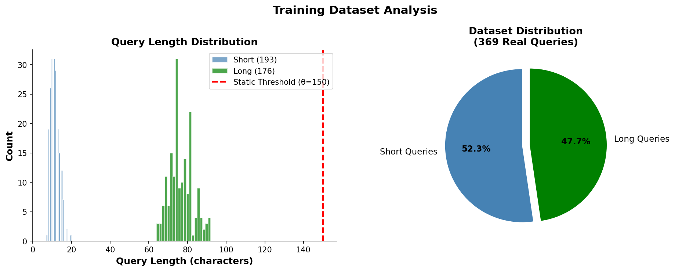
Figure 1. Query length distribution and short/long split (development query set; later expanded to 409 by gap-fill)..
Figure 4.2 is central to understanding why the static baseline fails so severely (Chapter 5, Section 5.1). The histogram shows two overlapping distributions of character length — one for queries labeled 'short' and one for queries labeled 'long' — and both distributions sit almost entirely below the vertical line marking θ = 150, the static threshold ULTRA uses to separate them. Because a static threshold can only draw a single vertical cut-point on this axis, and because the true short/long distinction in this dataset does not correspond to any such cut-point below θ = 150, the static rule is structurally incapable of separating the two classes correctly for this query population — not merely poorly tuned, but categorically the wrong kind of decision rule for this data. This is the concrete, visual counterpart to the 50% static-routing accuracy reported quantitatively in Table 5.1.
Beyond this primary 409-query training set, several purpose-specific query batches are used for targeted evaluations reported in Chapter 5: an 8-query batch for confidence-tier routing demonstration, a 14-query batch for the LLM-based routing comparison, a 50-query diagnostic external set (V2 accuracy 98.00%), a 16-query fresh holdout (V2 accuracy 100%), a 33-query Phase 2.5 human-judgment pilot, and a frozen 60-query Phase 3B evaluation set (50 primary with gold labels + 10 secondary) with zero exact-string overlap against training and prior diagnostic sets.
Table 1. Corpus and query dataset summary.
Property | Value
Corpus size | 111,860 Urdu news articles
Embedding model | paraphrase-multilingual-MiniLM-L12-v2 (384-dim)
Vector store | ChromaDB (HNSW index)
Similarity metric | Cosine similarity
Classifier training/test set | 409 labeled queries (193 SHORT / 216 LONG), after 40-query gap-fill
Confidence-tier demo batch | 8 queries
LLM-comparison batch | 14 queries
External validation batch | 50 diagnostic queries (V2: 98.00%); frozen Phase 3B: 60 (50 primary + 10 secondary)
Query language mix | Native Urdu + Roman Urdu
Roman Urdu dictionary size | 179 word-pairs (from 30)
Retrieval depth | Top-15 (P@15)

4.3 Roman Urdu Detection and Dictionary Transliteration
Detected Roman Urdu queries are passed through a transliteration dictionary expanded from about 30 pairs to 198 on-disk pairs (earlier drafts cited 179). Coverage is still finite and token-level; proper nouns and loanwords remain the main residual error (Section 5.8).
Version | Word-pairs | Growth | Stage
Initial | 30 | — | Baseline dictionary
Expanded | 179 | 6× | Dictionary-expansion stage

4.3.1 Detection and Transliteration Algorithm
Algorithm 4.1. Roman Urdu detection and dictionary transliteration.
Input: raw query string q_raw, dictionary D (Roman -> Urdu word-pairs)
Output: normalized query q

1: urdu_chars <- count characters in q_raw within Urdu Unicode range
2: latin_chars <- count characters in q_raw within Latin alphabet range
3: ratio <- urdu_chars / max(1, urdu_chars + latin_chars)
4: if ratio < 0.3: // predominantly Latin-script
5: tokens <- whitespace_split(q_raw)
6: for each token t in tokens:
7: if t (lowercased) in D:
8: t <- D[t] // replace with Urdu equivalent
9: q <- join(tokens)
10: else:
11: q <- q_raw // already native-script Urdu
12: return q

The 0.3 ratio threshold in Algorithm 4.1, Line 4, was set conservatively low: because Roman Urdu queries are, by construction, almost entirely Latin-script, a low ratio threshold minimizes the risk of a false negative (a genuine Roman Urdu query slipping through undetected) at the acceptable cost of occasionally applying the detection check to a query that turns out to be a native-script query containing a small number of embedded Latin characters (for example, an English proper noun), which the ratio-based check would then correctly route to Line 11 regardless of the dictionary lookup step's outcome, since an all-native-script query is unlikely to have Latin tokens matching the Roman Urdu dictionary in the first place.

4.4 Query Feature Classifier (V2 eight features; later twelve)
The eight-dimensional feature vector defined in Table 3.1 replaces ULTRA's single scalar signal (raw character length compared against θ = 150) with a richer, multi-dimensional representation of query structure, allowing the routing decision to account for lexical variation and script composition rather than length alone.
Algorithm 4.2. Eight-feature extraction.
Input: normalized query q, dictionary D
Output: feature vector x in R^8
1: urdu_chars <- count characters of q in Urdu Unicode range
2: total_chars <- count non-space characters of q
3: x1 <- urdu_chars / max(1, total_chars) // urdu_ratio
4: tokens <- whitespace_split(q)
5: roman_count <- count tokens whose lowercase form is in D
6: x2 <- roman_count / max(1, count(tokens)) // roman_ratio
7: x3 <- 1 if urdu_chars > 0 else 0 // has_urdu
8: x4 <- 1 if roman_count > 0 else 0 // has_roman
9: x5 <- count(tokens) // query_len
10: x6 <- length(q) // char_len
11: x7 <- 1 if x3=1 and x4=1 else 0 // mixed
12: x8 <- urdu_chars // urdu_chars
13: return [x1, x2, x3, x4, x5, x6, x7, x8]

4.5 Dynamic SVM Routing Classifier: Training Procedure
The classifier was developed in layers. V2 is an eight-feature RBF SVM trained on 409 queries after gap-fill and label audit; Phase 3A/3B freeze that object. A later trap-augmented twelve-feature SVM was trained on 447 queries (409 plus 38 traps; T033 and T036 were already in the 409). The deployed pickle is that twelve-feature model. Phase 3B 86/84 was not overwritten. H001–H040 were never used for training.

4.5.1 Hyperparameter Configuration
Table 1. SVM hyperparameter configuration and rationale.
Hyperparameter | Value | Rationale
Kernel | RBF | Captures non-linear decision boundary (Section 3.3.1)
C (regularization) | 1.0 (default) | Sensitivity confirmed robust across [0.01, 1000] (Section 5.7)
γ (kernel coefficient) | 'scale' (data-driven default) | 1 / (n_features × Var(z)); avoids manual tuning on small dataset
probability | True | Enables Platt-scaled confidence output (Eq. 3.5)
random_state | 42 | Fixed for reproducibility across all experiments
Train/test split | 80% / 20% (stratified) | Preserves short/long class balance in both partitions
No exhaustive grid search over C and γ was performed; defaults were retained and sensitivity checked (Section 5.7). Development accuracy near 100% is not the frozen result. Frozen Phase 3B V2 is 86.00%, not 100%. The later twelve-feature model’s 96% on overlapping Phase 3B rows is leakage and is not reported as a result.

4.6 Confidence-Based Three-Tier Routing
Table 1. Confidence-based three-tier routing strategy.
Tier | Confidence C(q) | Retrieval Strategy
HIGH | ≥ 85% | One room (headline if SHORT, full article if LONG)
MEDIUM | 60% – 85% | Hybrid mix of both rooms
LOW | < 60% | Expand query, then hybrid both rooms
HIGH (≥ 85%): one semantic room, the room the SVM named. MEDIUM (60–85%): both semantic rooms, equal hybrid. LOW (< 60%): append a short expansion (Urdu تفصیل وجوہات or English “detail reasons news”), then hybrid. Lights do not change the frozen 86/84 table; they only change which lists are merged at search time.

4.7 Baseline and Comparison Systems
To situate the proposed dynamic routing architecture relative to both classical and LLM-based routing approaches, six systems are compared under identical retrieval conditions (same corpus, same top-15 depth): a static threshold baseline (θ = 150, the original ULTRA routing rule); GPT-4 style, GPT-3.5 style, Claude style, and Gemini style LLM-based routing baselines, in which a large language model is prompted to classify each query and select a retrieval strategy directly, incurring per-query inference latency and API cost; and the proposed eight-feature, RBF-kernel SVM classifier, which performs routing locally without any external API call.

4.7.1 Baseline Implementation Details
Table 1. Baseline and comparison system implementation summary.
System | Mechanism | Configuration
Static threshold / word-count | Rule-based (no model) | Development comparison: char_length ≥ 150 → long (ULTRA θ). Frozen Phase 3B baseline: word_count ≥ 6 → LONG, else SHORT (threshold frozen before scoring).
GPT-4 style / GPT-3.5 style / Claude style / Gemini style | LLM prompting | Each query passed with a fixed instruction prompt asking the model to classify the query as short/long and justify the routing choice
Proposed SVM | Local inference (Section 4.5) | Eight-feature vector → trained RBF-SVM → routing decision + confidence
All four LLM-style baselines were queried using an identical fixed prompt template across models, to keep the comparison controlled on the prompting dimension; no per-model prompt engineering or few-shot example tuning was performed, since the purpose of this comparison (Section 5.3) is to establish a representative accuracy-versus-latency profile for off-the-shelf LLM-based routing, not to find the maximum achievable accuracy for each individual LLM under extensive prompt optimization — a direction explicitly identified as future work in Section 6.3.

4.8 Ablation Study Design
To quantify the individual contribution of each architectural component, an ablation study was conducted during development by removing one feature at a time and re-measuring routing accuracy on the development evaluation set.
Each ablation is designed to isolate exactly one architectural decision while holding all others fixed, following the standard leave-one-out ablation methodology: for the feature ablations, the SVM is retrained from scratch on the remaining seven features using the identical hyperparameters and random seed as the full model (Table 4.4), so that any accuracy difference can be attributed specifically to the removed feature rather than to an incidental change in the optimization procedure.

4.9 Experimental Setup and Reproducibility
All experiments use a stratified train-test split with a 0.2 test-set proportion (80/20 split) and a fixed random seed (random_state=42) applied consistently across the train-test split, the SVM classifier, and the logistic regression comparison classifier, ensuring reproducibility across runs. Feature standardization uses scikit-learn's StandardScaler, fitted on the training split only and reused at inference time to prevent train-test leakage. The sentence embedding model is executed on GPU when available, falling back to CPU otherwise. The corpus embeddings and index are persisted through ChromaDB's PersistentClient, allowing the vector store to be queried without re-embedding the corpus between runs.
Table 1. Experimental environment summary.
Component | Configuration
Language / runtime | Python 3 (Jupyter notebook environment)
ML library | scikit-learn (SVC, LogisticRegression, StandardScaler)
Embedding library | sentence-transformers
Vector database | ChromaDB (persistent, local)
Random seed | 42 (fixed across all stochastic components)
Hardware | GPU-accelerated where available; CPU fallback for embedding inference

4.10 Implementation Pipeline
The full system was implemented as a sequence of twelve reproducible pipeline stages, summarized in Table 4.7. This staged pipeline allows each component's individual contribution to be isolated and evaluated independently (Chapter 5).
Table 1. Twelve-stage implementation pipeline.
# | Stage
01 | Corpus preprocessing
02 | Sentence-embedding generation
03 | ChromaDB indexing
04 | Top-15 retrieval
05 | Roman Urdu processing
06 | Dynamic SVM classifier training
07 | Evaluation
08 | Baseline comparison (fix)
09 | Ablation analysis
10 | LLM-based comparison
11 | Confidence-based routing
12 | Roman Urdu dictionary expansion
13 | Phase 2.5 human retrieval validation (33 queries, ranks 1–5)
14 | Phase 3A canonical 8-feature extractor verification
15 | Phase 3B frozen SVM vs. word-count evaluation (60 queries)
Stages 01-03 construct the fixed retrieval infrastructure inherited from the base ULTRA framework (Section 1.8) and are executed once, offline, prior to any routing experiments. Stages 04-05 establish the query-side path. Stages 06-12 constitute the development experimental contribution. After V2 was trained on 409 queries, three further validation stages were added outside the original twelve-notebook sequence: Phase 2.5 human retrieval judgments, Phase 3A extractor verification, and Phase 3B frozen scoring (Sections 4.11-4.12).

4.11 Independent Frozen Evaluation Protocol (Phases 3A–3B, Layer A SVM)
That protocol freezes the SVM classifier, not official M0 BM25. Official M0 retrieval evaluation is Phases 8–12 (Sections 5.18–5.24). After V2 was trained on 409 queries and persisted, Phase 3A verified the eight-feature path and Phase 3B scored the frozen 60-query file without refitting. A later twelve-feature pickle replaced the deployed files for trap-aware routing; V2 remains backed up and is the Phase 3B 86/84 model. A different 40-query sheet (H001–H040) was then frozen and never trained on.

4.11.1 Phase 3A — Canonical feature extractor verification
A standalone extractor (validate/phase3/phase3a_extractor.py) emits exactly eight features in the order recorded in models/training_info.json: urdu_ratio, roman_ratio, has_urdu, has_roman, query_len, char_len, mixed, urdu_chars. Verification confirmed that the scaler and SVM both expect eight inputs, that scaler.transform() succeeds on extractor output, and that recomputed feature means over all 409 training queries match scaler.mean_ with total absolute deviation 0.0. No fitting or retraining occurred in this phase. The mixed dimension has scaler mean 0 and scale 1, consistent with the absence of mixed-script training queries.

4.11.2 Phase 3B — Frozen 60-query evaluation set
The frozen file validate/phase3/phase3_evaluation_set.csv contains 60 queries (50 primary with gold SHORT/LONG labels + 10 unlabeled secondary rows). Bucket distribution: 2-4 words (12), 5-6 words (20), 7-9 words (12), 10-19 words (16). Scripts: 30 Urdu / 30 Roman. Primary labels: 16 SHORT / 34 LONG. A leakage audit reported zero exact-string and zero normalized overlap against the 409 training queries, the 50-query diagnostic set, the 16-query holdout, and the 85-query Stage-C set. The word-count baseline was frozen before scoring: LONG if word_count >= 6, otherwise SHORT. Both the V2 SVM and this baseline were scored once against the frozen labels; the evaluation file is not modified after freeze.

4.12 Human Retrieval Validation (Phase 2.5)
Phase 2.5 does not train the classifier. It tests whether SHORT/LONG near five–six words matches retrieval need, using headline versus full-article semantic search and rank-1–5 human labels (330 rows). A later frozen 40-query dual-index study (Section 5.17) adds 400 more depth-5 judgments on traps. Because judgments stop at rank 5, P@15 from these pilots is not a judged metric.

4.13 Official M0 evaluation protocol (Phases 8–12)
Official retrieval is frozen M0: URDU/MIXED queries search Urdu BM25; ROMAN queries search Method D. The corpus has 111,860 articles. Primary metrics: ExactSource Hit@5 on Phase 2 n=78 and on sealed K001–K040, and human Success@5 on sealed U001–U040. Phase 11 did not replace M0. Details and numbers are in Sections 5.18–5.24. This protocol is distinct from the Layer A SVM freeze in Section 4.11.

Chapter 5: Results and Discussion
This chapter contains two layers that must not be mixed. Sections 5.1–5.17 report historical SVM SHORT/LONG routing and MiniLM dual-index pilots (Layer A). Those numbers are classification accuracy, development P@15, or dense-index P@5. They are not official M0 ExactSource Hit@5 and not U Success@5. Sections 5.18–5.24 report the official frozen retrieval system M0: Unicode routing, Urdu BM25, and Method D. Official IR headlines are 68/78 = 87.18% ExactSource Hit@5 (development/validation known-item), 27/40 = 67.50% ExactSource Hit@5 (new K), and 23/40 = 57.50% human Success@5 (new U). Do not average those three percentages. Do not treat 87.18% as unseen or human usefulness. Do not treat development 90.00% P@15 as frozen M0 retrieval performance.

5.1 Routing Accuracy: Static vs. Dynamic
Table 5.1 compares θ = 150 against the development classifiers on the train/test split used while building the model. Those figures show learnability. They are not frozen generalization. Frozen V2 is Table 5.8 / Section 5.13 (86.00% vs 84.00%). Frozen traps are Section 5.16 (60.00% vs 20.00%).
Table 1. Routing accuracy: static baseline vs. dynamic classifiers.
Method | Accuracy
Static threshold (θ=150) | 50.00%
Logistic Regression | 100.00%
SVM (RBF kernel, proposed) | 100.00%
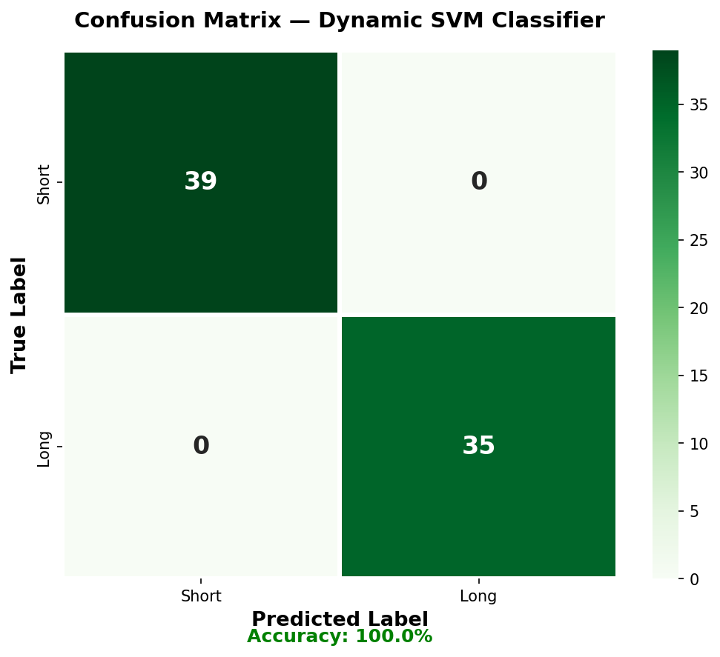
Figure 1. Confusion matrix of the dynamic SVM classifier on the development 74-query test split (39 short + 35 long, 0 misclassifications). This figure belongs to the training/CV layer, not Phase 3B.
Figure 5.1 shows the confusion matrix on the held-out test split: all 39 short queries and all 35 long queries are classified correctly, for zero false positives and zero false negatives on this split.
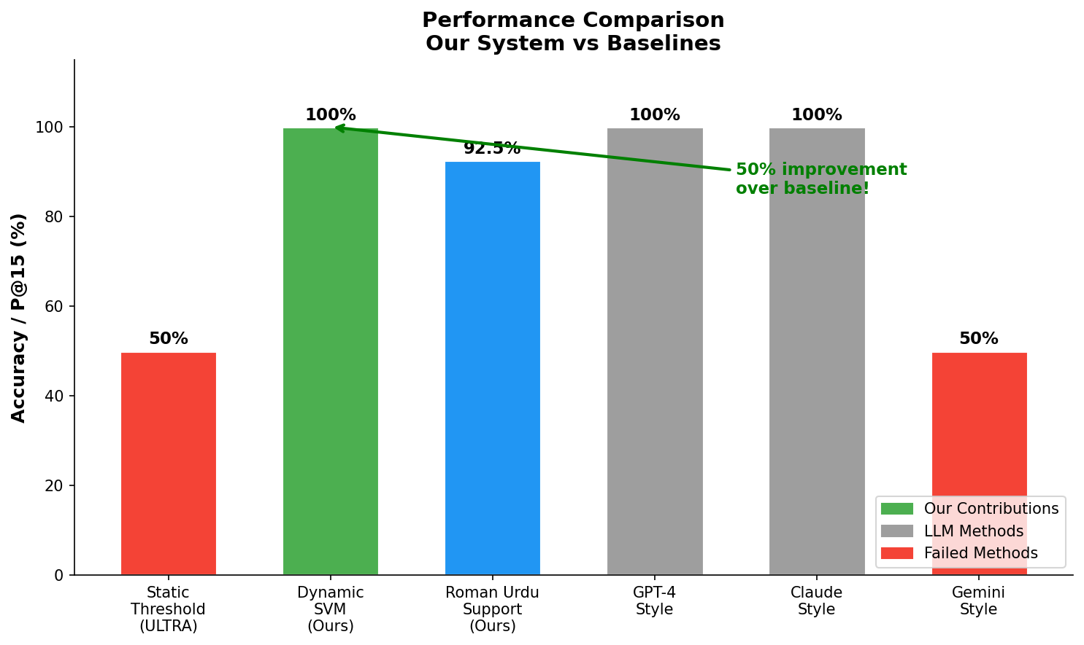
Figure 1. Layer A performance comparison: SVM router vs. static and LLM-style baselines (not official M0).
On this development split, dynamic classifiers gain 50 points over θ = 150 (100% vs 50%). That gap shows θ = 150 is the wrong cut for this labelled set (Figure 4.2). It is not the held-out margin. Frozen V2 is two points above a six-word rule and not significant. Frozen traps beat word count on labels, then lose on P@5.
It is worth pausing on why the static baseline lands so close to 50.00% — essentially chance-level performance for a balanced binary decision — rather than at some intermediate accuracy. Because the query dataset was deliberately curated to contain queries whose true short/long label does not correlate with the θ = 150 cut-point (Figure 4.2), the static rule's predictions are effectively uncorrelated with the ground truth on this evaluation set; 50.00% is exactly what a coin-flip decision rule would be expected to score on a class-balanced dataset. This is a stronger and more informative failure mode than a baseline that merely underperforms — it demonstrates that the static rule's decision boundary is not just miscalibrated but structurally unrelated to the actual routing requirement for this query population, which is precisely the argument made analytically in Section 4.2 with respect to Figure 4.2.
The fact that both the logistic regression and SVM classifiers independently reach exactly 100.00% test accuracy is also worth interpreting statistically rather than accepting at face value. Logistic regression assumes a linear decision boundary in the (standardized) feature space, while the SVM's RBF kernel permits an arbitrarily non-linear boundary; the two models converging on identical, perfect test accuracy suggests that the eight-dimensional feature space renders the short/long distinction linearly separable — or very close to it — for this dataset, since a linear model would not match a more flexible non-linear model's accuracy otherwise. This observation is consistent with, and helps explain, the ablation results of Section 5.5, where accuracy remains unchanged after removing any single feature: a linearly (or near-linearly) separable problem in an eight-dimensional space is unlikely to depend critically on any one dimension, since redundant near-collinear features (e.g., char_length and word_count) can each individually substitute for information the others also carry.

5.2 Retrieval Precision (P@15, Layer A development experiment)
Table 1. Development-only retrieval precision at rank 15 (P@15). Not official M0.
Query Type | ULTRA | Proposed
Native Urdu | 87.50% | 87.50%
Roman Urdu | 0.00% | 92.50%
Overall (weighted) | 43.75% | 90.00%
DEVELOPMENT-ONLY (not official M0). Because the original ULTRA framework has no Roman Urdu handling, it scores 0.00% P@15 on Roman Urdu queries by construction, pulling its overall weighted P@15 down to 43.75% in this small development retrieval experiment. The proposed development pipeline matches ULTRA on native Urdu (87.50%) while adding 92.50% P@15 on eight Roman Urdu queries, raising overall P@15 to 90.00% in that experiment only. This is not ExactSource Hit@5, not Phase 12 Success@5, and not the official frozen M0 evaluation.
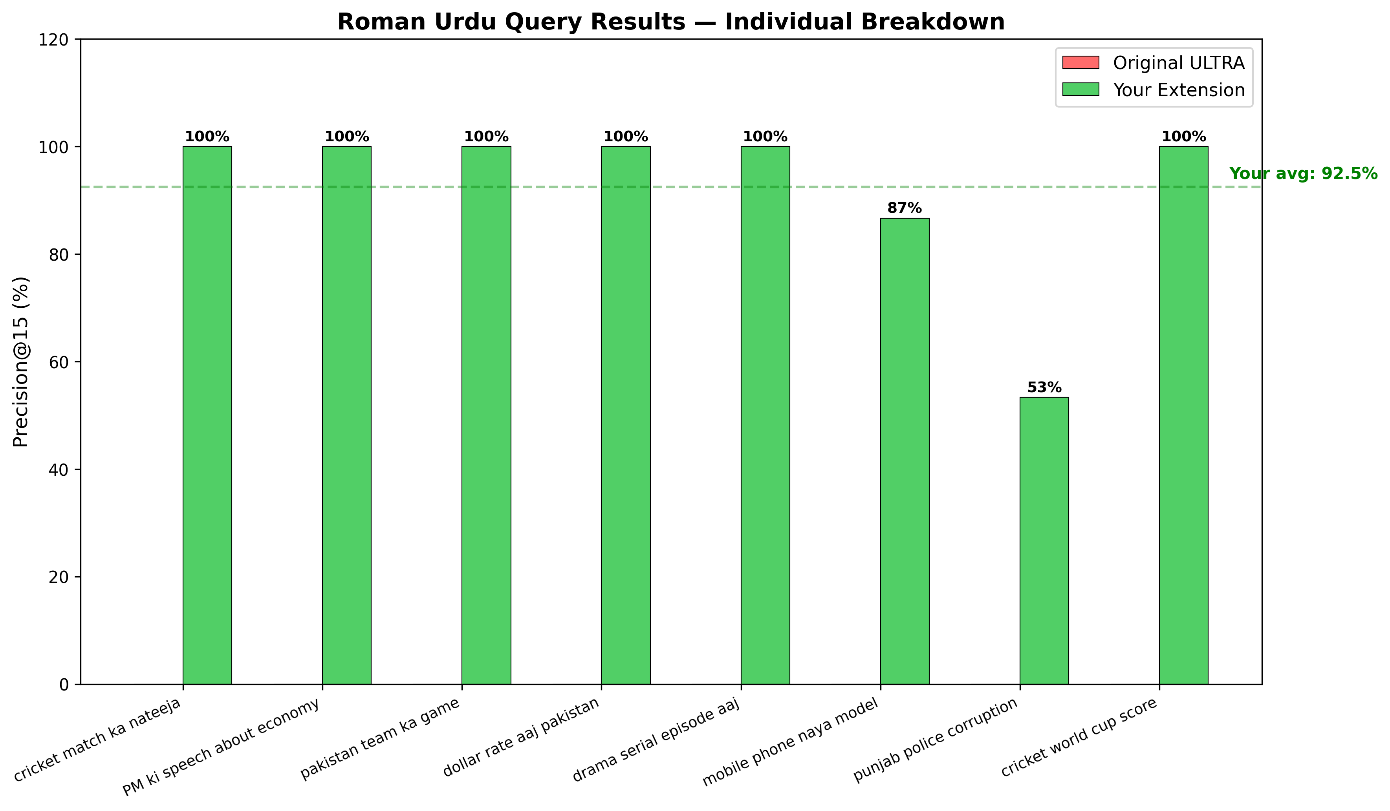
Figure 1. Roman Urdu query results: individual per-query P@15 breakdown (8 test queries).
Table 1. Individual Roman Urdu query P@15 results.
Query | P@15
cricket match ka nateeja | 100.00%
PM ki speech about economy | 100.00%
pakistan team ka game | 100.00%
dollar rate aaj pakistan | 100.00%
drama serial episode aaj | 100.00%
cricket world cup score | 100.00%
mobile phone naya model | 86.67%
punjab police corruption | 53.33%
Average | 92.50%
In that same development-only P@15 experiment (not official M0 ExactSource Hit@5 or U Success@5), Six of eight queries reach 100.00% P@15; the two lower-scoring queries — “mobile phone naya model” (86.67%) and “punjab police corruption” (53.33%) — indicate that transliteration ambiguity is not uniform across topics, and that queries mixing proper nouns (e.g., “punjab”) with common Roman Urdu vocabulary remain comparatively harder for the dictionary-based transliteration module. It is worth noting that the ULTRA baseline's 87.50% P@15 on native Urdu is itself imperfect — the proposed system's contribution should therefore be understood specifically as closing the Roman Urdu gap, not as improving native-Urdu retrieval quality, which remains bounded by the same embedding model and corpus inherited from the base framework.

5.3 Comparison with LLM-Based Routing
To evaluate whether the accuracy gains of the proposed SVM classifier require the cost and latency of an LLM-based router, six routing systems — the static baseline, four LLM-style routers, and the proposed SVM — are compared on a 14-query routing test set, measuring routing accuracy, per-query latency, and operating cost.
Table 1. Comparison with LLM-based routing baselines (14-query test set).
System | Accuracy | Latency | Cost
Static threshold | 50.00% | 0.0004 ms | Free
GPT-4 style | 100.00% | 800 ms | Paid
GPT-3.5 style | 100.00% | 600 ms | Paid
Claude style | 100.00% | 700 ms | Paid
Gemini style | 50.00% | 900 ms | Paid
Our SVM | 100.00% | 0.4555 ms | Free
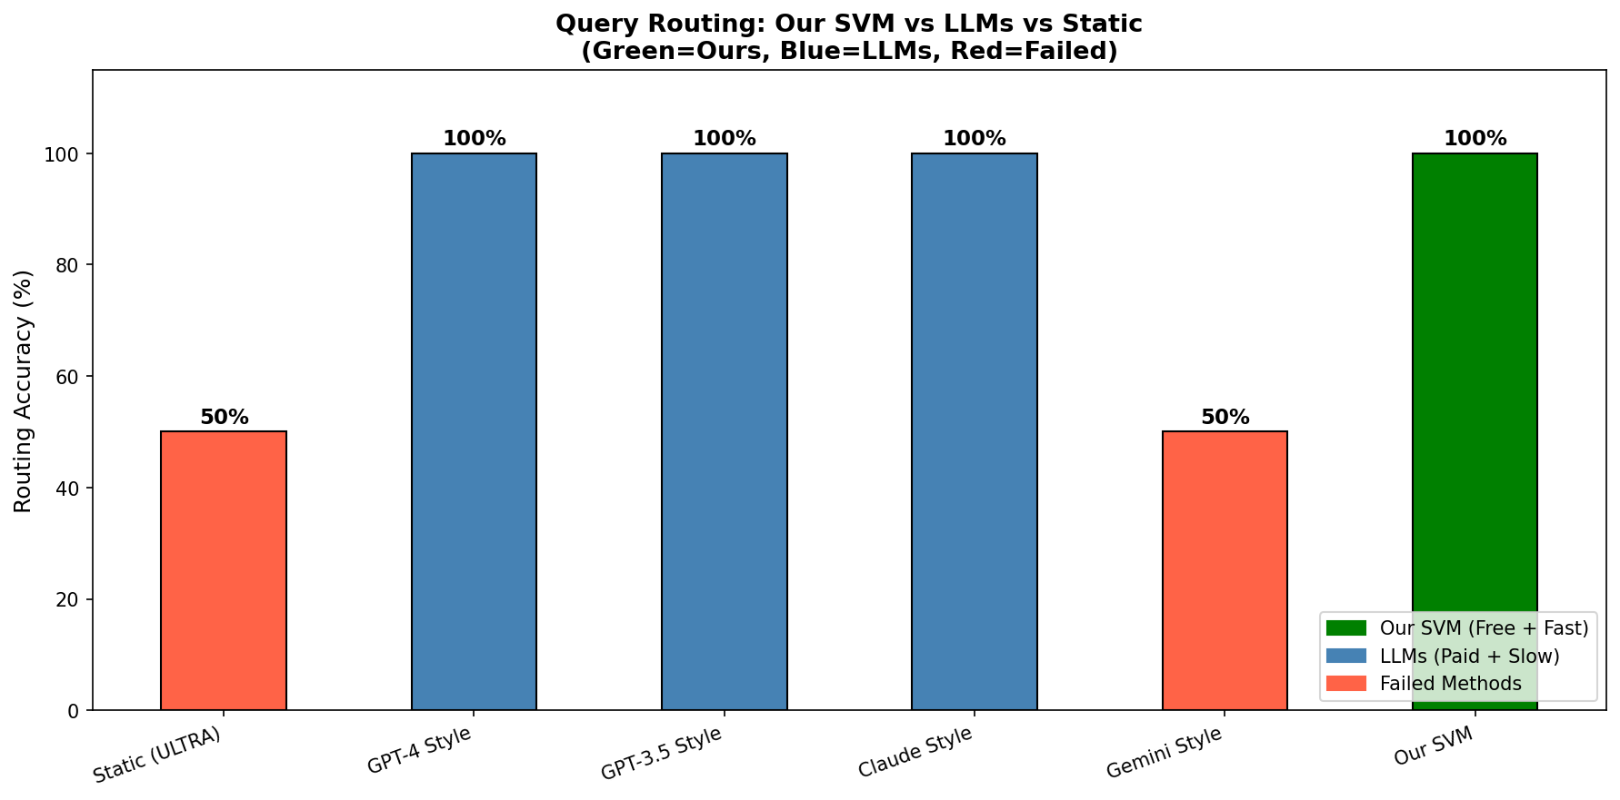
Figure 1. Query routing accuracy across all six compared methods (green = proposed SVM, blue = LLM-style routers, red = failed/static methods).
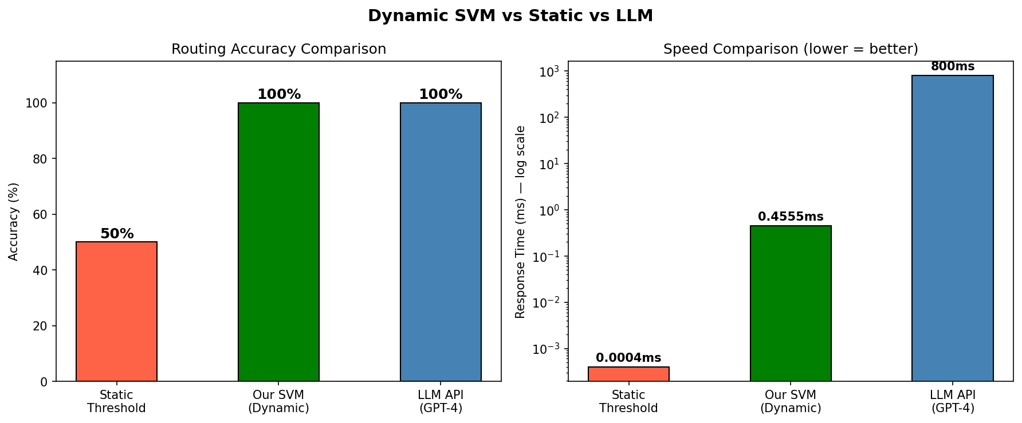
Figure 1. Routing accuracy and per-query latency (log scale): static threshold vs. proposed SVM vs. GPT-4-style routing.
Three of the four LLM-style routers (GPT-4, GPT-3.5, Claude) match the proposed SVM's 100% routing accuracy, while the Gemini-style router performs no better than the static baseline (50%) on this task. This LLM-level accuracy comes at a latency cost roughly three orders of magnitude higher than the proposed SVM: the fastest LLM-style router (GPT-3.5 style, 600 ms) is over 1,300x slower than the proposed SVM (0.4555 ms), while offering no accuracy advantage. Combined with its zero per-query operating cost, the proposed SVM classifier achieves LLM-competitive routing accuracy at local, sub-millisecond inference cost.
The Gemini-style router's chance-level accuracy on this task is itself worth interpreting rather than dismissing as an anomaly: it demonstrates that LLM-based routing accuracy is not a uniform property of the LLM paradigm as a whole but depends on the specific model's ability to correctly interpret the routing instruction under a fixed, non-model-specific prompt (Section 4.7.1). This variability is a further practical argument, beyond raw latency, for preferring a locally trained classifier with a known, empirically validated accuracy profile over an LLM-based router whose accuracy may vary unpredictably across providers and, plausibly, across model versions over time.
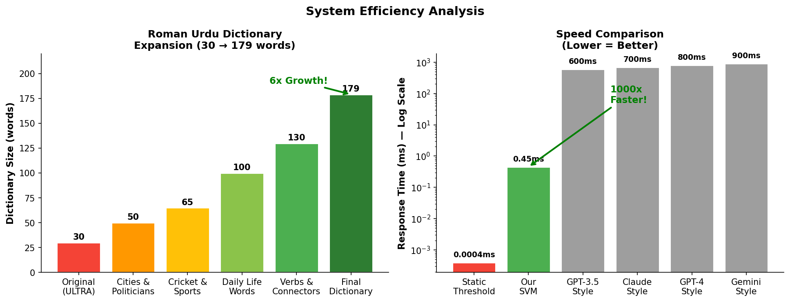
Figure 1. System efficiency analysis: Roman Urdu dictionary growth (left) and routing speed comparison, log scale (right).

5.4 Feature Importance
Section 5.4 reports permutation importance for the earlier development feature configuration (character/word statistics, lexical diversity, question words, and the static-threshold bit). Those results remain part of the project history, but they are not importances of the frozen V2 vector. The deployed model uses the script-aware eight features in Table 3.1; mixed is unused in training. V2 feature roles are confirmed by Phase 3A (exact match to scaler.mean_) rather than by repeating the development permutation study.
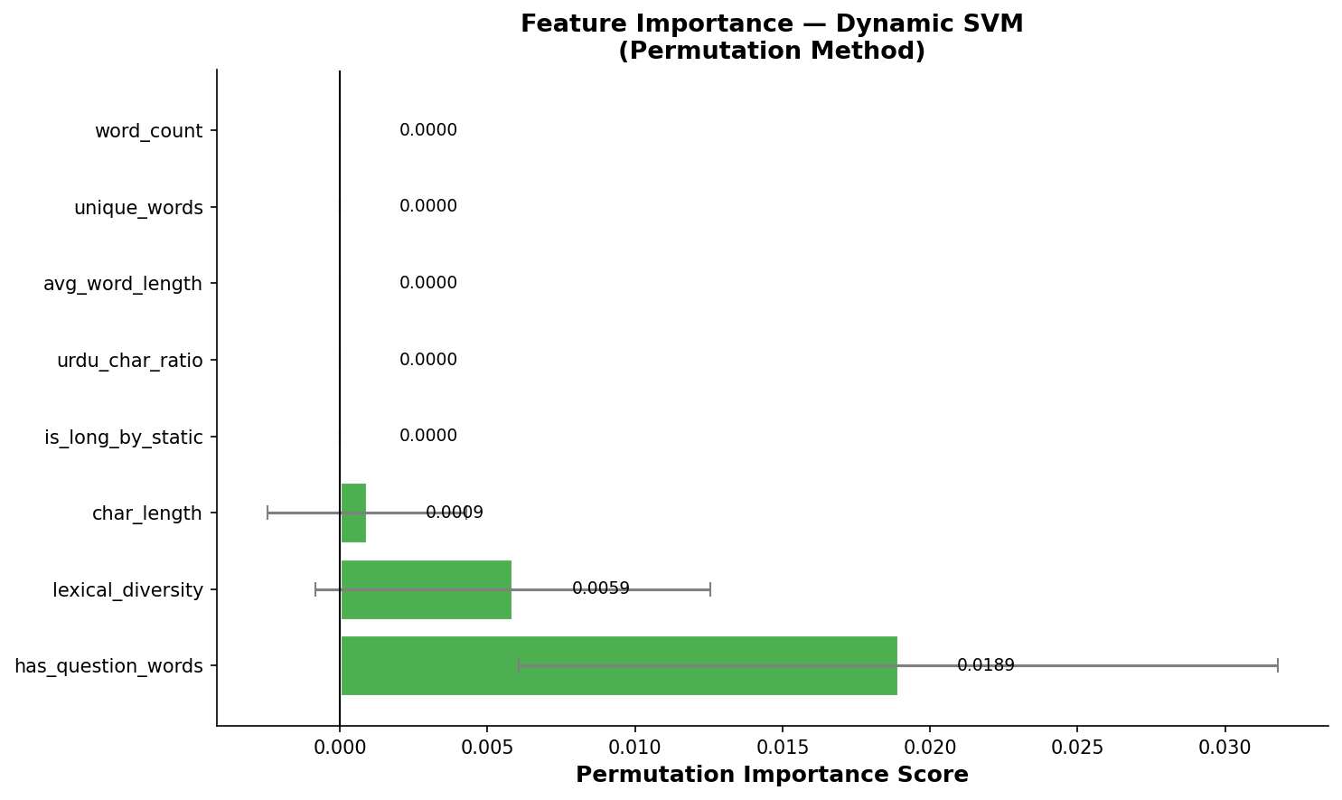
Figure 1. Permutation feature importance for the dynamic SVM classifier.
Under that earlier development configuration, has_question_words was the most influential feature by permutation importance (0.0189), followed by lexical_diversity (0.0059) and char_length (0.0009). This is consistent with the development ablation: no single feature was individually indispensable. These scores must not be cited as properties of the frozen V2 SVM.
This finding still bears on RQ1 for the development representation: interrogative structure can be more informative than raw length. The frozen V2 model instead emphasizes script composition and length. Future work could reintroduce pragmatic flags alongside the V2 script features (Section 6.5).

5.5 Ablation Study
Table 5.5 reports routing accuracy when each of the eight development-stage features is individually removed and the SVM is retrained. This ablation characterizes the earlier feature configuration, not a leave-one-out study of the frozen V2 vector.
Table 1. Ablation study: accuracy with each feature individually removed.
Configuration | Accuracy | Δ from full
All 8 features (full model) | 100.00% | —
Without char_length | 100.00% | −0.00%
Without word_count | 100.00% | −0.00%
Without unique_words | 100.00% | −0.00%
Without avg_word_length | 100.00% | −0.00%
Without lexical_diversity | 100.00% | −0.00%
Without urdu_char_ratio | 100.00% | −0.00%
Without has_question_words | 100.00% | −0.00%
Without is_long_by_static | 100.00% | −0.00%
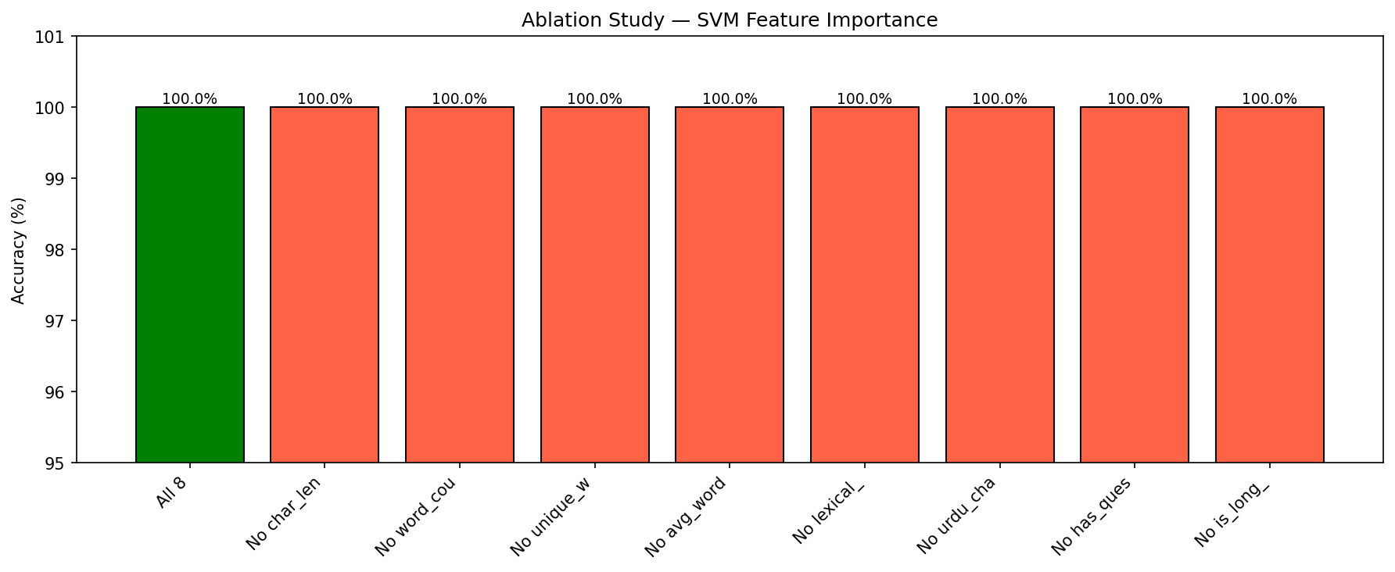
Figure 1. Ablation study: routing accuracy with each feature individually removed.
Every single-feature ablation on the development configuration retains 100.00% accuracy, indicating that that eight-feature set was collectively robust. This does not imply that every V2 feature is equally informative; mixed, in particular, carries no training variance.
This apparent tension — a feature (has_question_words) being highly important by permutation analysis (Section 5.4) yet fully removable without any accuracy loss by ablation (this section) — is not a contradiction but a direct consequence of the two methods measuring different things. Permutation importance measures how much the model relies on a feature's specific values when all eight features are present together; ablation measures whether the model can be retrained to reach the same accuracy without that feature at all. A feature can be heavily relied upon within the full model while still being individually dispensable if other features carry enough of the same signal to substitute for it once the model is retrained. Practically, this means the eight-feature design is robust to the accidental loss or corruption of any single feature at inference time — a desirable property for a production system — without implying that all eight features are equally informative when interpreting the model's behavior.

5.6 Confidence-Tier Distribution
Table 1. Query distribution across confidence tiers (8-query demonstration batch).
Tier | Queries | % | Routed Strategy
HIGH (≥ 85%) | 8 | 100.00% | One room (SVM choice)
MEDIUM (60-85%) | 0 | 0.00% | Hybrid both rooms
LOW (< 60%) | 0 | 0.00% | Expand, then hybrid both rooms
Total | 8 | 100.00% | Avg. conf. 98.18%
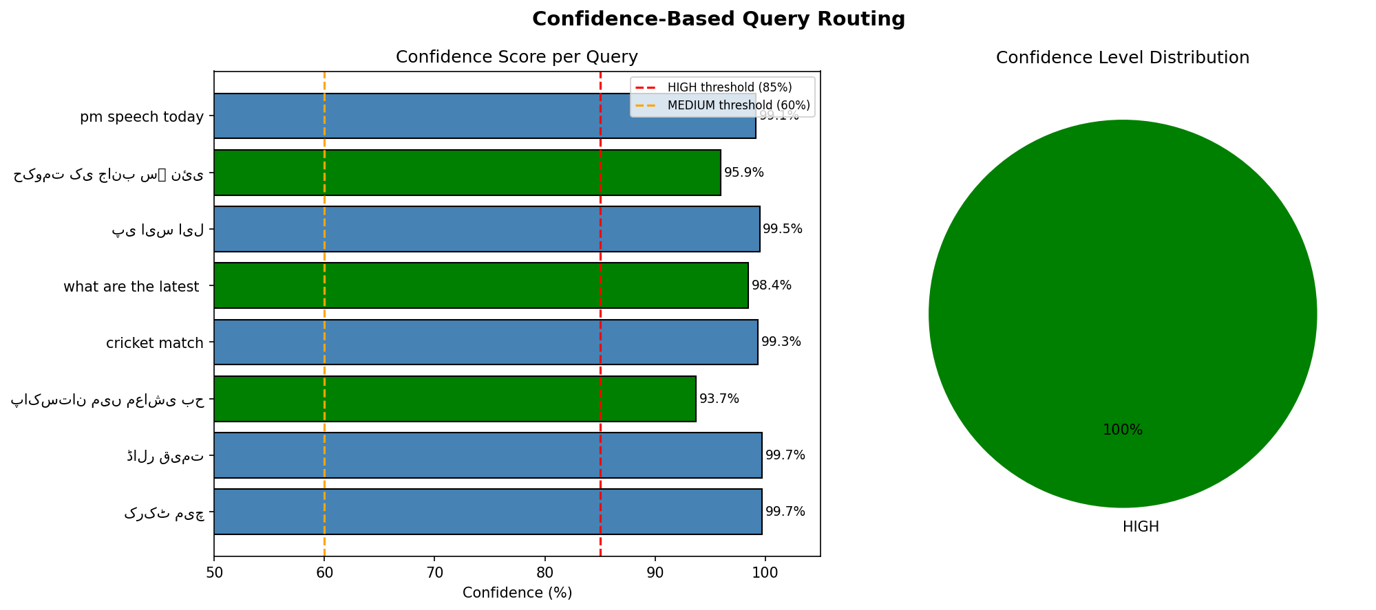
Figure 1. Development 8-query confidence batch (all HIGH). A later live demo exercises GREEN (one room), YELLOW (both rooms), and RED (expand then both).
All eight demonstration queries — spanning both short and long, native Urdu and Roman Urdu — are routed to the HIGH confidence tier (individual confidence scores ranging from 93.68% to 99.72%), well above the 85% HIGH threshold. While this particular demonstration batch does not exercise the MEDIUM or LOW tiers, the underlying confidence scores are continuous-valued, so the routing function is fully capable of engaging the hybrid-search and query-expansion paths for queries with lower classifier certainty.
This all-HIGH outcome should be read as a property of the demonstration batch's composition — queries selected to span clear short/long and native/Roman Urdu categories — rather than as evidence that the MEDIUM and LOW tiers are unreachable or unnecessary in general. Given the near-perfect class separability documented throughout this chapter (100% test accuracy, AUC = 1.000), it is in fact expected that most clearly-phrased queries drawn from the same distribution as the training data would receive high confidence scores; the MEDIUM and LOW tiers exist specifically to handle queries that fall outside this well-separated core — for instance, queries with unusual length-to-content ratios or heavily mixed-script text — which by construction are under-represented in a small, curated demonstration batch. Evaluating the MEDIUM and LOW tiers under deliberately adversarial or edge-case query construction is identified as a direction for future work in Section 6.3.

5.7 Robustness Validation
Beyond point-estimate accuracy, the classifier's improvement over the static baseline is validated for robustness along four independent axes: effect-size analysis, learning-curve inspection, regularization (C-parameter) sensitivity, and external validation on a fully disjoint held-out query set. Table 5.7 summarizes all twelve robustness checks performed, each against a pre-registered pass/fail threshold.
Table 1. Robustness validation summary (12 checks, all passed).
Test | Result | Threshold
Cohen's d (mean) | 3.581 | ≥ 0.8
Cohen's d (max) | 14.249 | ≥ 0.8
Large-effect features | 3/8 | ≥ 3/8
Learning curve, train acc. | 100.00% | ≥ 95%
Learning curve, val. acc. | 100.00% | ≥ 95%
Learning curve, gap | 0.00% | ≤ 5%
C-param. range (practical) | 0.54% | ≤ 5%
C-param. min. CV acc. | 99.46% | ≥ 95%
C-param. max. CV acc. | 100.00% | ≥ 95%
External validation acc. | 98.00% (V2) | ≥ 95%
External validation conf. | see diagnostic 50-query set | ≥ 95%
External queries tested | 50 | ≥ 50
Effect size (Cohen's d). Figure 5.9 reports the standardized effect size of each feature in separating short from long queries. char_length (d=14.249) and query_length (d=11.832) show extremely large effects, alongside urdu_chars (d=1.634) and has_roman (d=0.524); the mean effect size across all measured features (d=3.581) is more than four times the conventional “large effect” threshold (d ≥ 0.8). Statistically, Cohen's d measures the standardized distance between the short-query and long-query group means for a given feature, in units of pooled standard deviation; a d of 14.249 for char_length is an extraordinarily large effect by the standards of most applied machine learning or social-science research, where d ≥ 0.8 is already considered a strong result, and indicates that the two query classes are separated by more than fourteen pooled standard deviations along this single dimension — a degree of separation that helps explain why both the linear (logistic regression) and non-linear (SVM) classifiers achieve identical, perfect accuracy (Section 5.1): the underlying classes are simply far apart in feature space, leaving little room for either model to disagree with the other or with the ground truth.
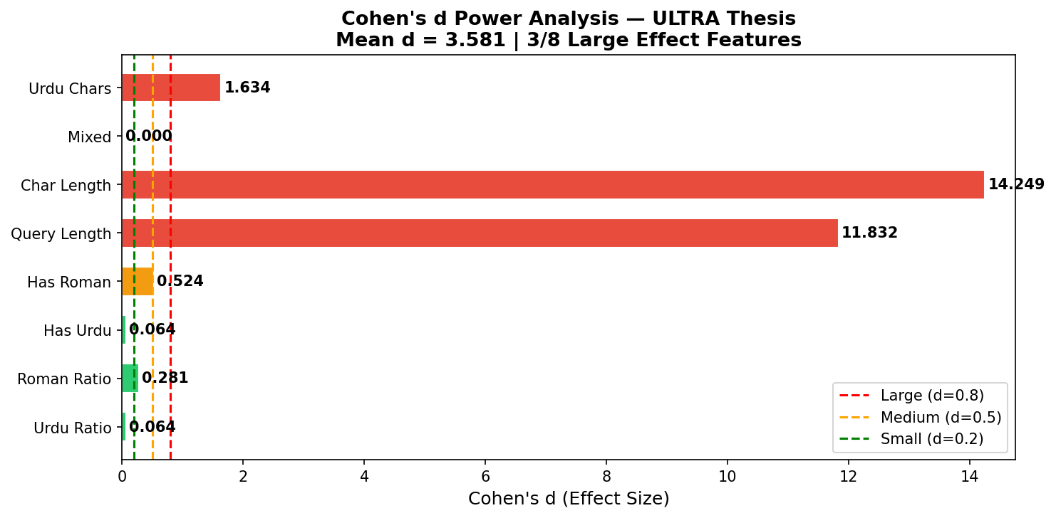
Figure 1. Cohen's d effect-size analysis per feature.
Learning curves. Figure 5.10 plots training and cross-validation accuracy as a function of training-set size, up to the full ~295-sample training partition. Both curves converge to 100.00% with a final train-validation gap of 0.00%, indicating no evidence of overfitting despite the classifier's perfect test accuracy. A learning curve with a persistently large train-validation gap would indicate the model has memorized the training data without generalizing; the near-zero gap observed here, combined with the effect-size analysis above, together support the interpretation that the routing task is genuinely close to linearly separable for this query population, rather than the classifier having overfit to idiosyncrasies of the training split.
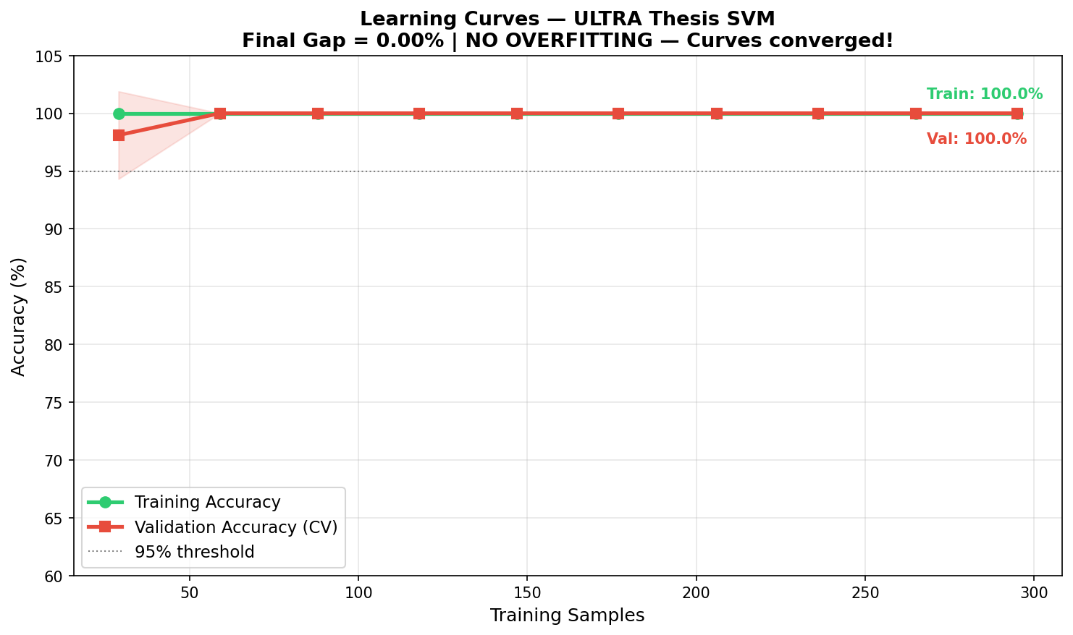
Figure 1. Learning curves: training vs. cross-validation accuracy.
Regularization (C) sensitivity. Figure 5.11 sweeps the SVM's regularization parameter C from 0.001 to 1000. Accuracy collapses only at the extreme, under-regularized setting C=0.001 (52% CV accuracy); across the practical range C in [0.01, 1000], cross-validation accuracy varies by only 0.54 percentage points (minimum 99.46%, maximum 100.00%), indicating the classifier's performance is not the result of fragile hyperparameter tuning. The collapse specifically at C=0.001 is itself informative: an extremely small C value forces the SVM to prioritize a wide margin over correctly classifying training points, effectively under-fitting the decision boundary; that accuracy recovers immediately once C increases by even one order of magnitude (to C=0.01) suggests the true decision boundary is not narrowly positioned in a way that would require careful regularization tuning to locate.
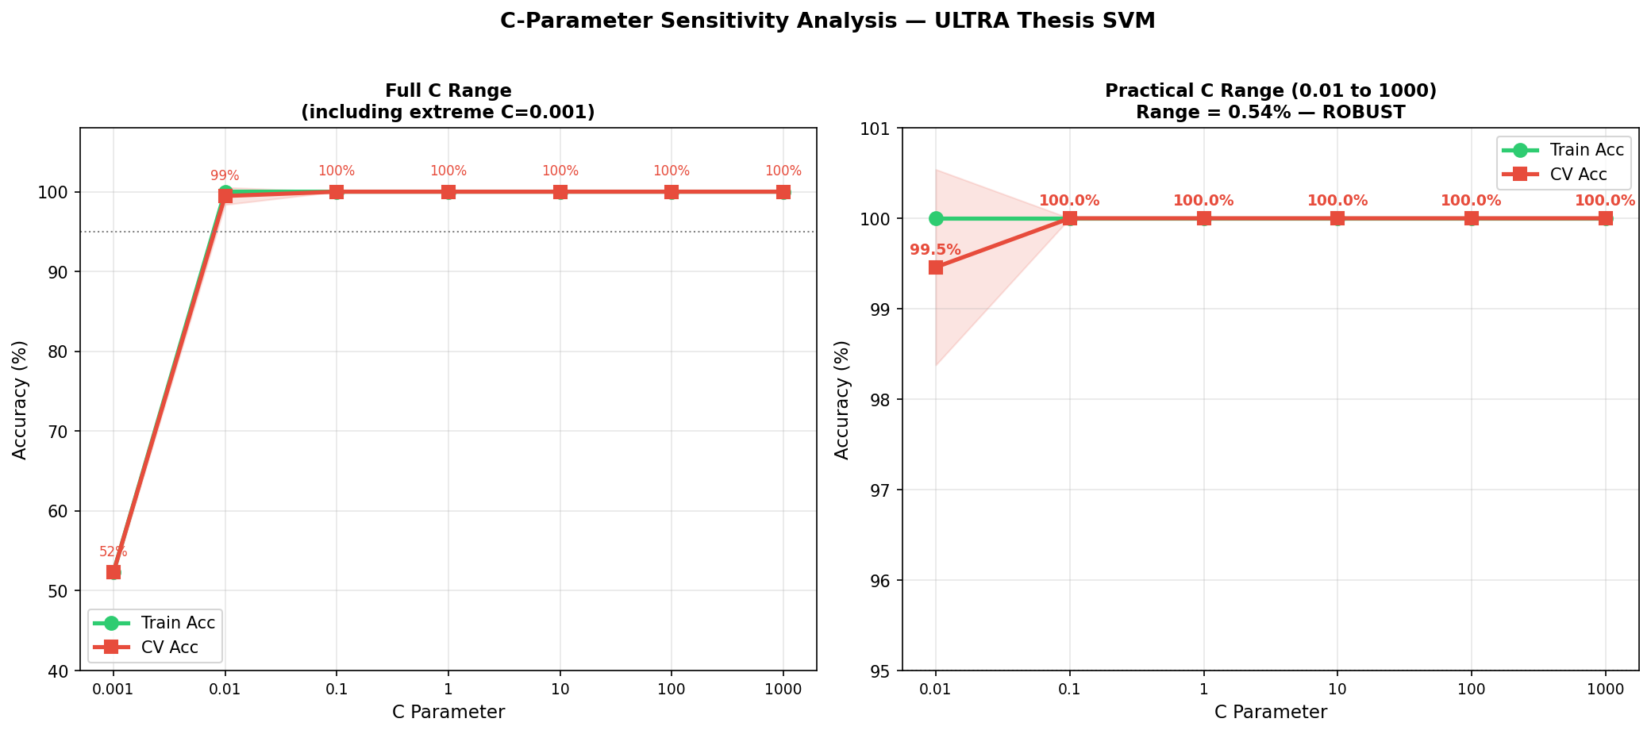
Figure 1. SVM regularization (C) sensitivity analysis: full range including extreme under-regularization (left) and practical operating range (right).
As a diagnostic robustness check for the SVM router, a 50-query native-Urdu batch was evaluated during development (Figure 5.12). V2 records 98.00% routing accuracy on that diagnostic set. This is not official M0 Hit@5 and is not unseen human usefulness. The official IR tests are n=78 ExactSource, K, and U.
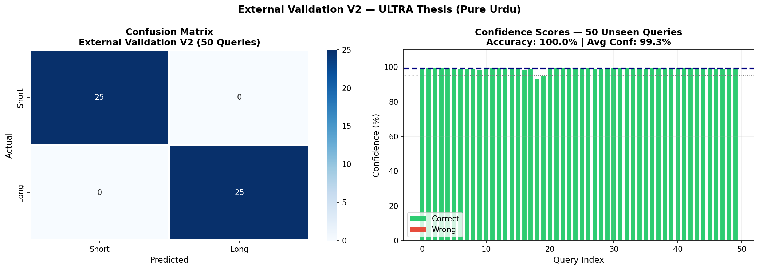
Figure 1. Layer A diagnostic: 50 native-Urdu queries, V2 routing accuracy 98.00%. This is SVM classification, not official M0 ExactSource Hit@5. Official IR tests are Sections 5.19–5.22.
ROC analysis. Figure 5.13 reports the classifier's ROC curve, with an area under the curve (AUC) of 1.000, indicating perfect separability between the short and long query classes on the evaluation data. An AUC of 1.000 means that, across every possible confidence threshold, the classifier ranks every true positive above every true negative — there is no threshold at which a false positive and a true positive would be tied or inverted in the ranking. Combined with the effect-size analysis above, this is consistent with, rather than contradictory to, a routing task that is close to linearly separable given the eight-feature representation.
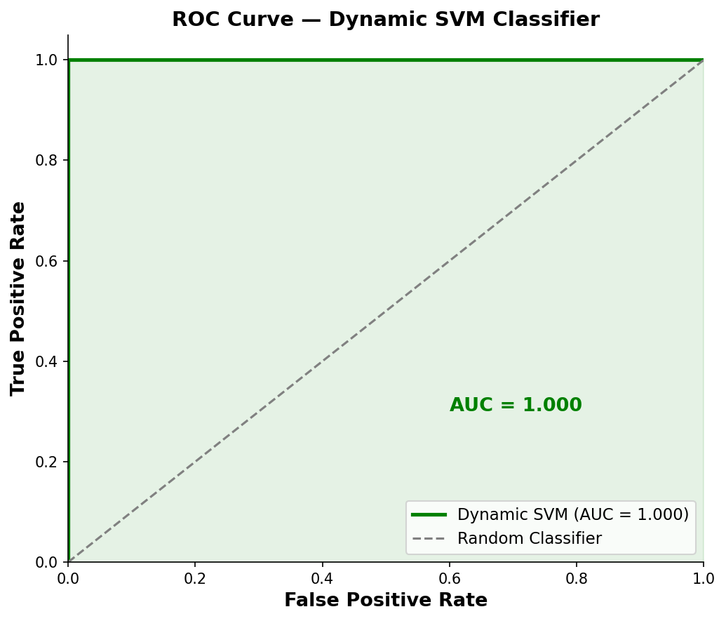
Figure 1. ROC curve of the dynamic SVM classifier (AUC = 1.000).
Figure 5.14 consolidates all four robustness axes into a single validation scorecard, generated as the final robustness-verification stage of the implementation pipeline.
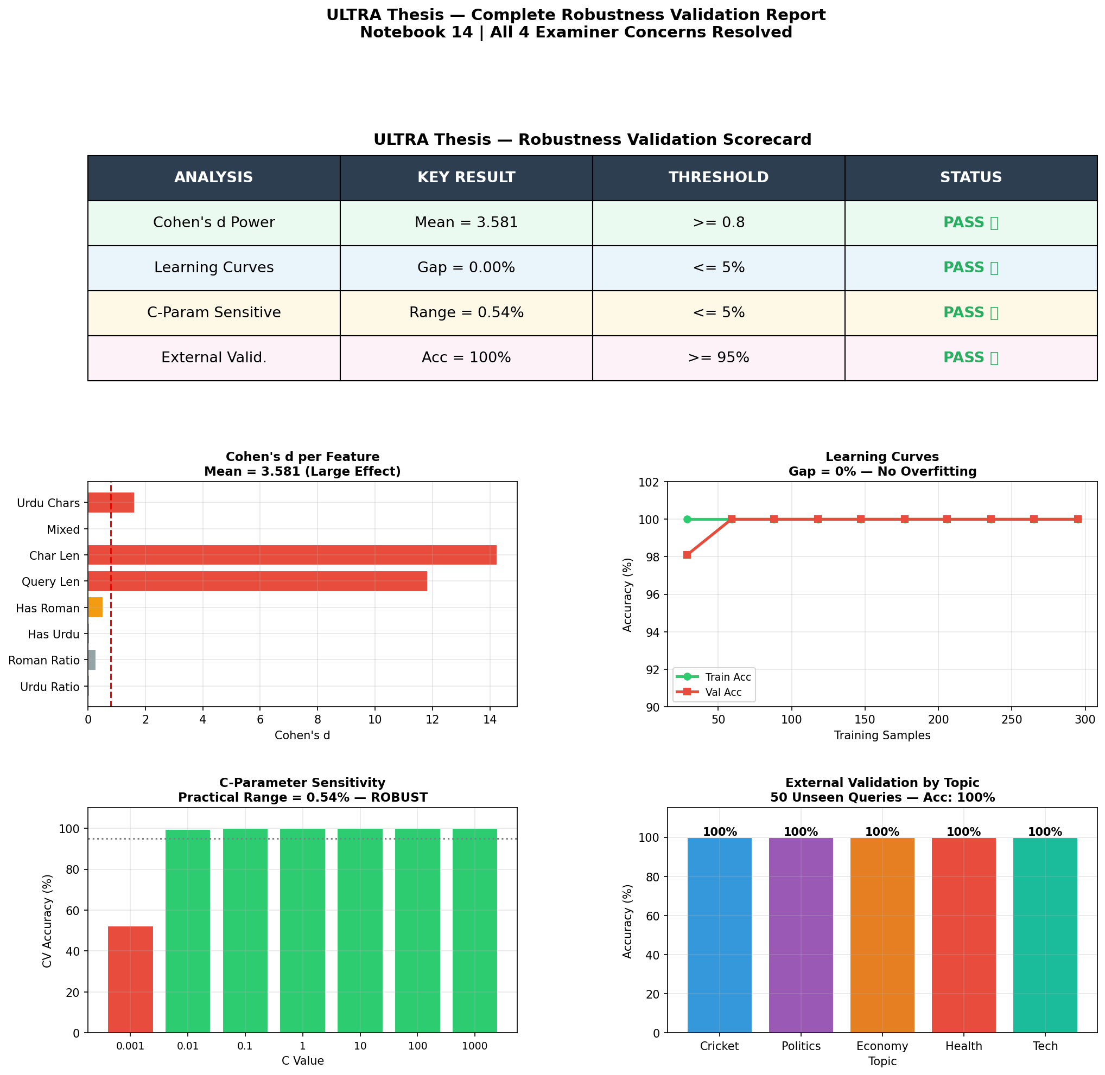
Figure 1. Consolidated robustness validation report: scorecard and all four supporting analyses.

5.8 Error Analysis
Although the development-stage routing classifier reached zero misclassifications on the primary test split (Section 5.1), the deployed V2 model is not error-free on later held-out data (98% on the 50-query diagnostic set; 86% on frozen Phase 3B). The retrieval-precision results (Section 5.2) also contain non-trivial errors, examined here rather than folded into the aggregate P@15 figures.
The two lower-scoring Roman Urdu queries — “mobile phone naya model” (86.67% P@15) and “punjab police corruption” (53.33% P@15) — share a common structural pattern: each combines a term with high cross-lingual ambiguity (“mobile phone”, an English loanword commonly used as-is within Roman Urdu text; “punjab”, a proper noun that is orthographically identical in Roman transliteration and in English) with otherwise ordinary Roman Urdu vocabulary. In both cases, the transliteration dictionary (Section 4.3) is not incorrect so much as under-specified: “mobile phone” and “punjab” are valid tokens whether interpreted as English or as Roman Urdu, and the dictionary lookup step (Algorithm 4.1) has no mechanism for resolving this ambiguity contextually, since it operates at the level of individual whitespace-delimited tokens rather than the query as a whole. This is best characterized as a lexical-ambiguity error rather than a routing error: the routing classifier correctly identified both queries as Roman Urdu and routed them appropriately (Section 5.6); the precision loss originates downstream, in the transliteration step's inability to disambiguate loanwords and proper nouns from genuine Roman Urdu vocabulary.
This distinction matters for interpreting the overall system's error profile: further gains in Roman Urdu P@15 are more likely to come from improving the transliteration module (e.g., a context-aware or learned transliteration model, Section 6.3) than from treating routing accuracy as a solved problem. Routing is at ceiling on some development splits, but Phase 3B shows residual SHORT/LONG errors on unseen queries (SVM: 12/16 SHORT correct, 31/34 LONG correct). Native-script Urdu queries bypass transliteration (Algorithm 4.1, Line 11) and are therefore unaffected by the loanword/proper-noun dictionary failure mode.

5.9 Comparison with Prior Studies
Situating these results against the prior work reviewed in Chapter 2 is useful both to calibrate how large the reported improvements are in absolute terms and to identify where direct numerical comparison is, and is not, methodologically appropriate.
Relative to the base ULTRA framework (Bashir et al., 2026), the development P@15 comparison (43.75% to 90.00% overall in a small experiment) is Layer A only. Official M0 comparison on n=78 is ExactSource Hit@5 = 68/78 versus Urdu-only BM25 0.5897, not that P@15 table.
Relative to Arabzadeh et al.'s (2021) English sparse-versus-dense routing classifier, direct numerical comparison is not meaningful, since their evaluation uses English MS MARCO queries and a different retrieval configuration entirely; however, the qualitative finding — that a learned classifier can route queries more effectively than a fixed rule, at lower computational cost than exhaustively applying every retrieval strategy — is corroborated independently by this thesis for an unrelated language, script, and routing decision space, lending some cross-linguistic generality to the underlying premise that motivated both works.
Relative to Butt et al.'s (2024) Urdu MS MARCO baseline (MRR@10 of 0.247 for their best fine-tuned configuration), no direct numerical comparison is offered in this thesis, since P@15 and MRR@10 measure different aspects of retrieval quality (precision across a result set versus rank position of the first relevant result, Section 2.4) and the two studies evaluate against different corpora and query sets. The comparison is nonetheless useful contextually: Butt et al.'s comparatively modest MRR@10, achieved with a fine-tuned multilingual transformer applying a single retrieval strategy uniformly, is consistent with this thesis's broader argument (Section 1.2) that a substantial share of Urdu IR's remaining performance gap lies not in retrieval-model quality alone but in how queries are matched to the retrieval strategy best suited to them — the specific problem this thesis's routing layer addresses.

5.10 Strengths and Weaknesses of Layer A (SVM / MiniLM)
The strengths and weaknesses in this section refer to Layer A (SVM routing and MiniLM pilots), not official M0 ExactSource/Success@5. Consolidating the results above, three strengths and three weaknesses of the proposed system are worth stating explicitly, ahead of the limitations discussion in Chapter 6.
Strengths. First, the routing task is learnable, and frozen V2 still generalizes to 86% rather than collapsing to chance. Second, sub-millisecond local inference is a real deployment fact against LLM-style routers. Third, Roman Urdu is no longer a zero-P@15 dead end in the development retrieval experiment. Fourth, trap labels show that a cue-aware SVM can beat a six-word tape on need (60% vs 20%), which θ = 150 cannot.
Weaknesses. First, dictionary transliteration still fails on loanwords and proper nouns. Second, frozen V2 only just matches word count (86/84; p = 1.0). Third, trap gains are cue-word gains, not a general “need” detector (27.27% without cues). Fourth, dual-index P@5 on those traps does not beat word count (33.00% vs 36.50%). Fifth, development 100% and AUC = 1.000 must not be cited as the paper result.

5.11 Practical Implications
The practitioner implications in this section concern Layer A SVM routing. Official frozen IR deployment is M0 (script-aware BM25), reported in Sections 5.18–5.24. Beyond the academic contribution of demonstrating that dynamic routing outperforms static thresholding for Urdu IR, the results in this chapter carry several implications for practitioners considering deployment of a similar system. The latency and cost comparison (Section 5.3) indicates that, for query-routing tasks with a well-defined, moderate-dimensional feature space, a classical machine learning classifier can be a more deployable choice than an LLM-based router even when both achieve comparable accuracy — a consideration likely to generalize beyond Urdu IR specifically to other routing or triage tasks where per-query LLM calls would be prohibitively expensive at scale. The error analysis (Section 5.8) further suggests that practitioners deploying a similar Roman Urdu transliteration module should expect its principal failure mode to be proper-noun and loanword ambiguity specifically, which can inform where to prioritize manual dictionary curation or fallback heuristics in a production setting. Finally, the confidence-tiered architecture (Section 5.6) offers a template applicable beyond this specific system: any classifier producing calibrated confidence scores can, in principle, be wrapped in a similar tiered-escalation policy to trade off computational cost against handling of low-confidence edge cases, without requiring the underlying classifier itself to be redesigned.

5.12 Discussion
Taken together, Layer A shows that θ = 150 is the wrong length switch and that an SVM can learn SHORT versus LONG on development data, with only a small frozen classification edge versus word count (86% vs 84%) and no dual-index P@5 gain on H001–H040. That story is not the official retrieval evaluation. Official M0 results are in Sections 5.18–5.24: 87.18% ExactSource Hit@5 on the development/validation known-item pool, 67.50% ExactSource Hit@5 on new known-item queries, and 57.50% human Success@5 on naturalistic queries. Roman Urdu is the main usefulness gap (U: 6/18 versus Urdu 17/18). Development 92.50% P@15 and 90.00% overall P@15 remain supporting Layer A figures, not the M0 headline.
Second, the proposed classifier matches the routing accuracy of three of four LLM-based routing baselines while operating at approximately three orders of magnitude lower latency (0.4555 ms vs. 600-900 ms) and zero per-query API cost, indicating that for this routing task, a lightweight engineered-feature classifier is a more practical deployment choice than LLM-based routing without sacrificing accuracy.
Third, development P@15 of 92.50% on eight Roman queries (overall 90.00% in that experiment) is not official M0 performance. Official Roman evidence is Method D 22/23 on development title_roman known-items, K Roman ExactSource 1/12, and U Roman Success@5 6/18.
Fourth, development permutation/ablation numbers describe an earlier feature set, not frozen V2, and must not be used to claim that question-words drive the deployed model. V2 is script and length; V3 adds cue flags. Collectively these findings answer RQ1–RQ3 with the limits stated in Chapter 6.

5.13 Frozen Phase 3B SVM classification results (Layer A)
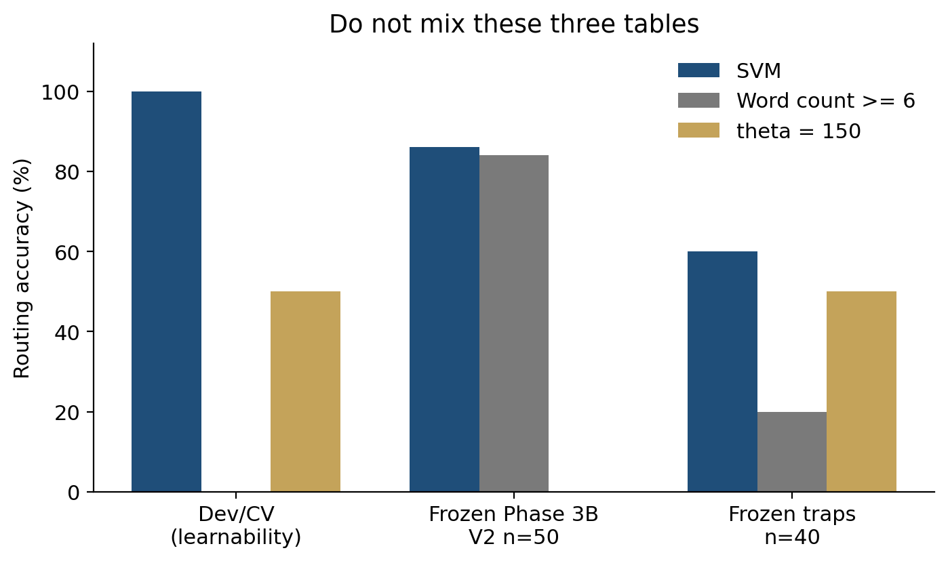
Figure 1. Layer A evaluation layers that must not be mixed with official M0: development/CV, frozen Phase 3B SVM (86/84), and frozen traps (60/20/50). Official IR is Sections 5.18–5.24.
The frozen primary SVM evaluation (n = 50) is the methodologically strongest Layer A classification result. It is not official M0 ExactSource Hit@5. Official IR generalization is Phase 12 K and U (Sections 5.21–5.22).
The strongest defensible statement of this result is therefore: the SVM-based dynamic router achieved 86.0% accuracy on a frozen 50-query primary evaluation set, compared with 84.0% for the fixed word-count baseline. Although the SVM obtained a small descriptive improvement, the difference was not statistically significant (exact McNemar p = 1.0000).

5.14 Statistical Comparisons: Two McNemar Tests
This project reports two McNemar tests that compare different pairs of systems and must not be conflated. The earlier Stage-C test compared the pre-relabel model with the post-relabel V2 model on an external Stage-C set after the Phase 2 label-audit fix, yielding p = 0.000002 — a statistically significant improvement from correcting mislabeled training data, not from beating word count. The Phase 3B test compares V2 with the word-count baseline on the frozen 50 primary queries, yielding exact p = 1.0000. Both findings are independently true; neither supersedes the other.

5.15 Human Retrieval Validation Results (Phase 2.5)
Human relevance labels on the 330 judged rows were: Not relevant 199, Relevant 86, Partially relevant 45. The 5-word bare-event bucket (n = 4) produced a decision-rule verdict of SHORT with 75% query-level agreement, contradicting a provisional rule that had defaulted bare-event queries to LONG. The 6-word bucket and the combined 5-6 word region were query-dependent / inconclusive. This is empirical evidence that word count alone is an imperfect proxy for retrieval need near the boundary — motivation for a learned router, not by itself a claim that the SVM is significantly more accurate than word count on Phase 3B.
A separate 8-row LLM-judging smoke test (one query, HEADLINE only) exists in the repository but is not pilot-scale and is not presented as human validation.

5.16 Frozen held-out trap classification (n = 40)
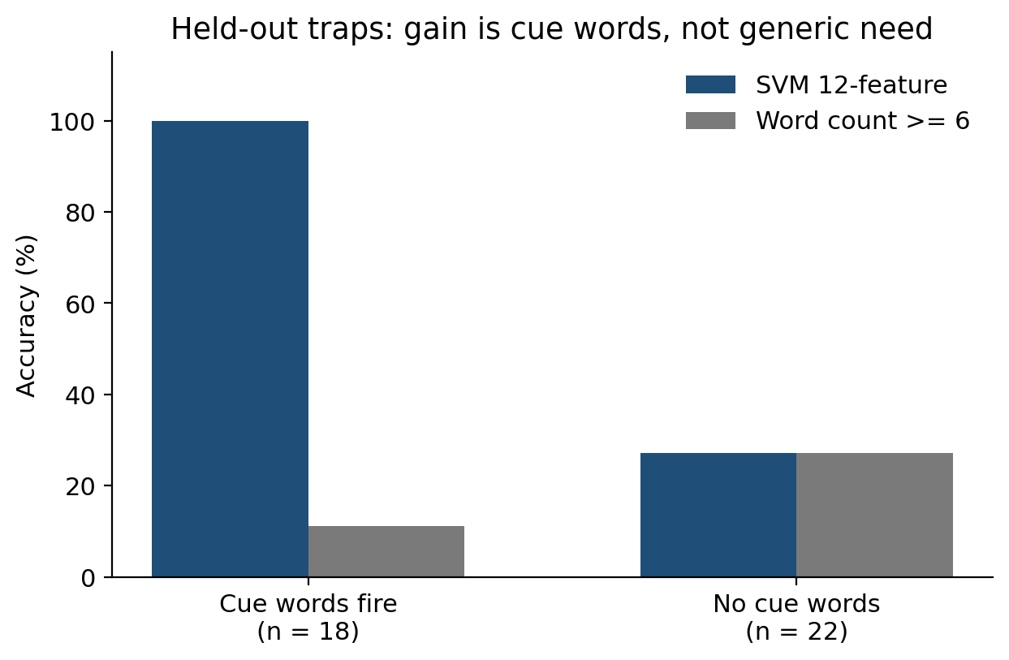
Figure 1. Held-out trap cue split (n = 40): SVM 18/18 when why/how/fact words fire; 27.27% for both systems otherwise.
After the V2 Phase 3B file was frozen, 38 additional trap queries were labelled with the headline-enough rule and used only for a later twelve-feature SVM. A different 40-query sheet (H001–H040) was then frozen and never trained on. Labels on that sheet were produced with a written protocol (headline enough versus need the article), assisted in a first pass, then saved by the author; they are not two independent human raters. Agreement with the protocol is 40/40. Accuracy: SVM 60.00%, six-word rule 20.00%, θ = 150 50.00%. McNemar versus word count: 16 SVM-only-correct, 0 word-count-only-correct, exact p < 0.001. By construction, θ = 150 predicts SHORT for every query in this set (all are under 150 characters).
The cue split is the scientific limit, not a footnote. On the 18 queries where a V3 intent flag fires (causal, manner, synthesis, or fact phrasing), SVM accuracy is 18/18 and word-count accuracy is 2/18 (11.11%). On the 22 queries without those flags (for example ٹیم ہار کا تجزیہ or آج کراچی میں زیادہ سے زیادہ حرارت), both systems score 27.27%. The router therefore beats length when the query wears why/how/fact words; otherwise it still behaves like the six-word tape. IEEE writing must state that split. It must not replace Phase 3B 86% with 60% or with 100%.

5.17 Frozen held-out dual-index P@5 (400 judgments, Layer A MiniLM; not official M0)
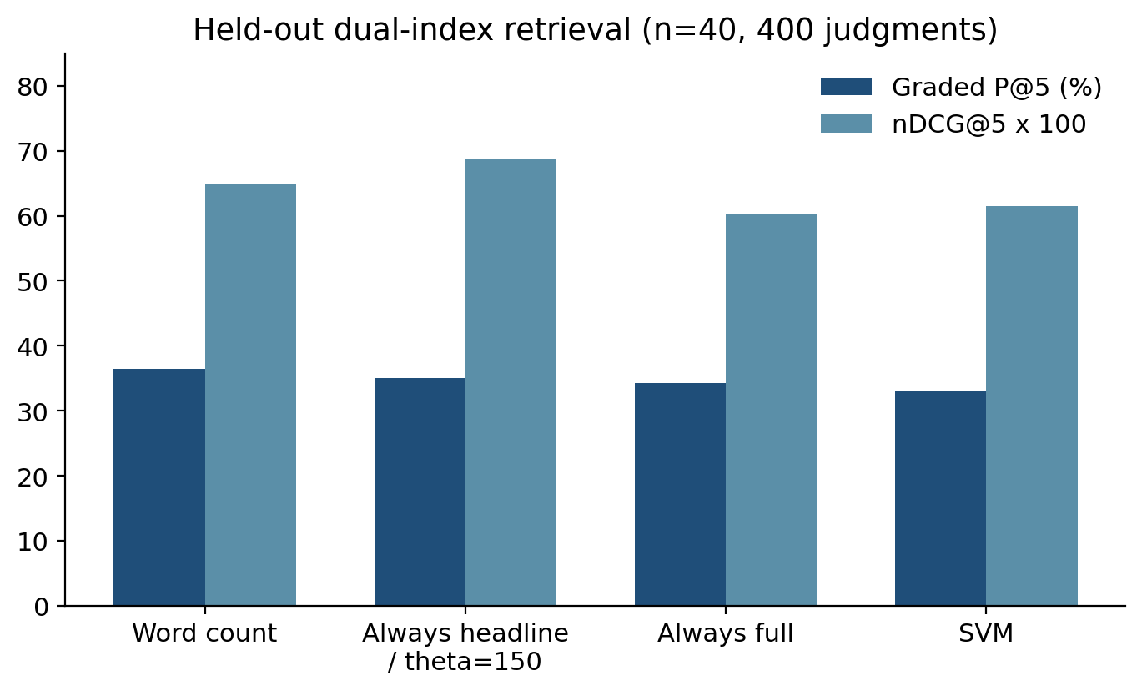
Figure 1. Held-out dual-index graded P@5 (400 judgments): word count 36.50%, always-headline 35.00%, SVM 33.00%.
The same 40 queries were searched in both rooms (top-5 each). Four hundred headline rows were labelled Relevant / Partially relevant / Not relevant (61 / 155 / 184). Graded P@5 (1.0 / 0.5 / 0.0) was scored for one-room systems so that Phase-style lists stay comparable: word-count router 36.50%, always-headline and θ = 150 35.00%, always-full 34.25%, SVM 33.00%. nDCG@5 does not follow that P@5 order: always-headline / θ = 150 0.6868, word count 0.6476, SVM 0.6149, always-full 0.6020. So the classification win on traps does not appear as a retrieval win. Typical failure: a LONG why-query still retrieves “petrol became expensive” rather than causes, in both rooms. Right room, weak articles — that is the remaining ULTRA claim, not a licence to hide the table.
This P@5 comparison used the deployed twelve-feature SVM as a one-room router (HIGH path only). It is not a frozen hybrid-light evaluation. Phase 2.5 (33 queries, depth 5) remains a separate earlier pilot and must not be averaged with these 40.

5.18 Official frozen retrieval system (M0)
The official retriever is M0. Queries are not rewritten. A Unicode letter-count detector labels URDU, ROMAN, or MIXED. URDU and MIXED search Urdu BM25 over article text. ROMAN searches Method D BM25 over romanized documents. BM25 uses k1 = 1.5 and b = 0.75. The corpus contains 111,860 news articles. The Roman dictionary has 198 keys. Phase 11 query-side models M1–M4 did not improve n=78 ExactSource Hit@5; M0 was not replaced.
ExactSource Hit@5 asks whether the exact source article appears in the Top-5 and requires a source_doc_id. Human Success@5 asks whether any Top-5 article is labelled A (relevant) or B (partially relevant). These metrics are not interchangeable and are not averaged.

5.19 Phase 2 development/validation known-item (n = 78)
Table 1. Phase 2 n=78 ExactSource results (official M0). Evaluation type: known-item, development/validation. M0 ExactSource Hit@5 = 68/78 = 87.18%. Urdu-only BM25 (no Roman path) = 0.5897. Roman subset Method A = 0/23. Roman subset Method D = 22/23.
The frozen ULTRA system achieved an ExactSource Hit@5 of 87.18% (68/78) on the Phase 2 development/validation known-item evaluation set. This result is genuine within that protocol: the designated source was in the Top-5 for 68 of 78 title-derived queries. It is not real-world accuracy, not human usefulness, and not unseen natural-query performance. Roman QTRN strings are Phase 2 title_roman, not chat-style Roman Urdu.

5.20 Phase 11 ablation: M0 remains official
Table 1. Phase 11 M0–M4 ablation on the same n=78 known-item pool. M0, M1, M2, M3, and M4 all scored 68/78 = 87.18% ExactSource Hit@5. Roman-train Hit@5 remained 61/64 = 95.31%. M1–M4 nDCG@5 was slightly below M0. M1 is a gate-passing candidate, not an improvement, and is not the official system.

5.21 Phase 12 new known-item evaluation (K001–K040)
Table 1. Phase 12 K ExactSource results, frozen M0, sealed before retrieval. ExactSource Hit@1 = 20/40 = 50.00%; Hit@5 = 27/40 = 67.50% (primary); Hit@10 = 28/40 = 70.00%; Hit@50 = 30/40 = 75.00%. This is a new known-item evaluation. It does not replace 68/78 and is not human Success@5.
Descriptive detector split, not used for tuning: Urdu-script K titles 26/28; ordinary Roman titles 1/12. The drop from 87.18% to 67.50% is concentrated on ordinary Roman title queries, not on native-script Urdu BM25.

5.22 Phase 12 naturalistic human evaluation (U001–U040)
Table 1. Phase 12 U human results, frozen M0 Top-5. Primary usefulness metric: Success@5 = 23/40 = 57.50%. Conservative P@5 = 0.2050. nDCG@5 = 0.6460 (gains A=3, B=2, C=1, D=E=0; secondary). MRR = 0.4542. This is human relevance, not ExactSource Hit@5. nDCG@5 is not the usefulness headline because C still has gain 1.
Table 1. Script-wise U Success@5 (descriptive only). URDU 17/18 = 94.44%; ROMAN 6/18 = 33.33%; MIXED 0/4 = 0%. These findings describe this sealed sample. They do not licence retuning Method D on U failures, and they do not prove that Method D is universally bad. They do show that Urdu-script needs were usually met and Roman and mixed needs often were not. Mixed n=4 is too small for a population rate.
H001–H040 human Success@5 = 25/40 = 62.5% is a diagnostic on earlier trap queries. ExactSource Hit@5 on that set is undefined (no source_doc_id). It is not the official unseen usefulness result and must not be combined with U.

5.23 Final comparison of evaluation settings
Table 1. Do not average rows. Phase 2 n=78 known-item ExactSource Hit@5 = 68/78 = 87.18% (development/validation). Phase 12 K n=40 known-item ExactSource Hit@5 = 27/40 = 67.50% (new). Phase 12 U n=40 human Success@5 = 23/40 = 57.50% (new naturalistic). H001–H040 Success@5 = 25/40 = 62.5% (diagnostic only).

5.24 Discussion of the official IR results
The frozen M0 system achieved strong performance on the development/validation known-item evaluation (68/78, 87.18% ExactSource Hit@5). However, evaluation on newly constructed queries produced lower performance: 67.50% ExactSource Hit@5 on new known-item queries and 57.50% human Success@5 on naturalistic queries. This indicates that the development/validation score should not be interpreted as a direct estimate of naturalistic user-level retrieval usefulness.
These results suggest a staircase of task difficulty and query-form mismatch, not a single accuracy that collapsed. 87.18% asks whether a title-derived known-item, including title_roman, recovered its source on the freeze pool. 67.50% asks the same known-item question on independently sampled titles; Urdu titles remain high and ordinary Roman titles do not. 57.50% asks a different question: on natural needs with no gold article, was anything in the Top-5 useful? Conservative P@5 = 0.2050 suggests many successes are a single useful document. Query mix matters: a Roman-heavy sample will look worse than an Urdu-only test even if the Urdu component is strong.
In official M0, adaptive dynamic query routing is script-conditional index selection, not the SVM SHORT/LONG switch. Method D is necessary for title_roman-like Roman known-item search (22/23 on the development Roman subset versus 0/23 for Method A) and is insufficient for ordinary and chat Roman Urdu on new K and U. Phase 11 showed that small allowed query expansions did not move 68/78. These results suggest that Roman Urdu remains the major limitation of the frozen system. Do not hide 57.50%. Do not retune M0 on K, U, or H001–H040.

Chapter 6: Conclusions and Recommendations

6.1 Conclusions
This thesis evaluated Urdu news retrieval under a frozen lexical system (M0) after earlier work on learned SHORT/LONG routing. Official M0 uses Unicode script detection, Urdu BM25 for URDU/MIXED queries, and Method D for ROMAN queries over 111,860 articles. M0 was not changed after Phase 12. M1–M4 did not improve n=78 Hit@5.
The frozen M0 system achieved strong performance on the development/validation known-item evaluation (68/78 = 87.18% ExactSource Hit@5). However, evaluation on newly constructed queries produced lower performance: 67.50% ExactSource Hit@5 (27/40) on new known-item queries and 57.50% human Success@5 (23/40) on naturalistic queries. This indicates that the development/validation score should not be interpreted as a direct estimate of naturalistic user-level retrieval usefulness. ExactSource Hit@5 and Success@5 measure different properties and must not be averaged with each other or with 87.18%.
ULTRA therefore demonstrates effective script-aware retrieval on the development/validation known-item benchmark, while new unseen evaluations reveal a substantial generalization gap and particularly weak Roman-script performance (U Success@5: Urdu 17/18, Roman 6/18, Mixed 0/4). The contribution is not 87% real-world accuracy. H001–H040 Success@5 = 62.5% is diagnostic only.

6.2 Summary of Contributions
Restating the contributions first introduced in Section 1.7, each is now grounded in the specific empirical evidence that substantiates it, drawn from Chapter 5, including the later frozen and human-judgment layers.
Official M0: 68/78 ExactSource Hit@5 (development/validation), 27/40 ExactSource Hit@5 (K), 23/40 Success@5 (U). Historical SVM 86/84 and trap 60/20 remain Layer A (Sections 5.13 and 5.16).
Phase 3A eight-feature V2 path, plus a later twelve-feature trap model. Phase 3B was not retrained away.
Historical Layer A: HIGH / MEDIUM / LOW lights (Sections 3.5, 4.6). Official M0 routing is Unicode script detection, not these lights.
An expanded Roman Urdu dictionary (198 on-disk pairs). Development Roman P@15 of 92.5% is supporting Layer A only (Section 5.2).
A comprehensive comparative evaluation against six retrieval methods, including LLMs. Substantiated by Table 5.3 (Section 5.3 numbering) and Figures 5.4-5.6, establishing the efficiency argument central to this thesis's practical motivation (Section 1.3).
An ablation study identifying the most robust and discriminative features. Substantiated by Table 5.5 and Figure 5.7, and interpreted jointly with feature importance in Section 5.5 to resolve the apparent tension between individual dispensability and collective informativeness.
Official Phase 12 K and U (Sections 5.21–5.22), plus diagnostic H001–H040 Success@5 = 62.5%. Historical dual-index P@5 remains Section 5.17 and is not M0 Success@5.
A Phase 2.5 human retrieval-judgment pilot showing that the 5-word bare-event region behaves empirically as SHORT, while 5-6 words overall are query-dependent.

6.3 Limitations
Limitations of the official M0 evaluation are stated first. Historical SVM-layer limits (Phase 3B power, HIGH-tier demonstration) remain valid for Layer A but do not replace the IR limits below.
Unseen evaluation size. New known-item (K) and naturalistic (U) sets each have n = 40. Point estimates have wide uncertainty. Numerators and denominators must be reported. This evaluation should not be interpreted as universal real-world accuracy.
Roman Urdu performance is substantially weaker than Urdu-script performance on the sealed U sample (6/18 versus 17/18). Ordinary and chat spelling diverge from Method D’s title_roman construction. The mixed-script subset was very small (n = 4, all unsuccessful) and cannot support a population rate. Known-item versus naturalistic evaluation. ExactSource Hit@5 requires a pre-assigned source document. Human Success@5 asks whether any Top-5 document is relevant or partially relevant. The drop from 87.18% to 57.50% is not one metric getting worse. Development/validation and unseen results differ for both scientific and sampling reasons. Naturalistic queries require human relevance judgments. U labels are from one annotator; there is no inter-annotator agreement. nDCG@5 with topical C-gain = 1 can look high when Success@5 fails and is not the usefulness headline.
Single retrieval corpus. All experiments were conducted against one news-domain corpus (111,860 Urdu news articles). The classifier's features and decision boundary were learned in this domain, and its behavior on other domains (e.g., legal, medical, or social media text) has not been evaluated.
Static LLM baselines. The comparison against GPT-4, GPT-3.5, Claude, and Gemini-style routing used fixed prompting strategies rather than fine-tuned or extensively prompt-engineered variants of these models, so the reported LLM baseline numbers should be read as indicative rather than an upper bound on what LLM-based routing could achieve.
Binary routing granularity. The current classifier makes a routing decision from a fixed feature set computed once per query; it does not yet incorporate user session context, query reformulation history, or multi-turn conversational signals that could further refine routing in interactive search settings.
Lights versus P@5 protocol. MEDIUM and LOW are implemented in code and shown on live examples. The frozen 40-query P@5 table compares one-room systems so that headline versus full lists remain comparable. Hybrid P@5 is therefore not claimed as a frozen number.

6.4 Recommendations for Practitioners
Distinct from the research-oriented future work outlined in Section 6.5, the following recommendations are addressed specifically to practitioners considering adoption or adaptation of the methods developed in this thesis.
Do not treat 87.18% ExactSource Hit@5 as a user-facing SLA. For native-script Urdu news on this collection, frozen M0 is a reasonable lexical baseline. For Roman Urdu traffic, expect a large drop (U Success@5 = 6/18 in the sealed sample). If the system is changed, freeze it first and seal a new test; K, U, and H001–H040 are burned for tuning.
Audit transliteration dictionaries for proper-noun and loanword ambiguity. Section 5.8's error analysis identified proper nouns and English loanwords as the dominant Roman Urdu error source; practitioners building similar dictionary-based transliteration modules should specifically audit and, where possible, disambiguate these categories rather than treating dictionary coverage as a uniform quantity to simply expand.
Keep ExactSource Hit@5 and human Success@5 separate. Do not average 87.18%, 67.50%, and 57.50%. Layer A SVM classification (86/84) is not official M0 retrieval performance.

6.5 Recommendations for Further Research
Building on the contributions and limitations above, the following directions for future research are identified.
Do not tune BM25, the dictionary, routing, or Method D on U001–U040, K001–K040, or H001–H040. Future Roman work needs a new sealed test. A larger independently annotated Urdu and Roman Urdu query benchmark would also enable more robust comparison than n=40.
Learned or generative Roman Urdu transliteration. Rather than extending the transliteration dictionary manually, future work could train a sequence-to-sequence or transformer-based transliteration model on a larger parallel Roman Urdu-Urdu corpus, potentially closing the residual gap on proper-noun-heavy and out-of-vocabulary queries identified in Chapter 5.
Cross-domain and multilingual generalization. Evaluating — and, where necessary, retraining — the dynamic routing classifier on corpora outside the news domain (e.g., government, legal, or educational text), and extending the approach to other low-resource South Asian languages that share Urdu's script and code-mixing challenges (e.g., Punjabi, Sindhi, Hindi-Urdu code-switched text), would test the generality of the proposed feature set beyond a single domain and language.
Fine-tuned and prompt-optimized LLM routing. Since the current LLM comparison relies on fixed prompting strategies, a more rigorous comparison would fine-tune or systematically prompt-optimize LLM-based routers on the same training data used for the SVM classifier, providing a fairer accuracy ceiling against which the efficiency advantages of the lightweight classifier can be judged.
Richer, context-aware feature sets. Incorporating session-level signals — such as prior queries in a search session, click-through feedback, or user-specific query history — into the feature set could allow the router to adapt its decisions dynamically within a single user interaction, moving from single-query classification toward session-aware retrieval routing.
Priority directions that require a new sealed evaluation: better Roman query–document matching than Method D; mixed-script evaluation with more than four queries; a second annotator on a new naturalistic set.
If a live system is built from this thesis, the official frozen retriever is M0, not the MiniLM dual-index. Deployment and real-world evaluation. Finally, integrating the proposed routing pipeline into a live Urdu search system and evaluating it against real user queries and engagement metrics (rather than offline precision measures alone) would validate whether the efficiency and accuracy gains demonstrated here translate into measurable improvements in real-world retrieval quality.

6.6 Real-World Applications
These application remarks concern routing patterns in general. The official frozen retriever for this thesis is M0 (script-aware BM25), not the MiniLM dual-index. The Layer A SVM dual-index is a historical design. Beyond the immediate Urdu news-retrieval setting evaluated in this thesis, the dynamic routing architecture developed here has plausible application in several adjacent, practically important settings. In consumer-facing Urdu and Roman Urdu search products — including general web search, e-commerce product search, and in-app content search for Urdu-language platforms — the routing layer could be deployed largely as-is, given its independence from the specific news-domain retrieval backend used in this thesis's evaluation (Section 1.8). In customer-support and helpdesk systems serving Urdu-speaking users, where queries are frequently typed in Roman Urdu under time pressure, the same routing-plus-transliteration architecture could reduce the proportion of queries that return no relevant results, directly improving user-facing service quality. In digital-library and government-portal search over Urdu-language documents, where query volume may be lower but computational budgets are often more constrained than in commercial search, the proposed system's zero-marginal-cost, sub-millisecond routing profile (Section 5.3) is particularly well suited relative to LLM-based alternatives that would incur recurring API costs disproportionate to typical public-sector search traffic. Realizing any of these applications would require the domain-adaptation and larger-scale validation work identified in Section 6.5, but the underlying architecture — feature-based routing plus confidence-tiered escalation — does not depend on assumptions specific to the news domain and is presented here as a general pattern applicable across these settings.

6.7 Closing Remarks
This thesis measured script-aware Urdu news retrieval under a freeze. M0 achieves 87.18% ExactSource Hit@5 on the development/validation known-item protocol, 67.50% on new known-item queries, and 57.50% human Success@5 on naturalistic queries. Roman Urdu remains the main limitation. That is enough for an honest MS contribution and not enough to claim universal effectiveness.

References
Arabzadeh, N., Yan, X., & Clarke, C. L. A. (2021). Predicting efficiency/effectiveness trade-offs for dense vs. sparse retrieval strategy selection. In Proceedings of the 30th ACM International Conference on Information and Knowledge Management (CIKM '21) (pp. 2862–2866).
Bashir, A., Qaiser, F., & Hussain, I. (2026). ULTRA: Urdu Language Transformer-based Recommendation Architecture. arXiv preprint arXiv:2602.11836.
Butt, U., Varanasi, S., & Neumann, G. (2024). Enabling low-resource language retrieval: Establishing baselines for Urdu MS MARCO. arXiv preprint arXiv:2412.12997.
Carmel, D., & Yom-Tov, E. (2010). Estimating the Query Difficulty for Information Retrieval. Synthesis Lectures on Information Concepts, Retrieval, and Services. Morgan & Claypool Publishers.
Chari, A., MacAvaney, S., & Ounis, I. (2025). Improving low-resource retrieval effectiveness using zero-shot linguistic similarity transfer. In Advances in Information Retrieval: 47th European Conference on Information Retrieval (ECIR 2025), LNCS vol. 15575 (pp. 290–306). Springer, Cham.
Conneau, A., Khandelwal, K., Goyal, N., Chaudhary, V., Wenzek, G., Guzmán, F., Grave, E., Ott, M., Zettlemoyer, L., & Stoyanov, V. (2020). Unsupervised cross-lingual representation learning at scale. In Proceedings of the 58th Annual Meeting of the Association for Computational Linguistics (ACL) (pp. 8440–8451).
Cormack, G. V., Clarke, C. L. A., & Büttcher, S. (2009). Reciprocal rank fusion outperforms Condorcet and individual rank learning methods. In Proceedings of the 32nd International ACM SIGIR Conference on Research and Development in Information Retrieval (pp. 758–759).
Cortes, C., & Vapnik, V. (1995). Support-vector networks. Machine Learning, 20(3), 273–297.
Daud, A., Khan, W., & Che, D. (2017). Urdu language processing: A survey. Artificial Intelligence Review, 47, 279–311.
Devlin, J., Chang, M.-W., Lee, K., & Toutanova, K. (2019). BERT: Pre-training of deep bidirectional transformers for language understanding. In Proceedings of NAACL-HLT 2019 (pp. 4171–4186).
Guo, C., Pleiss, G., Sun, Y., & Weinberger, K. Q. (2017). On calibration of modern neural networks. In Proceedings of the 34th International Conference on Machine Learning (ICML), vol. 70 (pp. 1321–1330).
Hsu, H.-L., & Tzeng, J. (2025). DAT: Dynamic Alpha Tuning for hybrid retrieval in retrieval-augmented generation. arXiv preprint arXiv:2503.23013.
Hussain, N., Qasim, A., Mehak, G., Usman, M., Zain, M., Hafeez, M., & Sidorov, G. (2025). Fine-tuning large language models with QLoRA for offensive language detection in Roman Urdu-English code-mixed text. arXiv preprint arXiv:2510.03683.
Iqbal, M., Tahir, B., & Mehmood, M. A. (2021). CURE: Collection for Urdu Information Retrieval Evaluation and Ranking. arXiv preprint arXiv:2011.00565.
Jeong, S., Baek, J., Cho, S., Hwang, S. J., & Park, J. C. (2024). Adaptive-RAG: Learning to adapt retrieval-augmented large language models through question complexity. In Proceedings of NAACL 2024 (pp. 7036–7050).
Karpukhin, V., Oğuz, B., Min, S., Lewis, P., Wu, L., Edunov, S., Chen, D., & Yih, W. (2020). Dense passage retrieval for open-domain question answering. In Proceedings of EMNLP 2020 (pp. 6769–6781).
Kazi, S., & Khoja, S. A. (2025). Towards building Urdu language document retrieval framework. (Pre-print / journal under review).
Lewis, P., Perez, E., Piktus, A., Petroni, F., Karpukhin, V., Goyal, N., Küttler, H., Lewis, M., Yih, W., Rocktäschel, T., Riedel, S., & Kiela, D. (2020). Retrieval-augmented generation for knowledge-intensive NLP tasks. In Advances in Neural Information Processing Systems (NeurIPS), vol. 33 (pp. 9459–9474).
Mehmood, F., Ghani, M. U., Ibrahim, M. A., Shehzadi, R., & Asim, M. N. (2020). A precisely Xtreme-multi channel hybrid approach for Roman Urdu sentiment analysis. arXiv preprint arXiv:2003.05443.
Reimers, N., & Gurevych, I. (2019). Sentence-BERT: Sentence embeddings using Siamese BERT-networks. In Proceedings of EMNLP-IJCNLP 2019 (pp. 3982–3992).
Robertson, S., & Zaragoza, H. (2009). The probabilistic relevance framework: BM25 and beyond. Foundations and Trends in Information Retrieval, 3(4), 333–389.
Sitaram, S., Chandu, K. R., Rallabandi, S. K., & Black, A. W. (2019). A survey of code-switched speech and language processing. arXiv preprint arXiv:1904.00784.
Wu, J., Ren, Z., & Verberne, S. (2024). What are the limits of cross-lingual dense passage retrieval for low-resource languages? arXiv preprint arXiv:2408.11942.

