**SSN COLLEGE OF ENGINEERING**

**DEPARTMENT OF COMPUTER SCIENCE AND ENGINEERING**

**UCS1712 – GRAPHICS AND MULTIMEDIA LAB**

**EX NO: 5b – 2D Transformations – Reflection and Shearing**

**________________________________________________________________**

Name   : Mohamed Hashim G

RegNo : 185001094

**______________________________________________________________________**

**AIM:**

To write a C++ program to perform rotation and shearing on polygon.

**ALGORITHM:**

1. Read the vertices for polygon be transformed as input.

2. Read the choice of operation to be performed.

3. For Reflection:

a. For each vertex (x,y) apply reflection as follows:

i. For reflection along x axis: y = -y

ii. For reflection along y axis: x = -x

iii. For reflection along origin: x = -x and y = -y

iv. For reflection along x=y : x,y = y,x

b. For polygon, draw the reflection of polygon using the four new

vertices.

4. For Shearing:

a. Read shearing axis and shearing factor sf.

b. If shearing axis is along X-axis:

i. Add the shearing factor to the x-coordinates of the 2 nd and 3 rd

vertex.

c. If shearing axis is along Y-axis:

i. Add the shearing factor to the y-coordinates of the 3 rd and 4 th

vertex.

d. For polygon, draw the sheared polygon using the four new vertices.

**CODE:**

#include <stdio.h>

#include <math.h>

#include <iostream>

#include <vector>

#include <GL/glut.h>

using namespace std;

int choice;

// Polygon

vector<int> pntX;

vector<int> pntY;

int xaxis=500, yaxis=500;

float shear;

double round(double d)

{

    return floor(d + 0.5);

}

// Polygon

void drawPolygon()

{

    glBegin(GL_QUADS);

    glColor3f(1.0, 1.0, 1.0);

    for (int i = 0; i < 4; i++)

    {

        glVertex2i(xaxis+pntX[i], yaxis+pntY[i]);

    }

    glEnd();

}

// REFLECTION

void drawPolygonReflection(int rx, int ry)

{

    glBegin(GL_QUADS);

    for (int i = 0; i < 4; i++)

    {

        glVertex2i(xaxis+pntX[i]*rx, yaxis+pntY[i]*ry);

    }

    glEnd();

}

// SHEAR

void drawPolygonShearX()

{

    glBegin(GL_QUADS);

    glColor3f(1.0, 0.0, 0.0);

    glVertex2f(xaxis+pntX[0] , yaxis+pntY[0]);

    glVertex2f(xaxis+pntX[1] , yaxis+pntY[1]);

    glVertex2f(xaxis+pntX[2] + (pntY[2]*shear), yaxis+pntY[2]);

    glVertex2f(xaxis+pntX[3] + (pntY[3]*shear), yaxis+pntY[3]);

    glEnd();

}

void drawPolygonShearY()

{

    glBegin(GL_QUADS);

    glColor3f(0.0, 0.0, 1.0);

    glVertex2f(xaxis+pntX[0] -100, yaxis+pntY[0] );

    glVertex2f(xaxis+pntX[1] -100, yaxis+pntY[1] + (pntX[1]*shear) );

    glVertex2f(xaxis+pntX[2] -100, yaxis+pntY[2] + (pntX[2]*shear) );

    glVertex2f(xaxis+pntX[3] -100, yaxis+pntY[3] );

    glEnd();

}

void myDisplay(void)

{

    glClear(GL_COLOR_BUFFER_BIT);

    // draw axes

    // Y-axis

    glBegin(GL_LINES);

        glVertex2f(500, 0);

        glVertex2f(500, 1000);

    glEnd();

    // X-axis

    glBegin(GL_LINES);

        glVertex2f(0, 500);

        glVertex2f(1000, 500);

    glEnd();

    drawPolygon();

    if(choice==0) // REFLECTION

    {

        // X=Y

        glBegin(GL_LINES);

            glVertex2f(0, 0);

            glVertex2f(1000, 1000);

        glEnd();

        glColor3f(0.0, 0.0, 1.0);

        drawPolygonReflection(1, -1);

        glColor3f(1.0, 0.0, 0.0);

        drawPolygonReflection(-1, 1);

        glColor3f(0.0, 1.0, 1.0);

        drawPolygonReflection(-1, -1);

        glBegin(GL_QUADS);

            glColor3f(0.8, 0.3, 0.9);

            for (int i = 0; i < 4; i++)

            {

                glVertex2i(yaxis+pntY[i], xaxis+pntX[i]);

            }

        glEnd();

    }

    else // SHEAR

    {

        // cout<<"shear";

        drawPolygonShearX();

        drawPolygonShearY();

    }

    glFlush();

}

int main(int argc, char** argv)

{

    glutInit(&argc, argv);

    glutInitDisplayMode(GLUT_SINGLE | GLUT_RGB);

    glutInitWindowPosition(700, 0);

    glutInitWindowSize(750, 750);

    glutCreateWindow("5b-Reflection & Shear");

    glClearColor(0,0,0,1);

    glMatrixMode(GL_PROJECTION);

    gluOrtho2D(0.0, 1000, 0.0, 1000);

    int i, pntX1, pntY1;

    freopen("in.txt", "r", stdin);

    cin>>choice;

    for (i = 0; i < 4; i++)

    {

        cin >> pntX1 >> pntY1;

        pntX.push_back(pntX1);

        pntY.push_back(pntY1);

    }

    // POLYGON

    if(choice==1)

    {

        cin>>shear;

    }

    glutDisplayFunc(myDisplay);

    glutMainLoop();

    return 0;

}

**OUTPUT:**

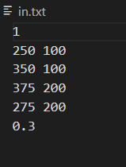

**REFLECTION**

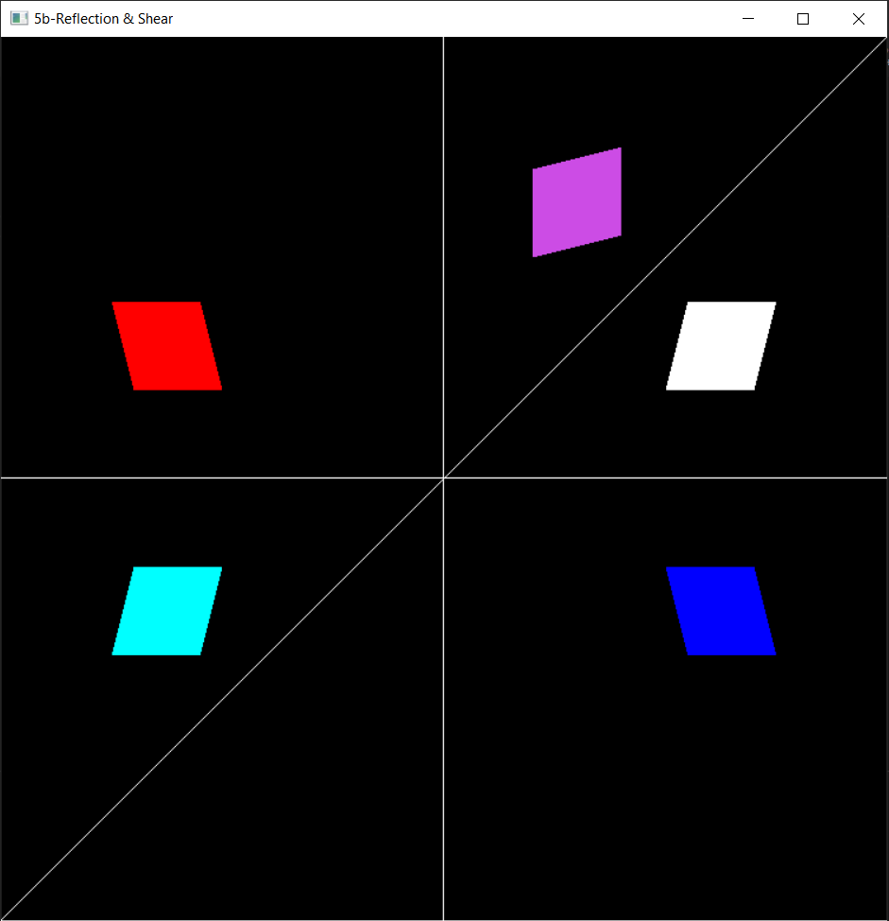

**SHEAR**

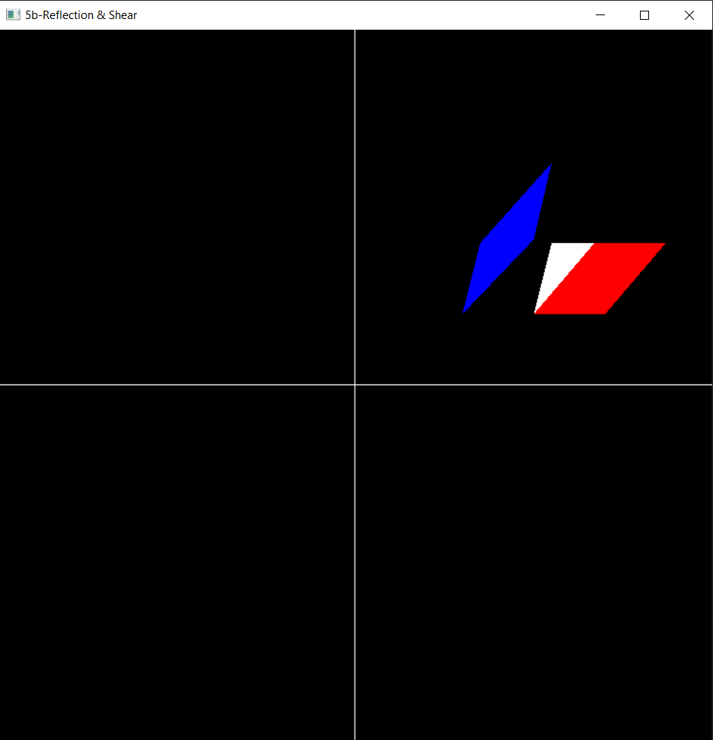

**RESULT:**

Thus 2D Transformations like rotation, shearing have been performed on polygons.