**S & J Motors Project**

**Java**

**Instructions for compiling**

1. The project has been compiled in Intellij Idea having following version

**IntelliJ IDEA 2022.2 (Ultimate Edition)**

**Build #IU-222.3345.118, built on July 26, 2022**

**Runtime version: 17.0.3+7-b469.32 amd64**

**VM: OpenJDK 64-Bit Server VM by JetBrains s.r.o.**

**Windows 10 10.0**

**Kotlin: 222-1.7.10-release-334-IJ3345.118**

1. We will recommend you use this version or higher ones to avoid dependency issues.
2. Open the mentioned IDE, select Open project from three options on top right. Browse to the path where project folder is located. Select that folder. The project will be opened as result.
3. On the top right, there will be debug option, click onto it, a box will be dropped. Select Edit Configuration. If like in picture shown below, “Java” is already written then no need to do this step and you can run by clicking green right arrow. 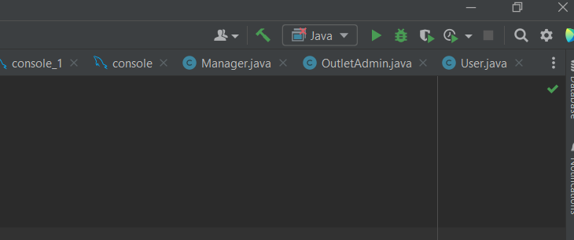
4. (If “Java” is not written), then select Edit Configuration. Select create new Configuration and from a list of options, select Application with icon shown in left pane of picture. You can name it as you like. After that fill the latter fields as shown in picture. 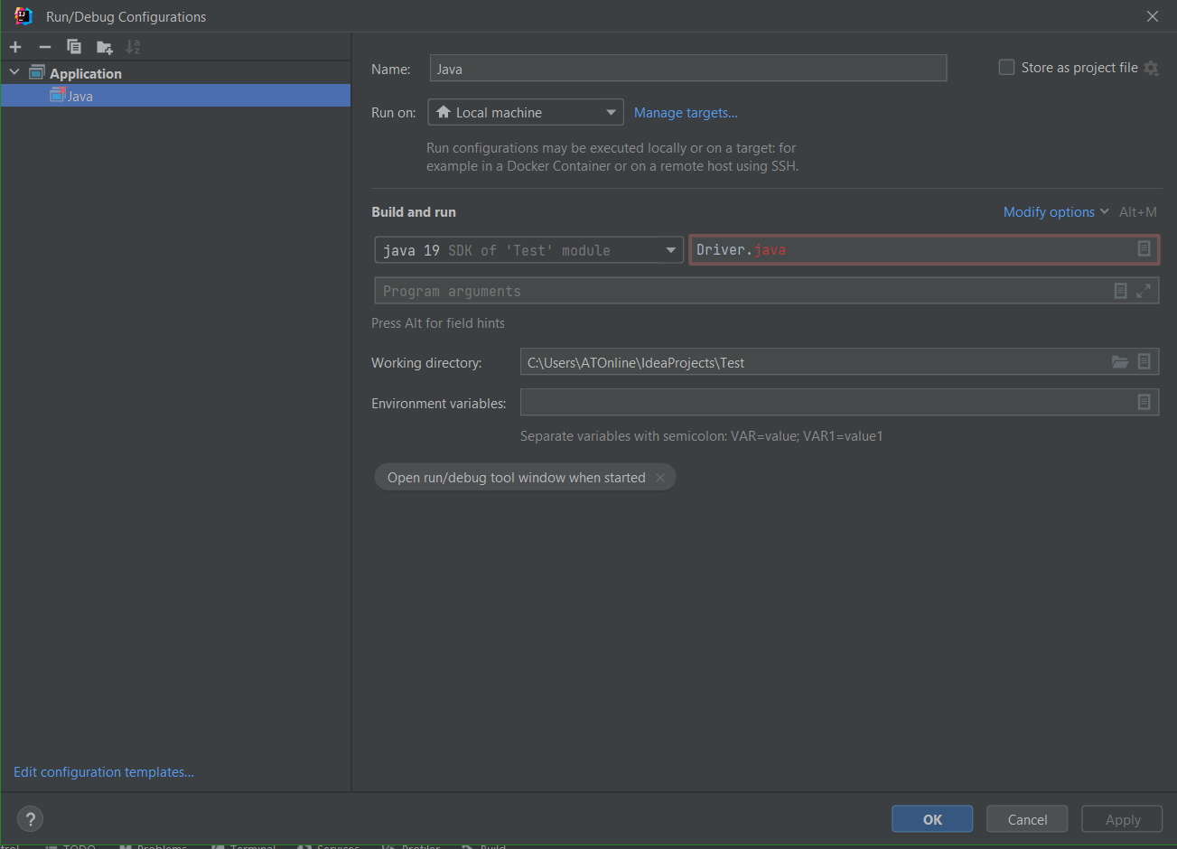
5. Now you can run the code and debug it as well.