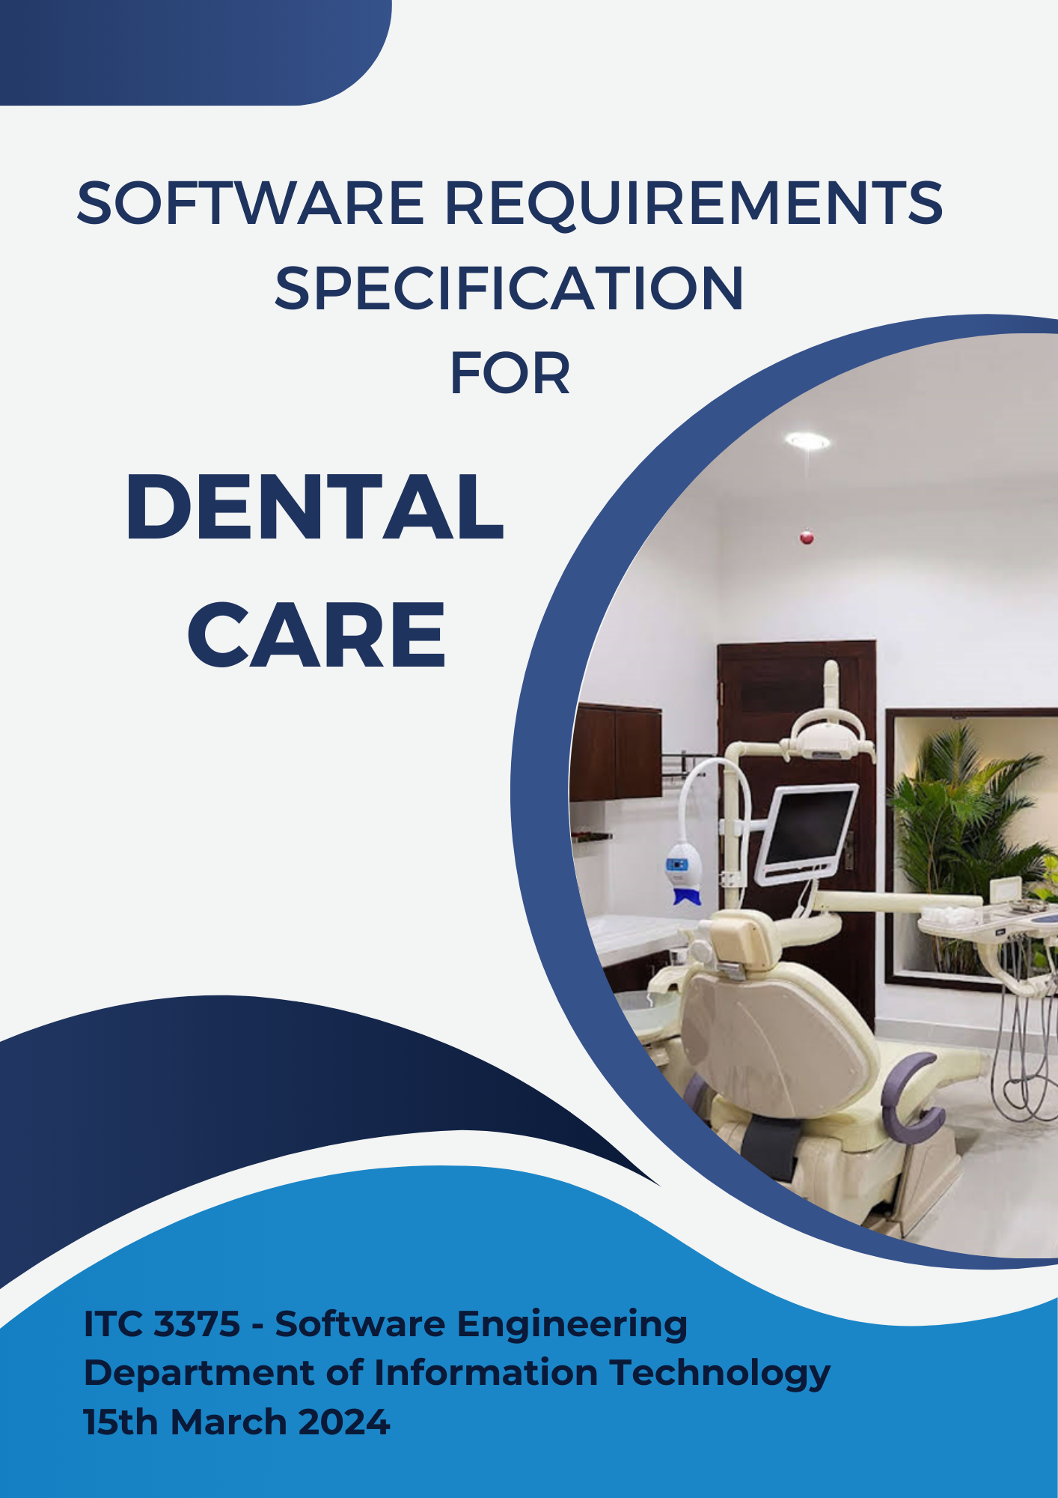
Prepared by:
CPM Number | MC Number | Name
22980 | 104038 | WICKRAMA ARACHCHI KANKANAMGE PIYUMI APSARIKA PRIYADARSHANEE
22981 | 104053 | PANDIGE ERAN DILSHAN FERNANDO
23007 | 104067 | MEGODA GAMAGE HASHINI SEWWANDI
23015 | 104016 | GALLAGE SUPIPI MADARA HASARANGI
23019 | 104074 | PUNCHIRALA VIDANELAGE CHAMODITHA ISHANKA NARASINGHE
23032 | 104079 | ABEKOON MUDIYANSELAGE VIBODHA LAKSHMI KUMARI THENNAKOON
23042 | 104036 | WANASINGHE MUDIYANSELAGE HARSHA KAVINDA KUMARA WANASINGHE
23051 | 104073 | THEWARA THANTHRIGE THARINDU SHEHAN FERNANDO
23174 | 104104 | CHARAKA DINUSHA KASTHURIARACHCHI

Table of Contents
1. Introduction 1
1.1 Purpose 1
1.2 Intended Audience and Reading Suggestions 1
1.3 Product Scope 3
1.4 References 4
2. Overall Description 6
2.1 Product Perspective 6
2.2 Product Functions 6
2.3 User Classes and Characteristics 6
2.4 Operating Environment 6
2.5 Design and Implementation Constraints 6
2.6 User Documentation 7
2.7 Assumptions and Dependencies 7
3. External Interface Requirements 8
3.1 User Interfaces 8
3.2 Hardware Interfaces 8
3.3 Software Interfaces 9
3.4 Communications Interfaces 9
4. System Features 10
4.1 Appointment Management 10
4.2 Patient Registration and Record-Keeping 10
4.3 Medical History and Treatment Recording 11
5. Other Nonfunctional Requirements 12
5.1 Performance Requirements 12
5.2 Safety Requirements 12
5.3 Security Requirements 12
5.4 Software Quality Attributes 13
5.5 Business Rules 13
6. Other Requirements 14

Introduction

Purpose
The features and functionalities required for the creation of an appointment and patient management system specifically for dental centers are described in this Software Requirements Specification (SRS) document. The development of a strong digital solution is required due to the identified critical concerns, which include the need for manual appointment scheduling, an inability to verify the availability of dentists online, disorganized patient records, and administrative overload.
The objectives of this system are to raise the standard of treatment given by dental centers, modernize operations, improve patient experience, and increase administrative efficiency. The whole system, which includes a consolidated patient database, an admin dashboard, a real-time dentist availability check, a secure payment gateway connection, an online appointment booking system, and powerful data analysis capabilities is covered by this SRS. The development team can use this paper as a complete guide to ensure that this crucial software solution is implemented successfully.

Intended Audience and Reading Suggestions
Intended Audience
The Online Appointment and Patient Management System for Dental Centers is being developed and implemented, and this Software Requirements Specification (SRS) document is intended for the several stakeholders involved. The following people are among the target audience:
- Developers: individuals in charge of the technical implementation of the system, including software engineers, database administrators, and programmers.
- Dental Center Staff: This group comprises the clinicians and administrative personnel who will utilize the system to handle patient records, schedule appointments, and perform other associated responsibilities.
- Testers: Experts in quality assurance tasked with verifying that the system satisfies the specifications and evaluating its functionality.
- Documentation Writers: Individuals responsible for producing training materials, system documentation, and user manuals.

Reading Suggestions
- Overview Sections
- Start with the Introduction to understand the purpose and extent of the document.
- Go to the General Description to get a high-level overview of the system's capabilities.

- Developer Perspective
- It is recommended that developers look into Specific Requirements.
- Functional requirements for a full understanding of the system's components.
- Non-functional requirements pertaining to performance, security, and usability.
- External Communication has to become knowledgeable about system interfaces.

- Project Manager and Dental Center Staff Perspective
  - Focus on Specific Requirements
- Functional requirements for understanding the system's processes and workflows.
- Non-Functional Performance and Compliance Expectations Standards.

- User Perspective
  - Users should review External Interface Requirements
- User Interfaces: they assist users in understanding how to interact with the system.

- Tester Perspective
  - Testers should refer to Specific Requirements
- Operational requirements for creating test cases and scenarios.
- Non-functional requirements for the parameters of performance and security testing.

- Documentation Writer Perspective
  - Lastly, documentation writers should refer to the Appendices.
- Glossary to properly define technical words.
- References for any extra materials that the SRS used.

Product Scope
Purpose
Digitize patient data and appointment scheduling for a dental center to improve patient care and efficiency.

Benefits
- Effective Appointment Management: Use automated reminders to lower the number of no-shows.
- Centralized patient records: Simple access to past medical information to help in decision-making.
- Better Communication: Inquiries and follow-ups are easily handled between the patient and the center.

Objectives
Online Appointment Booking: An easy-to-use scheduling tool.
Automated Reminders: Email and SMS alerts to lower the number of no-shows.
Professionals: Electronically document treatment plans and notes.
Communication Portal: Safe online forum for questions from patients.

Goals
- Reduce Administrative Burden: Reduce Staff Manual Tasks.
- Improve Adherence to Appointments: Decrease Missed Appointments.
- Strengthen Data Security: Put in place effective data security procedures.
With this technology, the Dental Center's operations will be revolutionized and in line with company objectives for patient care, efficiency, and digital advancement.

References

- "A Review of Online Appointment Systems for Dental Practices"
  - Author: John Doe, Jane Smith
  - Journal/Conference: Journal of Dental Technology
  - Date: 2020
  - Link:https://www.hilarispublisher.com/health-medical-informatics/instructionsforauthors.html
- "Implementation and Impact of Online Appointment Systems in Dental Clinics"
  - Author: Sarah Johnson, Michael Lee
  - Journal/Conference: International Journal of Dentistry
  - Date: 2018
  - Link: https://www.mdpi.com/journal/dentistry/announcements
- "Patient Management Systems: A Comparative Study of Dental Clinic Software"
  - Author: Emily White, David Brown
  - Journal/Conference: Conference on Healthcare Information and Management Systems
  - Date: 2019
  - Link: https://www.researchgate.net/profile/David-Brown-48
- "Improving Efficiency and Patient Satisfaction with Online Appointment and Patient Management Systems"
  - Author: Maria Garcia, Robert Smith
  - Journal/Conference: Dental Practice Management Journal
  - Date: 2021
  - Link: https://www.science.gov/topicpages/d/dental+practice+management

Overall Description

Product Perspective
The dental center system specified in this SRS is a new, self-contained product aimed at facilitating the management of appointments, patient records, and medical histories within a dental clinic environment. It is not a component of a larger system but serves as an essential tool for organizing and maintaining dental practice operations efficiently.

Product Functions
The major functions of the dental center system include:
- Appointment management
- Patient registration and record-keeping
- Medical history and treatment recording

User Classes and Characteristics
The anticipated user classes for this product include:
- Receptionists: Staff responsible for managing appointments and patient records.
- Dentists: Healthcare professionals providing dental services.

Operating Environment
The software will operate in a standard office environment, utilizing standard hardware platforms such as desktop computers or laptops. It will be compatible with common operating systems such as Windows, macOS, and Linux.

Design and Implementation Constraints
Design and implementation constraints for the dental center system include:
- Compliance with healthcare regulations such as HIPAA for patient data security.
- Integration with existing hardware and software infrastructure at the dental center.
- Use of standard technologies and programming languages for development.

User Documentation
User documentation components to be delivered with the software include user manuals and on-line help resources. The documentation will be provided in standard formats such as PDF and online HTML.

Assumptions and Dependencies
Assumptions and dependencies for the project include:
- Availability of necessary hardware and software components for system implementation.
- Compliance with regulatory requirements for handling patient data.
- Collaboration with external vendors or service providers for any additional functionalities required.

External Interface Requirements
The user has to fill the appropriate form from the menu which will be displayed on the screen based on the type of login. It will also provide dialog boxes to help users easily interact with the software. The input data is stored in the respective databases. There are all possible interactions of the software with the user and hardware.

User Interfaces
Dental Care is designed to enhance user experience through the implementation of familiar Windows standard menus positioned conveniently at the top of the screen. These menus provide intuitive access to a range of functions, facilitating efficient navigation and task execution within the software. and also, Message boxes offer informative feedback, alerts, and confirmation prompts, ensuring users are kept informed of system events and actions. Input boxes enable users to provide data, make selections, and input information required for various operations.
End Users, including receptionists, benefit from a user-friendly interface that supports seamless execution of common tasks. With the ability to perform commands such as viewing patient records, adding new appointments, editing existing data, and updating information, receptionists can efficiently manage their daily responsibilities.
The inclusion of standard Windows menus, message boxes, and input boxes not only improves the user-friendliness of the system but also promotes productivity and accuracy in performing various administrative and reception tasks. This intuitive interface design ensures that users can quickly adapt to the software and effectively utilize its features to streamline clinic operations

Hardware Interfaces
Hardware Requirements
Hare disk 40 GB+
4GB RAM+
I3 6th generation upward
Monitor
Keyboard
Mouse
Camara

Software Interfaces
Operating System - Microsoft Windows 7 or above
Software Interfaces - MySQL , C#

Communications Interfaces
“Dental Care” For Dental Clinic, functions as a standalone system primarily designed for internal operations within the clinic. However, it requires a communication interface to interact with the clinic's website for various purposes such as online appointment scheduling, patient information updates, and other web-based functionalities. While the system itself does not directly communicate with external systems beyond the website, the integration with the clinic's website facilitates seamless interaction and enhances the overall user experience.

System Features

Appointment Management
4.1.1 Description and Priority
The system feature facilitates the scheduling and management of appointments within the dental center. This feature is of high priority as it directly impacts the clinic's operational efficiency and patient satisfaction.
4.1.2 Stimulus/Response Sequences
    - Stimulus: User selects appointment booking option.
    - Response: System displays available time slots and allows user to select preferred appointment time.
4.1.3 Functional Requirements
- REQ-1: The system shall display available time slots for appointments based on dentist availability.
- REQ-2: Users shall be able to book, modify, or cancel appointments through the system interface.
- REQ-3: Automated reminders via email or SMS shall be sent to patients before their scheduled appointments.

Patient Registration and Record-Keeping
4.2.1 Description and Priority
This feature enables the registration and maintenance of patient records within the system. It is of high priority as accurate patient information is essential for providing quality dental care.
4.2.2 Stimulus/Response Sequences
- Stimulus: The receptionist initiates the patient registration process.
- Response: The system prompts the receptionist to enter patient details and stores the information securely in the database.
4.2.3 Functional Requirements
- REQ-4: The system shall allow receptionists to create new patient profiles with relevant personal and medical information.
- REQ-5: Patient records shall be stored securely and accessible only to authorized personnel.
- REQ-6: Users shall be able to update patient records with new medical history or treatment information.

Medical History and Treatment Recording
4.3.1 Description and Priority
This feature enables the recording and management of patient's medical histories and treatment plans. It is of high priority as it ensures continuity of care and informed decision-making by dental professionals.
4.3.2 Stimulus/Response Sequences
- Stimulus: Dentist accesses patient records during appointment.
- Response: System displays the patient's medical history and treatment details for reference.
4.3.3 Functional Requirements
- REQ-7: The system shall maintain detailed medical histories for each patient, including past treatments, allergies, and current medications.
- REQ-8: Dentists shall be able to document new treatments and update existing treatment plans within the patient record.
- REQ-9: The system shall provide secure access to patient records, limiting editing privileges to authorized personnel.

Other Nonfunctional Requirements

Performance Requirements
  - The system can be able to handle a minimum of 100 concurrent appointment scheduling requests without noticeable degradation in response time.
  - The system should have an uptime of at least 99% to ensure availability for users during operating hours.
  - Data retrieval operations, such as accessing patient records, should be completed within 3 seconds.
  - The system should be capable of storing and managing at least 100,000 patient records without performance degradation.
  - Storage capacity should be easily expandable to accommodate future growth in patient volume.

Safety Requirements
  - Patient data must be securely stored and encrypted to prevent unauthorized access.
  - Regular backups of patient data should be performed to prevent data loss in case of system failure.

Security Requirements
  - The system should have mechanisms in place to detect and prevent common security threats such as SQL injection and unauthorized access.
  - Secure communication protocols such as HTTPS should be used to protect data transmitted between the client and server.

Software Quality Attributes
  - The system should prioritize reliability and robustness to ensure uninterrupted service for patients and dental center staff.
  - Usability should be a key focus, with intuitive interfaces and streamlined workflows to enhance user experience.
  - Maintainability should be ensured through well-documented code and modular architecture to facilitate future updates and enhancements.
  - Interoperability with existing systems and compatibility with different devices and browsers should be considered to maximize accessibility.

Business Rules
  - Only registered users with appropriate roles (like administrators, dentists, receptionists) should be allowed to perform specific functions such as appointment scheduling, patient record management, and billing.
  - Medical staff (like administrators, dentists, receptionists) should be able to access patient appointment history, treatment plans, and billing details after logging into their accounts.
  - Appointment cancellations or rescheduling should adhere to predefined rules and notification protocols to minimize disruptions to the schedule.

Other Requirements
- Database Requirements

1.1 Patient Management
Efficient storage and retrieval of patient records including personal details, medical history, and insurance information.

1.2 Appointment Scheduling
Manage appointments with patient and dentist details, date/time, and support for scheduling changes and reminders.

1.3 Treatment Records
Record treatments, diagnoses, prescriptions, and follow-up instructions for each patient.

1.4 Staff Management
Maintain staff information such as contact details, qualifications, and roles with access controls.

1.5 Billing and Payment
Record services, costs, payment methods, and manage billing cycles and insurance claims.

1.6 Inventory Management
Track dental supplies, equipment, suppliers, and automate reordering based on stock levels.

- Internationalization Requirements

2.1 Multilingual Support
System should accommodate multiple languages for interfaces and documentation.

2.2 Localization
Adapt date/time formats, currency symbols, and cultural references to user's location.

2.3 International Date and Time Handling
Support different formats and time zones for global users.

2.4 Unicode Support
Enable display of non-Latin scripts and special characters.

2.5 Cultural Sensitivity
Design interfaces and messages to avoid cultural insensitivity.

- Legal Requirements

3.1 Healthcare Regulations
Comply with Ministry of Health regulations for healthcare practices, including dental clinics.

3.2 Data Protection Laws
Adhere to Sri Lankan data protection laws for handling patient information securely.

3.4 Medical Records Management
Follow guidelines for accurate and confidential management of patient records.

3.5 Professional Licensing
Ensure dental practitioners hold proper licenses as per Sri Lankan regulatory requirements.

3.6 Consumer Protection Laws
Abide by laws protecting patients' rights and ensuring fair healthcare transactions.

Appendix A: Analysis Models

Use Case Diagram

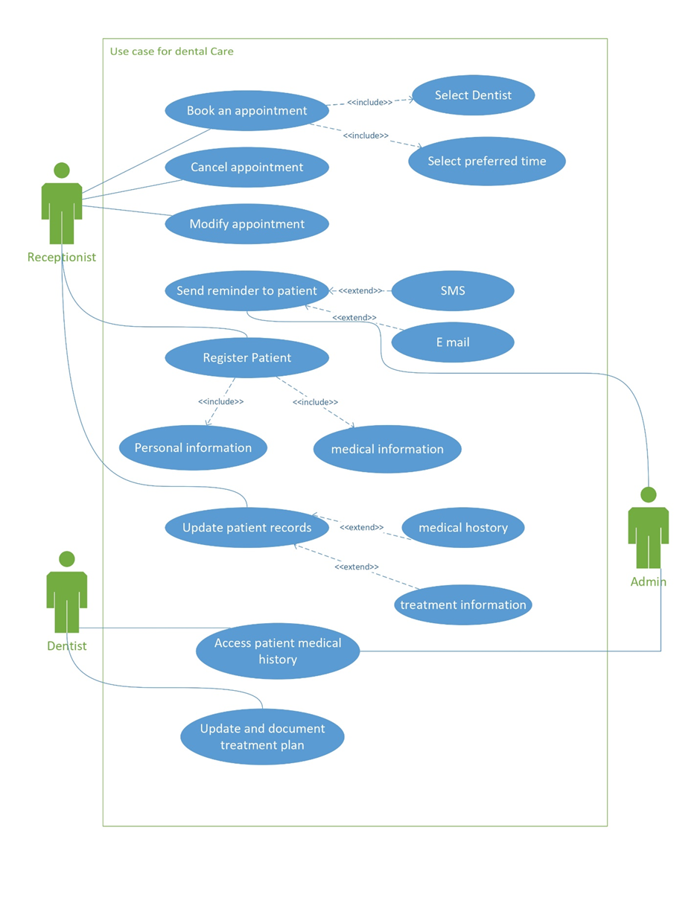

Activity Diagram

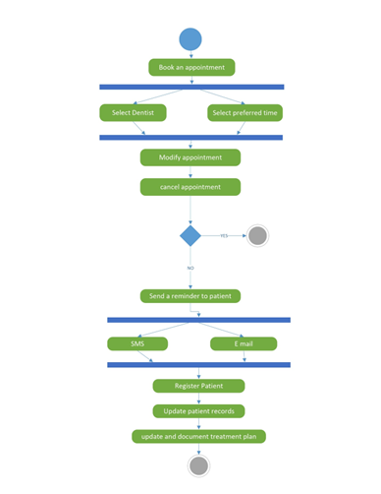

Thank you!

