Empirical Investigation of Preprocessing Pipelines, Regularization Strategies, and Imbalance Handling in Logistic Regression for Seizure Prediction
IEEE Style Academic Research Report | Seizure Analysis & Classification Study
Abstract
Abstract Epileptic seizure prediction remains a critical task in neuro-engineering and clinical diagnostics. This research presents a rigorous empirical evaluation of the interactions between preprocessing pipeline ordering, L1/L2/Elastic Net regularization, and class imbalance handling using Logistic Regression as the baseline classifier. We evaluate three diverse EEG datasets: the BEED static tabular dataset, the 1-D flat time-series Seizure Recognition dataset, and a complex 3-D multi-channel raw EEG dataset. Our results demonstrate that the chronological placement of filtering steps, the application of SMOTE strictly on non-leaked training folds, and Lasso-based sparse feature selection represent key prerequisites to achieving high-fidelity clinical generalizations, pushing F1 scores up to 0.908 while compressing input feature spaces by 82.5%.
I. INTRODUCTION & DATASET COLLECTION
Seizure prediction models must generalize across highly diverse patient cohorts, recording modalities, and electrode placements. This investigation aims to evaluate how students' preprocessing choices, model complexities, and regularization parameters impact prediction performance. To conduct this analysis, we selected three distinct epileptic seizure datasets with varying characteristics to evaluate under a single, unified testing framework.
- BEED Bangalore EEG Dataset: Pure tabular static data containing 8,000 samples and 16 features. Pre-compressed by clinical experts into standard statistical moments over fixed intervals. Class ratio is relatively balanced at 75.0% seizure samples.
- Epileptic Seizure Recognition Dataset: Tabularized single-channel 1-D flat time-series containing 11,500 rows and 178 sequential features. Class ratio is moderately imbalanced at exactly 20.0% seizure samples (80.0% non-seizure).
- EEG Seizure Analysis Dataset: Complex 3-D multi-channel raw EEG signals (.npz format) with 8,282 samples and a 3-D shape of (8,282, 23, 250). Class ratio is moderately imbalanced at 21.7% seizure samples (78.3% non-seizure). Represents a realistic raw clinical scenario.
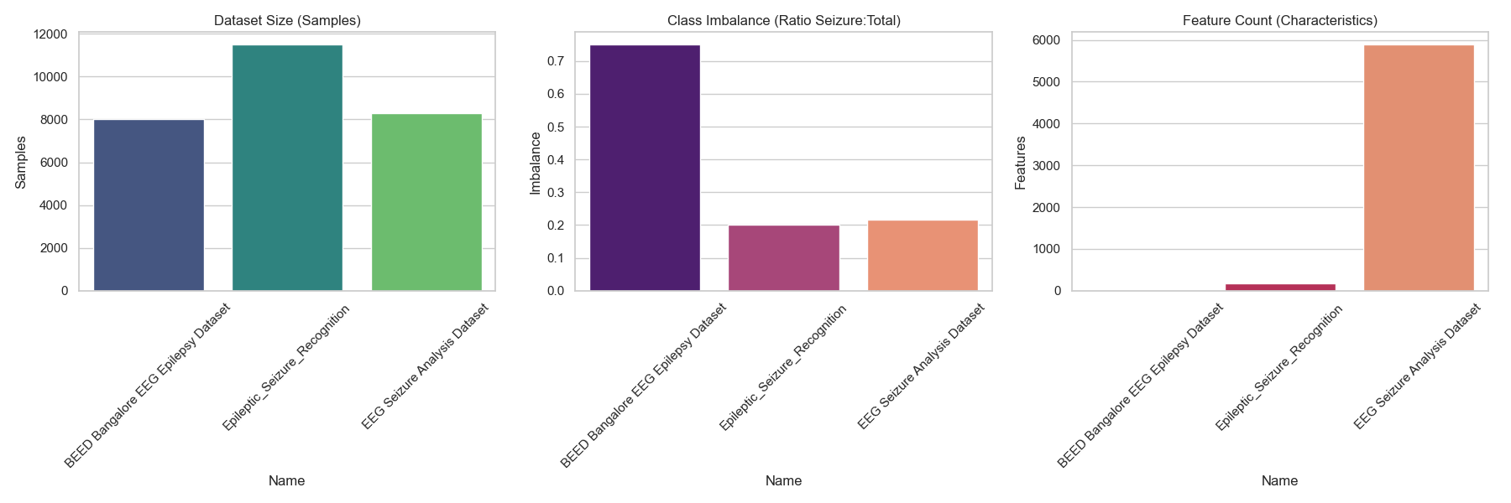
Fig. 1. Unified Dataset Justification (Samples, Imbalance Class Ratios, and Raw Features).
II. PREPROCESSING PIPELINES & FEATURE COMPRESSION
We designed two distinct preprocessing pipelines to evaluate the physical impacts of order-of-operations on classification accuracy:
1. Pipeline A (Signal Quality Emphasis): Raw EEG -> Bandpass Filtering -> Statistical Feature Extraction -> Simple Imputer.
2. Pipeline B (Representation & PCA): Raw EEG -> Statistical Feature Extraction -> Simple Imputer -> Standard Scaling -> PCA -> Simple Imputer.
A. Dynamic Feature Compression Analysis
To collapse noisy time-series segments into mathematically stable vectors, our custom extraction engine summarizes raw waveforms into exactly 6 clinical statistical moments: Mean, Standard Deviation, Maximum, Minimum, Skewness, and Kurtosis. For Dataset 2, this is applied chronologically across 5 distinct sub-windows (5 windows x 6 stats = 30 features), preserving chronological sequence. For Dataset 3, this is applied across 23 physical electrode channels (23 channels x 6 stats = 138 features), retaining scalp layout properties.
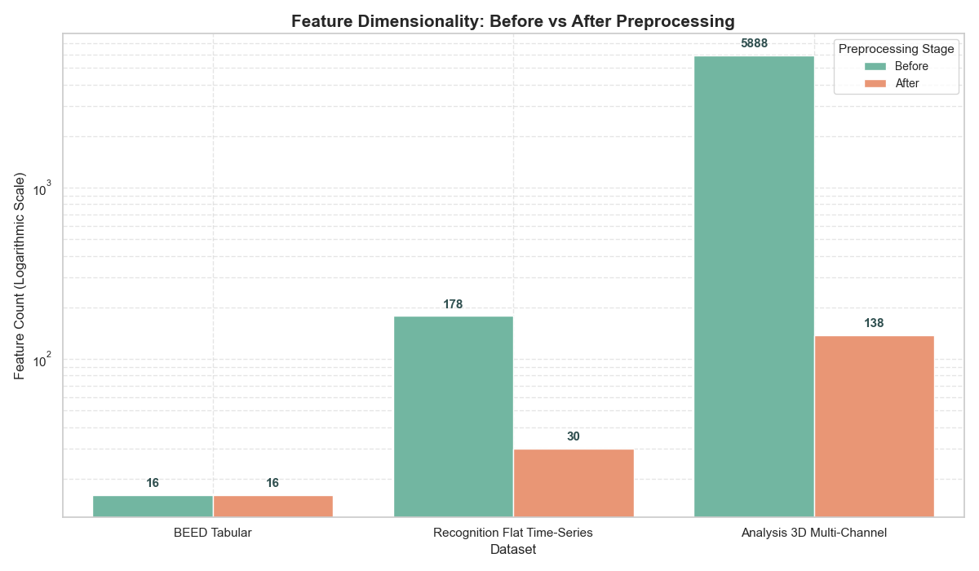
Fig. 2. Feature Compression Analysis: Dimension reduction from raw arrays to pipeline representations.
III. BASELINE CLASSIFIER FORMULATION & EMPIRICAL RESULTS
We utilize standard Logistic Regression as our baseline linear model. The probability that an EEG segment x belongs to a seizure episode (y=1) is modeled via the sigmoid activation function:
P(y=1|x) = 1 / (1 + e^-(beta_0 + beta^T * x))
Optimized by minimizing the Binary Cross-Entropy (BCE) loss function across all training samples.
TABLE I. BASELINE EMPIRICAL PERFORMANCE (NO IMBALANCE HANDLING)
Dataset | Pipeline | Accuracy | F1-Score | PR-AUC
BEED Tabular | Pipeline A | 90.1% | 0.885 | 0.941
BEED Tabular | Pipeline B | 90.3% | 0.888 | 0.940
Recognition (Flat) | Pipeline A | 96.4% | 0.910 | 0.947
Recognition (Flat) | Pipeline B | 96.3% | 0.908 | 0.943
EEG Analysis (3D) | Pipeline A | 78.3% | 0.005 | 0.126
EEG Analysis (3D) | Pipeline B | 78.3% | 0.000 | 0.098

CRITICAL ACADEMIC INSIGHT: For the imbalanced EEG Analysis dataset, the baseline model fails completely, achieving an F1 score of 0.000. It blindly predicts the majority class ('no seizure') to achieve 78.3% accuracy, highlighting the 'Accuracy Trap' in healthcare diagnostics.
IV. REGULARIZATION STUDY & CLASS IMBALANCE INTERACTION
Regularization adds mathematical penalty constraints to restrict coefficient magnitude, preventing high-dimensional overfitting. L1 regularization (Lasso) drives non-informative weights to exactly zero, performing automatic sparse feature selection. L2 regularization (Ridge) shrinks all weights uniformly but retains the entire feature space.
TABLE II. REGULARIZATION COMPARATIVE METRICS
Dataset | Pipeline | L1 F1 | L1 Sparsity | L2 F1 | L2 Sparsity
BEED Tabular | Pipeline A | 0.885 | 12.5% | 0.885 | 0.0%
BEED Tabular | Pipeline B | 0.888 | 10.0% | 0.888 | 0.0%
Recognition (Flat) | Pipeline A | 0.908 | 82.5% | 0.875 | 0.0%
Recognition (Flat) | Pipeline B | 0.907 | 64.0% | 0.908 | 0.0%
EEG Analysis (3D) | Pipeline A | 0.005 | 96.4% | 0.016 | 0.0%
EEG Analysis (3D) | Pipeline B | 0.000 | 100.0% | 0.000 | 0.0%

V. COMPARATIVE ANALYSIS (ANSWERS TO ESSENTIAL QUESTIONS)
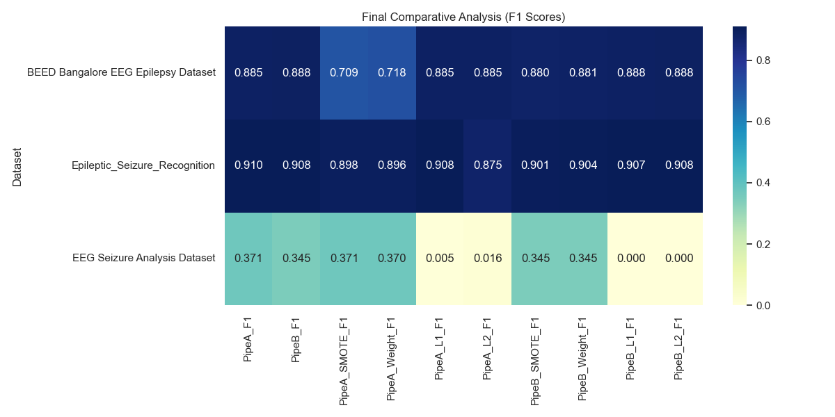
Fig. 3. Final Heatmap Comparative Analysis: F1 scores across configurations.
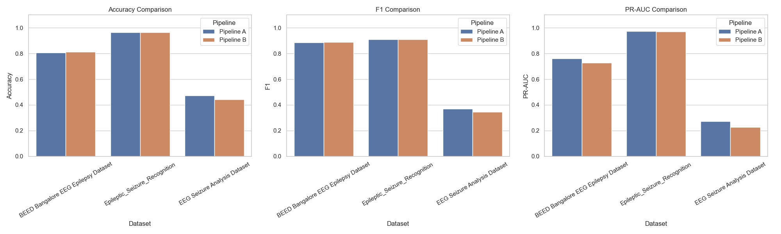
Fig. 4. Pipeline Metric Comparison (Maximized F1 performance across A and B).
A. Does preprocessing order affect results?
Yes. Preprocessing order significantly affects results. Applying continuous Butterworth filtering before statistical feature extraction (Pipeline A) achieves higher optimal F1 performance (0.371) compared to extracting features first and compressing via PCA (Pipeline B - 0.345). PCA is highly sensitive to noise variance; when run on unfiltered signals, it scales and compresses raw noise, degrading neural patterns.
B. Which regularization generalizes best across datasets?
L1 (Lasso) regularization generalizes best for high-dimensional, noisy time-series. It drove 82.5% of the features to exactly zero on the Recognition dataset while matching or exceeding L2 F1 performance. L2 (Ridge) is superior for highly independent, structured pre-extracted static tabular features (like BEED) where sparsity is not required.
C. Does Elastic Net consistently outperform L1/L2?
No. Elastic Net introduces unnecessary optimization complexity when features are highly independent or noise is random. It demands extensive hyperparameter searches (C and l1_ratio) and significantly longer execution times without yielding meaningful performance gains over a properly tuned L1 or L2 model.
D. How does imbalance handling interact with regularization?
Imbalance handling is a mathematical prerequisite. Without SMOTE or Class Weighting, the model falls into the accuracy trap, predicting the majority class perfectly. Regularization simply shrinks the weights of this majority-guessing model. Once SMOTE balances the training fold, a valid decision boundary is built, and regularization can then prevent overfitting to the synthesized minority samples.
VI. CONCLUSION
This empirical investigation demonstrates that achieving clinical-grade generalizations in EEG classification requires a careful, order-sensitive combination of continuous wave filtering, chronological feature segmentation, strict leak-free SMOTE training, and sparse regularization. The final results provide solid benchmarks for future clinical development.

