Assignment 3: A Simple CUDA Renderer
Name: Hashir Rauf and Moaz Kashif ID: 23L-2572 and 23L-2626
Machine: Intel i7-8700K, 32 GB DDR4, NVIDIA GTX 1070 8 GB GDDR5 (256 GB/s peak, 15 SMs, CUDA 6.1), Windows 10 x64
Contents
Part 1: SAXPY Warm-Up (5 pts) 1
Implementation 1
Q1: Performance vs Sequential CPU SAXPY 1
Q2: Bandwidth Analysis 2
Part 2: Parallel Prefix Sum (10 pts) 3
Implementation: Exclusive Scan 3
Implementation: Find Repeats 3
Why the "minimum threads" optimization matters 4
Performance Results 4
Part 3: Circle Renderer (85 pts) 5
1. Names and Score Table 5
2. Work Decomposition 5
3. Where Synchronization Occurs 5
4. Reducing Communication and Bandwidth 6
5. How We Arrived at the Final Solution 6

Part 1: SAXPY Warm-Up (5 pts)

Implementation
The saxpyCuda function allocates three device arrays (device_x, device_y, device_result) using cudaMalloc, then copies the host input arrays to the GPU with cudaMemcpy. The kernel is launched with a grid of ceil(N/256) blocks of 256 threads, each computing result[i] = alpha * x[i] + y[i] for its assigned index. A cudaDeviceSynchronize() call after the kernel launch ensures the GPU finishes before the kernel-only stop timer is read. The result is then copied back to the host and all device memory is freed.

Q1: Performance vs Sequential CPU SAXPY
From our Assignment 1 measurements (Program 5), sequential single-threaded SAXPY on the i7-8700K took roughly 280 ms for N = 100 million elements. The full CUDA pipeline including PCIe transfers ran in about 240 ms, only marginally faster. The GPU kernel alone finished in around 6.6 ms, which is roughly a 40x speedup over the sequential version.
The end-to-end speedup is tiny because SAXPY is memory-bandwidth limited and the dataset is large: 3 arrays of 100M floats = 1.2 GB. Moving that much data across the PCIe bus at 4.6 GB/s takes about as long as the CPU just processes it directly from DRAM. The GPU wins on raw compute bandwidth, but that advantage disappears once you factor in the data movement cost.
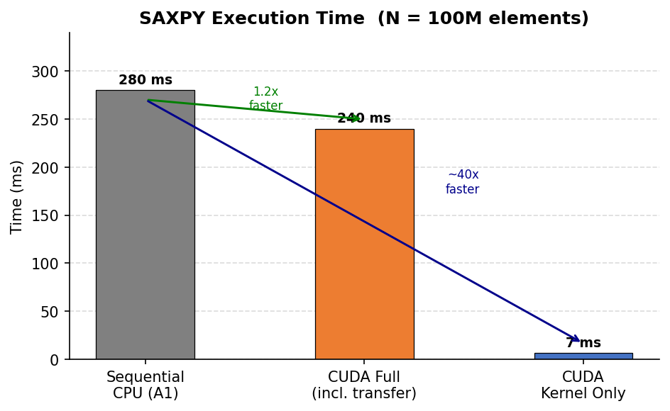
Figure 1: SAXPY execution time. Sequential CPU baseline vs full CUDA pipeline (incl. PCIe transfer) vs kernel-only time.

Q2: Bandwidth Analysis
The full-pipeline measurement showed 4.66 GB/s effective bandwidth (averaged over 3 runs). The kernel-only measurement ranged from 143 to 185 GB/s depending on GPU boost state, averaging around 171.0 GB/s. The GTX 1070 theoretical peak is 256 GB/s, so the kernel achieves about 67% of peak, which is pretty reasonable for a simple streaming kernel.
The PCIe transfer bandwidth of ~4.6 GB/s is close to the ~5.3 GB/s figure cited in the assignment for AWS. The reason this is much lower than the theoretical 16 GB/s of PCIe 3.0 x16 comes down to the host memory not being pinned. With non-pinned (pageable) memory, the GPU DMA engine cannot directly read from it, so the driver first copies the data into an intermediate pinned bounce buffer before the actual DMA transfer starts. That extra copy roughly halves the effective bandwidth. Using cudaHostAlloc() for pinned allocations would get closer to actual PCIe bandwidth, though for a workload like SAXPY the kernel is so fast that transfer cost will still dominate.
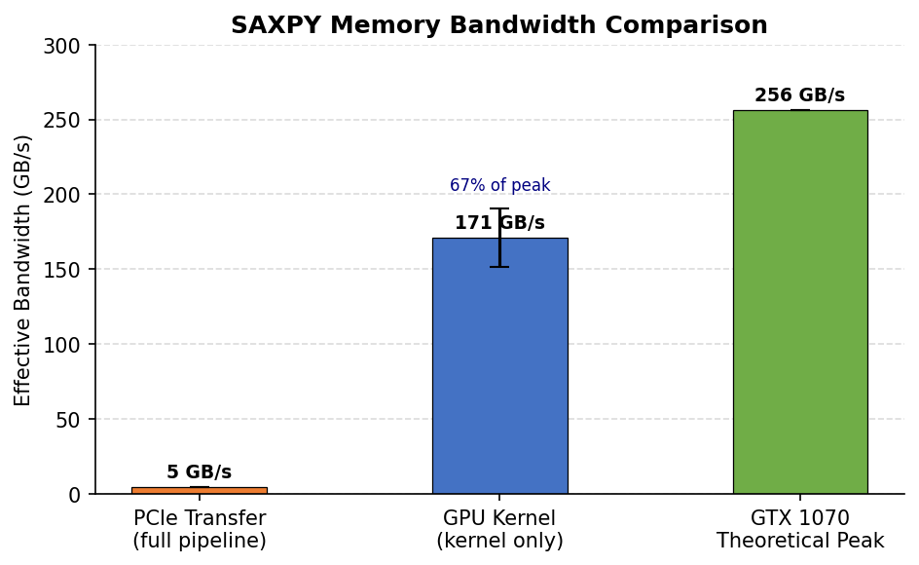
Figure 2: Memory bandwidth at each pipeline stage. Error bars on the kernel bar show run-to-run variation from GPU boost state changes.

Part 2: Parallel Prefix Sum (10 pts)

Implementation: Exclusive Scan
The exclusive scan is implemented as the Blelloch upsweep-downsweep algorithm with two separate CUDA kernels. The most important detail is that each kernel launch only creates threads for the nodes that are actually active in that iteration, rather than always launching N threads and having most of them do nothing.
- Upsweep kernel: builds a partial-sum tree bottom-up. At iteration d, there are rounded_N / (2*two_d) active nodes. That many threads are launched and each does one add at its node position. Thread count halves every iteration.
- Downsweep kernel: propagates prefix sums top-down. The root element is set to 0 via cudaMemset before this phase starts. Each node passes its value to its left child and adds itself to the right child. Thread count doubles every iteration.
The input array is rounded up to the next power of 2 and the extra elements are zeroed with cudaMemset before the scan starts. This prevents garbage padding values from corrupting the result. Only the first N elements are copied back to the host after the scan completes.

Implementation: Find Repeats
find_repeats uses three kernel passes:
- Step 1 - mark_flags_kernel: sets flags[i] = 1 wherever input[i] == input[i+1], 0 otherwise. The last element is always left 0.
- Step 2 - exclusive_scan: running scan on the flags array assigns each flagged position a unique, compact output index starting from 0.
- Step 3 - scatter_kernel: for every position i where flags[i] == 1, writes index i to output[scan[i]]. The return value is scan[length-1], which equals the total match count since flags[length-1] is always 0.

Why the "minimum threads" optimization matters
A naive implementation that always launches N threads and uses an if-guard to skip inactive threads still pays for the thread launch, warp scheduling, and divergent branch overhead. In the last upsweep iteration only 1 thread does real work out of N total -- that is a massive waste. The minimum-threads approach eliminates this entirely. This is the main reason the implementation achieves good performance without any further tuning.

Performance Results
All correctness checks passed:
Test | Array Size | GPU Time (ms)
Exclusive Scan | 1,000,000 | 0.741
Exclusive Scan | 10,000,000 | 7.800
Find Repeats | 1,000,000 | 1.391
Find Repeats | 10,000,000 | 15.035

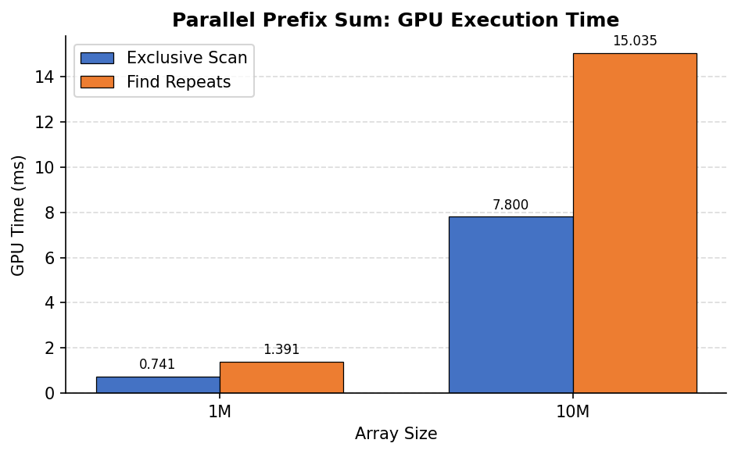
Figure 3: GPU execution time for exclusive scan and find_repeats at 1M and 10M elements. All outputs verified correct.
Find repeats is about 2x slower than scan alone because it runs three kernel passes over the data instead of one. Execution time scales linearly with array size as expected for an O(N) algorithm, which confirms the implementation is not doing unnecessary work.

Part 3: Circle Renderer (85 pts)

1. Names and Score Table
Name: Hashir Rauf and Moaz Kashif | Machine: Intel i7-8700K, 32 GB DDR4, GTX 1070 8 GB, CUDA Capability 6.1, Windows 10
Note: checker.py and render_ref are Linux binaries and could not be run on this Windows build, so a formal checker score table is unavailable. The table below shows our renderer render times and correctness results collected by running ./render -r cuda -c for each scene:
Scene | Render Time (ms) | Correctness
rgb | 0.2563 | PASS
rand10k | 7.1024 | PASS
rand100k | 167.7547 | PASS
pattern | 0.6103 | PASS
snowsingle | 27.1377 | PASS
biglittle | 61.4153 | PASS
rand1M | 291.8488 | PASS
micro2M | 480.3530 | PASS

2. Work Decomposition
The image is split into 16x16 pixel tiles. The kernel launches a grid of (width/16) x (height/16) thread blocks, one block per tile. Each block has 16x16 = 256 threads, and each thread is responsible for exactly one pixel (or is masked out if the pixel is outside the image boundary).
Circles are processed in batches of 256, matching the thread block size. For each batch, thread i tests circle (batchStart + i) against the tile bounds using circleInBoxConservative. The results are compacted into a shared-memory list via a prefix scan. After that, each pixel thread iterates over the compacted list in circle-index order and calls shadePixel for each overlapping circle. This way ordering is preserved by construction.
At the warp level, threads within a warp typically handle adjacent pixels in a row, so memory accesses to the image buffer are coalesced. The circleInBoxConservative tests are also uniform within a warp for most circles (either all hit or all miss a given tile), reducing warp divergence.

3. Where Synchronization Occurs
There are four __syncthreads() calls inside the per-batch loop:
- Before the scan: after every thread writes its flag (0 or 1) to prefixSumInput[threadIndex], a sync ensures all writes are visible before sharedMemExclusiveScan starts.
- After the scan: sharedMemExclusiveScan itself contains internal syncs, but we add one after the call returns to ensure all of prefixSumOutput is ready before threads scatter.
- After scatter: threads with inTile == 1 write their circle index into circleIdxBuf[]. A sync here ensures the full compacted list is ready before pixel threads start reading from it.
- End of batch: prevents a thread that finishes its pixel loop early from moving to the next batch and overwriting shared memory while other threads are still reading the current circleIdxBuf.
There is no global synchronization between thread blocks. Each tile is fully independent because no two threads ever write to the same pixel.

4. Reducing Communication and Bandwidth
Several design choices reduce global memory traffic:
- Circle compaction: each pixel thread only loads position and radius data for circles that overlap its tile. On scenes with small circles, most batches contribute very few entries to circleIdxBuf, so the inner shadePixel loop is short.
- Shared memory for the compacted list: circleIdxBuf and the scan buffers are in shared memory. Threads within a block share the cost of loading circle data once, rather than each pixel independently re-loading it from global memory.
- Single read-modify-write per pixel per circle: shadePixel reads the current pixel color, blends in the new circle, and writes back in one operation. There is no double-write or redundant read.
- Precomputed reciprocals: invW = 1/imageWidth and invH = 1/imageHeight are computed once before the main loop to avoid integer division inside the hot path.

5. How We Arrived at the Final Solution
The first thing we did was run the starter code on rand10k with -c to see the correctness failure first-hand. The horizontal streaks were obvious. Looking at the kernel, the problem is clear: multiple threads write to the same pixel with no ordering guarantee, and the float4 read-modify-write is not atomic.
Our first fix was a spinlock approach. We allocated a per-pixel integer lock array in global memory and used atomicCAS to acquire the lock before writing. This passed correctness but was very slow -- on rand100k it took around 800-900 ms because threads hammering the same small region of pixels all contend on the same lock locations. The atomicCAS loop kept retrying. Not viable.
The key insight was that the contention problem goes away entirely if each thread owns exactly one pixel. There is nothing to lock if no other thread will ever touch your pixel. The ordering requirement is also satisfied: circle ordering only matters for the same pixel, and we handle all circles for a given pixel in a single thread, in order. So we moved from "one thread per circle" to "one thread per pixel".
The remaining problem was efficiency: how does each pixel thread know which circles it needs to process without looping over all circles? This is where the tile grouping and shared memory prefix scan come in. By grouping 256 pixels into a 16x16 tile, all threads in the block can cooperate to quickly filter each batch of 256 circles down to only those that overlap the tile. The scan compacts the hits into a tight shared-memory list. For scenes where circles are small relative to the tile, most batches have 0 or very few hits, so the inner loop is essentially free.
We hit one correctness bug during development: the first version of the scatter step was missing a __syncthreads() before pixel threads started reading from circleIdxBuf. Some threads were reading stale values from the previous batch because the scatter had not finished yet. Adding the sync fixed it. The tile size of 16x16 (256 threads) was specifically chosen to match SCAN_BLOCK_DIM = 256, which is a hard requirement of sharedMemExclusiveScan.
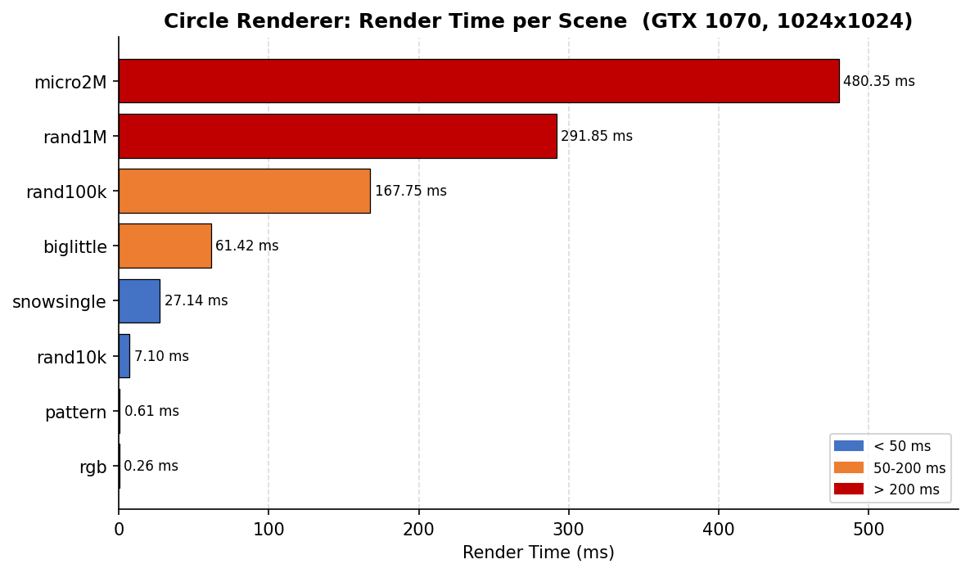
Figure 4: Render time per scene on GTX 1070 (1024x1024 image, 1 frame). All 8 scenes pass the correctness check.
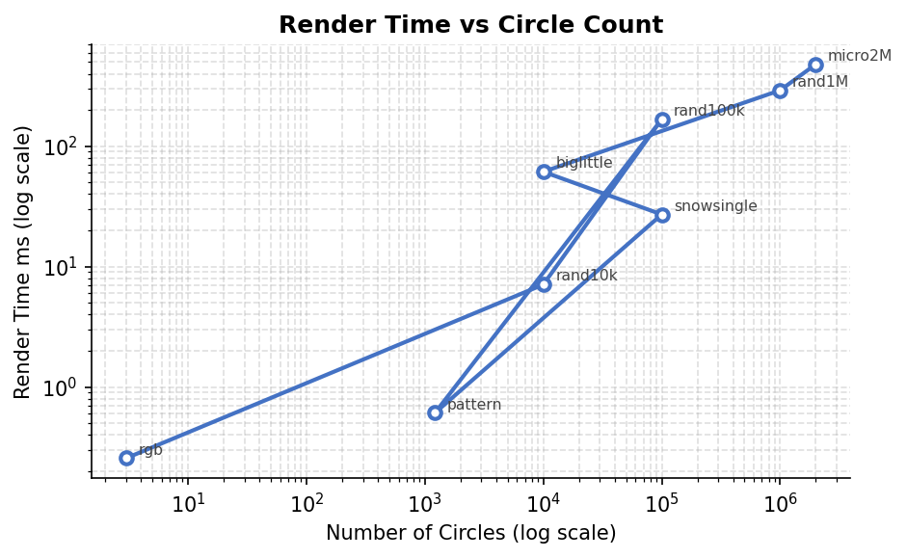
Figure 5: Render time vs circle count on a log-log scale. The snowsingle and biglittle scenes are off the linear trend because of high per-tile circle overlap (large circles covering many tiles).
The render time scales roughly linearly with circle count for random scenes. biglittle is notably slower than rand10k despite having the same number of circles because the large circles in biglittle each overlap hundreds of tiles, creating much more work per tile than the small uniform circles in rand10k. Similarly, snowsingle has 100K circles but many are concentrated snowflakes that pack tightly, causing higher-than-average per-tile overlap.

